Supplementary File
Table S1: Set of 10 ecological sensitive sets of BioClimatic variables
Set | Variables | Max_VIF | Max_  Pearson_r
- Extreme Thermal Stress Model | India_bio03, India_bio05, India_bio07, India_bio13, India_bio14, India_bio15, India_bio18, India_bio19 | 4.04 | 0.752
- Aridity-Limited Monsoon Model | India_bio03, India_bio05, India_bio07, India_bio13, India_bio15, India_bio17, India_bio18, India_bio19 | 4.05 | 0.752
- Primary Monsoon-Driven Suitability | India_bio02, India_bio03, India_bio05, India_bio13, India_bio14, India_bio15, India_bio18, India_bio19 | 4.14 | 0.733
- Warm-Season Transmission Baseline | India_bio03, India_bio07, India_bio10, India_bio13, India_bio14, India_bio15, India_bio18, India_bio19 | 4.17 | 0.752
- Precipitation Scarcity Risk Model | India_bio03, India_bio07, India_bio10, India_bio13, India_bio15, India_bio17, India_bio18, India_bio19 | 4.17 | 0.752
- Niche Stability & Water Stress Model | India_bio02, India_bio03, India_bio05, India_bio13, India_bio15, India_bio17, India_bio18, India_bio19 | 4.14 | 0.733
- Annual Mean Suitability Model | India_bio01, India_bio03, India_bio07, India_bio13, India_bio15, India_bio17, India_bio18, India_bio19 | 4.45 | 0.752
- Monsoon Onset & Mean Heat Model | India_bio01, India_bio03, India_bio07, India_bio13, India_bio14, India_bio15, India_bio18, India_bio19 | 4.49 | 0.752
- Global Climatic Stability Model | India_bio01, India_bio02, India_bio03, India_bio13, India_bio14, India_bio15, India_bio18, India_bio19 | 4.24 | 0.643
- Tropical Heat Interaction Model | India_bio02, India_bio03, India_bio10, India_bio13, India_bio14, India_bio15, India_bio18, India_bio19 | 4.26 | 0.699

Why these Bios are selected?
The selection of Bio02, Bio03, Bio05, Bio13, Bio14, Bio15, Bio18, and Bio19 gives a comprehensive climatic requirement of Aedes aegypti life cycle along with maintaining strict statistical parameters (VIF < 5.0, $|r| < 0.75$). Bio13 (Precipitation of Wettest Month) and Bio18 (Precipitation of Warmest Quarter) act as the "Monsoon Anchors," which captures the peak rainfall and humidity required for larval habitat creation and rapid viral replication during the summer heat and high cases in India are also registered during monsoon season. These are complemented by Bio05 (Max Temperature of Warmest Month), which decides the thermal ceiling and dictates the speed of the virus's Extrinsic Incubation Period (EIP).
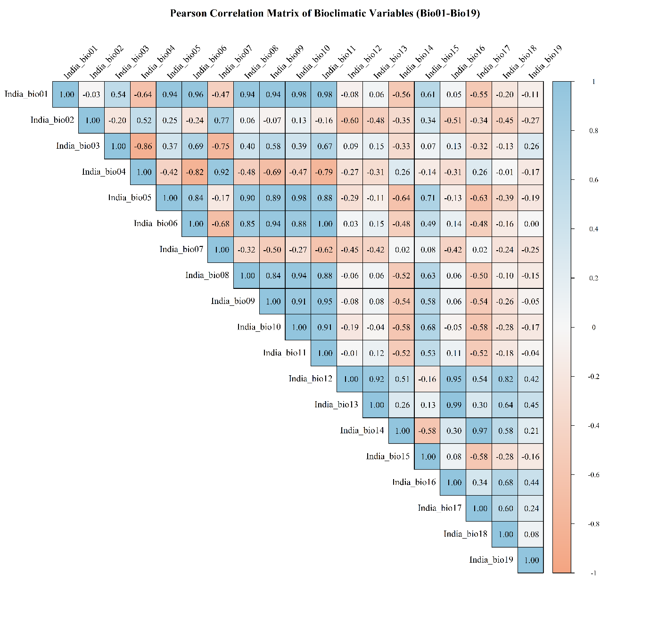
To capture the main essence of Indian climate, Bio15 (Precipitation Seasonality) and Bio14 (Precipitation of Driest Month) which define the wet-dry intensity and the critical population bottleneck of the dry season, respectively are used. The addition of Bio19 (Precipitation of Coldest Quarter) accounts for "Persistence Theory," identifying the winter moisture necessary for the survival of dormant eggs (overwintering) until the next monsoon. Finally, Bio02 (Mean Diurnal Range) and Bio03 (Isothermality) are used as they serve as proxies for climatic stability; a lower diurnal range indicates the high-humidity, stable conditions that maximize adult mosquito longevity. Together, these 8-variable set avoids multicollinearity while covering the four pillars of Dengue ecology: thermal acceleration, moisture availability, seasonal intensity, and overwintering persistence.
Figure S1. Pearson corelation between bioclimatic variables
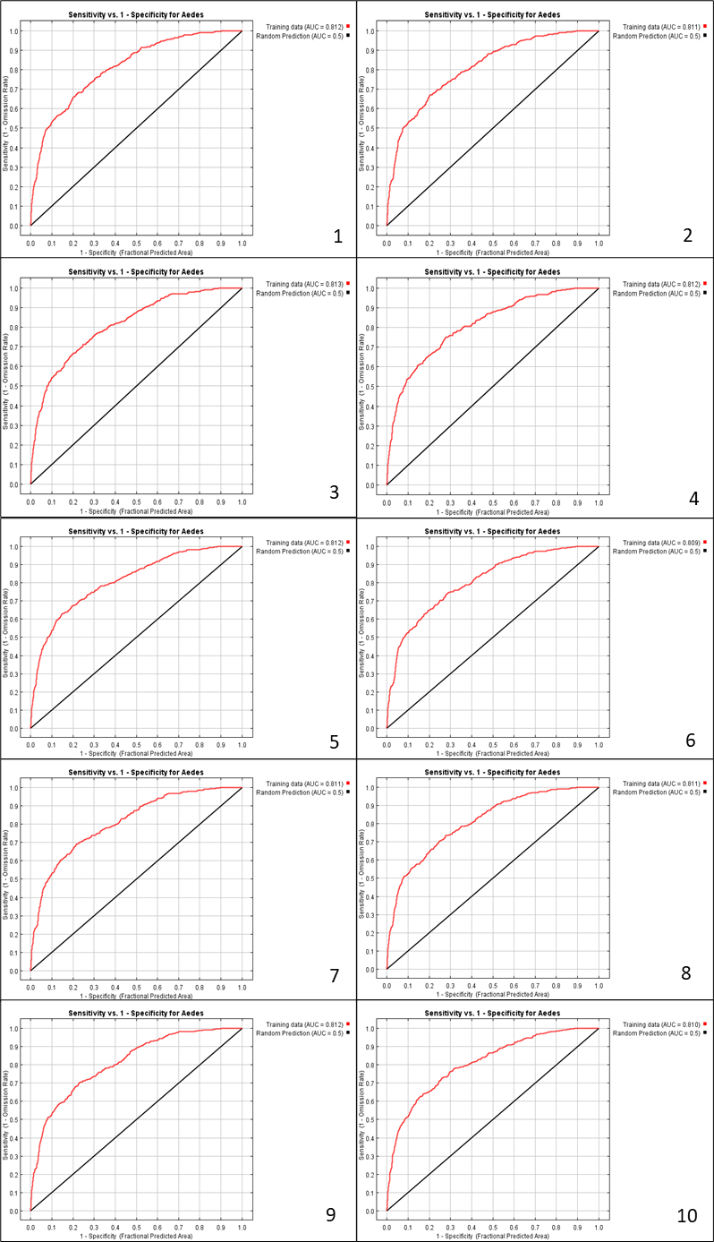
Figure S2. Receiver Operating Characteristic (ROC) Curve for 10 selected Aedes Model Validation
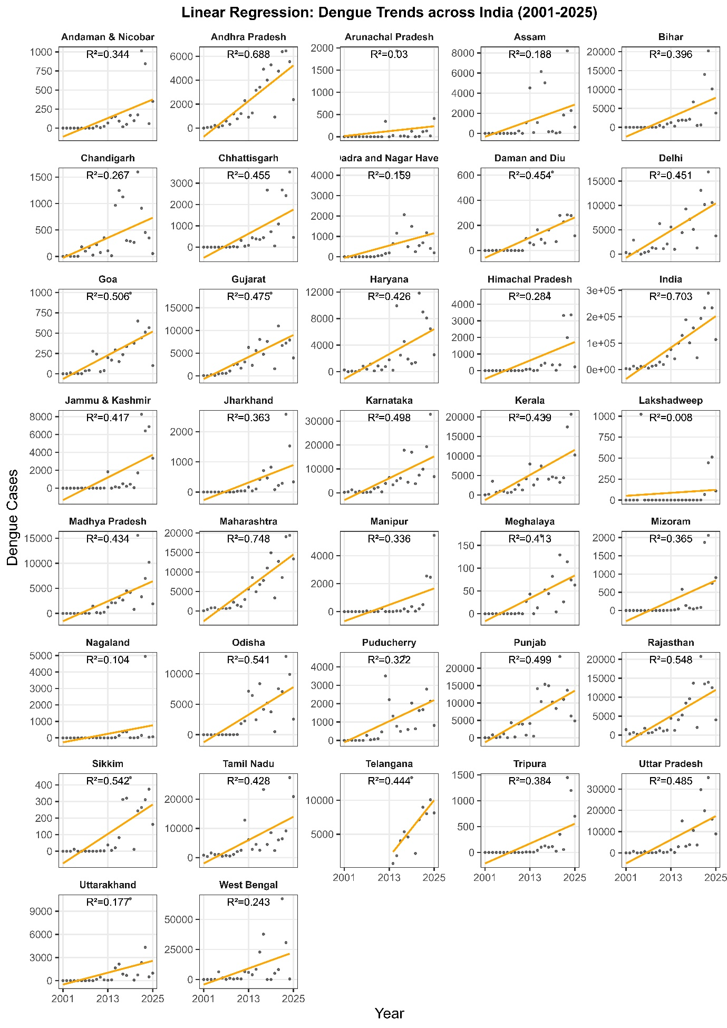
Figure S3. Trend of Dengue of in India from 2001 to 2025.

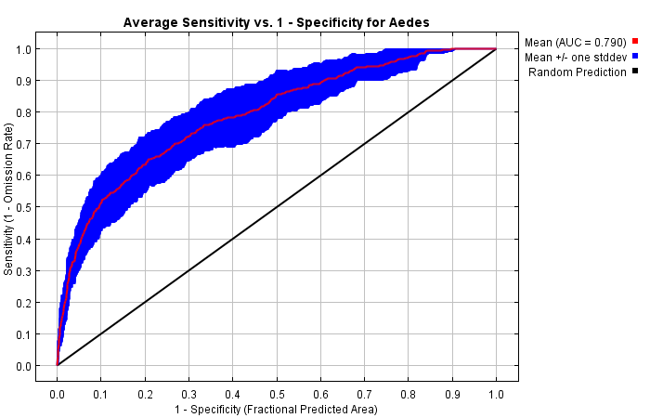
Figure S4. Receiver Operating Characteristic (ROC) Curve for Aedes Model Validation
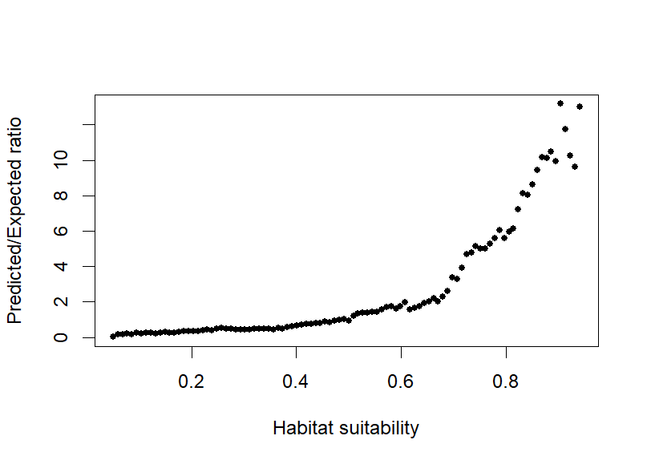

Figure S5. Boyce evaluation plot.

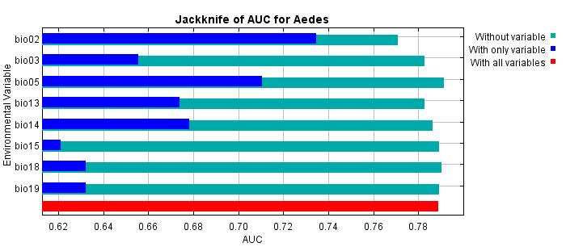
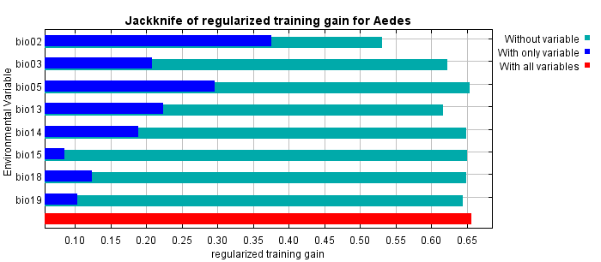
Figure S6. Jackknife of regularized training gain.
Figure S7. Jacknife of AUC for Aedes aegypti.
In contrast to the marginal response curves, each of the following curves represents a different model, namely, a Maxent model created using only the corresponding variable. These plots are showing the dependence of predicted suitability both on the selected variable and on dependencies caused by correlations between the selected variable and other variables. They may be easier to interpret if there are strong correlations between variables.
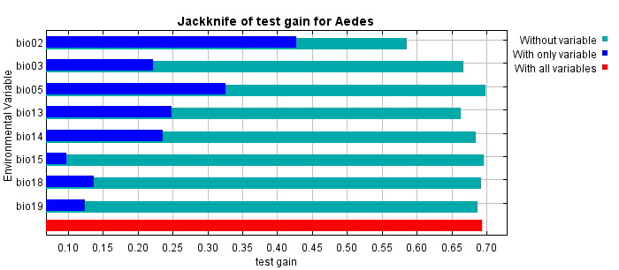
Single-variable MaxEnt models shows that thermal predictors, particularly maximum temperature of the warmest month (BIO5) and mean diurnal range (BIO2), exert strong independent control over predicted suitability, by producing clear unimodal (BIO5; optimum ~30–33 °C) and monotonic (BIO2; decline beyond ~8–10 °C) responses. In contrast, precipitation variables has shown pronounced unimodal relationships when modeled independently, with precipitation of the wettest month (BIO13) and warmest quarter (BIO18) peaking at intermediate ranges (~800–1600 mm) and declining sharply under extreme rainfall (>2000–3000 mm). Notably, responses for precipitation of the coldest quarter (BIO19) differ from marginal curves, which means that correlations among precipitation variables substantially influence full-model predictions. Together these single-variable models highlight temperature stability as a robust predictor, while precipitation effects appear more sensitive to inter-variable covariance.
Figure S8. Jacknife of test gain for Aedes aegypti.

Table S2: Quantitative Assessment of Climate-Driven Shifts in Suitability Zones (1980–2100)
Area(Km2) | ipsl-cm6a-lr |  |  |  |  |  | ukesm1-0-ll
Scenarios | Low | Medium | High | Low_% | Medium_% | High_% | Low | Medium | High | Low_% | Medium_% | High_%
2011-40_ssp126 | 1608984.3 | 1172946 | 532769.8 | 48.54 | 35.39 | 16.07 | 1733377.4 | 1071876.8 | 493922 | 52.54 | 32.49 | 14.97
2011-40_ssp370 | 1499639.3 | 1218876 | 596184.7 | 45.24 | 36.77 | 17.99 | 1796870.9 | 894128.5 | 623700.6 | 54.21 | 26.97 | 18.82
2011-40_ssp585 | 1505157.1 | 1197680.6 | 611862.5 | 45.41 | 36.13 | 18.46 | 1740325.9 | 960706.9 | 613667.3 | 52.5 | 28.98 | 18.51
2041-70_ssp126 | 1623681.5 | 1150336.6 | 540681.9 | 48.98 | 34.7 | 16.31 | 1642643.6 | 1152118.2 | 519938.2 | 49.56 | 34.76 | 15.69
2041-70_ssp370 | 1819638.1 | 954739.8 | 540322.2 | 54.9 | 28.8 | 16.3 | 1930793.5 | 802874 | 581032.5 | 58.25 | 24.22 | 17.53
2041-70_ssp585 | 1714101.3 | 934763.5 | 665835.2 | 51.71 | 28.2 | 20.09 | 1955152.4 | 816397.6 | 543150 | 58.98 | 24.63 | 16.39
2071-2100_ssp126 | 1700037.8 | 1039592.9 | 575069.4 | 51.29 | 31.36 | 17.35 | 2023039 | 729191.7 | 562468.6 | 61.03 | 22 | 16.97
2071-2100_ssp370 | 1916826.1 | 840888.7 | 556985.3 | 57.83 | 25.37 | 16.8 | 1662829.7 | 1080935.3 | 570935.1 | 50.17 | 32.61 | 17.22
2071-2100_ssp585 | 1937691.5 | 867108.5 | 509900.1 | 58.46 | 26.16 | 15.38 | 1888931.3 | 952913.3 | 472855.5 | 56.99 | 28.75 | 14.27
 | mpi-esm1-2-hr |  |  |  |  |  | gfdl-esm4
 | Low | Medium | High | Low_% | Medium_% | High_% | Low | Medium | High | Low_% | Medium_% | High_%
2011-40_ssp126 | 1681546.7 | 1122928.1 | 510225.3 | 50.73 | 33.88 | 15.39 | 1529706.6 | 1186867.74 | 598125.73 | 46.15 | 35.81 | 18.04
2011-40_ssp370 | 1402647.5 | 1308847.2 | 603205.3 | 42.32 | 39.49 | 18.2 | 1490573.6 | 1191908.87 | 632217.6 | 44.97 | 35.96 | 19.07
2011-40_ssp585 | 1529890 | 1241306.7 | 543503.3 | 46.15 | 37.45 | 16.4 | 1514852.4 | 1189763.61 | 610084.08 | 45.7 | 35.89 | 18.41
2041-70_ssp126 | 1576205.4 | 1044164.6 | 694330 | 47.55 | 31.5 | 20.95 | 1482457.2 | 1242749.47 | 589493.42 | 44.72 | 37.49 | 17.78
2041-70_ssp370 | 1577330.9 | 1234436.8 | 502932.4 | 47.59 | 37.24 | 15.17 | 1448552.8 | 1212541.99 | 653605.32 | 43.7 | 36.58 | 19.72
2041-70_ssp585 | 1389699.1 | 1207806.9 | 717194.1 | 41.93 | 36.44 | 21.64 | 1495371.2 | 1212560.41 | 606768.46 | 45.11 | 36.58 | 18.31
2071-2100_ssp126 | 1636700.5 | 1131633.3 | 546366.3 | 49.38 | 34.14 | 16.48 | 1518523.7 | 1191607.67 | 604568.72 | 45.81 | 35.95 | 18.24
2071-2100_ssp370 | 1298821.9 | 1148813.8 | 867064.4 | 39.18 | 34.66 | 26.16 | 1514494.3 | 1184671.21 | 615534.55 | 45.69 | 35.74 | 18.57
2071-2100_ssp585 | 1045021 | 1315569.8 | 954109.3 | 31.53 | 39.69 | 28.78 | 1519839.8 | 1180234.9 | 614625.34 | 45.85 | 35.61 | 18.54
 | mri-esm2-0
 | Low | Medium | High | Low_% | Medium_% | High_%
2011-40_ssp126 | 1482744.8 | 1278137.5 | 553817.8 | 44.73 | 38.56 | 16.71
2011-40_ssp370 | 1569259.3 | 1168748.4 | 576691.5 | 47.34 | 35.26 | 17.4
2011-40_ssp585 | 1571065.8 | 1240099.5 | 503534.8 | 47.4 | 37.41 | 15.19
2041-70_ssp126 | 1592757.1 | 1193044 | 528899 | 48.05 | 35.99 | 15.96 | Base Period
2041-70_ssp370 | 1479248.1 | 1243114.8 | 592337.2 | 44.63 | 37.5 | 17.87 | Low | Medium | High | Low_% | Medium_% | High_%
2041-70_ssp585 | 1716884.2 | 1067698.4 | 530117.4 | 51.8 | 32.21 | 15.99 | 1439004 | 1262945.21 | 612750.84 | 43.41 | 38.1 | 18.49
2071-2100_ssp126 | 1349111 | 1393447 | 572142.3 | 40.7 | 42.04 | 17.26
2071-2100_ssp370 | 1682376.6 | 1080719 | 551604.5 | 50.76 | 32.6 | 16.64
2071-2100_ssp585 | 1967542.5 | 872129.6 | 475028 | 59.36 | 26.31 | 14.33

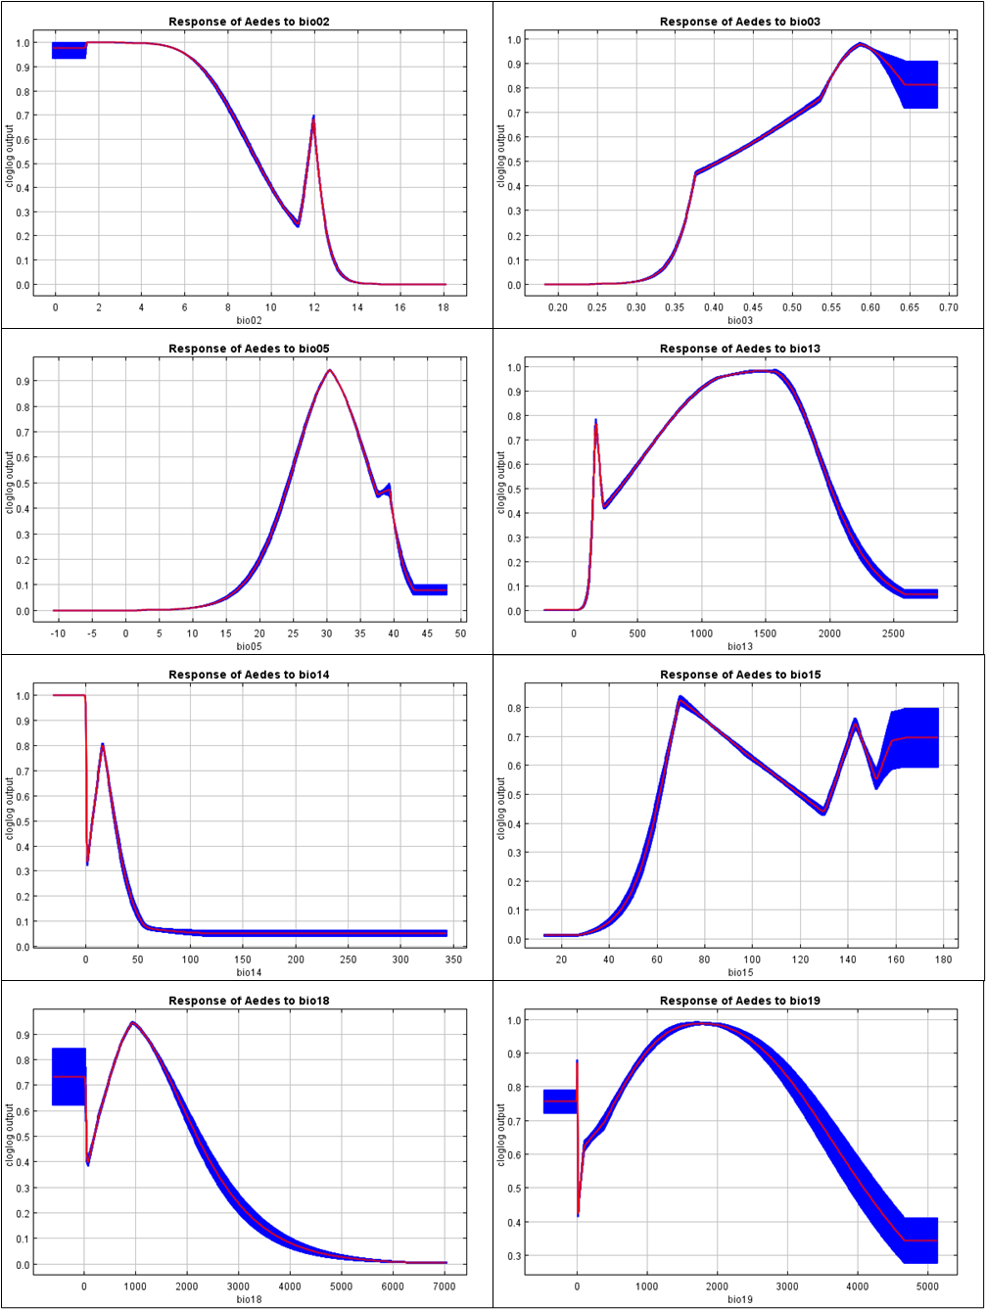
Figure S9. Univariate MaxEnt Response Curves

Table S3. State-wise Dengue cases in India from 2001 to 2025

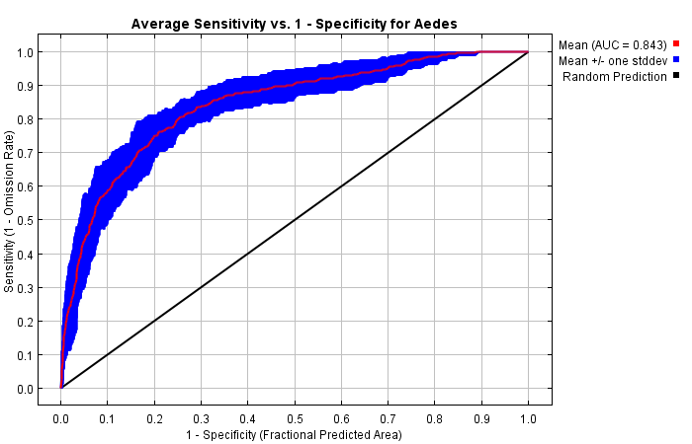
Figure S10. AUC curve If occurance is taken form GBIF only

