Table S1 – Bacterial quantification and genomic DNA concentration of the Escherichia coli strains used as controls.
 | CFU/mL | DNA (ng/µL)
UPEC CFT073 | 9 x 10⁷ | 56,3
042 | 4,3 x 10⁸ | 57,6
Colony-forming unit per milliliter (CFU/mL) values ​​and genomic DNA concentration (ng/µL) obtained for the E. coli strains used as controls in the molecular assays.

Figure S1 – Performance of the fyuA primer regarding amplification, specificity, and the qPCR reaction standard curve.

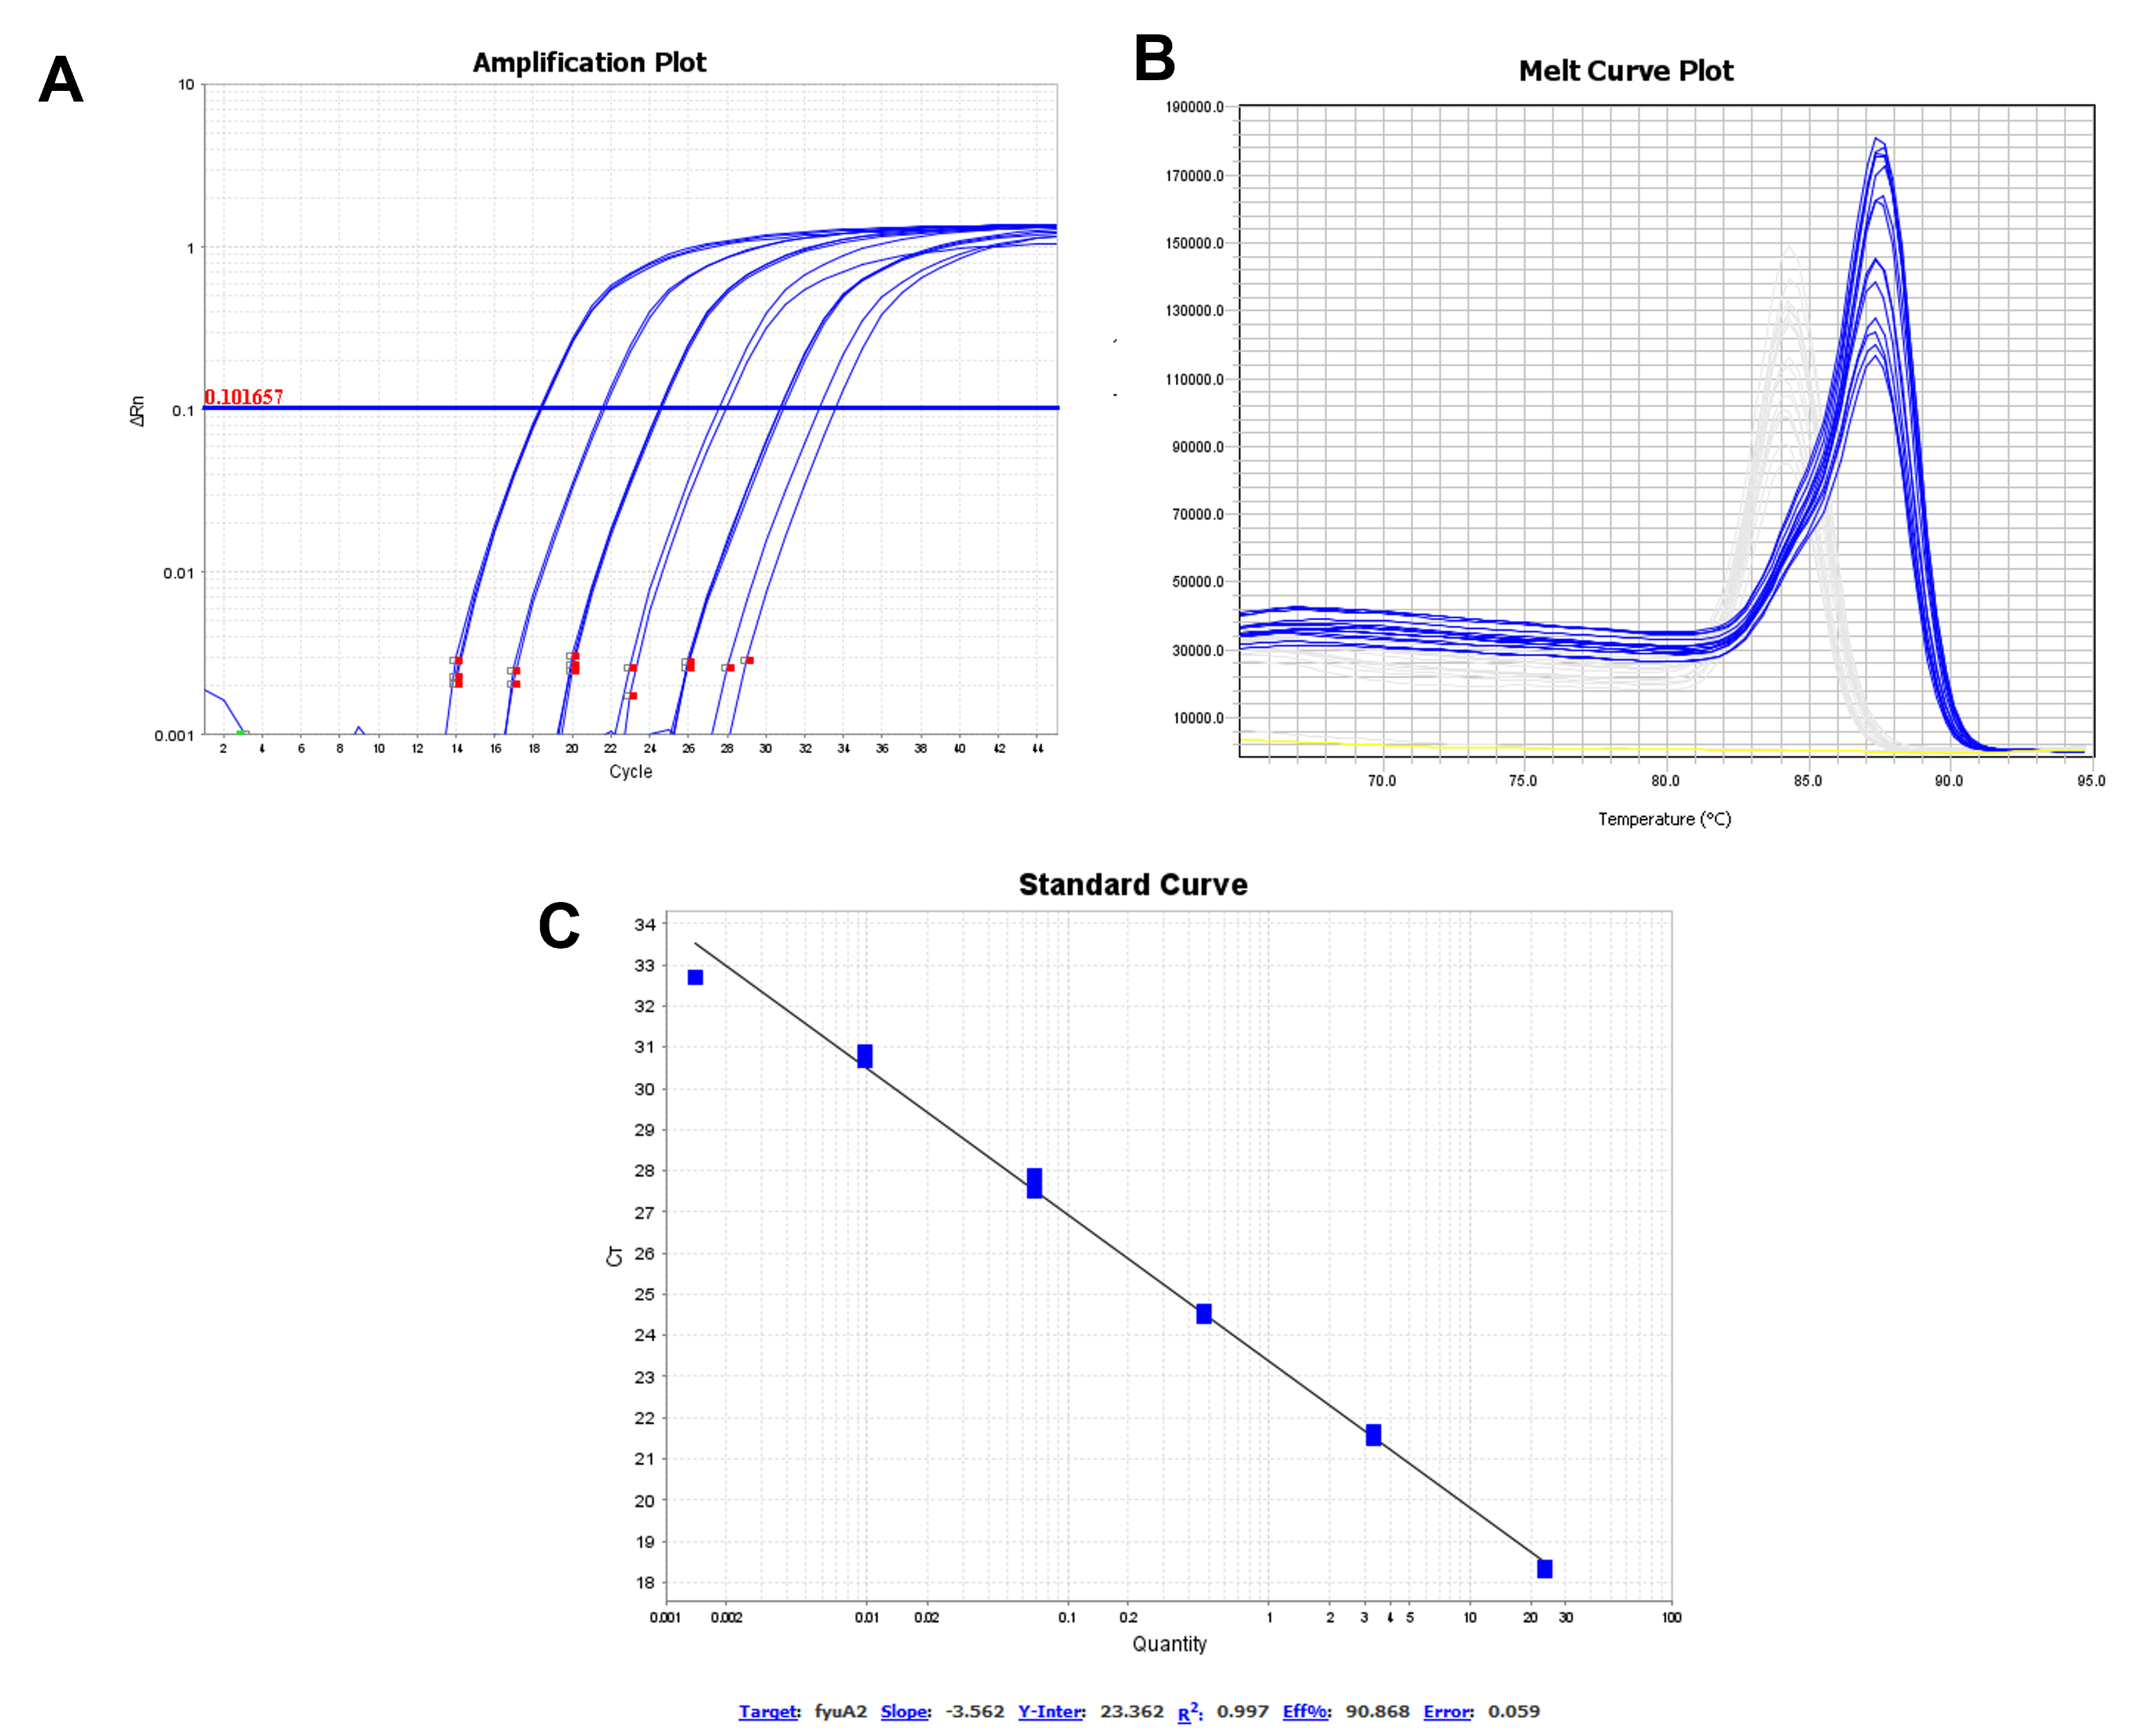
A seven-point standard curve was constructed for the fyuA primers using serial 1:8 dilutions of UPEC CFT073 DNA, with concentrations ranging from 56.3 ng/µL to 0.00021475 ng/µL. Panel (A) shows the amplification corresponding to the standard curve points; panel (B) displays the dissociation plot confirming the specificity of the amplified product; and panel (C) presents the amplified points and the final fit of the standard curve.

Figure S2 – Performance of the yfcV primer regarding amplification, specificity, and the qPCR reaction standard curve.

A standard curve for the yfcV primers was constructed using seven points obtained through serial 1:8 dilutions of UPEC CFT073 DNA, ranging in concentration from 56.3 ng/µL to 0.00021475 ng/µL. Panel (A) shows the amplification corresponding to the standard curve points for the primer; panel (B) displays the dissociation plot confirming the specificity of the amplified product; and panel (C) presents the amplified points and the final fit of the standard curve.

Figure S3 – Performance of the chuA primer regarding amplification, specificity, and the qPCR reaction standard curve.
A standard curve for the chuA primers was constructed using seven points obtained through serial 1:8 dilutions of UPEC CFT073 DNA, ranging in concentration from 56.3 ng/µL to 0.00021475 ng/µL. Panel (A) shows the amplification corresponding to the standard curve points for the primer; panel (B) displays the dissociation plot confirming the specificity of the amplified product; and panel (C) presents the amplified points and the final fit of the standard curve.

Figure S4 – Performance of the vat primer regarding amplification, specificity, and the qPCR reaction standard curve.
A standard curve for the vat primer pair was constructed using seven points obtained through serial 1:8 dilutions of UPEC CFT073 DNA, ranging in concentration from 56.3 ng/µL to 0.00021475 ng/µL. Panel (A) shows the amplification corresponding to the standard curve points for the primer; panel (B) displays the dissociation plot confirming the specificity of the amplified product; and panel (C) presents the amplified points and the final fit of the standard curve.

Figure S5 – Performance of the aggR primer regarding amplification, specificity, and the standard curve in the qPCR reaction.
A standard curve for the aggR primer pair was constructed using seven points obtained through serial 1:8 dilutions of EAEC 042 DNA, ranging in concentration from 57.6 ng/µL to 0.0002197265 ng/µL. Panel (A) shows the amplification corresponding to the standard curve points for the primer; panel (B) displays the dissociation plot confirming the specificity of the amplified product; and panel (C) presents the amplified points and the final fit of the standard curve.

Figure S6 – Performance of the aap primer regarding amplification, specificity, and the standard curve in the qPCR reaction
A standard curve was constructed for the aap primer, consisting of seven points obtained through serial 1:8 dilutions using EAEC 042 DNA at concentrations ranging from 57.6 ng/µL to 0.0002197265 ng/µL. Panel (A) shows the amplification corresponding to the primer standard curve points; panel (B) displays the dissociation plot confirming the specificity of the amplified product; and panel (C) presents the amplified points and the final fit of the standard curve.

