Additional file 1

Development and internal validation of a clinical prediction model for global developmental delay after neonatal hospitalization: a retrospective case-control study
Journal: BMC Pediatrics | Authors: Ruifeng Tian and Shiwen Xia | Corresponding author: Shiwen Xia, 908182570@qq.com
This appendix contains model-development details needed to interpret and reproduce the reported prediction model. Parental education groups were defined according to ISCED 2011: low education comprised levels 1-2, middle education levels 3-4, and high education levels 5-8. Numerical scores 1, 2, and 3 were assigned to these groups only for ordinal model calculation; code 0 denoted missing information and was recoded as missing before analysis. No patient-level records are included.

Supplementary Table S0. ISCED 2011 education classification used in this study
ISCED level | Official level description | Study education group
1 | Primary education | Low
2 | Lower secondary education | Low
3 | Upper secondary education | Middle
4 | Post-secondary non-tertiary education | Middle
5 | Short-cycle tertiary education | High
6 | Bachelor’s or equivalent level | High
7 | Master’s or equivalent level | High
8 | Doctoral or equivalent level | High
Note: The low/middle/high categories above define education in the manuscript. The ordinal values 1/2/3 are internal analysis scores only and are not ISCED levels. Code 0 denotes missing information.

Supplementary Figure S1
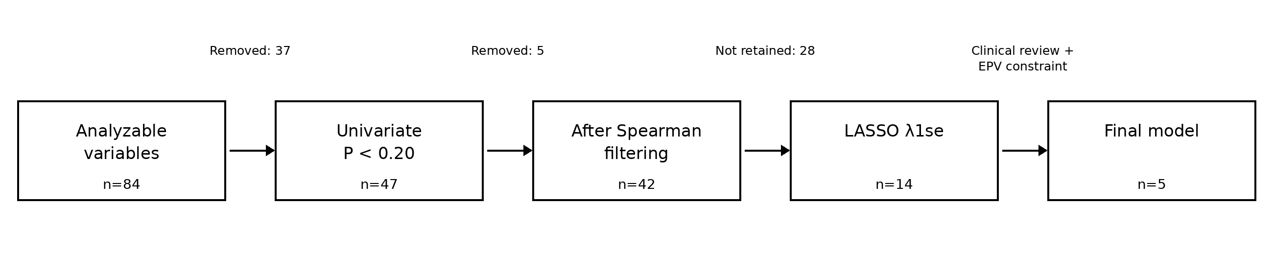
Supplementary Figure S1. Variable-compression process. Eighty-four analyzable predictors entered univariate screening; 47 predictors with P<0.20 entered Spearman filtering; 42 entered LASSO; 14 had non-zero coefficients at λ1se; and five were retained in the final interpretable model.

Supplementary Table S1. Final model formula and predictor coding
Term | Coefficient | Coding/units | Direction
Intercept | 3.105299 | Not applicable | Baseline log-odds component
Antibiotic duration | 0.116619 | Cumulative antibiotic-treatment days during neonatal hospitalization | Higher values increase the linear predictor
Paternal education | -0.714196 | Ordered ISCED group: low=1, middle=2, high=3; 0=missing. | Each one-group increase reduces the linear predictor
Perinatal infection | 1.161600 | 1=infection; 0=no infection | Presence increases the linear predictor
Male sex | 0.805803 | Binary: male=1; female=0 | Male sex increases the linear predictor
Apgar score at 1 min | -0.462934 | Recorded 1-min Apgar score, 0-10 | Higher values reduce the linear predictor
Linear predictor: LP = 3.105299 + 0.116619×antibiotic duration − 0.714196×paternal education score + 1.161600×perinatal infection + 0.805803×male sex − 0.462934×Apgar score at 1 min. Model-derived development-sample probability: P(GDD)=1/[1+exp(−LP)]. For calculation only, paternal education score is 1 for low education (ISCED 1–2), 2 for middle education (ISCED 3–4), and 3 for high education (ISCED 5–8). Code 0 is missing and must not be entered into the equation or nomogram. Because the study used case-control sampling, population absolute probabilities require prevalence-based recalibration.

Supplementary Table S2. Spearman correlation filtering
Removed variable | Retained variable | Spearman rho | Reason
Therapeutic hypothermia | Hypoxic-ischemic encephalopathy | 0.790 | The retained variable had a stronger univariate association and clearer diagnostic meaning
Vasoactive-inotropic score | Invasive ventilation duration | 0.774 | The retained variable had the stronger univariate association in the current dataset
Parenteral nutrition duration | Length of hospitalization | 0.798 | The retained variable had the stronger univariate association
Mean platelet volume | Large platelet ratio | 0.927 | Highly redundant platelet indices; retained variable had stronger univariate association
Birth weight | Gestational age | 0.710 | The retained variable had the stronger univariate association
A correlation threshold of |rho|≥0.70 was used. Decisions also considered clinical meaning; removal reflects redundancy in this dataset and not lack of clinical importance.

Supplementary Table S3. Predictors with non-zero coefficients at λ1se
Predictor | Final-model status | Reason/status
Hypoxic-ischemic encephalopathy | Not retained | Zero events in controls; quasi-complete separation
Lactate | Not retained | Not retained under model-size and interpretability constraints
Antibiotic duration | Retained | Final predictor
Apgar score at 1 min | Retained | Final predictor
Amniotic-fluid abnormality | Not retained | Not retained under model-size constraint
Paternal education | Retained | Final predictor; ordered ISCED group (low/middle/high)
Periventricular leukomalacia | Not retained | Zero events in controls; quasi-complete separation
Perinatal infection | Retained | Final predictor
Sedative duration | Not retained | Treatment-severity marker; not retained in parsimonious model
Aspiration syndrome | Not retained | Not retained under model-size constraint
Male sex | Retained | Final predictor
Large platelet ratio | Not retained | Limited bedside interpretability
Gestational diabetes | Not retained | Not retained under model-size constraint
Platelet distribution width | Not retained | Limited bedside interpretability
For reporting, λ was defined as 1/C, where C is the inverse regularization strength used by scikit-learn. λmin=4.406 [ln(λmin)=1.483]; λ1se=11.690 [ln(λ1se)=2.459]. Five-fold stratified cross-validation used random seed 2025. Final-model refinement considered separation, coefficient stability, redundancy, routine availability, interpretability, and the 71 observed GDD cases.

Supplementary Table S4. Internal validation summary
Metric | Estimate
Apparent AUC | 0.828 (95% CI 0.761-0.884)
Optimism-corrected AUC | 0.811
Apparent Brier score | 0.156
Optimism-corrected Brier score | 0.167
Optimism-corrected calibration slope | 0.899
Optimism-corrected calibration intercept | -0.058
Hosmer-Lemeshow test | chi-square=8.281; df=8; P=0.406
Bootstrap resamples | 1000
The development-sample calibration intercept of 0 and slope of 1 are expected when a logistic model is evaluated in the data used for fitting; bootstrap-corrected estimates are more informative for internal validity.

