Supporting Information for
Uropathogenic Escherichia coli remodels LPS to evade Caspase-11-dependent pyroptosis to establish intracellular bacterial communities

Yu Pang, Xueping Li, Si Zhang, Lingyan Jiang, Qian Wang, Hongmin Sun, Jianwei Mu, Qiyue Zhang, Chen Jin, Xiao Zhang, Peng Ding, Le Liu, Jiarui Zhou, Jiamin Qian, Yangyang Li, Jingliang Qin, Bin Liu, Simon Swift, Lu Feng, Lei Wang

Lu Feng and Lei Wang
Email: fenglu63@nankai.edu.cn; wanglei@nankai.edu.cn

This PDF file includes:
Figures S1 to S6
Tables S1 to S4
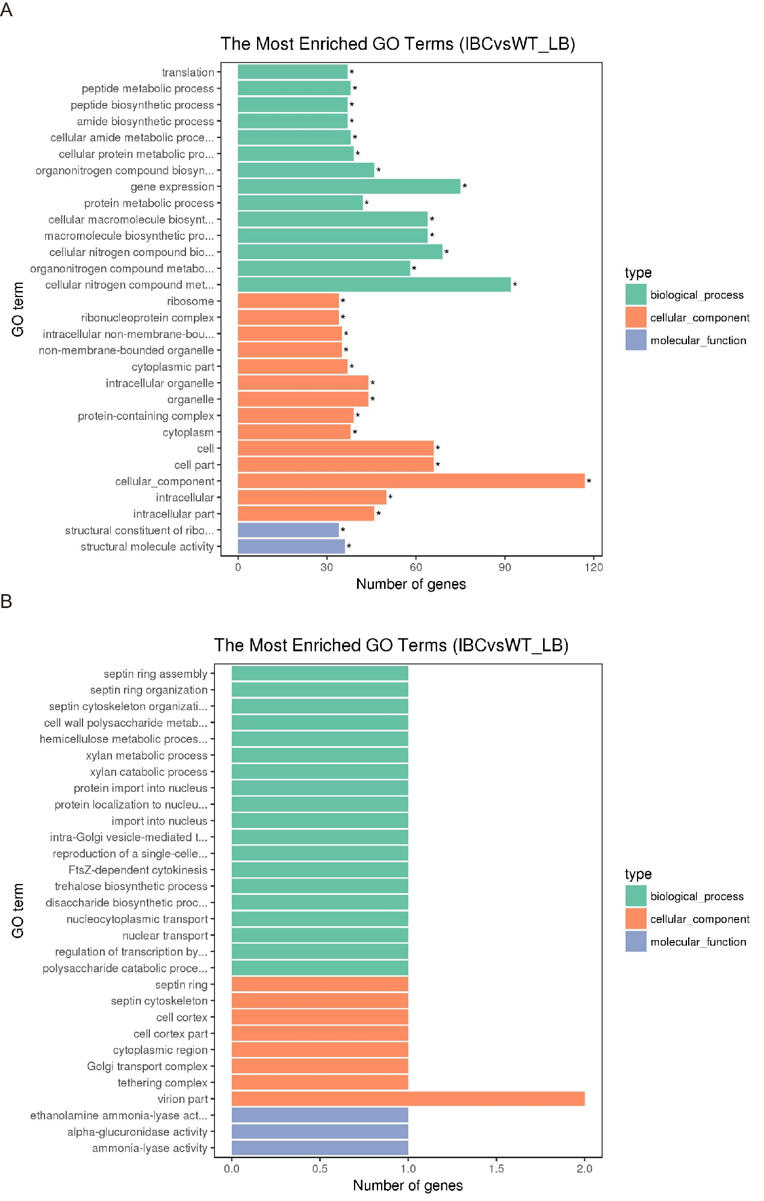

Figure S1.
A. GO analysis of the upregulated UPEC genes at 6 h p.i. in mouse bladders.
B. GO analysis of the downregulated UPEC genes at 6 h p.i. in mouse bladders.

Figure S2
A and B. Growth rates of the WT, ΔlpxT and ΔlpxT+. The WT, ΔlpxT and ΔlpxT+ strains were cultured in LB (A) or RPMI 1640 medium (B) at 37°C. The growth rate of each strain was determined based on the OD₆₀₀.
C. Intracellular bacterial titers of UPEC in the bladders of C3H/HeN mice transurethrally infected with WT, ΔlpxT or ΔlpxT+ at 2 h p.i. (n = 15).
D. Intracellular bacterial titers of WT and ΔlpxT in 5637 cells at 2, 6 and 8 h p.i.
E. Quantification of IBCs volume of C3H/HeN mouse bladders infected with WT, ΔlpxT or ΔlpxT+ at 6 h p.i. Each point represents the volume value for an individual IBC.
F. Fold change in the mRNA levels of lpxT in lpxT+ compared to WT cultured in M9 minimal medium.
Significance is indicated as the P value. ns, no significant difference.

Figure S3
A. 5637 cells were infected with WT, ΔlpxT, ΔlpxT+ or lpxT+. Cell death at an MOI of 10 for 4 h p.i. was determined by trypan blue, which was used to distinguish live (excluding blue) and dead cells (blue). The bar graph shows the percentage of cell mortality (Left). Representative images are shown (Right).
B. The effect of silencing Caspase-4 in 5637 cells. 5637 cells were transfected with siRNA targeting Caspase-4 or control siRNA. The silencing efficiency was evaluated by western blotting. The blots are representative of three independent experiments.
C. Control shRNA-expressing 5637 cells and caspase-4 shRNA-expressing 5637 cells were infected with WT, ΔlpxT, ΔlpxT+ or lpxT+. Cell death at an MOI of 10 for 4 h p.i. was determined by measuring LDH release.
Significance is indicated as the P value. ns, no significant difference.

Figure S4
A. Fold change in the mRNA levels of caspase-4 and caspase-11 in ΔlpxT-infected mouse bladders and 5637 cells compared to WT-infected at the indicated time points.
B. The effect of silencing GBP1 in 5637 cells. 5637 cells were transfected with siRNA targeting GBP1 or control siRNA. The silencing efficiency was evaluated by western blotting. The blots are representative of three independent experiments.
C. Control siRNA-transfected 5637 cells and gbp1 siRNA-transfected 5637 cells were infected with WT, ΔlpxT, ΔlpxT+ or lpxT+. Cell death at an MOI of 10 for 4 h p.i. was determined by measuring LDH release.
D and E. Control shRNA-expressing 5637 cells and caspase-4 shRNA-expressing 5637 cells were infected with WT, ΔlpxT, ΔlpxT+ or lpxT+. After 4 h, the amount of IL-1α (D) and IL-1β (E) in the culture medium was determined by ELISA.
F. 5637 cells were infected with WT, ΔlpxT, ΔlpxT+, or lpxT+ with or without polymyxin B. After 4 h, the amount of IL-6 in the culture medium was determined by ELISA.
Significance is indicated as the P value. ns, no significant difference.

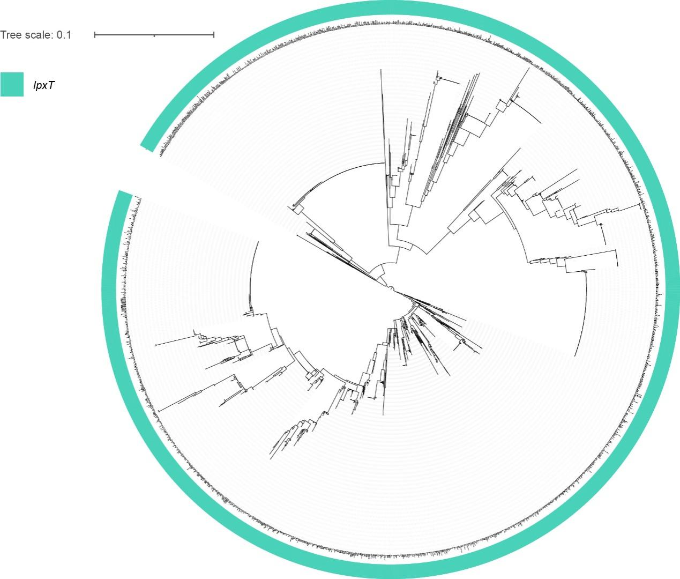

Figure S5 Phylogenetic analysis of 2,136 publicly available complete E. coli genomes. lpxT is labeled with a green semicircle.

Figure S6 The lpxT gene occupies the same genomic position in both Salmonella species and E. coli.
Table S1. Bacterial strains used in this study.
Strain | Characteristics or function | Source/Reference
E. coli CFT073 | An isolate from a patient with pyelonephritis | ATCC
ΔlpxT | CFT073 ΔlpxT::Cm; Cm^{r} | This study
ΔlpxT+ | CFT073 ΔlpxT::lpxT, Cm, Kan; Cm^{r}, Kan^{r} | This study
lpxT+ | CFT073 containing the plasmid pACYC 184 expressing lpxT; Cm^{r} | This study
CFT073-GFP | CFT073 containing pETDuet expressing gfp gene encoding green fluorescence; Amp^{r} | This study
ΔlpxT-GFP | ΔlpxT containing pETDuet expressing gfp gene encoding green fluorescence; Cm^{r},Amp^{r} | This study
ΔlpxT+-GFP | ΔlpxT+ containing pETDuet expressing gfp gene encoding green fluorescence; Cm^{r}, Kan^{r}, Amp^{r} | This study

Table S2. Plasmids used in this study.
Name | Description | Source/Reference
pACYC184 | Bacteria expression vector, Cm^{r} | Lab collection
pACYC184-lpxT | pACYC184 carrying lpxT from CFT073, Cm^{r} | This work
pETDuet-lpxT promoter-gfp | pETDuet harboring lpxT promoter-gfp gene, Amp^{r} | This work

Table S3. The sequence of shRNA or siRNA for silencing Caspase-4 and GBP1
Target gene | Sequence
caspase-4 shRNA | CCGAGGAATGGAGCTGACTTT
gbp1 siRNA | ACGGUGCAGUCUCACACUAAAGGAA

Table S4. Oligonucleotides used in this study.
Primers | Sequence (5'-3') | Usage
Cloning
pACYC184-pro-lpxT-F | GCTCTAGACTGATACGGTATTCGACAC | Cloning of lpxT gene to pACYC184 plasmid
pACYC184-pro-lpxT-R | CGGGATCCTTATTTGTTTTGGAAATGTTTG | Cloning of lpxT gene to pACYC184 plasmid
pACYC184-pro-lpxT-F | GCTCTAGACTTTACACTGGTGCCATATC | Cloning of lpxT gene to pACYC184 plasmid
pACYC184-pro-lpxT-R | CGGGATCCTCATTCACTCACTCTCCTG | Cloning of lpxT gene to pACYC184 plasmid
Complement-pro-lpxT-F1 | ATGTGTGGAATTGTTGGCGCGATC | Creation of lpxT-complemented strain from ΔlpxT
Complement-pro-lpxT-R1 | CCAATGGTGTCGAATACCGTATCAGTTACTCAACCGTTACCGATTTTGCC | Creation of lpxT-complemented strain from ΔlpxT
Complement-pro-lpxT-F2 | GGCAAAATCGGTAACGGTTGAGTAACTGATACGGTATTCGACACCATTGG | Creation of lpxT-complemented strain from ΔlpxT
Complement-pro-lpxT-R2 | CGAAGCAGCTCCAGCCTACACTTATTTGTTTTGGAAATGTTTGTTT | Creation of lpxT-complemented strain from ΔlpxT
Complement-pro-lpxT-F3 | AAACAAACATTTCCAAAACAAATAAGTGTAGGCTGGAGCTGCTTCG | Creation of lpxT-complemented strain from ΔlpxT
Complement-pro-lpxT-R3 | CCCGCTTACGCAGGGCATCCATTTACATATGAATATCCTCCTTAG | Creation of lpxT-complemented strain from ΔlpxT
Complement-pro-lpxT-F4 | CTAAGGAGGATATTCATATGTAAATGGATGCCCTGCGTAAGCGGG | Creation of lpxT-complemented strain from ΔlpxT
Complement-pro-lpxT-R4 | TTAGTACAGCGGCTTGCCGCTACTG | Creation of lpxT-complemented strain from ΔlpxT
Pro-lpxT-GFP-F1 | CGGAATTCCTGATACGGTATTCGACACCATTGG | Cloning of lpxT-promoter-gfp gene to pETDuet plasmid
Pro-lpxT-GFP-R1 | CCAGTGAAAAGTTCTTCTCCTTTACTCATCCTTACGCGGTAGTCGCTAAAC | Cloning of lpxT-promoter-gfp gene to pETDuet plasmid
Pro-lpxT-GFP-F2 | GTTTAGCGACTACCGCGTAAGGATGAGTAAAGGAGAAGAACTTTTCACTGG | Cloning of lpxT-promoter-gfp gene to pETDuet plasmid
Pro-lpxT-GFP-R2 | AACTGCAGTTATTTGTATAGTTCATCCATGCCATGTGTAATC | Cloning of lpxT-promoter-gfp gene to pETDuet plasmid
Cloning verification
pACYC184-F | TTGGTAGCTCAGAGAACCTTCG | Identification of pACYC184 plasmid
pACYC184-R | ATACCCACGCCGAAACAA | Identification of pACYC184 plasmid
Deletion
Del-lpxT-F | GCGCTGTTGAAGCTTCGTTTAGCGACTACCGCGTAAGGGTGTAGGCTGGAGCTGCTTCG | Identification of lpxT mutant
Del-lpxT-R | ACTATAAAAATAAACCTGATGATGTTAATTACTGTGAGCATATGAATATCCTCCTTAG | Identification of lpxT mutant
Mouse verification
Check-caspase-11-ko-F | CATAGTGATGCCCTAATAAGCA | Identification of caspase-11 knockout mutant
Check-caspase-11-ko-R | TCGTGTTCCCAGTATAGGATGT | Identification of caspase-11 knockout mutant
Check-caspase-11-WT-R | TTGTCACTGCGTTCAGCATTGT | Identification of caspase-11 knockout mutant
qRT‒PCR
RT-lpxT-F | TGTTCCCACGAAAGATGC | qRT-PCR for lpxT
RT-lpxT-R | ACCGACGATGATGTCAGTAA | qRT-PCR for lpxT
RT-gyrA-F | TGCGTATTCTTGGTAGCG | qRT-PCR for gyrA
RT-gyrA-R | ATCTTCCAGGTTGATGTCG | qRT-PCR for gyrA

