Supplementary Material

The Supplementary Material for this article can be found online.

Supplementary Figures

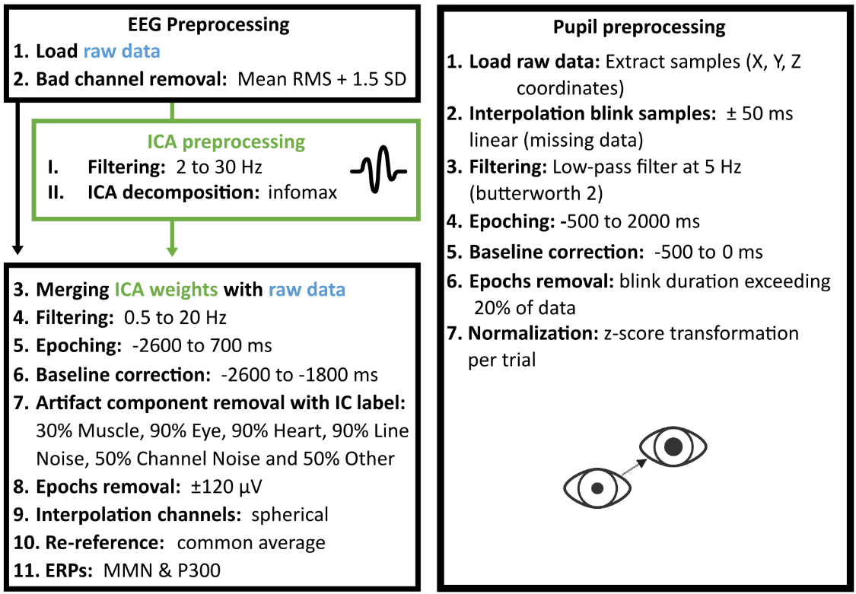

Supplementary Figure 1. Electroencephalography (EEG) and pupil preprocessing pipelines. Overview of the preprocessing steps applied to EEG and pupil data. The EEG pipeline included bad-channel detection based on root mean square values, ICA preprocessing, transfer of ICA weights to the raw data, filtering, epoching, baseline correction, ICLabel-based artifact component rejection, epoch rejection, spherical channel interpolation, common-average re-referencing, and ERP averaging. The pupil pipeline included raw-sample coordinate extraction, blink interpolation, low-pass filtering, epoching, baseline correction, rejection of blink-contaminated epochs, and z-score normalization. RMS, root mean square; ICA, independent component analysis; ERP, event-related potential.
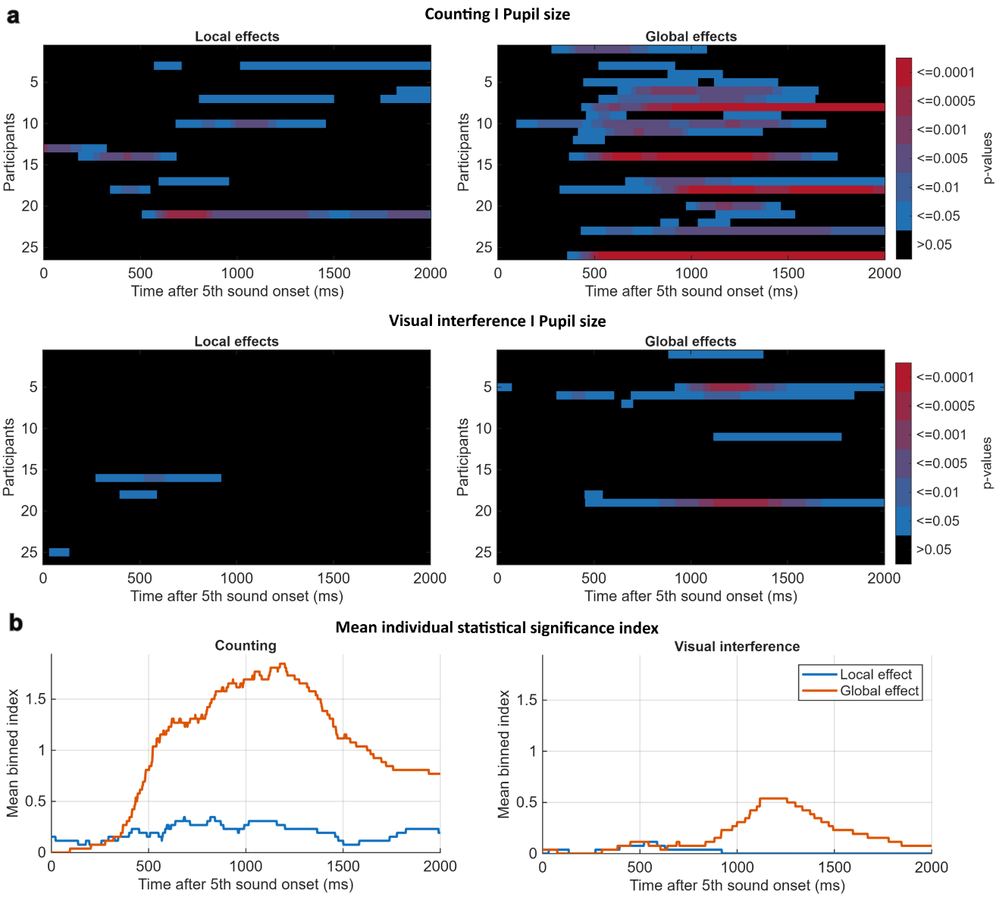

Supplementary Figure 2. Individual pupil effects and mean Statistical Significance Index (SSI). Individual-level pupil effects are shown separately for local and global contrasts in the counting and visual interference tasks. Panel (a) shows participant-by-time significance matrices based on trial-level tests; colors represent binned p-value thresholds, and black indicates non-significant time points. Panel (b) shows the mean Statistical Significance Index across participants over time for local and global effects. Higher values indicate stronger or more frequent individual-level evidence for an effect at a given time point. These individual-level analyses show more frequent and sustained pupil effects during counting, particularly for the global contrast, and weaker but still present effects during visual interference.

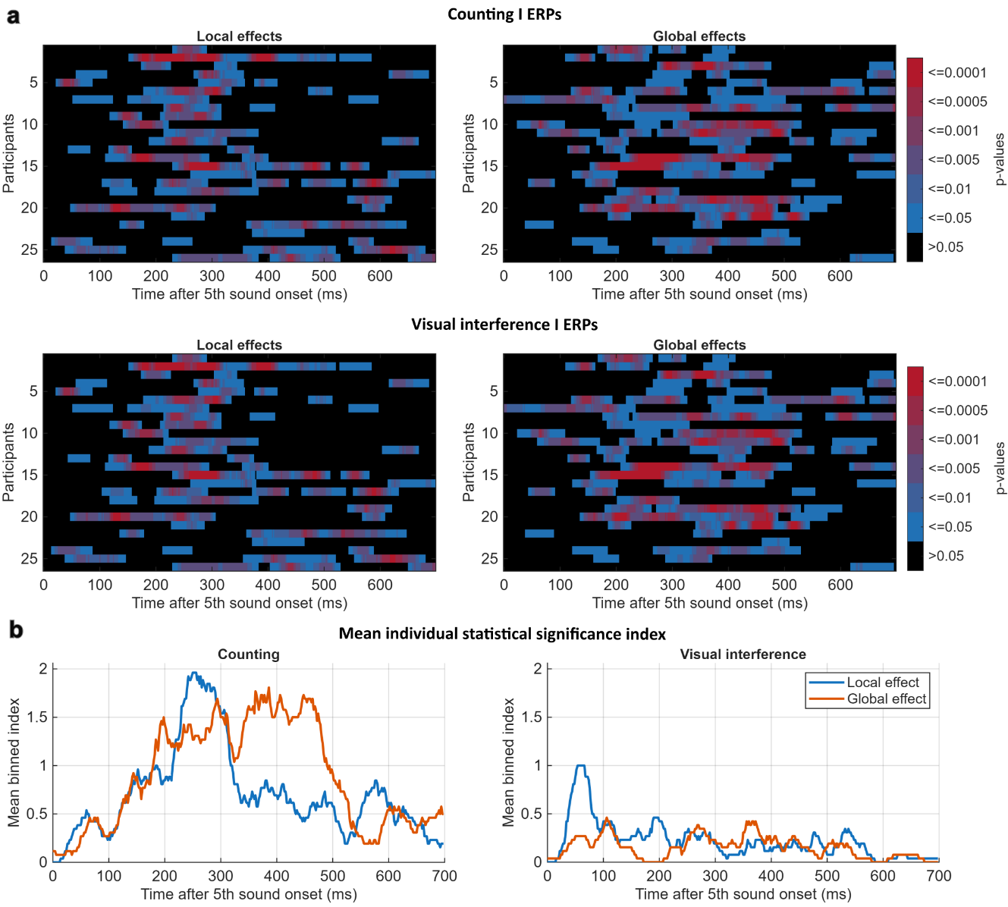

Supplementary Figure 3. Individual Event-Related Potential (ERP) effects and mean Statistical Significance Index (SSI). Individual-level ERP effects are shown separately for local and global contrasts in the counting and visual interference tasks. Panel (a) shows participant-by-time significance matrices based on trial-level tests; colors represent binned p-value thresholds, and black indicates non-significant time points. Panel (b) shows the mean Statistical Significance Index across participants over time for local and global effects. Higher values indicate stronger or more frequent individual-level evidence for an effect at a given time point. These individual-level analyses show stronger effects during counting than during visual interference.

Supplementary Tables

Pupil preprocessing summary results
Participant | Experiment | Retained Trials | Rejected Trials | Local Standard | Local Deviant | Global Standard | Global Deviant
S01 | Counting | 267 | 3 | 133 | 134 | 224 | 43
S02 | Counting | 269 | 1 | 134 | 135 | 226 | 43
S03 | Counting | 265 | 5 | 134 | 131 | 222 | 43
S04 | Counting | 182 | 88 | 117 | 65 | 156 | 26
S05 | Counting | 267 | 3 | 134 | 133 | 224 | 43
S06 | Counting | 269 | 1 | 134 | 135 | 226 | 43
S07 | Counting | 260 | 10 | 132 | 128 | 218 | 42
S08 | Counting | 269 | 1 | 134 | 135 | 226 | 43
S09 | Counting | 269 | 1 | 134 | 135 | 226 | 43
S10 | Counting | 230 | 40 | 125 | 105 | 200 | 30
S11 | Counting | 258 | 12 | 127 | 131 | 215 | 43
S12 | Counting | 226 | 44 | 123 | 103 | 188 | 38
S13 | Counting | 236 | 34 | 121 | 115 | 203 | 33
S14 | Counting | 206 | 64 | 111 | 95 | 172 | 34
S15 | Counting | 139 | 131 | 65 | 74 | 120 | 19
S16 | Counting | 249 | 21 | 127 | 122 | 208 | 41
S17 | Counting | 267 | 3 | 133 | 134 | 225 | 42
S18 | Counting | 267 | 3 | 134 | 133 | 224 | 43
S19 | Counting | 267 | 3 | 133 | 134 | 224 | 43
S20 | Counting | 257 | 13 | 122 | 135 | 214 | 43
S21 | Counting | 124 | 146 | 70 | 54 | 106 | 18
S22 | Counting | 267 | 3 | 134 | 133 | 225 | 42
S23 | Counting | 256 | 14 | 133 | 123 | 213 | 43
S24 | Counting | 269 | 1 | 134 | 135 | 226 | 43
S25 | Counting | 237 | 33 | 118 | 119 | 199 | 38
S26 | Counting | 268 | 2 | 134 | 134 | 225 | 43
S01 | Visual interference | 269 | 1 | 135 | 134 | 225 | 44
S02 | Visual interference | 268 | 2 | 134 | 134 | 225 | 43
S03 | Visual interference | 269 | 1 | 135 | 134 | 225 | 44
S04 | Visual interference | 170 | 100 | 105 | 65 | 147 | 23
S05 | Visual interference | 269 | 1 | 135 | 134 | 225 | 44
S06 | Visual interference | 257 | 13 | 132 | 125 | 216 | 41
S07 | Visual interference | 266 | 4 | 135 | 131 | 223 | 43
S08 | Visual interference | 269 | 1 | 135 | 134 | 225 | 44
S09 | Visual interference | 268 | 2 | 135 | 133 | 224 | 44
S10 | Visual interference | 269 | 1 | 135 | 134 | 225 | 44
S11 | Visual interference | 189 | 81 | 117 | 72 | 163 | 26
S12 | Visual interference | 191 | 79 | 113 | 78 | 167 | 24
S13 | Visual interference | 258 | 12 | 130 | 128 | 220 | 38
S14 | Visual interference | 245 | 25 | 125 | 120 | 207 | 38
S15 | Visual interference | 164 | 106 | 90 | 74 | 134 | 30
S16 | Visual interference | 264 | 6 | 133 | 131 | 221 | 43
S17 | Visual interference | 269 | 1 | 135 | 134 | 225 | 44
S18 | Visual interference | 268 | 2 | 133 | 135 | 225 | 43
S19 | Visual interference | 269 | 1 | 135 | 134 | 225 | 44
S20 | Visual interference | 269 | 1 | 135 | 134 | 225 | 44
S21 | Visual interference | 201 | 69 | 106 | 95 | 170 | 31
S22 | Visual interference | 269 | 1 | 135 | 134 | 225 | 44
S23 | Visual interference | 259 | 11 | 128 | 131 | 215 | 44
S24 | Visual interference | 269 | 1 | 135 | 134 | 225 | 44
S25 | Visual interference | 217 | 53 | 118 | 99 | 182 | 35
S26 | Visual interference | 268 | 2 | 134 | 134 | 224 | 44

Supplementary Table 1. Pupil preprocessing results from experimental tasks. The table reports a summary of the pupil preprocessing results for each participant for the active counting and the visual interference task. This includes the number of retained and rejected pupil epochs after data preprocessing with the described rejection criteria, including blink-contaminated epochs exceeding the predefined threshold and incomplete or invalid epochs. The retained epochs correspond to the trials used for condition averaging and group-level pupil analyses.

Electroencephalography preprocessing summary results
Participant | Experiment | Retained Trials | Rejected Trials | Local Standard | Local Deviant | Global Standard | Global Deviant
S01 | Counting | 270 | 0 | 135 | 135 | 226 | 44
S02 | Counting | 265 | 5 | 132 | 133 | 222 | 43
S03 | Counting | 270 | 0 | 135 | 135 | 226 | 44
S04 | Counting | 269 | 1 | 134 | 135 | 225 | 44
S05 | Counting | 270 | 0 | 135 | 135 | 226 | 44
S06 | Counting | 261 | 9 | 129 | 132 | 218 | 43
S07 | Counting | 268 | 2 | 133 | 135 | 225 | 43
S08 | Counting | 270 | 0 | 135 | 135 | 226 | 44
S09 | Counting | 270 | 0 | 135 | 135 | 226 | 44
S10 | Counting | 269 | 1 | 134 | 135 | 225 | 44
S11 | Counting | 270 | 0 | 135 | 135 | 226 | 44
S12 | Counting | 270 | 0 | 135 | 135 | 226 | 44
S13 | Counting | 267 | 3 | 134 | 133 | 223 | 44
S14 | Counting | 270 | 0 | 135 | 135 | 226 | 44
S15 | Counting | 256 | 14 | 127 | 129 | 212 | 44
S16 | Counting | 265 | 5 | 132 | 133 | 223 | 42
S17 | Counting | 268 | 2 | 135 | 133 | 224 | 44
S18 | Counting | 267 | 3 | 134 | 133 | 224 | 43
S19 | Counting | 255 | 15 | 128 | 127 | 213 | 42
S20 | Counting | 270 | 0 | 135 | 135 | 226 | 44
S21 | Counting | 268 | 2 | 134 | 134 | 225 | 43
S22 | Counting | 263 | 7 | 131 | 132 | 222 | 41
S23 | Counting | 269 | 1 | 135 | 134 | 225 | 44
S24 | Counting | 267 | 3 | 134 | 133 | 223 | 44
S25 | Counting | 254 | 16 | 127 | 127 | 214 | 40
S26 | Counting | 270 | 0 | 135 | 135 | 226 | 44
S01 | Visual interference | 269 | 1 | 135 | 134 | 225 | 44
S02 | Visual interference | 267 | 3 | 133 | 134 | 223 | 44
S03 | Visual interference | 270 | 0 | 135 | 135 | 226 | 44
S04 | Visual interference | 268 | 2 | 135 | 133 | 224 | 44
S05 | Visual interference | 270 | 0 | 135 | 135 | 226 | 44
S06 | Visual interference | 249 | 21 | 131 | 118 | 207 | 42
S07 | Visual interference | 265 | 5 | 133 | 132 | 223 | 42
S08 | Visual interference | 269 | 1 | 134 | 135 | 225 | 44
S09 | Visual interference | 270 | 0 | 135 | 135 | 226 | 44
S10 | Visual interference | 270 | 0 | 135 | 135 | 226 | 44
S11 | Visual interference | 270 | 0 | 135 | 135 | 226 | 44
S12 | Visual interference | 267 | 3 | 135 | 132 | 223 | 44
S13 | Visual interference | 265 | 5 | 132 | 133 | 222 | 43
S14 | Visual interference | 269 | 1 | 135 | 134 | 225 | 44
S15 | Visual interference | 253 | 17 | 128 | 125 | 213 | 40
S16 | Visual interference | 265 | 5 | 134 | 131 | 222 | 43
S17 | Visual interference | 263 | 7 | 133 | 130 | 221 | 42
S18 | Visual interference | 257 | 13 | 132 | 125 | 214 | 43
S19 | Visual interference | 263 | 7 | 130 | 133 | 220 | 43
S20 | Visual interference | 268 | 2 | 134 | 134 | 224 | 44
S21 | Visual interference | 269 | 1 | 135 | 134 | 225 | 44
S22 | Visual interference | 269 | 1 | 135 | 134 | 225 | 44
S23 | Visual interference | 270 | 0 | 135 | 135 | 226 | 44
S24 | Visual interference | 260 | 10 | 131 | 129 | 220 | 40
S25 | Visual interference | 239 | 31 | 126 | 113 | 199 | 40
S26 | Visual interference | 269 | 1 | 134 | 135 | 225 | 44

Supplementary Table 2. Electroencephalography (EEG) preprocessing results from experimental tasks. The table reports a summary of the EEG preprocessing results for each participant for the active counting and the visual interference task. This includes the number of retained and rejected EEG epochs after data preprocessing with the described rejection criteria, including ICLabel-based artifact component rejection, blink-contaminated epochs exceeding the predefined threshold (± 120 μV) and incomplete or invalid epochs. The retained epochs correspond to the trials used for condition averaging and group-level event-related potential (ERP) analyses.

Pupil size in counting (E1) and visual interference (E2)
Partic. | LS (E1) |  | LS (E2) |  | LD (E1) |  | LD (E2) |  | GS (E1) |  | GS (E2) |  | GD (E1) |  | GD (E2)
Partic. | Mean  (z) | Peak  (ms) | Mean  (z) | Peak  (ms) | Mean  (z) | Peak  (ms) | Mean  (z) | Peak  (ms) | Mean  (z) | Peak  (ms) | Mean  (z) | Peak  (ms) | Mean  (z) | Peak  (ms) | Mean  (z) | Peak  (ms)
S01 | 0.10 | 720 | 0.01 | 492 | 0.10 | 474 | 0.10 | 440 | 0.04 | 542 | 0.01 | 446 | 0.06 | 510 | 0.02 | 1052
S02 | 0.17 | 830 | 0.18 | 102 | 0.26 | 862 | 0.15 | 4 | 0.04 | 838 | -0.13 | 446 | 0.22 | 912 | 0.05 | 446
S03 | 0.03 | 746 | 0.07 | 600 | 0.30 | 638 | 0.11 | 464 | 0.02 | 644 | -0.05 | 448 | 0.38 | 672 | 0.13 | 524
S04 | 0.04 | 944 | 0.06 | 666 | 0.13 | 1056 | 0.00 | 488 | -0.05 | 940 | 0.00 | 456 | 0.58 | 1124 | 0.06 | 610
S05 | 0.10 | 518 | 0.04 | 612 | 0.13 | 476 | 0.09 | 648 | -0.04 | 460 | -0.04 | 636 | 0.17 | 532 | 0.32 | 1242
S06 | 0.03 | 592 | -0.02 | 280 | 0.23 | 490 | 0.15 | 452 | -0.11 | 416 | -0.03 | 446 | 0.73 | 858 | 0.17 | 446
S07 | 0.15 | 540 | 0.04 | 460 | 0.42 | 516 | 0.09 | 690 | -0.06 | 490 | -0.01 | 446 | 0.49 | 596 | 0.10 | 570
S08 | 0.17 | 382 | 0.04 | 0 | 0.18 | 412 | 0.11 | 64 | -0.24 | 370 | -0.08 | 446 | 0.97 | 1256 | -0.04 | 600
S09 | 0.05 | 434 | 0.05 | 0 | 0.11 | 430 | 0.15 | 406 | -0.11 | 398 | -0.07 | 446 | 0.24 | 524 | 0.13 | 1606
S10 | -0.05 | 44 | 0.05 | 446 | 0.21 | 1068 | 0.09 | 260 | -0.13 | 1058 | -0.10 | 446 | 0.78 | 1310 | 0.32 | 988
S11 | 0.05 | 674 | 0.01 | 0 | 0.23 | 730 | 0.12 | 486 | -0.06 | 714 | -0.13 | 446 | 0.46 | 920 | 0.44 | 1114
S12 | 0.14 | 328 | 0.08 | 690 | 0.06 | 164 | 0.09 | 430 | -0.05 | 308 | 0.03 | 854 | 0.00 | 480 | -0.17 | 446
S13 | 0.07 | 406 | 0.03 | 422 | 0.19 | 490 | 0.12 | 374 | -0.03 | 442 | -0.01 | 608 | 0.20 | 990 | 0.03 | 1818
S14 | 0.10 | 858 | 0.14 | 370 | 0.27 | 588 | 0.08 | 280 | -0.02 | 590 | -0.06 | 446 | 0.69 | 1114 | -0.16 | 446
S15 | 0.09 | 1020 | -0.06 | 690 | 0.03 | 1128 | 0.01 | 490 | 0.05 | 1112 | 0.03 | 930 | 0.25 | 1232 | 0.13 | 994
S16 | 0.04 | 708 | 0.04 | 482 | 0.08 | 600 | 0.15 | 552 | -0.01 | 610 | -0.01 | 520 | 0.17 | 644 | 0.01 | 588
S17 | -0.06 | 512 | 0.00 | 26 | 0.13 | 588 | 0.15 | 480 | -0.01 | 516 | -0.02 | 446 | 0.20 | 914 | -0.17 | 626
S18 | 0.01 | 958 | -0.05 | 690 | 0.13 | 444 | 0.02 | 494 | -0.06 | 420 | 0.03 | 950 | 0.41 | 1130 | 0.42 | 1160
S19 | 0.05 | 706 | 0.04 | 420 | 0.10 | 658 | 0.02 | 528 | -0.02 | 520 | -0.08 | 476 | 0.15 | 782 | 0.47 | 1064
S20 | 0.03 | 704 | 0.00 | 0 | 0.12 | 880 | 0.21 | 600 | -0.09 | 708 | -0.07 | 614 | 0.31 | 1132 | 0.09 | 1014
S21 | 0.02 | 880 | 0.04 | 690 | 0.30 | 1066 | 0.02 | 0 | -0.03 | 862 | 0.03 | 814 | 0.57 | 1142 | -0.29 | 622
S22 | 0.06 | 936 | 0.00 | 690 | 0.15 | 708 | 0.02 | 690 | -0.04 | 574 | 0.03 | 1030 | 0.41 | 910 | 0.02 | 628
S23 | 0.04 | 928 | 0.01 | 186 | 0.15 | 492 | 0.08 | 338 | -0.08 | 466 | -0.02 | 786 | 0.63 | 1298 | 0.10 | 1404
S24 | 0.24 | 564 | 0.07 | 370 | 0.03 | 480 | 0.02 | 606 | -0.06 | 466 | 0.03 | 864 | 0.15 | 568 | -0.07 | 542
S25 | -0.03 | 362 | 0.00 | 338 | 0.04 | 588 | 0.06 | 558 | -0.06 | 646 | 0.03 | 680 | 0.41 | 1552 | 0.03 | 1586
S26 | 0.05 | 684 | 0.07 | 588 | 0.19 | 738 | 0.12 | 394 | -0.16 | 482 | -0.06 | 446 | 0.79 | 1034 | 0.15 | 570

Supplementary Table 3. Individual pupil peak latency and mean pupil size values for local and global conditions. Participant-level pupil measures are shown for the counting task (E1; Experiment 1) and visual interference task (E2; Experiment 2). For each participant, mean pupil size (z-scored) and peak latency (ms) were extracted separately for Local Standard (LS), Local Deviant (LD), Global Standard (GS), and Global Deviant (GD) conditions. Values correspond to the condition-specific measures underlying the between-task pupil comparisons shown in Figure 3. Pupil latencies are expressed relative to the onset of the fifth tone.

Event-Related Potentials (ERPs) at Pz in counting (E1) and visual interference (E2)
Partic. | LS (E1) |  | LS (E2) |  | LD (E1) |  | LD (E2) |  | GS (E1) |  | GS (E2) |  |  | GD (E1) |  | GD (E2)
Partic. | Mean  (μV) | Peak  (ms) | Mean  (µV) | Peak  (ms) | Mean  (µV) | Peak  (ms) | Mean  (µV) | Peak  (ms) | Mean  (µV) | Peak  (ms) | Mean  (µV) | Peak  (ms) | Mean  (µV) |  | Peak  (ms) | Mean  (µV) | Peak  (ms)
S01 | -0.94 | 290 | 0.47 | 38 | 1.90 | 284 | -0.16 | 54 | -0.45 | 274 | -0.40 | 542 | 0.63 |  | 296 | 0.31 | 228
S02 | -2.03 | 254 | -0.53 | 62 | 7.18 | 234 | -1.11 | 80 | 0.63 | 216 | 0.09 | 510 | 2.22 |  | 250 | 1.62 | 296
S03 | 1.80 | 294 | 0.54 | 58 | 2.99 | 294 | 1.68 | 52 | 0.55 | 214 | 0.50 | 196 | 3.34 |  | 354 | 1.45 | 316
S04 | 0.84 | 324 | 0.03 | 80 | 3.42 | 306 | -1.09 | 80 | 0.61 | 314 | 0.19 | 220 | 2.26 |  | 296 | 0.89 | 432
S05 | -0.92 | 284 | 0.43 | 54 | 0.66 | 294 | -1.49 | 38 | -0.18 | 382 | -0.22 | 526 | 0.98 |  | 482 | 0.77 | 510
S06 | -0.73 | 222 | 0.26 | 80 | 4.75 | 256 | 0.11 | 58 | -0.18 | 230 | -0.47 | 196 | 2.72 |  | 258 | 1.34 | 292
S07 | 1.54 | 324 | 0.65 | 56 | 5.10 | 232 | -0.29 | 38 | 1.75 | 216 | -0.23 | 212 | 4.27 |  | 456 | 0.57 | 314
S08 | 0.56 | 324 | 0.35 | 80 | 3.76 | 244 | 0.10 | 80 | 1.03 | 222 | 0.40 | 362 | 4.01 |  | 338 | 0.12 | 544
S09 | -0.23 | 324 | -0.77 | 80 | 3.13 | 286 | -0.93 | 80 | 0.63 | 416 | 0.34 | 476 | 2.95 |  | 414 | -0.20 | 316
S10 | 0.44 | 324 | 0.58 | 80 | 0.91 | 296 | 0.68 | 80 | 0.66 | 236 | 0.54 | 322 | 2.01 |  | 458 | 0.36 | 480
S11 | 0.27 | 310 | 0.03 | 38 | 3.66 | 324 | -2.17 | 80 | 0.53 | 196 | 0.08 | 196 | 4.81 |  | 360 | 0.70 | 264
S12 | -0.25 | 302 | -0.34 | 80 | 1.57 | 234 | -0.64 | 38 | -0.11 | 196 | -0.28 | 196 | 1.46 |  | 472 | -0.15 | 214
S13 | 0.61 | 288 | 0.73 | 80 | 3.92 | 290 | 1.20 | 40 | 0.93 | 288 | 0.19 | 308 | 2.93 |  | 288 | 0.28 | 296
S14 | 0.19 | 220 | 0.14 | 80 | 0.37 | 294 | -0.71 | 80 | -0.40 | 198 | -0.01 | 480 | 0.61 |  | 286 | -0.21 | 538
S15 | 0.16 | 324 | -1.97 | 80 | 5.36 | 270 | -0.14 | 80 | 0.00 | 196 | -0.49 | 474 | 3.22 |  | 264 | -1.11 | 516
S16 | -0.49 | 220 | -0.45 | 80 | 1.46 | 324 | -0.91 | 80 | 0.01 | 324 | -0.44 | 196 | 2.00 |  | 534 | -0.09 | 460
S17 | -0.51 | 222 | -0.19 | 42 | 0.20 | 240 | -0.73 | 80 | -0.40 | 230 | -0.22 | 540 | 0.18 |  | 516 | -0.30 | 500
S18 | 0.29 | 262 | 0.23 | 64 | 3.78 | 306 | -0.21 | 72 | 0.96 | 262 | 0.20 | 394 | 1.94 |  | 302 | -0.37 | 544
S19 | 1.21 | 310 | 0.37 | 80 | 2.18 | 324 | -0.94 | 78 | 0.78 | 438 | -0.71 | 538 | 4.84 |  | 378 | 0.16 | 494
S20 | -0.22 | 324 | -1.22 | 80 | 3.52 | 232 | -2.31 | 38 | -0.56 | 544 | -0.26 | 446 | 2.92 |  | 214 | 1.95 | 462
S21 | 0.42 | 256 | 0.47 | 38 | 1.75 | 266 | 0.46 | 48 | 0.04 | 202 | -0.06 | 544 | 1.79 |  | 456 | 0.15 | 460
S22 | 0.39 | 324 | 0.16 | 74 | 1.38 | 318 | 1.31 | 60 | 0.26 | 450 | 0.14 | 366 | 2.47 |  | 328 | 0.15 | 488
S23 | 1.29 | 284 | 0.13 | 80 | 1.57 | 324 | 0.37 | 80 | 1.10 | 544 | 0.30 | 248 | 1.54 |  | 334 | 0.82 | 274
S24 | 0.27 | 324 | -0.78 | 80 | 1.33 | 296 | -0.86 | 80 | -0.50 | 322 | -0.18 | 356 | 2.29 |  | 352 | 0.34 | 430
S25 | 0.17 | 256 | 0.16 | 80 | 0.34 | 272 | -0.43 | 58 | 0.04 | 274 | -0.11 | 492 | 0.17 |  | 348 | 0.41 | 392
S26 | -1.59 | 220 | -0.56 | 48 | 1.56 | 300 | -0.52 | 80 | -0.61 | 538 | -0.53 | 542 | 0.74 |  | 452 | -0.09 | 480

Supplementary Table 4. Individual ERP peak latency and mean amplitude values at Pz for local and global conditions. Participant-level event-related potential (ERP) measures are shown for the counting task (E1) and visual interference task (E2). For each participant, mean amplitude (µV) and peak latency (ms) were extracted at Pz separately for Local Standard (LS), Local Deviant (LD), Global Standard (GS), and Global Deviant (GD) conditions. Values correspond to the condition-specific measures underlying the between-task ERP comparisons. ERP latencies are expressed relative to the onset of the fifth tone.

Group-level statistical results of local-global responses in counting (E1) and visual interference (E2)
Signal | Exp. | Effect | Start (ms) | End (ms) | Standard (M) | Standard (SEM) | Deviant (M) | Deviant (SEM) | Effect (M) | Effect (SEM) | Test  (t) | df | Cohen's dz | p | Unit
Pupil | E1 | Local | 44 | 1232 | 0.0655 | 0.0136 | 0.1646 | 0.0186 | 0.0991 | 0.0227 | 4.3655 | 25 | 0.8561 | 0.000193 | z-score
Pupil | E1 | Global | 288 | 2000 | -0.0529 | 0.0125 | 0.4008 | 0.0498 | 0.4537 | 0.0589 | 7.6987 | 25 | 1.5098 | 4.70E-08 | z-score
Pupil | E2 | Local | 0 | 690 | 0.0356 | 0.0102 | 0.0900 | 0.0107 | 0.0544 | 0.0135 | 4.0409 | 25 | 0.7925 | 0.000446 | z-score
Pupil | E2 | Global | 446 | 1818 | -0.0284 | 0.0100 | 0.0887 | 0.0374 | 0.1171 | 0.0426 | 2.7510 | 25 | 0.5395 | 0.0109 | z-score
Pz | E1 | Local | 220 | 324 | 0.0970 | 0.1767 | 2.6056 | 0.3473 | 2.5086 | 0.3970 | 6.3196 | 25 | 1.2394 | 1.30E-06 | µV
Fz | E1 | Local | 220 | 324 | -1.7887 | 0.2283 | -1.8039 | 0.4336 | -0.0152 | 0.3677 | -0.0414 | 25 | -0.0081 | 0.9673 | µV
Pz | E1 | Global | 196 | 544 | 0.2737 | 0.1214 | 2.2814 | 0.2590 | 2.0076 | 0.2130 | 9.4236 | 25 | 1.8481 | 1.05E-09 | µV
Fz | E1 | Global | 196 | 544 | -1.8068 | 0.2041 | -2.1852 | 0.3071 | -0.3784 | 0.1902 | -1.9889 | 25 | -0.3901 | 0.0578 | µV
Pz | E2 | Local | 38 | 80 | -0.0414 | 0.1252 | -0.3735 | 0.1892 | -0.3321 | 0.1739 | -1.9098 | 25 | -0.3745 | 0.0677 | µV
Fz | E2 | Local | 38 | 80 | -0.7302 | 0.1478 | -1.8723 | 0.2181 | -1.1420 | 0.2086 | -5.4751 | 25 | -1.0738 | 1.10E-05 | µV

Supplementary Table 5. Group-level statistical results for pupillary and ERP local-global responses in counting (E1) and visual interference (E2). The table summarizes the comparable descriptive and inferential statistics from both signal modalities and experiments, including effect type (local or global), significant time window, mean (M) ± standard error of the mean (SEM) for standard/deviant conditions and corresponding effects (contrasts), test statistic (t), degrees of freedom (df), Cohen’s dz, and the corresponding corrected significance value (p).
The p values are from participant-level paired t tests of window-averaged standard-versus-deviant responses. Pupil windows were defined by cluster-based permutation testing; ERP windows were defined by whole-scalp max-|t| permutation testing, with Pz/Fz rows showing channel-level averages within those windows.

Regularity Awareness Score (RAS)
Participant | Counting (E1) |  |  |  |  |  |  | Visual interference (E2)
Participant | Q1 | Q2 | Q3 | Q4 | Total | No. of perceived  deviant trials  (Block 1) | No. of perceived  deviant trials  (Block 2) | Q1 | Q2 | Q3 | Q4 | Total | No. of perceived  deviant trials  (Block 1) | No. of perceived  deviant trials  (Block 2)
S01 | 1 | 1 | 1 | 1 | 4 | 22 | 110 | 1 | 1 | 1 | 0 | 3 | 50 | 100
S02 | 1 | 1 | 1 | 0 | 3 | 21 | 113 | 1 | 1 | 1 | 1 | 4 | 40 | 100
S03 | 1 | 1 | 1 | 1 | 4 | 22 | 113 | 1 | 1 | 1 | 1 | 4 | 55 | 113
S04 | 1 | 1 | 1 | 1 | 4 | 21 | 109 | 1 | 1 | 1 | 1 | 4 | 32 | 54
S05 | 1 | 1 | 1 | 0 | 3 | 23 | 113 | 1 | 1 | 1 | 0 | 3 | 22 | 114
S06 | 1 | 1 | 1 | 1 | 4 | 22 | 112 | 1 | 1 | 1 | 1 | 4 | 20 | 100
S07 | 1 | 1 | 1 | 1 | 4 | 22 | 96 | 1 | 1 | 1 | 1 | 4 | 45 | 120
S08 | 1 | 1 | 1 | 1 | 4 | 22 | 113 | 1 | 1 | 1 | 1 | 4 | 15 | 400
S09 | 1 | 1 | 1 | 1 | 4 | 22 | 113 | 1 | 1 | 0 | 0 | 2 | 50 | 100
S10 | 1 | 1 | 1 | 1 | 4 | 22 | 125 | 1 | 1 | 1 | 0 | 3 | 40 | 110
S11 | 1 | 1 | 1 | 1 | 4 | 23 | 111 | 1 | 1 | 1 | 1 | 4 | 100 | 115
S12 | 1 | 1 | 1 | 1 | 4 | 22 | 99 | 1 | 1 | 1 | 1 | 4 | 15 | 90
S13 | 1 | 1 | 1 | 1 | 4 | 22 | 114 | 1 | 1 | 1 | 1 | 4 | 80 | 150
S14 | 1 | 1 | 1 | 1 | 4 | 20 | 112 | 1 | 1 | 1 | 0 | 3 | 20 | 70
S15 | 1 | 1 | 1 | 1 | 4 | 23 | 124 | 1 | 1 | 1 | 1 | 4 | 30 | 70
S16 | 1 | 1 | 1 | 1 | 4 | 22 | 104 | 1 | 1 | 1 | 1 | 4 | 60 | 90
S17 | 1 | 1 | 1 | 1 | 4 | 22 | 113 | 1 | 1 | 1 | 1 | 4 | 50 | 120
S18 | 1 | 1 | 1 | 1 | 4 | 22 | 112 | 1 | 1 | 1 | 0 | 3 | 30 | 75
S19 | 1 | 1 | 1 | 1 | 4 | 21 | 113 | 1 | 1 | 1 | 1 | 4 | 50 | 90
S20 | 1 | 1 | 1 | 1 | 4 | 22 | 114 | 1 | 1 | 1 | 1 | 4 | 20 | 100
S21 | 1 | 1 | 1 | 1 | 4 | 22 | 91 | 1 | 1 | 1 | 1 | 4 | 50 | 80
S22 | 1 | 1 | 1 | 1 | 4 | 22 | 110 | 1 | 1 | 1 | 1 | 4 | 30 | 150
S23 | 1 | 1 | 1 | 1 | 4 | 23 | 102 | 1 | 1 | 0 | 0 | 2 | 100 | 120
S24 | 1 | 1 | 1 | 1 | 4 | 24 | 111 | 1 | 1 | 0 | 0 | 2 | 15 | 125
S25 | 1 | 1 | 1 | 1 | 4 | 22 | 112 | 1 | 1 | 0 | 0 | 2 | 100 | 200
S26 | 1 | 1 | 1 | 0 | 3 | 22 | 110 | 1 | 1 | 1 | 0 | 3 | 40 | 115

Supplementary Table 6. Individual Regularity Awareness Score (RAS) responses and perceived deviant-trial counts for the counting and visual interference tasks. Participant-level responses to the Regularity Awareness Score (RAS), adapted from Bekinschtein et al. (2009), are shown separately for the counting task (E1; Experiment 1), and visual interference task (E2; Experiment 2). The four items assessed whether participants noticed the temporal structure of the sound sequences, the patterning of infrequent stimuli, and the occurrence of infrequent sequences in the forms xxxxY and xxxxx. The additional columns report each participant’s post-task estimate of the number of deviant trials perceived in Block 1 and Block 2. These estimates provide a complementary descriptive measure of task awareness, because values close to the actual number of deviant trials indicate more accurate perception of the deviant structure of the auditory sequence.
Note. Q = question; RAS = Regularity Awareness Score. Total scores were computed as the sum of Q1-Q4. Response coding follows Bekinschtein et al. (2009): 0 = no/unaware of the item; 1 = yes/aware of the item. Q1-Q4 refer to the four explicit awareness questions included in the RAS table after the subjective report phase. The perceived deviant-trial counts were not included in the RAS total score.

