Supplemental Materials
Table S1. TRIPOD Checklist.
Table S2. All variables included in the analysis.
Table S3. Comparison of baseline characteristics between pure and mix proliferative LN.
Table S4. Proposed modified NIH LN activity and chronicity scoring system.
Table S5. The 95% CI of bootstrapped VIMP.
Figure S1. Parameter of developing RSF model.
Figure S2. Survival curve of pure and mix proliferative LN patients.
Figure S3. The optimal cutoff value for prognostic factors by the MSRSM.
Figure S4. Comparison of survival between high- and low-risk groups with proliferative LN stratified by the optimal cut-off value.

Table S1. TRIPOD Checklist.
Section/Topic | Item |  | Checklist Item | Page
Title and abstract
Title | 1 | D;V | Identify the study as developing and/or validating a multivariable prediction model, the target population, and the outcome to be predicted. | 1
Abstract | 2 | D;V | Provide a summary of objectives, study design, setting, participants, sample size, predictors, outcome, statistical analysis, results, and conclusions. | 2-4
Introduction
Background and objectives | 3a | D;V | Explain the medical context (including whether diagnostic or prognostic) and rationale for developing or validating the multivariable prediction model, including references to existing models. | 5
Background and objectives | 3b | D;V | Specify the objectives, including whether the study describes the development or validation of the model or both. | 6
Methods
Source of data | 4a | D;V | Describe the study design or source of data (e.g., randomized trial, cohort, or registry data), separately for the development and validation data sets, if applicable. | 6
Source of data | 4b | D;V | Specify the key study dates, including start of accrual; end of accrual; and, if applicable, end of follow-up. | 6
Participants | 5a | D;V | Specify key elements of the study setting (e.g., primary care, secondary care, general population) including number and location of centres. | 6-7
Participants | 5b | D;V | Describe eligibility criteria for participants. | 6-7
Participants | 5c | D;V | Give details of treatments received, if relevant. | 7
Outcome | 6a | D;V | Clearly define the outcome that is predicted by the prediction model, including how and when assessed. | 7
Outcome | 6b | D;V | Report any actions to blind assessment of the outcome to be predicted. | 7
Predictors | 7a | D;V | Clearly define all predictors used in developing or validating the multivariable prediction model, including how and when they were measured. | 6-7
Predictors | 7b | D;V | Report any actions to blind assessment of predictors for the outcome and other predictors. | 6-7
Sample size | 8 | D;V | Explain how the study size was arrived at. | 6
Missing data | 9 | D;V | Describe how missing data were handled (e.g., complete-case analysis, single imputation, multiple imputation) with details of any imputation method. | 6
Statistical analysis methods | 10a | D | Describe how predictors were handled in the analyses. | 6-7
Statistical analysis methods | 10b | D | Specify type of model, all model-building procedures (including any predictor selection), and method for internal validation. | 7-8
Statistical analysis methods | 10c | V | For validation, describe how the predictions were calculated. | 7-8
Statistical analysis methods | 10d | D;V | Specify all measures used to assess model performance and, if relevant, to compare multiple models. | 7-8
Statistical analysis methods | 10e | V | Describe any model updating (e.g., recalibration) arising from the validation, if done. | 7-8
Risk groups | 11 | D;V | Provide details on how risk groups were created, if done. | None
Development vs. validation | 12 | V | For validation, identify any differences from the development data in setting, eligibility criteria, outcome, and predictors. | 7-8
Results
Participants | 13a | D;V | Describe the flow of participants through the study, including the number of participants with and without the outcome and, if applicable, a summary of the follow-up time. A diagram may be helpful. | 10 (Figure 1)
Participants | 13b | D;V | Describe the characteristics of the participants (basic demographics, clinical features, available predictors), including the number of participants with missing data for predictors and outcome. | 7、8、10、13 (Table1, Table S2, Table S3, Figure S2)
Participants | 13c | V | For validation, show a comparison with the development data of the distribution of important variables (demographics, predictors and outcome). | 10 (Figure1)
Model development | 14a | D | Specify the number of participants and outcome events in each analysis. | 10
Model development | 14b | D | If done, report the unadjusted association between each candidate predictor and outcome. | 10
Model specification | 15a | D | Present the full prediction model to allow predictions for individuals (i.e., all regression coefficients, and model intercept or baseline survival at a given time point). | 11
Model specification | 15b | D | Explain how to the use the prediction model. | 11-12
Model performance | 16 | D;V | Report performance measures (with CIs) for the prediction model. | 10、11 、12(Figure 3; Table 2; Figure S2)
Model-updating | 17 | V | If done, report the results from any model updating (i.e., model specification, model performance). | None
Discussion
Limitations | 18 | D;V | Discuss any limitations of the study (such as nonrepresentative sample, few events per predictor, missing data). | 19
Interpretation | 19a | V | For validation, discuss the results with reference to performance in the development data, and any other validation data. | 12-19
Interpretation | 19b | D;V | Give an overall interpretation of the results, considering objectives, limitations, results from similar studies, and other relevant evidence. | 12-19
Implications | 20 | D;V | Discuss the potential clinical use of the model and implications for future research. | 19
Other information
Supplementary information | 21 | D;V | Provide information about the availability of supplementary resources, such as study protocol, Web calculator, and data sets. | 7-9
Funding | 22 | D;V | Give the source of funding and the role of the funders for the present study. | 23

Table S2. All variables included in the analysis.
Demographic characteristics
Age | Temperature
Gender | Respirations
Duration of SLE | Temperature
Body mass index | Pulse
Clinical complications
Fever | Alopecia
Rash | Oral ulcers
Arthralgia | Hypertension
Photosensitivity
Clinical characteristics
Mean arterial pressure | Alkaline phosphatase
Urine total protein | Cholesterol
White blood cell count | Triglyceride
Neutrophilic granulocyte percentage | High-density lipoprotein
Lymphocyte ratio | Low-density lipoprotein
Monocyte percentage | Serum glucose
Eosinophil percentage | Serum K
Basophil percentage | Serum Na
Red blood cell count | Serum CL
Hemoglobin | Serum Ca
Hematocrit | CO₂CP
Mean corpuscular volume | Fibrinogen degradation products
Mean corpusular hemoglobin | Prothrombin time
CV (Mean corpusular hemoglobin concerntration percentage) | Activated partial thromboplastin time
CV (red blood cell distribution width percentage) | Fibrinogen
SD (red blood cell distribution width percentage) | Thrombin time
Platelets | D-dimer
Platelet distribution width | Prothrombin time ratio
Mean platelet volume | International normalized ratio
Urine specific gravity | Serum IgG
Urinary pH | Serum IgA
Urinary red blood cell | Serum IgM
Urinary epithelial cell quantification | Serum tIgE
Urinary leukocyte | Serum C3
Urinary proteinuria | Serum C4
Urinary CAST | Serum C1NIH
Urinary Bacteria CAST | Antihemolytic streptococcin o
Urinary Pathological CAST | Rheumatoid factor
Blood urea nitrogen | Hypersensitive C-reactive protein
Estimated glomerular filtration rate | Positive antinuclear antibodies
Serum uric acid | Positive anti-dsDNA
Cystatin C | Positive anti-RNP
Alanine amino transferase | Positive anti-Sm
Aspartate transaminase | Positive anti-SSA
Total protein | Positive anti-SSB
Serum albumin | Positive anti-Ro.52
Total bilirubin | Positive anti-Scl.70
Indirect bilirubin | Positive anti-Jo.1
Systemic lupus erythematosus disease activity index
Renal pathological changes
Activity index | Chronic index
Mesangial deposition of IgG | Mesangial deposition of IgA
Mesangial deposition of IgM | Mesangial deposition of C3
Mesangial deposition of C4 | Mesangial deposition of C1Q
Mesangial deposition of FiB
Treatment options
Induction therapy | Glucocorticoid
Immunosuppressive agent | Mycophenolate mofetil
Cyclosporin | Tacrolimus
Hydroxychloroquine | Rituximab
Belimumab | Research Analyst Assessment Specialist
Adrenergic receptor binder | Angiotensin converting enzyme inhibitors
Calcium channel blocker

Table S3. Comparison of baseline characteristics between pure and mix proliferative LN.
Characteristics | Total  (n=408) | Pure proliferative LN (n=192) | Mix proliferative LN (n=216) | P-value
Baseline (at renal biopsy)
Age (years) | 36.1±13.7 | 37.3 ± 14.2 | 35.1 ± 13.1 | 0.099
Female | 351(86.0%) | 163 (84.9%) | 188 (87%) | 0.533
ªBMI (kg/m²) | 22.9± 3.93 | 22.41 ± 3.54 | 23.4 ± 4.2 | 0.012
Duration of SLE (months) | 8.0 (2.0, 48.0) | 4.0 (1.3, 24) | 12 (3, 60) | ＜0.001
^{b}MAP (mmHg) | 100 (87.0,112) | 97 (84, 112) | 101 (89, 113) | 0.033
UTP (mg/24h) | 1916 (924,3600) | 1543 (778, 3590) | 2004 (1096, 3601) | 0.041
WBC (×10⁹/L) | 5.10 (3.49,7.10) | 4.70 (3.33, 6.77) | 5.34 (3.82, 7.37) | 0.076
BASO% (%) | 0.221± 0.271 | 0.234 ± 0.259 | 0.210 ± 0.280 | 0.370
RBC (× 10⁹/L) | 3.61± 0.76 | 3.50 ± 0.71 | 3.71 ± 0.79 | 0.005
Hb (g/L) | 105 ± 23 | 103 ± 21 | 107 ± 24 | 0.051
PLT (×10⁹/L) | 152 (104,205) | 147 (94, 197) | 155 (107,210) | 0.105
Urinary RBC (μL) | 131 (36.3,430) | 173.0 (44.8, 594.0) | 106.1 (32.3, 330.1) | 0.026
Urinary CAST (uL) | 1.44 (1.00,8.54) | 1.87 (1.00, 9.50) | 1.27 (1.01, 7.83) | 0.596
BUN (mmol/l) | 11.2 ± 29.4 | 7.3 (5.2, 11.7) | 7.36 (4.99, 10.86) | 0.799
^{c}eGFR (ml/min/1.73 m²) | 72.0 (47.8,95.7) | 68.6 (46.8, 89.9) | 75.3 (47.9, 98.8) | 0.358
UA (μmol/l) | 363 (281,448) | 370 (273,448) | 358 (283, 451) | 0.592
Serum albumin (g/L) | 28.0 ± 7.61 | 29.2 ± 7.0 | 26.9 ± 8.0 | 0.003
Serum IgG (g/L) | 11.6 (7.5, 16.5) | 11.9 (8.7, 16.6) | 11.1 (6.9, 16.1) | 0.070
Serum IgA (g/L) | 2.42 (1.80, 3.30) | 2.54 (1.95, 3.34) | 2.32 (1.67, 3.29) | 0.074
Serum IgM (g/L) | 0.94 (0.64, 1.42) | 0.94 (0.67, 1.52) | 0.93 (0.59, 1.39) | 0.250
Serum tIgE (g/L) | 103.5 (27.2, 346.8) | 106.0 (34.9, 316.0) | 84.0 (25.2, 370.5) | 0.489
Serum C3 (mg/dl) | 0.42 (0.29, 0.61) | 0.40 (0.27, 0.61) | 0.46 (0.32, 0.61) | 0.104
Serum C4 (mg/dl) | 0.07 (0.04, 0.13) | 0.06 (0.04, 0.12) | 0.07 (0.04, 0.13) | 0.122
hs.CRP (mg/dl) | 1.98 (0.81,7.38) | 1.64 (0.81, 6.00) | 2.46 (0.81, 9.55) | 0.086
Positive ANA | 403 (98.8%) | 189 (98.4%) | 214 (99.1%) | 0.560
Positive anti-dsDNA | 162 (39.7%) | 81 (42.2%) | 81 (37.5%) | 0.334
SLEDAI | 10 ± 4 | 11 ± 5 | 9 ± 3 | ＜0.001
AI | 6.00 (4.00,8.00) | 6.00 (4.00, 8.00) | 6.00 (4.00, 8.00) | 0.916
CI | 2.00 (1.00,3.00) | 1.00 (1.00, 3.00) | 2.00 (1.00, 3.00) | 0.016
Extrarenal manifestations
Fever | 85 (20.8%) | 41 (21.4%) | 44 (20.4%) | 0.807
Arthralgia | 127 (31.2%) | 61 (31.8%) | 65 (30.1%) | 0.714
Photosensitivity | 47 (11.5%) | 15 (7.8%) | 32 (14.8%) | 0.027
Rash | 48 (11.8%) | 24 (12.5%) | 24 (11.1%) | 0.664
Alopecia | 139 (34.1%) | 41 (26.3%) | 54 (34.4%) | 0.384
Oral ulcers | 41 (10.0%) | 17 (8.9%) | 24 (11.1%) | 0.449
Hypertension | 95 (23.3%) | 62 (32.3%) | 33 (15.3%) | ＜0.001
Induction therapy
Glucocorticoid only | 23 (5.64%) | 8 (4.2%) | 15 (6.9%) | 0.225
Mycophenolate mofetil | 99 (24.3%) | 52 (27.1%) | 47 (21.8%) | 0.221
Cyclophosphamide | 230 (56.4%) | 110 (57.3%) | 120 (55.6%) | 0.724
Tacrolimus | 20 (5.0%) | 6 (3.1%) | 14 (6.5%) | 0.117
Novel biological agents | 14 (3.4%) | 2 (1.0%) | 12 (5.5%) | ＜0.001
other | 32 (7.8%) | 14 (7.3%) | 8 (3.7%) | 0.301
Follow-up parameters
Follow-up (months) | 47.8 (19.2,87.7) | 43.9 (20.1, 74.6) | 50.5 (16.9, 104.9) | 0.049
Endpoint | 101 (20.7%) | 46 (24.0%) | 55 (25.5%) | 0.725
≥50% loss of eGFR | 51(12.5%) | 22(11.5%) | 29(13.4%) | 0.549
ESRD | 14(3.4%) | 7(3.6%) | 7(3.2%) | 0.822
Death | 36(8.8%) | 19(9.9%) | 17(7.9%) | 0.472
Note: Values are presented as the mean ± standard deviation, median (interquartile range) or n (%). LN, lupus nephritis. SLE, systemic lupus erythematosus. MAP, mean arterial pressure. BMI, body mass index. UTP, urine total protein. WBC, white blood cell. BASO%, basophil percentage. RBC, red blood cell. Hb, hemoglobin. HCT, haematocrit. PLT, platelet. BACT, bacteria CAST. Path, pathological. BUN, blood urea nitrogen. eGFR, estimated glomerular filtration rate. UA, uric acid. hs.CRP, hypersensitive C-reactive protein. AI, activity index. CI, chronicity index. SLEDAI, systemic lupus erythematosus disease activity index ANA, antinuclear antibodies. anti-dsDNA, anti-double stranded deoxyribonucleic antibody. anti-Sm, anti-Smith antibody. anti-RNP, anti-ribosomal P antibody. anti-SSA, anti-SSA antibody. anti-SSB, anti-SSB antibody.
ª BMI was calculated as weight/height²;
^{b} MAP was calculated by diastolic blood pressure + systolic blood pressure/3 based on initial blood pressure measurements upon admission;
^{c} eGFR was calculated by the CKD-EPI (Chronic Kidney Disease Epidemiology Collaboration) equation.

Table S4. Proposed modified NIH LN activity and chronicity scoring system.
Modified NIH activity index | Definition | Score
Endocapillary hypercellularity | Endocapillary hypercellularity in <25% (1+), 25%–50% (2+), or >50% (3+) of glomeruli | 0–3
Neutrophils/karyorrhexis | Neutrophils and/or karyorrhexis in <25% (1+), 25%–50% (2+), or >50% (3+) of glomeruli | 0–3
Fibrinoid necrosis | Fibrinoid necrosis in <25% (1+), 25%–50% (2+), or >50% (3+) of glomeruli | (0–3) × 2
Hyaline deposits | Wire loop lesions and/or hyaline thrombi in <25% (1+), 25%–50% (2+), or >50% (3+) of glomeruli | 0–3
Cellular/fibrocellular crescents | Cellular and/or fibrocellular crescents in <25% (1+), 25%–50% (2+), or >50% (3+) of glomeruli | (0–3) × 2
Interstitial Inflammation | Interstitial leukocytes in <25% (1+), 25%–50% (2+), or >50% (3+) in the cortex | 0–3
Total |  | 0–24
Modified NIH chronicity | Definition | Score
Total glomerulosclerosis score | Global and/or segmental sclerosis in <25% (1+), 25%–50% (2+), or >50% (3+) of glomeruli | 0–3
Fibrous crescents | Fibrous crescents in <25% (1+), 25%–50% (2+), or >50% (3+) of glomeruli | 0–3
Tubular atrophy | Tubular atrophy in <25% (1+), 25%–50% (2+), or >50% (3+) of the cortical tubules | 0–3
Interstitial fibrosis | Interstitial fibrosis in <25% (1+), 25%–50% (2+), or >50% (3+) in the cortex | 0–3
Total |  | 0–12
NIH, National Institutes of Health.

Table S4. The 95% CI of bootstrapped VIMP.
Variables | lower | mean | upper | p-value
CI | 0.065 | 0.141 | 0.216 | 0.000125
eGFR | 0.075 | 0.134 | 0.195 | 5.64E-06
Age | 0.016 | 0.068 | 0.118 | 0.004771
BUN | 0.018 | 0.052 | 0.087 | 0.005204
RBC | 0.009 | 0.034 | 0.604 | 0.004337
UA | 0.008 | 0.032 | 0.057 | 0.005204
BASO% | 0.002 | 0.031 | 0.060 | 0.018029
Note: 95% CI, 95% confidence interval; VIMP, variable importance. CI, chronic index. BUN, blood urea nitrogen. eGFR, estimated glomerular filtration rate. RBC, red blood cell. UA, uric acid. BASO%, basophil percentage.

Figure S1. Parameter of developing RSF model.
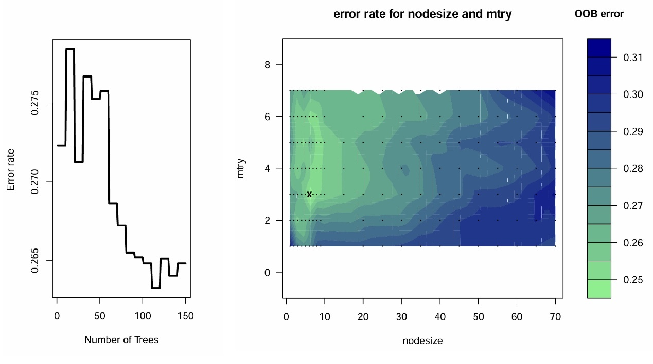
The ntree, the mtry and nodesize was 150, 3 and 6, respectively. RSF, random survival forests.

Figure S2. Survival curve of pure and mixed proliferative LN patients.
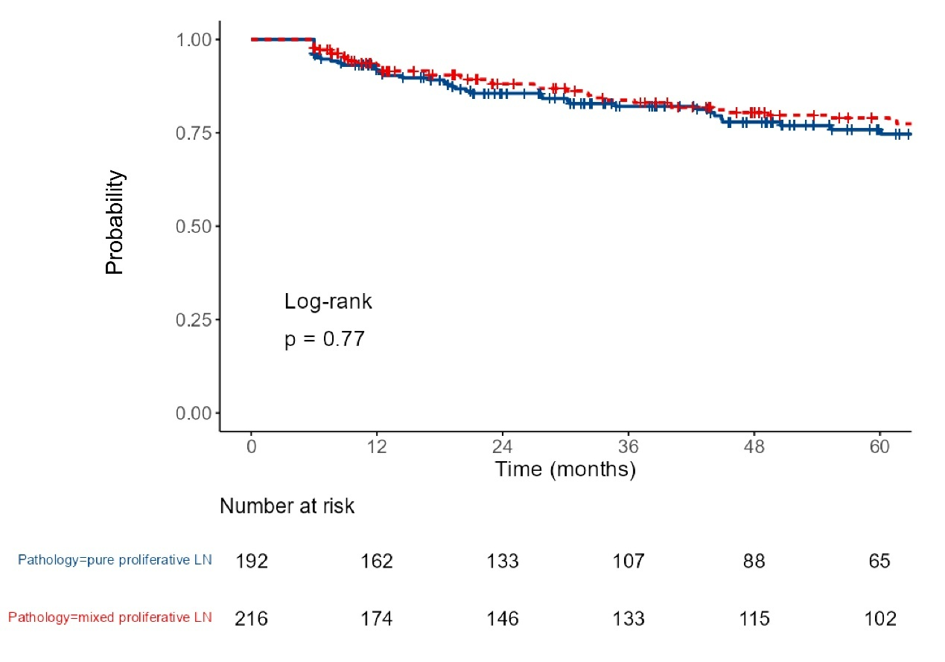
LN, lupus nephritis.

Figure S3. The optimal cutoff value for prognostic factors by the MSRSM.
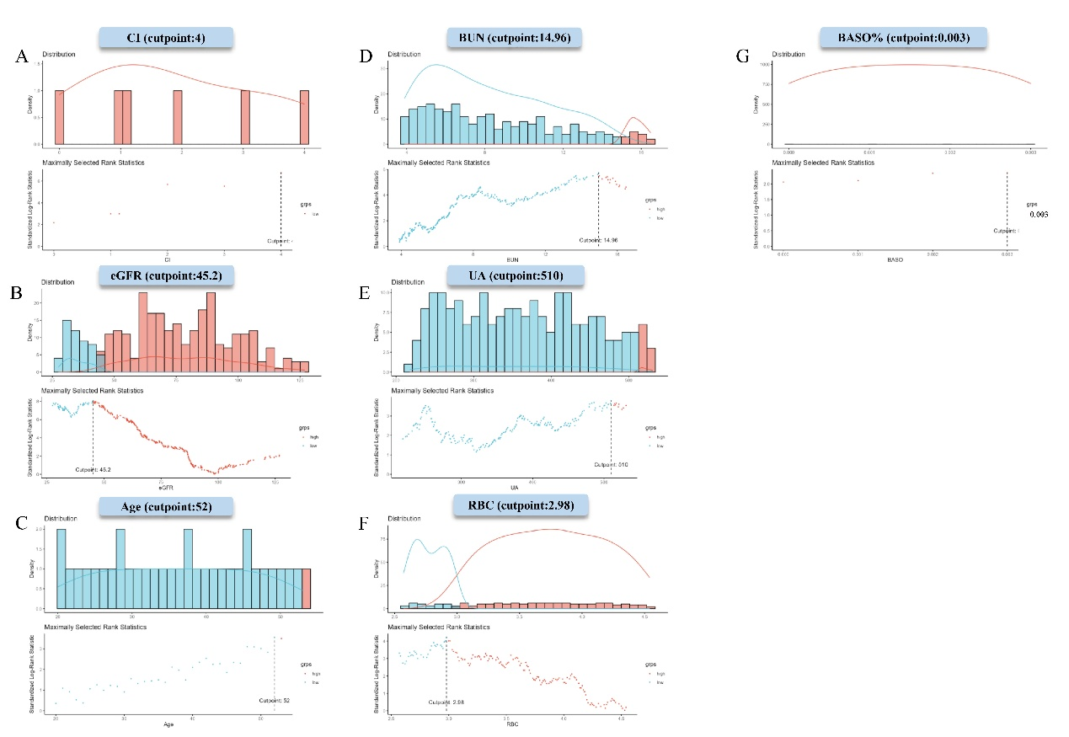
CI, chronic index. BUN, blood urea nitrogen. eGFR, estimated glomerular filtration rate. RBC, red blood cell. UA, uric acid. BASO%, basophil percentage. MSRSM, Maximally Selected Rank Statistics Method.

Figure S4. Comparison of survival between high- and low-risk groups with proliferative LN stratified by the optimal cut-off value.
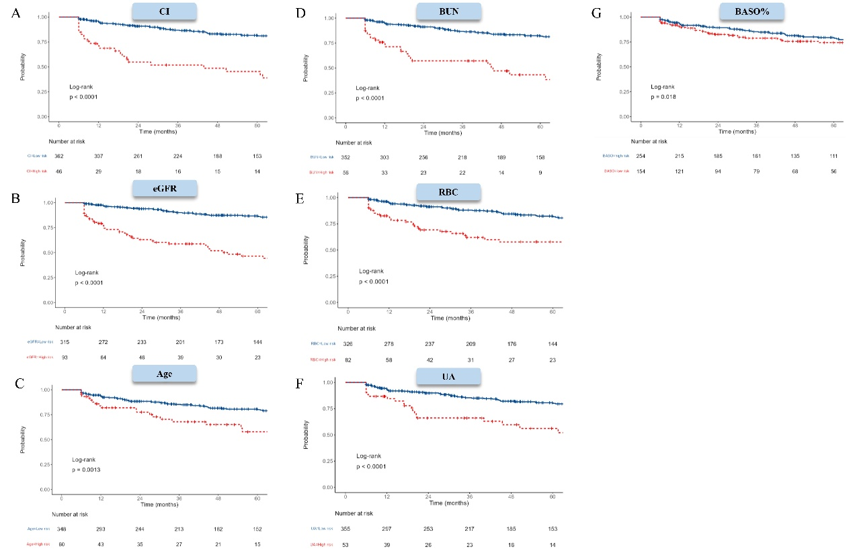
LN, lupus nephritis. CI, chronic index. BUN, blood urea nitrogen. eGFR, estimated glomerular filtration rate. RBC, red blood cell. UA, uric acid. BASO%, basophil percentage.

