Supplementary material

Table S1. Dataset characteristics and NII score distribution.
Table S2. Correlations between NII score and other NPS.
Table S3. Baseline characteristics of the study population by tertiles of NII score in NHANES.
Supplementary Note 1 SHAP dependence plot coloring and interaction conventions.
Supplementary Note 2 Abridged prompt template for LLM-derived NII.
Fig. S1. Predictive validity of nutrient composition for LLM-derived NII.
Fig. S2. NII scores according to NOVA/Nutri-Score/HSR category for foods and beverages consumed in the United States (NHANES/FNDDS 2017-18).
Fig. S3. NII scores according to NOVA category for different food subgroup consumed in the United States (NHANES/FNDDS 2017-18).
Fig. S4. NII scores according to Nutri-Score category for different food subgroup consumed in the United States (NHANES/FNDDS 2017-18).
Fig. S5. NII scores according to HRS category for different food subgroup consumed in the United States (NHANES/FNDDS 2017-18).
Fig. S6. FCS scores for foods and beverages classified as UPFs under the NOVA classification, consumed by US adults based on NHANES 2017-18.
Fig. S7. Dependence structure for the top six SHAP-ranked features.
Fig. S8. Sensitivity analysis of association between NII scores and mortality in NHANES.
Fig. S9. Sensitivity analysis of the joint associations of UPFs and the NII with mortality.
Fig. S10. Flow chart of final sample from NHANES.

Dataset and NII overview
Across 7,083 foods, the LLM produced a NII for each item (0-100, higher = healthier). Outputs were complete for all records. Scores covered the full range (min 0.0, max 100.0) with a mean of 67.30 (SD 24.64) and a median of 74.0 (interquartile range 48.5-88.0). The distribution was broad rather than clustered: 39.1% (2,771/7,083) scored 81-100, 25.2% (1,787) 61-80, 19.2% (1,359) 41-60, 10.6% (751) 21-40, and 5.8% (413) 0-20. This widespread indicates that the NII functions as a continuous measure of healthfulness across products, rather than a coarse grouping (Table S1).
Proxy modelling of the LLM-derived NII
Across 7,083 foods (NII range 0-100), we trained proxy models to quantify how well objective nutrient composition can reconstruct the LLM-derived NII. On a held-out test set (n = 1,417; 80/20 split), tree-based ensemble methods consistently outperformed linear and kernel baselines (Fig. S1a-c). The best-performing model (Gradient Boosting Regressor) achieved R² = 0.813, RMSE = 10.614 and MAE = 7.108, with LightGBM, XGBoost and Random Forest yielding near-identical test performance (R² ≈ 0.808-0.811; RMSE ≈ 10.66-10.76; MAE ≈ 7.17-7.48), indicating that the nutrient-NII mapping is strongly non-linear but robust to the choice of tree ensemble (Fig. 1a-c). By contrast, SVR and penalised linear models showed materially weaker fit (SVR: R² = 0.558; Ridge/Lasso: R² ≈ 0.489; Fig. S1c), supporting the presence of thresholds and interactions rather than a predominantly linear scoring rule.
Generalisation gaps were modest but detectable: tree ensembles achieved high training fit (Train R² ≈ 0.936-0.967) relative to test performance (Fig. S1d), consistent with flexible models capturing genuine non-linear structure alongside some overfitting. Predicted-versus-observed values closely followed the identity line (Fig. S1e), with residuals centered near zero but widening for some mid-range predictions (Fig. S1f-g), suggesting heteroscedastic errors and occasional outliers rather than a systematic global bias. Predicted and observed score distributions were broadly aligned (Fig. S1h), indicating that the proxy model preserves the overall score calibration at the population level.
Correlations between NII score and other NPS
As shown in Table S2, NII was strongly correlated with the FCS across all food items (Spearman’s r = 0.78), with moderate correlations observed for the HSR (r = 0.67) and Nutri-Score (r = 0.63). Correlation strength varied across food categories, with stronger associations for fruits (r = 0.85), vegetables (r = 0.79), beverages (r = 0.76), and weaker correlations for fats and oils (r = 0.29) and grains (r = 0.45). Overall, NII score patterns were broadly consistent with classifications defined by NOVA, HSR, and Nutri-Score across major food groups and subgroups (Fig. S2-S5).
Population Characteristics in NHANES
Table S3 summarizes the baseline characteristics of U.S. adults according to tertiles of the weighted NII score in NHANES. Participants with higher NII scores tended to be older and had slightly lower total energy intake compared with those in the lowest tertile (P < 0.001). The proportion of females increased across increasing NII tertiles, while the prevalence of current smoking and heavy alcohol consumption decreased markedly. Individuals in the highest NII tertile were more likely to have higher educational attainment, and belong to higher income categories.
Sensitivity analyses
Fig. S8 presents sensitivity analyses evaluating the robustness of the association between NII and mortality outcomes. The inverse association between higher NII and mortality remained consistent across multiple alternative model specifications, including exclusion of early deaths, restriction to older participants, varying thresholds of missing dietary data, and alternative NII calculation approaches, supporting the stability of the primary findings.

Table S1. Dataset characteristics and NII score distribution.
Category | Metric | Value
Dataset | Foods assessed, n | 7,083
Output completeness | NII score; extracted features; reasoning chain | 7,083/7,083 (100%) each
NII summary | Mean (SD) | 67.30 (24.64)
NII summary | Median (Q1, Q3) | 74.0 (48.5, 88.0)
NII summary | Min, max | 0.0, 100.0
NII score bands | 0 to 20, n (%) | 413 (5.8)
NII score bands | 21 to 40, n (%) | 751 (10.6)
NII score bands | 41 to 60, n (%) | 1,359 (19.2)
NII score bands | 61 to 80, n (%) | 1,787 (25.2)
NII score bands | 81 to 100, n (%) | 2,771 (39.1)
Notes: NII ranges from 0 to 100 (higher values indicate healthier nutritional integrity). Q1 and Q3 denote the 25th and 75th percentiles. Percentages are rounded to one decimal place.

Table S2. Correlations between NII score and other NPS.
Food category | No. of items | NII score vs. FCS | NII score vs. HSR | NII score vs. Nutri-Score | FCS vs. HSR | FCS vs. Nutri-Score | HSR vs. Nutri-Score
Overall | 6,146 | 0.78 | 0.67 | 0.63 | 0.72 | 0.71 | 0.84
Beverages | 268 | 0.76 | 0.45 | 0.26 | 0.62 | 0.30 | 0.62
Grains | 641 | 0.45 | 0.66 | 0.62 | 0.38 | 0.43 | 0.82
Fruits | 119 | 0.85 | 0.82 | 0.54 | 0.81 | 0.53 | 0.67
Vegetables | 658 | 0.79 | 0.56 | 0.65 | 0.60 | 0.81 | 0.60
Legumes, nuts and seeds | 173 | 0.62 | 0.34 | 0.33 | 0.60 | 0.49 | 0.78
Meat, poultry and eggs | 712 | 0.58 | 0.51 | 0.45 | 0.60 | 0.69 | 0.83
Seafood | 307 | 0.70 | 0.36 | 0.25 | 0.51 | 0.44 | 0.77
Dairy | 244 | 0.50 | 0.43 | 0.48 | 0.53 | 0.65 | 0.74
Fats and oils | 117 | 0.29 | -0.12 | -0.04 | 0.30 | 0.31 | 0.76
Mixed dishes | 1947 | 0.77 | 0.62 | 0.62 | 0.63 | 0.64 | 0.84
Sauces and condiments | 124 | 0.72 | 0.54 | 0.56 | 0.61 | 0.59 | 0.94
Savoury snacks and sweet desserts | 836 | 0.56 | 0.51 | 0.41 | 0.45 | 0.36 | 0.88

Table S3. Baseline characteristics of the study population by tertiles of NII score in NHANES.
Characteristics | Overall,  N = 23,521 | Tertile 1,  N = 7,841 (9-66) | Tertile 2,  N = 7,840 (66-83) | Tertile 3,  N = 7,840 (83-99) | P value
NII score, median (IQR) | 58.7 (49.8, 67.6) | 45.9 (40.4, 49.8) | 58.7 (56.0, 61.4) | 71.3 (67.6, 76.5) | <0.001
Age, median (IQR), year | 50.0 (35.0, 64.0) | 43.0 (31.0, 59.0) | 52.0 (36.0, 66.0) | 55.0 (39.0, 67.0) | <0.001
BMI, median (IQR), kg/m² | 28.1 (24.3, 32.6) | 28.2 (24.3, 32.9) | 28.1 (24.5, 32.5) | 27.9 (24.2, 32.3) | 0.070
Total energy, median (IQR), kcal/d | 1,863.0 (1,376.0, 2,498.0) | 2,105.0 (1,546.0, 2,822.0) | 1,929.0 (1,458.0, 2,539.0) | 1,603.0 (1,212.0, 2,100.0) | <0.001
Sex |  |  |  |  | <0.001
Male | 11,671 (49.6) | 4,543 (57.9) | 3,892 (49.6) | 3,236 (41.3)
Female | 11,850 (50.4) | 3,298 (42.1) | 3,948 (50.4) | 4,604 (58.7)
Race |  |  |  |  | <0.001
Non-Hispanic White | 10,058 (42.8) | 3,423 (43.7) | 3,440 (43.9) | 3,195 (40.8)
Non-Hispanic Black | 4,436 (18.9) | 1,906 (24.3) | 1,401 (17.9) | 1,129 (14.4)
Mexican American | 4,156 (17.7) | 1,467 (18.7) | 1,408 (18.0) | 1,281 (16.3)
Others | 4,871 (20.7) | 1,045 (13.3) | 1,591 (20.3) | 2,235 (28.5)
Educational attainment |  |  |  |  | <0.001
<11 grade | 6,117 (26.0) | 2,254 (28.8) | 2,006 (25.6) | 1,857 (23.7)
High school | 5,382 (22.9) | 2,119 (27) | 1,734 (22.1) | 1,529 (19.5)
More than high school | 11,999 (51.1) | 3,462 (44.2) | 4,095 (52.3) | 4,442 (56.7)
Drinking status |  |  |  |  | <0.001
Non-drinker | 6,583 (29.6) | 1,810 (24.2) | 2,201 (29.8) | 2,572 (34.9)
1-5 drinks/month | 11,119 (50.0) | 3,753 (50.3) | 3,709 (50.2) | 3,657 (49.6)
5-10 drinks/month | 1,635 (7.4) | 657 (8.8) | 523 (7.1) | 455 (6.2)
10+ drinks/month | 2,903 (13.1) | 1,248 (16.7) | 960 (13) | 695 (9.4)
Smoking status |  |  |  |  | <0.001
Never | 12,748 (54.2) | 3,718 (47.4) | 4,280 (54.6) | 4,750 (60.6)
Former | 5,788 (24.6) | 1,627 (20.8) | 2,115 (27.0) | 2,046 (26.1)
Current | 4,971 (21.1) | 2,493 (31.8) | 1,440 (18.4) | 1,038 (13.2)
Income level |  |  |  |  | <0.001
PIR < 1 | 4,654 (21.6) | 1,882 (25.8) | 1,438 (20.1) | 1,334 (18.9)
PIR(1-4) | 11,520 (53.5) | 3,962 (54.4) | 3,868 (54) | 3,690 (52.2)
PIR ≥ 4 | 5,351 (24.9) | 1,442 (19.8) | 1,859 (25.9) | 2,050 (29.0)
History of hypertension |  |  |  |  | <0.001
No | 14,989 (63.9) | 5,241 (67.2) | 4,922 (62.9) | 4,826 (61.7)
Yes | 8,456 (36.1) | 2,557 (32.8) | 2,901 (37.1) | 2,998 (38.3)
History of diabetes |  |  |  |  | <0.001
No | 20,410 (86.8) | 7,044 (89.9) | 6,783 (86.6) | 6,583 (84.0)
Yes | 3,098 (13.2) | 793 (10.1) | 1,053 (13.4) | 1,252 (16.0)

Supplementary Note 1. SHAP dependence plot coloring and interaction conventions
For dependence plots, point colors encode the value of a putative interacting feature (selected either by SHAP’s default interaction heuristic or by the strongest interactions observed in the interaction matrix), using a continuous color scale in which lower values are shown in blue and higher values in magenta. This color choice is consistent across panels to support visual comparison of interaction gradients.

Supplementary Note 2. Abridged prompt template for LLM-derived NII
We prompted GPT-5.1 to assign a continuous Nutritional Integrity Index (NII; 0-100, higher indicates better nutritional integrity) from ingredient lists and processing descriptions. The prompt fixed the model role as a food science and nutritional epidemiology expert and instructed stepwise evaluation of ingredient ordering (ingredients listed by weight), processing semantics (for example, cues indicative of industrial processing), additive burden and the presence of a whole-food matrix, while explicitly discouraging unsupported numeric inference. Scores were anchored to qualitative bands (0-20 critical risk, 21-40 high risk, 41-60 moderate, 61-80 good, 81-100 excellent) to improve consistency. The model produced a structured output comprising (i) a compact semantic cue record (JSON), (ii) a brief rationale grounded in the provided text and (iii) a single numeric NII. To prevent information leakage, numeric nutrient facts were not provided. A concise prompt excerpt is included in the Supplementary Information; the full prompt text (including exemplars) and implementation are provided in the code.

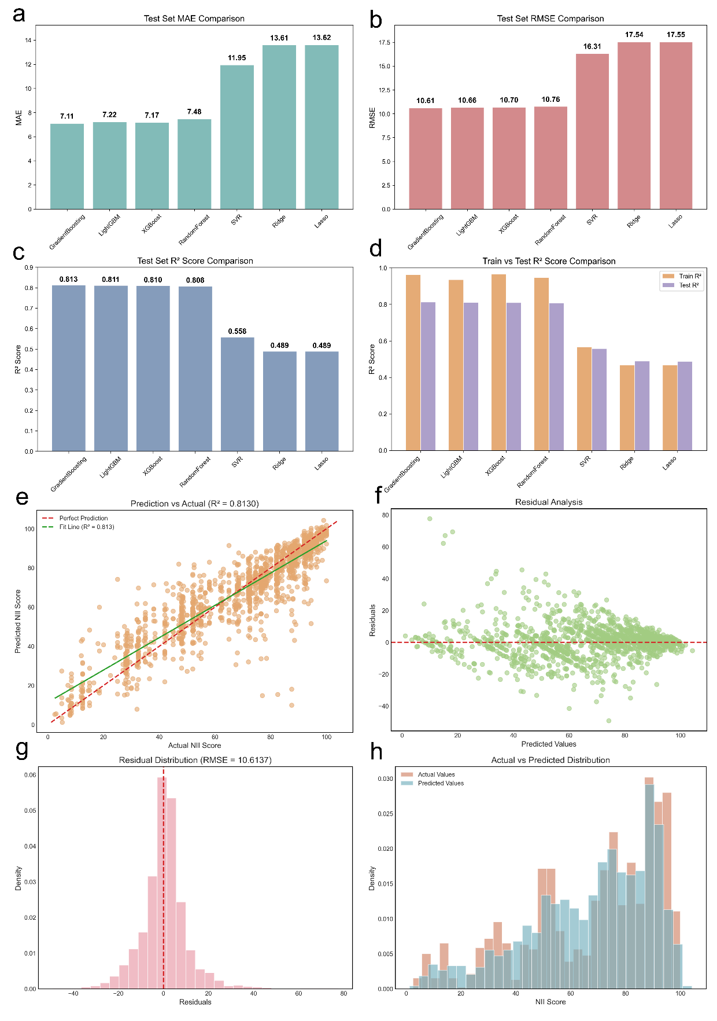
Fig. S1. Predictive validity of nutrient composition for LLM-derived NII.
a-c, Test-set performance across models using mean absolute error (MAE; a), root mean squared error (RMSE; b) and coefficient of determination (R²; c). Tree-based ensembles (Gradient Boosting, LightGBM, XGBoost, Random Forest) show consistently higher predictive performance than SVR and penalised linear models. d, Train versus test R² illustrates moderate generalisation gaps for flexible ensembles. e, Predicted versus observed NII scores for the best-performing model (Gradient Boosting), with the identity line and fitted trend line. f, Residuals versus predicted values (residual = predicted-observed), indicating residuals centered near zero with widening dispersion in some prediction ranges. g, Residual distribution for the best-performing model, with RMSE annotated. h, Overlaid distributions of observed and predicted NII scores on the test set.

Fig. S2. NII scores according to NOVA/Nutri-Score/HSR category for foods and beverages consumed in the United States (NHANES/FNDDS 2017-18).

Fig. S3. NII scores according to NOVA category for different food subgroup consumed in the United States (NHANES/FNDDS 2017-18).

Fig. S4. NII scores according to Nutri-Score category for different food subgroup consumed in the United States (NHANES/FNDDS 2017-18).

Fig. S5. NII scores according to HRS category for different food subgroup consumed in the United States (NHANES/FNDDS 2017-18).

Fig. S6. FCS scores for foods and beverages classified as UPFs under the NOVA classification, consumed by US adults based on NHANES 2017-18.

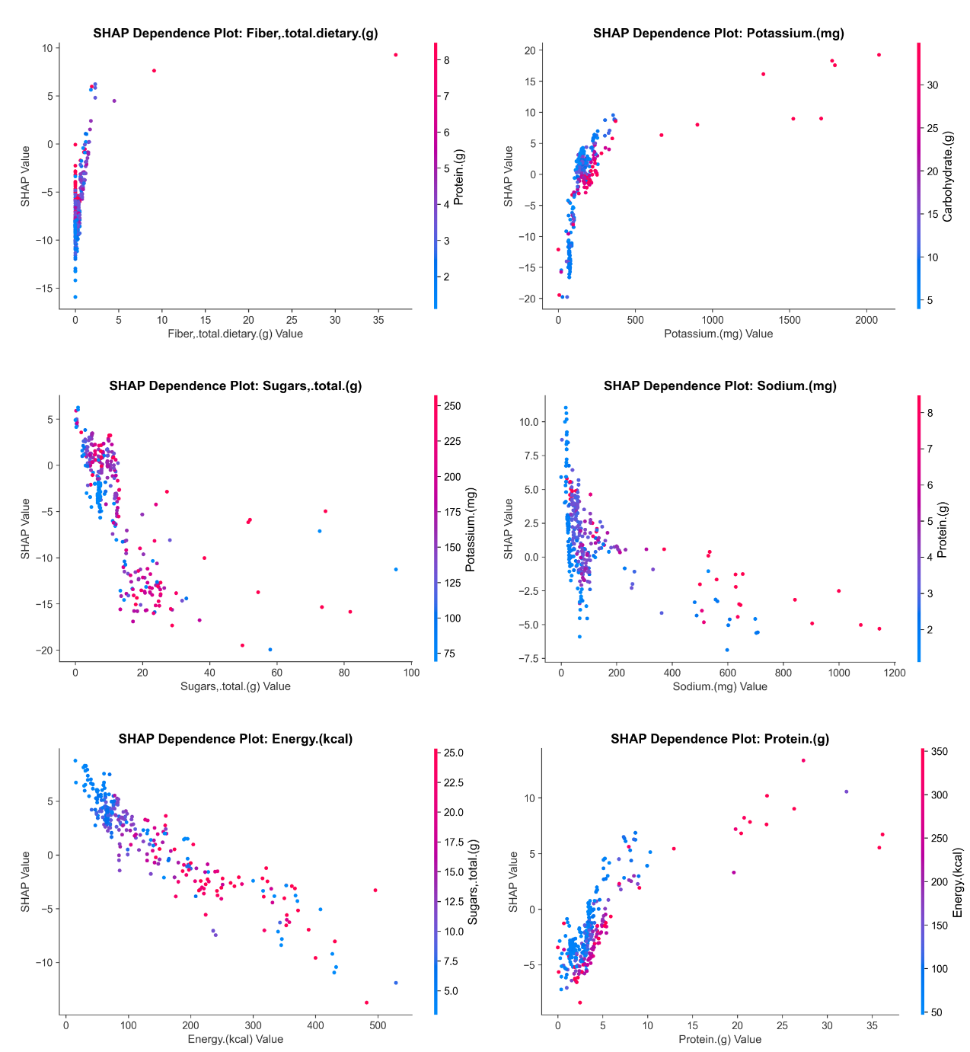
Fig. S7. Dependence structure for the top six SHAP-ranked features.
In each panel, the x-axis indicates the feature value and the y-axis indicates the SHAP value (feature contribution to the predicted NII). Point colors encode a secondary feature to visualize interaction gradients, using a continuous scale in which lower values are shown in blue and higher values in magenta: fibre colored by protein, potassium colored by carbohydrate, total sugars colored by potassium, sodium colored by protein, energy colored by total sugars, and protein colored by energy.

Fig. S8. Sensitivity analysis of association between NII scores and mortality in NHANES.
Model 4: Fully adjusted model with survey cycles; Model 5: Fully adjusted model-excluding mortality within two years of follow-up; Model 6: Fully adjusted model-excluding mortality within five years of follow-up; Model 7: Fully adjusted model-excluding participants under the age of 40; Model 8: Fully adjusted model-excluding participants with NII missing>10%; Model 9: Fully adjusted model-excluding participants with NII missing>20%; Model 10: Fully adjusted model-using total energy to calculate NII scores; Model 11: Fully adjusted model with survey cycles-using total energy to calculate NII scores.

Fig. S9. Sensitivity analysis of the joint associations of UPFs and the NII with mortality.

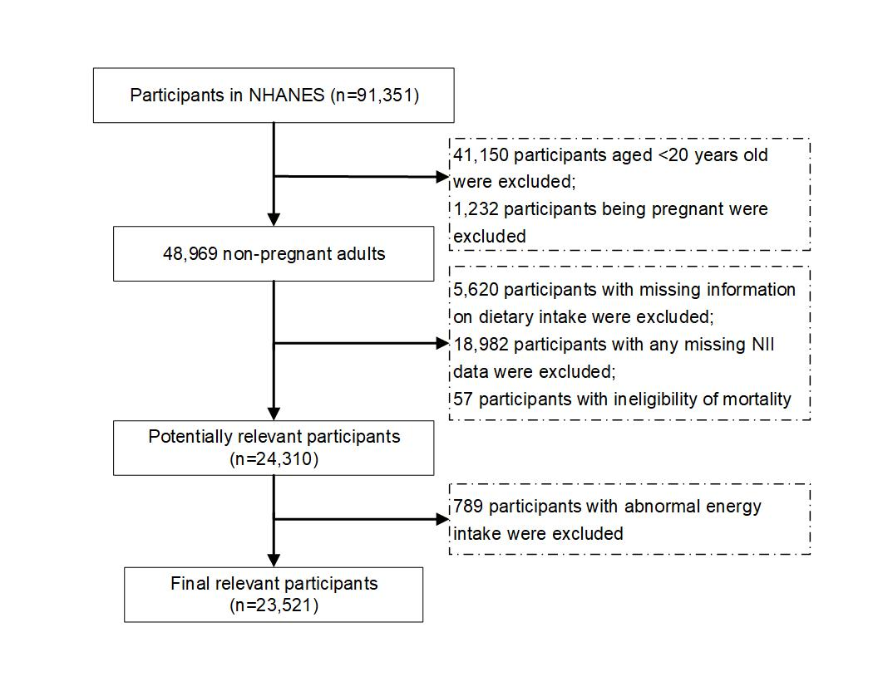
Fig. S10. Flow chart of final sample from NHANES.

