Supplemental Materials
1. Additional Information on How the Philly Vax Sweepstakes Was Advertised 2
2. Selecting the Null Hypotheses in Our Equivalence Tests 4
3. Estimating the Effect of the Philly Vax Sweepstakes on Overall Vaccination Rates in Philadelphia 6
4. Robustness Check of County Analyses Using an Alternative Data Source 8
5. Data on Manual Registrations for Philly Vax Sweepstakes 10
References for the Supplemental Materials 11
Supplemental Figures 19
Supplemental Tables 22

1. Additional Information on How the Philly Vax Sweepstakes Was Advertised
Each two-week lottery was accompanied by city-wide and zip-code specific marketing efforts. Details are provided in Table S1 and below.
On the first day of the Philly Vax Sweepstakes (June 7th) and on the dates of the first and second lottery drawings (June 21st and July 6th, respectively), a new treatment zip code was publicly announced and the terms of the lottery were detailed via a range of channels. The first announcement on June 7th was accompanied by an online press conference with the Philadelphia Mayor and Health Commissioner (1), a dedicated press release by the Mayor’s Office (2), a subsequent press release by the University of Pennsylvania (3), and coverage by major local news outlets including the Philadelphia Inquirer (4), NBC10 (5), FOX29 (6), and 6ABC (7). Ultimately, 35 news outlets published original stories about the sweepstakes (8-63) with 61.8% of those stories published during the first treatment period, 29.0% published during the second treatment period, and 9.1% published during the third treatment period.
On June 7th, the City of Philadelphia also sent out emergency text messages to residents who had signed up for the ReadyPhiladelphia emergency information notification system (N=81,000) to inform them about the sweepstakes. A second text message went out through the emergency notification system on June 29th to remind residents of the soon-to-close second round of the sweepstakes. The City of Philadelphia also posted messages on Nextdoor, a hyperlocal social networking service, throughout the six-week period (advertisements were posted on June 9th, June 17th, July 1st, July 2nd, July 7th and July 9th) to advertise each two-week lottery.
Philadelphia-wide marketing efforts increased during the second and third lottery periods, but attention to the sweepstakes as measured by Google search volume waned (see Figure S3). The second and third announcements of treatment zip codes were made only on the Philly Vax Sweepstakes website, as an item in a regularly-issued press release from the Mayor’s office (64-65) and on social media by the City of Philadelphia. Additionally, on June 25th, during the second two-week lottery period, one of the grand prize winners of the first lottery who elected to be named was announced and participated in a press conference with the Mayor of Philadelphia that was picked up by other media sources (66-67). This press conference was held at a clinic in the second treatment zip code (19133) in an effort to build awareness of the lottery among residents of that neighborhood (66). On July 15th, during the third two-week lottery period, the Philadelphia Department of Public Health put out a press release with quotes from the second lottery’s grand prize winners. Neither winner wished to be named publicly (68). The Black Doctors COVID Consortium organized at least 42 vaccination clinics during the six-week sweepstakes, and residents visiting these clinics were informed about the sweepstakes (69).
An additional marketing push took place during the final two-week lottery period. On July 12th, 2021, Penn Medicine sent out emails about the sweepstakes to all of their Philadelphia-based patients with accessible email addresses (N=229,675). On July 16th, Penn Medicine sent text messages to all residents of Philadelphia who had been vaccinated at their pop-up clinics (and who had consented to receive text messages) reminding them of the sweepstakes and asking them to tell others about it (N=10,039). Finally, two prominent local radio stations, Power 99 and Hip-Hop 103.9, featured brief ads throughout the week to promote the sweepstakes from Monday, July 12th to Sunday, July 18th 2021 (70-71).
To ensure residents in the treatment zip codes were aware that their zip codes had been selected for special treatment, several local organizations, such as Philly Counts, helped spread the word. During the second and third lottery periods, the City of Philadelphia set up automated calls to residents in each treatment zip code to notify them about the sweepstakes. On June 30th, 2021, 10,045 residents of 19133 were called and 3,796 were reached, which means either that they picked up and heard some portion of the message live or that it was left on their voicemail (or 19% of the adult residents of 19133). On July 12th, 2021, 12,466 residents of 19142 were called and 7,831 were reached (or 38% of the adult residents of 19142).

2. Selecting the Null Hypotheses in Our Equivalence Tests
To select the appropriate null hypotheses to consider in our equivalence tests, we began by assuming that a policy capable of generating an extra vaccination at a cost of $1,000 or less would create value, but a policy with a higher price tag might not. This threshold selection is debatable, but we based our decision on a discussion of a reasonable incentive governments might offer to encourage vaccination in an article published in the Journal of the American Medical Association in 2021 (72). To determine the number of additional vaccinations per 100,000 people each treatment zip code’s sweepstakes drawing would need to motivate in order to generate one extra vaccination per $1,000 spent, we made the following calculations. During 19126’s two weeks as the treatment zip code, $63,000 in lottery prizes were offered to its 12,485 adult residents and $63,000 in lottery prizes were offered to the other 1,229,325 adult residents in Philadelphia’s remaining zip codes. Dividing $63,000 by 12,485 and then subtracting the ratio of $63,000 over 1,229,325 gives us the marginal price per person of increasing the vaccine incentives in 19126 by 98x when it was the treatment zip code. That marginal price per person came to $4.99. Multiplying this marginal price per person by the adult population of 19126 gives us the marginal price of the geographically-targeted lottery for the entire zip code: $4.99*12,485 = $62,360. Dividing that marginal price for the entire zip code by $1,000 gives us the additional vaccinations we would need to generate for the population of the selected zip code during its two-week lottery treatment period to generate one extra vaccination per $1,000 spent: $62,360/$1,000 = 62.36. To put this number into units of extra vaccinations per 100,000 people, we need to multiply 62.36 by 100,000 and divide by the adult population of 19126: 62.36*100,000/12,485 = 499.48. Finally, to put this number into units of extra vaccinations per 100,000 people per week, we need to divide by two because the geographically-targeted 19126 zip code lottery took place over the course of two weeks. Dividing 499.48 by two gives us 249.74, which is the weekly number of vaccinations per 100,000 we would need to generate with our geographically-targeted 19126 lottery to conclude each $1,000 spent produced one extra vaccination. This is the equivalence bound we use in our one-sided t-test when examining the effect of our targeted lottery in zip code 19126.
For 19133 and 19142 we repeat these calculations with their respective adult populations of 19,824 and 20,565 to generate equivalence bounds of 156.32 and 150.59. For our pooled zip code lotteries, we calculate the average of the three equivalence bounds (249.74 + 156.32 + 150.59) / 3 to generate an equivalence bound of 185.55.

3. Estimating the Effect of the Philly Vax Sweepstakes on Overall Vaccination Rates in Philadelphia
In an attempt to measure the overall effect of the Philly Vax Sweepstakes on COVID-19 vaccination rates in Philadelphia County, we compared the weekly first-dose vaccinations in Philadelphia County per 100,000 people during the sweepstakes with the weekly first-dose vaccinations in adjacent Pennsylvania counties (Bucks, Delaware, and Montgomery Counties, following (Roberto et al., 2019 (73)) and in Pittsburgh’s Allegheny County following our pre-registered analysis strategy. Table S2 provides summary statistics on the demographic composition of residents of these communities as well as the percent of each population with at least one COVID-19 vaccination prior to the start of the Philly Vax Sweepstakes on June 6, 2021.
Multiple data sources report on daily vaccination rates in Philadelphia County. We use data from the Centers for Disease Prevention and Control (CDC) (74) as our primary data source in our analyses because it was 1) the only source which included data on adults 18 years of age and older (the population eligible for our sweepstakes) across all geographies studied, and 2) the most complete data source (data from the Philadelphia Department of Public Health does not include Philadelphia residents who were vaccinated outside of Philadelphia or within Philadelphia at Federal vaccination sites).
Because calculating standard errors in difference-in-differences regressions when there is a limited number of clusters poses challenges (75-76), we begin by visualizing raw weekly vaccination data. As shown in Figure S1, Panels A and B, there was a slight initial uptick in vaccinations in Philadelphia County following the announcement of the Sweepstakes compared to surrounding counties and, for one week (the second week of the Sweepstakes), compared to Pittsburgh’s Allegheny County. While these show at most a 50% boost in one atypical week’s first-dose vaccinations per 100,000 people (from a baseline of 1,419 per 100,000 people), neither appears sustained. Further, Philadelphia County’s vaccination rate was trending upward compared to surrounding counties at the time of the Sweepstakes, so it’s likely the Sweepstakes was not wholly responsible for the small initial improvement in Philadelphia’s vaccination rate compared to surrounding counties.
In an attempt to statistically model the data visualized in Figure S1, we ran two ordinary least squares (OLS) regressions. Our regressions presented in Table S3 predict weekly first-dose vaccinations of adults per 100,000 by county with fixed effects for each week of the year, an indicator variable equal to 1 for Philadelphia during the six weeks of the sweepstakes (June 7 through July 19, 2021), and fixed effects for each county. Model 1 includes Philadelphia and its surrounding counties, and Model 2 includes Philadelphia and Allegheny County. Following our analysis of treatment zip codes, in an attempt to be conservative in how we estimate standard errors, we run each model three times and report the standard errors produced when clustering by week, clustering by region (county in this case), and using simple robust standard errors. This approach has been used by other researchers (77).
As shown in Table S2, over the course of the six-week sweepstakes, Model 1 estimates that the first-dose weekly vaccination rate in Philadelphia county rose by a marginally significant 383 extra vaccinations per 100,000 people compared to the adjacent counties of Bucks, Delaware, and Montgomery (most conservative 95% CI: [-52; 819], p=0.080 and least conservative 95% CI: [131; 636], p=0.017) while Model 2 estimates that the first-dose weekly vaccination rate in Philadelphia county fell by an insignificant 116 vaccinations per 100,000 people compared to Allegheny County (most conservative 95% CI: [-960; 729], p=0.772 and least conservative 95% CI: [-664; 432], p=0.656). These estimates suggest, respectively, a 27% increase or a 8% decrease relative to Philadelphia’s pre-sweepstakes first-dose vaccination rate -- estimates that are so different as to be generally uninformative. Further, Figure S1, Panels A and B suggests a parallel trends violation of the analysis from Model 1, which means estimates from this model are likely biased upwards.

4. Robustness Check of County Analyses Using an Alternative Data Source
To assess the robustness of our supplemental results examining the overall effect of the Philly Vax Sweepstakes on Philadelphia’s first-dose vaccination rate, we re-ran our aforementioned analyses comparing Philadelphia County to surrounding counties and Allegheny County using available data from the Philadelphia Department of Public Health (79). We relied on our original CDC data source for first-dose vaccinations for the three surrounding counties and Allegheny County. Our model remained the same as in our primary county-level analysis: an ordinary least squares (OLS) regression predicting weekly first dose vaccinations per 100,000 adults by county with fixed effects for county, fixed effects for week, and an indicator variable that took on a value of 1 for Philadelphia during the six weeks of the sweepstakes (June 7 through July 19, 2021). When calculating standard errors, we again run each model three times clustering by week, clustering by region (county in this case), and using simple robust standard errors.
As shown in Table S4, over the course of the six-week sweepstakes, we estimate that the first-dose vaccination rate in Philadelphia County rose an insignificant 350 vaccinations per 100,000 people compared to adjacent counties of Bucks, Delaware, and Montgomery (most conservative 95% CI: [-144; 845], p=0.151 and least conservative 95% CI: [98; 603], p=0.022). When comparing Philadelphia to Allegheny, there was an insignificant decrease of first-dose vaccinations of 149 per 100,000 people (most conservative 95% CI: [-892; 594], p=0.672 and least conservative 95% CI: [-621; 322], p=0.506). Figure S2, Panels A through D visualize and compare the vaccination rates in these geographies over time and show that Philadelphia’s vaccination rates were already climbing relative to surrounding counties prior to the Sweepstakes, while there were relatively parallel trends in vaccination rates between Philadelphia and Allegheny prior to the Sweepstakes.

5. Data on Manual Registrations for the Philly Vax Sweepstakes
Universal Promotions, Inc. provided information on the manual registrations for the Philly Vax Sweepstakes (N=76,035), which we summarize in our main manuscript. The data was provided at the individual registrant level with each de-identified observation including the date and time of registration as well as the resident’s self-reported zip code. Six hundred and seventy-two registrants reported residing in a zip code outside of Philadelphia, and we excluded these registrants from our analyses. Another 6,401 entries in the dataset were missing a date and time stamp. However, Universal Promotions, Inc. communicated that registrants were listed in the database in chronological order by registration time. Therefore, to deal with missing date and time stamps in the database, we assumed the date of a registration was equal to the date of adjacent registrations with non-missing data, and we applied this rule successfully to 6,391 entries missing a date and time stamp. For 10 registrants missing a date and time stamp, the date stamp on adjacent database entries was inconsistent (i.e., the last complete prior entry was from date T and the next complete entry was from date T+1). In these cases, we assumed the date of a registration matched the date of the adjacent entry that met the following criterion: whichever of the two adjacent entries was furthest away from midnight was presumed to be the date on which the registration in question occurred. We did not exclude registrants (N=6,355) who failed to report their zip code since a Philadelphia zip code was a prerequisite for entering the lottery, and we assumed registrants were following the rules unless we had evidence to the contrary.

REFERENCES FOR THE SUPPLEMENTAL MATERIALS

- Press Briefing on Philly Vax Sweepstakes. City of Philadelphia, https://www.facebook.com/cityofphiladelphia/videos/4408150352577050 (2021).
- Mayor Kenney Announces “Philly Vax Sweepstakes” Giving Vaccinated Philadelphians Dozens of Chances to Win Up to $50,000, City of Philadelphia Board of Health, Managing Director’s Office, Department of Public Health, Office of the Mayor, Office of Emergency Management https://www.phila.gov/2021-06-07-mayor-kenney-announces-philly-vax-sweepstakes-giving-vaccinated-philadelphians-dozens-of-chances-to-win-up-to-50000/ (2021).
- D. Patel, Penn teams up with the City of Philadelphia to announce vaccine sweepstakes. Penn Today, https://penntoday.upenn.edu/news/penn-teams-city-philadelphia-announce-vaccine-sweepstakes (2021).
- L. McCrystal, Philadelphia residents could now win as much as $50,000 for getting the COVID-19 vaccine, The Philadelphia Inquirer, https://www.inquirer.com/health/coronavirus/vaccine-sweepstakes-cash-drawing-prize-philadelphia-covid-20210607.html (2021).
- D. Stamm, Philly to Give $50,000 in Cash to Residents in COVID ‘Vax Sweepstakes', NBC 10 Philadelphia, https://www.nbcphiladelphia.com/news/coronavirus/philly-giving-away-multiple-50000-cash-prizes-in-vax-sweepstakes/2839533/ (2021).
- S. Wilson, Philly Vax Sweepstakes: City giving vaccinated residents a chance to win up to $50K. FOX 29 Philadelphia, https://www.fox29.com/news/philadelphia-announces-50000-sweepstakes-for-covid-19-vaccinations (2021).
- Philadelphia offers prizes up to $50,000 as incentive for residents to get COVID vaccine. 6ABC, https://6abc.com/10757437/ (2021).
- City announces first round of winners of Philly Vax Sweepstakes. 6ABC, https://6abc.com/philly-vax-sweepstakes-winners-announced-who-won-the-philadelphia-covid-vaccines-covid-19-vaccinations/10831485/ (2021).
- Philadelphia to Give Away Nearly $400,000 in Vaccine Prizes. Associated Press, https://www.usnews.com/news/best-states/pennsylvania/articles/2021-06-07/philadelphia-to-give-away-nearly-400-000-in-vaccine-prizes (2021).
- D. Henninger, Don’t regret it! ‘Philly Vax Sweepstakes’ offers $50,000 prizes — but only if you’re vaccinated. Billy Penn, https://billypenn.com/2021/06/08/philly-vax-sweepstakes-50000-vaccine-wharton-black-doctors-incentive/ (2021).
- K. Lazar, Million-dollar COVID vaccine lotteries grab attention, but cheaper, targeted approaches may be just as successful. Boston Globe, https://www.bostonglobe.com/2021/06/12/nation/million-dollar-covid-vaccine-lotteries-grab-attention-cheaper-targeted-approaches-may-be-just-successful/ (2021).
- M. Markusa, The Province has put up $1.9 million for grabs in the COVID-19 vaccine incentive lottery. But will it work? CBC Listen, https://www.cbc.ca/listen/live-radio/1-29-information-radio-mb (2021).
- S. Stahl, Philadelphia Announces City’s 1st Vaccine Sweepstakes Winner. CBS Philadelphia, https://philadelphia.cbslocal.com/2021/06/25/philadelphia-vaccine-sweepstakes-winner-daniel-silva-covid-vaccine-incentives/ (2021).
- 36 Fully Vaccinated Philadelphians To Win Up To $50,000 Through New Philly Vax Sweepstakes Program. CBS Philadelphia, https://philadelphia.cbslocal.com/2021/06/07/philly-covid-19-vaccine-program-sweepstakes/ (2021).
- Phillies Offering Free Tickets To Fans Who Get Johnson & Johnson COVID-19 Vaccine During Braves Series This Week. CBS Philadelphia, https://philadelphia.cbslocal.com/2021/06/07/phillies-johnson-johnson-vaccine-covid-19-braves-series-incentives/ (2021).
- E. Roces, City of Phila. reaches milestone as 70% of adults receive first dose of COVID-19 vaccine. The Daily Pennsylvanian, https://www.thedp.com/article/2021/06/philadelphia-covid-19-vaccine-milestone-70-percent (2021).
- M. Espinoza, First-round of the Philly Vax Sweepstakes winners announced. FOX 29 Philadelphia, https://www.fox29.com/news/first-round-of-the-philly-vax-sweepstakes-winners-announced (2021).
- First "Philly Vax Sweepstakes" winner collects $50,000 at press conference. FOX 29 Philadelphia, https://www.fox29.com/video/948575 (2021).
- J. Joyce, Philadelphia reaches target of 70% adults vaccinated at least once. FOX 29 Philadelphia, https://www.fox29.com/news/philadelphia-reaches-target-of-70-adults-vaccinated-at-least-once (2021).
- City officials launch Philly Vax Sweepstakes as to incentivize further vaccinations. FOX 29 Philadelphia, https://www.fox29.com/video/941558 (2021).
- Penn Teams Up With The City Of Philadelphia To Announce Vaccine Sweepstakes. India Education Diary, https://indiaeducationdiary.in/penn-teams-up-with-the-city-of-philadelphia-to-announce-vaccine-sweepstakes/ (2021).
- KHN Morning Briefing Tuesday June, 8, 2021. KHN, https://khn.org/morning-briefing/tuesday-june-8-2021/ (2021).
- Philly to give away up to $50,000 to dozens of vaccinated people. KYW News Radio, https://www.audacy.com/kywnewsradio/news/local/philly-to-give-away-up-to-usd50-000-with-vaccination-incentive (2021).
- J. Tomczuk, Philly to give away $400k in vaccine sweepstakes. Metro, https://philly.metro.us/philly-to-give-away-400k-in-vaccine-sweepstakes/ (2021).
- Philadelphia, University of Pennsylvania Announce First-Round Winners of “Philly Vax Sweepstakes”. MyChesCo, https://www.mychesco.com/a/news/regional/philadelphia-university-of-pennsylvania-announce-first-round-winners-of-philly-vax-sweepstakes/ (2021).
- “Philly Vax Sweepstakes” Giving Vaccinated Philadelphians Dozens of Chances to Win Up to $50,000. MyChesCo, https://www.mychesco.com/a/news/regional/philly-vax-sweepstakes-giving-vaccinated-philadelphians-dozens-of-chances-to-win-up-to-50000/ (2021).
- H. Gross, Philly Picks Winners of $50k Vax Sweepstakes as City Hits 70% Vaccinated Goal. NBC 10 Philadelphia, https://www.nbcphiladelphia.com/news/coronavirus/philly-picks-winners-of-50k-vax-sweepstakes-as-city-hits-70-vaccinated-goal/2854771/ (2021).
- J. Brant, Free Weed, Beer and Guns? Vaccine Incentives Get Creative. NBC Connecticut, https://www.nbcconnecticut.com/lx/free-weed-beer-and-parking-vaccine-incentives-get-creative/2504778/ (2021).
- M. Bennett, First Philly Vaccine Sweepstakes Winners Announced. Patch, https://patch.com/pennsylvania/philadelphia/first-philly-vaccine-sweepstakes-winners-announced (2021).
- M. Bennett, $400K In Prizes Available In Philadelphia Vaccination Sweepstakes. Patch, https://patch.com/pennsylvania/philadelphia/400k-prizes-available-philadelphia-vaccination-sweepstakes (2021).
- K. Rose, Philadelphia launches $378K vaccine lottery to incentivize residents to get the shot. Philadelphia Business Journal, https://patch.com/pennsylvania/philadelphia/400k-prizes-available-philadelphia-vaccination-sweepstakes (2021).
- Philadelphia Residents Can Win 50k in Philly Vax Sweepstakes. Philly Caller, https://phillycaller.com/index.php/politics/608-philadelphia-residents-can-win-50k-in-philly-vax-sweepstakes (2021).
- J. Laughlin, Philly announces first winners of its vaccine lottery. The Philadelphia Inquirer, https://www.inquirer.com/health/coronavirus/philadelphia-vaccine-lottery-sweepstakes-covid-doses-20210625.html (2021).
- A. Wood, ‘Raw happiness’ as Philly reopens | Coronavirus Newsletter. The Philadelphia Inquirer, https://www.inquirer.com/health/coronavirus/newsletter/philadelphia-reopen-happiness-anxiety-20210609.html (2021).
- D. Murrell, Want a Shot at $50,000? All You Have to Do Is Get Vaccinated. The Philly Magazine, https://www.phillymag.com/news/2021/06/07/philadelphia-vaccine-lottery/ (2021).
- Mayor Kenney announces “Philly Vax Sweepstakes” giving vaccinated Philadelphians dozens of chances to win up to $50,000. The Philadelphia Sunday SUN, https://www.philasun.com/local/mayor-kenney-announces-philly-vax-sweepstakes-giving-vaccinated-philadelphians-dozens-of-chances-to-win-up-to-50000/ (2021).
- A. Jones, Sweepstakes gives vaccinated residents a chance to win up to $50,000. The Philadelphia Tribune, https://www.phillytrib.com/news/health/coronavirus/sweepstakes-gives-vaccinated-residents-a-chance-to-win-up-to-50-000/article_62666fe6-97f9-5739-b69f-855fd985e6b7.html (2021).
- M. Tanenbaum, Philly Vax Sweepstakes awards cash prizes to first group of winners. Philly Voice, https://www.phillyvoice.com/philly-vax-sweepstakes-awards-first-winners-cash-prizes-second-drawing-july-6/ (2021).
- M. Tanenbaum, With Philly Vax Sweepstakes, city residents have chances to win up $50,000 for getting their COVID-19 shots. Philly Voice, https://www.phillyvoice.com/how-to-enter-philly-covid-19-vaccine-sweepstakes-cash-prizes/ (2021).
- H. Kanik, Phillies offering free tickets to fans who get Johnson & Johnson vaccine this week. Philly Voice, https://www.phillyvoice.com/phillies-free-tickets-johnson-johnson-vaccine-week/ (2021).
- A, Merelli, Philadelphia is offering extreme vaccine incentives with help from Wharton economists. Quartz, https://qz.com/2018957/a-vaccine-lottery-in-philadelphia-is-hoping-to-change-behavior/ (2021).
- Premiarán en efectivo los que se vacunaron o están por hacerlo. Telemundo 62, https://www.telemundo62.com/noticias/local/premiaran-en-efectivo-los-que-se-vacunaron-o-estan-por-hacerlo/2134932/ (2021).
- K. Volpp, Vaccine Incentives. Wharton Business Daily, https://shows.acast.com/wharton-on-siriusxm/episodes/kevin-volpp-on-wharton-business-daily-2 (2021).
- Philadelphia Picks Vax Sweepstakes Winners. Where Philly, https://www.wherephilly.com/index.php/116-philly-news/917-philadelphia-picks-vax-sweepstakes-winners (2021).
- R. Briggs, ‘Just take it’: West Oak Lane resident wins Philly vaccine sweepstakes, encourages others to get vaxxed. WHYY.org, https://whyy.org/articles/just-take-it-west-oak-lane-resident-wins-philly-vaccine-sweepstakes-encourages-others-to-get-vaxxed/ (2021).
- A. Yu, Philly residents could win as much as $50K for getting COVID vaccine. WHYY.org, https://whyy.org/articles/pa-coronavirus-update-vaccine-sweepstakes-coming-to-philly/ (2021).
- K. Cooper, Philly to lift indoor mask restrictions and 11 p.m. last call beginning Friday. WHYY.org, https://whyy.org/articles/philly-to-lift-indoor-mask-restrictions-and-11-p-m-last-call-beginning-friday/ (2021).
- T. MacDonald, Philly to announce first winners of COVID vaccine sweepstakes this week. WHYY.org, https://whyy.org/articles/philly-to-announce-first-winners-of-covid-vaccine-sweepstakes-this-week/?utm_campaign=sproutsocial&utm_content=1624307173&utm_medium=post&utm_source=facebook,twitter (2021).
- N. Barlage, The City of Philadelphia Announced Philly Vax Sweepstakes for Chance to Win $50,000. 95.7 BEN FM Philadelphia, https://957benfm.com/2021/06/07/the-city-of-philadelphia-announced-philly-vax-sweepstakes-for-chance-to-win-50000/ (2021).
- Twelve More People Set To Cash In On Philly's Vax Sweepstakes. MSN, https://www.msn.com/en-us/sports/motorsports/twelve-more-people-set-to-cash-in-on-phillys-vax-sweepstakes/vp-AALQeoH (2021).
- The first drawings in the Philly Vax Sweepstakes were pulled. iradiophilly, http://www.iradiophilly.com/conversation.php?idConversation=9522 (2021).
- A. Vitarelli, Final Philly Vax Sweepstakes cash prizes to be awarded soon. 6ABC, https://6abc.com/philly-vax-sweepstakes-winners-announced-who-won-the-philadelphia-covid-vaccines-covid-19-vaccinations/10889910/ (2021).
- Philly’s Vax Sweepstakes End This Week. CBS Philly, https://philadelphia.cbslocal.com/2021/07/13/philly-vax-sweepstakes-covid/ (2021).
- Second set of winners announced in Philly Vax Sweepstakes. FOX 29 Philadelphia, https://www.fox29.com/news/philadelphia-announces-50000-sweepstakes-for-covid-19-vaccinations (2021).
- Here is how to participate in the Philadelphia vaccination raffle and what prizes you can get. Justice News Flash Report, https://www.justicenewsflash.com/2021/06/07/here-is-how-to-participate-in-the-philadelphia-vaccination-raffle-and-what-prizes-you-can-get_20210607144787.html (2021).
- J. Beebe, Free beer, tacos, cash prizes—can vaccine incentives overcome fear and mistrust? Market Watch, https://www.marketwatch.com/story/free-beer-tacos-cash-prizescan-vaccine-incentives-overcome-fear-and-mistrust-11624043429 (2021).
- Philly launches COVID vaccine lottery with a chance to win $50K. Pennsylvania Capital Star, https://www.penncapital-star.com/covid-19/philly-launches-covid-vaccine-lottery-with-a-chance-to-win-50k/ (2021).
- G. Samuel, Sweepstakes give vaccinated residents a chance to win up to $50,000.Coronavirus. Pennsylvania News today, https://pennsylvanianewstoday.com/sweepstakes-give-vaccinated-residents-a-chance-to-win-up-to-50000-coronavirus/161722/ (2021).
- Philadelphia to giveaway big bucks in vaccine sweepstakes. PHL17, https://phl17.com/phl17-news/philadelphia-to-giveaway-big-bucks-in-vaccine-sweepstakes/ (2021).
- S. Cheever, Penn sponsors 'Philly Vax Sweepstakes' to incentivize Phila. residents to get vaccinated. The Daily Pennsylvanian, https://www.thedp.com/article/2021/06/penn-contributes-philly-vaccine-lottery (2021).
- L. Greiss, Vaccine rates are dropping in Pennsylvania, including in the Lehigh Valley, but ‘we still have work to do,’ health officials say. The Morning Call, https://www.mcall.com/coronavirus/mc-nws-coronavirus-vaccine-update-lehigh-valley-20210611-6cfhvmjabvadzetpdmczwh5via-story.html (2021).
- T. MacDonald, Lotto good times for winners of Philadelphia Vax sweepstakes. WHYY.org, https://whyy.org/articles/lotto-good-times-for-winners-of-philadelphia-vax-sweepstakes/ (2021).
- Philly Vax Sweepstakes Are Coming To An End. CBS Philadelphia, https://news.yahoo.com/philly-vax-sweepstakes-coming-end-095400603.html (2021).
- City Provides Update on COVID-19 for Monday, June 21, 2021. City of Philadelphia ​​Board of Health, Philadelphia Parks & Recreation, Managing Director’s Office, Department of Public Health, Office of the Mayor, & Office of Emergency Management, https://www.phila.gov/2021-06-21-city-provides-update-on-covid-19-for-monday-june-21-2021/ (2021).
- City Provides Update on COVID-19 for Thursday, July 8, 2021. City of Philadelphia Board of Health, Managing Director’s Office, Department of Public Health, & Office of the Mayor, Office of Emergency Management, https://www.phila.gov/2021-07-08-city-provides-update-on-covid-19-for-thursday-july-8-2021/ (2021).
- Mayor Kenney Announces Winners of "Philly Vax Sweepstakes". City of Philadelphia , https://www.facebook.com/cityofphiladelphia/videos/4408150352577050 (2021).
- City, University of Pennsylvania Announce First-Round Winners of “Philly Vax Sweepstakes”. City of Philadelphia Board of Health, Department of Public Health, & Office of the Mayor, https://www.phila.gov/2021-06-25-city-university-of-pennsylvania-announce-first-round-winners-of-philly-vax-sweepstakes/ (2021)
- Philly Vax Sweepstakes Second Round Winners Chosen, City of Philadelphia Board of Health, Department of Public Health, https://www.phila.gov/2021-08-11-philly-vax-sweepstakes-second-round-winners-chosen/ (2021).
- Black Doctors Covid19 Consortium. (n.d.). Home [Facebook page]. Facebook. Retrieved August 12, 2021, from https://www.facebook.com/BlackDoctorsCovid19Consortium
- City of Philadelphia. (2021). Philly Vax Sweepstakes Promotion [Radio advertisement]. Philadelphia, Pennsylvania: POWER 99.
- City of Philadelphia. (2021). Philly Vax Sweepstakes Promotion [Radio advertisement]. Philadelphia, Pennsylvania: Hip Hop 103.9.
- E.A. Largent, F.G. Miller. Problems With Paying People to Be Vaccinated Against COVID-19. JAMA, 325(6), 534–535 (2021)
- A. Roberto, et al. Association of a Beverage Tax on Sugar-Sweetened and Artificially Sweetened Beverages With Changes in Beverage Prices and Sales at Chain Retailers in a Large Urban Setting. JAMA 321(18), 1799-1810 (2019).
- COVID-19 Vaccinations in the United States,County. Centers for Disease Control and Prevention, https://data.cdc.gov/Vaccinations/COVID-19-Vaccinations-in-the-United-States-County/8xkx-amqh (2021).
- M. Bertrand, D. Esther, & M. Sendhil, How Much Should We Trust Differences-in-Differences Estimates? Quarterly Journal of Economics 119(1), 249-275 (2004).
- S. Cunningham, Causal Inference: The Mixtape (Yale University Press, New Haven, CT, 2021), pp. 424.
- D. Arindrajit, K. Ethan, & N. Suresh, Coups, Corporations, and Classified Information, The Quarterly Journal of Economics 126(3), 1375–1409 (2011).
- A. C. Cameron, J. B. Gelbach, & D. L. Miller. Bootstrap-Based Improvements for Inference with Clustered Errors. The Review of Economics and Statistics 90(3), 414-427 (2008).
- Data | Department of Public Health. City of Philadelphia, https://www.phila.gov/departments/department-of-public-health/data/ (2021).
- American Community Survey (ACS). United States Census Bureau, https://www.census.gov/programs-surveys/acs (2019).

SUPPLEMENTAL FIGURES

Fig. S1. Panels on the left present the weekly average first-dose vaccinations per 100,000 people for adult Philadelphia County residents versus adult residents of comparison counties (Bucks, Delaware and Montgomery County residents pooled in Panel A, and Allegheny County residents in Panel C). Panels on the right present the difference in weekly first-dose adult vaccinations per 100,000 people between adult Philadelphia County residents and adult residents of comparison counties (Bucks, Delaware and Montgomery County residents pooled in Panel B, and Allegheny County residents in Panel D).
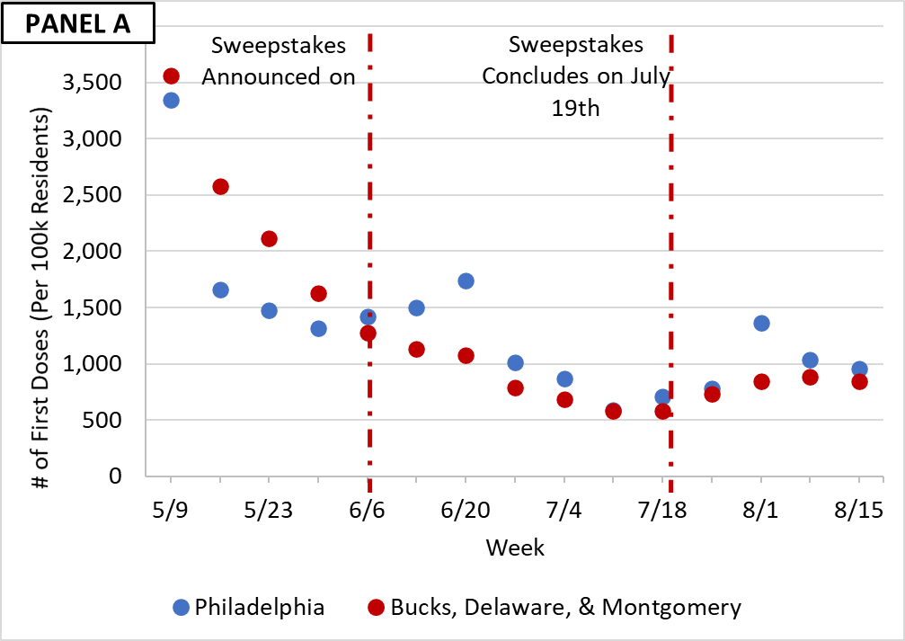 | 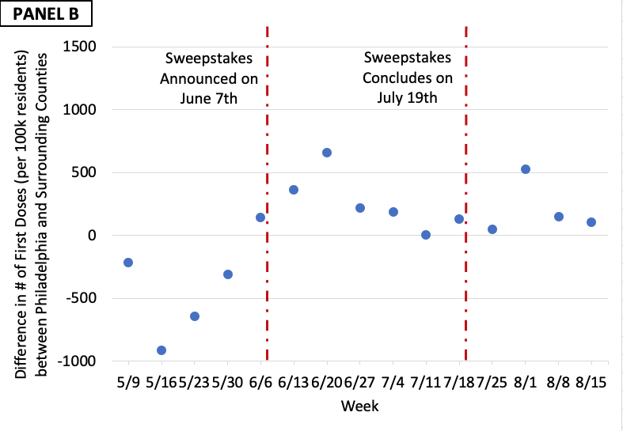
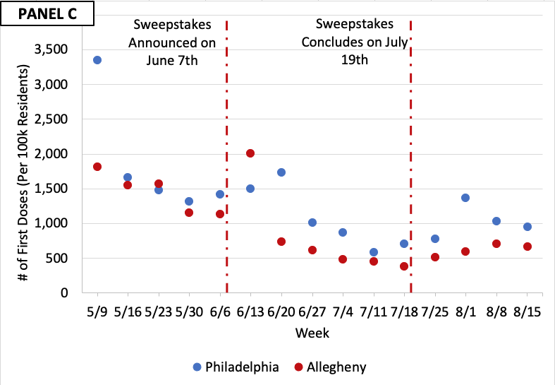 | 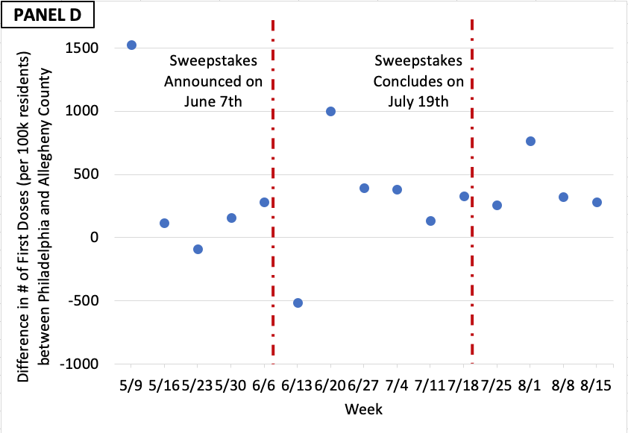
Note. Weekly data is plotted on the last day of a given week (e.g., data for the week 5/31-6/6 is plotted on 6/6).

Fig. S2. Panels on the left present weekly average first-dose vaccinations per 100,000 people for adult Philadelphia County residents versus adult residents of comparison counties (Bucks, Delaware, and Montgomery County residents pooled in Panel A, and Allegheny County residents in Panel C) using data from the Philadelphia Department of Public Health for Philadelphia and CDC data for comparison counties. Panels on the right present the difference in weekly first-dose adult vaccinations per 100,000 people between adult Philadelphia County residents and adult residents of comparison counties (Bucks, Delaware and Montgomery County residents pooled in Panel B, and Allegheny County residents in Panel D).

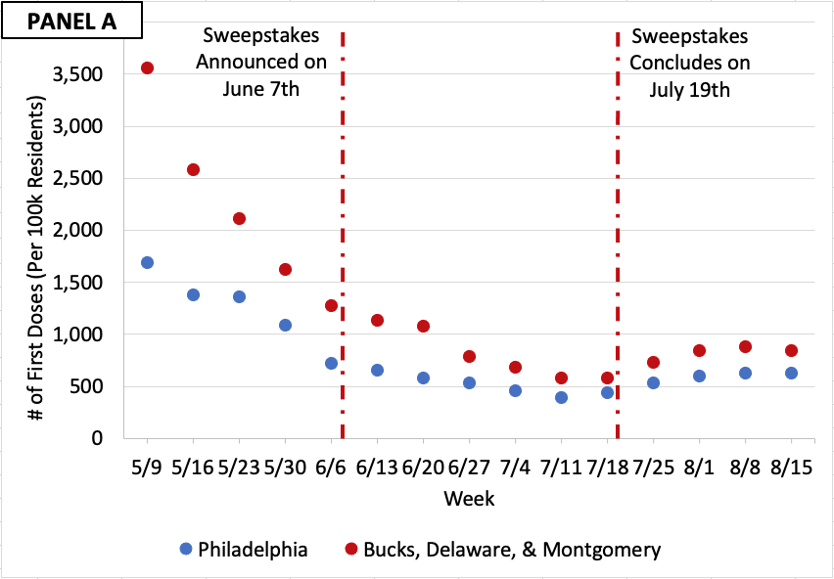 | 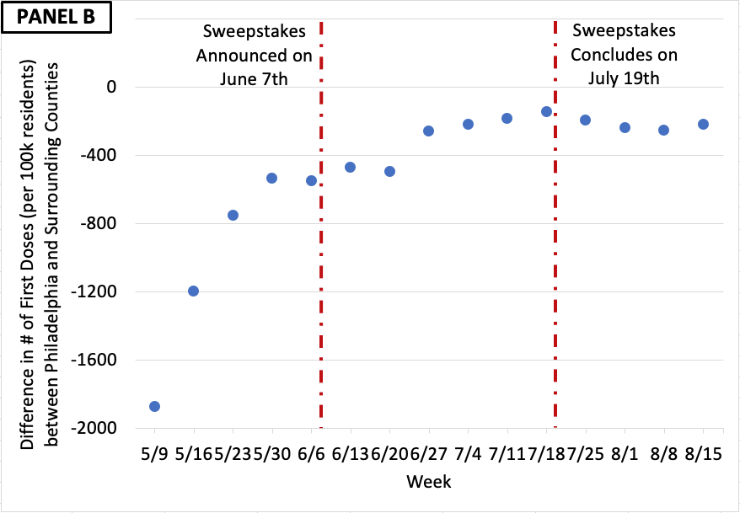
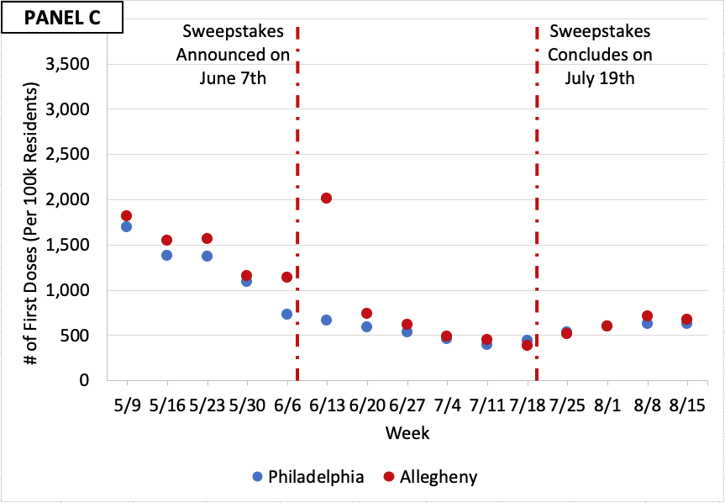 | 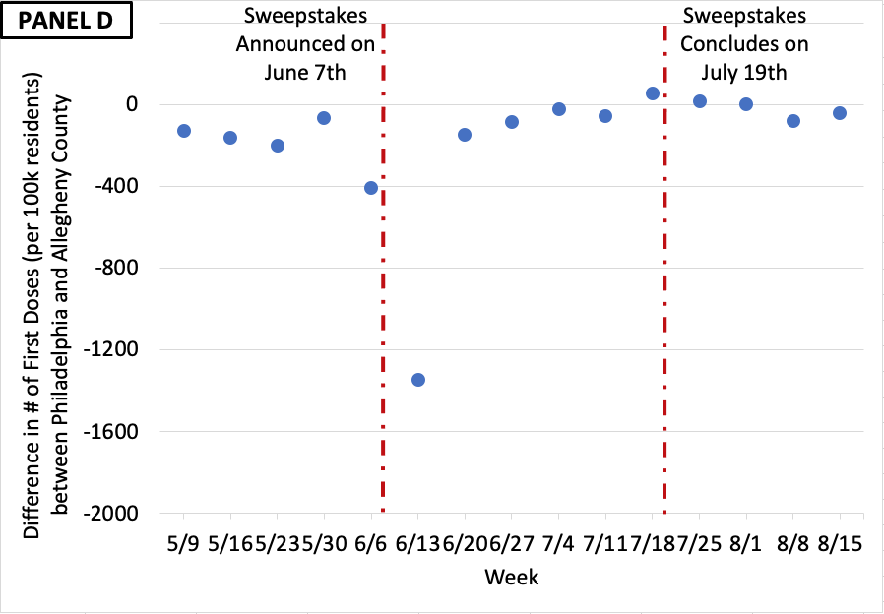
Note. Weekly data is plotted on the last day of a given week (e.g., data for the week 5/31-6/6 is plotted on 6/6).

Fig. S3. Google trends search volume for the “Philly Vax Sweepstakes” from June 1, 2021 to August 1, 2021.
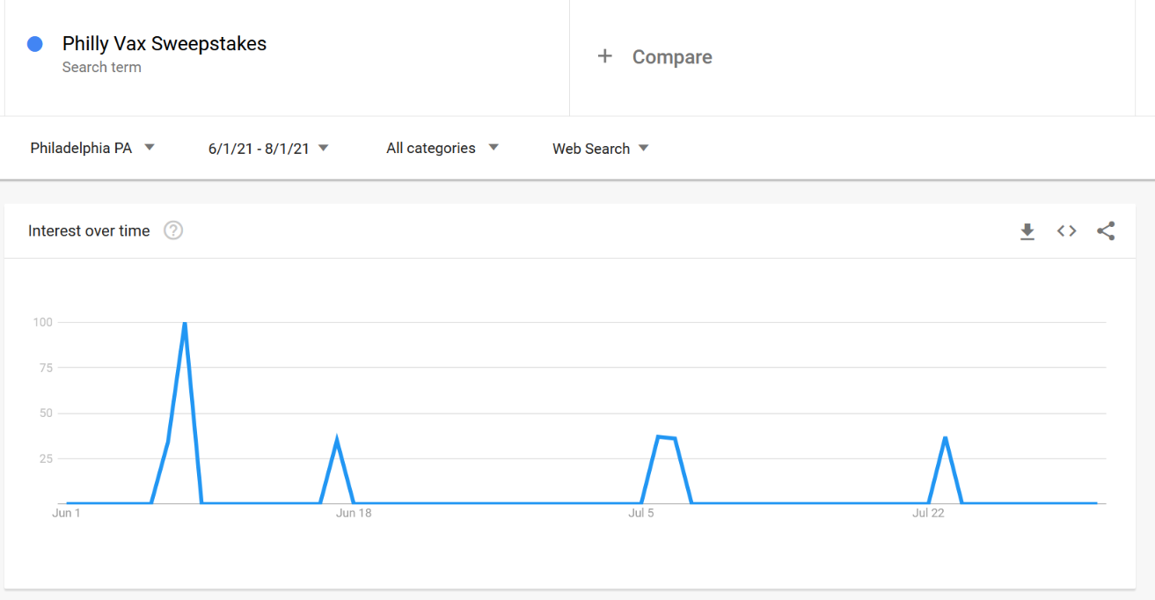

SUPPLEMENTAL TABLES

Table S1. Philly Vax Sweepstakes’ Marketing Efforts & Media Mentions

Date | Marketing Efforts & Media Mentions
6/7/2021 | · 19126 Announced as Selected Zip Code in Press Releases by The Mayor's Office & University of Pennsylvania, & an Online Press Conference
 | · Emergency Texts to 81,000 Residents by the City of Philadelphia
 | · Articles in Patch, Phillymag, Philadelphia Tribune, PhillyVoice, Telemundo62, WHYY, 95.7 Ben FM, NBC10 Philadelphia, Fox 29, CBS Philly, U.S. News, Audacy, Metro, Inquirer, MyChesCo, Pennsylvania News Today Announcing Sweepstakes
 | · Article in CBS Philly Discussing Vaccine Incentives
6/8/2021 | · Articles in BillyPenn, The Philadelphia Caller, Capital-Star, KHN, PhillyVoice, PHL17 Announcing Sweepstakes
6/9/2021 | · City of Philadelphia Nextdoor Post for all Residents of Philadelphia
 | · Articles in NBC CT, The Philadelphia Inquirer, Quartz, WHYY Discussing Vaccination Lotteries
6/10/2021 | · Article in PennToday Announcing Sweepstakes
6/11/2021 | · Articles in The Philadelphia Sun, The Morning Call Announcing Sweepstakes
6/12/2021 | · Article in India Education Diary Announcing Sweepstakes
 | · Article in Boston Globe Comparing Sweepstakes to Vax-a-Million
6/16/2021 | · Radio Interview on SiriusXM Discussing Sweepstakes & Vaccine Lotteries
 | · Article in The Daily Pennsylvanian Announcing Sweepstakes
6/17/2021 | · City of Philadelphia Nextdoor Post for all Residents of Philadelphia
6/18/2021 | · CBC Radio Episode Discussing Vaccine Incentives
6/21/2021 | · 19133 Announced as Selected Zip Code on Sweepstakes Website
 | · Articles in Fox29, NBC10 Philadelphia, WHYY Announcing First-Round Winners
 | · Article MarketWatch Discussing Vaccine Incentives & Lotteries
6/23/2021 | · Articles in Where Philly, iradiophilly Announcing First-Round Winners
6/25/2021 | · City of Philadelphia Press Conference by First Grand Prize Winner
 | · Articles in Fox29, The Philadelphia Inquirer, WHYY Philly Voice, 6ABC, CBS Philly, Patch, Fox29 Announcing First Grand Prize Winner
6/26/2021 | · Articles in MyChesCo Announcing First-Round Winners
6/28/2021 | · Articles in The Daily Pennsylvanian Announcing Sweepstakes
6/29/2021 | · Emergency Texts to 81,000 Residents by the City of Philadelphia
6/30/2021 | · Automated Calls reaching 3,796 out of 10,045 Residents of 19133 with phone numbers
7/1/2021 | · City of Philadelphia Nextdoor Post for all Residents of Philadelphia
7/2/2021 | · City of Philadelphia Nextdoor Post for Residents of 19133
7/6/2021 | · 19142 Announced as Selected Zip Code on Sweepstakes Website
 | · Coverage by CBS Philly Announcing Second-Round Winners
7/7/2021 | · City of Philadelphia Nextdoor Post for all Residents of Philadelphia
7/8/2021 | · City of Philadelphia Press Release on Second Drawing
7/9/2021 | · City of Philadelphia Nextdoor Post for Residents of 19142
7/12/2021 | · Radio Advertisements on Hip Hop 103.9 & Power 99
 | · Automated Calls reaching 7,831 out of 12,466 Residents of 19142 with phone numbers
 | · Penn Medicine Emails to all Philadelphia-based Patients
7/13/2021 | · Radio Advertisements on Hip Hop 103.9 & Power 99
 | · Coverage by CBS Philly Announcing Sweepstakes Nearing its End
7/14/2021 | · City of Philadelphia Press Release on Second Drawing Winners
 | · Radio Advertisements on Hip Hop 103.9 & Power 99
7/15/2021 | · Radio Advertisements on Hip Hop 103.9 & Power 99
 | · City of Philadelphia Press Release with Quotes from Second Grand Prize Winner
 | · Article in WHYY Announcing Second Round Winners
 | · Articles in 6ABC, WHYY Announcing Third-Round Drawing
7/16/2021 | · Radio Advertisements on Hip Hop 103.9 & Power 99
 | · Penn Medicine Text Messages to Residents who had Vaccinated in Pop-up Clinics
7/17/2021 | · Radio Advertisements on Hip Hop 103.9 & Power 99
7/18/2021 | · Radio Advertisements on Hip Hop 103.9 & Power 99
7/19/2021 | · Radio Advertisements on Hip Hop 103.9 & Power 99

Table S2. Population Summary Statistics for Philadelphia and Comparison Counties.
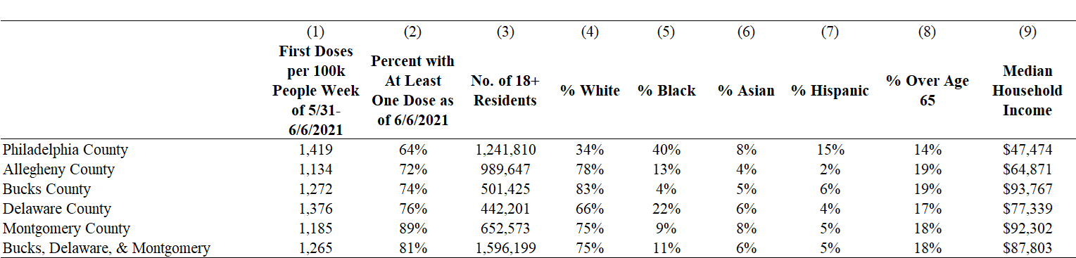
Note. In columns 1 and 2, county-level vaccination data comes from the Centers for Disease Control and Prevention (74). All county-level vaccination data pertains to the 18 and over population. Columns 3-9 and all population data come from the 2019 American Community Survey (80). Columns 4-8 reflect the percentages of each respective variable relative to the total population. Column 9 presents the median household income for each unique geography, and the average of those medians where geographies are pooled.

Table S3. Regression-estimated impact of the Philly Vax Sweepstakes on Weekly First-Dose COVID-19 Vaccinations per 100,000 People in Philadelphia County (Compared with Surrounding Counties and Allegheny County).
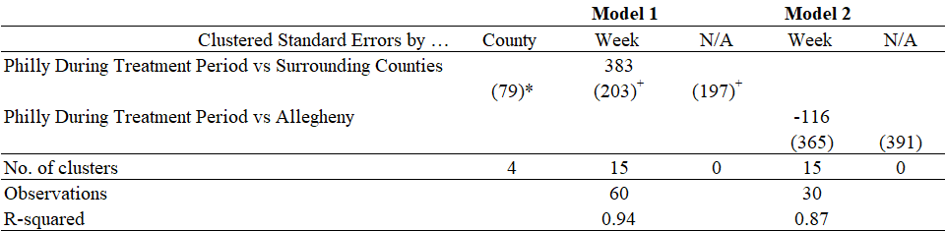
Note. This table reports difference-in-differences models relying on an ordinary least squares regression to predict a county’s weekly first-dose COVID-19 vaccinations per 100,000 adult residents. The predictor variables include county fixed effects, week fixed effects, and an indicator that takes on a value of 1 after the Philly Vax Sweepstakes was announced on June 7, 2021, until the Philly Vax Sweepstakes concluded on July 19, 2021, and 0 otherwise. Standard errors have been estimated clustered by zip code (first), clustered by week (second) and robustly without clustering (third) for all four models and are reported in parentheses. +p<0.10; *p<0.05; **p<0.01; ***p<0.001. We do not report standard errors when clustering by county for the Philadelphia and Allegheny model because there are only two clusters. Small sample cluster-robust Wald test results are not possible when clustered standard errors are normally distributed, thus a T distribution equal to the number of clusters minus one is used to form critical values and p-values. However, this is still not conservative enough to avoid over-rejection, especially when there are only two clusters

Table S4. Regression-estimated impact of the Philly Vax Sweepstakes on Weekly First-Dose COVID-19 Vaccinations per 100,000 people in Philadelphia County (Compared with Surrounding Counties and Allegheny) using Philadelphia Department of Public Health data for Philadelphia, and CDC data for control counties.
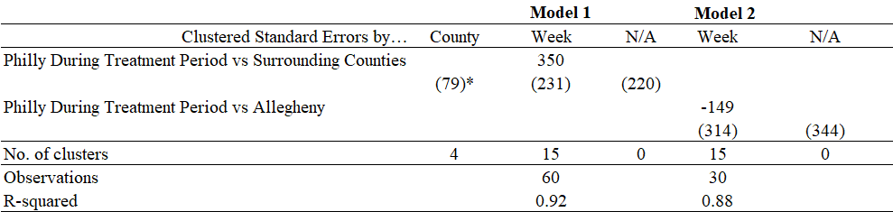
Note. This table reports difference-in-differences models relying on an ordinary least squares regression to predict a county’s weekly first dose COVID-19 vaccination rate per 100,000 adult residents. The predictor variables include county fixed effects, week fixed effects, and an indicator that takes on a value of 1 after the Philly Vax Sweepstakes was announced on June 7, 2021, until the Philly Vax Sweepstakes concluded on July 19, 2021, and 0 otherwise. Standard errors have been estimated clustered by zip code (first), clustered by week (second) and robustly without clustering (third) for all four models and are reported in parentheses. +p<0.10; *p<0.05; **p<0.01; ***p<0.001. We do not report standard errors when clustering by county for the Philadelphia and Allegheny model because there are only two clusters. Small sample cluster-robust Wald test results are not possible when clustered standard errors are normally distributed, thus a T distribution equal to the number of clusters minus one is used to form critical values and p-values. However, this is still not conservative enough to avoid over-rejection, especially when there are only two clusters

Unlike Roberto et al. (2019), we do not include Baltimore, Maryland as a comparator because Maryland launched its own statewide sweepstakes to motivate COVID-19 vaccination in May 2021.
We do not report standard errors when clustering by county for the Philadelphia and Allegheny model because there are only two clusters. Small sample cluster-robust Wald test results are not possible when clustered standard errors are normally distributed, thus a T distribution equal to the number of clusters minus one is used to form critical values and p-values. However, this is still not conservative enough to avoid over-rejection, especially when there are only two clusters (78).
We tested for violations of the parallel trends assumption inherent in each of these difference-in-difference models by adding interactions between dummies for each week and an indicator for Philadelphia to a given regression model. We then examined the significance of the coefficient estimates on the pre-treatment interaction terms and conducted an F-test of their joint significance. The coefficient on the interaction term between the week ending on 5/16 and Philadelphia is significant (p≤0.020) and the joint F-test also reveals significant differences in pre-treatment trends (p=0.010). This suggests we can reject the validity of the assumption of parallel trends leading up to the treatment of Philadelphia and that this difference-in-difference estimation should be interpreted with extreme caution in light of that violation. We could not conduct this test for the Philadelphia vs. Allegheny County analysis since the existence of only two clusters failed to yield standard errors on the interaction terms. Therefore, we rely on graphs to look for parallel trends between Philadelphia and Allegheny Counties, which unfortunately suggest a likely parallel trends violation in this data too.
For clarity, the Philadelphia Department of Health did not have equivalent data on the three surrounding counties.
We tested for violations of the parallel trends assumption inherent in each of these difference-in-difference models by adding interactions between dummies for each week and an indicator for Philadelphia to a given regression model. We then examined the significance of the coefficient estimates on the pre-treatment interaction terms and conducted an F-test of their joint significance. The coefficients on all the interaction terms between pre-treatment weeks and Philadelphia are significant (p≤0.026) and so is the joint F-test (p<0.001). This suggests we can reject the validity of the assumption of parallel trends leading up to the treatment of Philadelphia and that this difference-in-difference estimation should be interpreted with extreme caution in light of that violation. We could not conduct this test for the Philadelphia vs. Allegheny County analysis since the existence of only two clusters failed to yield standard errors on the interaction terms. Therefore, we rely on graphs to look for parallel trends between Philadelphia and Allegheny Counties, which unfortunately suggest a likely parallel trends violation in this data too.

