1 Characterization

1.1 Brunauer-Emmett-Teller (BET)
Nitrogen adsorption-desorption measurements were performed on an automatic specific surface area and porosity analyzer (ASAP 2460 3.01, Micromeritics, USA) to determine the pore structural parameters of the catalyst samples, including the BET specific surface area, total pore volume and average pore diameter. Prior to the adsorption tests, all samples were degassed under vacuum conditions at 300 °C for 7 h to remove adsorbed impurities. Nitrogen was employed as the adsorbate at a temperature of 77 K. The BET specific surface area was determined using the classic BET method.

2 Results and Discussion

2.1 Brunauer-Emmett-Teller (BET) Analysis
N₂ adsorption-desorption measurements and BET calculations were conducted on an automatic specific surface area and porosity analyzer to investigate the pore structures of 4%Ni-TS-1, 4%Ni-TS-1-1%Co, 4%Ni-TS-1-5%Co and 4%Ni-TS-1-7%Co catalysts. The adsorption-desorption isotherms of the four catalysts are shown in Figure 8, and the corresponding structural parameters in Table 2. All four catalysts exhibited hysteresis loops within the relative pressure range of 0.4 - 1.0 (P/P₀), which indicates that these Ni-based molecular sieve catalysts possess mesoporous structures^{[61,62]}. Mesoporous structures provide abundant active sites, which can effectively stabilize CH₄ and CO₂ molecules within the pore channels during the dry reforming of methane (DRM) reaction, thus significantly enhancing the catalytic activity for the DRM reaction^{[63]}.

3 tables and figures
Table 2. Structural parameters of the nickel-based catalysts
Catalyst | BET surface area  (m²·g⁻¹) | Micropore surface area (m²·g⁻¹) | External surface area (m²·g⁻¹) | Total pore volume  (cm³·g⁻¹) | Mesopore volume  (cm³·g⁻¹) | Average pore diameter  (nm)
4%Ni-TS-1 | 429.33 | 338.96 | 90.38 | 0.25 | 0.11 | 2.33
4%Ni-TS-1-1%Co | 396.91 | 368.37 | 28.54 | 0.26 | 0.10 | 2.64
4%Ni-TS-1-5%Co | 259.79 | 238.67 | 21.12 | 0.16 | 0.06 | 2.47
4%Ni-TS-1-7%Co | 423.31 | 335.39 | 87.92 | 0.27 | 0.13 | 2.55
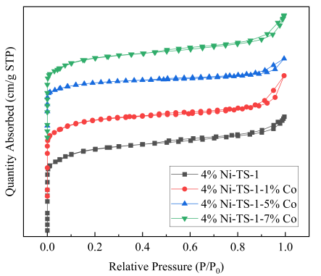
Figure 8. N₂ adsorption-desorption isotherms of the nickel-based catalysts

Reference
- Xiong J, Mei X, Liu J, et al (2019) Efficiently multifunctional catalysts of 3D ordered mesomacroporous Ce_{0.3}Zr_{0.7}O₂-supported PdAu@CeO₂ core-shell nanoparticles for soot oxidation: Synergetic effect of Pd-Au-CeO₂ ternary components. Appl Catal B Environ, 251: 247-260.
- Xiong J, Wu Q, Mei X, et al (2018) Fabrication of Spinel-Type Pd_{x}Co_{3-x}O₄ Binary Active Sites on 3D Ordered Meso-macroporous Ce-Zr-O₂ with Enhanced Activity for Catalytic Soot Oxidation. ACS Catal, 8: 7915-7930
- Al-Fatesh A S, Ibrahim A A, Fakeeha A H, et al (2024) Ni-Based Molecular Sieves Nanomaterials for Dry Methane Reforming: Role of Porous Structure and Active Sites Distribution on Hydrogen Production. Nanomaterials, 14: 1320-1320.

