APPENDIX B – Supplementary data
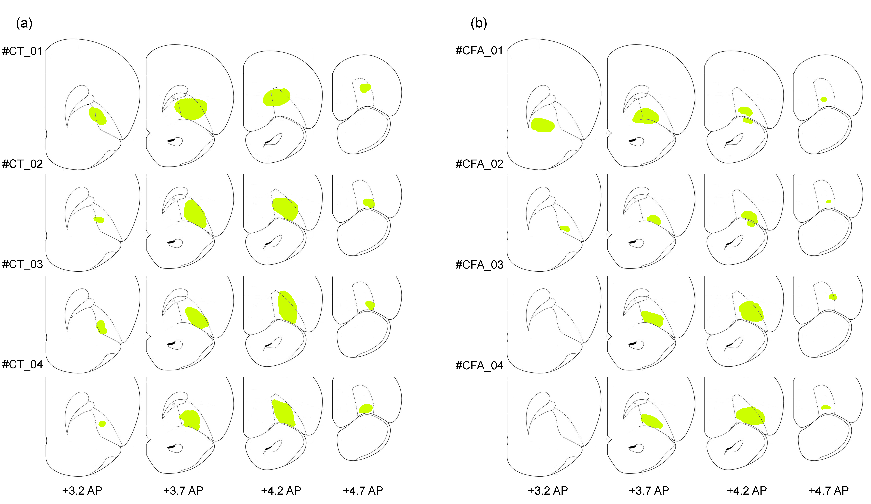
FIGURE S1. – Extent of GCaMP8f transfection area in the lateral orbitofrontal cortex (lOFC). (a) Representative reconstruction of the transfected area in saline-treated rats (control; n=4). (b) Representative reconstruction of the transfected area in CFA-treated rats (n=4). Each row of coronal sections corresponds to an individual animal, illustrating the rostrocaudal distribution of viral expression within the lOFC. Anterior-posterior (AP) coordinates are indicated relate to bregma.

