Appendix A. Relevant Theory
Authors | Factors | Theory | Description
Barabadi, Barabady, and Markeset 2011; Besnard and Patriksson 2011 | Risk escalation; degradation; failure probability | Reliability / Maintenance Optimization | Assets deteriorate over time, leading to increasing failure risk and maintenance cost if intervention is delayed. Maintenance decisions are driven by risk mitigation and system reliability rather than economic optimization/ opportunistic maintenance planning frameworks
Vatn 1997; Dehua et al. 2022 | Inspection timing; risk exposure | Risk-Based Maintenance (RBM) | Maintenance prioritization is based on risk levels derived from probability–consequence assessments, emphasizing safety and technical integrity over profitability.
Ahn, Kim, and Lee 2019 | Heterogeneous intervention duration and outcomes | Heterogeneous Asset Management Theory | Assets within the same system exhibit heterogeneous maintenance needs, durations, and performance impacts, necessitating differentiated intervention strategies rather than uniform policies.
Aladeitan et al. 2019; Guedes and Santos 2016 | Selective maintenance; opportunity loss | Selective Maintenance Theory | Under resource constraints, not all assets should be serviced; optimal decisions require selecting a subset of interventions that maximize system-level performance or value.
Feillet, Dejax, and Gendreau 2005; Archetti and Speranza 2014; Vansteenwegen, Souffriau, and Van Oudheusden 2011 | Selective visitation; resource constraints | Profit-Based Routing / Orienteering Theory | Routing decisions are guided by economic rewards, allowing selective visitation of nodes under limited resources, forming the basis for value-driven intervention selection.
Ichoua, Gendreau, and Potvin 2003; Campbell and Savelsbergh 2004 | Time-dependent costs; travel time variability | Time-Dependent Routing Theory | Travel times, costs, or rewards vary over time, requiring routing decisions to account for temporal dynamics rather than static parameters.
Gunawan, Lau, and Vansteenwegen 2016; Dada et al. 2021 | Dynamic rewards; economic timing | Time-Dependent Reward Optimization | The value of servicing a node change over time, implying that the timing of intervention directly affects realized economic benefit.
Fagerholt and Lindstad 2000; Halvorsen-Weare and Fagerholt 2013 | Vessel availability; logistics constraints | Maritime Logistics Planning Theory | Offshore operations are constrained by limited vessels, travel distances, and weather exposure, making routing and scheduling central to feasibility and cost efficiency.
Fernández-Cuesta et al. 2017 | Multi-vessel routing; offshore logistics | Fleet Routing and Scheduling Theory | Multiple vessels must be coordinated to service spatially distributed offshore assets, introducing fleet-level interactions and scheduling complexity.
Bridge and Bradshaw 2017 | Aging assets; declining production | Mature Asset Lifecycle Theory | Mature production systems experience declining output and rising intervention costs, shifting decision-making from growth optimization to value preservation.
Dixit and Pindyck 1994; Guedes and Santos 2016 | Economic prioritization vs technical urgency | Economic Priority Theory | Technical urgency does not necessarily align with economic optimality; intervention decisions must balance risk mitigation against value creation.
Gongcheng et al. 2019; Goodman 2023 | Heuristic decision-making; transparency | Heuristic Optimization Theory | In NP-hard, large-scale systems, heuristics provide scalable and interpretable solutions that support practical decision-making under uncertainty.
De Lima, Gomes, and Leoneti 2022; López-Santana, Méndez, and Franco 2023 | Integrated routing and maintenance | Integrated Operations–Maintenance Theory | Operational routing and maintenance decisions should be jointly optimized to avoid suboptimal outcomes caused by sequential or decoupled planning.

Appendix B. Relevant Research
Authors | Topics | Country / Context | Research Methods
Feillet, Dejax, and Gendreau 2005 | Profit-based routing; Orienteering problem | Generic | Formal mathematical formulation of OP/VRPP; exact optimization with branch-and-bound; computational experiments
Vansteenwegen, Souffriau, and Van Oudheusden 2011 | Selective routing with profits | Generic | Comprehensive literature survey; taxonomy of models; comparative analysis of solution approaches
Archetti and Speranza 2014 | Vehicle routing problems with profits | Generic | Systematic review of VRPP variants; complexity analysis; methodological synthesis
Ichoua, Gendreau, and Potvin 2003 | Time-dependent vehicle routing | Generic | Dynamic travel-time modelling; time-dependent cost functions; heuristic solution procedures
Campbell and Savelsbergh 2004 | Dynamic routing and decision support | Generic | Decision-support framework; dynamic optimization; computational testing
Gunawan, Lau, and Vansteenwegen 2016 | Time-dependent rewards and costs | Generic | Mathematical modelling of dynamic rewards; heuristic/metaheuristic algorithms; scenario-based evaluation
Fernández-Cuesta et al. 2017 | Offshore supply vessel routing | Generic (offshore logistics) | MILP formulation; decomposition; heuristic extensions for large-scale offshore logistics
Halvorsen-Weare and Fagerholt 2013 | Offshore maintenance vessel scheduling | Norway | Heuristic scheduling algorithms; rolling-horizon planning; case-based computational study
Christiansen et al. 2013 | Maritime logistics and routing | Norway | Optimization modelling of maritime routing; cost minimization under operational constraints
Besnard and Bertling 2010 | Maintenance optimization & decision support | Generic | Conceptual framework; optimization-based maintenance planning; decision-support analysis
Vatn 1997 | Risk-based maintenance planning | Generic | Probabilistic risk modelling; maintenance policy optimization; analytical evaluation
Barabadi, Barabady, and Markeset 2011 | Reliability and degradation modelling | Norway | Stochastic degradation processes; probabilistic reliability analysis; maintenance optimization
Ahn, Kim, and Lee 2019 | Heterogeneous maintenance activities | Generic | Empirical data analysis; statistical modelling of heterogeneous maintenance effects
Aladeitan et al. 2019 | Selective maintenance decisions | Generic | Optimization-based maintenance selection; cost–benefit evaluation
Alirahmi et al. 2023 | Maintenance scheduling under constraints | Generic | Mathematical programming; constraint-based scheduling; numerical experiments
Dixit and Pindyck 1994 | Economic prioritization of maintenance | Generic | Conceptual–economic analysis; comparative evaluation of prioritization strategies
Dekker 1996 | Maintenance optimization policies | Generic | Optimization modelling; policy comparison through computational experiments
Coutinho et al. 2024 | Offshore maintenance planning | Generic | Optimization-based planning framework; scenario analysis
De Lima, Gomes, and Leoneti 2022 | Offshore logistics and maintenance | Brazil | Heuristic/metaheuristic routing and scheduling; offshore case application
Dehua et al. 2022 | Risk-based inspection planning | Generic | Probabilistic inspection modelling; optimization under uncertainty
Dawoud 2021 | Maintenance planning under uncertainty | Generic | Stochastic optimization; uncertainty modelling; numerical validation
El-Abbasy et al. 2014 | Offshore project & maintenance planning | Generic | Simulation-based planning; optimization of offshore project schedules
Elgabiri et al. 2021 | Offshore maintenance logistics | Generic | Heuristic routing and scheduling; operational case analysis
Eyni, Stanko, and Schümann 2022 | Risk-based maintenance prioritization | Iran | Fuzzy multi-criteria decision-making; risk scoring and ranking
Fan et al. 2015 | Offshore operations planning | Generic | Simulation integrated with optimization; operational scenario analysis
Goodman 2023 | Transparent heuristic decision-making / interpretable heuristics | Generic | Decision-support framework; interpretable/transparent heuristic design; computational evaluation
Dada et al. 2021 | Dynamic routing with endogenous value | Generic | Mathematical modelling of endogenous rewards; heuristic solution methods
Cruz et al. 2023 | Profit-based routing under uncertainty | Generic | Heuristic/metaheuristic optimization; uncertainty modelling
Emmanuel 2024 | Offshore system operations planning | Generic | Optimization modelling; system-level planning analysis
Bridge and Bradshaw 2017 | Aging offshore assets & economics | Global | Policy/economic analysis; conceptual discussion;
Olajire 2017 | Offshore oil & gas maintenance | Generic | Narrative literature review; synthesis of maintenance practices
Selvik, Abrahamsen, and Engemann 2020 | Maintenance terminology & concepts | Norway | Conceptual analysis; taxonomy and definitions review
López-Santana, Méndez, and Franco 2023 | Integrated maintenance–routing optimization | Generic | Integrated optimization formulation; computational experiments
Su et al. 2023 | Predictive maintenance offshore systems | Taiwan | Fuzzy optimization; predictive maintenance modelling

Appendix C. Research data well-level maintenance duration (days) by platform and cluster
Node | Platform Name | Cluster | Maintenance Days per Well
Node | Platform Name | Cluster | Well 1 | Well 2 | Well 3 | Well 4 | Well 5 | Well 6 | Well 7 | Well 8 | Well 9 | Well 10 | Well 11 | Well 12 | Well 13
1 | MWEPS | North | 18 | 2 | 17 | - | - | - | - | - | - | - | - | - | -
2 | WEPN2 | North | 6 | 6 | 4 | 5 | 3 | 12 | 5 | - | - | - | - | - | -
3 | WEPN3 | North | 1 | 3 | 3 | 6 | 5 | - | - | - | - | - | - | - | -
4 | WEPN4 | North | 6 | 6 | - | - | - | - | - | - | - | - | - | - | -
5 | WEPS2 | North | 4 | 3 | 3 | 3 | 8 | 2 | - | - | - | - | - | - | -
6 | WEPS3 | North | 18 | 18 | 6 | 2 | - | - | - | - | - | - | - | - | -
7 | BEL | Central-North | 8 | 8 | 8 | 3 | 3 | 29 | 4 | 4 | - | - | - | - | -
8 | BEG | Central-North | 15 | 13 | 5 | 5 | 15 | 15 | 4 | 5 | 7 | 5 | 5 | 15 | 15
9 | MWEPA | Central-South | 5 | 5 | 4 | 4 | 4 | - | - | - | - | - | - | - | -
10 | MWEPB | Central-South | 4 | 4 | 7 | 12 | 3 | 4 | 4 | 4 | 4 | - | - | - | -
11 | MWEPC | Central-South | 14 | 11 | 11 | 11 | 3 | 3 | 6 | - | - | - | - | - | -
12 | SWEPF | Central-South | 7 | 7 | 7 | 7 | 7 | 7 | 14 | - | - | - | - | - | -
13 | SWEPJ | Central-South | 7 | 7 | 4 | 4 | 4 | 4 | 4 | 6 | 14 | - | - | - | -
14 | SWEPE | Central-South | 7 | 7 | 7 | 7 | 7 | 7 | 4 | - | - | - | - | - | -
15 | SWEPG | Central-South | 4 | 4 | 4 | - | - | - | - | - | - | - | - | - | -
16 | SWEPK | Central-South | 5 | 5 | 6 | 4 | 7 | 14 | - | - | - | - | - | - | -
17 | SPE2 | South | 6 | 6 | - | - | - | - | - | - | - | - | - | - | -
18 | SPE1 | South | 6 | 6 | - | - | - | - | - | - | - | - | - | - | -
19 | MDE1 | South | 4 | 4 | 3 | 3 | 3 | 4 | 4 | 2 | - | - | - | - | -
20 | JEM1 | South | 9 | 9 | 9 | 9 | 6 | 8 | 4 | 7 | - | - | - | - | -
21 | JMEL1 | South | 9 | 8 | 11 | - | - | - | - | - | - | - | - | - | -

Appendix D. Routing outcomes of intervention planning scenario 2 and 3
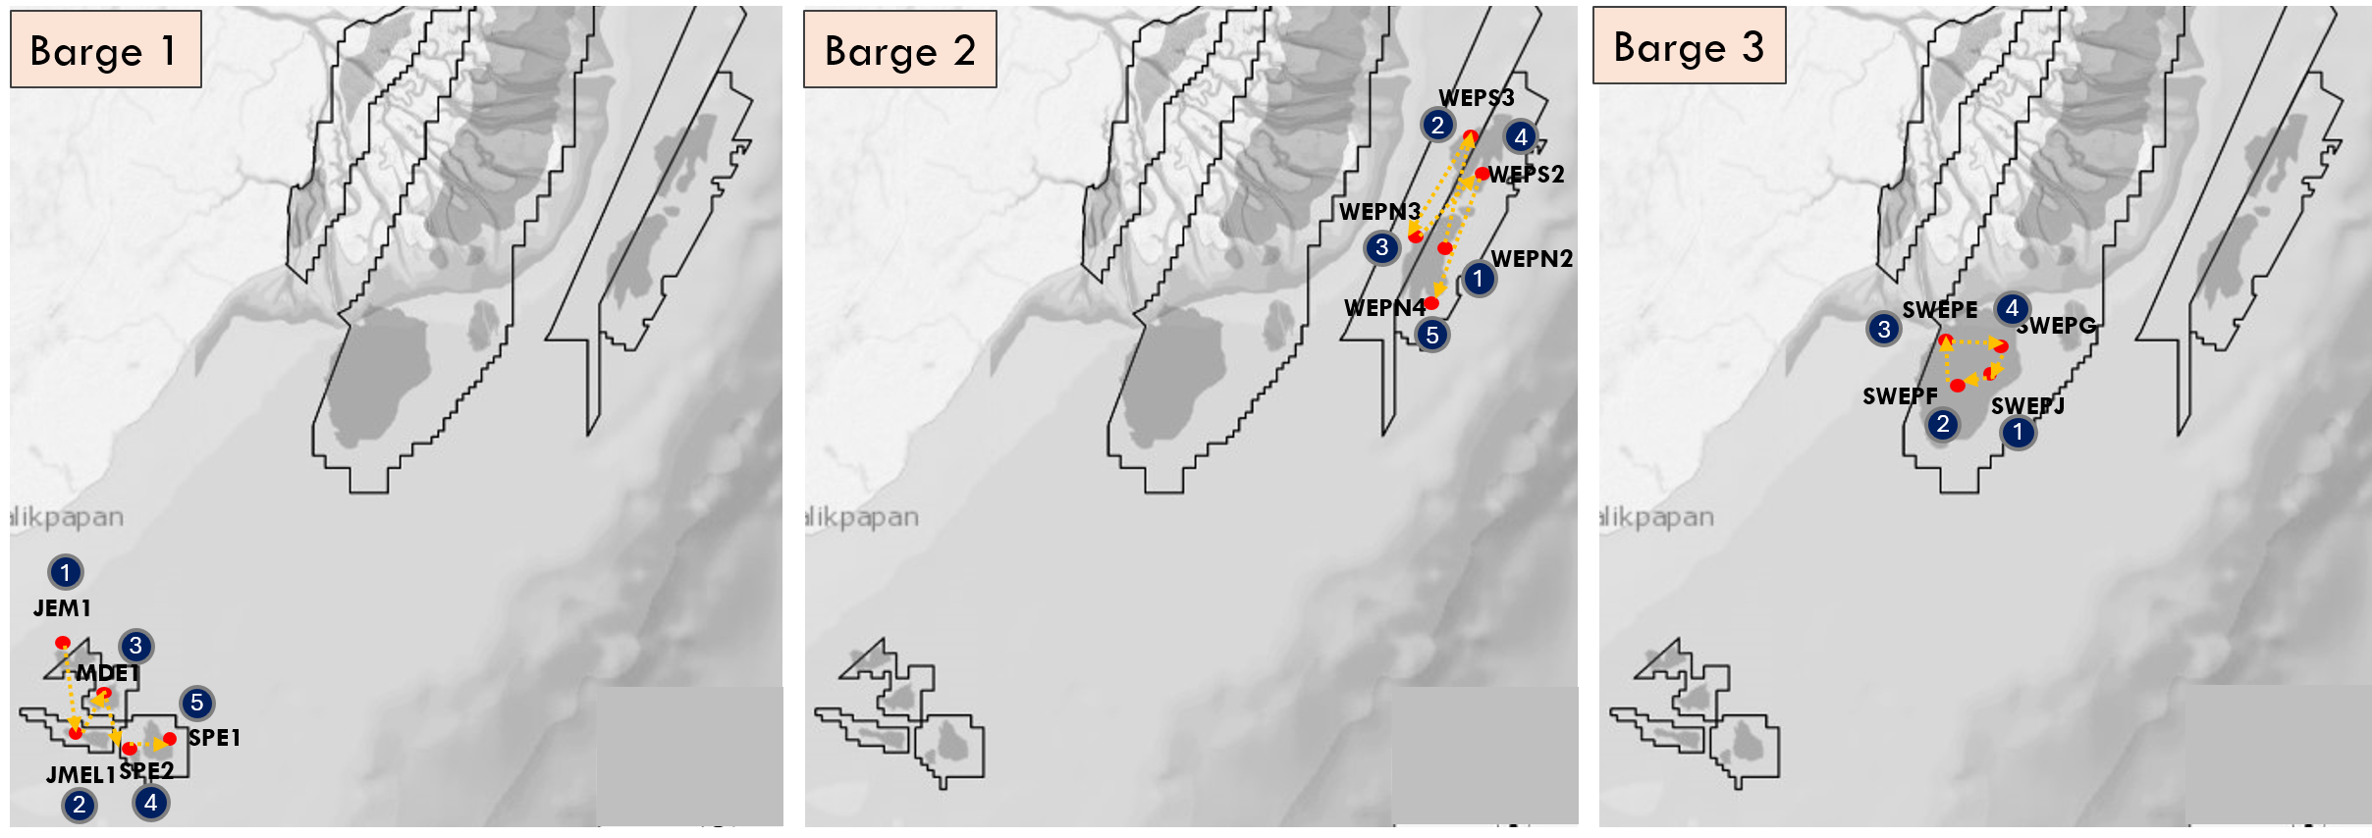
Figure D1. Routing outcome for Case 2. Numbers denote the sequence of barge visits, red dots indicate offshore platform locations, and yellow arrows represent barge sailing routes.
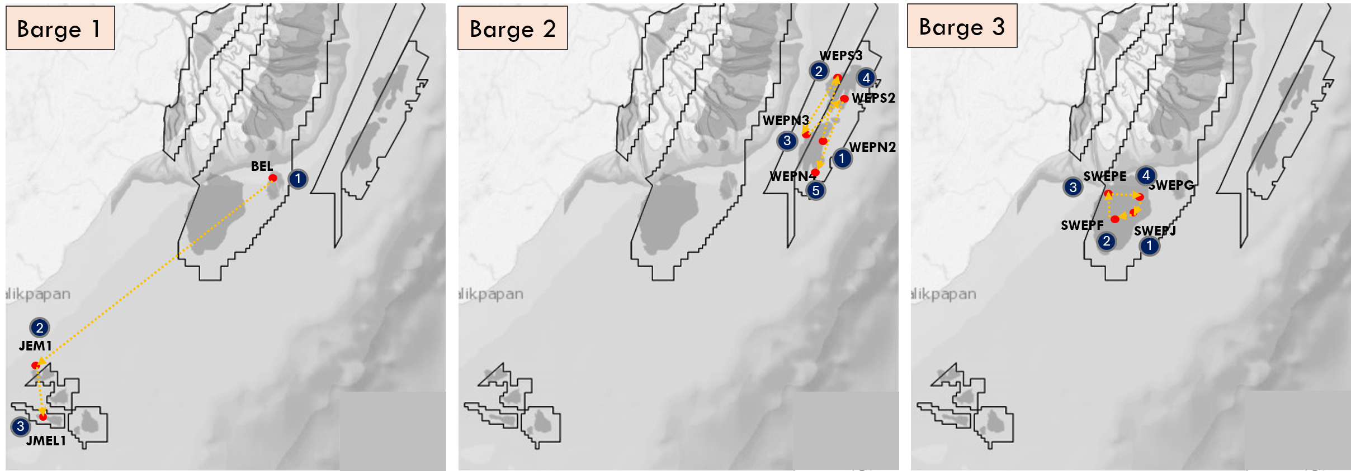
Figure D2. Routing outcome for Case 3. Numbers denote the sequence of barge visits, red dots indicate offshore platform locations, and yellow arrows represent barge sailing routes.
Appendix E. Economic Parameters and Price Assumption

Table E1. Monthly oil price deck used in the analysis
Month | Days | Oil Price (\bar P_m) (USD/bbl)
1 | 1–30 | 120
2 | 31–60 | 80
3 | 61–90 | 140
4 | 91–120 | 65
5 | 121–150 | 70
6 | 151–180 | 95

Table E2. Summary statistics of oil uplift and decline parameters (non-zero wells)
Parameters used in Eqs. (2) and Appendix G, Eqs. (G1)-(G2); statistics computed over wells with non-zero oil gain.

Parameter | Unit | (N) | Min | P25 | Median | P75 | Max | Mean | Std
qij,1 | bbl/day | 20 | 50.00 | 68.75 | 90.00 | 111.25 | 150.00 | 91.50 | 29.47
dij​ | – | 20 | 0.993805 | 0.994784 | 0.995453 | 0.995817 | 0.996612 | 0.995262 | 0.000859
gij,1​ | MMSCF/day | 64 | 0.8 | 1.5 | 2.5 | 3.5 | 15.0 | 3.14 | 2.61
dijgas​ | - | 64 | 0.992921 | 0.997219 | 0.998145 | 0.999089 | 1.000247 | 0.998214 | 0.00134

Notes: $g_{ij,1}$is the initial post-intervention gas gain per well; $d_{ij}^{gas}$is the daily exponential gas decline factor, Values slightly above 1 arise from history-matched noise and are capped at 1.0 in the revenue calculation.

Table E3. Sediment washing escalation parameters
Escalation applied to wells requiring sediment washing (Eq. (3)). Derivation of $α_{ij}$(USD/day) from $ρ$and $S_{ij}$
Parameter | Unit | Description | Value
ρ | 1/day | Daily risk cost escalation rate | 0.02
Sij​ | – | Sediment washing severity index | Min 3, Median 6, Max 10
Affected wells | % | Wells with (S_{ij}>0) | 4.0%

Appendix F. Schematic of offshore platform typology
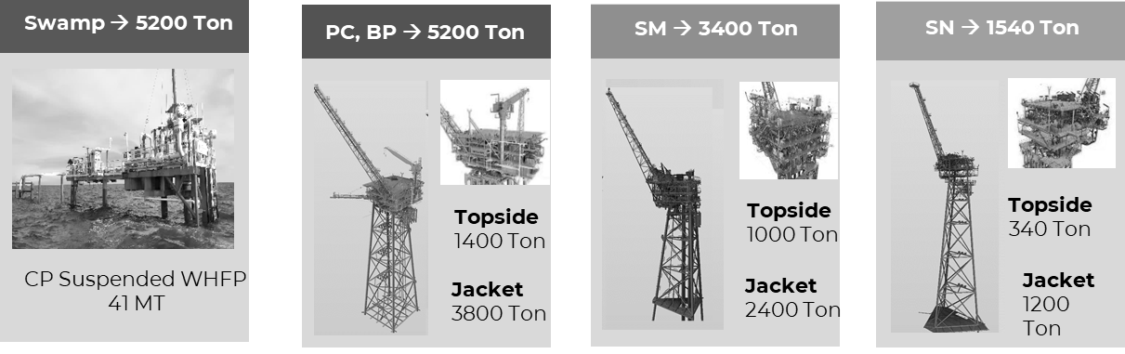
Figure F1. Schematic of offshore platform typology in MHK offshore field (modified from (Chakrabarti 2005))
Appendix G. Formulation of production decline, cost escalation, and opportunity loss
This appendix presents the mathematical foundations that support the revenue–cost evaluation framework applied in offshore production engineering, maintenance economics, and selective routing theory.
G.1 Post-Intervention Production Decline
Post-intervention oil and gas production for each well is modeled using exponential decline, consistent with classical decline curve analysis for mature offshore fields (Arps 1945; Fetkovich 1980). For well j on platform i, production at discrete time h after intervention is:
$$\begin{matrix} & q_{ij}^{o}(h)=q_{ij,1}^{o} (d_{ij}^{o})^{h-1} & & \text{Eq. }\text{(G1)}\end{matrix} \\ \begin{matrix} & q_{ij}^{g}(h)=q_{ij,1}^{g} (d_{ij}^{g})^{h-1} & & \text{Eq. }\text{(G2)}\end{matrix}$$This structure captures timing-driven revenue erosion: when intervention is delayed, the effective production window shortens and cumulative recoverable production decreases, even when technical feasibility is preserved.
G.2 Timing-dependent cost escalation
Deferred intervention cost escalation is represented through a time-accumulating risk component, consistent with reliability-centered and risk-based maintenance models. Total intervention cost for well $j$ on platform $i$ executed at time $t_{i}$is:
$$\begin{matrix} & C_{ij}(t_{i})=C_{ij}^{\text{base}}+α_{ij} t_{i} & & \text{Eq. }\text{(G3)}\end{matrix}$$The linear form provides a first-order approximation over moderate delay horizons; escalation parameters are summarized in Appendix E (Table E3) and used as a first-order approximation over a 180-day horizon. Nonlinear escalation can be incorporated as a robust extension.
G.3 Earliest-start benchmark
The earliest-start benchmark $t_{i}^{0}$represents a platform-specific lower bound computed using identical travel and service primitives as the routing model, excluding fleet interaction and queuing effects. It is used as a counterfactual reference in the definition of opportunity loss (Eq. (4)).

