Step 1:
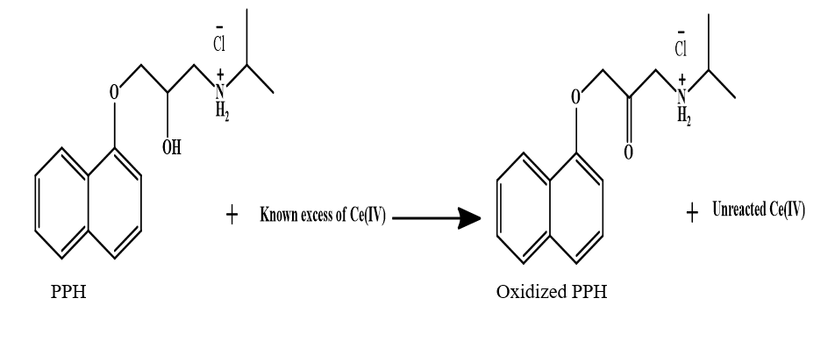

Step 2:
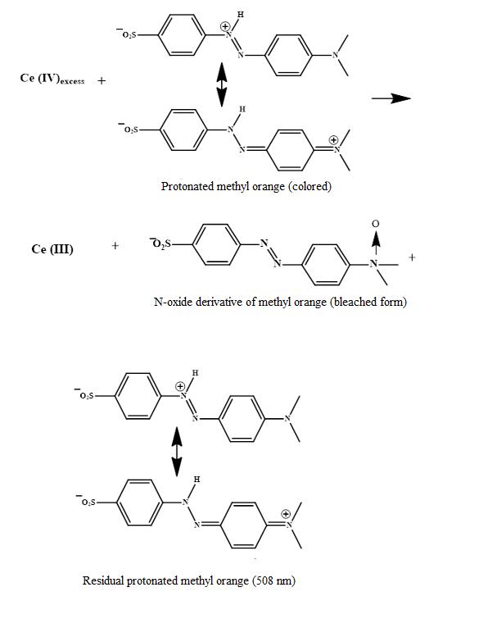

Scheme 1. Proposed reaction mechanism for the oxidation of propranolol hydrochloride (PPH) by ceric ammonium sulfate (CAS) and subsequent bleaching of methyl orange (MO) where Ce(IV) converted to Ce(III) and amine oxidized bleach was formed.

