Sequential Fenton reaction and biodegradation for treating decabromodiphenyl ether in soil slurries

Cheng-Chun Lin, Chun-Wen Yang, Po-Hsin Yuan and Yi-Tang Chang *

Supplementary information A

Department of Microbiology
Soochow University
70, Linhsi Rd., Shinlin District
Taipei, 11102
Taiwan

*Corresponding author:
Distinguished Professor
Tel: +886-2-28819471-6862
FAX: +886-2-28831193
E-mail: ytchang@scu.edu.tw; timchang08@gmail.com

Table S1. Parameters of TCS measured during the experimental period

Composition (%) |  |  | pH | BET-(N2)  SA (m² g⁻¹) | SOM (%) | CEC (meq/100 g)
Sand | Slit | Clay
10 | 54 | 36 | 8.03 | 5.21 | 1.883 | 1.37

Table S2. Composition of iron oxides in TCS
Free iron oxides (mg g⁻¹) | Amorphous iron oxides (mg g⁻¹) | Crystalline iron oxides (mg g⁻¹)¹
5.84 | 2.59 | 3.25

¹Crystalline iron oxides = Free iron oxides − Amorphous iron oxides is satisfied (Sun et al., 2024). Therefore, the following analysis focuses on free iron oxides and amorphous iron oxides.

Experimental procedure for analyzing free and amorphous iron oxides in soil
The method for analyzing free iron oxides in soil involves weighing 2.0 g of soil, adding 100 mL of 0.2 M acidic oxalic acid–ammonium oxalate solution, and shaking the mixture in the dark for 4 h. Subsequently, a few drops of 0.4% Superfloc® are added, the suspension is vigorously shaken for 10 s, allowed to stand for 30 min, centrifuged at 1164 × g for 15 min, and the resulting supernatant is filtered through Whatman No. 42 filter paper before being analyzed by atomic absorption spectrometry.
The method for analyzing amorphous iron oxides in soil involves accurately weighing 1.0 g of soil, adding 40 mL of 0.3 M sodium citrate solution and 5 mL of 1 M sodium bicarbonate solution, and then placing the mixture in an 80°C water bath for approximately 15–20 min. Subsequently, 1 g of sodium dithionite is added and stirred for approximately 15 min, followed by the addition of 10 mL of saturated sodium chloride solution, centrifugation at 3,500 ×g for 15 min, and collection of the suspension, with these steps repeated until the soil turns gray. Finally, the suspension is diluted to 100 mL and analyzed using atomic absorption spectrometry at 372 nm.

References:
Sun, Z., Liu, S., Jiang, Y., 2024. Iron composition of a typical Loess-Paleosol sequence in Northeast China. Agronomy, 14, 1333. https://doi.org/10.3390/agronomy14061333

Table S3. Removal rate of BDE‐209 following the Fenton reaction
Sample | Initial BDE‐209 (mg kg⁻¹) | Final BDE‐209 (mg kg⁻¹)
Blank | 20.21±0.86 | 19.16 ± 0.00
Fenton processed | 20.21±0.86 | 11.32 ± 1.52

Table S4. Design of a single carbon source for the MT2 microplate

A1  MSB | A2  BDE‐99 | A3  3′‐OH‐BDE‐7
B1  Hexane (negative control) | B2  BDE‐100 | B3  3′‐OH‐BDE‐28
C1  Glucose (positive control) | C2  BDE‐153 | C3  3′‐OH‐BDE‐47
D1  Biphenyl ether | D2  BDE‐154 | D3  6‐OH‐BDE‐180
E1  BDE‐3 | E2  BDE‐209 | E3  2′‐MeO‐BDE‐3
F1  BDE‐28 | F2  5Br mix¹ | F3  3′‐MeO‐BDE‐7
G1  BDE‐47 | G2  PBDE mix² | G3  3′‐MeO‐BDE‐28
H1  BDE‐66 | H2  2′‐OH‐BDE‐3 | H3  3′‐MeO‐BDE‐47
¹BDE‐47, BDE‐99, BDE‐100, BDE‐85, and BDE‐119 30 ppm each
²BDE‐3, BDE‐28, BDE‐47, BDE‐66, BDE‐99, BDE‐100, BDE‐153, BDE‐154, and BDE‐209 30 ppm each.

Table S5. Colony and microscopic characteristics of isolated strains in the FB group (scale bar = 10 μm)

Strain no. | Colony characteristics |  |  |  |  |  |  | Microscopy
Strain no. | Graph | Shape | Size (mm) | Surface | Pigment | Margin | Transparency | Graph | Gram stain | Shape
B2 |  | Oval | 2.0 | Rough | White | Undulate | Slightly translucent | 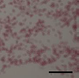 | G− | Rod
P5 |  | Circular | 1.0 | Smooth | Yellow | Smooth | Opaque | 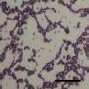 | G+ | Rod
D1 |  | Oval | 2.0 | Smooth | White | Undulate | Slightly translucent | 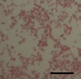 | G− | Cocci
D2 |  | Circular | 2.0 | Smooth | Beige | Smooth | Opaque | 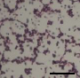 | G+ | Rod
D3 |  | Circular | 2.0 | Smooth | White | Smooth | Opaque | 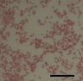 | G− | Short rod

D4 |  | Oval | 3.0 | Smooth | White | Undulate | Slightly translucent | 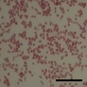 | G− | Cocci
D5 |  | Circular | 1.0 | Smooth | White | Smooth | Opaque | 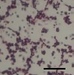 | G+ | Cocci
D6 |  | Circular | 3.0 | Smooth | White | Smooth | Opaque | 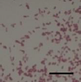 | G− | Rod
D7 |  | Circular | 1.0 | Smooth | Yellow | Smooth | Opaque | 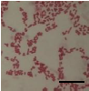 | G− | Rod
D8 |  | Circular | 1.0 | Smooth | Beige | Smooth | Opaque | 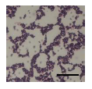 | G+ | Cocci
Table S3. Colony and microscopic characteristics of isolated strains in the FB group. (Continued)

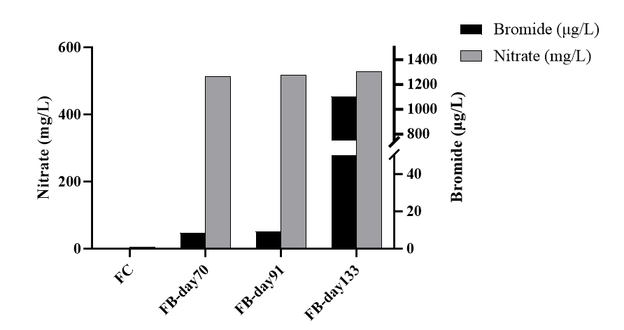
Fig. S1. Analysis of ion concentrations (Br⁻, NO₃⁻) following sequential Fenton oxidation and biodegradation.

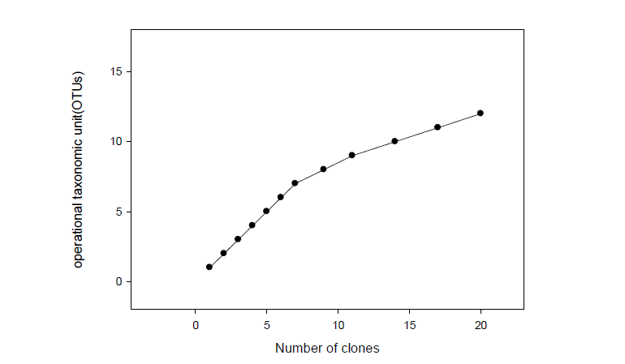
Fig. S2. Number of clones and operational taxonomic units (OTUs) in the Da‐an chemostat.

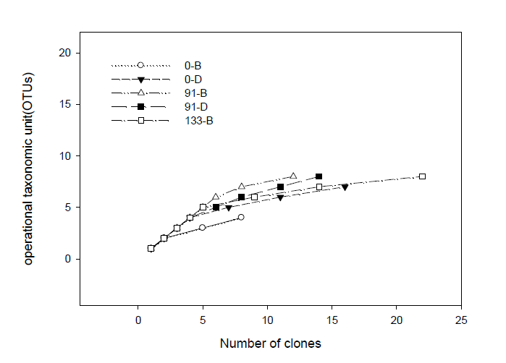
Fig. S3. Number of clones and operational taxonomic units (OTUs) in the FB and D11 groups (the first number in the legend indicates degradation time; “B” in the legend represents the FB group; “D” in the legend represents the D11 group).

