Determinants of pre-implantological augmentation procedures – a case vignette study in the severely atrophic single- or multiple-tooth gap

Case 1

- This is a male patient. Age 52 years/76 years. Tooth 36 is already missing for one year.
- General anamnesis: No systemic diseases. Currently not in medical treatment/endocarditis prophylaxis required due to artificial heart valves.
- Special anamnesis: The patient is a non-smoker and is critical about the procedure.
- Clinical findings: Gap 36 narrowed, gap width 7 mm.
- Radiographic findings (CBCT): narrow jaw region 36, sufficient bone height
- Referrer’s request: - The referring dentist wishes to place a single crown on an implant to replace tooth 36.

CBCT

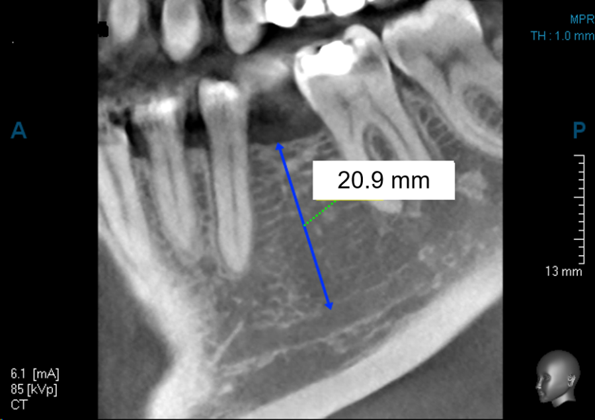

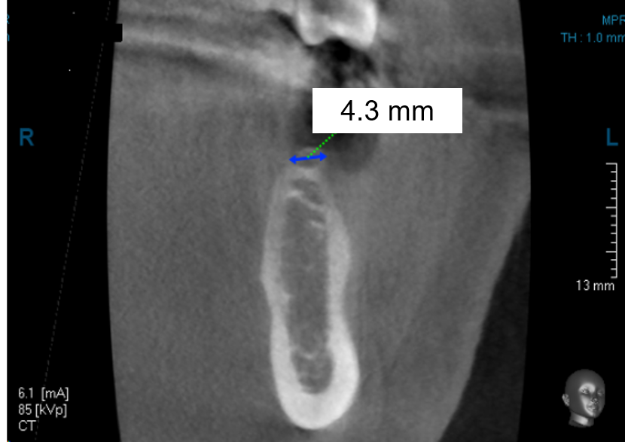

Please analyze the records. How would you proceed surgically in this case?  Yes: This option represents the therapy of my choice (please tick yes only once).  Not at all: This therapy is not possible  Possibly: I am considering this option. I will decide during surgery. You can select "Possibly" more than once. | Yes | Not at all | Possibly
Bone Split
Bone block
Augmentation with bone substitute material
Resection
No therapy
Other | ------------------------------------------------------------------

Case 2

- This is a female patient. She is 57 years old.
- General anamnesis: No systemic diseases. Currently not in medical treatment/FOSAMAX (bisphosphonate) medication due to osteoporosis (1 x weekly 70 mg oral).
- Special anamnesis: unremarkable
- Tooth 35 was not retainable due to a vertical root fracture and was therefore removed.
- The patient could not tolerate the temporary denture Regio 35-37.
- The patient has a positive attitude towards the procedure / the patient is very anxious.
- Radiographic findings (orthopantomogram and CBCT): sufficient bone height region 35-37
- Referrer's request: The referring dentist would like to place a fixed denture in the lower jaw.

Orthopantomogram (prior to tooth extraction 35)
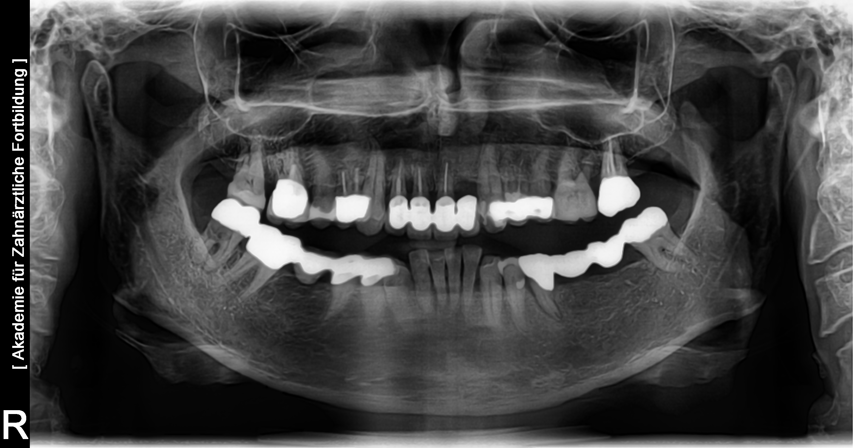

CBCT (5 months after extraction of tooth 35)

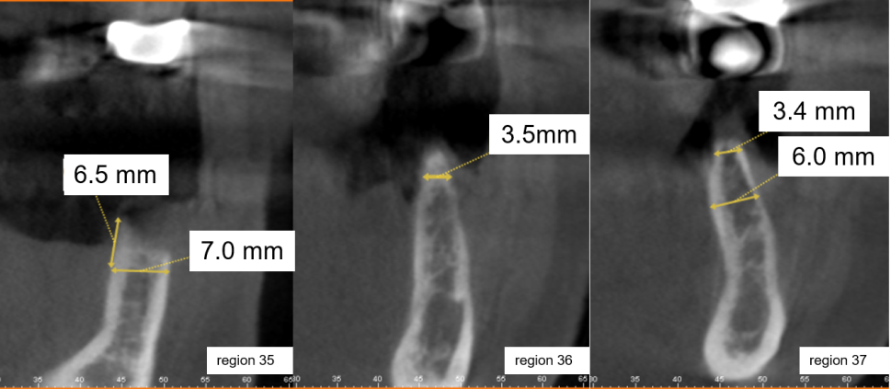
Region 35 Region 36 Region 37

Please analyze the records. How would you proceed surgically in this case?  Yes: This option represents the therapy of my choice (please tick yes only once).  Not at all: This therapy is not possible  Possibly: I am considering this option. I will decide during surgery. You can select "Possibly" more than once. | Yes | Not at all | Possibly
Bone Split
Bone block
Augmentation with bone substitute material
Resection
No therapy
Other | ------------------------------------------------------------------

Commentary to the case vignettes:
The variable descriptors in the anamnesis were combined in this supplementary material. The variables are highlighted in red and green.

