Supplementary Materials

Ileal transcriptomic and mucosal microbiome features at resection are associated with postoperative recurrence in Crohn’s disease
Moting Liu¹, Dianne Jansen¹, Tjasso Blokzijl¹, Zainab M A Al Radi¹, Froukje J Hoogenboom², Johan F M Lange², Gerard Dijkstra¹, Marcela A. Hermoso¹, Klaas Nico Faber¹, Ranko Gacesa^{1∗}, Rinse K Weersma^{1∗}

¹Department of Gastroenterology and Hepatology, University Medical Center Groningen, University of Groningen, Groningen, The Netherlands
²Department of Abdominal Surgery, University Medical Center Groningen, University of Groningen, Groningen, The Netherlands

∗ Authors share co-senior authorship

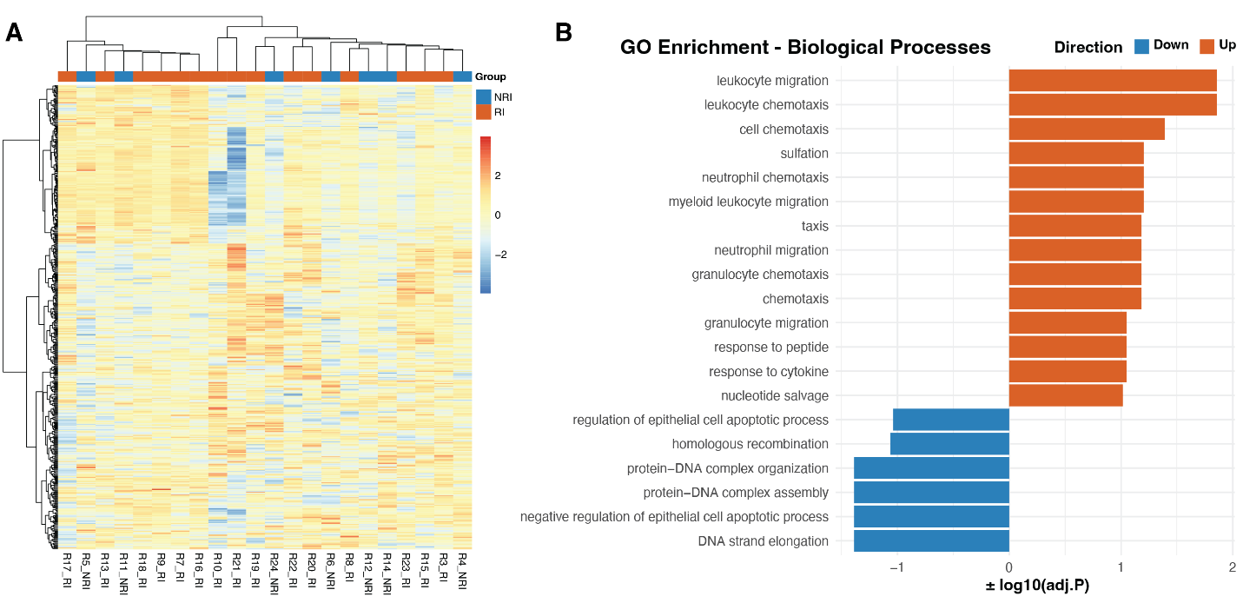
Supplementary Figure S1. Transcriptomic characterization of recurrence-associated host signals
(A) Unsupervised hierarchical clustering heatmap of the top 500 most variable genes across all samples, based on variance-stabilized expression values. Rows represent genes and columns represent individual samples. Expression levels are scaled by gene (row z-score). Samples are annotated by postoperative outcome (NRI, blue; RI, orange). Clustering was performed using Euclidean distance and complete linkage.
(B) Gene Ontology (GO) Biological Process enrichment analysis of genes with nominal differential expression (P < 0.01) between RI and NRI. Bars represent significantly enriched GO terms (FDR < 0.05), with positive enrichment scores indicating overrepresentation among genes upregulated in RI and negative scores indicating enrichment among genes upregulated in NRI.
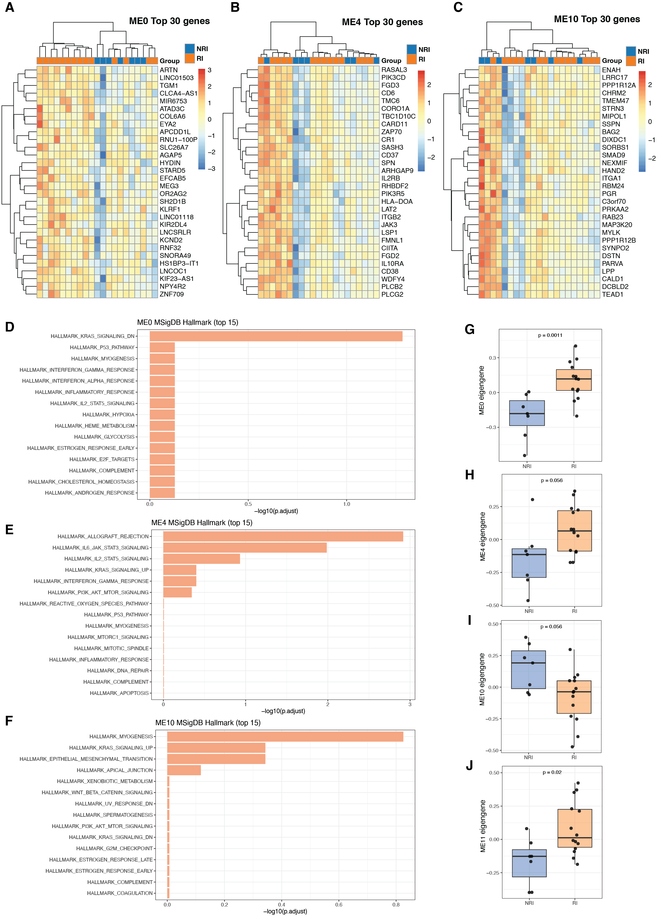
Supplementary Figure S2. Characterization of recurrence-associated co-expression modules
(A–C) Heatmaps of the top 30 genes from selected recurrence-associated modules (ME0, ME4, and ME10). Rows represent genes and columns represent samples; expression values are scaled by gene (row z-scores). Samples are annotated by postoperative outcome (NRI vs RI). Hierarchical clustering is shown for both genes and samples.
(D–F) MSigDB Hallmark enrichment analysis of the corresponding modules. Bars indicate −log10(adjusted P value) for enriched pathways.
(G–J) Distribution of module eigengenes (MEs) stratified by postoperative outcome. Boxplots display ME values in NRI and RI samples. P values were calculated using a two-sided Wilcoxon rank-sum test. MEs represent the first principal component of the scaled expression of genes within each module.

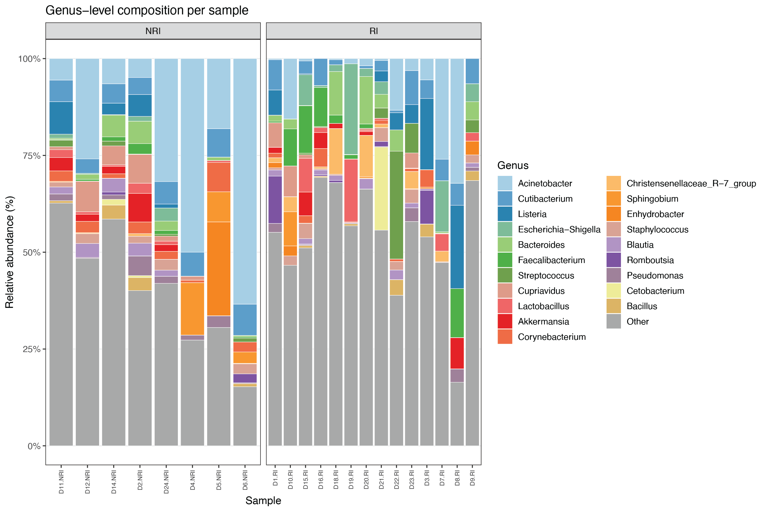
Supplementary Figure S3. Individual-level genus composition of tissue-associated microbiota
Stacked bar plots showing relative abundance of the top 20 genera across individual samples, stratified by postoperative outcome (NRI vs RI). Each bar represents one sample. Genera are colored by taxonomic identity; less abundant genera are grouped as “Other”.

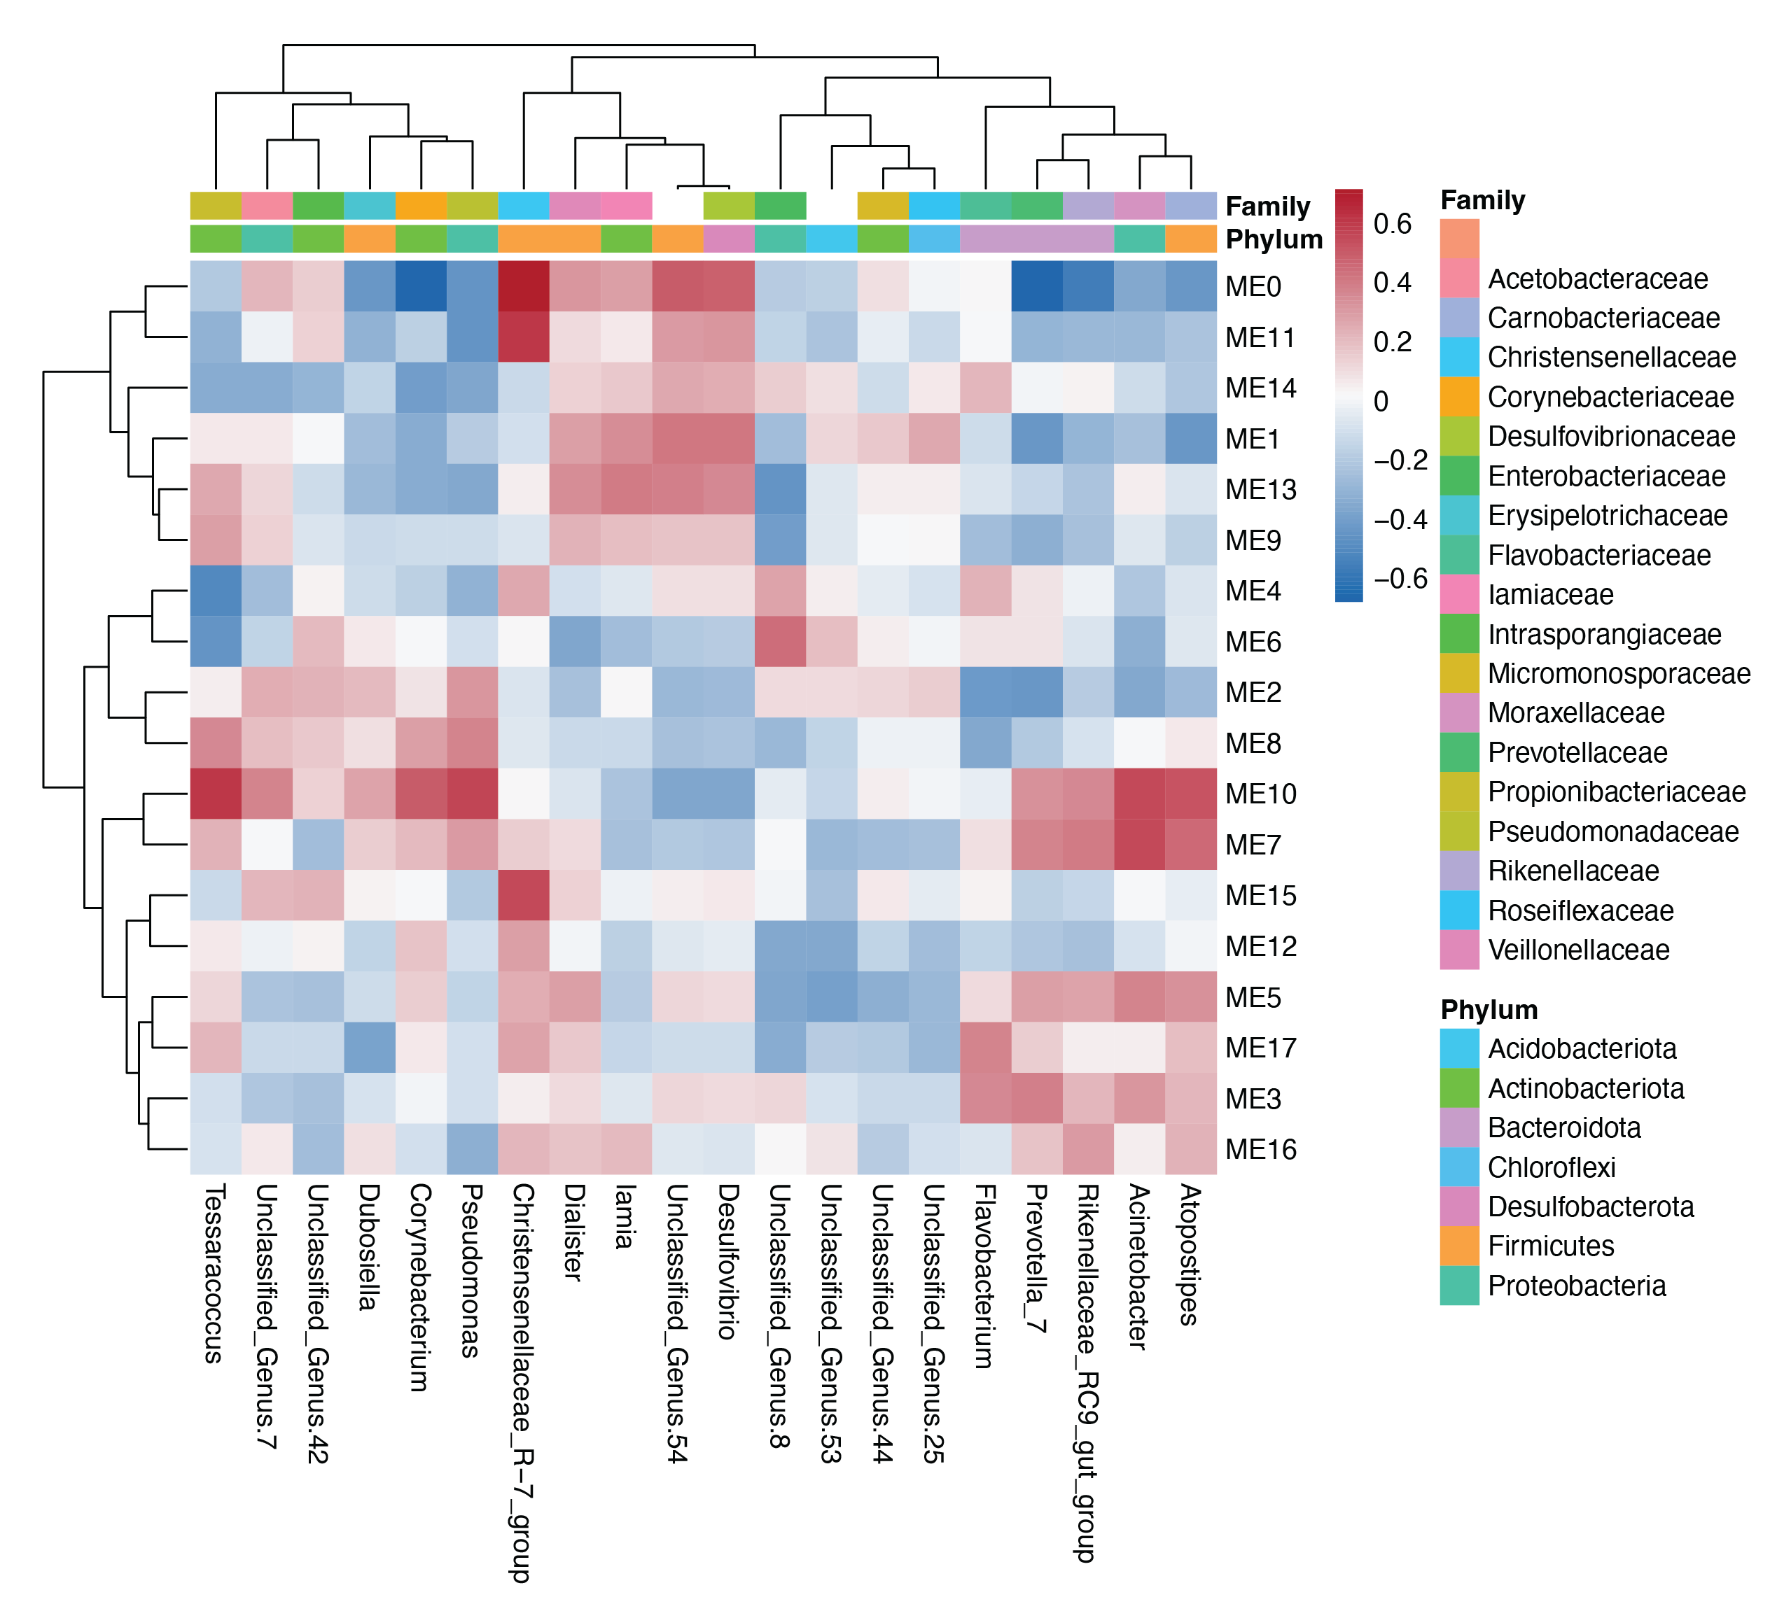
Supplementary Figure S4. Expanded module–genus correlation map supports the directionality of host–microbiome associations
Heatmap showing Spearman correlations between all WGCNA module eigengenes (MEs) and an expanded set of bacterial genera. Genus abundances were CLR-transformed with a pseudocount prior to association testing. Genera included here are the 20 taxa with the smallest Wilcoxon P values for RI vs NRI (regardless of whether P < 0.05). Colours indicate Spearman’s ρ, and columns are annotated by bacterial family and phylum.

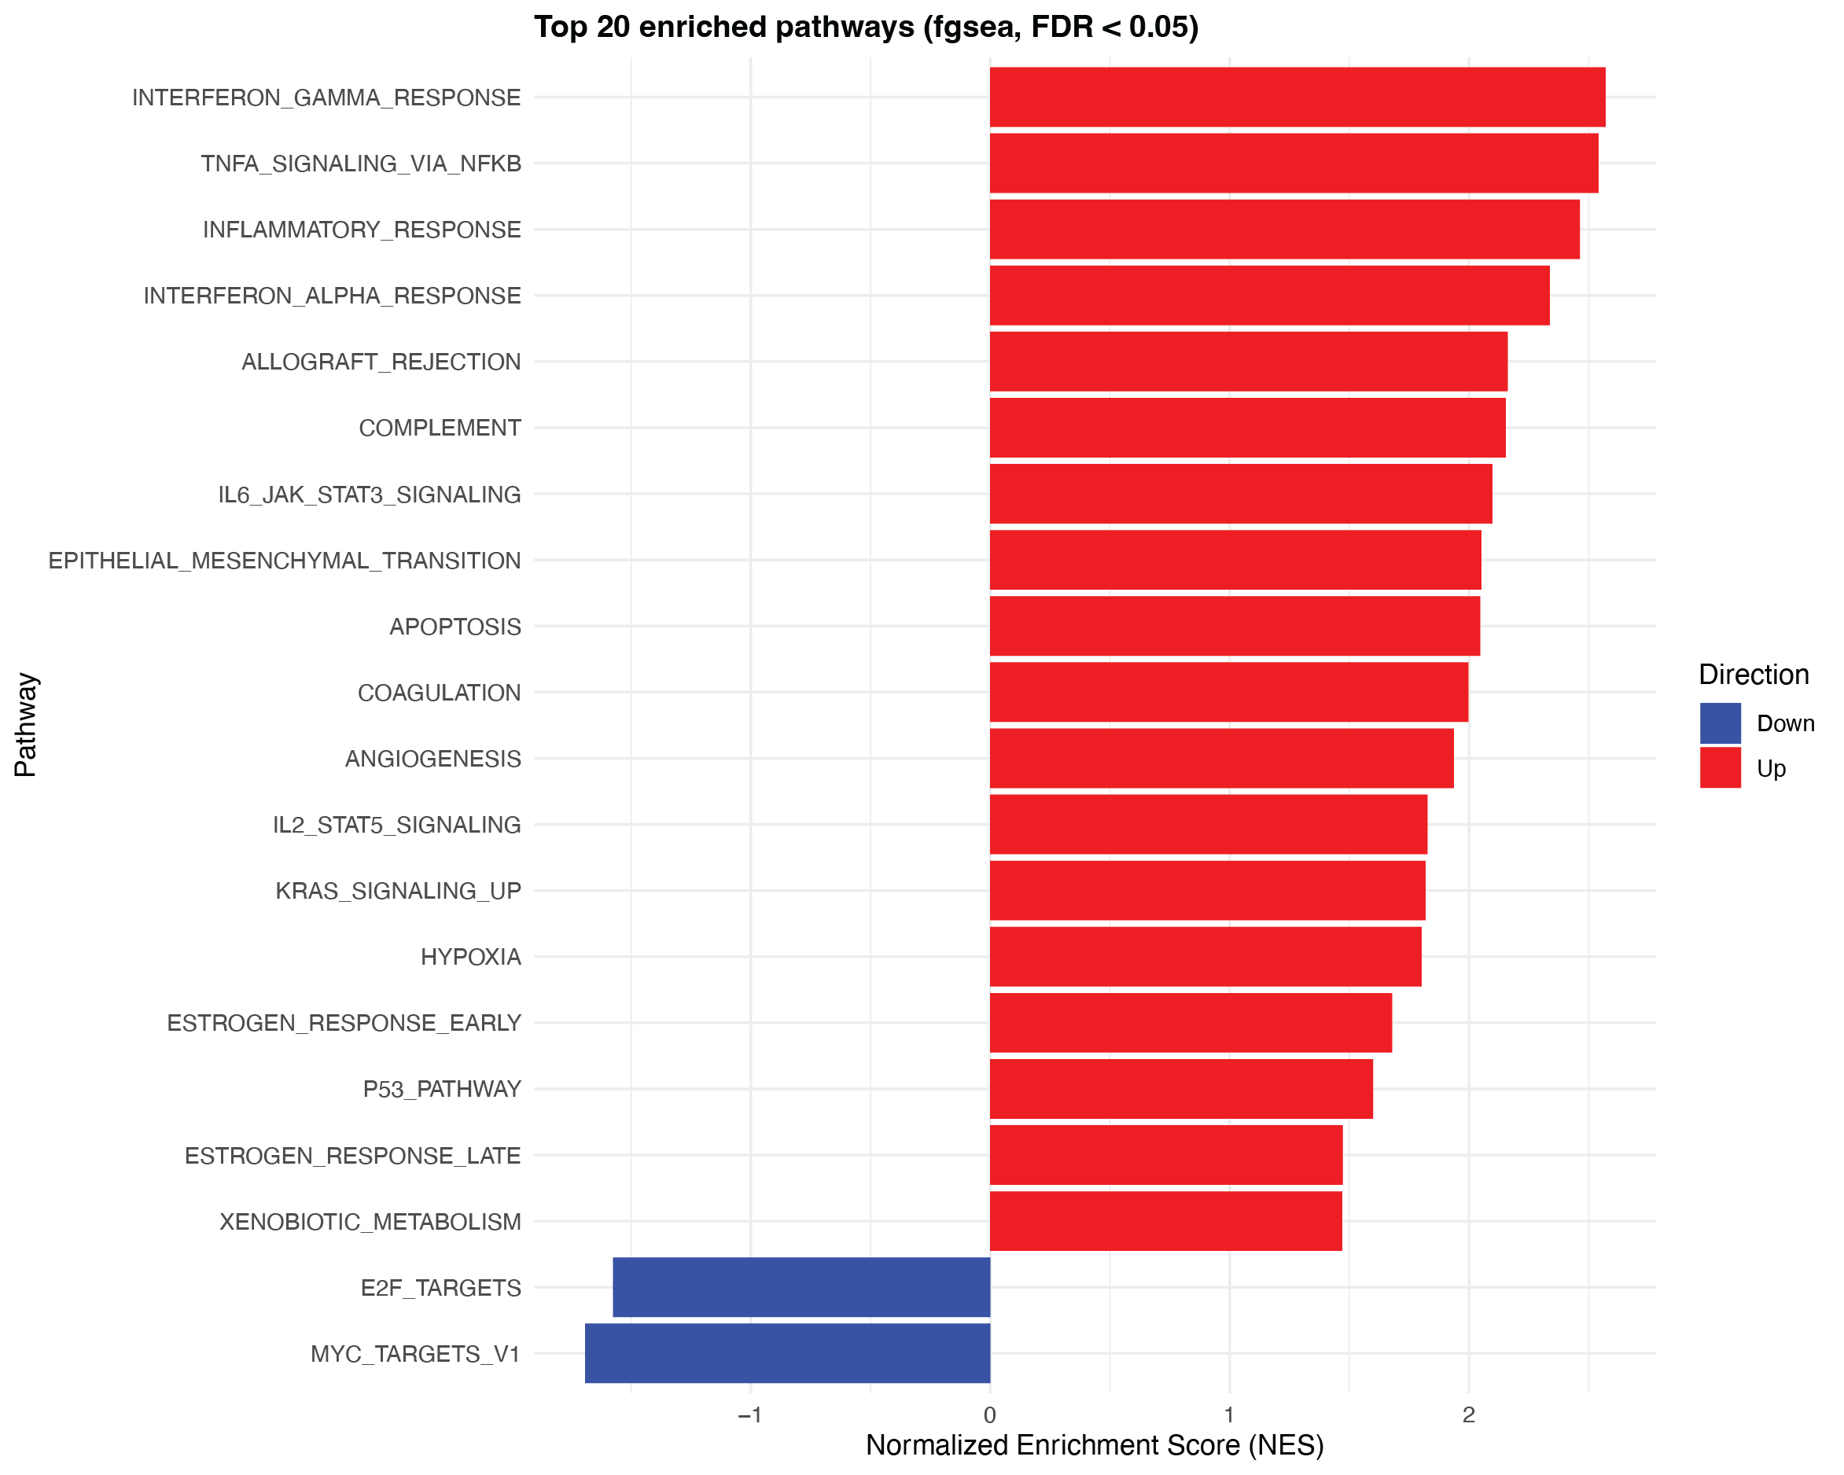
Supplementary Figure S5. Pathway enrichment analysis under a stricter recurrence definition (Rutgeerts ≥ 2)
Gene set enrichment analysis (fgsea) comparing proximal ileal resection margin tissue from patients with Rutgeerts score ≥ i2 versus those with i0. The top 20 significantly enriched Hallmark pathways (FDR < 0.05) are shown, ranked by normalized enrichment score (NES). Red bars indicate pathways enriched in the recurrence group, and blue bars indicate pathways enriched in the i0 samples. Interferon- and NF-κB–related inflammatory programs remained prominently enriched under this stricter definition, supporting the robustness of the host immune activation signature.

