Supplementary materials
Table S 1: Database search results
Database | Search string | Total hits | Restricted to Journal Articles and English
Web of Science’s Core collection (TS) | ( "Shade tree*" OR "agr? forest*" OR agr?forest* OR agr?ecosystem* OR "inter? crop*" OR inter?crop* OR "mult? purpose*" OR mult?purpose* OR "mult? strata" OR plantation* OR "tree specie*" ) AND ( cocoa OR cacao OR theobroma ) AND ( diversit* OR function* OR "functional diversit*" OR trait* ) AND ( litterfall* OR litter OR "leaf litter" OR "Nutrient Cycl*" OR nutrient* OR rhizosphere OR "soil fertility" OR "organic matter" OR "nutrient content" OR "soil propert*" OR "soil health" OR c OR n OR p OR k OR carbon OR nitrogen OR phosphorus OR potassium OR yield* ) | 433 | 385
Scopus (TITLE-ABS-KEY) | TITLE-ABS-KEY ( ( "Shade tree*" OR "agr? forest*" OR agr?forest* OR agr?ecosystem* OR "inter? crop*" OR inter?crop* OR "mult? purpose*" OR mult?purpose* OR "mult? strata" OR plantation* OR "tree specie*" ) AND ( cocoa OR cacao OR theobroma ) AND ( diversit* OR function* OR "functional diversit*" OR trait* ) AND ( litterfall* OR litter OR "leaf litter" OR "Nutrient Cycl*" OR nutrient* OR rhizosphere OR "soil fertility" OR "organic matter" OR "nutrient content" OR "soil propert*" OR "soil health" OR c OR n OR p OR k OR carbon OR nitrogen OR phosphorus OR potassium OR yield* ) ) AND ( LIMIT-TO ( DOCTYPE , "ar" ) ) AND ( LIMIT-TO ( LANGUAGE , "English" ) ) | 327 | 261
CAB Abstracts  <1910 to 2025 Week 02> | ( "Shade tree*" OR "agr? forest*" OR agr?forest* OR agr?ecosystem* OR "inter? crop*" OR inter?crop* OR "mult? purpose*" OR mult?purpose* OR "mult? strata" OR plantation* OR "tree specie*" ) AND ( cocoa OR cacao OR theobroma ) AND ( diversit* OR function* OR "functional diversit*" OR trait* ) AND ( litterfall* OR litter OR "leaf litter" OR "Nutrient Cycl*" OR nutrient* OR rhizosphere OR "soil fertility" OR "organic matter" OR "nutrient content" OR "soil propert*" OR "soil health" OR c OR n OR p OR k OR carbon OR nitrogen OR phosphorus OR potassium OR yield* ) | 367 | 293
Total |  | 1,127 | 939

Table S 2: Study inclusion/exclusion criteria. For the articles captured by the search in the databases to be relevant for the review, it is supposed to meet the set inclusion criteria according to the research question elements (PICOS) as follows: include a relevant population, include a relevant intervention, include a relevant outcome, include a relevant comparator, include a relevant study design as shown below:
Question key element | Include | Exclude
Population (P): | Relevant Population/system: Any studies that looked at different cocoa production systems. | Studies on other crops other than cocoa.
Intervention (I) | Relevant Intervention: Any study with the following interventions shade trees, agroforestry, shade tree species diversity, functional diversity, functional traits, monoculture. | Any other processes and features that are not related to coca and cocoa agroforest system features.
Comparator (C) | Relevant Comparator: Agroforestry system that have different characteristics and/or with monoculture as a comparator.
Outcome (O) | Relevant Outcome: firstly, studies with a stated clear outcome at abstract. Then at full text screening studies specifically reporting outcomes relevant to nutrient cycling, soil properties, and/or cocoa yields.
Study design (S) | Relevant study design: Studies that used primary data, observational studies, non-model studies. | Irrelevant study design: Studies that use models, Review articles, conceptual frameworks, inventory, interview, thesis, and questionnaire.
Experimental study design | Quasi-experimental studies at the farm, experiments with minimal controlled situations on farm e.g exclosure experiments | experiments in controlled environments e.g lab, greenhouse, garden
Experimental study design | Meta-analysis: Study with more all the treatment within the study i.e both deciduous and evergreen shade trees or studies with atleast two species richness levels excluding the control.
Language | English | Any other languages

Table S 3: Inclusion criteria and excluded publications with reasons
Criteria - exclude if does not have: | Number of exclusion(s)
Is/contains: cocoa production systems or cocoa farms  (Population) | 21
Agroforestry or shade trees or intercropping  (Intervention/Exposure) | 17
Number of shade tree species, complex agroforests, Species diversity, functional diversity, functional traits, diversity gradient, Deciduous, Evergreen, crown diameter, leaf phenology, leaf habitat or monoculture, species composition  (Comparator) | 40
Studies with a stated clear outcome in abstract that is related to litterfall, litter decomposition, soil nutrient, properties, nutrient cycling, yield, or carbon stocks  (Outcome) | 27
Use of primary data, observational studies, non-simulated data, Quasi-experiments, not modelled  (Study design) | 8
Not: Systematic review, Thesis, Protocol, Guideline or Manual  (article type and Language) | 3
Fulltext not available | 2
Fulltext not assessible | 0
Fulltext duplicate | 0
As no primary data/summary statistics are presented | 0

Table S 4: Critical appraisal criteria
Criteria | Addressed bias | Scale | Final score
1.1 Is it possible for the impact of exposure or the effectiveness of the intervention to be confounded in this study? | Confounding Bias |  | Low if (1.1 = No, 1.2 = Yes), Medium if (1.1 = Yes, 1.2 = Yes), High if (1.1 = Yes, 1.2 = No)
  1 [No]
  2 [Yes]
1.2 Did the author(s) control for all the potential confounders (e.g climate, temperature, rainfall and soil type)? | Confounding Bias
  1 [Yes]
  2 [No]
2.1 Was the selection of subjects or areas after intervention or exposure random or systematic (i.e., based on random or systematic sampling), and exchangeability between groups could be assumed based on the selection approach? OR was the entire (or nearly entire) population of inference followed-up after intervention or exposure, and exchangeability between before and after groups could be assumed? | Selection Bias |  | Low if (2.1= Yes,  2.2 =Yes),  Medium if (2.1= No,  2.2 =Yes),  High if (2.1= Yes,  2.2 =No) Or (2.1= No,  2.2 =No)
  1 [No]
  2 [Yes]
2.2 Were the subjects or areas included in the study (or analysis) comparable between groups and so they allowed a valid comparison to be made (i.e., comparator of cocoa systems instead of natural forests or pastures)? | Selection Bias
  1 [No]
  2 [Yes]
3.1 Were the intervention or exposure (group) and the comparator (group) of interest sufficiently well-defined so that no meaningful vagueness remains for the intended assessment of causal effect of interest? | Risk of misclassified comparison biases |  | Low if (3.1 = Yes),  High if (3.1 = No)
  1 [No]
  2 [Yes]
5.1 Were the methods for measuring the outcome data the same across the groups? | Detection Bias |  | Low if (5.1 = Yes),  High if (5.1 = No)
  1 [No]
  2 [Yes]
6.1 Were the sample sizes same for all the groups? | Attrition Bias |  | Low if (6.1 = Yes),  High if (6.1 = No)
  1 [No]
  2 [Yes]

Critical appraisal/validity check
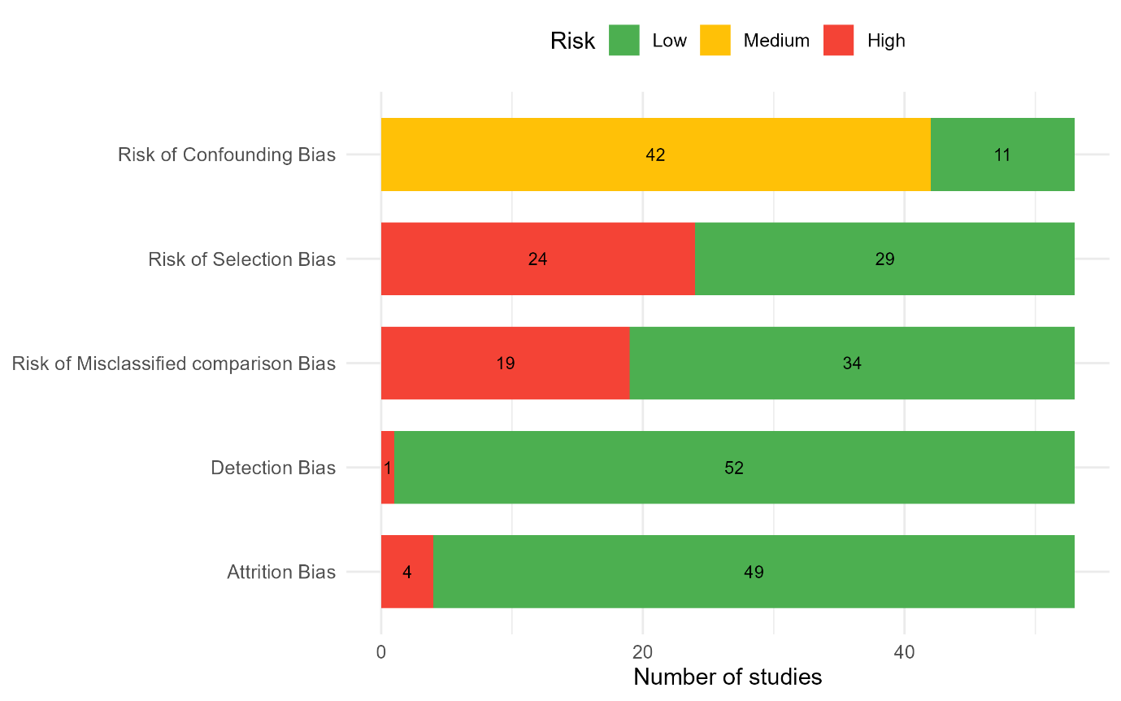
Figure S 1: Critical appraisal results

Publication Bias

Soil N
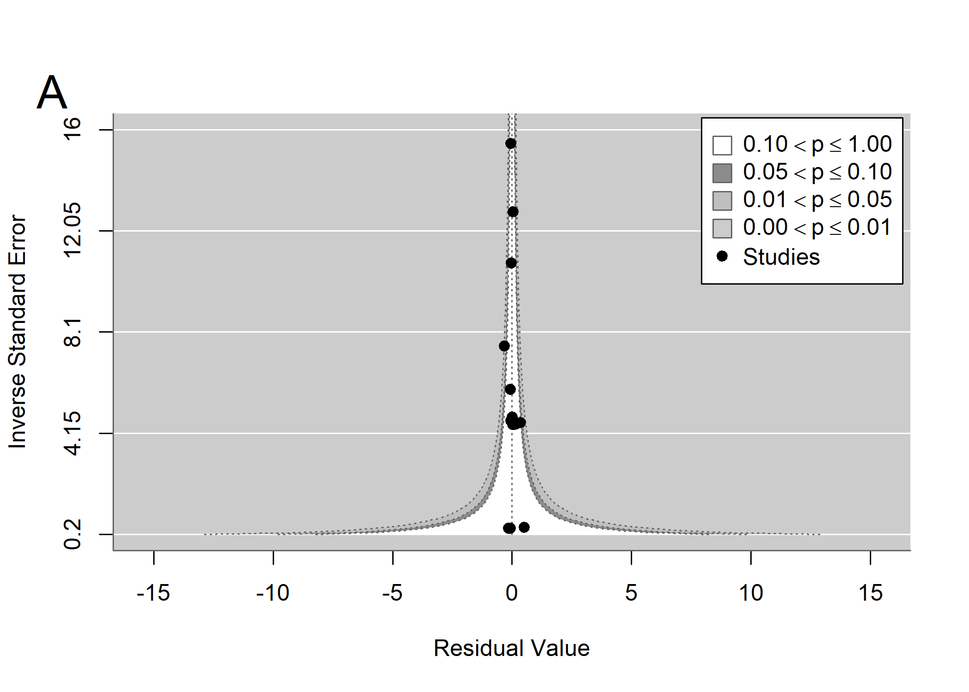
Figure S 2: funnel plot for effects of species richness on soil total N

Soil organic carbon
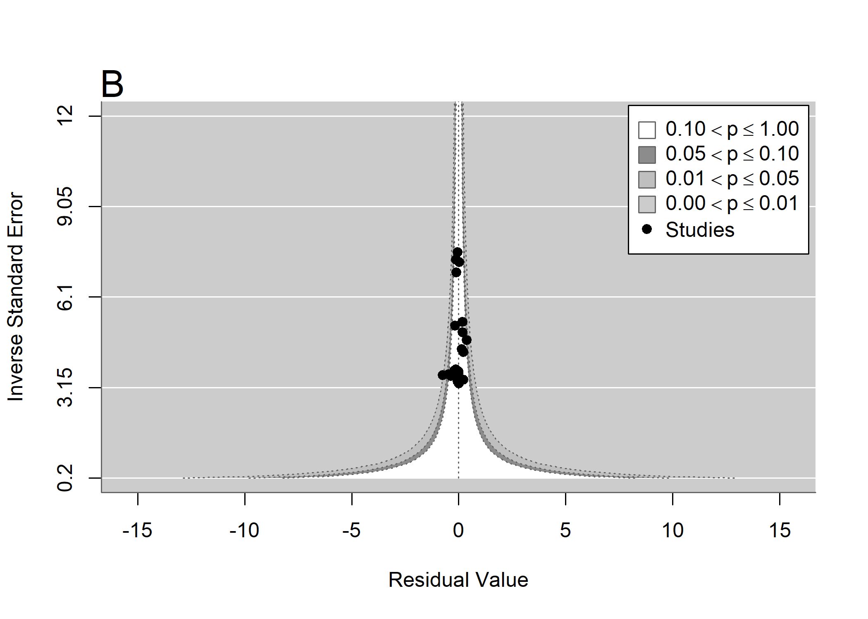
Figure S 3: funnel plot for effects of species richness on soil organic carbon
Soil available P
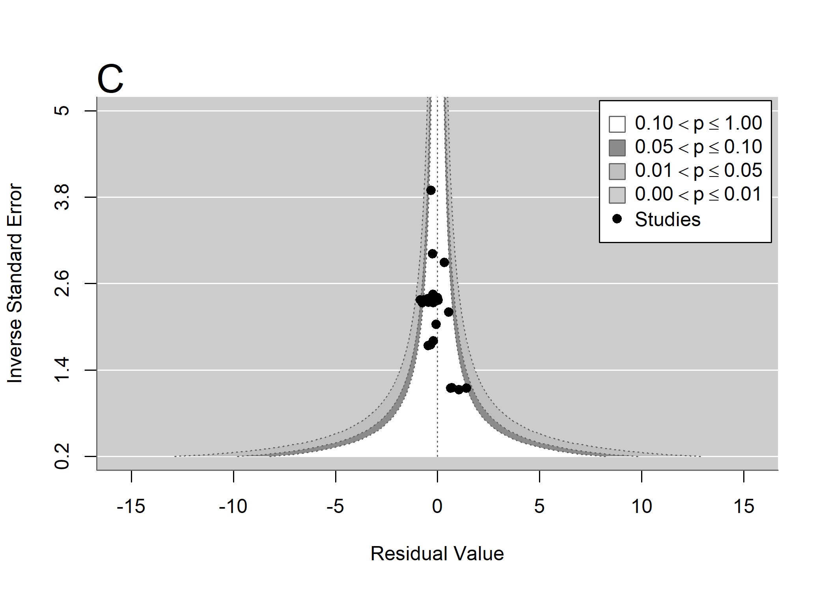
Figure S 4: funnel plot for effects of species richness on soil available P

Soil K
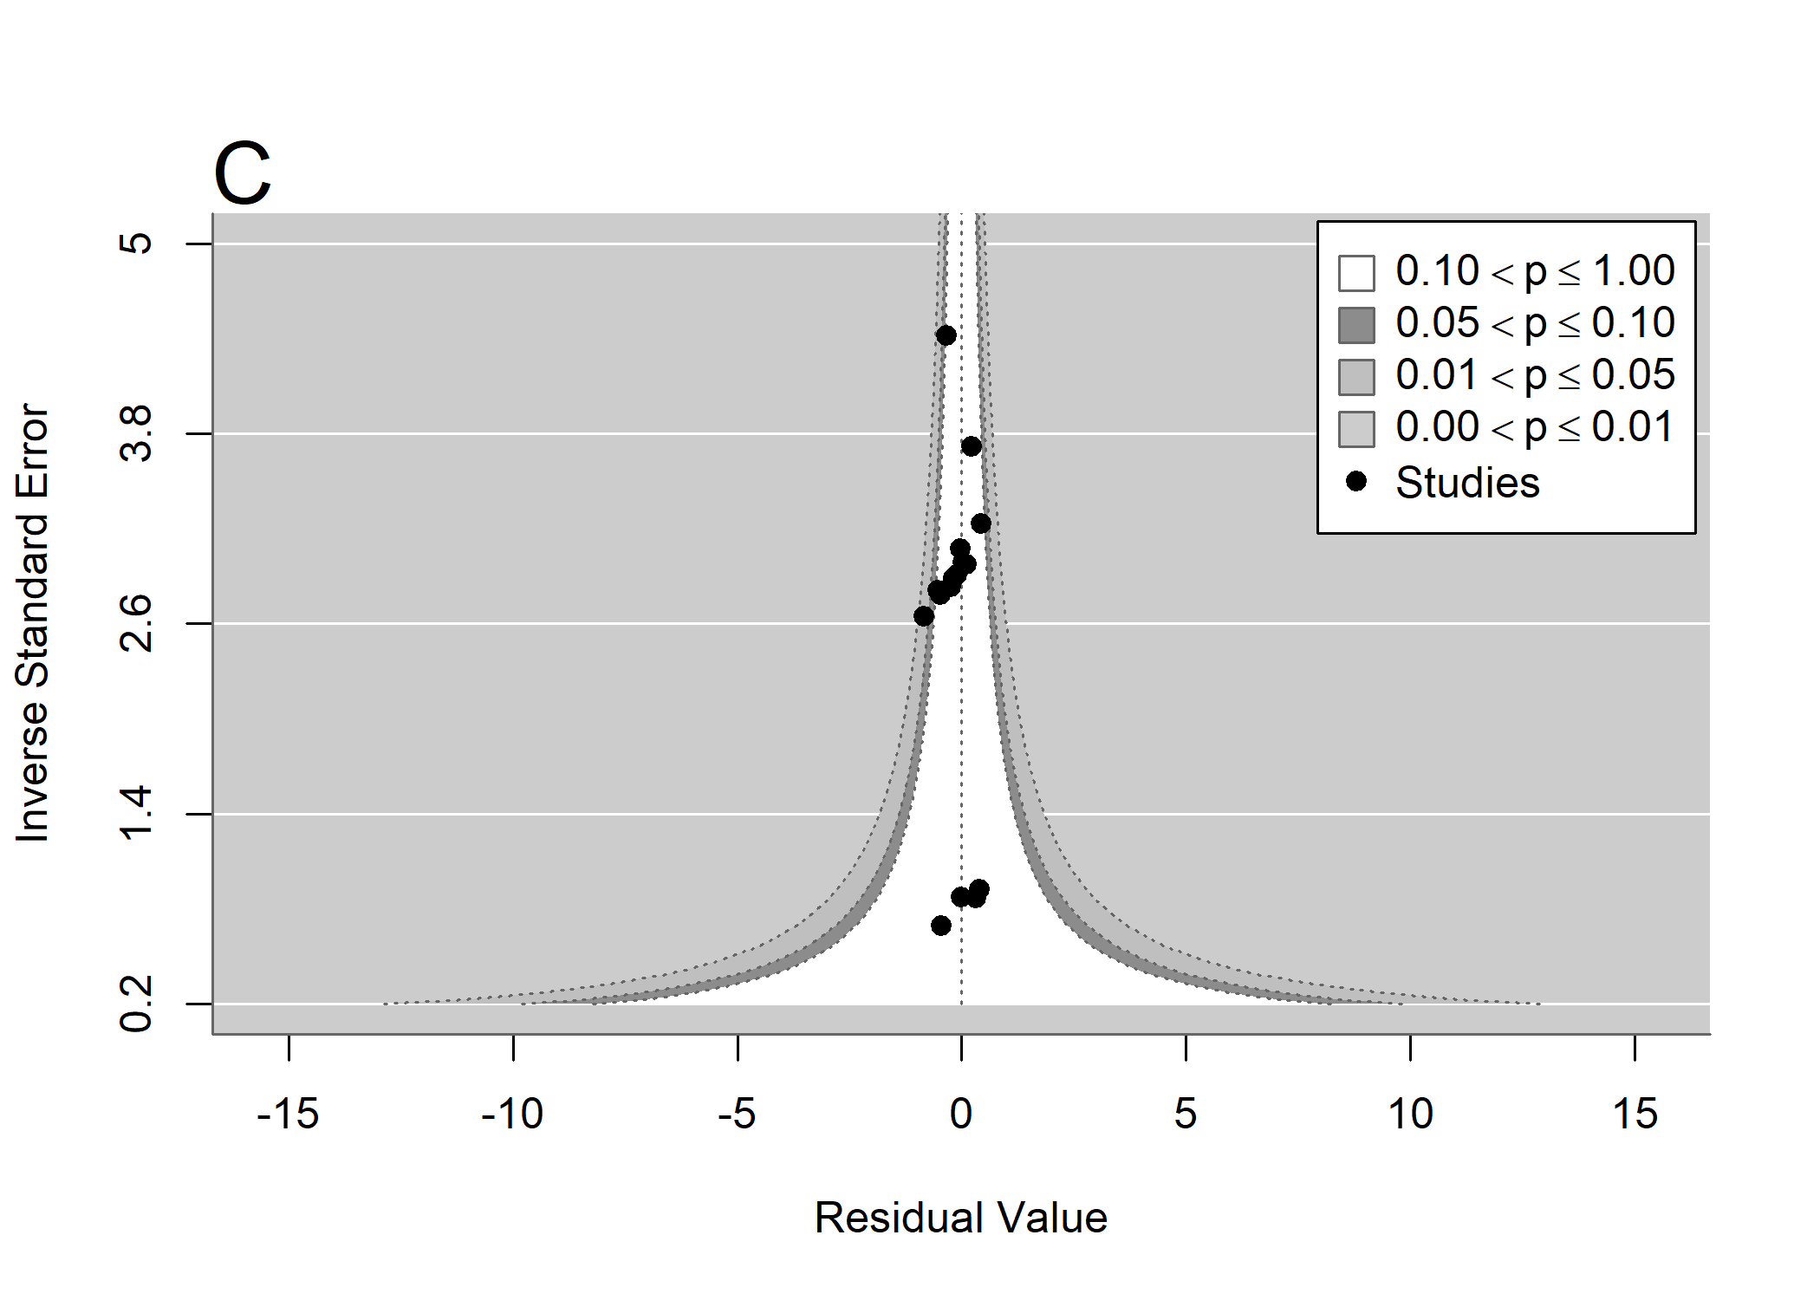
Figure S 5: funnel plot for effects of species richness on soil K

Time lag bias

Soil N
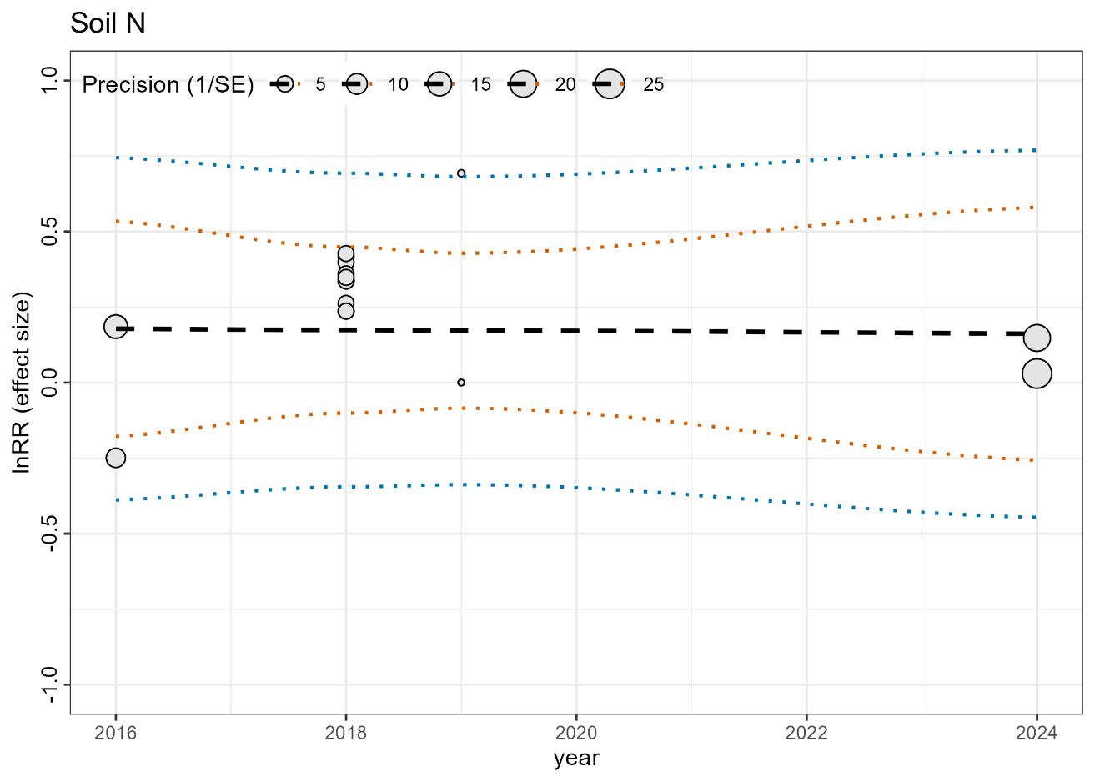
Figure S 6: Time-lag for effects of species richness on soil total N

Soil organic carbon
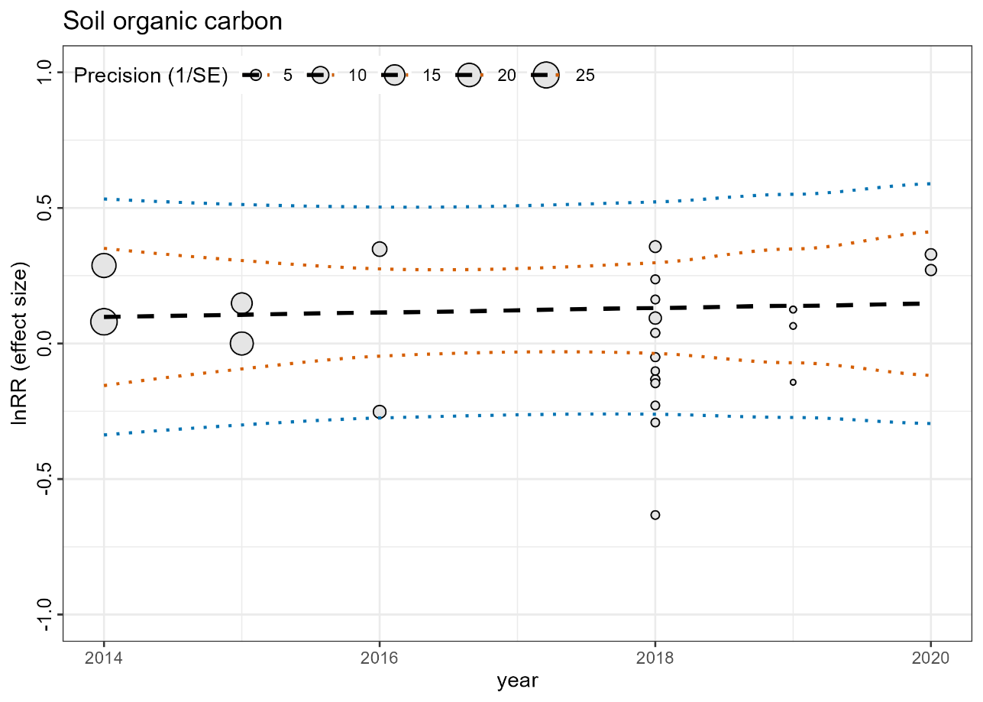
Figure S 7: Time-lag for effects of species richness on soil organic carbon
Soil available P

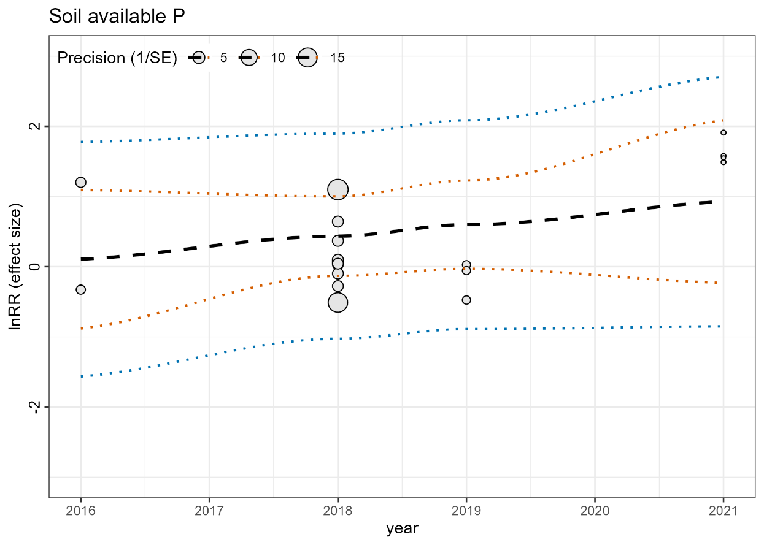
Figure S 8: Time-lag for effects of species richness on soil available P

Soil K

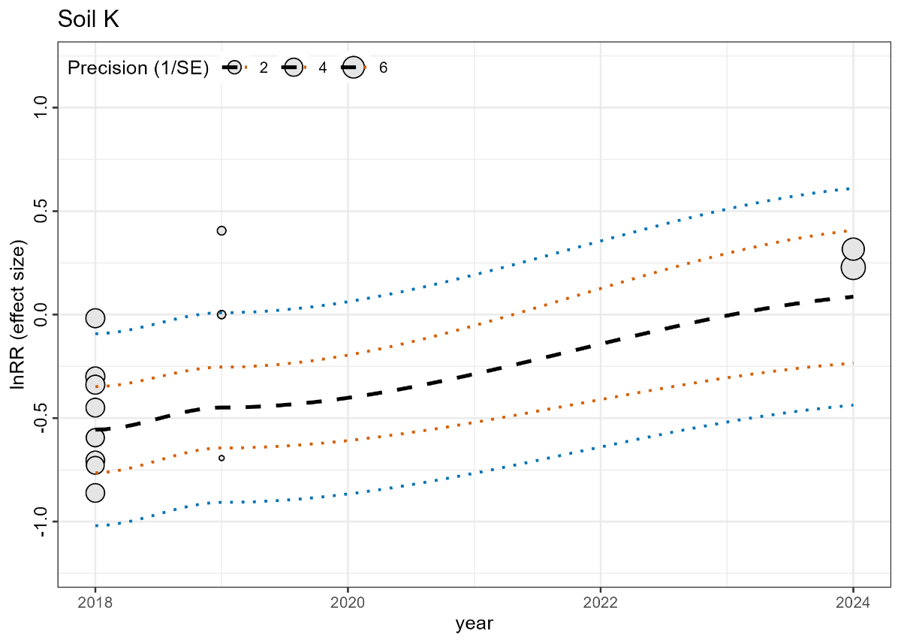
Figure S 9: Time-lag for effects of species richness on soil K

Shade tree leaf traits effects on soil nutrient properties.
Across these studies (N= 5 publications) that met the criteria of having both deciduous and evergreen shade trees within the study, deciduous shade trees were associated with positive mean effects sizes relative to evergreen species for soil total nitrogen (log-RR = 0.041 ± 0.060 SE; p = 0.500), SOC (log-RR = 0.029 ± 0.030 SE; p = 0.345), available phosphorus (log-RR = 0.1598 ± 0.175 SE; p = 0.374) and soil pH (log-RR = 0.012 ± 0.031 SE; p = 0.720). However, none of these effects was statistically significant, and standard errors were relatively large in relation to the estimated effects.

