Supplementary Table 1. Characteristics of male COVID-19 patients admitted to the resuscitation unit and used for serum hormonal measurements (Excel file attached)

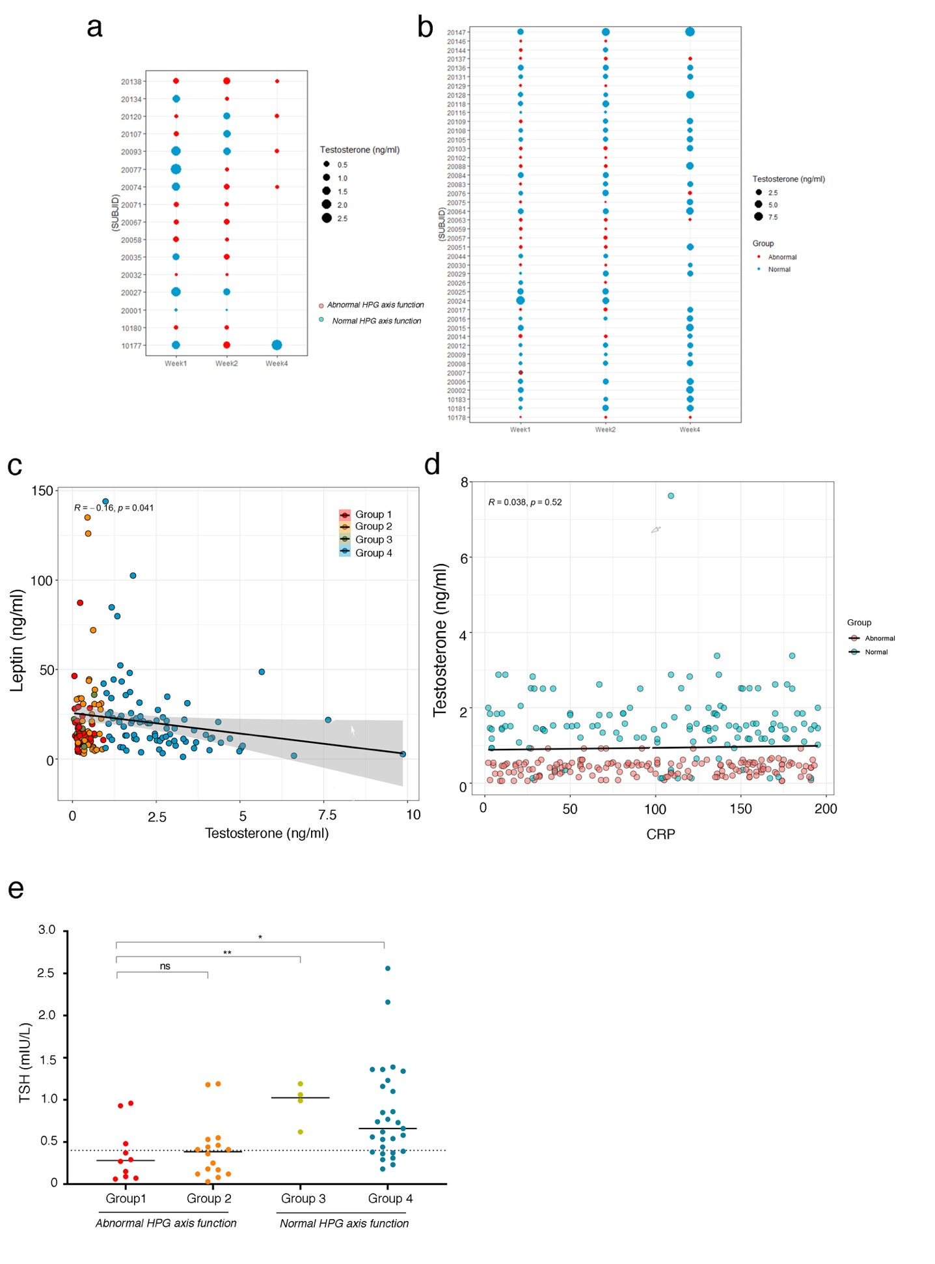
Supplementary Figure 1. COVID-19 patient survival and serum leptin, CRP and TSH levels
(a) Characterization of serum testosterone levels and HPG axis functions in deceased patients.
(b) Characterization of serum testosterone levels and HPG axis functions in surviving patients.
(c) Negative correlation (R = -0.16, t₍₁₅₉₎ = -2.0595, P = 0.04108, n= 161 from 60 patients) between serum leptin and testosterone levels in Groups 1-4 irrespective of sampling week, where R is the measure of the strength of linear association between leptin and testosterone (Pearson’s product moment correlation), and P is the t-test significance value.
(d) Absence of correlation between C-reactive protein (CRP) levels, an indicator of inflammation, and serum testosterone levels (R =0.038, t₍₂₉₆₎ = 0.6491, P = 0.52, n = 299 from 59 patients) where R is the Pearson’s product moment correlation and P is the t-test significance).
(e) Serum TSH levels follow the same pattern as serum LH levels in the different groups, indicating a perturbation of hypothalamic-pituitary hormonal axes in general in the hypogonadotropic hypogonadal group and the groups with abnormal HPG axis function. A two-tailed unpaired t-test (Group 2 vs Group 1, t₍₂₄₎ = 0.2759, P = 0.785; Group 3 vs Group 1, t₍₁₂₎ = 3.220, P = 0.0074; Group 4 vs Group 1, t₍₃₇₎ = 2.428, P = 0.0202) was used to estimate the significance of the difference between groups, where n=59 samples from 57 patients during first week of sampling (n for Group 1 = 10, Group 2 = 16, Group 3 = 4, Group 4 = 29) and *p < 0.05, **p < 0.01, ns = non-significant.

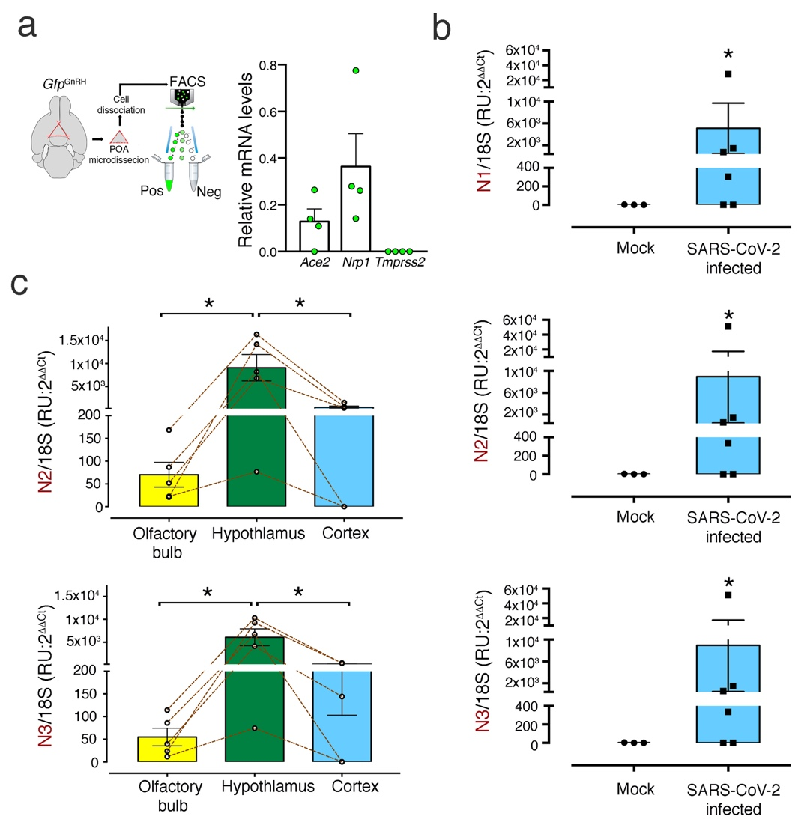

Supplementary Figure 2. Quantitative PCR analysis of susceptibility factors in GnRH neurons and SARS-CoV-2 N-protein in the infected mouse brain
(a) Quantitative PCR analyses for Ace2, TMPRSS2 and NRP1 in mouse GnRH neurons isolated by fluorescence-activated cell sorting (FACS) from Gnrh::Gfp mice.
(b) Quantitative PCR analysis for N-protein transcript levels in the cortex of 7d SARS-CoV-2- and mock-infected K18-hACE2 mice using three distinct sets of probes (N1, N2 and N3). Values are expressed relative to transcripts of the housekeeping 18S RNA. (n= 3 mock and 5 SARS-CoV-2-infected animals; two-tailed Mann-Whitney U test; N1, N2 and N3: U=2, P = 0.0476).
(c) Quantitative PCR analysis comparing N-protein transcript levels between the olfactory bulb, hypothalamus and cortex of 7d SARS-CoV-2 infected K18-hACE2 mice using the N2 and N3 probe sets (related to Figure 2a). Friedman’s multiple comparison test: N2 Fr = 7.600, P = 0.0239; N3 Fr = 7.600, P = 0.0239, followed by an uncorrected Dunn's post-test. N2: Olfactory bulb vs. Hypothalamus p = 0.0114 and Cortex vs. Hypothalamus p = 0.0269. N3: Olfactory bulb vs. Hypothalamus p = 0.0114 and Cortex vs. Hypothalamus p=0.0269).

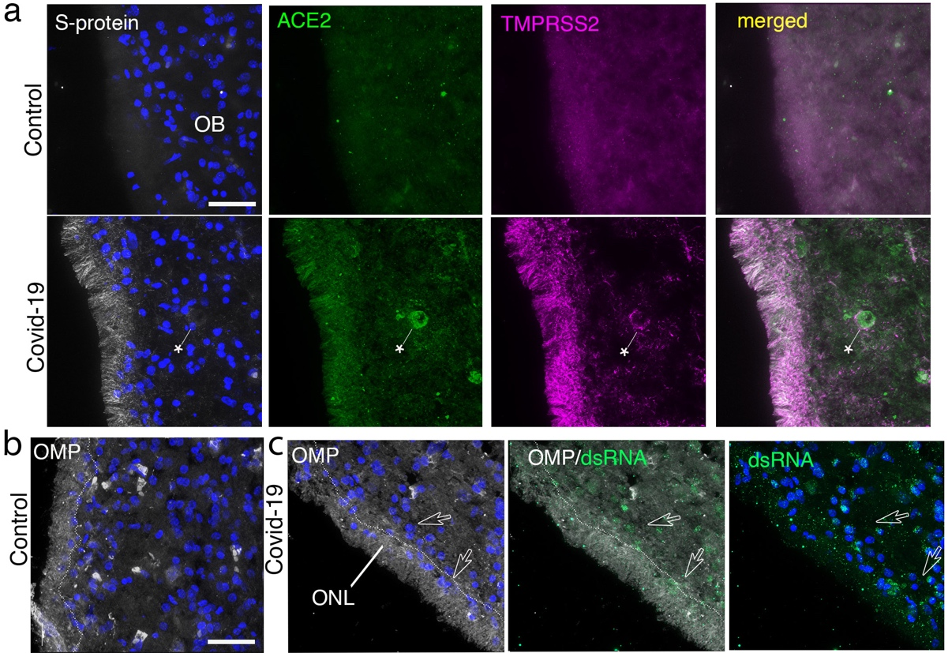

Supplementary Figure 3. ACE2 and TMPRSS2 expression in control and COVID-19 patient olfactory bulbs
(a) Olfactory bulb (OB) of a 36-year old control subject (top panels) and a 63-year-old COVID-19 patient (bottom panels) showing heavy S-protein labeling (white) as well as strong ACE2 (green) and TMPRSS2 (magenta) expression in the outer (olfactory nerve) layer of the OB, consisting of fibers from olfactory sensory neurons in the nose. ACE2 is enriched in capillary walls as well (asterisk). Blue: DAPI. Scale bar: 40μm.
(b) Immunolabeling for the olfactory marker protein (OMP; white), a marker of olfactory sensory neurons and axons, clearly indicating that this layer, delineated by the faint dotted line, is indeed the olfactory nerve layer. Numerous cells of unknown identity containing dsRNA (green) occur close to the border (empty arrowheads) as well as further inside the parenchyma of the glomerular layer, but rarely in the ONL. Blue: DAPI. Scale bar: 40μm.

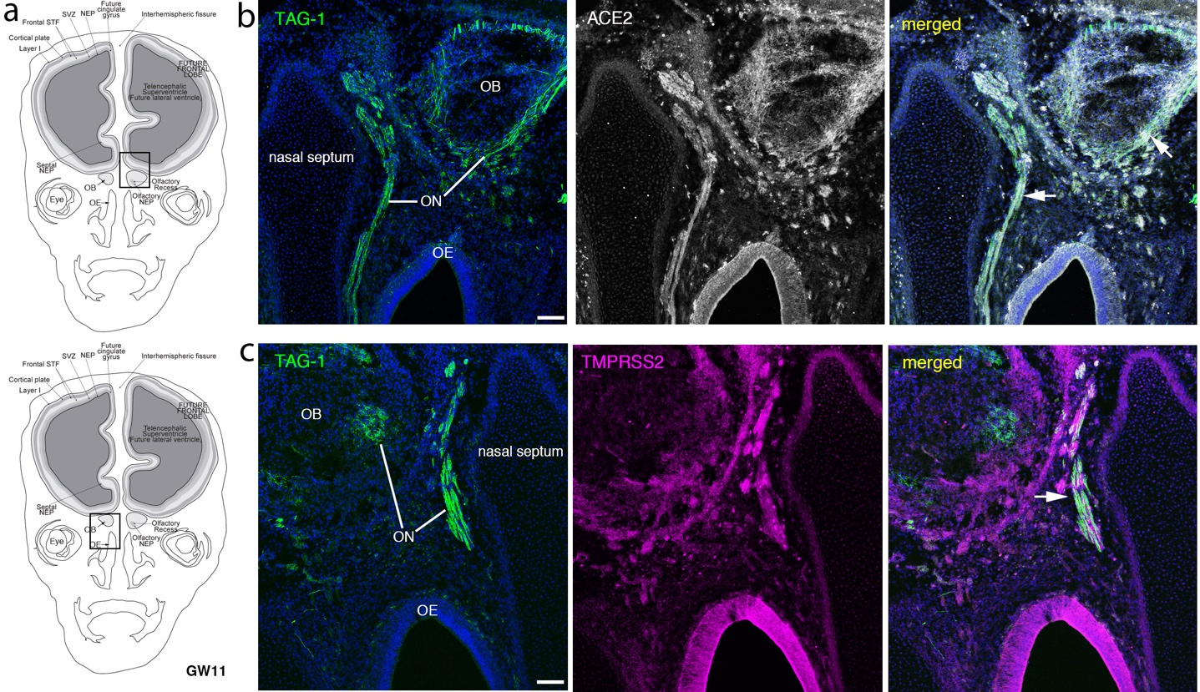
Supplementary Figure 4. Immunolabeling for ACE2 and TMPRSS2 in the embryonic human nose and olfactory bulb
(a) Schematic diagram of the cross section of an embryonic head at gestational week (GW) 11, showing areas represented. Boxes in (a) depict the areas shown in the photomicrographs in (b,c).
(b,c) ACE2 (b, white) and TMPRSS2 (c, magenta) colocalize (white arrows) with TAG-1 (green), a marker for the axon tracts of the olfactory nerve (ON) and vomeronasal nerve in the primary olfactory region that, at this stage, start projecting to the presumptive olfactory bulbs (OB). Olfactory epithelium: OE. Blue: DAPI. Scale bars = 100 μm.

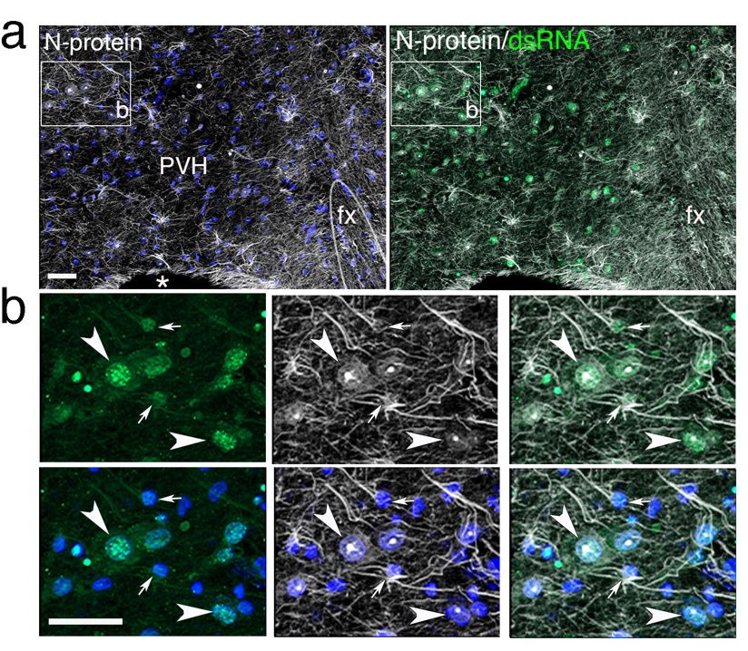
Supplementary Figure 5. Evidence of viral infection in the paraventricular nucleus of the hypothalamus
(a) Abundant immunolabeling for N-protein (white) and dsRNA (green) in the paraventricular nucleus of the hypothalamus (PVH) of a COVID-19 patient. fx: fornix. Blue: DAPI. Scale bars = 100 μm.
(b) High magnification of image in (a) showing viral markers in both putative neurons (arrowheads) and glial cells (arrows). Blue: DAPI. scale bars = 50 μm.

