Supplementary Material
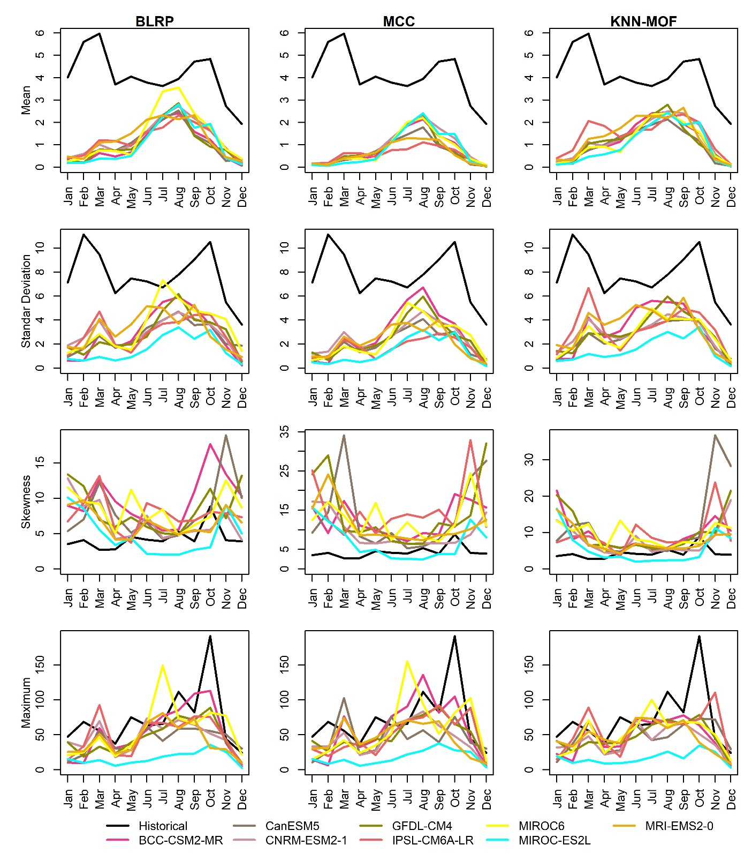
Figure S1 Rainfall for 3hr at monthly statistics for observed vs GCMs

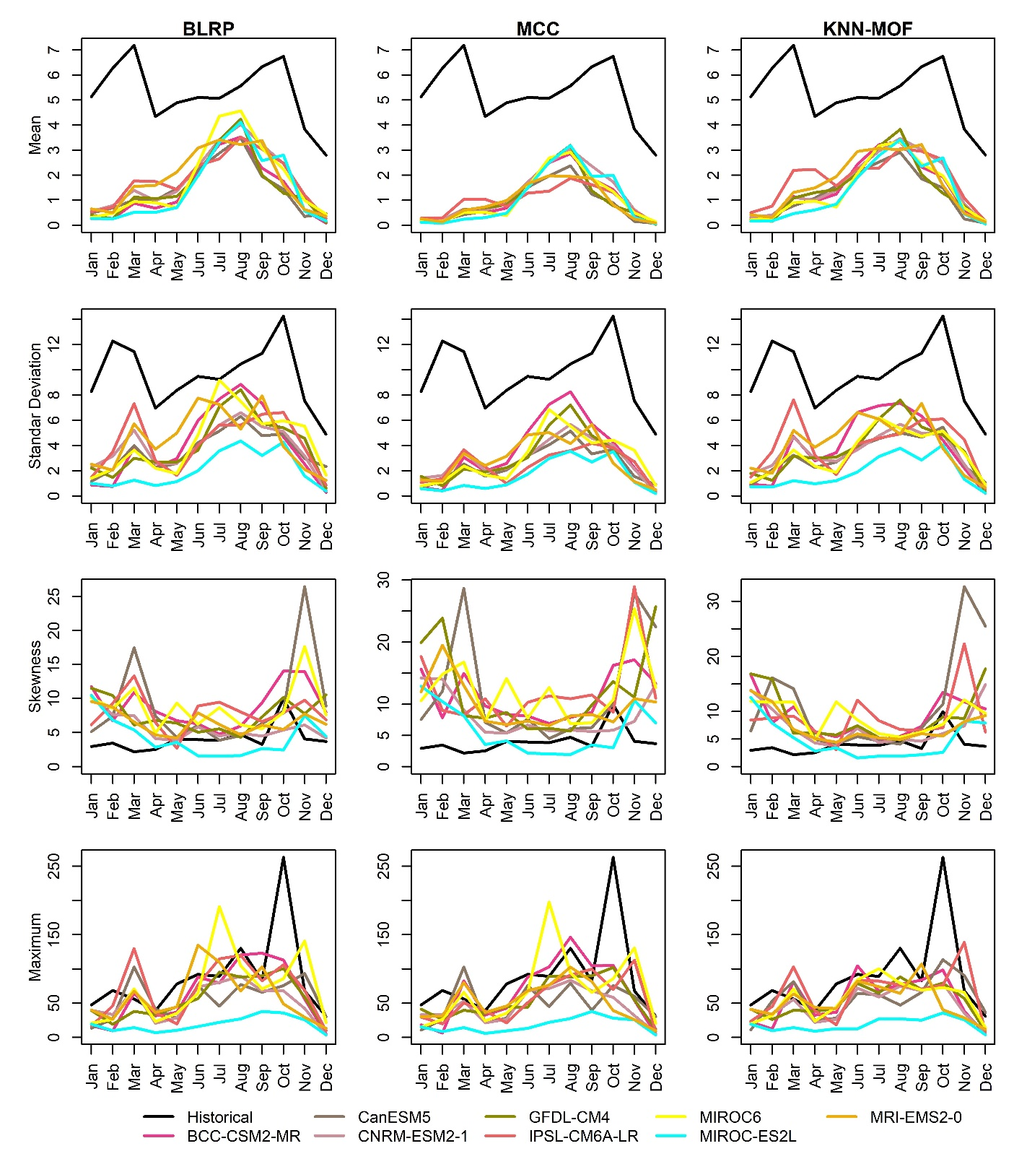
Figure S2 Rainfall for 6hr at monthly statistics for observed vs GCMs
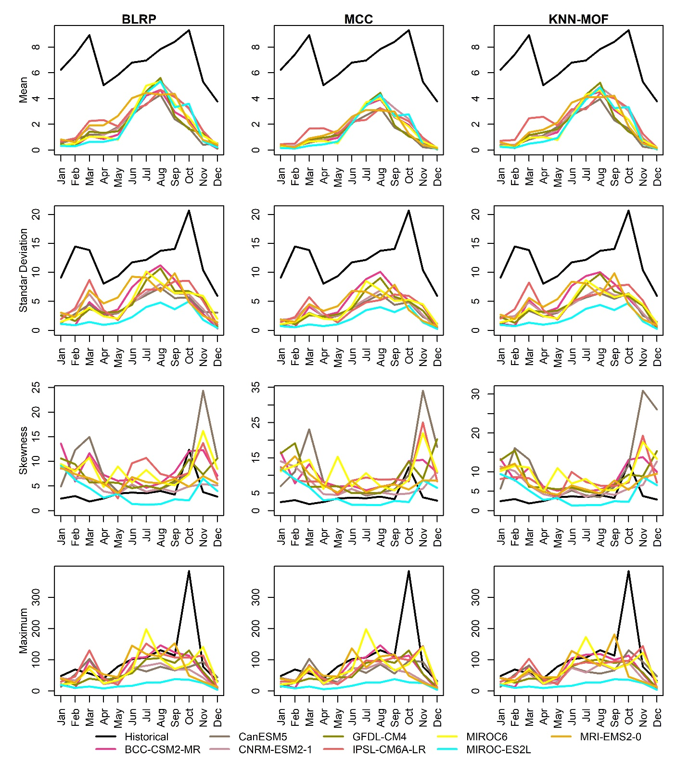
Figure S3 Rainfall for 12hr at monthly statistics for observed vs GCMs

