Supporting Information for
Rapid and slow quartz precipitation during cyclic fault healing in seismogenic fault rocks from subduction zones
T. Hosokawa^{1*}, Y. Hashimoto¹, R. Kilian², M. Stipp²
¹ Graduate School of Integrated Art and Sciences, Kochi University, Akebonocho 2-5-1, Kochi, 780-8520, Japan
² Institute of Geosciences and Geography, Martin Luther University Halle-Wittenberg, Von-Seckendorff-Platz 3, 06120 Halle, Germany

Introduction
The Supporting Information contains
- Fig. S1-S2
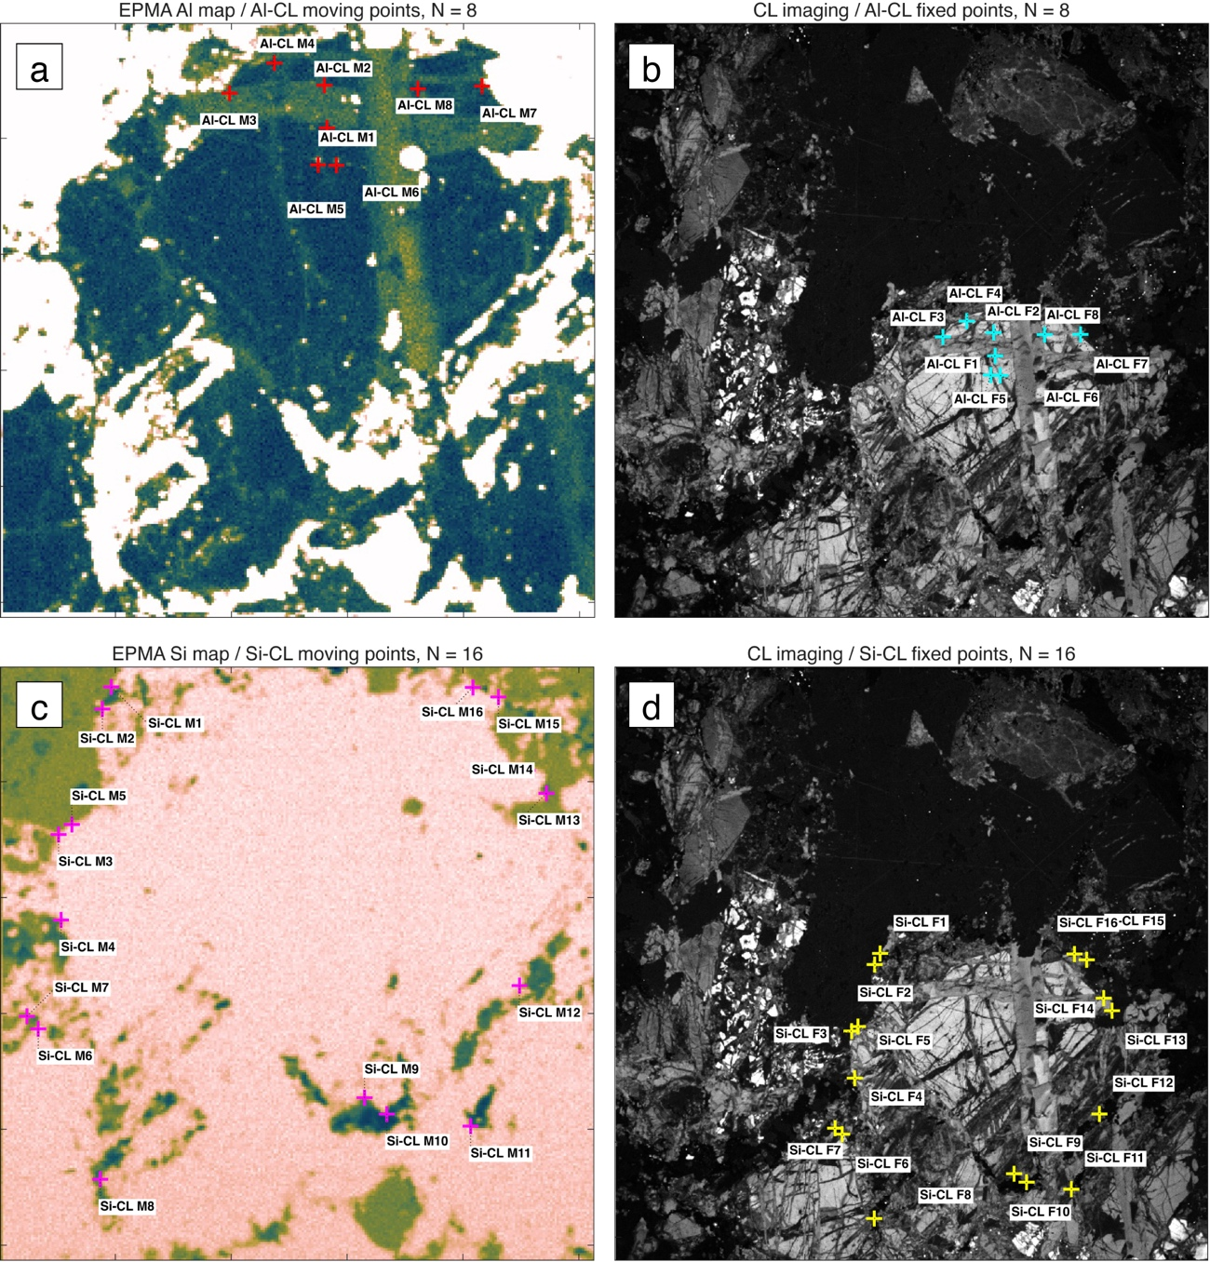
Fig. S1. (a) EPMA Al map showing moving control points used for registration to the corresponding CL image. (b) CL image showing fixed control points corresponding to the Al map in panel (a). (c) EPMA Si map showing moving control points used for registration to the corresponding CL image. (d) CL image showing fixed control points corresponding to the Si map in panel (c).
Fig. S2. (a) ROIs manually defined on the CL image for quartz-filled microcracks and host quartz grains. Blue outlines represent quartz-filled microcrack ROIs, whereas orange outlines represent host quartz grain ROIs. (b) ROIs after morphological erosion on the CL image. The erosion was applied prior to coordinate transformation to reduce the effects of image-registration uncertainty and differences in pixel size between the CL images and EPMA Al maps. The erosion distance was 2.5 pixels on the CL image, equivalent to 1 μm. Purple ROIs indicate eroded ROIs retained for subsequent analysis, whereas cyan ROIs indicate ROIs excluded from analysis because no valid pixels remained after erosion. (c) Eroded ROIs transformed onto the EPMA Al map using the affine transformation estimated from the control points shown in Fig. S1. The transformed ROIs were used to extract Al concentration values from regions spatially equivalent to the CL-image ROIs. For each retained ROI, the median CL intensity and median Al concentration were calculated, and intra-ROI variability was evaluated using the interquartile range.

