Supplementary Material

Design and analysis strategies to increase efficiency in malaria cluster-randomised trials by minimising between-cluster heterogeneity of outcomes

Table of contents

S1 Figure 2
S2 Figure 2
S3 Figure 3
S4 Figure 4
S5 Figure 5
S6 Figure 6
S7 Figure 7
S8 Figure 8
S9 Figure 9
S10 Figure 10
S11 Figure 11
S12 Figure 12
S13 Figure 13

S1 Figure: The number of repeated cross-sectional surveys in prevalence trials stratified by season. Filled: Malaria season, Hollow: Non-malaria season. Horizontal dash: intervention roll out period.
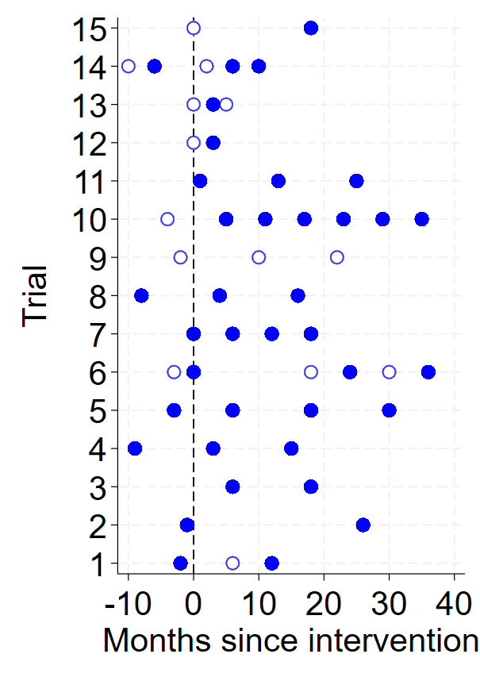

S2 Figure: The number of study years incidence was collected for in trials that provided incidence data. Horizontal dash: intervention roll out period.
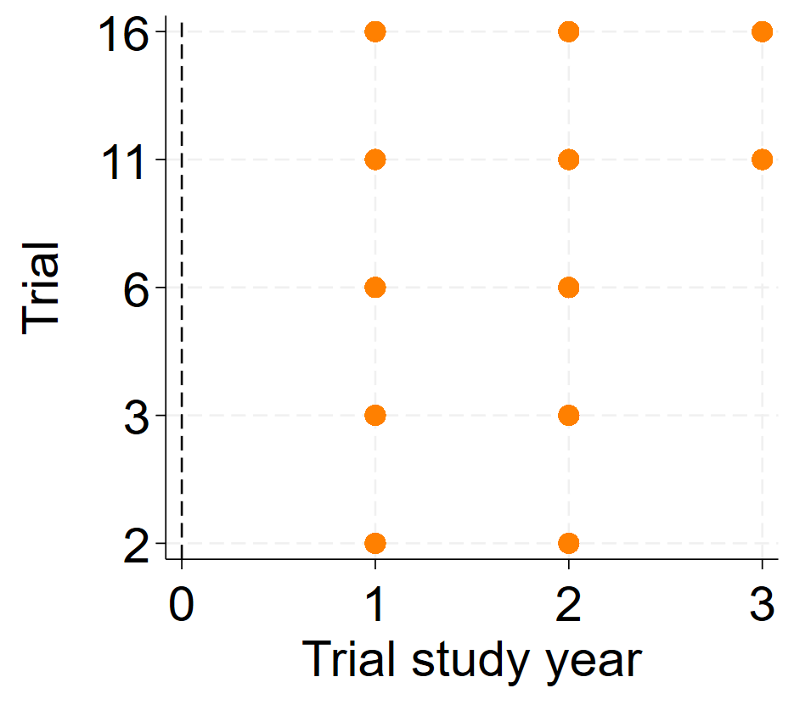

S3 Figure: Heat plot of cluster-level malaria (A) prevalence and (B) incidence outcomes stratified by time period among the included trials. Incidence aggregated for each year and corresponds to the number of new malaria cases per person year (pp pa).
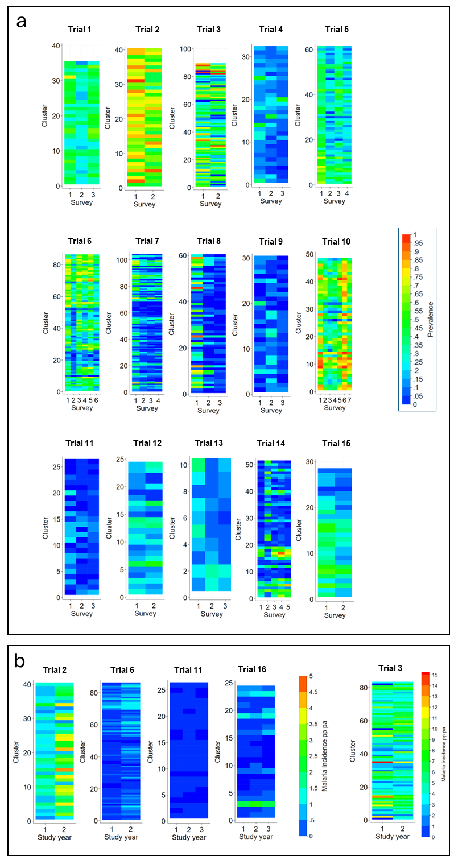
S4 Figure: Empirical autocorrelation parameters in malaria CRTs measuring incidence outcomes. A: Distribution of empirical CAC estimates for all consecutive study-year pairs. B: Trial-specific CAC estimates by time period (consecutive study year pair). Error bars: 95%CIs. Horizontal lines represent overall CAC parameters accounting for time period under different correlation structures: exchangeable (solid line), nested-exchangeable (long-dashed line) and exponential decay (short-dashed line). CAC: cluster autocorrelation coefficient.
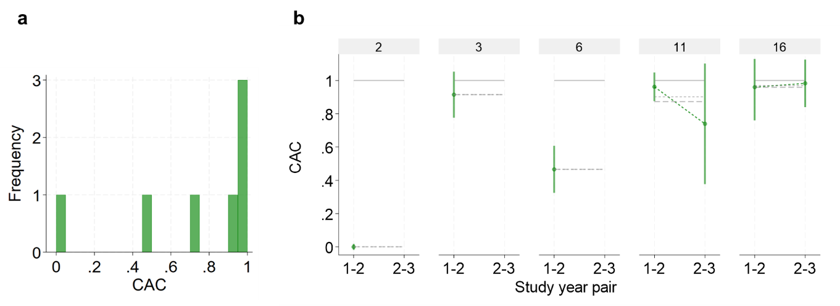

S5 Figure: Empirical correlation parameters (wpICC, bpICC and CAC) measured between baseline and subsequent post-intervention surveys. Correlation parameters (A: wpICC, B: bpICC and C: CAC) for prevalence outcomes estimated between baseline and all subsequent post-intervention surveys stratified by trial. Error bars: 95%CIs. WpICC: within-period intra-cluster correlation coefficient, bpICC: between-period intra-cluster correlation coefficient, CAC: cluster autocorrelation coefficient. Filled marker colour: Both surveys were conducted in the wet season. Partially filled marker colour: Surveys conducted in different seasons. Grey marker colour: Both surveys conducted in the dry season. In trials 6, 13, and 14, post-intervention surveys were conducted in the same and different seasons to the baseline.
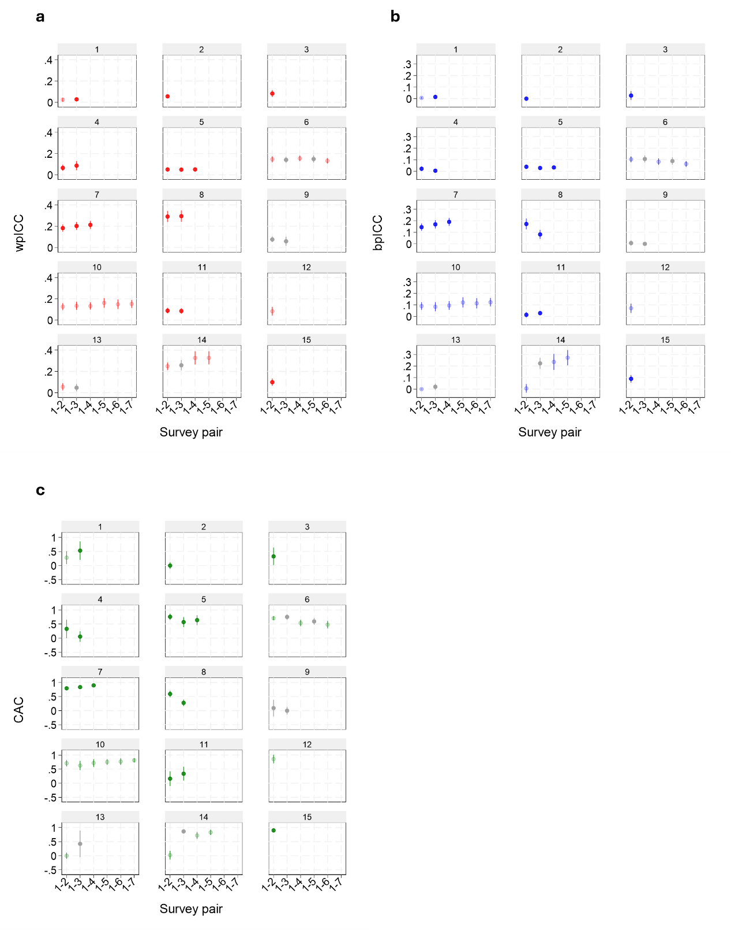

S6 Figure: Factors associated with empirical correlation patterns: wpICC (a), bpICC (b) and CAC (c) in malaria CRTs. Survey pair prevalence: the overall malaria prevalence in across consecutive pair of surveys in trials. Total clusters: the total number of clusters in each trial. Mean N tested per cluster: the average number of individuals surveyed per cluster. Survey pair seasons: Whether consecutive pairs of trial surveys were conducted in the same or different seasons (malaria/non-malaria). Survey pair time interval: calendar time between consecutive surveys categorised as </> 1 year. Error bars: 95%CIs. Rho: Spearman’s correlation coefficient. **: p-value<0.01. Violin plot depicting the range (bars), interquartile range (box) and median (white dot).

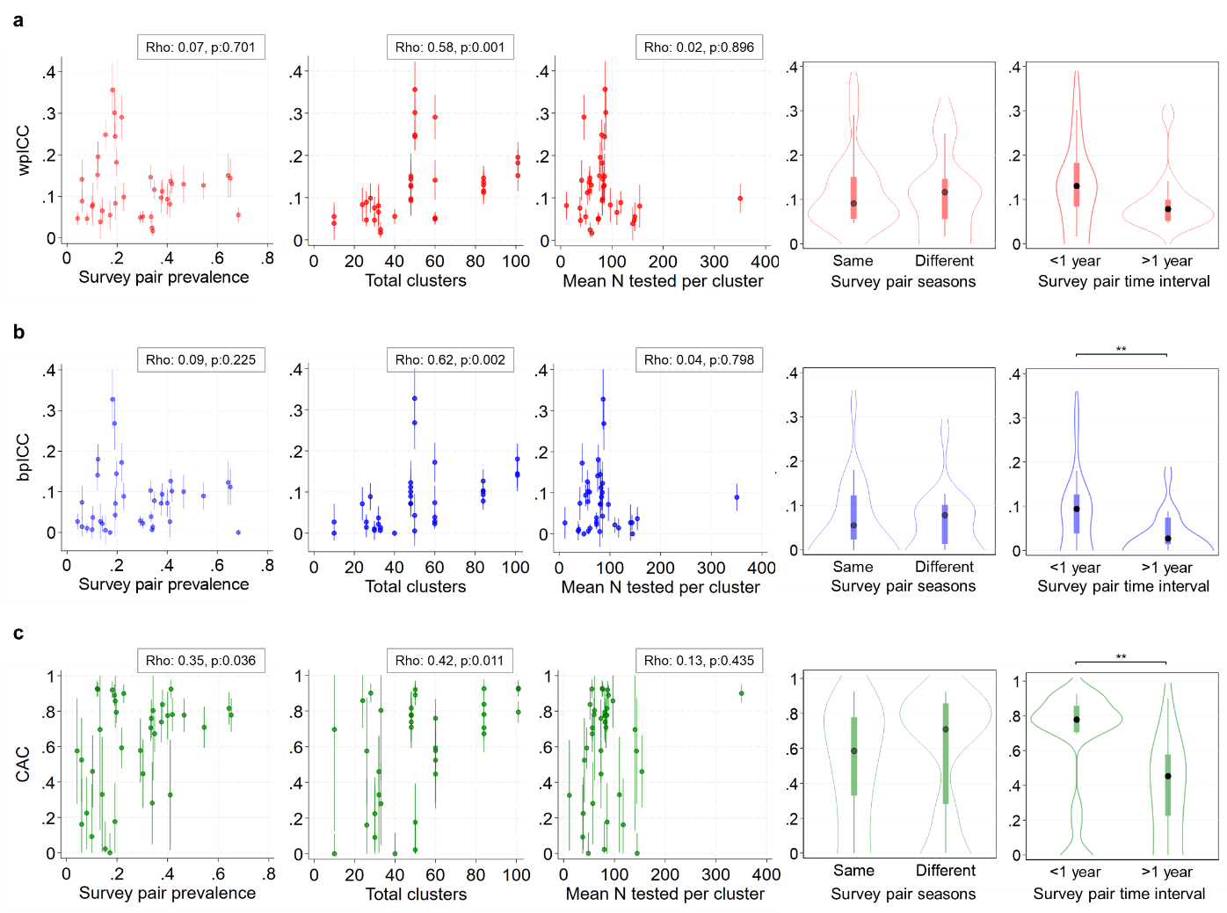

S7 Figure: Distributions of trial-specific cluster-level prevalence distributions with top/bottom 5 percentile of clusters flagged for exclusion according to baseline prevalence in malaria CRTs. A: Trial-specific baseline prevalence cluster distributions with clusters flagged for exclusion in red. B: Trial-specific cluster distributions for all surveys with clusters flagged for exclusion in red.
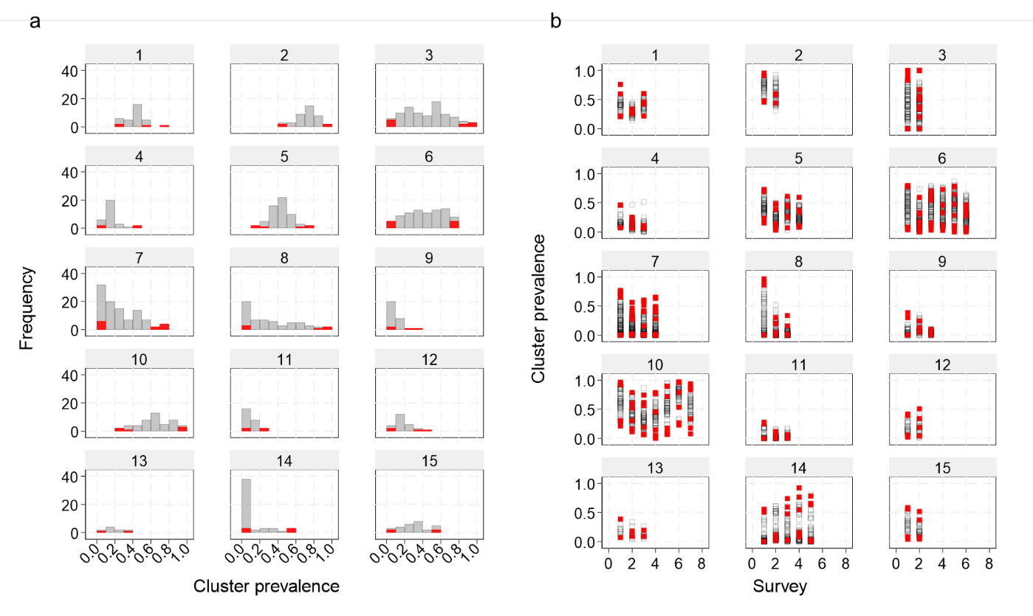

S8 Figure : A: The effect of excluding/not excluding clusters according to the top/bottom 5% prevalence percentile at baseline on the coefficient of variation (CV) of prevalence in the 15 malaria CRTs that included prevalence data. Dots: trial surveys. B: Scatter plot comparing the trial and survey specific reduction in prevalence CV after excluding clusters according to outlier prevalence values to the trials overall empirical CAC estimate. Dots above the red line depict surveys that experienced a reduction in the CV after cluster exclusion. CAC estimated according to nested-exchangeable correlation structure.

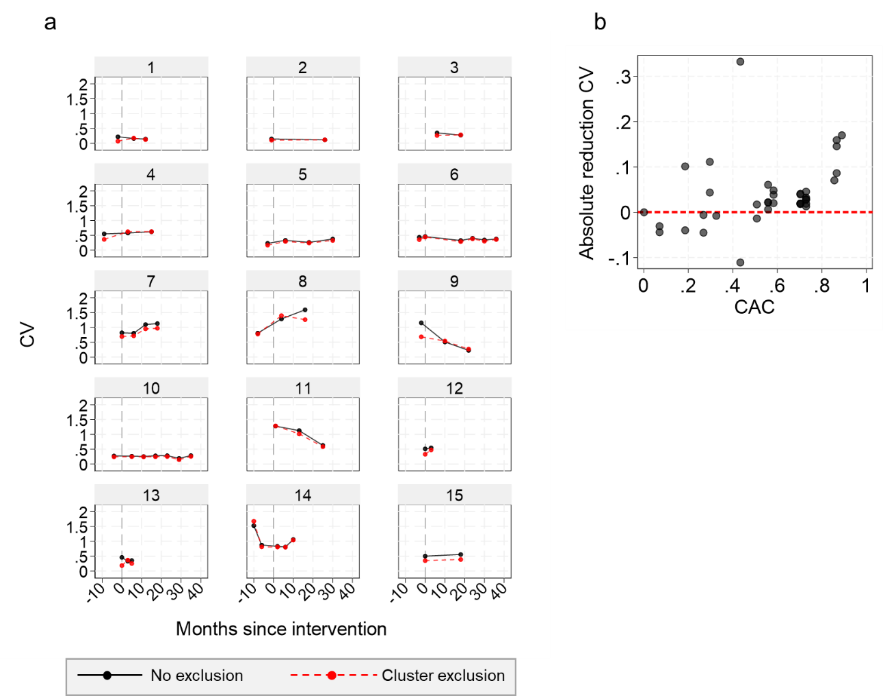

S9 Figure: The effect of excluding clusters according to the top/bottom 5% prevalence percentile at baseline on the coefficient of variation (CV) of incidence in the 4 malaria CRTs that measured prevalence and incidence in the same study clusters. A: Cluster-level incidence for each study year of the trial with clusters flagged for exclusion (red)according to the top/bottom 5% percentile prevalence at baseline. B: The effect of excluding/not excluding flagged clusters according to the top/bottom 5% prevalence percentile at baseline on the coefficient of variation (CV) of incidence in the 4 malaria CRTs that included prevalence and incidence data. Pp pa: per person per annum.
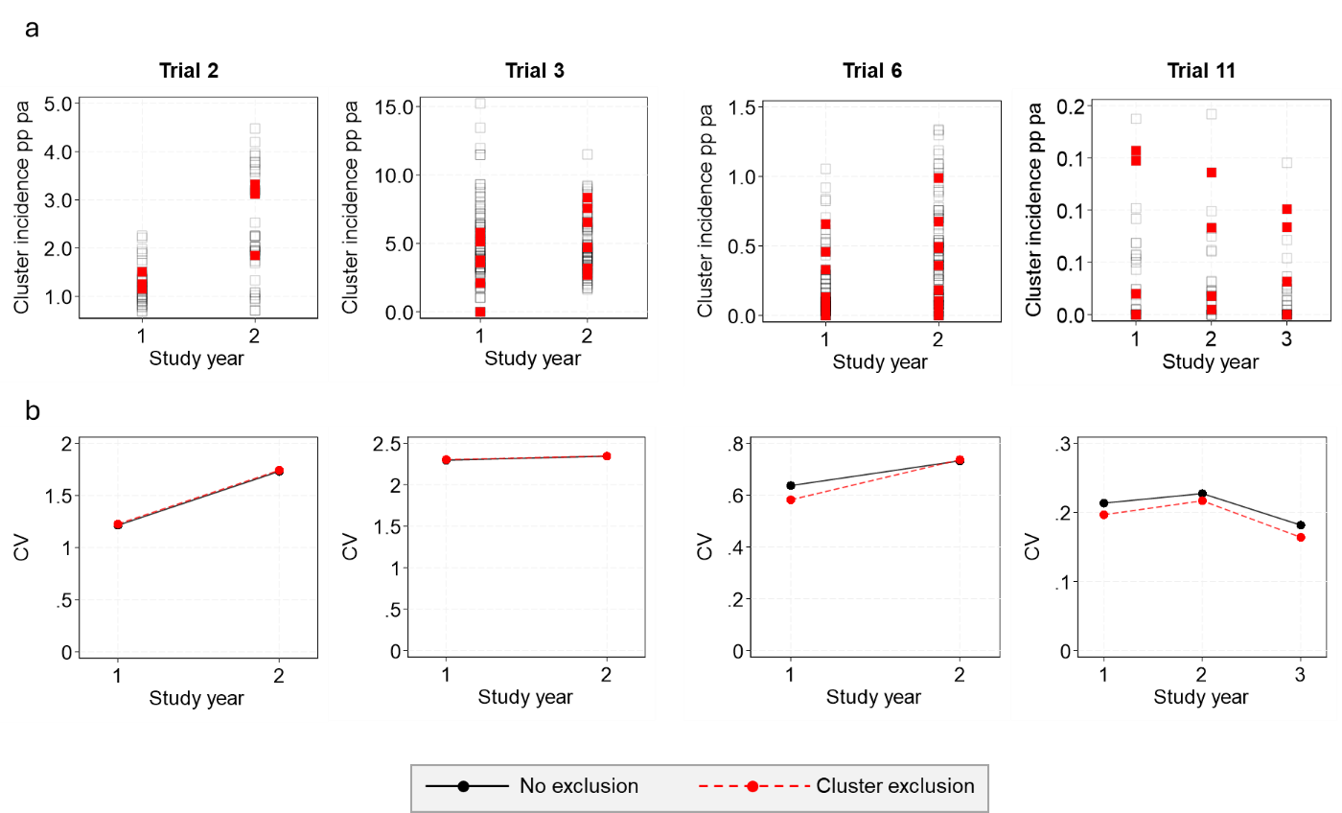

S10 Figure: Empirical coefficient of variation (CV) of prevalence estimates for trial-specific post-intervention surveys generated from models with/without adjustment for baseline cluster-level prevalence by time since intervention roll out. Horizontal line: Intervention roll out period.
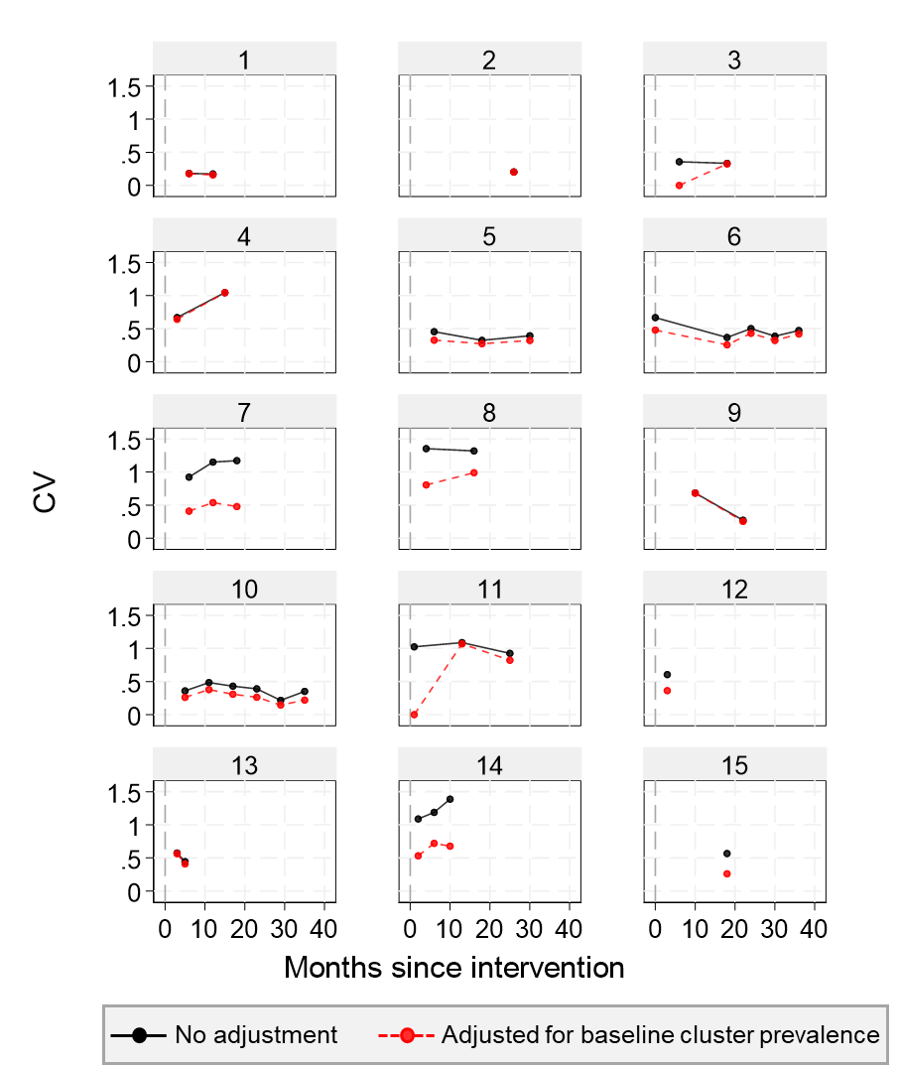

S11 Figure: Relative efficiency (proportional reduction in treatment effect standard errors) gained by adjusting for baseline cluster-level prevalence (black) or baseline cluster-level strata group into tow equal high/low strata (blue) among post-intervention surveys compared to the trials overall CAC estimate. Relative efficiency >0 indicates a reduction in treatment effect standard error.

S12 Figure: The effect of adjusting malaria incidence post-intervention treatment effects by baseline cluster-level prevalence in malaria CRTs that measured both outcomes in the same study clusters. A: The trial and study year specific estimates of the incidence coefficient of variation obtained from models with/without adjustment for baseline cluster-level prevalence. B: Incidence treatment effect relative efficiency (proportional reduction in treatment effect standard errors) gained by adjusting for baseline cluster-level prevalence among all study years and trials. Surveys with RE>0 depict reductions in the SE.
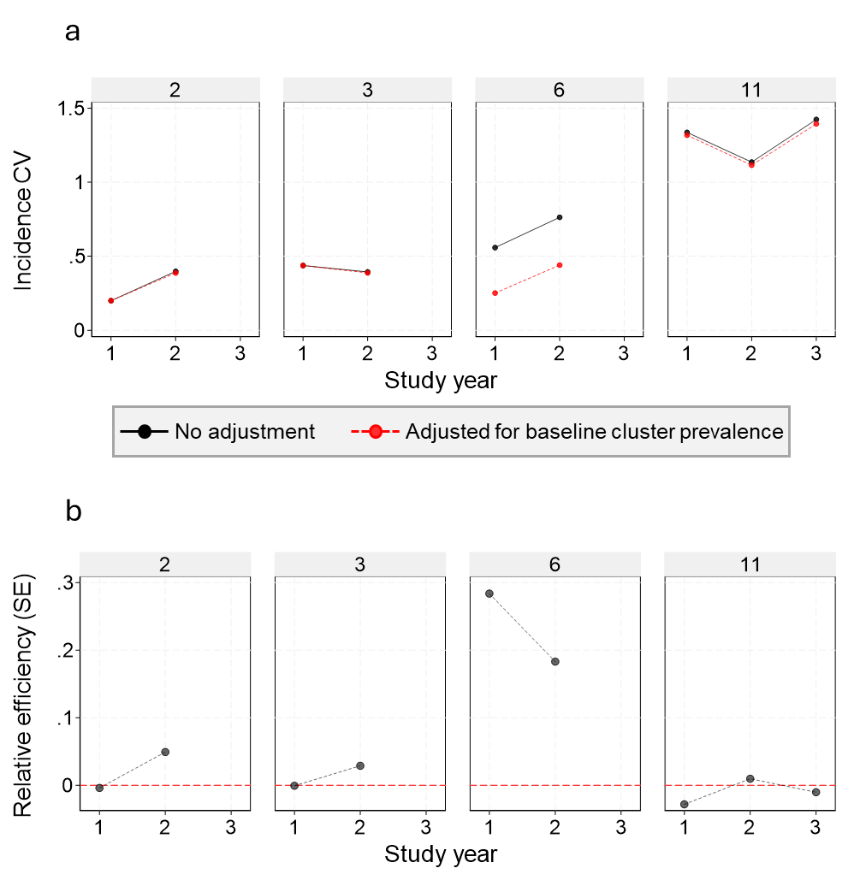

S13 Figure: Scatter plots comparing the baseline cluster-level prevalence and annually aggregated cluster-level incidence for study years 1 (green), 2 (blue) and 3 (red) among trials that measured both outcomes. Pp pa: per person per annum.
