Simultaneous determination of 20 veterinary drugs in grass carp Yanyan Yang, Na Li, Aiying Wang, Aijing Chen, Hongcai Liu, Mengmeng Wu, Chao Wang, Dong Sun*
Shandong Freshwater Fisheries Research Institute, Jinan 250117, Shandong, China.

*Corresponding authors. Tel.: +86 15253108061.
E-mail address: yyyfei310@126.com; gaosundong@163.com.

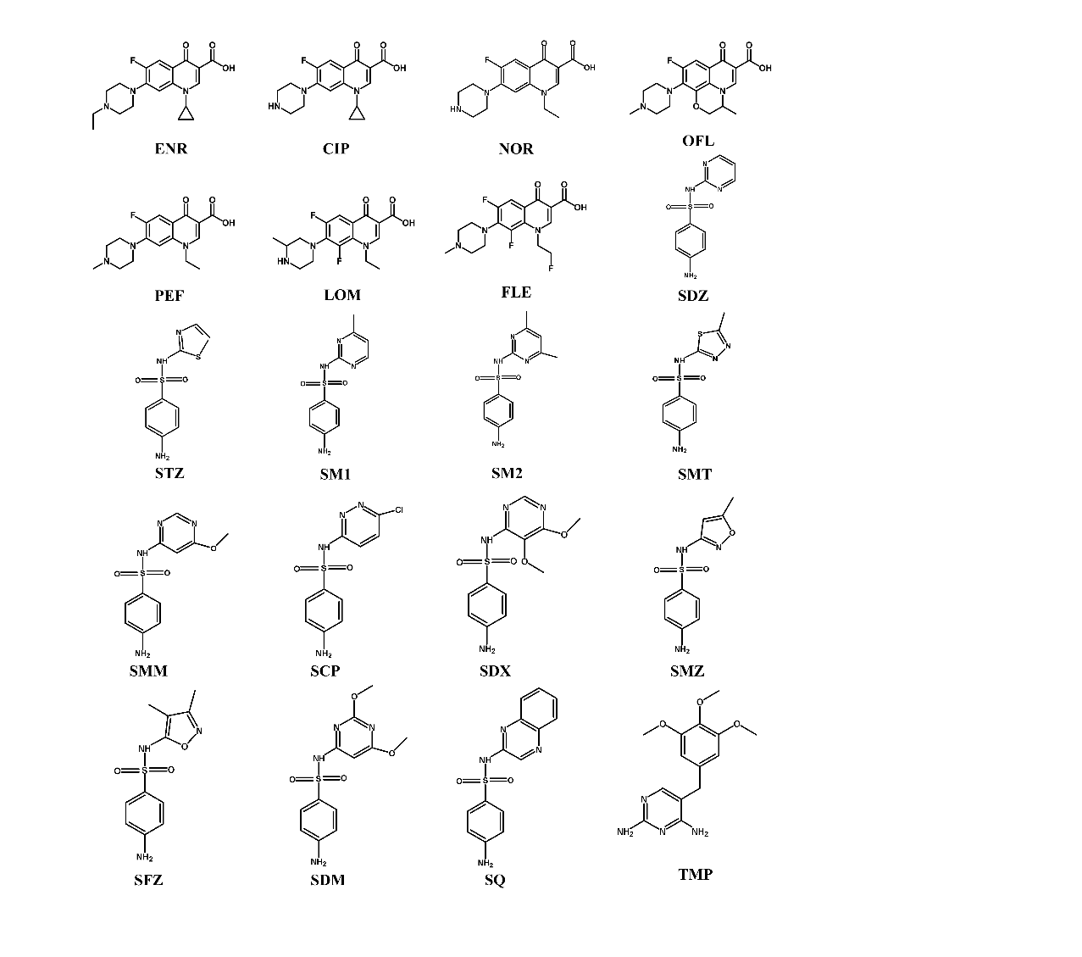
Figure S1. The structural formulas of 20 veterinary drugs

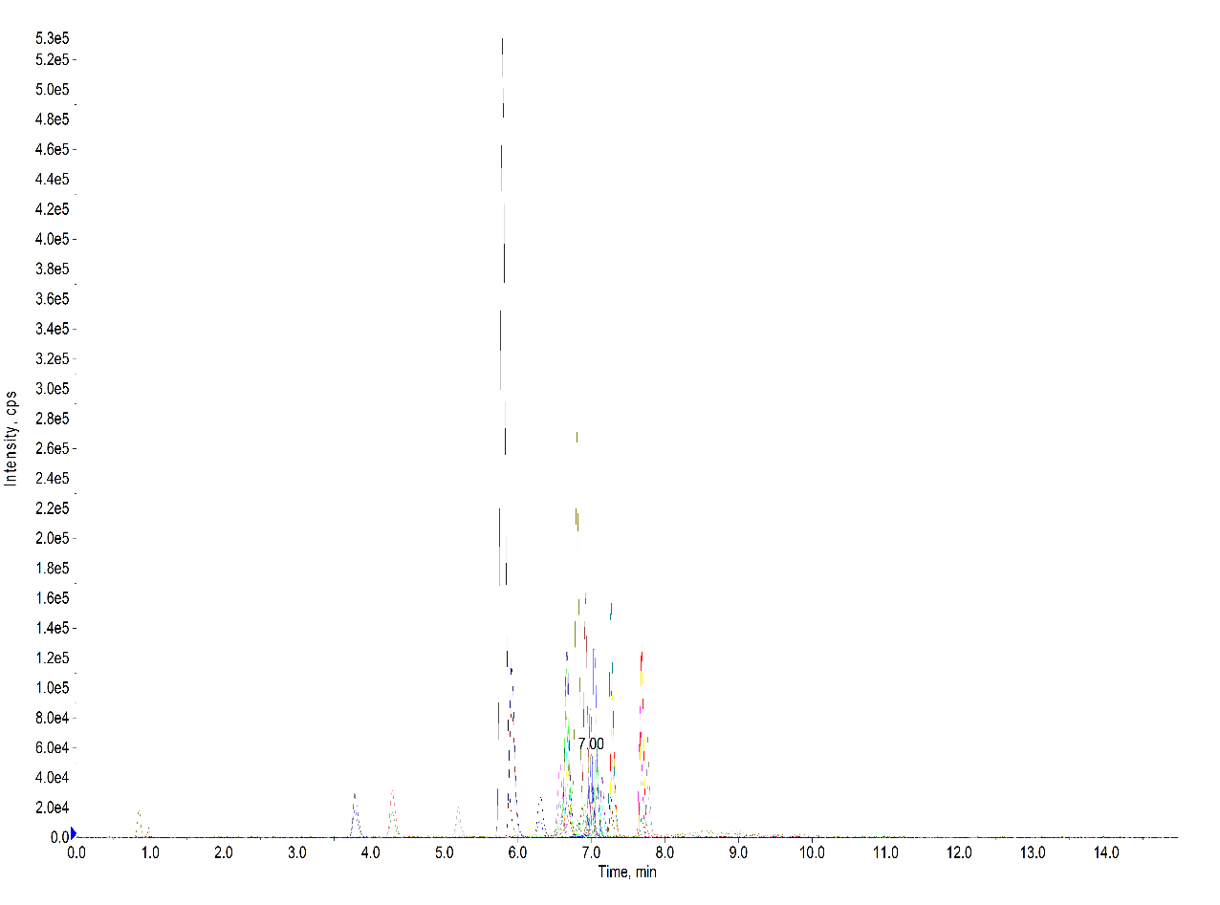
Figure S2. Ion chromatograms of 20 veterinary drugs at a concentration of 5 µg/L
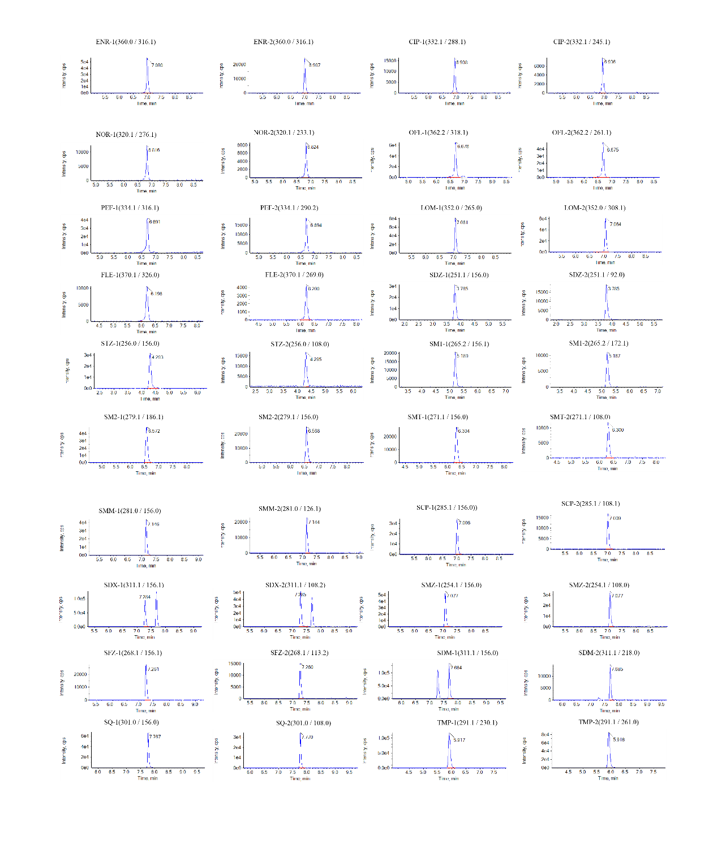
Figure S3. Extracted ion chromatograms of 20 veterinary drugs at a concentration of 5 µg/L

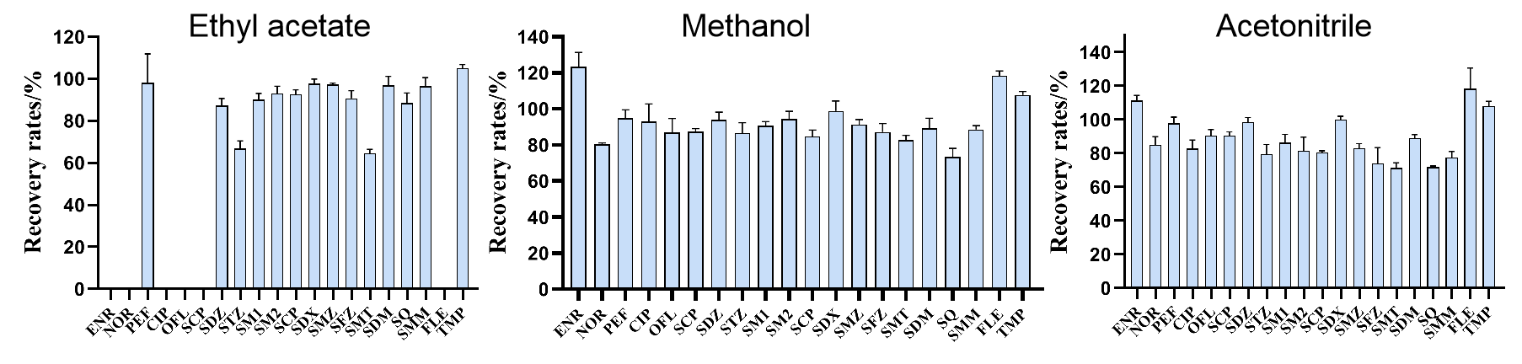
Figure S4. Comparison of average recovery rates for 20 veterinary drugs using different extraction solvents. The error bars represent the relative standard deviations (RSDs) for each veterinary drug at different extraction method.

Table S1. Average Peak Areas and Matrix Effects (ME) of 20 Veterinary Drugs Using External Standard Calibration
Compound | Concentration/  (ng/mL) |  |  | Average signal peak areas (n=4) |  |  |  |  |  | ME/%
Compound |  |  |  | B |  |  | A
ENR | 5 | 20 | 50 | 641500 | 2293000 | 5592000 | 215100 | 953300 | 2253000 | 331.3 | 291.6 | 294.2
NOR | 5 | 20 | 50 | 89090 | 336500 | 875000 | 47280 | 189100 | 410700 | 323.9 | 285.9 | 286.4
PEF | 5 | 20 | 50 | 706900 | 2805000 | 6826000 | 213400 | 961900 | 2320000 | 298.2 | 240.5 | 248.2
CIP | 5 | 20 | 50 | 101900 | 391000 | 970900 | 56140 | 241200 | 521300 | 266.5 | 230.4 | 230.7
OFL | 5 | 20 | 50 | 797400 | 2970000 | 7247000 | 299200 | 1289000 | 3141000 | 188.4 | 177.9 | 213.1
FLE | 5 | 20 | 50 | 191100 | 749100 | 1862000 | 59000 | 262000 | 650100 | 181.5 | 169.4 | 186.5
LOM | 5 | 20 | 50 | 525200 | 1969000 | 4900000 | 293700 | 1162000 | 2628000 | 178.8 | 162.1 | 186.2
SDZ | 5 | 20 | 50 | 169300 | 700600 | 1873000 | 144200 | 633900 | 1635000 | 127.5 | 116.0 | 114.6
STZ | 5 | 20 | 50 | 209300 | 792600 | 2128000 | 164200 | 719900 | 1983000 | 117.4 | 115.1 | 113.9
SM1 | 5 | 20 | 50 | 92840 | 405900 | 1078000 | 90100 | 349900 | 1014000 | 117.1 | 113.9 | 111.1
SM2 | 5 | 20 | 50 | 289000 | 1215000 | 3110000 | 246800 | 1067000 | 2854000 | 115.5 | 110.5 | 109.0
SCP | 5 | 20 | 50 | 143900 | 590500 | 1527000 | 125700 | 568000 | 1475000 | 114.5 | 110.1 | 107.6
SDX | 5 | 20 | 50 | 319200 | 1223000 | 3194000 | 301400 | 1218000 | 3222000 | 113.0 | 108.8 | 107.3
SMZ | 5 | 20 | 50 | 196200 | 807100 | 1982000 | 190100 | 777900 | 2062000 | 105.9 | 108.1 | 106.3
SFZ | 5 | 20 | 50 | 90190 | 406900 | 1044000 | 94290 | 393800 | 1011000 | 104.9 | 107.3 | 103.5
SMT | 5 | 20 | 50 | 166200 | 660700 | 1719000 | 147100 | 607200 | 1597000 | 104.5 | 104.0 | 103.4
SDM | 5 | 20 | 50 | 483900 | 1979000 | 5069000 | 419100 | 1720000 | 4561000 | 103.2 | 103.8 | 103.3
SQ | 5 | 20 | 50 | 207500 | 815400 | 2205000 | 198500 | 792600 | 2132000 | 103.0 | 103.3 | 100.3
SMM | 5 | 20 | 50 | 140600 | 562100 | 1500000 | 142800 | 524000 | 1495000 | 98.5 | 102.9 | 99.1
TMP | 5 | 20 | 50 | 611200 | 2272000 | 5564000 | 582400 | 2102000 | 4883000 | 95.7 | 100.4 | 96.1

