Supplementary Materials
Nonlinear Symptom Escalation and Residual Burden After Recovery in Adolescent Depression:
Cross-Validated Trajectory Analysis in 2,809 Chinese Adolescents
This file contains Figures S1–S2 and Tables S1–S5.
Figure S1. Five-step analytic framework.
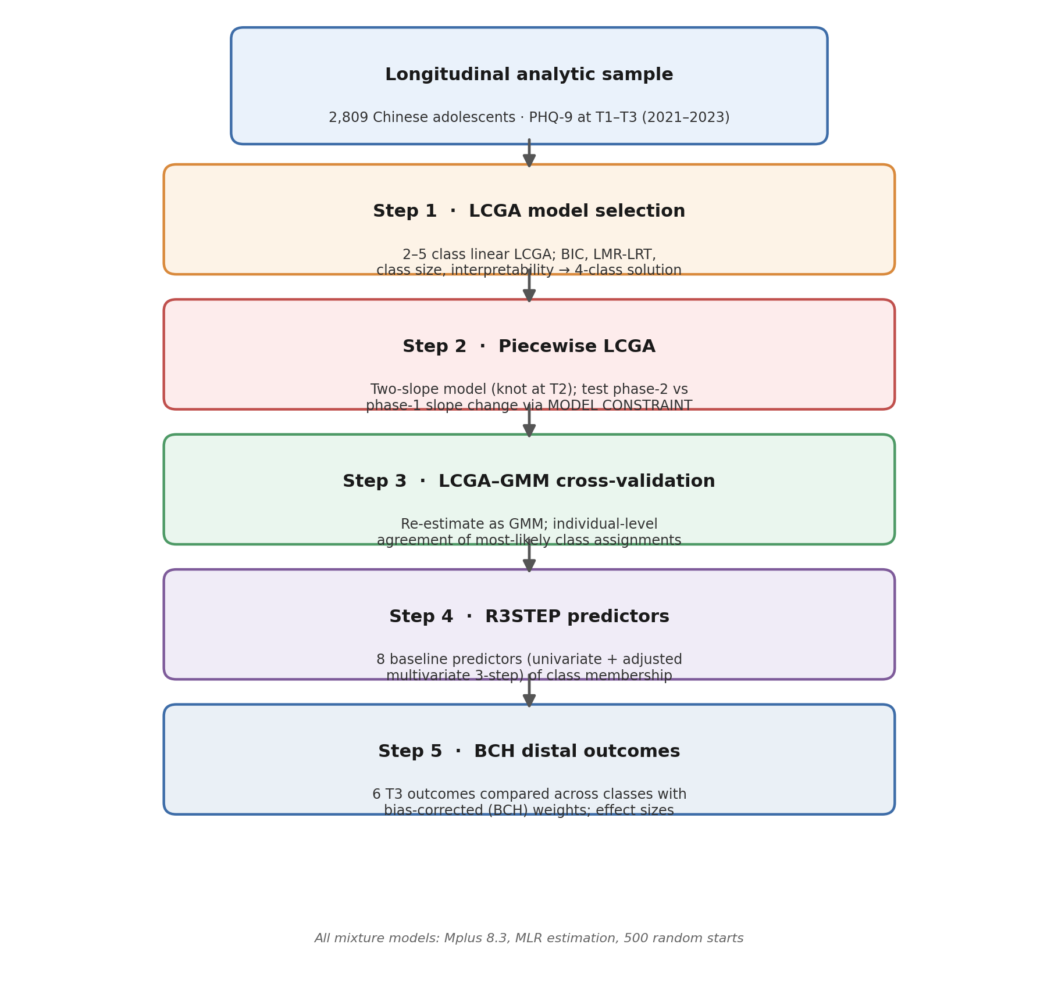
All mixture models were estimated in Mplus 8.3 with robust maximum likelihood (MLR) estimation, 500 random starts, and 100 final-stage optimizations. The four-class solution retained in Step 1 was carried forward through Steps 2–5.
Table S1. Summary of missing data (analytic sample, N = 2,809).
Variable | N total | N valid | N missing | % missing
PHQ-9 (T1, 2021) | 2,809 | 2,809 | 0 | 0.0
PHQ-9 (T2, 2022) | 2,809 | 2,809 | 0 | 0.0
PHQ-9 (T3, 2023) | 2,809 | 2,809 | 0 | 0.0
Gender | 2,809 | 2,809 | 0 | 0.0
School stage | 2,809 | 2,809 | 0 | 0.0
Family SES | 2,809 | 2,803 | 6 | 0.2
Family functioning (APGAR) | 2,809 | 2,803 | 6 | 0.2
Only-child status ᵃ | 2,809 | 2,803 | 6 | 0.2
Parental education ᵇ | 2,809 | 2,685 | 124 | 4.4
GAD-7 (T1) | 2,809 | 2,809 | 0 | 0.0
ISI (T1) | 2,809 | 2,809 | 0 | 0.0
Self-harm (T3) | 2,809 | 2,809 | 0 | 0.0
GAD-7 (T3) | 2,809 | 2,809 | 0 | 0.0
ISI (T3) | 2,809 | 2,809 | 0 | 0.0
Life satisfaction (T3) | 2,809 | 2,809 | 0 | 0.0
Loneliness (T3) | 2,809 | 2,809 | 0 | 0.0
Resilience (T3) | 2,809 | 2,809 | 0 | 0.0
Suicidal ideation (T3) ᶜ | 2,809 | 2,809 | 0 | 0.0
Note. PHQ-9 total scores were complete at all three waves; missing data affected only baseline predictors, handled by listwise deletion within each model. ᵃ Table 1 percentages use the valid N (1,669/2,803 = 59.5%). ᵇ The response option “unclear” (n = 118) was recoded as missing because it is not an educational level; with 6 originally missing this yields 124 missing and a valid N of 2,685, the sample for the multivariate model. ᶜ PHQ-9 item 9; reported descriptively only (Table 2) and never entered as a distal outcome, as it is embedded in the PHQ-9 total that defines the trajectories.
Table S2. Univariate and multivariate R3STEP associations of baseline predictors with trajectory membership (reference = Low-Stable).
Predictor | Trajectory | Univariate OR [95% CI] | Univ. p | Adjusted OR [95% CI] | Adj. p | Change ᵃ
Gender (female) | Worsening | 1.50 [1.20, 1.89] | <.001 | 1.50 [1.17, 1.92] | .002 | Sig→Sig
 | Improving | 1.91 [1.34, 2.73] | <.001 | 1.39 [0.81, 2.39] | .227 | Sig→ns
 | High-Increasing | 1.68 [1.13, 2.48] | .010 | 1.39 [0.88, 2.20] | .160 | Sig→ns
School stage (senior) | Worsening | 1.31 [1.04, 1.64] | .022 | 0.98 [0.77, 1.26] | .894 | Sig→ns
 | Improving | 1.34 [0.94, 1.90] | .101 | 0.83 [0.48, 1.44] | .502 | ns→ns
 | High-Increasing | 0.97 [0.65, 1.45] | .896 | 0.55 [0.34, 0.90] | .017 | ns→Sig
Family SES | Worsening | 0.68 [0.57, 0.81] | <.001 | 0.72 [0.58, 0.90] | .004 | Sig→Sig
 | Improving | 0.75 [0.53, 1.06] | .105 | 1.13 [0.74, 1.73] | .568 | ns→ns
 | High-Increasing | 0.95 [0.68, 1.31] | .733 | 1.08 [0.73, 1.60] | .704 | ns→ns
Family functioning | Worsening | 0.81 [0.77, 0.84] | <.001 | 0.89 [0.84, 0.94] | <.001 | Sig→Sig
 | Improving | 0.63 [0.59, 0.68] | <.001 | 0.87 [0.78, 0.96] | .004 | Sig→Sig
 | High-Increasing | 0.70 [0.65, 0.76] | <.001 | 0.81 [0.74, 0.89] | <.001 | Sig→Sig
Only-child status | Worsening | 0.84 [0.67, 1.05] | .131 | 0.94 [0.72, 1.21] | .615 | ns→ns
 | Improving | 0.91 [0.64, 1.29] | .590 | 0.83 [0.48, 1.42] | .491 | ns→ns
 | High-Increasing | 1.44 [0.94, 2.19] | .092 | 1.76 [1.02, 3.02] | .042 | ns→Sig
Parental education | Worsening | 0.90 [0.82, 0.99] | .027 | 0.96 [0.87, 1.07] | .482 | Sig→ns
 | Improving | 1.03 [0.88, 1.21] | .733 | 0.95 [0.77, 1.18] | .662 | ns→ns
 | High-Increasing | 1.02 [0.86, 1.20] | .835 | 0.98 [0.81, 1.19] | .852 | ns→ns
Baseline anxiety (GAD-7) | Worsening | 1.20 [1.16, 1.24] | <.001 | 1.10 [1.06, 1.15] | <.001 | Sig→Sig
 | Improving | 1.77 [1.67, 1.87] | <.001 | 1.57 [1.47, 1.68] | <.001 | Sig→Sig
 | High-Increasing | 1.43 [1.35, 1.52] | <.001 | 1.29 [1.20, 1.38] | <.001 | Sig→Sig
Baseline insomnia (ISI) | Worsening | 1.20 [1.16, 1.25] | <.001 | 1.12 [1.07, 1.16] | <.001 | Sig→Sig
 | Improving | 1.60 [1.50, 1.70] | <.001 | 1.34 [1.25, 1.44] | <.001 | Sig→Sig
 | High-Increasing | 1.35 [1.28, 1.42] | <.001 | 1.17 [1.10, 1.24] | <.001 | Sig→Sig
Note. Univariate models were estimated one predictor at a time (N = 2,809; parental education N = 2,685). The multivariate model entered all eight predictors simultaneously (manual three-step; N = 2,685, 27 free parameters). All p-values are logit-scale Wald tests. ᵃ Change in significance at α = .05 from the univariate to the adjusted model (Sig = p < .05; ns = p ≥ .05). Three associations changed materially after adjustment: gender→Improving/High-Increasing and parental education→Worsening lost significance, whereas school stage→High-Increasing and only-child→High-Increasing gained significance (suppression).
Figure S2. Univariate versus multivariate (adjusted) R3STEP odds ratios, by trajectory (reference = Low-Stable).
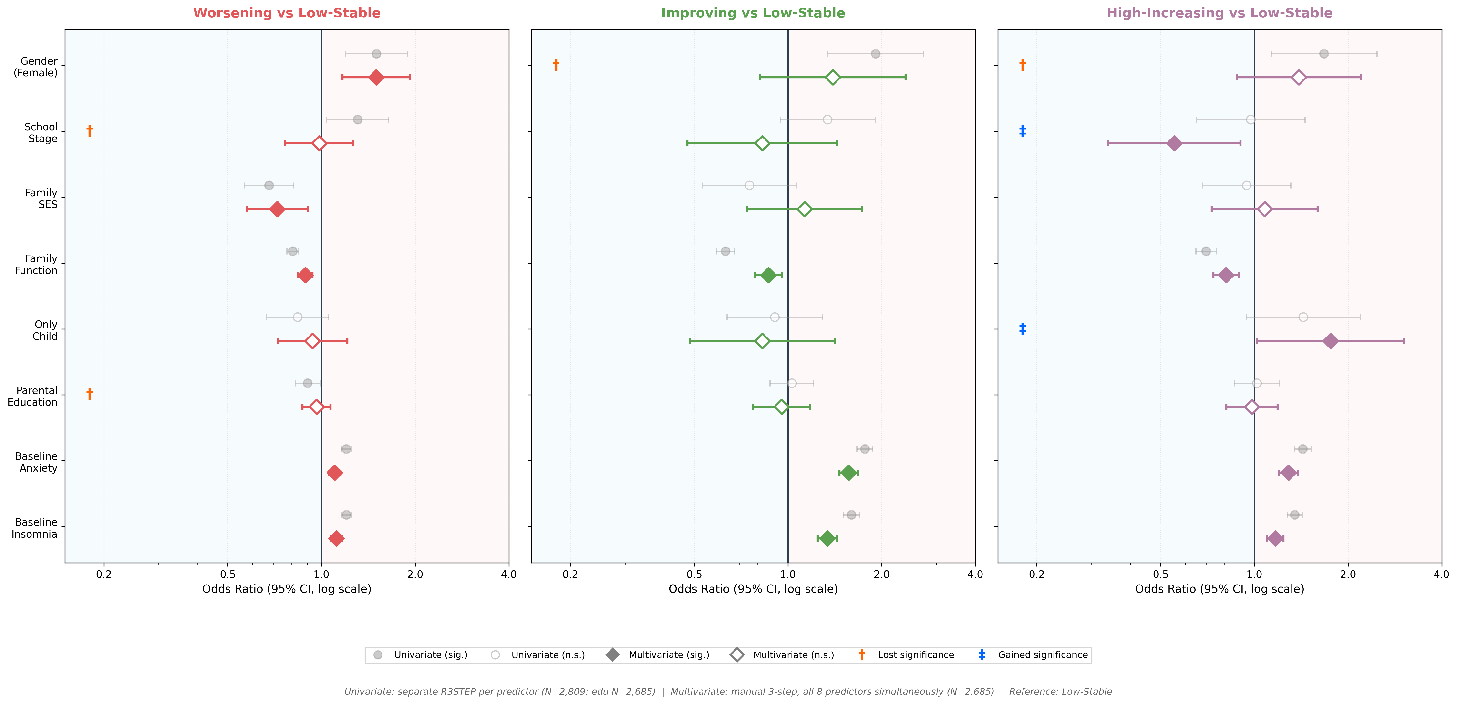
Note. Filled markers denote p < .05; open markers p ≥ .05 (logit-scale Wald test). Daggers (†) mark associations that lost significance after mutual adjustment; double daggers (‡) mark associations that gained significance (suppression effects: school stage→High-Increasing and only-child→High-Increasing). Odds ratios are plotted on a log scale.
Table S3. Longitudinal measurement invariance of the PHQ-9 across the three waves.
Model | χ² (df) | CFI | TLI | RMSEA [90% CI] | SRMR | ΔCFI | ΔRMSEA | Scaled Δχ² (Δdf), p | Decision
1. Configural | 1,255.36 (294) | .957 | .948 | .034 [.032, .036] | .026 | — | — | — (baseline) | Baseline
2. Metric | 1,269.59 (310) | .957 | .951 | .033 [.031, .035] | .027 | .000 | −.001 | 25.76 (16), .058 | Supported
3. Scalar | 1,360.20 (326) | .953 | .950 | .034 [.032, .035] | .028 | −.004 | +.001 | 105.90 (16), <.001 | Supported ᵃ
Note. MLR estimation; three correlated factors (one per wave) with same-item residual covariances across waves. Invariance was judged a priori by incremental-fit criteria (|ΔCFI| ≤ .010, |ΔRMSEA| ≤ .015); Satorra–Bentler scaled Δχ² values are reported for completeness. ᵃ Although the scaled Δχ² for scalar invariance was significant (expected at this sample size), ΔCFI = −.004 and ΔRMSEA = +.001 both met the fit-based criteria, so scalar invariance was supported. Factor loadings and item intercepts were therefore stable over time.
Table S4. Growth mixture model (GMM) class enumeration.
Classes | Log-likelihood | Free params | AIC | BIC | aBIC | Entropy
3 | −23,959.69 | 12 | 47,943.37 | 48,014.66 | 47,976.53 | .914
4 | −23,854.13 | 15 | 47,738.26 | 47,827.37 | 47,779.71 | .868
5 | −23,701.58 | 18 | 47,439.16 | 47,546.10 | 47,488.90 | .921
Note. GMM freely estimated the within-class intercept variance (slope variance fixed at zero, as three occasions cannot support both). Unlike LCGA, GMM enumeration was less decisive: BIC continued to decrease through the five-class solution and the Lo–Mendell–Rubin adjusted LRT comparing three versus four classes was non-significant (p = .112). GMM is used here only to cross-validate the LCGA classification, not to re-select the number of classes; individual-level agreement between the four-class LCGA and GMM solutions was 97.0% (2,726/2,809). aBIC = sample-size-adjusted BIC.
Table S5. Internal consistency (Cronbach’s α) of the PHQ-9, GAD-7, and ISI at each wave.
Scale | Wave | Items (k) | Valid N | Cronbach’s α | 95% CI | Interpretation
PHQ-9 | T1 (2021) | 9 | 2,809 | .886 | [.880, .893] | Good
GAD-7 | T1 (2021) | 7 | 2,809 | .911 | [.906, .916] | Excellent
ISI | T1 (2021) | 7 | 2,809 | .843 | [.833, .851] | Good
PHQ-9 | T2 (2022) | 9 | 2,809 | .885 | [.878, .891] | Good
GAD-7 | T2 (2022) | 7 | 2,809 | .918 | [.913, .922] | Excellent
ISI | T2 (2022) | 7 | 2,809 | .856 | [.848, .864] | Good
PHQ-9 | T3 (2023) | 9 | 2,809 | .913 | [.908, .918] | Excellent
GAD-7 | T3 (2023) | 7 | 2,809 | .939 | [.936, .943] | Excellent
ISI | T3 (2023) | 7 | 2,809 | .886 | [.879, .892] | Good
Note. All scales showed good-to-excellent internal consistency at every wave.

