Supporting Information
Adsorbate-induced Active Site in Zeolite
Guangchao Li^{1,2,3}, Christopher Foo^{2,5}, Xianfeng Yi¹, Wei Chen¹, Pu Zhao², Pan Gao⁴, Tatchamapan Yoskamtorn², Yao Xiao ^{1,3}, Sarah Day⁵, Chiu C. Tang⁵, Guangjin Hou⁴, Anmin Zheng^{1*}, S.C. Edman Tsang^{2*}
¹State Key Laboratory of Magnetic Resonance and Atomic and Molecular Physics, National Center for Magnetic Resonance in Wuhan, Wuhan Institute of Physics and Mathematics, Innovation Academy for Precision Measurement Science and Technology, Chinese Academy of Sciences, Wuhan, PR China
²Wolfson Catalysis Centre, Department of Chemistry, University of Oxford, Oxford OX1 3QR, U.K.
³University of Chinese Academy of Sciences, Beijing, PR China
⁴State Key Laboratory of Catalysis, National Laboratory for Clean Energy, 2011-Collaborative Innovation Center of Chemistry for Energy Materials, Dalian Institute of Chemical Physics, Chinese Academy of Sciences, Dalian, PR China
⁵Diamond Light Source Ltd., Harwell Science and Innovation Campus, Didcot, OX11 0DE, U.K
*Email: edman.tsang@chem.ox.ac.uk (S. C. E. Tsang); zhenganm@wipm.ac.cn (A. M. Zheng)

This PDF file includes:

Materials and Methods
Supplementary results
Figs. S1 to S17
Scheme S1
Tables S1 to S9

- Materials and Methods
- Chemicals
Zeolites of H-SAPO-34, H-SAPO-18, H-SAPO-35 and H-SSZ-13 were obtained from State Key Laboratory of Catalysis, Dalian Institute of Chemical Physics, China.
All chemicals like methanol, acetone, ¹³C-methanol, ¹⁸O-methanol, ¹³C-2-acetone, ¹³C-ethanol, D₄-methanol, D₆-acetone were commercially available (Sigma-Aldrich and Fluorochem), with 99 % purity or above, and used as received.
- Characterization techniques
Solid-state NMR experiments
Sample treatments.
At first, the samples were performed on a vacuum line (Fig. S1) for dehydration. The temperature was gradually increased at a rate of 1K/min and the samples were kept at a final temperature of 573 K at a pressure below 10⁻³ Pa over a period of 10 h. After the samples being cooled to ambient temperature, a known amount of ¹³C-acetone or ¹³C-methanol was introduced into the activated samples. The amount of probe molecules can be calculated by using the ideal gas equation: PV=nRT. Finally, the sample tubes were flame sealed. Prior to NMR experiments, the sealed sample was transferred into a ZrO₂ rotor with a Kel-F endcap under a dry nitrogen atmosphere in a glovebox.
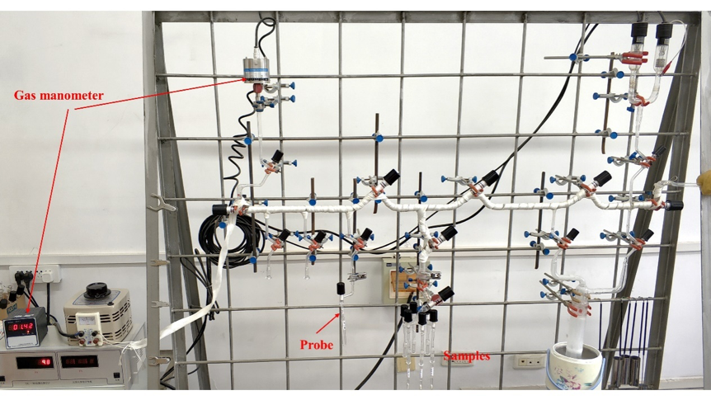
Fig. S1. The device of vacuum system for probes adsorption.
Characterization
The chemical shifts of ¹H, ¹³C, ²⁷Al, ²⁹Si ³¹P were referenced to adamantane (1.74 ppm), hexamethylbenzene (17.35 ppm for methyl groups), aqueous Al(NO₃)₃(1 M, 0 ppm), and Kaolin (-91.5 ppm), (NH₄)₂HPO₄ (1 ppm), respectively.
1 Dimensional (D) ¹H magic Angle Spinning(MAS) NMR measurements were carried out using a Bruker Avance III 400 WB spectrometer at resonance frequencies of 399.33 MHz. ¹H MAS NMR spectra were acquired on a 4 mm probe with a spinning rate of 10 kHz, a π/2 pulse length of 3.8 μs, and a recycle delay of 5 s, while the samples used for the ¹H MAS NMR studies were additionally dehydrated in vacuum at 673 K for 10 h before the measurements or the loading with the adsorption molecules.
2D ¹H-¹H single quantum-double quantum (SQ-DQ) MAS NMR experiments, double-quantum coherences were excited and reconverted with the R12$\begin{matrix}2 \\ 5\end{matrix}$ pulse sequence with ν_{1H} = 3 ν_{R}= 37.5 kHz, and the excitation and reconversion time were set to 0.48 ms. The increment interval in the indirect dimension was set to 80 μs, and 72 t1 increments and 180 scan accumulations for each t1 increment were used.
²⁷Al, ²⁹Si, ³¹P MAS NMR experiments were carried out on a Varian InfinityPlus-300 spectrometer with the Larmor frequencies of 78.16, 59.59, 121.50 MHz, respectively. ²⁷Al MAS NMR spectra were recorded with a pulse length of 0.2 µs (<π/12), a recycle delay of 1 s, and a spinning rate of 10 kHz. ²⁹Si MAS NMR spectra with high-power proton decoupling were recorded on a 7.5 mm probe with a spinning rate of 3.5 kHz, a π/2 pulse length of 5.2 μs, and a recycle delay of 80 s. Unlike the ¹H and ¹³C NMR spectra, which were obtained from dehydrated samples, the ²⁷Al and ²⁹Si MAS NMR investigations were carried out with samples that were fully hydrated at ambient temperature overnight in a desiccator. ³¹P MAS NMR spectra were recorded with a pulse length of 4.6 µs (π/2), a recycle delay of 3 s, and a spinning rate of 10 kHz.
1D ¹³C cross-polarization (CP) and all the 2D MAS NMR experiments were performed on Bruker Avance III 400 WB spectrometer at resonance frequencies of 104.22 MHz. ¹³C CP MAS NMR were acquired on a 4 mm probe with a contact time of 4 ms, a recycle delay of 2.5 s, and a sample spinning rate of 10 kHz.
2D ¹³C-¹³C proton-driven spin diffusion (PDSD) MAS NMR experiments were performed to determine the correlations between ¹³C signals. ¹H→¹³C cross polarization with a contact time of 4.8 ms was used to prepare the initial ¹³C signal. The π/2 pulse width of ¹³C is 4.9 μs and the mixing time was set to 100 ms. A TPPM-13 ¹H decoupling at 62.5kHz was applied to the acquisition time t2. The experiments were acquired with 64 scans per experiment and 360 experiments in the State-TPPI scheme.
2D ¹³C-¹H hetero-nuclear correlation MAS NMR experiments were carried out with a contact time of 4.8 ms and with a repetition time of 2 s. The Hartmann–Hahn condition was optimized by using hexamethylbenzene. High-power broad band ¹H decoupling, using the pulse scheme TPPM-13 with the amplitude of 62.5 kHz, was applied during ¹³C signal acquisition to enhance spectral resolution and sensitivity.
¹³C-²⁷Al symmetry-based rotational-echo saturation-pulse double-resonance (SRESPDOR) MAS NMR experiments were carried out with the help of a frequency splitter (REDOR-BOX), which enables tuning and matching to the Larmor frequencies of the ¹³C and ²⁷Al nuclei on the X channel of 4mm HXY MAS NMR probe at the same time. The pulse sequence of ¹³C-²⁷Al RESPDOR is shown in Scheme S1.(1) The initial ¹³C signal was prepared by ¹H→¹³C cross polarization (same condition as the previous ¹H-¹³C CP MAS experiments). SR4 dipolar recoupling was used on the ¹³C channel with ν_{nut,13C} =20 kHz. Continuous-wave ¹H decoupling with the amplitude of 62.5 kHz was used during SR4, while a SPINAL-64 (small-phase incremental alternation with 64 steps) ¹H decoupling with the amplitude of 62.5 kHz was used during acquisition. A π pulse length of 8 μs was used on the ¹³C channel. The saturation pulse on the ²⁷Al channel was divided into two pulses with duration of 75 μs (0.75 Tr) to transfer ¹³C-²⁷Al interactions. Since the S-RESPDOR experiment is extremely sensitive to the resonance offset, the ¹³C irradiation frequency was placed in the center of the observed signals (52 ppm), and the saturation pulse on the ²⁷Al channel was irradiating at 50.6 ppm, which corresponds to the tetrahedral framework Al of the H-SAPO-34 zeolite. The recycle delay was set to 3 s.
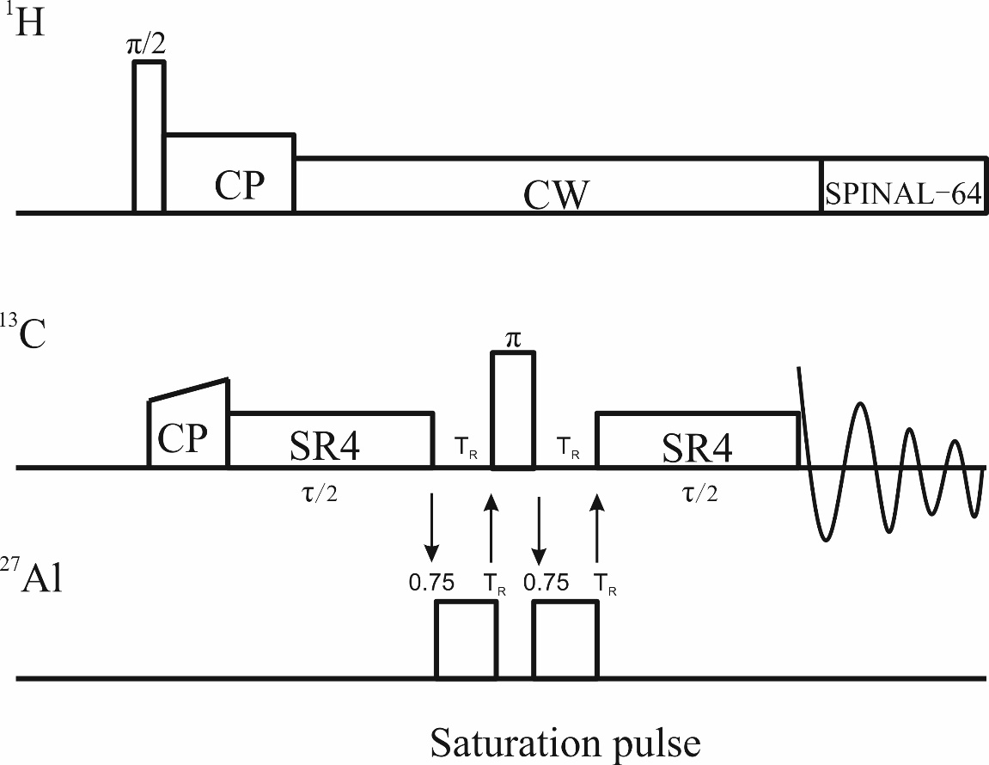
Scheme S1. Pulse sequence for ¹³C-²⁷Al SRESPDOR experiment.

Synchrotron powder X-ray diffraction (SXRD) and Neutron powder diffraction (NPD)
SXRD data were collected at Beamline I11, Diamond Light Source, Harwell, UK. The energy of the incident X-ray flux was set at 15 keV. The wavelength and 2θ-zero point were refined using a diffraction pattern obtained from a high-quality silicon powder (SRM640c). For the parent sample, H-SAPO-34 was ground and loaded in a 0.5 mm borosilicate glass capillary and then activated under vacuum at 423 K for 2 h. For the methanol-loaded and acetone-loaded samples, each sample was degassed at 473 K for 3 h under reduced pressure using a Schlenk line. The sample was then naturally cooled down to the room temperature. The sample was loaded into a quartz-type capillary with a diameter of 0.5 mm and sealed perfectly by using a flame. High-resolution SXRD data were obtained from the zeolite samples using the multi-analyser crystals (MAC) detectors. The patterns were collected in the 2θ range 0-150° with 0.003° data binning. Each MAC pattern was collected for 20 mins for good statistics.
NPD data were collected at beamline “the general purpose powder diffractometer” (GDDP), China Spallation Neutron Source (CSNS), Dongguan, China, using the time-of-flight diffractometer GPPD. Before a NPD data collection, H-SAPO-34 was dehydrated under vacuum at 573K for 24 h to remove the adsorbed water and other impurity gas molecules on the vacuum line. After cooling to the room temperature, a known amount of D₄-methanol and D₆-acetone were introduced into the samples named with D₄-methanol/H-SAPO-34 and D₆-acetone/H-SAPO-34, respectively. A sample was loaded in a vanadium can with 9.1 mm in diameter in a glove box. The wavelength (l = 1.4940(1) and 1.8856(1) Å) and the 2θ zero point (2θ = -0.02269º) were determined by fitting the diffraction data of a high-quality Na₂Al₂Ca₃F₁₄ sample. The diffraction patterns were scanned for 4 hours for good statistics.
Considering the adsorption of D₆-acetone inside H-SAPO-34 may induce structural changes with long-range periodic, SXRD and NPD were adopted to probe the adsorption sites of acetone and the subtle changes of H-SAPO-34 framework at the atomic level. It is worth noting that high-resolution NPD is of paramount importance to study BAS H⁺ in zeolites(2). Unlike X-ray, neutron diffraction signal does not depend on the atomic number (Z) but the coherent neutron scattering cross-sections (σ_{c}). As the σ_{c} values of O, C, H, Si, P, and Al are comparatively close to each other (4.2, 5.6, 1.8, 2.2, 3.3 and 1.5 barns, respectively)(3), signals from H can be detected. Since the large incoherent neutron scattering cross section of H could induce high level of noise to neutron diffraction data, fully deuterated acetone (D₆-acetone) were used instead. In the Rietveld refinement, the structural details of the parent H-SAPO-34 is adopted from our previous work.(4) D₆-acetone molecules were added into the cage of H-SAPO-34 one by one, following the indication from the Fourier difference map. Weighted-profile R-factor (R_{wp}) and goodness-of-fit (GOF, χ2) were used to gauge the quality of Rietveld refinement. The Fourier difference map represents the difference between the experimental electron/nuclear density map generated from the diffraction data and the theoretical electron/nuclear density map generated from the crystal structural model using the Fourier transform (electron density map for SXRD and nuclear density map for NPD). Any electron/nuclear density absence in the theoretical electron/nuclear density map can be found on the Fourier difference map and indicates the existence of extra atoms at that location in the crystal structural model. Proper addition of atoms and/or alteration of atomic positions in the crystal structural model will result in the better fitting of the diffraction data, i.e. smaller R_{wp} and GOF of the Rietveld refinement. By utilizing the Fourier difference map based on high-resolution diffraction data, we are able to unambiguously determine the nature, location, and quantity of foreign species such as D₆-acetone molecules inside H-SAPO-34 pores. We are also able to detect the subtle changes of H-SAPO-34 framework upon D₆-acetone adsorption.

In situ Diffuse Reflectance Infrared Fourier Transform (DRFIT) spectroscopy experiments
In situ DRFIT experiments were performed on Nicolet iS50 FT-IR spectrometer with a high temperature, high pressure DRIFT reaction cell using an MCT/A detector and at a resolution of 4 cm⁻¹.
In situ DRIFT of methanol adsorption experiments, 50 mg H-SAPO-34 zeolites (after calcination in air at 823K for 6 h) was first activated in pure N₂ flow (10 mL/min) at 673K (with linear heating to 673K for 2 h and holding for 2 h). Following, the system was cooled down to room temperature. After taking the background spectrum under N₂ atmosphere at room temperature, a constant N₂ flow 5% (10 mL/min) were introduced into a ¹⁶O-methanol/¹⁸O-methnaol solution for bubbling 2 mins. Then heating up to 523K hold for 3 mins for reaction. After that, N₂ was introduced into the system again to purge the extra-adsorbed species and cool down to the room temperature for scanning. Each spectra was scanned 64 times. For DRIFT of H-ZSM-5 zeolite, all the procedures are same with that of H-SAPO-34, except that the temperature of data collection in the range of 373K to 523K.

Density Functional Theory (DFT) calculations
The structural optimization presented in this work were performed using VASP software.(5, 6) The generalized gradient approximation (GGA) under the scheme proposed by Perdew, Burke and Ernzerhof (PBE) was used,(7) Grimme’s method was added to the GGA energy to account for the long range-interactions (DFT-D3).(8) The projector augmented wave (PAW) was used to describe electron-ion interaction with the plane wave basis set kinetic energy cutoff equal to 500 eV. The sampling of Brillouinzone was only with Gamma point (1x1x1). The convergence criterion for the electronic self-consistency measured by the change in the total energy between successive iterations was set to 10⁻⁵ eV/u.c. All the atomic positions was relaxed within a conjugate-gradient algorithm until all the forces acting on the atoms were lower than 0.03 eV/ Å.
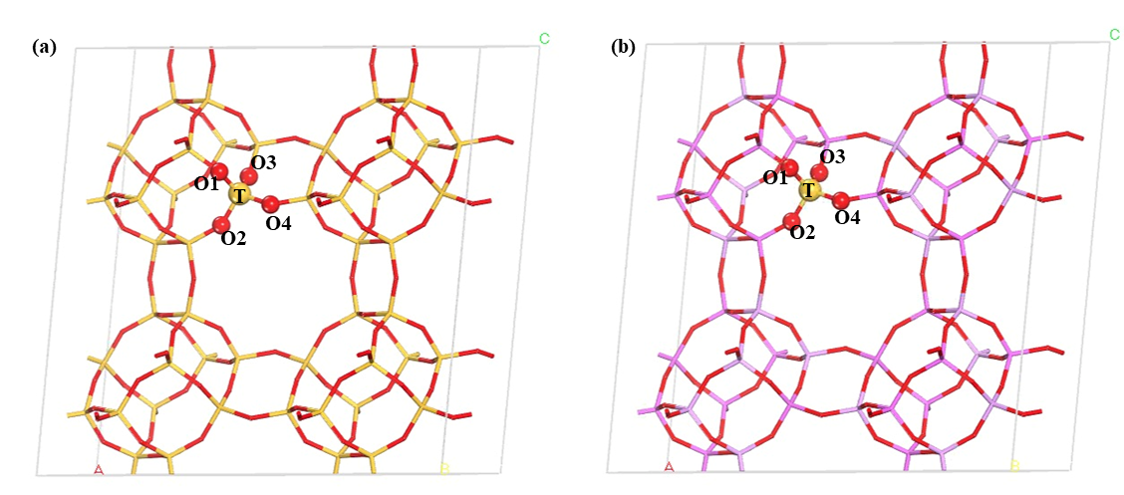
Fig. S2. (2x2x1) cell of purely siliceous SSZ-13(a) and SAPO-34 (b). Both of them are CHA type connected with interconnected D6R units. Each SiO₄ tetrahedral unit is equivalent. Four geometrically distinct oxygen position are marked: Si=yellow; O=red; Al=pink; P=purple.

Chabazite (CHA) is an interesting zeolite since the SiO4 tetrahedral(T) are linked to a network with four crystallographically distinct Si-O-Si angles. Thus, the response to external stress is likely to be more complex. An initial single unit cell of SSZ-13 (CHA type, Si₃₆O₇₂) retrieved form the International Zeolite Association (IZA).(9) SSZ-13 results from connection of hexagonal prisms by tilted 4-membered rings(MR), which gives rise to three large cha cages through 8-MR. Although there are 36 crystallographic in a single unit cell, each T site is equivalent. (Fig. S2a) In addition, by substitution of Si with P, SSZ-13 becomes its crystallographically isomorphs silicoaluminophosphate (SAPO-34, Fig. S2b), which possesses the same structures but different chemical compositions with that of SSZ-13. BAS inside SAPO-34 is created when the framework P atoms are token placed by Si atoms, thus there are four acid proton locations namely HO1, HO2, HO3 and HO4 owing to the four different Si-O-Al angles. In this work, we considered all four geometrically possible Bronsted acid sites in both as summarized in Tables S1and S2. Si-O2H-Al site was chosen as the BAS for the further calculations.
To fully take into consideration of the flexibility of the zeolite framework and the dynamics of the guest molecules under reaction temperature, AIMD simulations were performed by periodic density functional theory (DFT). Firstly, equilibrium AIMD simulation of reactant state species were carried out 5 ps at NPT ensemble to relax the cell parameters and atoms positions. Next, the metadynamics (MTD) methods were performed to explore the methanol dehydration in H-SAPO-34 in AIMD simulations.
All the AIMD simulations were employed by CP2K software, and the linked PLUMED code was used to carry out the MTD simulations. The PBE functional(10) with consideration of Grimme’s D3 dispersion corrections(11) was chosen for the DFT calculations. The double-ζ valence plus polarization DZVP basis set(12) and Goedecker-Teter-Hutter (GTH) pseudopotential(13) was used for the system. During the SCF procedure, a 360 Ry density CUTOFF criterion with the finest grid level was employed, together with multi-grids number 4 (NGRID 4 and REL CUTOFF 70). The temperature of AIMD was controlled by a chain of five Nosé-Hoover thermostats,(14) and the integration time step was set to 0.5 fs.
Metadynamics (MTD) simulation(15) was employed to explore the methanol dehydration over Lewis acidic sites. This is done by first optimizing the geometrical structures and cell parameters of the configuration by periodic DFT followed by a 5 ps NPT molecular dynamics simulation to relax the structure and cell parameters under experimental conditions such as temperature and pressure. Accordingly, MTD simulations were performed at 300 K in NVT ensemble, and this advanced sampling technique is used to enhance the probability of sampling chemical reactions or rare events provided that a limited number of collective variables (CV) describing the reaction coordinate were well-defined. Nonetheless, MTD simulation is normally biased by regularly spawning Gaussian hills along the chosen CVs, which may be defined by coordination numbers (CN):
$$CN=\sum_{ij}{\frac{1-{\left(\frac{r_{ij}-d_{0}}{r_{0}}\right)}^{n}}{1-{\left(\frac{r_{ij}-d_{0}}{r_{0}}\right)}^{m}}}$$
where rij represents the interatomic distance between atoms i and j and r0 is the reference distance. In this work, parameters d0, n and m were set to 0, 6, and 12, respectively. Accordingly, CVs may be defined by in terms CNs, namely CV1=CN(O_{MeOH}−Si_{Zeolite}) and CV2=CN(O_{Zeolite}−H_{MeOH}). By setting a reference distance of 1.6 Å for CN(O_{MeOH}−Si_{Zeolite}) and 1.0 Å CN(O_{Zeolite}−H_{MeOH}) and a Gaussian hill width and height of 0.035 and 2 kJ/mol for both CV1 and CV2, respectively, spawning every 50 fs. The simulations were allowed to continue till the height of additional hills no longer affect the resultant free energy profile.

2). Supplementary results

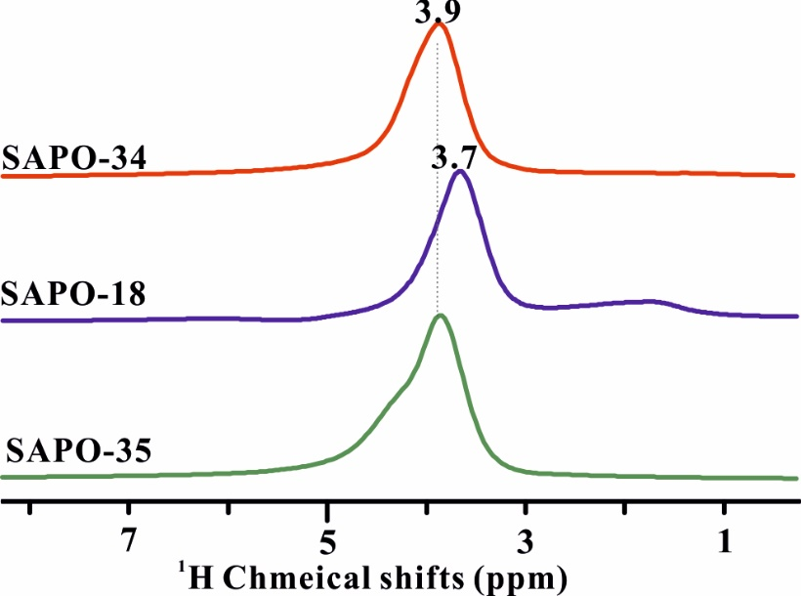
Fig. S3. ¹H solid-state NMR spectrum of parent H-SAPO-34, H-SAPO-18 and H-SAPO-35. The ¹H NMR measurements were carried out by Bruker Avance III 400 WB spectrometer using 4mm rotor at a spinning speed of 10 kHz with a recycle delay of 2.0s at 298K. Basically, only one ¹H peak over the samples was observed.

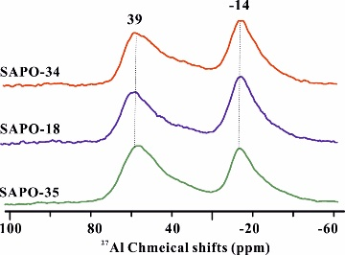
Fig. S4. ²⁷Al one-pulse solid-state NMR spectrum of H-SAPO-34, H-SAPO-18 and H-SAPO-35 after hydration at 298 K, The ²⁷Al NMR measurements were carried out by Varian InfinityPlus-300 spectrometer spectrometer using 4mm rotor at a spinning speed of 10 kHz with a recycle delay of 3.0s at 298K.

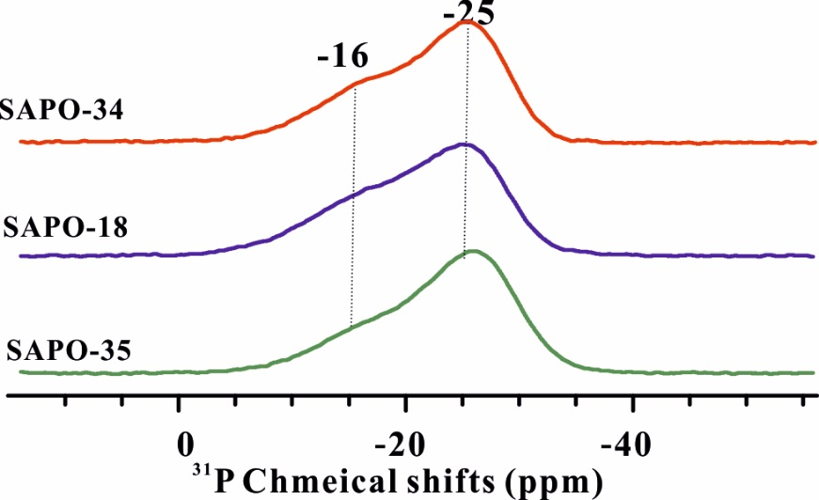
Fig. S5. ³¹P cross-polarization solid state NMR spectrum of H-SAPO-34, H-SAPO-18 and H-SAPO-35after hydration. The ³¹P NMR measurements were carried out by Varian InfinityPlus-300 spectrometer spectrometer using 4mm rotor at a spinning speed of 10 kHz with a recycle delay of 3.0 s at 298K.

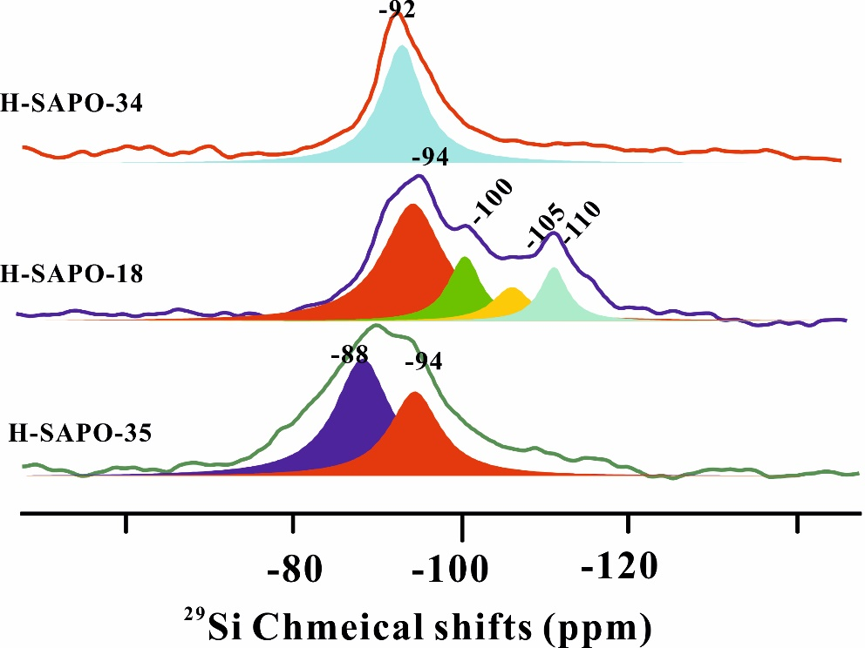
Fig. S6. ²⁹Si one-pulse solid state MAS NMR spectrum of H-SAPO-34 (a), H-SAPO-18 (b) and H-SAPO-35(c). The ²⁹Si NMR measurements were carried out by Varian InfinityPlus-300 spectrometer spectrometer using 7 mm rotor at a spinning speed of 5 kHz with a recycle delay of 60.0s at 298K.

¹H MAS chemical shifts of three samples (H-SAPO-34, H-SAPO-18, H-SAPO-35) are shown in Fig. S3, to the best of our knowledge, the ¹H chemical shifts at 3.7-4.3 ppm can be unambiguously assigned to the bridging hydroxyl.(16) For the ²⁷Al MAS NMR spectrum(Fig. S4), two signals at 39 ppm and -14 ppm are obviously observed, according to the previous studies,(17, 18) the peak at 39 ppm is attributed to the distorted tetrahedral coordinated framework aluminum atoms. Octahedral coordinated framework aluminum atoms appearing at -14 ppm due to the additional coordination of water molecules to the framework aluminum atoms. For ³¹P MAS NMR spectra of samples, two broad peaks at -16 ppm and -25 ppm in Fig. S5 can be assigned to tetrahedrally coordinated phosphorus atoms bound to four aluminum atoms and the framework phosphorus coordinated by water molecules, respectively(16). As for the ²⁹Si MAS spectrum(Fig. S6), signals at -94 ppm, -100 ppm, -105 ppm and -110 ppm in H-SAPO-18 can be assigned to silicon atoms located at Si(3Al,1Si), Si(2Al,2Si), Si(1Al,3Si) and Si(4Si) sites, respectively. While no Si island was observed in the samples of H-SAPO-34 and H-SAPO-35, there is only one signal at -92 ppm for H-SAPO-34 and two peaks at -88 ppm and -94 ppm for H-SAPO-35, which means the Si atoms in this two samples are all located at framework Si(4Al) sites. All the results mentioned above suggest that the structures of those SAPO zeolites are well crystalline without any obvious amorphous species.

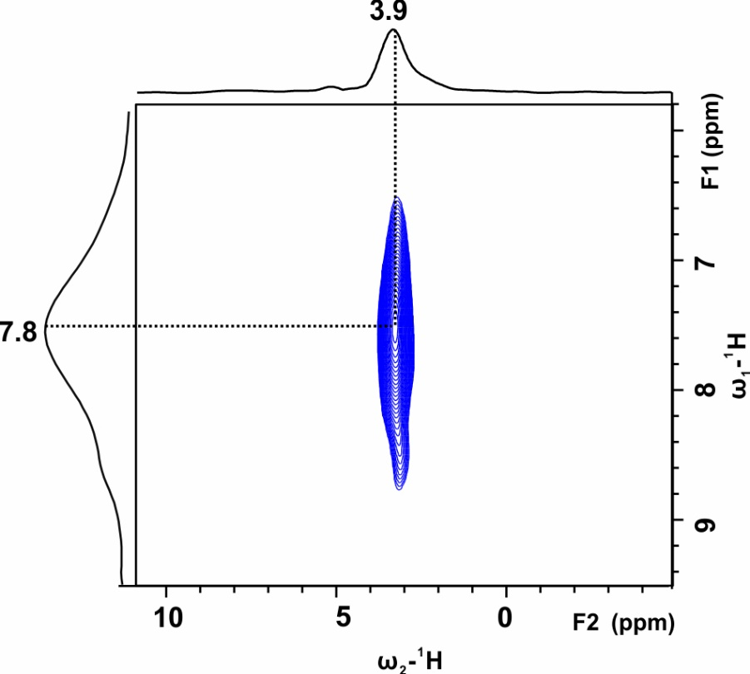
Fig. S7. ¹H-¹H SQ-DQ MAS NMR spectra of H-SAPO-34, record at a MAS rate of 12 kHz with a recycle of 2s and a mixing time of 0.5 ms under 298K.

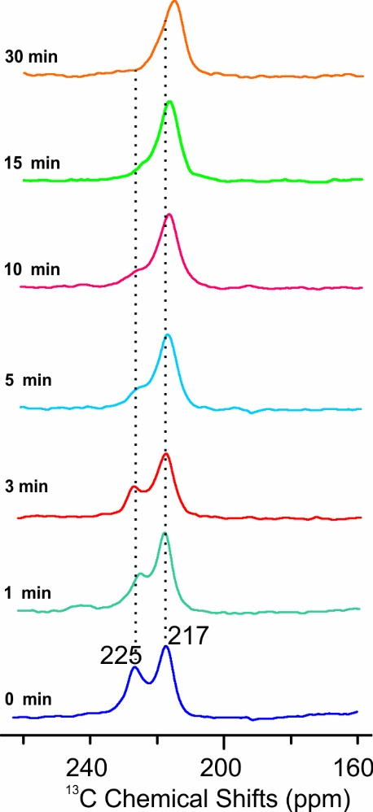
Fig.S8. ¹³C CP solid-state NMR spectrum of ¹³C-acetone adsorbed on H-SAPO-34 zeolite before(a) and after exposing to the air to absorb water at 298K with different time. The ¹³C NMR measurements were carried out by Bruker Avance III 400 WB spectrometer using 4mm rotor at a spinning speed of 10 kHz with a recycle delay of 3.0 s at 298K.

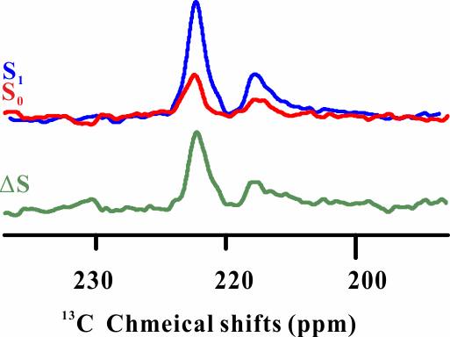
Fig. S9. ¹³C-²⁷Al SRESPDOR solid state NMR spectra of ¹³C-acetone adsorbed on H-SAPO-34 zeolite. The red and blue lines represent the spectra observed with (S₁) and without (S0) ¹³C-²⁷Al SRESPDOR dipolar dephasing (with a recoupling period of τ=16 ms). △S represents the difference spectrum of S1 and S0.

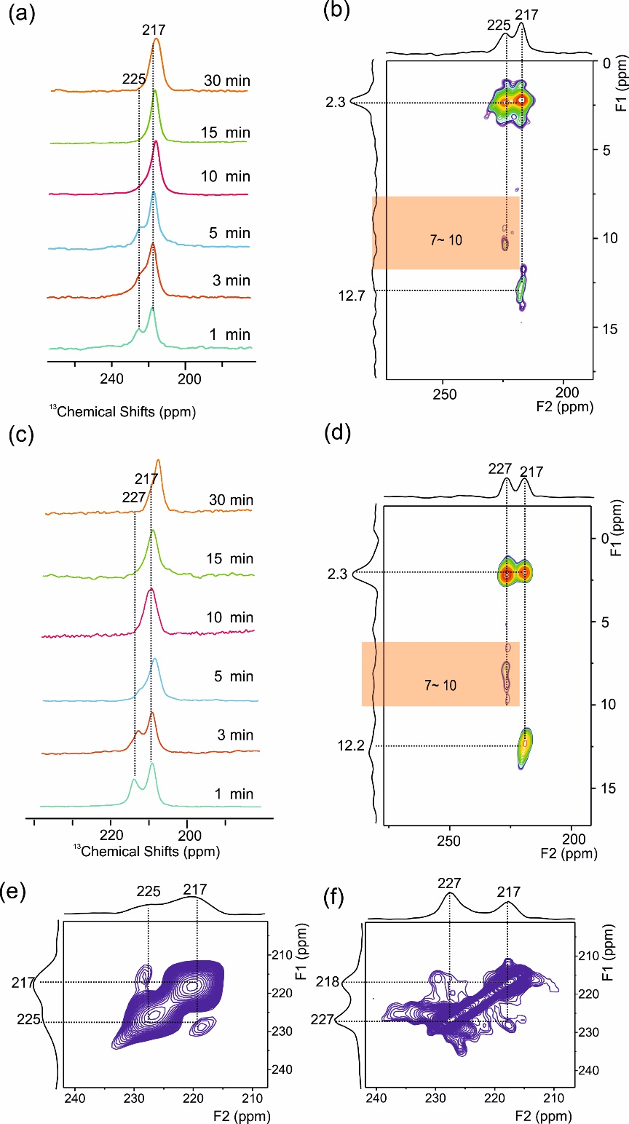
Fig. S10. ¹³C CP MAS NMR spectrum of ¹³C-acetone adsorbed on H-SAPO-18 (a) and H-SAPO-35 (c) zeolites before and after exposing to the air to absorb water with various time. Two-dimensional ¹³C-¹H hetero-nuclear correlation MAS NMR spectrum of co-adsorption of ¹³C-acetone adsorbed on H-SAPO-18 (b) and H-SAPO-35 (d) zeolites. Two-dimensional ¹³C-¹³C proton-driven spin diffusion MAS NMR spectrum of ¹³C-acetone adsorbed on H-SAPO-18 (e) and H-SAPO-35 (f) zeolites. All the data were collected on Bruker Avance III 400 WB spectrometer using 4mm rotor at a spinning speed of 10 kHz at 298K.

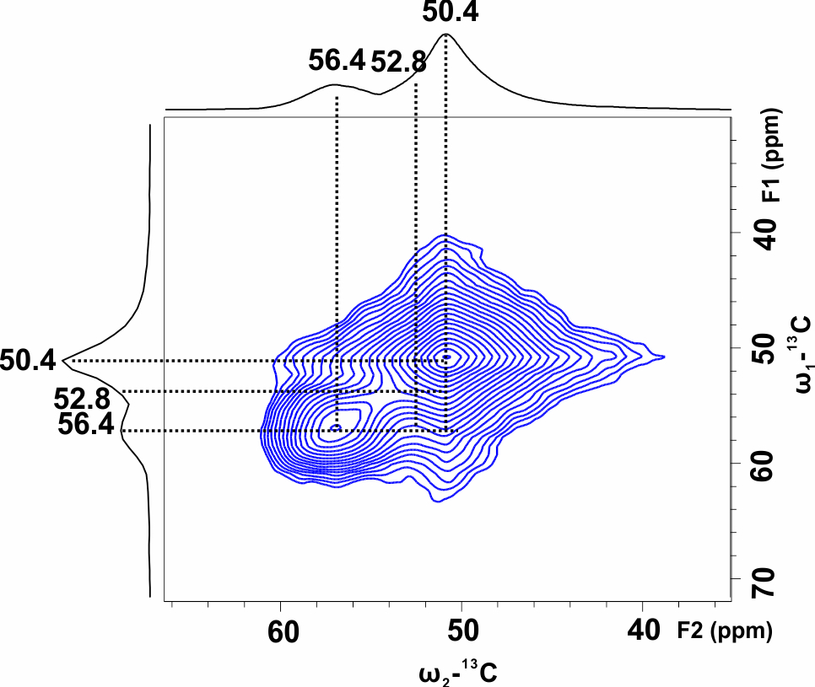
Fig. S11.Two-dimensional ¹³C-¹³C proton-driven spin diffusion MAS NMR spectra of ¹³C-methaniol adsorbed on H-SAPO-34 zeolites. All the data were collected on Bruker Avance III 400 WB spectrometer using 4mm rotor at a spinning speed of 12 kHz at 298K.

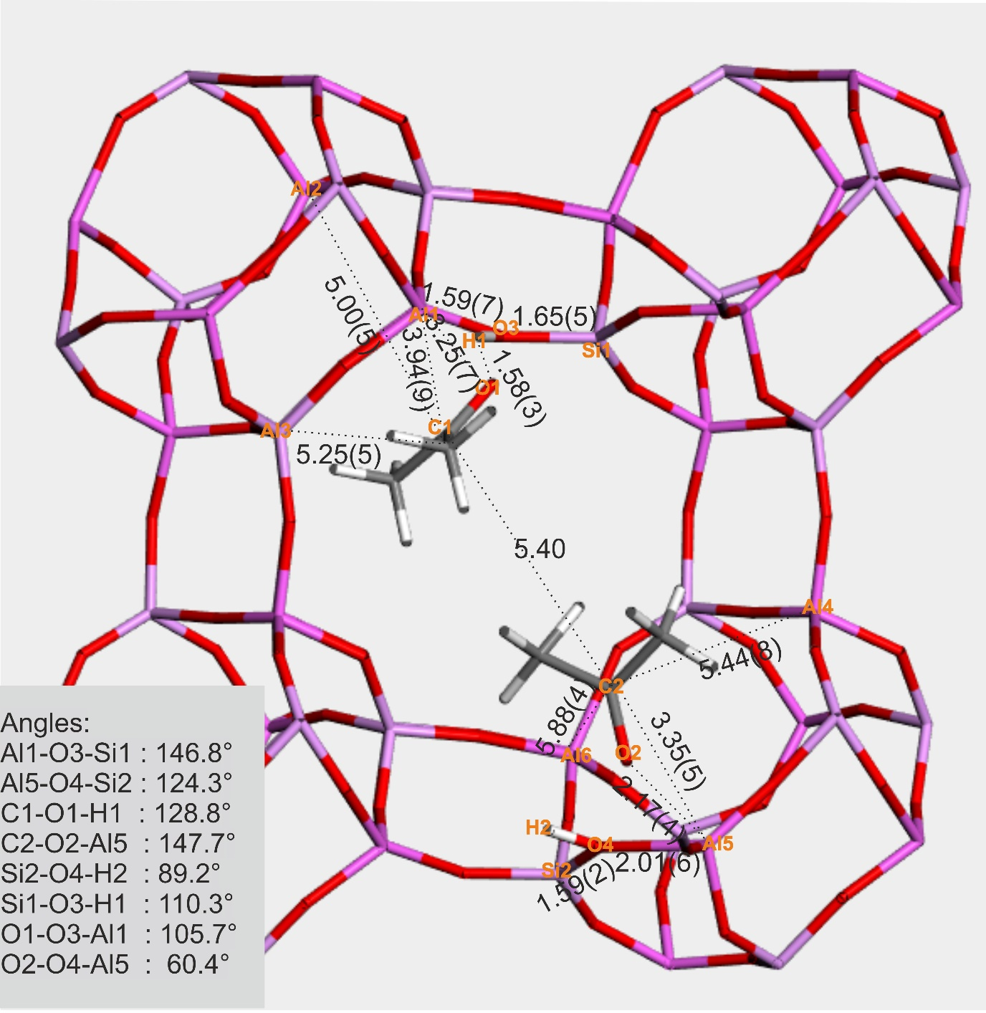
Fig. S12. Rietveld refined structure of acetone adsorbed on H-SAPO-34 derived from SXRD and NPD. SXRD data measured at 298K with refined parameters (Rwp= 8.9%, χ2 = 1.97); NPD data measured at 298K of D₆-acetone with refined parameters (Rwp= 1.9%, χ2 = 2.27) by TOPAS Academic 6. Symmetry for adsorption sites are disregarded for clarity. The full atomic and crystallographic coordinates and angles are summarized in Tables S4, 5, 7, 9.

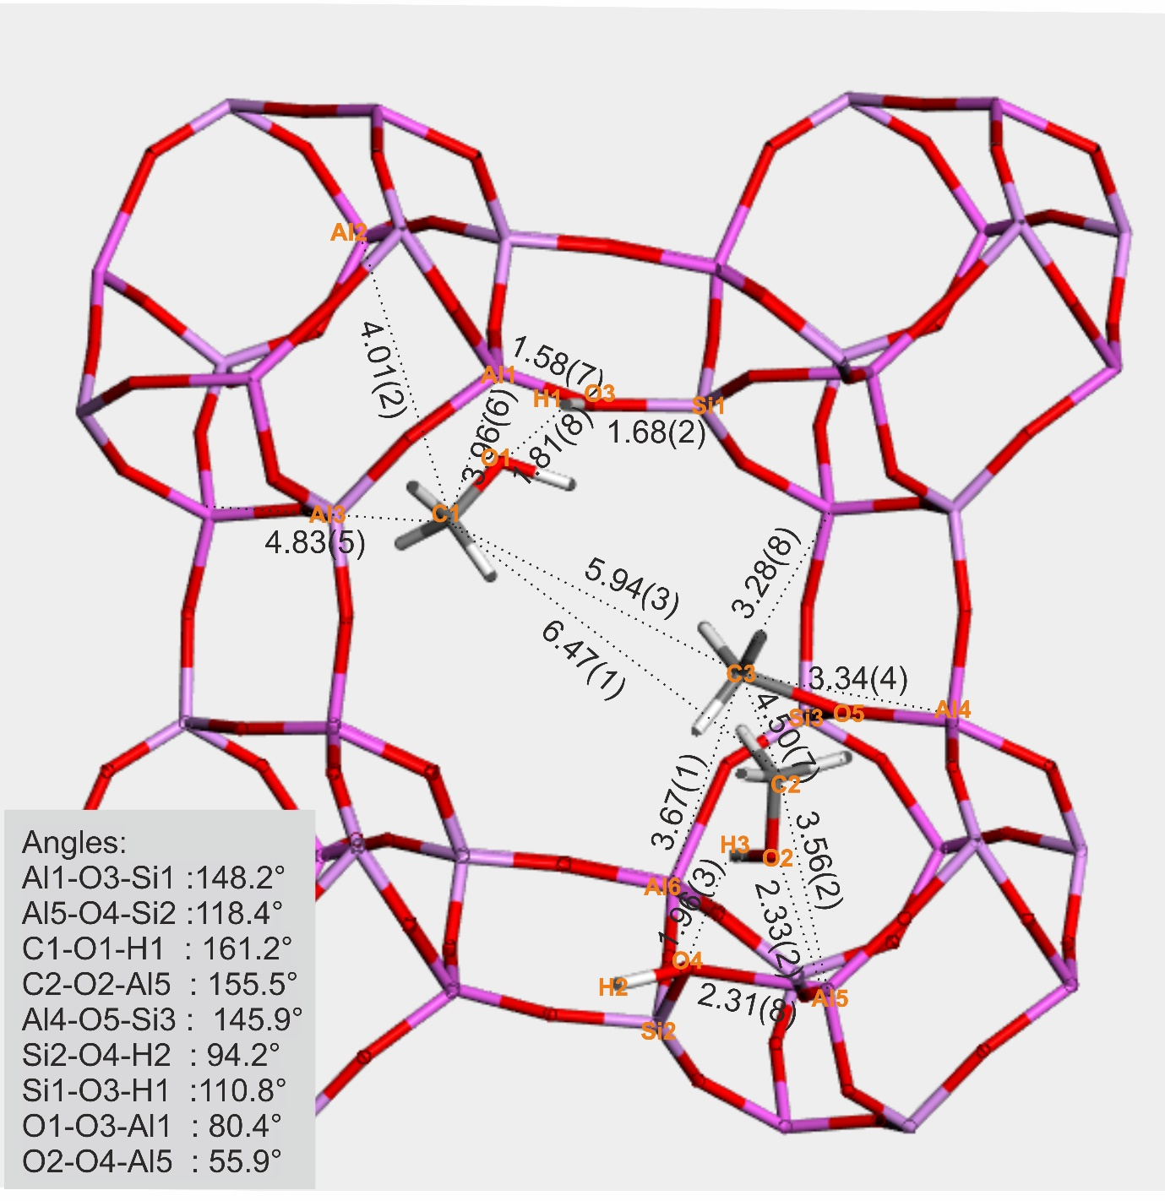
Fig. S13. Rietveld refined structure of methanol adsorbed on H-SAPO-34 derived from SXRD and NPD. SXRD data measured at 298K with refined parameters (Rwp = 9.4%, χ2 = 10.34); NPD data measured at 298K of D₄-methanol with refined parameters (Rwp= 1.4%, χ2 = 1.6) by TOPAS Academic 6. Symmetry for adsorption sites are disregarded for clarity. The full atomic and crystallographic coordinates and angles are summarized in Tables S4, 5, 6, 8.

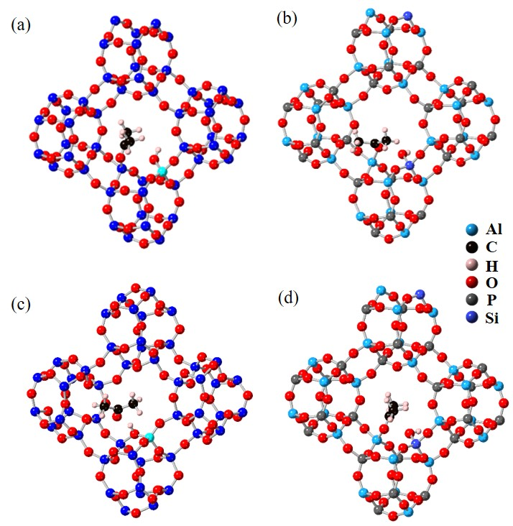
Fig. S14. Optimized structures of acetone adsorbed on the framework Al site of bridging hydroxyl for H-SSZ-13 (a) and H-SAPO-34 (b). Snapshot of equilibrium states of acetone adsorbed on H-SSZ-13 (c) and H-SAPO-34 (d) based on AIMD simulations.

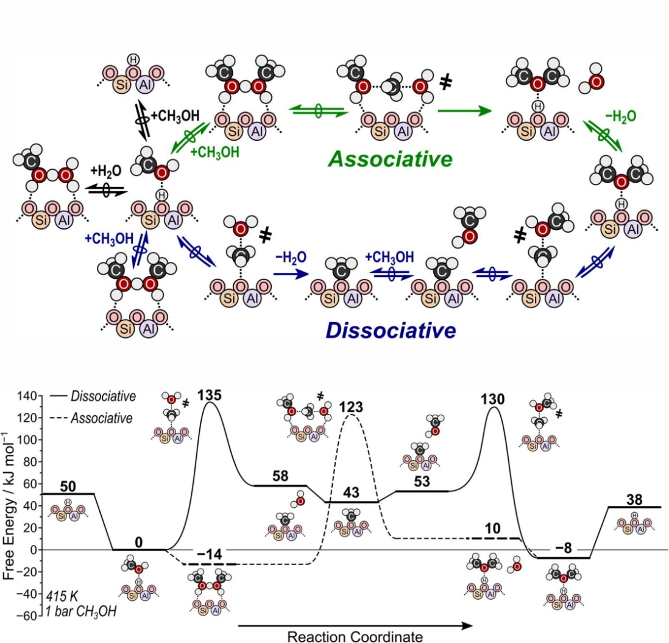
Fig. S15. Methanol dehydration routes over BAS with corresponding energy barriers adapted from ref (19) .

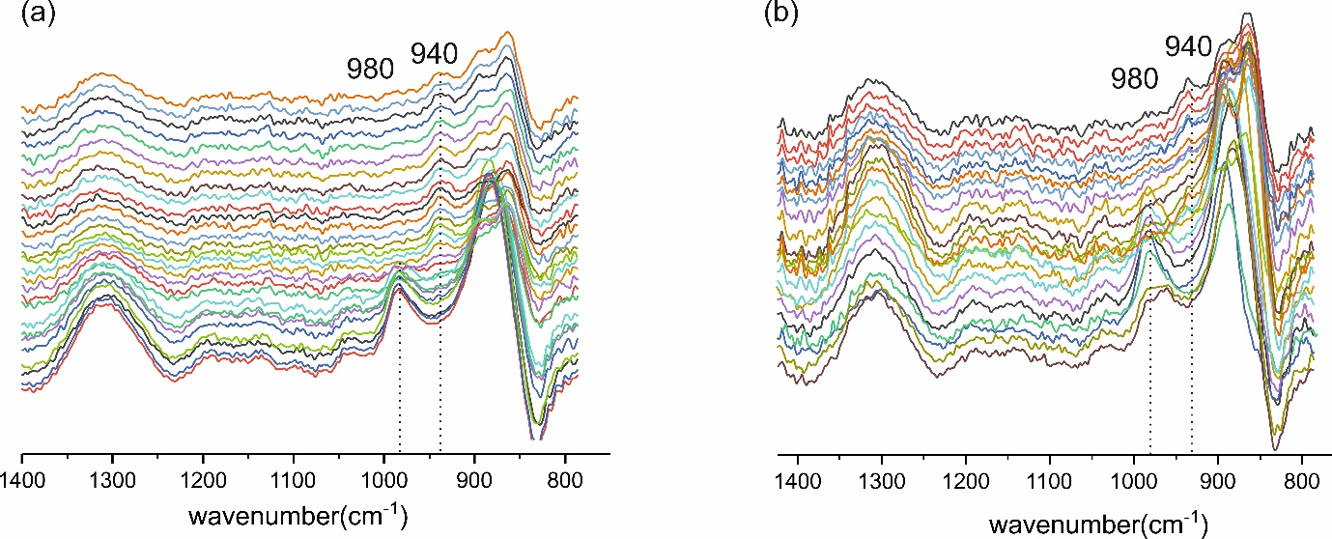
Fig. S16. In situ DRIFT experiments of ¹⁶O-methanol (a) and ¹⁸O-methanol (b) over ZSM5 zeolite from 373K to 523K. 940 cm⁻¹ and 980 cm⁻¹ can be attributed to the symmetrical and asymmetrical C-O stretching vibrations of SMS.
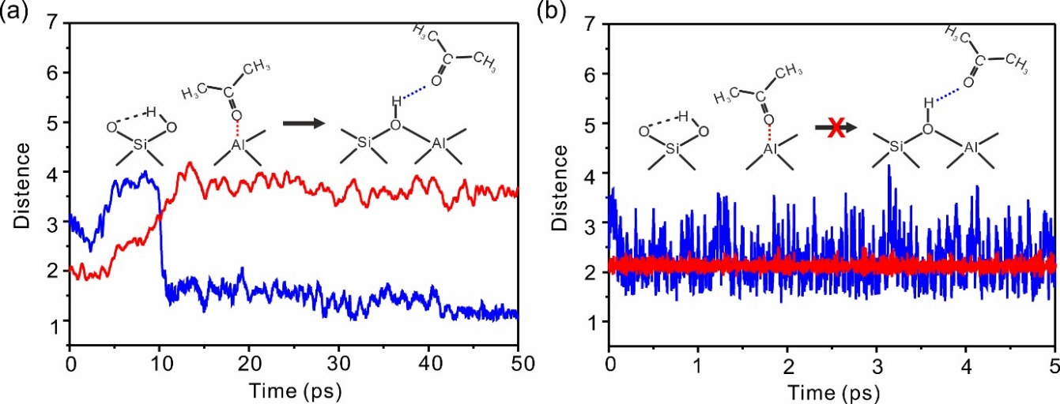
Fig. S17. Optimized structures of acetone adsorbed on the framework Al site of bridging hydroxyl for H-SSZ-13 and H-SAPO-34. The changes of bond distance for acetone adsorbed on induced FLP acid site during the AIMD simulations for H-SSZ-13 (a) and H-SAPO34 (b). Red: distance between O of acetone and framework Al(O_ace-Al_zeo), blue: distance between O of acetone and H of BAS(O_zeo-H_zeo).
Due to the same topological structure between H-SSZ-13 and H-SAPO-34 (Fig. S2), acetone adsorption on the H-SSZ-13 and H-SAPO-34 were first compared. According to the static DFT calculations as shown in Figs. S14a-b, acetone can be directly adsorbed on both the framework Al site of bridging hydroxyl in H-SSZ-13 and H-SAPO-34 by breaking Al-O bond of BAS and the remaining silicon hydroxyl group is bonded to its oxygen via hydrogen-bond interaction. Thus, we set this mode as the initial state and when taking the temperature and pressure into consideration during the AIMD simulations, a clear difference occurs between H-SSZ-13 and H-SAPO-34 zeolites. The Al-O bond in H-SSZ-13 was rebuilt immediately and the acetone adsorption on BAS was resumed. Whereas, acetone persistently coordinated to the framework Al atoms on H-SAPO-34 without any obvious change of the bond distance including O_ace-Al_zeo and O_zeo-H_zeo (Figs. S14c- d). Curves of bond distance plotted in Figs. 17a-b suggest that the recovery process of BAS takes place at the very early stage (0.2 ps)of the whole simulation for H-SSZ-13, demonstrating that it is a more stable adsorption mode for acetone to BAS rather than to the framework Al atoms. While for H-SAPO-34, BAS can be induced to become FLP during the adsorption of acetone. This justifies the co-existence of the two peaks at 225 ppm and 217 ppm of ¹³C-acetone on H-SAPO-34 ( Fig. 1e).
Table S1: Energies, bond lengths, and angles for BAS with proton located on four different framework oxygens inside H-SAPO-34.
 | Energy ª (kJ/mol) | T-O-T angle(deg.) | Al-O length(Å) | Si-O length(Å)
HO1 | 4.9 | 129.74 | 1.799 | 1.714
HO2 | 0.0 | 130.81 | 1.917 | 1.825
HO3 | 12.1 | 136.18 | 1.836 | 1.787
HO4 | 19.5 | 145.85 | 1.841 | 1.762
ª energies are referred to state proton connecting to O2

Table S2: Energies, bond lengths, and angles for BAS with proton located on four different framework oxygens inside SSZ-13.
 | Energy ª (kJ/mol) | T-O-T angle(deg.) | Al-O length(Å) | Si-O length(Å)
HO1 | 11.5 | 133.81 | 1.841 | 1.681
HO2 | 0.0 | 135.19 | 1.972 | 1.789
HO3 | 5.3 | 134.01 | 1.913 | 1.708
HO4 | 10.6 | 136.74 | 1.921 | 1.709
ª energies is referred to state proton connecting to O2

Table S3: Amount of induced Lewis acids estimated from the single pulse NMR data and their adsorption energies by different probes with various polarities inside H-SAPO-34 zeolite.
Probes | polarity | (type-II+ the formed surface-alkoxy)/( all adsorption states) | Adsorption energy (kJ/mol)
D₂O | 1.0 | 0.79(7) | -10(2)
¹³C-methanol | 0.76 | 0.50(6) | -45(5)
¹³C-ethanol | 0.65 | 0.34(6) | -67(7)
¹³C-acetone | 0.36 | 0.13(3) | -124(10)

Table S4. Crystallographic data and details of methanol/ H-SAPO-34, acetone/ H-SAPO-34 based on SXRD
Samples | methanol@SAPO34 | acetone@SAPO34
Crystal system | Trigonal | Trigonal
Space group | R-3 | R-3
2θ range refinement | 3 – 45 º | 3 – 45 º
Detector | Multi-analyser crystals | Multi-analyser crystals
Refinement methods | Rietveld | Rietveld
a (Å) | 13.78(2) | 13.77(3)
b (Å) | 13.78(2) | 13.77(3)
c (Å) | 14.84(2) | 14.86(3)
V (Å³ ) | 2441.33(18) | 2439.10(22)
Rwp / Rp / Rexp (%) | 9.4/6.8/0.91 | 8.9/6.8/4.5
Wavelength (Å) | 0.688160 | 0.826551
2θ Zero point (°) | -0.00028 | 0.000339
Gof χ2 | 10.34 | 1.97

Table S5. Crystallographic information files from the Rietveld refinement of methanol/ H-SAPO-34 based on SXRD.
Species | Atom | X | Y | z | SOF | Beq (Å²)
Zeolite framework | P1 | 0.44677 | 0.11301 | 1.43481 | 0.84 | 0.32(30)
Zeolite framework | P2 | 0.44136 | 0.33720 | 1.22664 | 0.84 | 0.32(30)
Zeolite framework | Si1 | 0.44677 | 0.11301 | 1.43481 | 0.16 | 0.32(30)
Zeolite framework | Si2 | 0.44136 | 0.33720 | 1.22664 | 0.16 | 0.32(30)
Zeolite framework | Al1 | 0.43929 | 0.32880 | 1.44139 | 1 | 0.32(30)
Zeolite framework | Al2 | 0.43274 | 0.32686 | 1.43919 | 1 | 0.32(30)
Zeolite framework | O1 | 0.43172 | 0.10057 | 1.22661 | 1 | 0.58(50)
Zeolite framework | O2 | 0.38569 | 0.06109 | 1.33531 | 1 | 0.58(50)
Zeolite framework | O5 | 0.44053 | 0.21514 | 1.47263 | 1 | 0.58(50)
Zeolite framework | O7 | 0.43082 | 0.33444 | 1.33710 | 1 | 0.58(50)
Zeolite framework | O3 | 0.46250 | 0.25216 | 1.22735 | 0.5 | 0.58(50)
Zeolite framework | O4a | 0.56592 | 0.15297 | 1.46922 | 0.5 | 0.58(50)
Zeolite framework | O6 | 0.32864 | 0.03407 | 1.16290 | 0.5 | 0.58(50)
Zeolite framework | O8 | 0.54567 | 0.45483 | 1.20239 | 0.5 | 0.58(50)
Zeolite framework | O3a | 0.58705 | 0.43408 | 1.46922 | 0.5 | 0.58(50)
Zeolite framework | O4 | 0.37210 | 0.00469 | 1.49623 | 0.5 | 0.58(50)
Zeolite framework | O6a | 0.54517 | 0.09084 | 1.20239 | 0.5 | 0.58(50)
Zeolite framework | O8a | 0.35106 | 0.34510 | 1.50324 | 0.5 | 0.58(50)
SMS | C | 0.39730 | 0.15398 | 1.57622 | 0.07 | 8(2)
Methanol -1 | C1 | 0.15739 | 0.10824 | 1.36558 | 0.07 | 15(4)
Methanol -1 | O1 | 0.27529 | 0.18551 | 1.36465 | 0.07 | 18(4)
Methanol-2 | Ca | 0.58293 | 0.39377 | 0.96294 | 0.18 | 3(1)
Methanol-2 | Oa | 0.52680 | 0.33102 | 1.04176 | 0.18 | 3(1)

Table S6. Crystallographic information files from the Rietveld refinement of acetone/H-SAPO-34 based on SXRD.
Species | Atom | X | Y | Z | SOF | Beq (Å²)
Zeolite framework | P1 | 0.44532 | 0.11150 | 1.42356 | 0.84 | 0.32(30)
Zeolite framework | P2 | 0.43922 | 0.33368 | 1.21832 | 0.84 | 0.32(30)
Zeolite framework | Si1 | 0.44532 | 0.11150 | 1.42356 | 0.16 | 0.32(30)
Zeolite framework | Si2 | 0.43922 | 0.33368 | 1.21832 | 0.16 | 0.32(30)
Zeolite framework | Al1 | 0.43612 | 0.33295 | 1.42792 | 1 | 0.32(30)
Zeolite framework | Al2 | 0.43292 | 0.10674 | 1.21235 | 1 | 0.32(30)
Zeolite framework | O1 | 0.42720 | 0.08672 | 1.32045 | 1 | 0.63(50)
Zeolite framework | O2 | 0.41104 | 0.20604 | 1.45385 | 1 | 0.63(50)
Zeolite framework | O5 | 0.41078 | 0.34707 | 1.31609 | 1 | 0.63(50)
Zeolite framework | O7 | 0.46866 | 0.23423 | 1.20472 | 1 | 0.63(50)
Zeolite framework | O3 | 0.56103 | 0.12216 | 1.44865 | 0.5 | 0.63(50)
Zeolite framework | O4a | 0.56113 | 0.03211 | 1.14462 | 0.5 | 0.63(50)
Zeolite framework | O6 | 0.37555 | 0.43254 | 1.18107 | 0.5 | 0.63(50)
Zeolite framework | O8 | 0.56746 | 0.30777 | 1.14120 | 0.5 | 0.63(50)
Zeolite framework | O3a | 0.35890 | 0.43897 | 1.44865 | 0.5 | 0.63(50)
Zeolite framework | O4 | 0.56113 | 0.01010 | 1.47795 | 0.5 | 0.63(50)
Zeolite framework | O6a | 0.37555 | 0.10520 | 1.18107 | 0.5 | 0.63(50)
Zeolite framework | O8a | 0.56746 | 0.36332 | 1.47453 | 0.5 | 0.63(50)
Acetone (type-I) | C1 | 0.17556 | 0.05997 | 1.35216 | 0.25 | 8(2)
Acetone (type-I) | C2 | 0.08783 | -0.04398 | 1.39837 | 0.25 | 8(2)
Acetone (type-I) | C3 | 0.20690 | 0.05435 | 1.25639 | 0.25 | 8(2)
Acetone (type-I) | O | 0.22443 | 0.15494 | 1.39512 | 0.25 | 8(2)
Acetone-((type-II) | C1a | 0.65145 | 0.44337 | 1.02781 | 0.07 | 8(2)
Acetone-((type-II) | C2a | 0.66523 | 0.40804 | 0.93539 | 0.07 | 8(2)
Acetone-((type-II) | C3a | 0.75283 | 0.51786 | 1.08337 | 0.07 | 8(2)
Acetone-((type-II) | Oa | 0.55164 | 0.40943 | 1.05976 | 0.07 | 8(2)

Table S7. Crystallographic data and details of D₄-methanol/H-SAPO-34, D₆-acetone/H-SAPO-34 based on NPD.
Samples | methanol@SAPO34 | acetone@SAPO34
Crystal system | Trigonal | Trigonal
Space group | R-3 | R-3
Wavelength bands  (Å) | 0.1-4.9 | 0.1-4.9
Refinement methods | Rietveld | Rietveld
a (Å) | 13.78(2) | 13.77(3)
b (Å) | 13.78(2) | 13.77(3)
c (Å) | 14.84(2) | 14.86(3)
V (Å³ ) | 2441.33(18) | 2439.10(22)
Rwp / Rp / Rexp (%) | 1.42/1.30/0.88 | 1.86/1.56/0.82
Gof χ2 | 1.62 | 2.27

Table S8. Crystallographic information files from the Rietveld refinement of D₄-methanol/ H-SAPO-34 based on NPD.
Species | Atom | X | Y | z | SOF | Beq (Å²)
Zeolite framework | P1 | 0.44677 | 0.11301 | 1.43481 | 0.84 | 0.32(30)
Zeolite framework | P2 | 0.44136 | 0.33720 | 1.22664 | 0.84 | 0.32(30)
Zeolite framework | Si1 | 0.44677 | 0.11301 | 1.43481 | 0.16 | 0.32(30)
Zeolite framework | Si2 | 0.44136 | 0.33720 | 1.22664 | 0.16 | 0.32(30)
Zeolite framework | Al1 | 0.43929 | 0.32880 | 1.44139 | 1 | 0.32(30)
Zeolite framework | Al2 | 0.43274 | 0.32686 | 1.43919 | 1 | 0.32(30)
Zeolite framework | O1 | 0.43172 | 0.10057 | 1.22661 | 1 | 0.58(50)
Zeolite framework | O2 | 0.38569 | 0.06109 | 1.33531 | 1 | 0.58(50)
Zeolite framework | O5 | 0.44053 | 0.21514 | 1.47263 | 1 | 0.58(50)
Zeolite framework | O7 | 0.43082 | 0.33444 | 1.33710 | 1 | 0.58(50)
Zeolite framework | O3 | 0.46250 | 0.25216 | 1.22735 | 0.5 | 0.58(50)
Zeolite framework | O4a | 0.56592 | 0.15297 | 1.46922 | 0.5 | 0.58(50)
Zeolite framework | O6 | 0.32864 | 0.03407 | 1.16290 | 0.5 | 0.58(50)
Zeolite framework | O8 | 0.54567 | 0.45483 | 1.20239 | 0.5 | 0.58(50)
Zeolite framework | O3a | 0.58705 | 0.43408 | 1.46922 | 0.5 | 0.58(50)
Zeolite framework | O4 | 0.37210 | 0.00469 | 1.49623 | 0.5 | 0.58(50)
Zeolite framework | O6a | 0.54517 | 0.09084 | 1.20239 | 0.5 | 0.58(50)
Zeolite framework | O8a | 0.35106 | 0.34510 | 1.50324 | 0.5 | 0.58(50)
SMS | C | 0.39730 | 0.15398 | 1.57622 | 0.07 | 8(2)
Methanol-((type-I)) | C1 | 0.15739 | 0.10824 | 1.36558 | 0.07 | 15(4)
Methanol-((type-I)) | O1 | 0.27529 | 0.18551 | 1.36465 | 0.07 | 15(4)
Methanol-((type-I)) | H-3 | 0.21029 | 0.13379 | 1.26611 | 0.07 | 15(4)
Methanol-((type-I)) | H-4 | 0.21532 | 0.33592 | 1.33915 | 0.07 | 15(4)
Methanol-((type-I)) | H-5 | 0.14148 | 0.20447 | 1.38719 | 0.07 | 15(4)
Methanol-((type-I)) | H-6 | 0.30754 | 0.29149 | 1.37081 | 0.07 | 15(4)
Methanol-(type-II) | Ca | 0.58293 | 0.39377 | 0.96294 | 0.18 | 3(1)
Methanol-(type-II) | Oa | 0.52680 | 0.33102 | 1.04176 | 0.18 | 3(1)
Methanol-(type-II) | H-3a | 0.54668 | 0.34261 | 1.12720 | 0.18 | 3(1)
Methanol-(type-II) | H-4a | 0.60624 | 0.34891 | 0.93697 | 0.18 | 3(1)
Methanol-(type-II) | H-5a | 0.56669 | 0.43848 | 0.98406 | 0.18 | 3(1)
Methanol-(type-II) | H-6a | 0.70143 | 0.42857 | 1.01873 | 0.18 | 3(1)

Table S9. Crystallographic information files from the Rietveld refinement of D₆-acetone/H-SAPO-34 based on NPD.
Species | Atom | X | Y | Z | SOF | Beq (Å²)
Zeolite framework | P1 | 0.44532 | 0.11150 | 1.42356 | 0.84 | 0.32(30)
Zeolite framework | P2 | 0.43922 | 0.33368 | 1.21832 | 0.84 | 0.32(30)
Zeolite framework | Si1 | 0.44532 | 0.11150 | 1.42356 | 0.16 | 0.32(30)
Zeolite framework | Si2 | 0.43922 | 0.33368 | 1.21832 | 0.16 | 0.32(30)
Zeolite framework | Al1 | 0.43612 | 0.33295 | 1.42792 | 0.96 | 0.32(30)
Zeolite framework | Al2 | 0.43292 | 0.10674 | 1.21235 | 1 | 0.32(30)
Zeolite framework | O1 | 0.42720 | 0.08672 | 1.32045 | 1 | 0.63(50)
Zeolite framework | O2 | 0.41104 | 0.20604 | 1.45385 | 1 | 0.63(50)
Zeolite framework | O5 | 0.41078 | 0.34707 | 1.31609 | 1 | 0.63(50)
Zeolite framework | O7 | 0.46866 | 0.23423 | 1.20472 | 1 | 0.63(50)
Zeolite framework | O3 | 0.56103 | 0.12216 | 1.44865 | 0.5 | 0.63(50)
Zeolite framework | O4a | 0.56113 | 0.03211 | 1.14462 | 0.5 | 0.63(50)
Zeolite framework | O6 | 0.37555 | 0.43254 | 1.18107 | 0.5 | 0.63(50)
Zeolite framework | O8 | 0.56746 | 0.30777 | 1.14120 | 0.5 | 0.63(50)
Zeolite framework | O3a | 0.35890 | 0.43897 | 1.44865 | 0.5 | 0.63(50)
Zeolite framework | O4 | 0.56113 | 0.01010 | 1.47795 | 0.5 | 0.63(50)
Zeolite framework | O6a | 0.37555 | 0.10520 | 1.18107 | 0.5 | 0.63(50)
Zeolite framework | O8a | 0.56746 | 0.36332 | 1.47453 | 0.5 | 0.63(50)
Acetone（type-I） | C1 | 0.17556 | 0.05997 | 1.35216 | 0.48 | 8(2)
Acetone（type-I） | C2 | 0.08783 | -0.04398 | 1.39837 | 0.48 | 8(2)
Acetone（type-I） | C3 | 0.20690 | 0.05435 | 1.25639 | 0.48 | 8(2)
Acetone（type-I） | O | 0.22443 | 0.15494 | 1.39512 | 0.48 | 8(2)
Acetone（type-I） | H5 | 0.38635 | 0.49568 | 0.94852 | 0.48 | 8(2)
Acetone（type-I） | H6 | 0.24273 | 0.38022 | 0.93579 | 0.25 | 8(2)
Acetone（type-I） | H7 | 0.27418 | 0.52585 | 0.92560 | 0.25 | 8(2)
Acetone（type-I） | H8 | 0.14310 | 0.43946 | 1.14513 | 0.25 | 8(2)
Acetone（type-I） | H9 | 0.12601 | 0.49160 | 1.04535 | 0.25 | 8(2)
Acetone（type-I） | H10 | 0.09456 | 0.34598 | 1.05555 | 0.25 | 8(2)
Acetone-(type-II) | C1a | 0.65145 | 0.44337 | 1.02781 | 0.07 | 8(2)
Acetone-(type-II) | C2a | 0.66523 | 0.40804 | 0.93539 | 0.07 | 8(2)
Acetone-(type-II) | C3a | 0.75283 | 0.51786 | 1.08337 | 0.07 | 8(2)
Acetone-(type-II) | Oa | 0.55164 | 0.40943 | 1.05976 | 0.07 | 8(2)
Acetone-(type-II) | H5a | 0.65737 | 0.18893 | 1.01483 | 0.07 | 8(2)
Acetone-(type-II) | H6a | 0.59953 | 0.21933 | 0.92312 | 0.07 | 8(2)
Acetone-(type-II) | H7a | 0.69077 | 0.33277 | 0.99401 | 0.07 | 8(2)
Acetone-(type-II) | H8a | 0.39148 | 0.27294 | 1.05048 | 0.07 | 8(2)
Acetone-(type-II) | H9a | 0.52881 | 0.38394 | 1.01573 | 0.07 | 8(2)
Acetone-(type-II) | H10a | 0.43758 | 0.27049 | 0.94484 | 0.07 | 8(2)

References and notes
1. F. Pourpoint et al., Measurement of Aluminum–Carbon Distances Using S‐RESPDOR NMR Experiments. ChemPhysChem 13, 3605-3615 (2012).
2. M. Czjzek, H. Jobic, A. N. Fitch, T. Vogt, Direct determination of proton positions in DY and HY zeolite samples by neutron powder diffraction. J. Phys. Chem. 96, 1535-1540 (1992).
3. V. F. Sears, Neutron scattering lengths and cross sections. Neutron news 3, 26-37 (1992).
4. B. Lo et al., Dynamic modification of pore opening of SAPO-34 by adsorbed surface methoxy species during induction of catalytic methanol-to-olefins reactions. Appl. Catal. B 237, 245-250 (2018).
5. G. Kresse, J. Furthmüller, Efficiency of ab-initio total energy calculations for metals and semiconductors using a plane-wave basis set. Comput. Mater. Sci. 6, 15-50 (1996).
6. G. Kresse, J. Furthmüller, Efficient iterative schemes for ab initio total-energy calculations using a plane-wave basis set. Phys. Rev. B 54, 11169 (1996).
7. P. E. Blöchl, Projector augmented-wave method. Phys. Rev. B 50, 17953 (1994).
8. G. Kresse, D. Joubert, From ultrasoft pseudopotentials to the projector augmented-wave method. Phys. Rev. B 59, 1758 (1999).
9. C. Baerlocher, L. B. McCusker. vol. 2018.
10. J. P. Perdew, K. Burke, M. J. P. r. l. Ernzerhof, Generalized gradient approximation made simple. 77, 3865 (1996).
11. S. Grimme, J. Antony, S. Ehrlich, H. Krieg, A consistent and accurate ab initio parametrization of density functional dispersion correction (DFT-D) for the 94 elements H-Pu. J. Chem. Phys. 132, 154104 (2010).
12. G. Lippert, J. Hutter, M. Parrinello, The Gaussian and augmented-plane-wave density functional method for ab initio molecular dynamics simulations. Theor. Chem. Acc. 103, 124-140 (1999).
13. S. Goedecker, M. Teter, J. Hutter, Separable dual-space Gaussian pseudopotentials. Phys. Rev. B 54, 1703 (1996).
14. H. A. Posch, W. G. Hoover, F. J. Vesely, Canonical dynamics of the Nosé oscillator: stability, order, and chaos. Phys. Rev. A 33, 4253-4265 (1986).
15. A. Laio, M. Parrinello, Escaping free-energy minima. PNAS 99, 12562-12566 (2002).
16. M. Muller, G. Harvey, R. Prins, Quantitative multinuclear MAS NMR studies of zeolites. Micropor. Mesopor. Mat. 34, 281-290 (2000).
17. A. Buchholz, W. Wang, M. Xu, A. Arnold, M. Hunger, Thermal stability and dehydroxylation of Bronsted acid sites in silicoaluminophosphates H-SAPO-11, H-SAPO-81 H-SAPO-31, and H-SAPO-34 investigated by multi-nuclear solid-state NMR spectroscopy. Micropor. Mesopor. Mat. 56, 267-278 (2002).
18. W. Shen et al., A study of the acidity of SAPO-34 by solid-state NMR spectroscopy. Micropor. Mesopor. Mat. 158, 19-25 (2012).
19. J. R. Di Iorio et al., Mechanistic origins of the high-pressure inhibition of methanol dehydration rates in small-pore acidic zeolites. J. Catal. 380, 161-177 (2019).

