INTRODUCTION
Congenital heart disease (CHD) constitutes the most common group of congenital malformations in newborns and remains a major cause of neonatal and infant morbidity and mortality worldwide. The estimated global incidence of CHD ranges from 8 to 10 per 1,000 live births [1][2][3], translating into a substantial public health burden, particularly in low- and middle-income countries. Advances in neonatal intensive care, pediatric cardiology, and cardiac surgery have significantly improved survival rates [4][21] of children with congenital heart defects. However, these benefits are highly dependent on timely diagnosis and early initiation of appropriate management. Delayed or missed diagnosis of critical congenital heart disease (CCHD) during the neonatal period continues to be a major contributor to preventable neonatal deaths and long-term complications.
Congenital heart diseases encompass a broad spectrum of structural abnormalities of the heart and great vessels that arise due to abnormal cardiac development during early embryogenesis. While some lesions are mild and may remain asymptomatic or present later in childhood, a significant proportion of CHD cases are classified as critical congenital heart disease. CCHD includes duct-dependent and cyanotic heart lesions that require urgent medical or surgical intervention [5][24][25] within the first days or weeks of life to ensure survival. Common examples include transposition of the great arteries, hypoplastic left heart syndrome, pulmonary atresia, critical coarctation of the aorta, tricuspid atresia, and total anomalous pulmonary venous connection. These conditions often present with rapid clinical deterioration once the ductus arteriosus begins to close, making early detection essential.
The transition from fetal to neonatal circulation is a complex physiological process involving closure of fetal shunts and a dramatic increase in pulmonary blood flow. In newborns with CCHD, this transition may be compromised, leading to hypoxemia, metabolic acidosis, shock, and multiorgan dysfunction. Importantly, many of these infants may appear clinically well during the immediate postnatal period, with minimal or no signs of cyanosis or cardiovascular compromise. This “silent period” poses a significant diagnostic challenge, particularly in busy postnatal wards where early discharge is common. Reliance solely on clinical examination [6][7][21] has been shown to be inadequate for detecting a large proportion of CCHD cases before discharge.
Traditionally, the detection of congenital heart disease has relied on antenatal ultrasonography and postnatal clinical examination. Although fetal anomaly scans have improved prenatal detection rates, their sensitivity varies widely depending on operator expertise, equipment quality, gestational age at screening, and availability of fetal echocardiography. In many parts of India and other resource-limited settings, access to high-quality antenatal cardiac screening remains limited. As a result, a significant number of infants with CHD are born without a prenatal diagnosis. Postnatal clinical examination, including assessment for murmurs, cyanosis, tachypnea, and poor perfusion, also has limited sensitivity, particularly for duct-dependent lesions and lesions that do not produce an early murmur.
Several studies have demonstrated that up to 30–50% of infants [6][7][10][18] with critical congenital heart disease may be discharged from hospital without a diagnosis when routine clinical examination alone is used as the screening method. These undiagnosed infants are at high risk of presenting later with life-threatening complications, often in peripheral healthcare facilities that lack advanced neonatal and pediatric cardiac services. Late presentation is associated with higher mortality, increased need for emergency interventions, prolonged hospital stays, and poorer neurodevelopmental outcomes.
Pulse oximetry has emerged as an effective, non-invasive, and inexpensive screening tool for early detection of hypoxemia in newborns [5][6][18][23]. Pulse oximetry measures peripheral arterial oxygen saturation (SpO₂) using differential light absorption by oxygenated and deoxygenated hemoglobin. Clinically apparent cyanosis is often not detectable until oxygen saturation falls below 80–85%, whereas pulse oximetry can reliably identify even mild degrees of hypoxemia. This makes it particularly useful for detecting CCHD lesions that cause subtle but clinically significant reductions in arterial oxygen saturation.
The physiological rationale for pulse oximetry screening in newborns lies in the fact that many critical congenital heart lesions result in right-to-left shunting, impaired pulmonary blood flow, or mixing of oxygenated and deoxygenated blood. Measurement of both pre-ductal (right hand) and post-ductal (foot) oxygen saturation [5][7][10] allows detection of differential hypoxemia, which is characteristic of certain duct-dependent cardiac lesions such as coarctation of the aorta and persistent pulmonary hypertension associated with structural heart disease. Standardized screening algorithms have been developed that define cut-off values for oxygen saturation and acceptable pre- and post-ductal differences, thereby improving the accuracy and reproducibility of screening.
Over the last two decades, multiple large-scale studies and meta-analyses have demonstrated that [6][7][8][10][15] newborn pulse oximetry screening significantly improves early detection rates of critical congenital heart disease when used in conjunction with routine clinical examination. The addition of pulse oximetry has been shown to reduce the proportion of infants discharged without a diagnosis of CCHD and to decrease mortality related to late presentation. Importantly, pulse oximetry screening has high specificity, resulting in a low false-positive rate, particularly when performed after the first 24 hours of life. This minimizes unnecessary investigations and parental anxiety.
Based on robust evidence, several international organizations, including the American Academy of Pediatrics [5][9][12], have endorsed routine pulse oximetry screening for all newborns prior to hospital discharge. Many countries have successfully implemented universal newborn pulse oximetry screening programs, integrating them into existing newborn care protocols. These programs have demonstrated feasibility, cost-effectiveness, and acceptability among healthcare providers and parents alike. Pulse oximetry screening is now considered a standard of care in several high-income countries.
The World Health Organization has also emphasized [13] the importance of early detection of congenital anomalies, including congenital heart disease, as part of strategies to reduce neonatal mortality and achieve global child health targets. Early identification of CCHD allows timely referral to specialized centers, initiation of prostaglandin therapy when indicated, and planned surgical or catheter-based interventions, thereby significantly improving outcomes.
In the Indian context, congenital heart disease represents a major but under-recognized public health problem [14][20]. India contributes a substantial proportion of the global burden of CHD births each year due to its large population and high birth rate [14][20]. Despite this, systematic newborn screening for CCHD is not uniformly practiced across the country. Limitations in healthcare infrastructure, variability in training of healthcare personnel, early postnatal discharge practices, and lack of standardized screening protocols contribute to delayed diagnosis and poor outcomes.
Tertiary care hospitals in India, particularly government medical colleges and referral centers, manage a large number of high-risk newborns and serve as critical points for early detection of congenital anomalies. Neonatal intensive care units in these centers are increasingly equipped with pulse oximeters and trained personnel, making them ideal settings for implementing and evaluating newborn pulse oximetry screening programs. Generating local data on the effectiveness, sensitivity, specificity, and feasibility of pulse oximetry screening is essential to support wider implementation and policy formulation at regional and national levels [19][20].
While pulse oximetry is a simple tool, its effectiveness depends on proper timing, standardized methodology, and appropriate interpretation of results. Factors such as timing of screening, altitude, presence of pulmonary pathology, sepsis, or persistent pulmonary hypertension can influence oxygen saturation readings. Therefore, it is important to evaluate pulse oximetry screening in real-world clinical settings and to understand its strengths and limitations within the local healthcare context.
The present study has been undertaken to evaluate the role of newborn pulse oximetry as a screening tool for the detection of congenital heart disease in neonates admitted to a tertiary care hospital. The study aims to assess the incidence of CHD detected through pulse oximetry screening, determine its sensitivity and specificity in comparison with echocardiography, and analyze the spectrum of cardiac lesions identified. By providing institution-specific and region-specific data, this study seeks to contribute to the growing body of evidence supporting newborn pulse oximetry screening and to inform clinical practice and policy decisions aimed at reducing neonatal morbidity and mortality due to congenital heart disease.

Need for the Present Study

Although pulse oximetry screening has been widely studied and implemented in many developed countries, its utilization in many developing regions remains limited [7][10][12][25].

In India, data regarding the effectiveness of pulse oximetry screening in large newborn populations are still evolving. Conducting studies in different healthcare settings is essential to evaluate the feasibility, diagnostic yield, and clinical impact of this screening method.

Early detection of congenital heart disease through pulse oximetry screening has the potential to significantly reduce neonatal morbidity and mortality by enabling prompt diagnosis and timely referral for specialized cardiac care [4][12][23].

Aims and objectives:
1. To evaluate the sensitivity and specificity of SpO2 screening for detecting CHD in newborns.
2. To assess the diagnostic accuracy of SpO2 screening compared to standard diagnostic methods such as echocardiography.
3. To identify factors influencing the performance of SpO2 screening, including gestational age, birth weight, and presence of other congenital anomalies.
4. To develop evidence-based recommendations for the integration of SpO2 screening into newborn screening programs for CHD

REVIEW OF LITERATURE

Congenital heart disease represents a heterogeneous group of structural and functional abnormalities of the heart and great vessels that arise as a consequence of disordered embryogenesis [1][2][3][14]. Understanding the embryological development of the heart is fundamental to appreciating the anatomical complexity, physiological consequences, and clinical presentation of congenital cardiac lesions. Cardiac development begins early in the third week of gestation [24][25], at a time when the embryo measures only a few millimeters in length. The primitive heart originates from mesodermal cells in the cardiogenic field [24][25][27][29], which coalesce to form paired endocardial tubes that subsequently fuse in the midline to create a single primitive heart tube. This tubular structure demonstrates intrinsic contractility and initiates circulation even before complete morphogenesis, underscoring the critical importance of uninterrupted cardiac development during early embryonic life.

The primitive heart tube undergoes a highly regulated process of rightward looping, known as D-looping, which establishes the spatial relationship between future atrial and ventricular chambers. Errors during looping can result in complex congenital anomalies [24][28][29] such as dextrocardia, congenitally corrected transposition of the great arteries, and heterotaxy syndromes. Following looping, septation of the atria, ventricles, and outflow tracts occurs between the fourth and eighth weeks of gestation. The atrial septum develops through the coordinated formation and resorption of the septum primum and septum secundum, creating the foramen ovale, a vital structure in fetal circulation. Ventricular septation involves both muscular and membranous components, the latter being particularly vulnerable to developmental defects, explaining the high prevalence of ventricular septal defects among congenital heart diseases. Simultaneously, the truncus arteriosus divides into the aorta and pulmonary artery through neural crest cell migration and spiral septation, and abnormalities in this process give rise to conotruncal defects [24] such as tetralogy of Fallot, truncus arteriosus, and transposition of the great arteries.

By the end of the eighth week of gestation, the heart has acquired its definitive four-chambered structure [24][25][29], and the majority of congenital heart defects are already established. This early timing explains why many congenital heart diseases coexist with extracardiac anomalies and chromosomal disorders, reflecting a shared disruption of early embryonic development. Importantly, although the anatomical defect is present at birth, the clinical manifestation of congenital heart disease is often delayed and depends largely on postnatal circulatory changes.

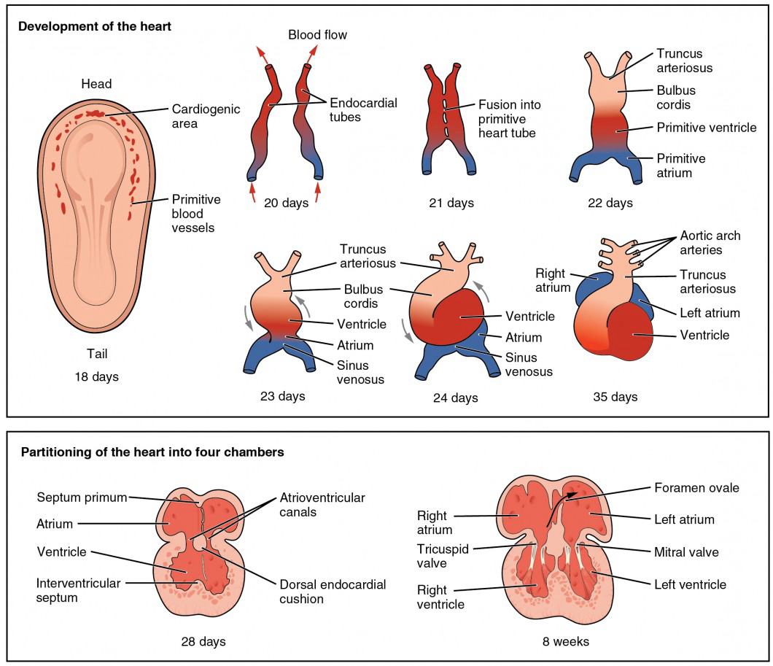
Development of the human heart showing formation of the primitive heart tube, cardiac looping, and partitioning into four chambers between day 18 and 8 weeks of gestation. (Adapted from Langman’s Medical Embryology) [66]

Fetal circulation is a unique physiological adaptation [24][25][30][31] designed to ensure adequate oxygen and nutrient delivery to the developing fetus in the absence of functional pulmonary respiration. Unlike postnatal circulation, the fetal cardiovascular system operates in a parallel rather than series arrangement, with the placenta serving as the primary organ of gas exchange. Oxygenated blood from the placenta is transported to the fetus via the umbilical vein, which carries blood with the highest oxygen saturation in the fetal circulation. A significant portion of this blood bypasses the hepatic circulation through the ductus venosus, allowing preferential streaming of well-oxygenated blood into the inferior vena cava and subsequently into the right atrium. This strategic diversion ensures optimal oxygen delivery to vital organs, particularly the brain and myocardium.

Within the fetal heart, blood flow is directed by pressure gradients and anatomical shunts that facilitate bypass of the non-functioning lungs. The foramen ovale, an interatrial communication, allows oxygen-rich blood entering the right atrium from the inferior vena cava to pass directly into the left atrium [30][31]. This blood then enters the left ventricle and is ejected into the ascending aorta, supplying the coronary circulation and cerebral vessels with relatively well-oxygenated blood. In contrast, blood returning from the superior vena cava, which is relatively desaturated, preferentially enters the right ventricle and is pumped into the pulmonary artery. Due to the high pulmonary vascular resistance in utero, only a small fraction of this blood reaches the lungs, while the majority is diverted through the ductus arteriosus into the descending aorta.

The ductus arteriosus serves as a critical conduit connecting the pulmonary artery to the descending aorta, allowing right ventricular output to bypass the lungs and contribute to systemic circulation. Blood in the descending aorta supplies the lower body and returns to the placenta via the umbilical arteries for reoxygenation. This arrangement results in differential oxygen saturation within the fetal circulation, with the highest saturation in blood supplying the brain and heart and lower saturation in blood perfusing the lower extremities. The presence of these physiological shunts—the ductus venosus, foramen ovale, and ductus arteriosus—is essential for normal fetal development and survival.

Understanding fetal circulation is fundamental to the pathophysiology of congenital heart disease and the rationale behind newborn screening strategies. Many critical congenital heart defects are well tolerated in utero because fetal circulation allows effective systemic perfusion despite abnormal cardiac anatomy. However, after birth, closure of fetal shunts and the transition to postnatal circulation can unmask these defects, leading to sudden hemodynamic compromise. The persistence or altered flow across fetal channels also forms the physiological basis for differential oxygen saturation between preductal and postductal sites, a principle that underpins pulse oximetry screening [5][6][7][8][9][22] for critical congenital heart disease. Thus, fetal circulation not only explains the delayed clinical presentation of certain cardiac lesions but also provides the physiological foundation for early postnatal screening and diagnosis.

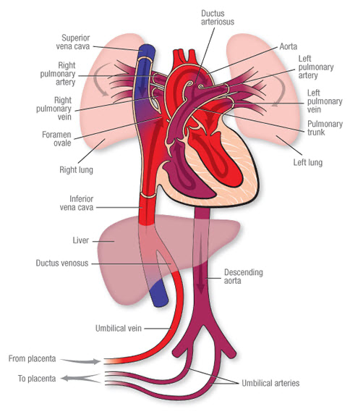
Diagrammatic representation of fetal circulation demonstrating physiological shunts [31].
The figure illustrates normal fetal circulation showing oxygenated blood from the placenta entering the fetus via the umbilical vein, bypassing the liver through the ductus venosus, preferential streaming across the foramen ovale into the left atrium, and diversion of right ventricular output into the descending aorta through the ductus arteriosus. These fetal shunts ensure optimal oxygen delivery to vital organs and are central to the pathophysiology of duct-dependent congenital heart diseases after birth.
Physiological transition from fetal to neonatal circulation [24][25][30] by illustrating progressive changes in blood flow patterns, oxygen saturation, and pressure relationships across the heart and great vessels. In fetal life, the lungs are non-functional for gas exchange and pulmonary vascular resistance remains high due to fluid-filled alveoli and hypoxic pulmonary vasoconstriction. Consequently, only a small proportion of combined ventricular output, typically around 3–8%, is directed to the pulmonary circulation, as indicated by low flow fractions accompanying oxygen saturation values in the pulmonary arteries. The majority of right ventricular output is diverted away from the lungs through a widely patent ductus arteriosus, resulting in right-to-left shunting from the pulmonary artery into the descending aorta. Oxygenated blood returning from the placenta via the umbilical vein and inferior vena cava has an oxygen saturation of approximately 70% and is preferentially streamed across the foramen ovale from the right atrium into the left atrium. This streaming mechanism ensures that relatively well-oxygenated blood supplies the left ventricle, ascending aorta, coronary arteries, and cerebral circulation, resulting in oxygen saturation levels of approximately 65% in these regions. Because pulmonary and systemic circulations function in parallel rather than in series, significant structural cardiac defects are often physiologically well tolerated in utero and may remain clinically silent before birth.

At birth, clamping of the umbilical cord abruptly removes the low-resistance placental circulation, leading to a rapid rise in systemic vascular resistance. Simultaneously, lung expansion with the initiation of breathing and increased alveolar oxygen tension causes a marked reduction in pulmonary vascular resistance. This results in a substantial increase in pulmonary blood flow and pulmonary venous return to the left atrium. The rise in left atrial pressure relative to right atrial pressure promotes functional closure of the foramen ovale. During this immediate postnatal transitional period, the ductus arteriosus typically remains patent, although the magnitude and direction of shunting decrease and may become bidirectional. Oxygen saturation throughout the circulation increases significantly, with left ventricular and systemic arterial saturations approaching 95–97%. Despite these improvements in oxygenation, pressure and flow relationships remain dynamic and unstable during this phase, allowing some duct-dependent congenital heart lesions to remain temporarily compensated. As a result, newborns with critical congenital heart disease may appear clinically stable in the early hours of life, and cardiac murmurs may still be absent or faint due to minimal pressure gradients across abnormal cardiac structures.

Within the first 24–48 hours after birth, pulmonary vascular resistance continues to fall, and systemic vascular resistance stabilizes at higher levels, resulting in establishment of the normal serial circulation. Functional closure of the foramen ovale is complete, and the ductus arteriosus progressively constricts in response to increased arterial oxygen tension and declining circulating prostaglandins. Pulmonary blood flow increases substantially, and oxygen saturation in the pulmonary veins, left ventricle, and systemic circulation reaches 98–99%. Systemic arterial pressures rise to typical neonatal values, often represented in the diagram by notations such as 80/50 mmHg with a mean arterial pressure of approximately 60 mmHg, reflecting improved systemic perfusion. At this stage, congenital heart defects that are dependent on fetal shunts for maintenance of adequate pulmonary or systemic blood flow become clinically manifest. Closure of the ductus arteriosus may precipitate sudden hypoxemia, metabolic acidosis, cardiovascular collapse, or shock in affected infants [24][25].

This physiological sequence explains why clinical examination alone is insufficient for reliable detection of critical congenital heart disease in the immediate newborn period. Cyanosis may not be clinically apparent until oxygen saturation falls below 80–85%, and murmurs may be absent during the transitional phase due to low pressure gradients and ongoing shunting. Pulse oximetry screening directly exploits the physiological changes illustrated in the diagram by detecting subtle but clinically significant hypoxemia during the period when pulmonary and systemic circulations are separating. By identifying abnormal oxygen saturation before overt clinical deterioration occurs, pulse oximetry enables early diagnosis, timely referral, and prevention of potentially catastrophic outcomes associated with delayed recognition of critical congenital heart disease.

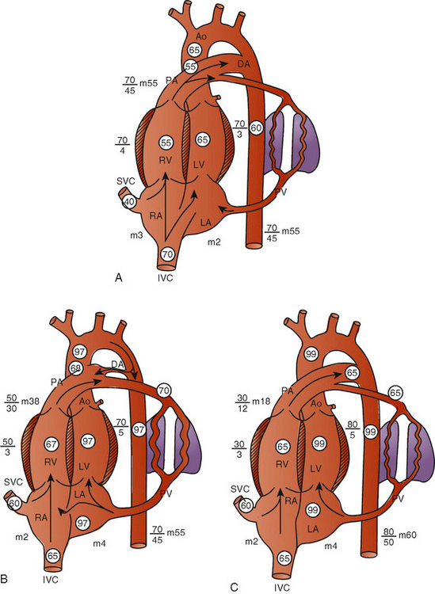

Fetal and neonatal circulation. Circled values are oxygen saturation, with values for pressure (systolic, diastolic, and mean) appearing beside their respective chamber or vessel. A, Fetal circulation near term. B, Transitional circulation at younger than 1 day old. C,Neonatal circulation at several days old. Ao, Aorta; DA, ductus arteriosus; IVC, inferior vena cava; LA, left atrium; LV, left ventricle; PA, pulmonary artery; PV, pulmonary veins; RA, right atrium; RV, right ventricle; SVC, superior vena cava.

(From Rudolph AM: The fetal circulation and Rudolph AM: Changes in the circulation after birth. In Rudolph AM, editor: Congenital diseases of the heart,Chicago, 1974, Mosby.)
This transitional period is critical in determining the clinical expression of congenital heart disease. Lesions that depend on fetal shunts [4] [30][31] for adequate systemic or pulmonary blood flow may remain asymptomatic in the immediate newborn period but can deteriorate rapidly following ductal closure. Duct-dependent systemic lesions such as coarctation of the aorta and hypoplastic left heart syndrome may present with shock and metabolic acidosis, while duct-dependent pulmonary lesions such as pulmonary atresia may manifest with profound hypoxemia. Importantly, clinical examination alone may fail to detect these conditions [4][21][35] during the early neonatal period, particularly in well-appearing infants, leading to delayed diagnosis and potentially fatal outcomes.

The physiological basis of this delayed presentation highlights the need for reliable, objective screening strategies that can detect subtle abnormalities in oxygenation before overt clinical deterioration occurs. Pulse oximetry screening has emerged as a direct response to this unmet need, leveraging the physiological consequences of abnormal transitional circulation to identify newborns at risk of critical congenital heart disease. A clear understanding of embryology, fetal circulation, and neonatal transition therefore provides the essential foundation upon which the rationale for pulse oximetry screening is built.
Clinical examination using a stethoscope has traditionally been the primary method for cardiovascular assessment in the newborn; however, it is inherently limited as a screening tool for congenital heart disease, particularly critical congenital heart disease. Auscultation relies on the detection of murmurs generated by turbulent blood flow across abnormal cardiac structures. In the immediate neonatal period, many critical cardiac lesions do not produce significant turbulence because pressure gradients across valves, septa, or outflow tracts are minimal during transitional circulation. Elevated pulmonary vascular resistance, persistence of fetal shunts, and balanced intracardiac mixing often result in silent or very soft murmurs, leading to false reassurance despite the presence of life-threatening disease. Consequently, the absence of a murmur does not exclude critical congenital heart disease, making auscultation an unreliable standalone screening method [24][25].

In contrast, pulse oximetry directly measures arterial oxygen saturation and detects hypoxemia resulting from abnormal circulatory physiology rather than structural turbulence. Many critical congenital heart defects impair effective oxygen delivery through abnormal mixing, parallel circulation, or reduced pulmonary blood flow, leading to measurable desaturation even when clinical signs are subtle or absent. Pulse oximetry identifies these physiological disturbances objectively and quantitatively, allowing detection of disease before the onset of overt cyanosis, shock, or cardiovascular collapse. This ability to identify subclinical hypoxemia represents a fundamental advantage over auscultation, which depends on subjective auditory interpretation.

Another important limitation of stethoscope-based examination is the delayed appearance of clinical signs. Cyanosis, a key indicator of hypoxemia, is visually detectable only when oxygen saturation falls below approximately 80–85 percent. In many newborns with critical congenital heart disease, oxygen saturation may be significantly reduced yet remain above this threshold, particularly during the early postnatal period. This phenomenon is further influenced by skin pigmentation, ambient lighting, and hemoglobin concentration, all of which reduce the sensitivity of visual assessment. Pulse oximetry overcomes these limitations by detecting even mild reductions in oxygen saturation, thereby identifying at-risk infants who appear clinically pink and well perfused on routine examination.

The reliability of auscultation is also highly dependent on examiner expertise, time constraints, and environmental conditions. In busy postnatal wards and delivery rooms, background noise, brief examination duration, and interobserver variability significantly reduce the sensitivity of murmur detection. Studies have demonstrated substantial variation in clinicians’ ability to correctly identify pathological murmurs in newborns, even among experienced practitioners. Pulse oximetry, by contrast, provides standardized, reproducible results that are independent of operator skill, making it particularly suitable for universal screening programs across diverse healthcare settings.

Furthermore, auscultation lacks specificity as a screening tool because innocent or transitional murmurs are common in healthy neonates. Physiological flow murmurs related to peripheral pulmonary stenosis or a closing ductus arteriosus may lead to unnecessary referrals, investigations, and parental anxiety. Pulse oximetry demonstrates very high specificity, particularly when screening is performed after 24 hours of life, resulting in fewer false-positive results and more efficient use of diagnostic resources. Importantly, false-positive pulse oximetry results often identify other clinically significant conditions such as neonatal sepsis or persistent pulmonary hypertension, which also benefit from early recognition and management[26][33].

Pulse oximetry is additionally superior in its ability to detect duct-dependent congenital heart disease at a critical window in neonatal adaptation. As fetal shunts begin to close and pulmonary and systemic circulations separate, infants with duct-dependent lesions may rapidly deteriorate. Auscultation may fail to provide early warning during this transition, whereas pulse oximetry detects declining oxygen saturation before clinical decompensation occurs. Early identification allows timely initiation of prostaglandin therapy, planned referral, and stabilization prior to definitive intervention, thereby reducing morbidity and mortality associated with late diagnosis.

Taken together, these factors establish pulse oximetry as a superior screening modality compared with stethoscope-based examination alone. While auscultation remains an essential component of comprehensive neonatal assessment, it lacks the sensitivity, objectivity, and reproducibility required for effective population-level screening. Pulse oximetry complements clinical examination by providing an objective physiological measure that identifies hypoxemia early, reduces missed diagnoses, and bridges the diagnostic gap between antenatal detection and postnatal clinical presentation of congenital heart disease.

Before the introduction of routine pulse oximetry screening, a substantial proportion of critical congenital heart diseases were diagnosed only after hospital discharge, often presenting as sudden cardiovascular collapse [21][30][45], severe hypoxemia, or death. Diagnosis relied primarily on antenatal ultrasonography and postnatal clinical examination, both of which have limited sensitivity, especially in resource-limited settings.
The incorporation of pulse oximetry into newborn screening programs has transformed early CHD detection by enabling identification of asymptomatic hypoxemia during the first 24–48 hours of life [18][19]. This shift has led to earlier diagnosis, reduced incidence of late presentations, and improved pre-operative stability of affected neonates. From a public health perspective, pulse oximetry screening is cost-effective, easily scalable, and feasible even in peripheral healthcare settings with minimal training. Early identification facilitates timely referral to tertiary centers, reduces emergency admissions, prevents circulatory collapse, and contributes to lower neonatal morbidity and mortality. In countries with high birth rates and limited access to prenatal screening, pulse oximetry plays a crucial role in narrowing health inequities and strengthening neonatal health systems. Thus, SpO₂-based screening represents a major advancement in population-level strategies for reducing CHD-related mortality.

Congenital heart diseases are traditionally classified into acyanotic and cyanotic lesions [24][25][26] based on the presence or absence of systemic arterial desaturation; however, this distinction is dynamic and depends on physiological factors such as shunt direction, pulmonary vascular resistance, and the patency of fetal channels. Acyanotic congenital heart diseases constitute the majority of lesions diagnosed in infancy and childhood and are primarily characterized by left-to-right shunting or obstructive physiology without significant arterial desaturation in the early stages. These lesions may nonetheless progress to cyanosis over time due to pulmonary vascular disease or evolving hemodynamics.
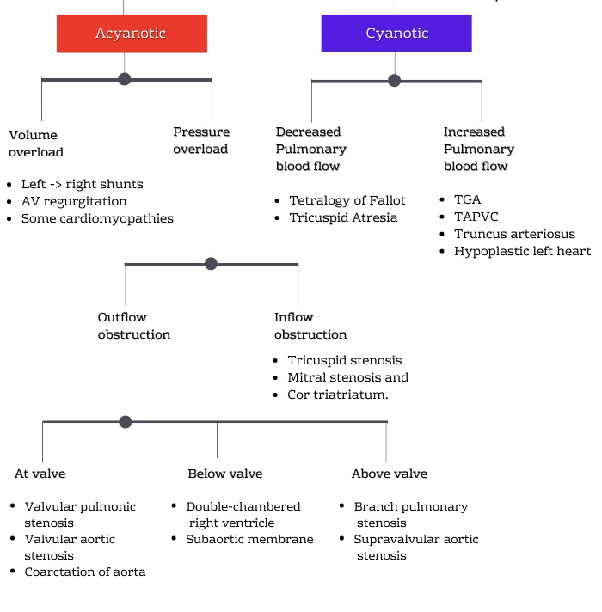
Physiological classification of congenital heart disease based on presence of cyanosis and hemodynamic burden [24][25].

Among acyanotic lesions, ventricular septal defect [24][25][26] is the most common congenital heart disease worldwide. It results from incomplete formation of the interventricular septum and may involve the membranous, muscular, inlet, or outlet portions. Hemodynamically, a left-to-right shunt occurs due to higher systemic vascular resistance compared to pulmonary vascular resistance after birth. The magnitude of shunting depends on defect size and pulmonary vascular resistance. Small defects may be asymptomatic, whereas large defects lead to pulmonary overcirculation, congestive heart failure, and failure to thrive. Although systemic oxygen saturation remains normal initially, pulse oximetry may detect subtle desaturation in large defects complicated by pulmonary hypertension or evolving Eisenmenger physiology.

Atrial septal defects [24][25][26], particularly the ostium secundum type, result from deficient septal tissue at the fossa ovalis. These defects typically produce volume overload of the right atrium and right ventricle due to left-to-right shunting at the atrial level. Because atrial pressures are low, shunting is usually well tolerated in infancy, and cyanosis is absent. However, prolonged right-sided volume overload may eventually lead to pulmonary hypertension and right-to-left shunting later in life. In the neonatal period, oxygen saturation is generally normal, explaining why pulse oximetry screening may not detect isolated atrial septal defects.

Patent ductus arteriosus [24][25][26][33] represents persistence of the fetal ductal connection between the descending aorta and pulmonary artery. After birth, a left-to-right shunt develops as systemic pressure exceeds pulmonary pressure. Hemodynamic consequences include pulmonary overcirculation and left heart volume overload. In preterm infants, ductal shunting may be associated with systemic hypoperfusion and respiratory compromise. Although cyanosis is not typical, differential cyanosis may occur in rare circumstances when pulmonary hypertension leads to right-to-left ductal shunting, a phenomenon detectable by preductal and postductal pulse oximetry differences.

Atrioventricular septal defects [24][25][26] arise from abnormal development of the endocardial cushions and are frequently associated with chromosomal anomalies such as trisomy 21. These defects result in a common atrioventricular junction with varying degrees of atrial and ventricular communication. Large left-to-right shunts lead to early onset heart failure and pulmonary hypertension. While systemic oxygen saturation may be preserved initially, progressive pulmonary vascular disease can result in desaturation, making early detection and intervention crucial.

Obstructive acyanotic lesions include coarctation of the aorta [24][25][26][21], aortic stenosis, and pulmonary stenosis. Coarctation of the aorta involves narrowing of the aortic arch, most commonly near the insertion of the ductus arteriosus. In duct-dependent systemic circulation, closure of the ductus leads to acute systemic hypoperfusion, metabolic acidosis, and shock. Oxygen saturation may be normal in the upper limbs but reduced in the lower limbs, producing differential saturation that forms the physiological basis for preductal and postductal pulse oximetry screening. Importantly, isolated coarctation may not produce hypoxemia initially, explaining its status as a common false-negative lesion in pulse oximetry screening.

Cyanotic congenital heart diseases are characterized by right-to-left shunting or parallel circulations resulting in systemic arterial desaturation. These lesions often present early in the neonatal period, particularly after closure of fetal shunts, and are the primary targets of pulse oximetry screening programs.

Tetralogy of Fallot [24][25][26] is the most common cyanotic congenital heart disease beyond the neonatal period and consists of ventricular septal defect, right ventricular outflow tract obstruction, overriding aorta, and right ventricular hypertrophy. The degree of cyanosis depends on the severity of right ventricular outflow tract obstruction. In severe forms, significant right-to-left shunting across the ventricular septal defect results in marked hypoxemia detectable by pulse oximetry. In milder forms, cyanosis may be minimal in the early neonatal period, potentially delaying diagnosis without screening.

Transposition of the great arteries [25][26] represents a condition of ventriculoarterial discordance, resulting in parallel rather than series circulation. Survival depends on adequate mixing at the atrial, ventricular, or ductal level. Despite normal pulmonary blood flow, systemic circulation receives desaturated blood, leading to profound hypoxemia that is often disproportionate to the degree of respiratory distress. Pulse oximetry reliably detects low oxygen saturation in these infants [5][6][7][8], even when clinical cyanosis is subtle, making it one of the most effectively screened lesions.

Total anomalous pulmonary venous connection [25][26] is characterized by failure of pulmonary veins to connect to the left atrium, resulting in systemic venous admixture. Oxygenated pulmonary venous blood returns to the right atrium, leading to varying degrees of cyanosis depending on the presence and size of an atrial septal communication and the degree of pulmonary venous obstruction. Obstructed forms present with severe hypoxemia and respiratory distress, whereas unobstructed forms may have milder desaturation detectable by pulse oximetry before clinical deterioration.

Tricuspid atresia [25][26] involves absence of the tricuspid valve, resulting in hypoplastic right ventricle and obligatory right-to-left shunting at the atrial level. Pulmonary blood flow depends on the presence of a ventricular septal defect or patent ductus arteriosus. Cyanosis is universal and typically evident in the neonatal period. Pulse oximetry readily identifies reduced systemic oxygen saturation in these infants.

Pulmonary atresia [25][26] with intact ventricular septum represents a spectrum of disease characterized by complete obstruction of the right ventricular outflow tract. Pulmonary blood flow is entirely duct-dependent, and closure of the ductus arteriosus results in profound hypoxemia and cardiovascular collapse. Early detection through pulse oximetry before ductal closure is critical for survival.

Single ventricle [25][26] physiology encompasses a group of complex lesions in which only one functional ventricular chamber is present. Systemic and pulmonary circulations mix at the ventricular level, resulting in chronic hypoxemia of variable severity. Oxygen saturation levels may fall in an intermediate range, often between 75% and 90%, making pulse oximetry an important screening tool despite the absence of dramatic cyanosis.

Hypoplastic left heart syndrome [25][26] represents one of the most severe forms of congenital heart disease, characterized by underdevelopment of the left-sided cardiac structures. Systemic circulation is entirely duct-dependent, and closure of the ductus arteriosus leads to catastrophic circulatory failure. Early oxygen saturation levels may appear deceptively acceptable due to ductal mixing, but pulse oximetry often reveals lower-than-expected saturations or differential patterns, supporting early suspicion.

Thus, while acyanotic and cyanotic congenital heart diseases differ in their initial physiological impact on systemic oxygenation, both categories encompass lesions that may present with subtle or delayed manifestations in the neonatal period. Pulse oximetry screening exploits these physiological principles by identifying hypoxemia or differential saturation patterns before clinical decompensation occurs. Understanding the full spectrum of congenital heart disease pathophysiology is essential for interpreting screening results and underscores the importance of integrating pulse oximetry with clinical examination and echocardiography in comprehensive neonatal cardiac care.

The clinical manifestations of congenital heart disease vary widely depending on the type of defect, severity of hemodynamic disturbance, presence of shunts or obstruction, and the stage of postnatal circulatory adaptation [25][26][30]. Many congenital heart defects are well tolerated in utero due to the unique characteristics of fetal circulation, and symptoms often emerge only after birth when fetal shunts begin to close and pulmonary vascular resistance falls. Consequently, the timing and nature of presentation range from asymptomatic murmurs detected incidentally to life-threatening cardiovascular collapse in the neonatal period.

In the neonatal period, symptoms of congenital heart disease are often subtle and nonspecific, making early recognition challenging. Poor feeding is one of the earliest and most common manifestations, reflecting the increased metabolic demand and reduced cardiac reserve associated with significant cardiac lesions. Infants may tire easily during feeding, require frequent pauses, or demonstrate prolonged feeding times. Failure to gain weight and poor postnatal growth frequently accompany these feeding difficulties, particularly in lesions associated with increased pulmonary blood flow or congestive heart failure. Excessive sweating, especially during feeding, is a characteristic symptom resulting from sympathetic overactivity and increased work of breathing.

Respiratory symptoms are prominent in many forms of congenital heart disease. Tachypnea, often persistent and disproportionate to the degree of respiratory illness, is a key clinical feature. In left-to-right shunt lesions such as large ventricular septal defects or patent ductus arteriosus, increased pulmonary blood flow leads to pulmonary congestion and reduced lung compliance, resulting in rapid, shallow breathing. Recurrent lower respiratory tract infections are commonly observed in these infants due to pulmonary overcirculation and interstitial edema. In contrast, cyanotic congenital heart diseases may present with relatively mild respiratory distress despite significant hypoxemia, a phenomenon that helps differentiate cardiac from primary pulmonary pathology.

Cyanosis is a hallmark feature of many congenital heart diseases but may be clinically inapparent in the early neonatal period. Visible cyanosis typically appears when arterial oxygen saturation falls below approximately 80–85% [18][22][23], and mild hypoxemia may go undetected by visual inspection alone. Central cyanosis involving the lips, tongue, and mucous membranes suggests systemic arterial desaturation and is characteristic of cyanotic congenital heart disease. The intensity of cyanosis varies with the degree of right-to-left shunting, pulmonary blood flow, and hemoglobin concentration. In duct-dependent lesions, cyanosis may worsen dramatically following closure of the ductus arteriosus, leading to acute clinical deterioration [21][30][35].

Cardiovascular signs frequently provide important diagnostic clues. Tachycardia is a common finding and reflects compensatory mechanisms aimed at maintaining cardiac output. Bounding peripheral pulses and widened pulse pressure are characteristic of conditions associated with runoff lesions such as patent ductus arteriosus, while weak or absent femoral pulses raise suspicion of obstructive lesions like coarctation of the aorta. Differential pulses or blood pressure discrepancies between upper and lower limbs may be present but can be difficult to appreciate in the immediate neonatal period.

Heart murmurs are among the most frequently detected signs of congenital heart disease, although their presence and intensity do not always correlate with disease severity. Some critical lesions may be associated with soft or absent murmurs, particularly in the early neonatal period when pressure gradients across defects are low. Conversely, loud murmurs may be present in relatively benign conditions. The timing, location, and quality of murmurs, along with associated findings such as thrills or abnormal heart sounds, provide valuable diagnostic information but must be interpreted in the context of the overall clinical picture.

Signs of congestive heart failure are particularly prominent in infants with large left-to-right shunts. These include tachypnea, hepatomegaly, poor feeding, excessive sweating, and failure to thrive [24][25][26]. Hepatomegaly is a sensitive indicator of right-sided heart failure in infants and may precede the development of peripheral edema, which is less common in this age group. As pulmonary vascular resistance decreases over the first few weeks of life, the magnitude of shunting increases, leading to progressive worsening of symptoms.

Obstructive congenital heart diseases often present dramatically when ductal patency is lost. Infants with critical coarctation of the aorta, hypoplastic left heart syndrome, or severe aortic stenosis may appear well initially but develop signs of systemic hypoperfusion after ductal closure. These signs include poor feeding, lethargy, pallor, cold extremities, prolonged capillary refill time, metabolic acidosis, and oliguria. Shock may develop rapidly and is frequently misattributed to sepsis unless a high index of suspicion is maintained.

Older infants and children with congenital heart disease may present with exercise intolerance, easy fatigability, and poor weight gain. In cyanotic heart disease, chronic hypoxemia leads to secondary erythrocytosis, resulting in symptoms such as headache, dizziness, and fatigue. Digital clubbing may develop over time, reflecting chronic tissue hypoxia. Squatting behavior, particularly observed in children with tetralogy of Fallot, is a compensatory maneuver that increases systemic vascular resistance and temporarily reduces right-to-left shunting, alleviating cyanotic symptoms.

Neurological manifestations may occur as secondary complications of congenital heart disease. Hypoxic spells, particularly in cyanotic lesions, can lead to syncope or seizures. Stroke and brain abscess are recognized complications in children with right-to-left shunts due to paradoxical embolization. Developmental delay may be observed, particularly in children with prolonged hypoxemia, recurrent hospitalizations, or associated genetic syndromes.

Gastrointestinal and systemic manifestations further reflect the multisystem impact of congenital heart disease. Poor perfusion and chronic congestion can impair gastrointestinal function, contributing to feeding intolerance and malabsorption. In severe cases, necrotizing enterocolitis has been reported in neonates with duct-dependent systemic circulation. Renal dysfunction may occur secondary to chronic hypoperfusion, particularly in obstructive lesions.

The clinical presentation of congenital heart disease is further influenced by associated extracardiac anomalies and syndromic associations. Conditions such as Down syndrome, DiGeorge syndrome, and Noonan syndrome are frequently associated with specific cardiac defects and may present with characteristic dysmorphic features alongside cardiac symptoms. Recognition of these associations facilitates early diagnosis and comprehensive evaluation.
Investigation of congenital heart disease requires a structured, stepwise approach aimed at defining cardiac anatomy, physiology, hemodynamic consequences, and associated extracardiac involvement [24][25][26]. While clinical examination and basic investigations provide initial suspicion, definitive diagnosis and characterization of congenital heart disease relies predominantly on echocardiography. Advances in non-invasive cardiac imaging have transformed the evaluation of congenital heart disease, with two-dimensional echocardiography serving as the cornerstone investigation across all age groups, including the neonatal period.

Initial investigations in suspected congenital heart disease often begin with basic bedside and laboratory assessments. Pulse oximetry provides an objective measure [5][9][14][17] of arterial oxygen saturation and serves as an important screening and monitoring tool, particularly for cyanotic and duct-dependent lesions. Electrocardiography may reveal chamber hypertrophy, axis deviation, conduction abnormalities, or arrhythmias suggestive of underlying structural disease. Chest radiography offers supportive information regarding cardiac size, pulmonary vascularity, and lung fields, with findings such as cardiomegaly, pulmonary plethora, or oligemia aiding in differential diagnosis. However, these investigations are adjunctive and lack the specificity required for definitive diagnosis.

Two-dimensional echocardiography has emerged as the primary diagnostic modality for congenital heart disease [24][25][26] due to its non-invasive nature, absence of ionizing radiation, bedside applicability, and ability to provide real-time anatomical and functional information. Echocardiography is based on the transmission and reflection of high-frequency ultrasound waves at tissue interfaces, with the reflected signals processed to generate detailed images of cardiac structures. The integration of two-dimensional imaging with Doppler techniques allows comprehensive assessment of cardiac morphology, blood flow patterns, pressure gradients, and ventricular function.

The evaluation of congenital heart disease by echocardiography follows a systematic, segmental approach, ensuring accurate identification of cardiac anatomy irrespective of complexity. This approach begins with determination of situs, including atrial arrangement and position of abdominal viscera, followed by assessment of atrioventricular connections, ventricular morphology, ventriculoarterial connections, and great vessel relationships. Such a structured method minimizes diagnostic errors and is particularly important in complex congenital heart disease.

Two-dimensional imaging forms the foundation of echocardiographic assessment. It enables visualization of cardiac chambers, valves, septa, and great vessels, allowing identification of structural defects such as atrial and ventricular septal defects, atrioventricular septal defects, valvular stenosis or regurgitation, and abnormalities of the outflow tracts. Chamber size and wall thickness provide insight into pressure and volume overload states, while assessment of ventricular morphology helps differentiate right and left ventricles based on trabeculation patterns, papillary muscle arrangement, and moderator band presence.

M-mode echocardiography, although less commonly used in isolation, remains valuable for precise measurement of cardiac dimensions and assessment of ventricular systolic function. It provides high temporal resolution, allowing accurate evaluation of ventricular wall motion, fractional shortening, and valve motion. M-mode is particularly useful in serial follow-up of ventricular function in children with volume or pressure overload.

Doppler echocardiography is indispensable in the functional assessment of congenital heart disease. Color Doppler imaging allows visualization of blood flow direction and turbulence, facilitating detection of intracardiac shunts, valvular regurgitation, and abnormal flow patterns. Left-to-right shunts across atrial or ventricular septal defects are readily identified, while right-to-left shunting can be detected in cyanotic lesions. Pulsed-wave Doppler provides quantitative assessment of blood flow velocities at specific sites, enabling estimation of pressure gradients across stenotic valves or obstructed outflow tracts using the modified Bernoulli equation. Continuous-wave Doppler is particularly useful for measuring high-velocity jets in severe stenosis or regurgitation.

A comprehensive echocardiographic evaluation of congenital heart disease requires acquisition of standard imaging planes or views, each providing specific anatomical and functional information. The parasternal long-axis view allows assessment of left ventricular size and function, mitral and aortic valves, interventricular septum, and left ventricular outflow tract. This view is crucial for identifying ventricular septal defects, aortic valve abnormalities, and left ventricular outflow obstruction. The parasternal short-axis view, obtained at various levels, enables detailed evaluation of ventricular geometry, papillary muscles, semilunar valves, and great vessels. Short-axis views at the level of the great arteries are particularly valuable for identifying transposition of the great arteries and assessing pulmonary valve morphology.

The apical four-chamber view [24][25][26] provides simultaneous visualization of both atria and ventricles, atrioventricular valves, and interventricular and interatrial septa. This view is essential for diagnosing atrial and ventricular septal defects, atrioventricular septal defects, and assessing atrioventricular valve regurgitation. Doppler interrogation from this window allows evaluation of diastolic function and estimation of ventricular filling pressures. The apical five-chamber view extends this assessment to include the left ventricular outflow tract and aortic valve.

Subcostal views [25][26] are particularly valuable in neonates and infants due to favorable acoustic windows. These views allow excellent visualization of atrial septum, inferior vena cava, hepatic veins, and systemic venous connections. Subcostal imaging is critical for detecting atrial septal defects, assessing shunt direction, and evaluating venous anomalies such as total anomalous pulmonary venous connection. In addition, subcostal views provide important information regarding diaphragmatic motion and associated extracardiac pathology.

Suprasternal views [25][26] enable assessment of the aortic arch, its branches, and pulmonary arteries. These views are indispensable for diagnosing coarctation of the aorta, interrupted aortic arch, and anomalies of arch branching patterns. Doppler interrogation from the suprasternal window allows evaluation of flow gradients across the aortic arch and detection of ductal flow patterns.

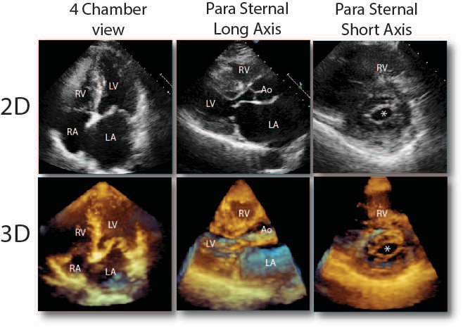

Comparison of conventional two-dimensional (2D) and three-dimensional (3D) echocardiographic images in standard cardiac views [24][25].
The figure demonstrates apical four-chamber view, parasternal long-axis view, and parasternal short-axis view obtained using 2D echocardiography (upper panel) and corresponding reconstructed 3D echocardiographic images (lower panel). RA—right atrium; RV—right ventricle; LA—left atrium; LV—left ventricle; Ao—aorta. The asterisk (*) highlights structural delineation in the short-axis plane.
Source: Adapted from standard pediatric echocardiography descriptions (Ref. 24).

Echocardiography also plays a central role in evaluating duct-dependent lesions. Assessment of ductus arteriosus patency, flow direction, and contribution to systemic or pulmonary circulation is critical in conditions such as hypoplastic left heart syndrome, pulmonary atresia, and critical coarctation of the aorta. Echocardiography guides urgent medical management, including prostaglandin therapy, and informs surgical or interventional planning.

In addition to structural diagnosis, echocardiography provides valuable prognostic information by assessing ventricular function, pulmonary artery pressures, and associated anomalies. Serial echocardiographic evaluations are essential for monitoring disease progression, response to therapy, and postoperative outcomes. In the context of newborn screening, echocardiography serves as the confirmatory investigation following abnormal pulse oximetry results, ensuring timely and accurate diagnosis.

The physiological basis of pulse oximetry screening for congenital heart disease is rooted in the principles of oxygen transport and hemoglobin oxygen saturation. Oxygen is carried in blood predominantly bound to hemoglobin, and the proportion of oxygenated hemoglobin relative to total hemoglobin determines arterial oxygen saturation (SpO₂). Pulse oximetry is a non-invasive technique that estimates arterial oxygen saturation by analyzing the differential absorption of light by oxyhemoglobin and deoxyhemoglobin. This technology relies on the Beer–Lambert law [36][37][38], which states that light absorption by a substance is proportional to its concentration and path length. Pulse oximeters emit red light (approximately 660 nm) and infrared light (approximately 940 nm), wavelengths at which oxyhemoglobin and deoxyhemoglobin exhibit distinct absorption characteristics. By detecting pulsatile changes in light absorption corresponding to arterial blood flow, pulse oximetry selectively measures arterial oxygen saturation while excluding venous and capillary blood signals.

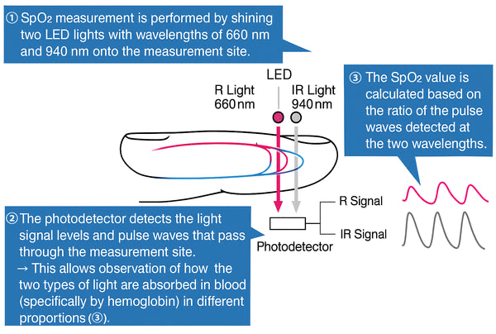
The principle of pulse oximetry is based on Beer–Lambert law and photoplethysmography, using red (660 nm) and infrared (940 nm) wavelengths to calculate SpO₂
Adapted from Jubran A. Pulse oximetry. Critical Care. 2015.

The discovery and evolution of pulse oximetry represent a major milestone in neonatal and pediatric monitoring. Early work on light absorption by hemoglobin dates back to the 19th century, but modern pulse oximetry was developed in the 1970s and 1980s, primarily through advances in photoplethysmography [36][39][41] and microprocessor technology. The clinical adoption of pulse oximetry accelerated after recognition of its ability to provide continuous, real-time oxygen saturation monitoring without the need for arterial blood sampling. Over time, pulse oximetry has transitioned from a monitoring tool in intensive care units to a screening modality in population-based newborn health programs. Large epidemiological studies demonstrated that many infants with critical congenital heart disease (CCHD) appear clinically stable at birth and may not exhibit overt cyanosis, yet have measurable hypoxemia detectable by pulse oximetry, thereby establishing its role in early detection.

Technological refinements have significantly improved the accuracy and reliability of pulse oximetry in neonates. Motion artifact [40][41], low perfusion states, and ambient light interference were early limitations, particularly relevant in newborns with transitional circulation. Signal extraction technology, as pioneered by Masimo Corporation, introduced advanced algorithms capable of distinguishing true arterial signals from noise. These innovations enabled accurate oxygen saturation measurements even in conditions of low perfusion, movement, or weak pulsatile signals—common challenges in neonates. Several studies have shown that motion-tolerant pulse oximetry improves screening sensitivity for CCHD while reducing false-positive rates, thereby strengthening its feasibility for universal newborn screening programs.

Pulse oximetry screening for critical congenital heart disease is based on well-established principles of fetal and transitional circulation, oxygen physiology, and population-level screening performance characteristics. The choice of specific cut-off values and screening protocols is not arbitrary but represents a balance between sensitivity, specificity, feasibility, and avoidance of unnecessary false positives in the immediate postnatal period. Understanding the rationale behind these parameters is essential for interpreting screening results and for appreciating the role of pulse oximetry as a public health intervention in the early detection of congenital heart disease.

The selection of an oxygen saturation cut-off of less than 95 percent as abnormal is rooted in normal postnatal oxygen physiology. In healthy term neonates, arterial oxygen saturation rises progressively after birth as pulmonary vascular resistance decreases and pulmonary blood flow increases. By 24 hours of life, most healthy newborns achieve stable oxygen saturation values above 95 percent in room air [42][43][44]. Large population studies have demonstrated that sustained oxygen saturation values below this level beyond the transitional period are uncommon in normal infants and often indicate underlying pathology. Critical congenital heart diseases associated with right-to-left shunting, parallel circulation, or reduced pulmonary blood flow frequently result in mild to moderate hypoxemia that may not produce visible cyanosis but is sufficient to keep saturation persistently below 95 percent. Using this threshold allows detection of these clinically silent but physiologically significant lesions.

A lower cutoff such as 90 percent would miss a substantial proportion of infants with critical congenital heart disease, particularly those with lesions such as transposition of the great arteries, total anomalous pulmonary venous connection, or coarctation of the aorta with duct-dependent systemic circulation, where saturations may remain in the low-to-mid 90s. Conversely, raising the cutoff above 95 percent would significantly increase false-positive rates, particularly due to transitional hypoxemia, mild pulmonary disease, or probe-related artifacts. Therefore, the cutoff of less than 95 percent represents an optimal compromise that maximizes sensitivity while maintaining acceptable specificity in large-scale screening programs.

The criterion of a difference greater than 3 percent between preductal and postductal [43][47] oxygen saturation is based on the physiology of ductal shunting and differential oxygenation. In normal postnatal circulation, once pulmonary vascular resistance falls and the ductus arteriosus begins to close, oxygen saturation in the right upper limb (preductal) and lower limbs (postductal) becomes nearly identical. A persistent difference exceeding 3 percent suggests ongoing ductal flow with abnormal hemodynamics. In conditions such as persistent pulmonary hypertension of the newborn, transposition of the great arteries, and duct-dependent systemic or pulmonary circulation, differential shunting across the ductus arteriosus leads to measurable differences in oxygen saturation between preductal and postductal sites.

The threshold of greater than 3 percent is derived from studies showing that smaller differences frequently occur due to measurement variability, motion artifact, or transient physiological fluctuations and do not reliably indicate disease. Differences exceeding this threshold, particularly when reproducible, are strongly associated with pathological ductal shunting or abnormal pulmonary vascular resistance. This criterion is especially valuable in detecting lesions that may not produce absolute hypoxemia but still result in abnormal distribution of oxygenated blood.

Measurement of preductal oxygen saturation, typically obtained from the right hand, is critical because it reflects oxygenation of blood supplied to the brain and coronary arteries, which arise proximal to the ductus arteriosus. In contrast, postductal saturation measured from the foot reflects blood that has potentially mixed with deoxygenated blood via the ductus arteriosus. In duct-dependent lesions affecting systemic circulation, such as coarctation of the aorta or interrupted aortic arch, postductal saturation may be lower due to reduced oxygenated blood flow to the lower body. In lesions with right-to-left ductal shunting, postductal desaturation may be the earliest detectable abnormality even when preductal saturation appears normal.

The emphasis on preductal and postductal comparison rather than a single-site measurement increases the diagnostic yield of pulse oximetry screening. Single-site screening may fail to detect lesions where overall oxygen saturation is preserved but differential perfusion exists. By simultaneously assessing two physiologically distinct circulatory territories, pulse oximetry provides indirect insight into ductal flow dynamics and systemic versus pulmonary blood flow balance.

In certain clinical settings, measurement of oxygen saturation in all four limbs may provide additional diagnostic information. Four-limb assessment is particularly useful in suspected obstructive lesions of the aortic arch, where upper limb saturations may be normal while lower limb saturations are reduced. Although routine four-limb pulse oximetry is not universally mandated in all screening protocols due to feasibility considerations, its selective use enhances detection of coarctation of the aorta and interrupted aortic arch, conditions that are known to be more difficult to detect through pulse oximetry alone. When combined with pulse palpation and blood pressure assessment, four-limb saturation measurement strengthens clinical suspicion and prompts timely echocardiographic evaluation.

The timing of pulse oximetry screening after 24 hours of life [45][46] rather than immediately at birth is a critical aspect of screening accuracy. The immediate postnatal period is characterized by rapid and dynamic cardiovascular and respiratory changes as the newborn transitions from fetal to neonatal circulation. During the first several hours of life, pulmonary vascular resistance remains relatively high, functional closure of the ductus arteriosus is incomplete, and lung fluid clearance is ongoing. These factors contribute to transient hypoxemia even in healthy neonates, leading to a high false-positive rate if screening is performed too early.

Studies have consistently shown that pulse oximetry performed within the first 6–12 hours of life yield a significantly higher proportion of abnormal results that resolve spontaneously without intervention. Many of these early abnormal readings are attributable to delayed lung aeration, mild pulmonary hypertension, or incomplete circulatory transition rather than structural heart disease. Delaying screening until after 24 hours allows stabilization of pulmonary blood flow, reduction of pulmonary vascular resistance, and more reliable differentiation between physiological transitional hypoxemia and pathological hypoxemia due to congenital heart disease.

Furthermore, closure of the ductus arteriosus during the first 24–48 hours unmask duct-dependent lesions that may not be apparent immediately after birth. Screening performed too early may falsely reassure clinicians in infants with duct-dependent systemic or pulmonary circulation, as oxygen saturation may appear acceptable while the ductus remains patent. Performing screening after 24 hours increases the likelihood that ductal constriction has begun, thereby revealing hypoxemia or differential saturation associated with critical lesions.

The rationale for not delaying screening excessively beyond 48 hours lies in the need for timely detection before clinical deterioration occurs. Many critical congenital heart diseases can progress rapidly once ductal closure is complete, leading to shock, metabolic acidosis, or sudden collapse. Pulse oximetry screening at 24–48 hours represent an optimal window that balances physiological stability with early detection, allowing prompt referral and intervention before catastrophic decompensation.

Taken together, the use of a saturation cutoff of less than 95 percent, a differential of more than 3 percent between preductal and postductal measurements, assessment of preductal and postductal sites, selective use of four-limb measurements, and screening after 24 hours of life reflects [45][46] a physiology-driven, evidence-based approach. These criteria are designed to detect clinically significant hypoxemia and abnormal circulatory patterns that are characteristic of critical congenital heart disease while minimizing false positives and unnecessary investigations [47][48]. Pulse oximetry screening thus serves as a powerful adjunct to clinical examination, bridging the gap between bedside assessment and definitive diagnostic imaging in the early identification of congenital heart disease [36][37][38].

Beyond diagnosis, congenital heart disease represents a significant public health challenge. CHD is among the most common congenital anomalies globally and contributes substantially to neonatal and infant morbidity and mortality, particularly in low- and middle-income countries. Delayed diagnosis often results in presentation with cardiogenic shock, metabolic acidosis, or sudden collapse after ductal closure. These preventable outcomes place a considerable burden on healthcare systems and families. Universal newborn screening using pulse oximetry has emerged as a cost-effective strategy to reduce late detection and improve survival outcomes, especially in resource-limited settings.
Prevention of congenital heart disease represents a critical component of child health strategies [52][53], given the substantial contribution of these conditions to neonatal and infant morbidity and mortality worldwide. Although advances in surgical and interventional cardiology have significantly improved survival, prevention remains the most effective approach to reducing disease burden, particularly in low- and middle-income countries. Preventive strategies for congenital heart disease are conventionally categorized into primordial, primary, and secondary prevention, each addressing different stages in the natural history of disease development and progression. These approaches are closely interlinked with parental awareness, counselling, and psychosocial support, which play a pivotal role in successful implementation and outcomes [26][54][55].

Primordial prevention [54][55] focuses on reducing population-level risk factors that predispose to congenital heart disease even before conception. This level of prevention aims to create an environment that minimizes exposure to known and potential teratogens and promotes optimal maternal health. Socioeconomic determinants such as poverty, poor nutrition, lack of access to healthcare, and limited health literacy significantly influence the risk of congenital anomalies, including heart defects. Public health measures that improve maternal education, ensure access to antenatal care, and promote healthy reproductive practices form the foundation of primordial prevention. Control of environmental pollutants, regulation of exposure to industrial chemicals, and prevention of substance abuse among women of reproductive age are also essential components. Vaccination programs, particularly rubella immunization [26][49][54], have demonstrated a dramatic reduction in congenital heart disease associated with congenital rubella syndrome, underscoring the effectiveness of population-based preventive strategies.

Primary prevention refers to interventions aimed at preventing the occurrence of congenital heart disease in individuals at risk, particularly during the periconceptional and antenatal periods. Maternal health plays a central role in this stage, as several maternal conditions are strongly associated with an increased risk of congenital heart defects [26][49][51]. Poorly controlled pregestational diabetes mellitus is a well-established risk factor, associated with a several-fold increase in the incidence of structural cardiac anomalies. Optimal glycemic control before conception and throughout pregnancy has been shown to significantly reduce this risk. Similarly, maternal phenylketonuria [26][29], when inadequately controlled, is associated with a high incidence of congenital heart disease, highlighting the importance of metabolic control prior to conception.

Nutritional factors also contribute significantly to primary prevention. Periconceptional folic acid supplementation [26][54] is well known for its role in preventing neural tube defects, and emerging evidence suggests a protective effect against certain congenital heart defects. Adequate intake of micronutrients, including iodine and vitamin B12, supports normal fetal development. Avoidance of known teratogenic medications [49][51], such as isotretinoin, certain antiepileptic drugs, and alcohol, is a critical preventive measure. Maternal infections during pregnancy, particularly in the first trimester, have been implicated in the development of congenital heart disease. Early antenatal screening, timely treatment of infections, and preventive strategies such as vaccination contribute to reducing this risk. Genetic counselling is an important element of primary prevention in families with a history of congenital heart disease or known chromosomal abnormalities, enabling informed reproductive choices.

Secondary prevention focuses on early detection of congenital heart disease to prevent complications, reduce morbidity, and improve survival. Advances in antenatal ultrasonography have enabled detection of many congenital heart defects during fetal life, allowing planned delivery in tertiary care centers and early postnatal intervention. However, antenatal detection remains incomplete, particularly for lesions involving the outflow tracts and aortic arch. Postnatal screening strategies, including clinical examination and pulse oximetry screening, play a vital role in secondary prevention by identifying critical congenital heart disease before the onset of severe symptoms. Early diagnosis enables timely medical or surgical intervention, prevents circulatory collapse following ductal closure, and reduces the risk of hypoxic injury to vital organs. Secondary prevention thus bridges the gap between disease occurrence and definitive treatment, emphasizing the importance of systematic screening programs.

Parental concerns and psychosocial issues form an integral part of congenital heart disease prevention and management [52][53]. The diagnosis or even suspicion of congenital heart disease in a newborn often evokes intense emotional responses, including anxiety, guilt, fear, and uncertainty. Many parents experience feelings of self-blame, particularly mothers who may attribute the condition to perceived actions or omissions during pregnancy. Addressing these concerns through sensitive and structured counselling is essential. Healthcare providers play a crucial role in reassuring parents that most congenital heart diseases arise from multifactorial causes and are not the result of a single preventable action.

Counselling should begin at the time of screening or diagnosis and continue throughout the diagnostic and treatment process. Clear communication regarding the nature of the disease, its severity, available treatment options, and expected outcomes is fundamental. Use of simple, non-technical language, supplemented by diagrams or visual aids, enhances understanding and reduces anxiety. Parents should be informed about the purpose and limitations of screening tests, including the possibility of false-positive and false-negative results, to ensure realistic expectations. In cases where further investigations are required, timely referral and transparent communication help maintain parental trust in the healthcare system [59][62][65].

Long-term counselling [60] addresses issues beyond immediate medical management. Parents often have concerns regarding the child’s growth, development, physical activity, schooling, and long-term prognosis. Discussion of these aspects, including the likelihood of normal development following successful intervention, provides reassurance and promotes adherence to follow-up care. Genetic counselling may be indicated in certain conditions, particularly when congenital heart disease is associated with chromosomal or syndromic diagnoses. Families benefit from understanding recurrence risks in future pregnancies and available options for prenatal diagnosis.

Socioeconomic challenges [52][53] frequently influence parental decision-making, especially in resource-limited settings. Financial constraints, travel distance to specialized centers, and loss of income during prolonged hospitalizations can add to the burden experienced by families. Counselling should therefore adopt a holistic approach, acknowledge these challenges and facilitate access to social support services wherever possible. Involving parents as active partners in care planning fosters empowerment and improves overall outcomes.

In the broader context, parental awareness and education contribute indirectly to prevention efforts. Educated parents are more likely to seek early antenatal care, adhere to screening recommendations, and recognize warning signs in the postnatal period. Community-level education initiatives and incorporation of congenital anomaly awareness into maternal and child health programs further strengthen preventive strategies.

In summary, the integration of pulse oximetry into newborn screening programs is supported by robust physiological principles, technological advancements, and extensive clinical evidence. Understanding the embryological basis of congenital heart disease, the dynamics of fetal-to-neonatal circulatory transition, and the scientific rationale behind screening thresholds strengthens the clinical application of pulse oximetry. When combined with confirmatory echocardiography and comprehensive parental counselling, pulse oximetry screening represents a critical step toward improving early detection, reducing preventable morbidity and mortality, and addressing the broader public health impact of congenital heart disease.
Antenatal detection of congenital heart disease [49][50] constitutes a cornerstone of contemporary perinatal care and reflects the integration of embryological knowledge, advances in prenatal imaging, and risk-based screening strategies. Congenital heart disease originates during early embryogenesis, predominantly between the third and eighth weeks of gestation, when the primitive heart tube undergoes looping, septation, and differentiation into a four-chambered structure with aligned great vessels. Disruption at any stage of this complex developmental process may result in structural or functional cardiac abnormalities. Although these defects are physiologically well tolerated in utero due to parallel fetal circulation, they can be identified antenatally if systematic screening protocols are applied.

Routine obstetric ultrasonography forms the foundation of antenatal cardiac screening and is universally performed during pregnancy. The mid-trimester anomaly scan, typically conducted between 18 and 22 weeks of gestation, provides the optimal window for cardiac assessment due to favorable fetal size, amniotic fluid volume, and image resolution [50][51]. Initial evaluation focuses on cardiac situs, position, and size within the thorax, followed by assessment of the four-chamber view. This view allows visualization of atrial and ventricular symmetry, integrity of the interventricular septum, atrioventricular valve offset, and ventricular contractility. Many major defects, including atrioventricular septal defects, hypoplastic left heart syndrome, large ventricular septal defects, and single ventricle physiology, may be suspected at this stage. However, reliance on the four-chamber view alone is insufficient, as several critical congenital heart diseases may have a normal four-chamber appearance.

To improve detection rates, assessment of the ventricular outflow tracts and great vessels has become an essential component of antenatal screening. Visualization of the left and right ventricular outflow tracts enables identification of conotruncal anomalies such as transposition of the great arteries, tetralogy of Fallot, truncus arteriosus, and double outlet right ventricle. The three-vessel and three-vessel-trachea views provide additional information regarding the size, alignment, and spatial relationship of the pulmonary artery, ascending aorta, and superior vena cava, thereby facilitating recognition of aortic arch abnormalities and great vessel malpositions. Abnormal vessel size, asymmetry, or arrangement often serves as an early marker of complex congenital heart disease.

Fetal echocardiography represents [49][50][51] the definitive modality for antenatal diagnosis of congenital heart disease and is indicated when screening ultrasound raises suspicion or when specific risk factors are present. It is usually performed between 18 and 24 weeks of gestation, though early fetal echocardiography may be undertaken in high-risk pregnancies. This specialized examination employs two-dimensional imaging, M-mode, color Doppler, and spectral Doppler techniques to allow detailed assessment of cardiac anatomy, ventricular function, valvular morphology, venous connections, and blood flow patterns. Fetal echocardiography can detect both structural abnormalities and rhythm disturbances, and it permits serial evaluation to monitor disease progression or evolving lesions such as coarctation of the aorta.

Identification of antenatal risk factors is crucial in guiding targeted screening and optimizing detection rates. Maternal metabolic disorders represent a significant risk category, with pregestational diabetes mellitus being strongly associated with congenital heart disease, particularly septal defects, transposition of the great arteries, and cardiomyopathy. Poor glycemic control during early pregnancy is especially implicated. Phenylketonuria, when inadequately controlled, markedly increases the risk of congenital heart disease due to toxic effects of elevated phenylalanine levels on embryonic development.

Maternal infections during pregnancy, particularly in the first trimester, are well-established risk factors for congenital heart disease. Rubella infection [26][49] is classically associated with patent ductus arteriosus, pulmonary artery stenosis, and septal defects. Other viral infections, including cytomegalovirus and parvovirus B19, have also been implicated, though with less consistent associations. Maternal febrile illnesses during early gestation may interfere with cardiac morphogenesis through hyperthermia-related teratogenic effects.

Exposure to teratogenic substances constitutes another important antenatal risk factor. Medications such as isotretinoin, lithium, certain antiepileptic drugs including valproate and phenytoin, and alcohol are associated with increased risk of congenital heart disease. Alcohol exposure, particularly in the context of fetal alcohol spectrum disorders, is linked to septal defects and conotruncal anomalies. Environmental exposures, including organic solvents and pesticides, have also been implicated, though causal relationships are more difficult to establish.

Maternal autoimmune and connective tissue disorders [51][29] contribute to antenatal cardiac risk. Systemic lupus erythematosus and Sjögren syndrome are associated with fetal cardiac conduction abnormalities, particularly congenital heart block, due to transplacental passage of maternal autoantibodies. These conditions necessitate close fetal cardiac rhythm monitoring during pregnancy.

Fetal risk factors detectable on antenatal imaging often prompt detailed cardiac evaluation. Increased nuchal translucency measured during first-trimester screening is strongly associated with congenital heart disease, even in chromosomally normal fetuses. Structural extracardiac anomalies involving the central nervous system, gastrointestinal tract, or skeletal system frequently coexist with congenital heart disease and should raise suspicion of associated cardiac defects. Fetal growth restriction and abnormal amniotic fluid volume have also been linked to an increased prevalence of cardiac anomalies.

Chromosomal and genetic abnormalities represent a major category of antenatal risk factors. Congenital heart disease is commonly associated with aneuploidies such as trisomy 21, trisomy 18, and trisomy 13 [26][49][51], as well as microdeletion syndromes including 22q11.2 deletion syndrome. Advances in prenatal genetic screening, including non-invasive prenatal testing, chorionic villus sampling, and amniocentesis, have enhanced early identification of these conditions. Detection of a chromosomal abnormality significantly increases the likelihood of associated congenital heart disease and warrants comprehensive fetal echocardiographic evaluation.

A positive family history of congenital heart disease is another important risk factor, reflecting genetic susceptibility and shared environmental influences. Recurrence risk is higher when a first-degree relative is affected, particularly when the mother has congenital heart disease. This underscores the importance of targeted fetal echocardiography in such pregnancies.

The antenatal detection of congenital heart disease carries substantial clinical and prognostic significance. Prenatal diagnosis enables planned delivery in a tertiary care center with appropriate neonatal, cardiology, and surgical facilities, thereby reducing postnatal morbidity and mortality. It allows immediate postnatal stabilization, timely initiation of prostaglandin therapy in duct-dependent lesions, and avoidance of circulatory collapse. Furthermore, antenatal diagnosis facilitates structured parental counselling regarding expected clinical course, treatment options, survival outcomes, and long-term neurodevelopmental implications.

Postnatal clinical examination alone has long been recognized as insufficient for early detection of critical congenital heart disease. Cyanosis may not be clinically apparent until oxygen saturation falls below 80–85% [26][42][43] a level that may not be reached in the early neonatal period due to compensatory mechanisms and residual fetal shunts. Murmurs may be absent or subtle in the first days of life, particularly in duct-dependent lesions or those with balanced circulations. Femoral pulses may appear normal initially [29][30][33] in infants with evolving coarctation of the aorta, only becoming weak or absent after ductal closure. These limitations of clinical examination underscore the need for an objective, physiological screening tool capable of detecting hypoxemia before overt clinical deterioration occurs.

Pulse oximetry screening has emerged as a complementary strategy bridging the diagnostic gap between antenatal detection and clinical examination. Large population-based studies across Europe, North America, and Asia have demonstrated that pulse oximetry screening significantly improves the early detection rate of critical congenital heart disease when combined with routine physical examination. Meta-analyses have consistently shown high specificity, often exceeding 99%, and moderate sensitivity [42][46][48], typically around 75–85% for critical lesions. Importantly, pulse oximetry screening has been shown to reduce the incidence of late diagnosis, defined as detection after hospital discharge, which is associated with increased morbidity, need for emergency interventions, and higher mortality rates [42][47][53].

The performance characteristics of pulse oximetry screening must be interpreted in the context of its intended purpose as a screening rather than diagnostic tool. False-positive results, although relatively uncommon when screening is performed after 24 hours of life, may occur due to non-cardiac causes of hypoxemia such as neonatal sepsis, persistent pulmonary hypertension of the newborn, pneumonia, or respiratory distress syndrome [47][48]. While these conditions are not congenital heart defects, their early identification through abnormal pulse oximetry is clinically beneficial, as they also require prompt evaluation and management. Thus, pulse oximetry screening contributes to broader neonatal health surveillance beyond congenital heart disease alone.

False-negative results represent an important limitation of pulse oximetry screening and are most commonly associated with lesions that do not cause significant hypoxemia in the early neonatal period. These include isolated coarctation of the aorta, mild forms of left ventricular outflow tract obstruction, and certain balanced mixing lesions. The presence of these false negatives highlights the continued importance of thorough clinical examination, vigilant post-discharge follow-up, and parental education regarding warning signs. Nonetheless, studies have demonstrated that the addition of pulse oximetry screening substantially reduces, though does not entirely eliminate, the risk of missed critical congenital heart disease.

From a health systems perspective, pulse oximetry screening is particularly attractive due to its simplicity, low cost [52][53], and feasibility of integration into routine newborn care. The screening process requires minimal training, can be performed by nursing staff, and yields immediate results. Cost-effectiveness analyses conducted in various healthcare settings have demonstrated that the cost per life-year saved through pulse oximetry screening is well within acceptable thresholds, especially when accounting for the reduction in emergency admissions and intensive care utilization associated with late diagnosis. In resource-limited settings, where access to pediatric cardiology services may be constrained, early identification through screening enables timely referral and planned management, thereby optimizing use of available resources.

The relevance of pulse oximetry screening is particularly pronounced in countries with high birth rates and limited specialized healthcare infrastructure. In India, congenital heart disease constitutes a major contributor to infant mortality, with a significant proportion of deaths occurring in the neonatal period. Sociocultural factors, delayed health-seeking behavior, and geographic barriers further exacerbate the consequences of late diagnosis. Universal newborn screening using pulse oximetry has the potential to address these disparities by providing an equitable, point-of-care method for early detection irrespective of socioeconomic status or place of birth. Pilot studies and regional programs in India have demonstrated the feasibility and acceptability of pulse oximetry screening, supporting its broader implementation.

Ethical considerations [48][54][52] surrounding newborn screening emphasize the balance between benefits and potential harms. Pulse oximetry screening is non-invasive, painless, and does not pose physical risk to the newborn. Concerns regarding parental anxiety related to false-positive results have been addressed in multiple studies, which indicate that appropriate counselling and clear communication significantly mitigate adverse psychological effects. In fact, many parents' report reassurance from knowing that their child has undergone screening for serious conditions. Ethical frameworks for newborn screening support pulse oximetry as it fulfills key criteria, including clinical importance of the condition, availability of effective treatment, and the presence of a reliable screening test.

Integration of pulse oximetry screening into existing newborn care protocols requires coordination among obstetric, neonatal, and pediatric services. Clear referral pathways must be established to ensure timely echocardiographic evaluation of infants with abnormal screening results. Documentation and data collection are essential for quality assurance, monitoring program effectiveness, and guiding policy decisions. Training healthcare providers in the interpretation of screening results and subsequent management steps is critical to avoid unnecessary delays or inappropriate reassurance.

In the broader context of congenital heart disease management, early detection through screening enables a continuum of care extending from diagnosis to long-term follow-up. Early identification allows optimization of preoperative condition, planned transfer to specialized centers, and avoidance of hemodynamic collapse associated with ductal closure. For families, early diagnosis facilitates anticipatory guidance, financial planning, and psychological adjustment. At a societal level, improved survival and reduced morbidity translate into long-term benefits, including better neurodevelopmental outcomes and reduced healthcare costs.

In conclusion, the literature strongly supports pulse oximetry screening as an effective, feasible, and ethically sound strategy [61] for early detection of critical congenital heart disease. When implemented alongside antenatal screening and thorough clinical examination, pulse oximetry enhances diagnostic yield and addresses key gaps in neonatal care. Its particular relevance in low- and middle-income countries underscores its importance as a public health intervention. The integration of physiological understanding, technological innovation, and health system planning forms the foundation for successful implementation of pulse oximetry screening programs, ultimately contributing to improved neonatal outcomes and reduced burden of congenital heart disease.
The evolution of pulse oximetry screening for congenital heart disease has been strongly influenced by accumulating global evidence and subsequent policy recommendations. Professional bodies and public health agencies across high-income countries have progressively endorsed pulse oximetry as part of routine newborn screening. These recommendations emerged following large-scale observational studies and randomized trials demonstrating that early detection of critical congenital heart disease through pulse oximetry significantly reduces mortality and morbidity associated with delayed diagnosis. The incorporation of pulse oximetry into national newborn screening programs reflects a paradigm shift from reliance solely on clinical examination toward evidence-based physiological screening.

In the United States, pulse oximetry screening for critical congenital heart disease was added to the Recommended Uniform Screening Panel following extensive review of evidence regarding test accuracy, feasibility, and clinical impact. Subsequent nationwide implementation demonstrated a measurable decline in early infant deaths attributed to critical congenital heart disease. Similar endorsements were made in several European countries, including the United Kingdom, where pulse oximetry screening has been evaluated through large implementation studies within the National Health Service framework. These studies emphasized not only diagnostic yield but also operational feasibility, parental acceptability, and integration into routine postnatal care pathways.

International health organizations have increasingly recognized the relevance of pulse oximetry screening in low- and middle-income countries. While universal antenatal anomaly scanning may not be feasible in many regions, pulse oximetry offers a scalable and cost-effective alternative for early detection. The World Health Organization has highlighted the importance of strengthening early diagnosis of congenital anomalies as part of newborn and child health strategies, particularly in settings with high neonatal mortality rates. Pulse oximetry screening aligns with these goals by enabling early identification of life-threatening cardiac conditions using minimal infrastructure.

In the Indian context, congenital heart disease constitutes a significant yet under-recognized contributor to neonatal and infant mortality [55][63]. Despite improvements in institutional deliveries, systematic screening for congenital heart disease remains inconsistent across healthcare facilities. Antenatal detection rates vary widely, and postnatal diagnosis is often delayed until infants present with severe illness. Recognizing this gap, several Indian professional bodies and expert groups have advocated for the incorporation of pulse oximetry screening into routine newborn care, particularly in tertiary and secondary care hospitals. Pilot programs conducted in different regions of India have demonstrated the feasibility of implementing pulse oximetry screening even in busy postnatal wards, with high acceptance among healthcare workers and parents.

Implementation of pulse oximetry screening requires standardized protocols to ensure consistency and reliability. Screening algorithms typically define criteria for pass, repeat testing, and fail outcomes, along with clear referral pathways for echocardiographic evaluation. Adherence to standardized protocols minimizes interobserver variability and reduces unnecessary referrals. Training of nursing staff and resident doctors plays a crucial role in successful implementation, as correct sensor placement, interpretation of readings, and documentation are essential for accurate screening outcomes. Studies have shown that brief, structured training programs are sufficient to achieve high competency levels among healthcare providers.

Quality assurance is an integral component of any screening program. Regular audit of screening outcomes, including rates of positive screens, false positives, false negatives, and confirmed diagnoses, is necessary to monitor program effectiveness. Data collection also facilitates identification of system-level gaps, such as delays in referral or limited access to echocardiography. In teaching hospitals, incorporation of pulse oximetry screening into routine neonatal care provides an opportunity for training postgraduate students in evidence-based screening practices, aligning clinical service with academic objectives.

Medico-legal considerations [53][54] have also contributed to the growing emphasis on early detection of congenital heart disease. Delayed or missed diagnosis of critical congenital heart disease is a recognized cause of preventable neonatal morbidity and mortality and may have legal implications for healthcare providers and institutions. Pulse oximetry screening offers a defensible standard of care by demonstrating that reasonable measures were taken to identify serious conditions early. Documentation of screening results in medical records enhances transparency and accountability while supporting continuity of care.
Despite the substantial evidence supporting pulse oximetry screening for congenital heart disease, several limitations and areas of ongoing debate are highlighted in the literature. One of the most frequently discussed limitations is the inability of pulse oximetry to detect all forms of congenital heart disease, particularly lesions that do not produce significant hypoxemia in the early neonatal period. Conditions such as isolated coarctation of the aorta, mild left ventricular outflow tract obstruction, and certain forms of balanced circulations may escape detection during routine screening. This limitation underscores the importance of recognizing pulse oximetry as a screening rather than a diagnostic modality and reinforces the continued role of meticulous clinical examination and follow-up.

Another area of concern relates to variability in screening protocols across different healthcare settings. Differences in timing of screening, choice of cut-off values, number of measurements, and interpretation algorithms can influence screening outcomes. Although most international guidelines recommend screening after 24 hours of life, logistical constraints such as early postnatal discharge may necessitate earlier screening in some settings, potentially increasing false-positive rates. The literature reflects ongoing discussion regarding optimal screening strategies that balance early detection with diagnostic accuracy, particularly in settings with limited postnatal hospital stay.

The accuracy of pulse oximetry screening may also be influenced by factors intrinsic to the newborn. Prematurity, low birth weight, poor peripheral perfusion, anemia, and skin pigmentation have been studied as potential confounders affecting oxygen saturation measurements. While modern motion-tolerant oximeters have mitigated many technical limitations, residual variability remains, especially in sick or unstable neonates. These factors highlight the need for contextual interpretation of screening results and caution against over-reliance on single measurements.

In low- and middle-income countries, implementation challenges represent a significant gap between evidence and practice. Limited availability of pulse oximeters, lack of standardized training, high patient-to-provider ratios, and inadequate referral networks can compromise the effectiveness of screening programs. In rural and peripheral healthcare settings, timely access to confirmatory echocardiography remains a major barrier. The literature emphasizes that screening without the capacity for appropriate follow-up may lead to delays, parental anxiety, and suboptimal outcomes, thereby underscoring the importance of system-level preparedness.

Another debated aspect in the literature is the cost-effectiveness [52][53] of universal screening in resource-constrained environments. While most economic analyses demonstrate favorable cost–benefit ratios, these findings are often derived from high-income countries with established referral and surgical infrastructure. Extrapolation of these results to low-resource settings requires caution. There is a relative paucity of region-specific cost-effectiveness data from countries such as India, where healthcare financing, accessibility, and disease burden differ substantially. This gap highlights the need for locally generated evidence to inform policy decisions.

Ethical considerations [61] also feature prominently in discussions surrounding newborn screening. Although pulse oximetry is non-invasive and generally well accepted, false-positive results may lead to parental distress and unnecessary investigations. Conversely, false-negative results may create a false sense of reassurance. The literature consistently emphasizes the importance of informed parental counselling, both before and after screening, to ensure realistic expectations and appropriate understanding of screening outcomes. Effective communication strategies are particularly important in culturally diverse populations with varying levels of health literacy.

From a research perspective, several gaps in the existing literature remain. Many studies focus primarily on detection rates of critical congenital heart disease, with comparatively fewer exploring long-term outcomes such as neurodevelopment, quality of life, and family-centered outcomes following early versus late diagnosis. Additionally, there is limited data examining the impact of pulse oximetry screening on health system utilization and long-term healthcare costs in developing countries. The role of adjunctive parameters, such as perfusion index and advanced signal analysis, also warrants further investigation to determine their potential to enhance screening sensitivity.

In the Indian context, available studies are largely hospital-based, with limited representation from community and rural settings. Variability in study design, sample size, and screening protocols further limits the generalizability of findings. There is a clear need for large, prospective studies conducted in diverse healthcare settings to assess the real-world effectiveness of pulse oximetry screening in India. Such studies are essential to generate robust evidence that can guide national policy and standardize newborn screening practices.

The present study is undertaken against this backdrop of established evidence and existing gaps. By evaluating the role of pulse oximetry screening for congenital heart disease in a tertiary care setting, this study aims to contribute locally relevant data on screening outcomes, detection rates, and operational feasibility. The findings are expected to provide insight into the applicability of internationally recommended screening protocols within the Indian healthcare context. Furthermore, the study seeks to reinforce the importance of integrating pulse oximetry screening into routine newborn care as part of a comprehensive strategy for early detection of congenital heart disease.

In conclusion, while pulse oximetry screening has emerged as a valuable tool for early detection of critical congenital heart disease, its optimal implementation requires careful consideration of technical, clinical, ethical, and systemic factors [64]. Addressing existing limitations and evidence gaps through context-specific research is essential to maximize the benefits of screening programs. The present study is positioned to add to the growing body of literature by examining pulse oximetry screening within a real-world clinical setting, thereby supporting informed decision-making and improved neonatal outcomes.

MATERIALS AND METHODS

Study Design

The present study was conducted as an observational cohort study to evaluate the effectiveness of pulse oximetry screening for the early detection of congenital heart disease in newborns.

An observational cohort design was chosen because it allows for the systematic observation of newborns undergoing pulse oximetry screening without any intervention that alters routine clinical care. This design helps in determining the diagnostic value of pulse oximetry screening by following newborns from screening to confirmation of diagnosis using standard diagnostic methods.

Study Setting

The study was conducted in the Department of Pediatrics at a tertiary care teaching hospital in Maharashtra, India.

The hospital serves as a major referral center and provides comprehensive maternal and neonatal healthcare services. It includes:
- A fully equipped labour room complex
- Neonatal intensive care unit (NICU)
- postnatal wards
- Diagnostic facilities including echocardiography, electrocardiography, and radiological imaging

The presence of these facilities ensured appropriate screening, diagnosis, and follow-up of newborns included in the study.

Study Population

The study population consisted of newborn infants delivered at the tertiary healthcare center during the study period.

Only newborns who met the eligibility criteria were included in the study.

The study focused on term newborns with normal birth weight, as these infants are generally considered healthy and are routinely discharged early, making early screening particularly important.

Study Period

The study was conducted over a two-year period from 1st May 2024 to 30th April 2026.

This duration was selected to allow adequate recruitment of newborns and ensure a sufficient sample size for statistical analysis.

Sample Size

The sample size included all newborns meeting the inclusion criteria during the study period who underwent pulse oximetry screening [11][14][22].

Newborns were considered screen positive if they had:
- Oxygen saturation (SpO₂) less than 95% in the right hand (pre-ductal) or foot (post-ductal), or
- A difference of ≥3% between pre-ductal and post-ductal oxygen saturation values

These newborns were further evaluated for congenital heart disease.

Inclusion Criteria

Newborns were included in the study if they met the following criteria:
- Term newborns with gestational age between 37 and 42 weeks.
- Normal birth weight ranging between 2.5 kg and 4 kg.
- Newborns who underwent routine pulse oximetry screening within the first 24–48 hours of life.

Exclusion Criteria

Newborns were excluded from the study if they had any of the following:
- Known chromosomal abnormalities or syndromes associated with congenital heart disease.
- Critical respiratory illness, such as:
  - Meconium aspiration syndrome
  - Respiratory distress syndrome
  - Congenital pneumonia
  - Congenital diaphragmatic hernia
  - Severe respiratory distress requiring immediate intensive care management
- Newborns with prenatally diagnosed congenital heart disease.

Ethical Considerations

Prior to initiation of the study, ethical approval was obtained from the Institutional Ethics Committee (IEC) of the tertiary care hospital.

The study was conducted in accordance with the ethical principles outlined in the Declaration of Helsinki.

Key ethical considerations included:
- Informed consent: Parents or legal guardians of eligible newborns were informed about the purpose, procedures, benefits, and potential risks of the study. Written informed consent was obtained prior to enrollment.
- Confidentiality: Personal information of participants was kept strictly confidential. Data collected during the study were anonymized and used solely for research purposes.
- Right to withdraw: Parents were informed that participation was voluntary and that they had the right to withdraw their child from the study at any point without affecting the medical care provided.

Methodology

Participant Enrollment

Eligible newborn infants were identified in the postnatal wards and labour room of the hospital.

The steps involved in participant enrollment included:
- Identification of newborns who met the inclusion criteria.
- Explanation of the study objectives and procedures to parents or legal guardians.
- Obtaining written informed consent from parents or guardians.
- Enrollment of newborns into the study following consent.

Baseline Data Collection

After enrollment, baseline demographic and clinical information was collected for each participant [1][45].

Data were obtained from medical records, maternal history, and clinical examination.

The following information was recorded:
- Gestational age
- Birth weight
- Gender of the newborn
- Mode of delivery (normal vaginal delivery or cesarean section)
- Maternal medical history
- Antenatal complications
- Prenatal care history
- Apgar scores
- Vital signs at birth

A complete physical examination of each newborn was performed, including cardiovascular and respiratory examination.

Pulse Oximetry Screening

Pulse oximetry screening was performed using pulse oximeters approved for neonatal use.

The screening was conducted according to a standardized protocol [19][20].

Screening Procedure
- Pulse oximetry screening was performed between 24 and 48 hours of life.
- Oxygen saturation was measured at two sites:
  - Right hand (pre-ductal measurement)
  - Foot (post-ductal measurement)
- A neonatal pulse oximeter probe was placed securely on the infant’s hand and foot.
- Readings were recorded once a stable signal was obtained.

Interpretation of Results

Screening results were categorized as:

Normal Screen
- Oxygen saturation ≥95% in both extremities
- Difference between pre-ductal and post-ductal saturation ≤3%

Abnormal Screen
- Oxygen saturation <95% in either extremity, or
- Difference between pre-ductal and post-ductal saturation ≥3%

Newborns with abnormal screening results were referred for further evaluation [29][30].
For the purpose of analysis, atrial septal defect less than 5 mm, ventricular septal defect less than 5 mm, and small patent foramen ovale were considered physiologically insignificant. Newborns with these findings following an abnormal pulse oximetry screen were classified as false positive cases.

Diagnostic Evaluation

Newborns who had abnormal pulse oximetry screening results underwent further diagnostic investigations to confirm the presence of congenital heart disease [2][11].

These investigations included:
- Echocardiography
- Electrocardiography (ECG)
- Chest X-ray
- Additional imaging studies if required

Echocardiography was considered the gold standard for diagnosis of congenital heart disease.

All findings were documented and recorded in the study database.

Follow-Up and Management

Newborns diagnosed with congenital heart disease received appropriate management based on the severity and type of cardiac defect.

Management included:
- Medical treatment
- Referral to pediatric cardiology services
- Surgical or catheter-based intervention when necessary

Participants diagnosed with congenital heart disease were followed up to assess:
- Clinical progress
- Growth and development
- Cardiac function
- Overall health status

Data Recording and Management

All collected data were entered into structured data collection forms and subsequently transferred to electronic databases for analysis [33].

Data recorded included:
- Demographic details
- Pulse oximetry screening results
- Diagnostic investigation results
- Final diagnosis
- Clinical outcomes

Care was taken to ensure accuracy and completeness of data.

Statistical Analysis
All data collected during the study were entered into a structured data collection sheet and subsequently compiled into a computerized database for analysis. The data were checked for completeness and accuracy prior to statistical evaluation.

Descriptive statistical methods were used to summarize the demographic and clinical characteristics of the study population. Continuous variables such as gestational age and birth weight were expressed as mean and percentages, while categorical variables such as screening status, type of congenital heart disease, mode of delivery, clinical presentation, family history, and maternal antenatal risk factors were presented as frequencies and percentages.

The total number of newborns screened using pulse oximetry during the study period was calculated, and the proportion of screen-positive and screen-negative newborns was determined.

Among screen-positive newborns, the distribution of congenital heart disease was analyzed and categorized into critical congenital heart disease (CCHD) and non-critical congenital heart disease.

The spectrum of congenital heart disease detected in the study population was described by calculating the frequency and percentage of each cardiac defect identified on echocardiography, which was considered the gold standard diagnostic modality.

Associations between categorical variables such as clinical presentation, family history of congenital heart disease, and mode of delivery with type of congenital heart disease (critical vs non-critical) were analyzed using the Chi-square test.

For variables with small sample sizes or expected cell counts less than five, such as maternal antenatal risk factors, the Fisher’s Exact test was applied to determine statistical significance.

A p-value less than 0.05 was considered statistically significant.

Since echocardiography was performed only in screen-positive newborns, complete diagnostic accuracy parameters such as sensitivity, specificity, positive predictive value (PPV), and negative predictive value (NPV) could not be calculated in this study.

All statistical analyses were performed using appropriate statistical methods.

Observations and Result:

RESULTS TABLES

Table 1: Total Newborns Screened by Pulse Oximetry
Screening Status | Number of Newborns | Percentage (%)
Abnormal saturation | 45 | 0.34
Normal saturation | 13,075 | 99.66
Total | 13,120 | 100

Table 1 depicts the distribution of newborns based on pulse oximetry screening results for the detection of congenital heart disease. Out of a total of 13,120 newborns screened, 45 (0.34%) were found to have abnormal saturation , while the vast majority, 13,075 newborns (99.66%), were found to have normal saturation.

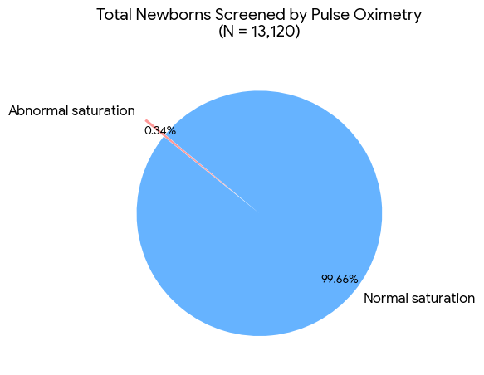

Table 2: Birth Weight distribution
Birth Weight | Number | Percentage (%)
2.5–2.75 kg | 16 | 35.6
2.76–3.0 kg | 18 | 40.0
>3 kg | 11 | 24.4
Total | 45 | 100
Mean birth weight ≈ 2.86 kg
The table shows the distribution of newborns with congenital heart disease according to birth weight. The majority of affected newborns had a birth weight between 2.76–3.0 kg, accounting for 18 cases (40.0%), followed by those weighing 2.5–2.75 kg in 16 cases (35.6%). Newborns with a birth weight of more than 3 kg constituted 11 cases (24.4%)

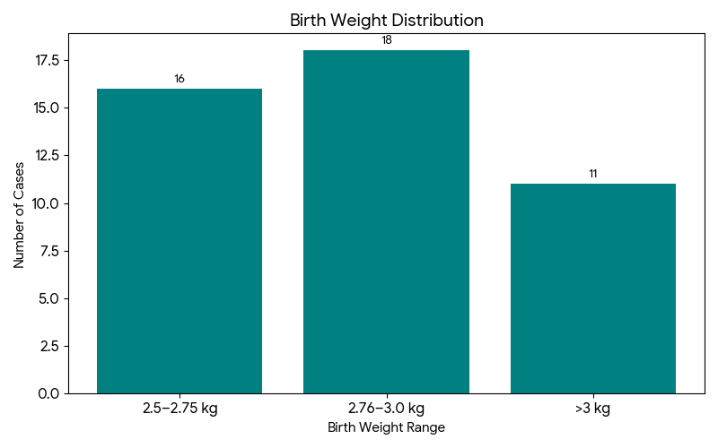

Table 3: Gestational Age distribution
Gestational Age | Number | Percentage (%)
37 weeks | 10 | 22.2
38 weeks | 21 | 46.7
39–40 weeks | 14 | 31.1
Total | 45 | 100
Mean gestational age ≈ 38.1 weeks
Table shows the distribution of newborns with congenital heart disease according to gestational age at birth. The largest proportion of affected newborns were born at 38 weeks of gestation, accounting for 21 cases (46.7%). This was followed by newborns delivered at 39–40 weeks, comprising 14 cases (31.1%), while 10 newborns (22.2%) were born at 37 weeks of gestation.

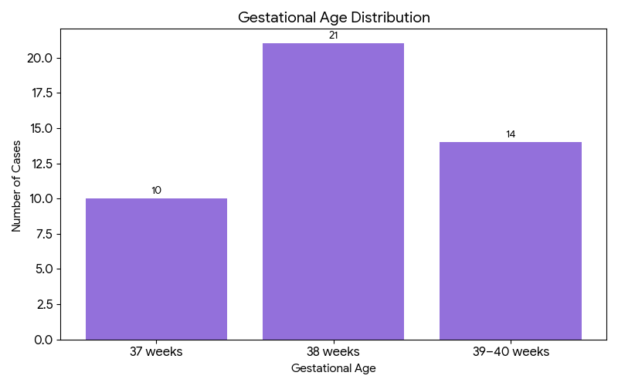

Table 4: Mode of Delivery Distribution Among CHD Cases
Mode of Delivery | Number of Newborns | Percentage (%)
Normal Vaginal Delivery (NVD) | 20 | 44.4
Lower Segment Cesarean Section (LSCS) | 25 | 55.6
Total | 45 | 100
Table illustrates the distribution of newborns diagnosed with congenital heart disease according to the mode of delivery. Among the 45 newborns, 25 infants (55.6%) were delivered by lower segment cesarean section (LSCS), while 20 infants (44.4%) were delivered through normal vaginal delivery (NVD).

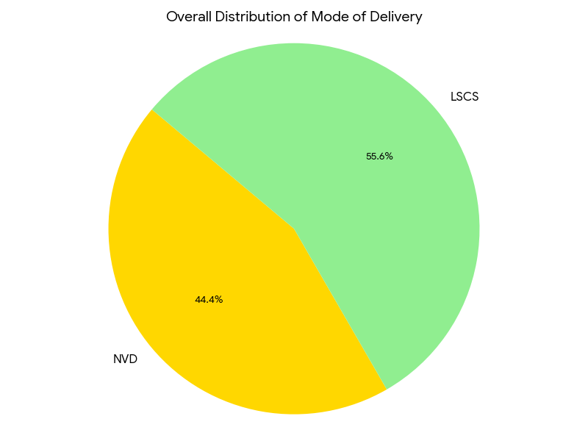

Table 5: Mode of Delivery vs Type of CHD
Mode of Delivery | Critical CHD | Non-Critical CHD | Total
NVD | 16 | 4 | 20
LSCS | 15 | 10 | 25
Total | 31 | 14 | 45
Table compares the mode of delivery with the type of congenital heart disease among the affected newborns. Among infants delivered by normal vaginal delivery (NVD), 16 newborns were diagnosed with critical CHD, while 4 newborns had non-critical CHD. In contrast, among those delivered by lower segment cesarean section (LSCS), 15 newborns had critical CHD and 10 newborns had non-critical CHD.

The association between mode of delivery and type of congenital heart disease was analyzed using the Chi-square test. The analysis showed no statistically significant association (χ² = 2.27, df = 1, p = 0.13).

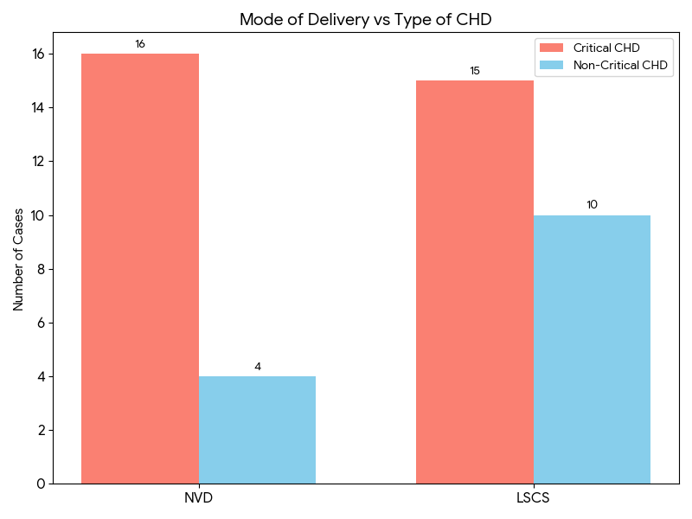

Table 6: Distribution of CHD among Screen Positive Babies
Type of CHD | Number | Percentage (%)
Critical CHD | 31 | 68.9
Non-Critical CHD | 14 | 31.1
Total | 45 | 100

Table illustrates the distribution of congenital heart disease among newborns who screened positive on pulse oximetry. Of the 45 screen-positive newborns, a substantial majority, 31 infants (68.9%), were diagnosed with critical congenital heart disease (CCHD), while 14 infants (31.1%) had non-critical CHD.

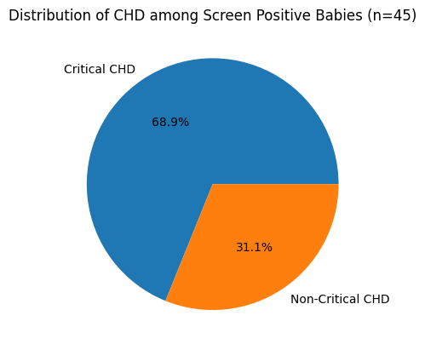

Table 7: Spectrum of Congenital Heart Disease
Type of CHD | Number | Percentage (%)
Tetralogy of Fallot (TOF) | 12 | 26.7
Double Outlet Right Ventricle (DORV) | 7 | 15.6
D-TGA | 6 | 13.3
VSD | 2 | 4.4
ASD | 3 | 6.7
PDA | 3 | 6.7
HLHS | 3 | 6.7
Persistent LSVC | 2 | 4.4
PFO | 2 | 4.4
TAPVC | 1 | 2.2
Coarctation of Aorta | 1 | 2.2
Tricuspid Atresia | 1 | 2.2

Table demonstrates the spectrum and relative frequency of various congenital heart defects identified among the screen-positive newborns. Tetralogy of Fallot (TOF) was the most common lesion, accounting for 12 cases (26.7%), followed by Double Outlet Right Ventricle (DORV) in 7 newborns (15.6%) and Dextro-Transposition of the Great Arteries (D-TGA) in 6 newborns (13.3%). Collectively, these cyanotic and complex cardiac lesions formed a significant proportion of detected CHDs.

Among acyanotic lesions, atrial septal defect (ASD) and patent ductus arteriosus (PDA) were observed in 6.7% each, while ventricular septal defect (VSD) constituted 4.4% of cases. Critical lesions such as hypoplastic left heart syndrome (HLHS) were identified in 6.7%, highlighting the ability of pulse oximetry screening to detect severe duct-dependent lesions early in life. Less common defects included persistent left superior vena cava, patent foramen ovale, total anomalous pulmonary venous connection (TAPVC), coarctation of the aorta, and tricuspid atresia, each contributing a smaller proportion.

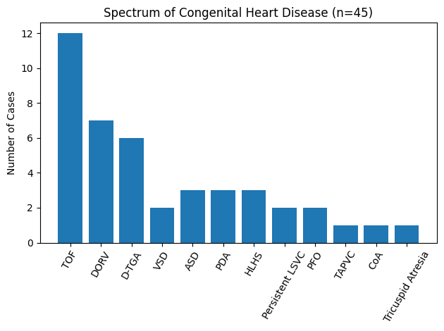

Table 8: Distribution of Critical Congenital Heart Disease
Type of CCHD | Number
Tetralogy of Fallot | 12
DORV | 7
D-TGA | 6
HLHS | 3
TAPVC | 1
Coarctation of Aorta | 1
Tricuspid Atresia | 1
Total | 31

Table depicts the distribution of various types of critical congenital heart disease (CCHD) identified among the screen-positive newborns. Tetralogy of Fallot was the most frequently observed critical lesion, accounting for 12 cases, followed by Double Outlet Right Ventricle (DORV) in 7 newborns and Dextro-Transposition of the Great Arteries (D-TGA) in 6 newborns. These lesions together constituted the majority of CCHD cases detected through pulse oximetry screening.

Severe duct-dependent and life-threatening defects such as Hypoplastic Left Heart Syndrome (HLHS) were identified in 3 newborns, while Total Anomalous Pulmonary Venous Connection (TAPVC), Coarctation of the Aorta, and Tricuspid Atresia were each observed in one newborn.

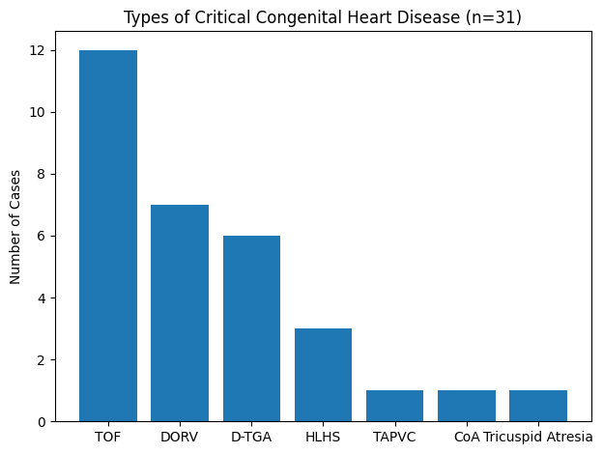

Table 9: Distribution of True Positive and False Positive Cases among Screen-Positive Newborns (n = 45)

Outcome among screen-positive newborns | Number (n) | Percentage (%)
True positive (clinically significant CHD) | 40 | 88.9
False positive | 5 | 11.1
Total screen-positive newborns | 45 | 100

Of the 45 newborns who screened positive on pulse oximetry, 40 (88.9%) were confirmed to have clinically significant congenital heart disease on echocardiography and were classified as true positives, while 5 (11.1%) were false positives due to physiologically insignificant cardiac lesions.

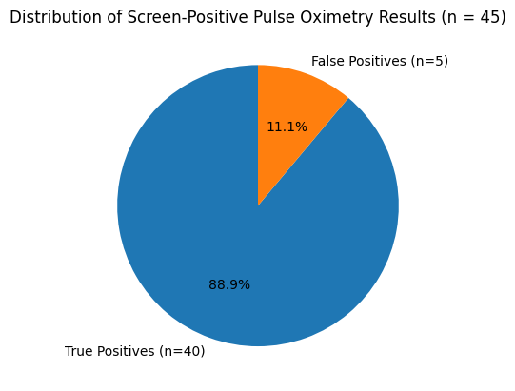

Table 10: Distribution of Newborns Based on Single vs Multiple Congenital Heart Defects

Type of CHD | Number of Patients (n) | Percentage (%)
Single CHD | 4 | 8.9
Multiple CHD | 41 | 91.1
Total | 45 | 100

The majority of newborns detected with CHD on pulse oximetry screening had multiple cardiac defects (91.1%), while only 8.9% had an isolated single congenital heart lesion.

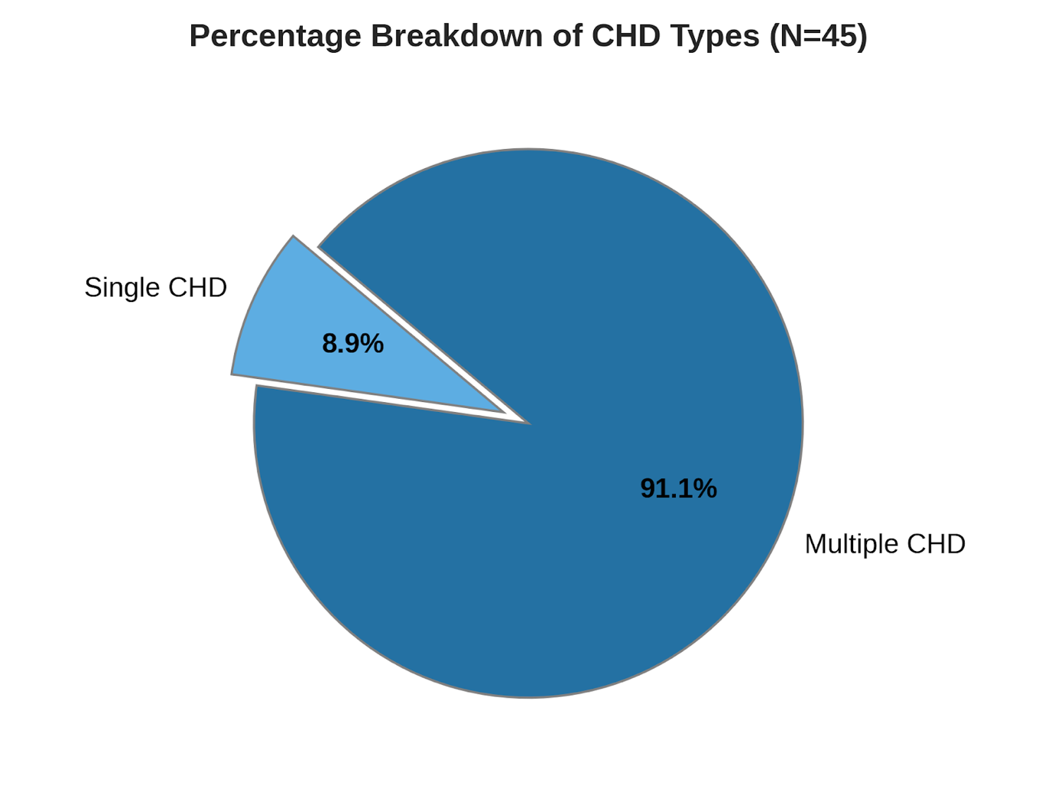

Table 11: Clinical Presentation
Clinical Status | Number | Percentage
Symptomatic | 33 | 73.3
Asymptomatic | 12 | 26.7
Total | 45 | 100

Table depicts the clinical presentation of newborns diagnosed with congenital heart disease among the screen-positive cohort. Of the 45 newborns, 33 infants (73.3%) were symptomatic at the time of detection, while 12 newborns (26.7%) were asymptomatic.

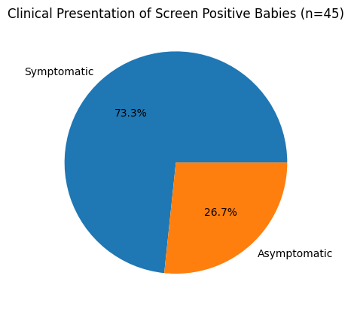

Table 12: Asymptomatic CHD Cases
Category | Number
Non-Critical CHD | 10
Critical CHD | 2
Total | 12

Table presents the distribution of congenital heart disease among asymptomatic newborns identified through pulse oximetry screening. Of the 12 asymptomatic infants, the majority, 10 newborns, were diagnosed with non-critical congenital heart disease, while 2 newborns were found to have critical congenital heart disease.

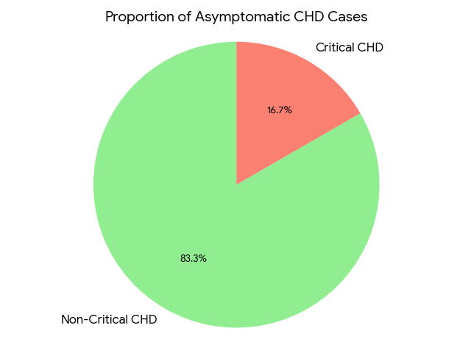

Chi-Square Result
- Chi-square (χ²) = 20.82
- Degrees of freedom = 1
- p-value < 0.001

Interpretation

Since p < 0.05, the association is statistically significant.

This means critical CHD babies were significantly more symptomatic.

The association between clinical presentation and type of CHD was analyzed using Chi-square test. A statistically significant association was observed (χ² = 20.82, p < 0.001), indicating that newborns with critical congenital heart disease were significantly more likely to be symptomatic compared to those with non-critical CHD.

Table 13: Symptom-wise Distribution of Newborns with Congenital Heart Disease

Symptom Pattern | Number of Patients (n) | Percentage (%)
Cyanosis | 17 | 37.8
Asymptomatic | 11 | 24.4
Cyanosis + Tachypnea | 7 | 15.6
Tachypnea alone | 5 | 11.1
Cyanosis + Poor feeding | 3 | 6.7
Poor feeding + Tachypnea | 1 | 2.2
Poor feeding alone | 1 | 2.2
Total | 45

Cyanosis was the most common presenting symptom (37.8%), either alone or in combination with respiratory distress. Notably, 24.4% of newborns were asymptomatic, highlighting the importance of pulse oximetry screening for early detection of critical CHD before clinical deterioration.

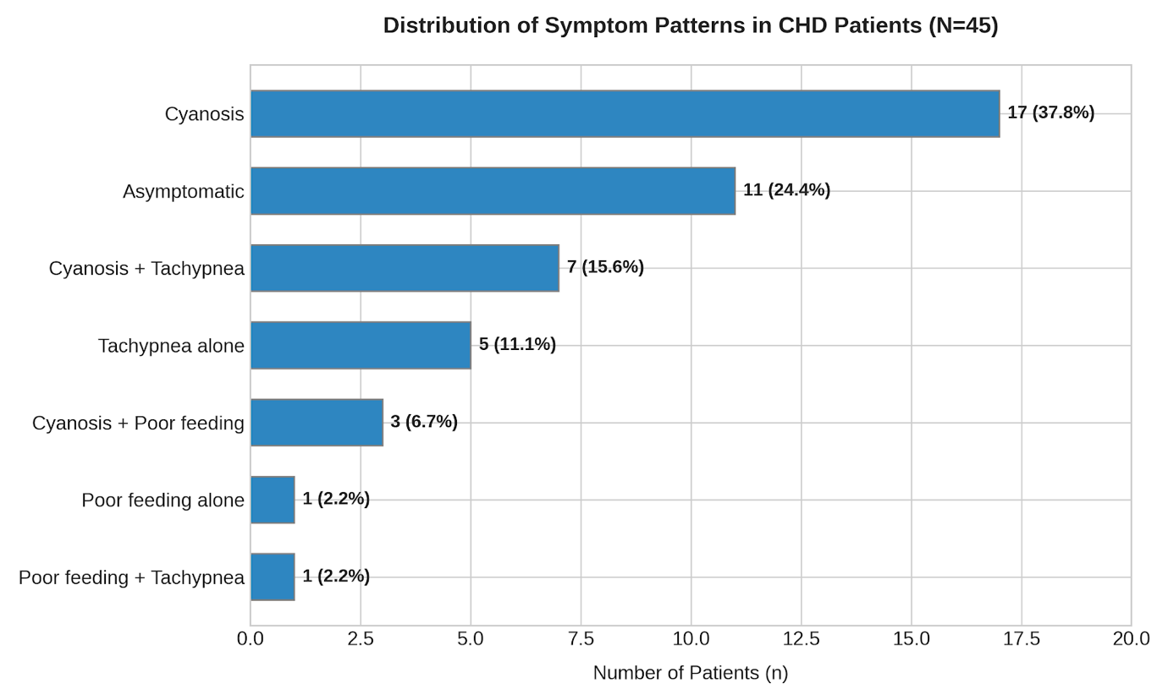

Table 14: Family History of CHD
Family History | Critical CHD | Non-Critical CHD | Total
Present | 2 | 2 | 4
Absent | 29 | 12 | 41
Total | 31 | 14 | 45
Table illustrates the association between family history of congenital heart disease (CHD) and the type of CHD identified among screen-positive newborns. A positive family history of CHD was present in 4 newborns, of whom 2 had critical CHD and 2 had non-critical CHD. In contrast, the majority of newborns, 41 cases, had no family history of CHD, with 29 diagnosed with critical CHD and 12 with non-critical CHD.

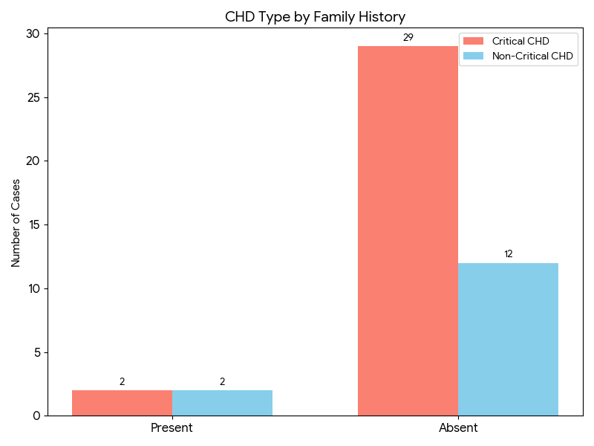

Chi-Square Calculation
- Chi-square (χ²) = 0.73
- Degrees of freedom = 1
- p-value ≈ 0.39

Interpretation

Since p > 0.05, the association is not statistically significant.

Chi-square test was applied to assess the association between family history of congenital heart disease and type of CHD. The analysis showed no statistically significant association (χ² = 0.73, p = 0.39).

Table 15: Maternal Antenatal Risk Factors
Risk Factor | Number of Cases
PIH | 3
GDM | 3
Rubella/CMV | 1
Polyhydramnios | 1
Oligohydramnios | 4

Table summarizes the maternal antenatal risk factors identified among mothers of newborns diagnosed with congenital heart disease. Pregnancy-induced hypertension (PIH) and gestational diabetes mellitus (GDM) were the most commonly observed risk factors, each present in 3 cases, suggesting a possible association between maternal metabolic or hypertensive disorders and adverse fetal cardiac development.

Other antenatal risk factors included oligohydramnios, observed in 4 cases, making it the most frequent antenatal condition in this cohort. Polyhydramnios was noted in one case, while maternal infections such as rubella or cytomegalovirus (CMV) were identified in one case, acknowledging their known teratogenic potential in fetal cardiac development.

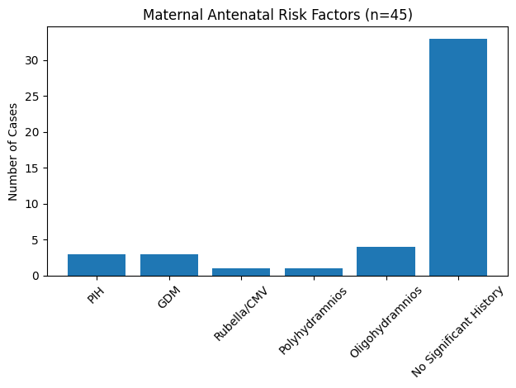

Table 16: Antenatal Risk Factors Distribution by CHD Type
Risk Factor | Critical CHD | Non-Critical CHD
PIH | 0 | 3
GDM | 2 | 1
Rubella/CMV | 1 | 0
Polyhydramnios | 1 | 0
Oligohydramnios | 4 | 0
Table presents the distribution of maternal antenatal risk factors according to the type of congenital heart disease diagnosed in newborns. Pregnancy-induced hypertension (PIH) was observed exclusively among newborns with non-critical CHD (3 cases), while none of the critical CHD cases had a history of PIH.

Gestational diabetes mellitus (GDM) was identified in both groups, with a higher occurrence among critical CHD cases (2 newborns) compared to non-critical CHD (1 newborn), suggesting a possible association with more severe cardiac defects. Maternal rubella/CMV infection, polyhydramnios, and oligohydramnios were observed only in newborns with critical congenital heart disease, with oligohydramnios being the most frequent antenatal risk factor in this group (4 cases).

Overall, the findings indicate that certain antenatal risk factors, particularly oligohydramnios, maternal infections, and polyhydramnios, were more commonly associated with critical CHD, whereas PIH showed an association with non-critical CHD.

Risk Factor | Critical CHD | Non-Critical CHD | p-value (Fisher’s Exact) | Significance
PIH | 0 | 3 | 0.026 | Significant
GDM | 2 | 1 | 0.46 | Not Significant
Rubella/CMV | 1 | 0 | 1.00 | Not Significant
Polyhydramnios | 1 | 0 | 1.00 | Not Significant
Oligohydramnios | 4 | 0 | 0.21 | Not Significant

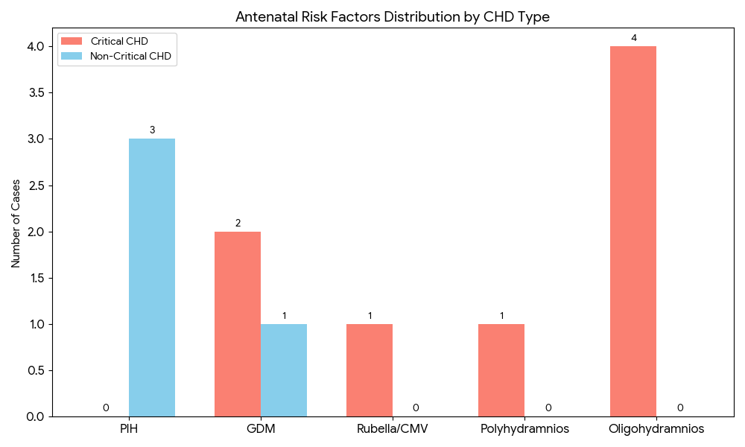

DISCUSSION

Total Newborns Screened by Pulse Oximetry
A total of 13,120 newborns underwent pulse oximetry screening for the detection of congenital heart disease during the study period. Of these, 45 newborns (0.34%) were identified to have abnormal saturation , while 13,075 (99.66%) were found to have normal saturation . The low proportion of screen-positive cases observed in this cohort is an expected finding in universal newborn screening programs, as pulse oximetry is specifically intended to detect critical congenital heart disease associated with hypoxemia rather than all structural cardiac anomalies. Since only a small subset of congenital heart defects leads to significant oxygen desaturation in the early neonatal period, the majority of newborns are appropriately classified as screen negative.
The observed screen positivity rate of 0.34% is comparable to results reported in earlier Indian studies, where positivity rates typically range from 0.2% to 0.6%. Several hospital-based studies from tertiary care centers across India have demonstrated similar proportions, particularly when screening is performed after the first 24 hours of life using standardized pre-ductal and post-ductal oxygen saturation measurements and predefined cutoff values. Studies by Indian investigators such as Saxena and Kumar have reported screen-positive rates close to 0.3–0.4% (Saxena et al., 2015; Kumar et al;2016) closely mirroring the findings of the present study. The consistency across Indian studies likely reflects similarities in neonatal physiology, prevalence of critical congenital heart disease, and adherence to uniform screening protocols.Internationally, large population-based studies have reported pulse oximetry screen positivity rates ranging between 0.1% and 0.8% (Mahle et al., 2009; Ewer et al., 2011; de-Wahl Granelli et al., 2009; Thangaratinam et al., 2012). Data supporting universal screening recommendations by organizations such as the American Academy of Pediatrics and the Centers for Disease Control and Prevention indicate positivity rates around 0.2–0.3%, which are very close to the 0.34% observed in this cohort. Some European studies have documented slightly higher rates, often attributed to earlier timing of screening within the first 24 hours of life, when transitional circulatory changes and delayed ductal closure may result in transient hypoxemia and increased false-positive screens.
Minor variations in screen positivity rates between different studies can be explained by several methodological and population-related factors. The timing of screening plays a critical role, with earlier screening associated with higher positivity due to physiological transitional hypoxemia. Differences in altitude, baseline oxygen saturation norms, proportion of high-risk deliveries, and inclusion of non-cardiac causes of hypoxemia such as sepsis, respiratory distress, or persistent pulmonary hypertension can also influence results. Additionally, strict adherence to repeat testing protocols before labeling a newborn as screen positive, as followed in this study, helps minimize false-positive rates and contributes to the observed low yet clinically meaningful screen-positive proportion.

Birth Weight Distribution
Among the 45 newborns who were screen positive on pulse oximetry, birth weight distribution showed a predominance of infants in the normal birth weight range. The majority of newborns, 18 (40.0%), had a birth weight between 2.76 and 3.0 kg, followed by 16 newborns (35.6%) in the 2.5–2.75 kg range, while 11 newborns (24.4%) had a birth weight greater than 3.0 kg. The mean birth weight of the screen-positive cohort was approximately 2.86 kg, indicating that most affected infants were appropriate for gestational age and not predominantly low birth weight.
This pattern is consistent with the epidemiology of critical congenital heart disease, which frequently occurs in term or near-term neonates with normal birth weight. Unlike conditions such as neonatal sepsis or respiratory distress syndrome, CCHD does not have a strong association with prematurity or low birth weight. Consequently, pulse oximetry screening tends to identify infants across the normal birth weight spectrum, as reflected in this study. The absence of infants weighing less than 2.5 kg in the screen-positive group may also reflect exclusion or delayed screening of very low birth weight or clinically unstable neonates, who often remain in intensive care and may be evaluated by echocardiography before routine screening. Indian studies evaluating pulse oximetry screening have reported similar findings, (Singh et al., 2015; Saxena et al., 2015; Kumar et al., 2016) with most screen-positive newborns falling within the normal birth weight range of 2.5–3.0 kg. This trend reflects the overall birth weight distribution of live births in Indian hospital settings, where the majority of term deliveries cluster within this range. Studies conducted in tertiary care centers have shown mean birth weights among screen-positive neonates ranging from 2.7 to 3.0 kg, closely comparable to the mean birth weight of 2.86 kg observed in the present study. The similarity may be attributed to comparable maternal demographics, antenatal care practices, and inclusion of predominantly term neonates in screening programs.
International studies have also demonstrated that pulse oximetry–detected CCHD is commonly seen in newborns with normal or near-normal birth weight (Ewer et al., 2011; Mahle et al., 2009; Peterson et al., 2013) Large population-based studies from the United States and Europe report mean birth weights of screen-positive infants between 2.8 and 3.2 kg, reinforcing the observation that birth weight alone is not a reliable predictor of CCHD. Guidelines and data supporting universal screening programs endorsed by organizations such as the American Academy of Pediatrics and the Centers for Disease Control and Prevention emphasize that restricting screening based on birth weight would result in missed diagnoses, as many infants with life-threatening cardiac lesions are born with weights within the normal range.
Minor variations in birth weight distribution across studies can be explained by differences in population characteristics, referral patterns, and inclusion criteria. Centers with a higher proportion of high-risk or growth-restricted pregnancies may report lower mean birth weights among screen-positive infants, while studies limited to well-baby nurseries tend to show higher averages. Additionally, early neonatal hemodynamic compromise in severe CCHD may influence postnatal weight measurements due to fluid shifts or early feeding difficulties, though this effect is generally minimal in the first day of life when screening is performed.

Gestational Age Distribution
The gestational age distribution of the 45-pulse oximetry screen-positive newborns shows a clear predominance of term infants. Nearly half of the newborns, 21 (46.7%), were delivered at 38 weeks of gestation, followed by 14 (31.1%) born between 39 and 40 weeks, while 10 newborns (22.2%) were delivered at 37 weeks. The mean gestational age of approximately 38.1 weeks indicates that the majority of screen-positive cases occurred in early-term and full-term neonates rather than in preterm infants.
This finding is epidemiologically consistent with the known distribution of critical congenital heart disease, which most commonly presents in term newborns. Congenital cardiac malformations are primarily determined during early embryogenesis and are not strongly linked to prematurity. As a result, neonates with critical congenital heart disease are often born at term with apparently normal gestational parameters and may appear clinically stable in the immediate postnatal period. Pulse oximetry screening is therefore particularly valuable in this group, as routine clinical examination alone may fail to detect underlying hypoxemia in the absence of overt symptoms.
Indian studies evaluating pulse oximetry screening for congenital heart disease have similarly reported that the majority of screen-positive newborns are term infants, with mean gestational ages ranging from 38 to 39 weeks. (Singh et al., 2015; Kumar et al., 2016). Studies conducted in tertiary care hospitals across India have shown clustering of screen-positive cases around 38 weeks of gestation, closely resembling the pattern observed in the present study. This similarity likely reflects comparable obstetric practices, with a high proportion of institutional deliveries occurring between 38 and 40 weeks, as well as uniform screening protocols that preferentially include clinically stable term neonates in postnatal wards.
International literature also supports these findings. Large population-based studies from North America and Europe have consistently demonstrated that most newborns identified through pulse oximetry screening are born at term, with average gestational ages close to 38–39 weeks (Ewer et al., 2011; Thangaratinam et al., 2012; Mahle et al., 2009). Data underlying universal screening recommendations issued by organizations such as the American Academy of Pediatrics and the Centers for Disease Control and Prevention indicate that restricting screening to preterm or high-risk infants would miss a substantial number of affected neonates, as many infants with life-threatening cardiac lesions are born at optimal gestational ages.
Minor differences in gestational age distribution across studies may be attributed to variations in inclusion criteria, timing of screening, and obstetric practices. Centers with higher rates of elective early-term deliveries may observe a greater proportion of cases at 37–38 weeks, while those including more spontaneous term deliveries may see clustering closer to 39–40 weeks. Additionally, very preterm infants are often excluded from routine screening protocols or undergo targeted echocardiographic evaluation due to clinical instability, which may explain their underrepresentation among screen-positive cohorts in most studies.

Mode of Delivery Distribution Among CHD Cases
Among the 45 newborns who were identified as screen positive for congenital heart disease, a slightly higher proportion were delivered by lower segment cesarean section. Of the total, 25 newborns (55.6%) were born via LSCS, while 20 newborns (44.4%) were delivered by normal vaginal delivery. This distribution suggests a modest predominance of cesarean deliveries among CHD cases, though both modes of delivery were substantially represented. The observed higher proportion of LSCS in this cohort is consistent with trends reported in several Indian studies, where cesarean delivery rates among neonates with suspected or confirmed congenital anomalies are often higher than the general obstetric population. This may be partly explained by increased antenatal surveillance, (Saxena et al., 2015; Singh et al., 2015) detection of fetal anomalies on prenatal ultrasonography, or the presence of obstetric indications such as fetal distress, oligohydramnios, or previous cesarean delivery. In some cases, even when a congenital heart defect is not definitively diagnosed antenatally, indirect signs such as abnormal fetal growth patterns or altered Doppler findings may influence the decision toward operative delivery.
It is important to note that congenital heart disease itself is not an indication for cesarean section, and the mode of delivery does not influence the occurrence of CHD, as cardiac malformations develop early in embryogenesis. The slightly higher LSCS rate observed in this study therefore reflects obstetric decision-making rather than a causal relationship between cesarean delivery and congenital heart disease. Similar observations have been made in Indian tertiary care centers, where institutional delivery practices and referral bias often result in higher cesarean section rates among neonates subsequently diagnosed with congenital anomalies.
International studies have also reported variable distributions (Wren et al., 2008; Peterson et al., 2013) of mode of delivery among infants with congenital heart disease, with cesarean section rates ranging from 40% to 60%, depending on the population studied and the level of perinatal care. Differences across studies may be attributed to variations in obstetric protocols, availability of fetal echocardiography, and local thresholds for operative delivery. In centers where antenatal diagnosis of CHD is more frequent, planned cesarean sections may be performed to ensure delivery at facilities equipped with neonatal intensive care and pediatric cardiology services.

Mode of Delivery vs Type of CHD
The distribution of congenital heart disease subtypes according to mode of delivery demonstrates distinct patterns between critical and non-critical lesions. Among the 20 newborns delivered by normal vaginal delivery, the majority, 16 cases, were diagnosed with critical congenital heart disease, while only 4 had non-critical defects. In contrast, among the 25 newborns delivered by lower segment cesarean section, 15 were found to have critical CHD and 10 had non-critical CHD. Overall, critical CHD constituted the larger proportion of cases in both delivery groups, accounting for 31 of the 45 screen-positive newborns.
The higher proportion of critical CHD among vaginally delivered newborns may reflect the fact that many infants with severe duct-dependent lesions are born without antenatal diagnosis and undergo routine vaginal delivery. These newborns often appear clinically stable initially and are identified only after pulse oximetry screening detects hypoxemia. In such cases, the absence of prenatal suspicion means that obstetric management follows standard protocols, resulting in a higher representation of critical CHD among infants delivered by normal vaginal delivery.
Conversely, the relatively higher proportion of non-critical CHD among newborns delivered by cesarean section may be influenced by increased antenatal surveillance and obstetric interventions. Pregnancies complicated by suspected fetal anomalies, growth restriction, or abnormal antenatal imaging are more likely to be delivered by planned or emergency cesarean section. Even when the cardiac lesion is non-critical, heightened clinical concern during pregnancy or labor may lead to operative delivery, thereby increasing the proportion of non-critical CHD cases in the LSCS group.
Importantly, these findings should not be interpreted as indicating any causal relationship between mode of delivery and the severity of congenital heart disease. The type and severity of CHD are determined during early embryological development and are unrelated to intrapartum factors. The observed distribution is more likely a reflection of obstetric decision-making, referral bias, and differential antenatal detection rates rather than a true association between delivery mode and CHD subtype.
Similar trends have been described in other Indian and international studies (Wren et al., 2008; Singh et al., 2015; Saxena et al., 2015) , where critical CHD is frequently diagnosed postnatally through screening or clinical deterioration, while a subset of non-critical lesions is identified antenatally and delivered in a more controlled obstetric setting. Overall, the data emphasize that reliance on mode of delivery or antenatal risk stratification alone is insufficient for identifying newborns with critical congenital heart disease. Universal pulse oximetry screening remains essential for timely detection of both critical and non-critical CHD across all modes of delivery.

Distribution of CHD among Screen-Positive Babies
Among the 45 newborns identified as screen positive on pulse oximetry, a substantial majority were diagnosed with critical congenital heart disease. Critical CHD accounted for 31 cases (68.9%), while non-critical CHD constituted 14 cases (31.1%). This predominance of critical lesions among screen-positive newborns highlights the effectiveness of pulse oximetry in preferentially identifying clinically significant and potentially life-threatening cardiac defects that are associated with hypoxemia in the early neonatal period.
The higher proportion of critical CHD in this cohort is consistent with the fundamental principle of pulse oximetry screening, which is designed to detect defects that cause reduced systemic oxygen saturation, particularly duct-dependent and cyanotic cardiac lesions. Conditions such as transposition of the great arteries, pulmonary atresia, truncus arteriosus, total anomalous pulmonary venous connection, hypoplastic left heart syndrome, and severe forms of tetralogy of Fallot are more likely to result in early hypoxemia and therefore trigger a positive screen. In contrast, many non-critical defects, including small ventricular septal defects or atrial septal defects, often do not produce significant desaturation in the immediate postnatal period and may escape detection by pulse oximetry alone.
Indian studies evaluating pulse oximetry screening have reported similar distributions (Singh et al., 2015; Kumar et al., 2016), with critical CHD comprising approximately 60–75% of screen-positive cases. The findings in the present study fall well within this range, suggesting comparable screening performance and disease spectrum. The consistency across studies may be attributed to uniform definitions of critical CHD, similar screening algorithms, and comparable neonatal populations in tertiary care settings. Moreover, the high proportion of critical CHD detected underscores the clinical value of pulse oximetry screening in the Indian context, where delayed presentation of undiagnosed critical heart disease continues to be a major contributor to neonatal morbidity and mortality.
International data also demonstrate (Mahle et al., 2009; Ewer et al., 2011; de-Wahl Granelli et al., 2009) that pulse oximetry screening yields a higher detection rate for critical CHD compared to non-critical lesions. Large population-based studies from various regions have shown that nearly two-thirds of infants detected through screening have critical forms of CHD, closely mirroring the proportion observed in this study. Minor variations in reported percentages across studies may be related to differences in inclusion criteria, timing of screening, and availability of antenatal diagnosis.

Spectrum of Congenital Heart Disease
The spectrum of congenital heart disease observed among the 45 screen-positive newborns in this study demonstrates a predominance of complex cyanotic and conotruncal cardiac lesions. Tetralogy of Fallot was the most frequently identified defect, accounting for 12 cases (26.7%), followed by double outlet right ventricle in 7 cases (15.6%) and dextro-transposition of the great arteries in 6 cases (13.3%). Collectively, these three conditions constituted more than half of all diagnosed CHD, reflecting the tendency of pulse oximetry screening to preferentially detect lesions associated with significant right-to-left shunting or impaired pulmonary blood flow leading to early hypoxemia.
Among the remaining critical lesions, hypoplastic left heart syndrome was identified in 3 newborns (6.7%), while total anomalous pulmonary venous connection, coarctation of the aorta, and tricuspid atresia were each observed in one case (2.2% each). Although coarctation of the aorta is traditionally considered a challenging lesion to detect by pulse oximetry due to preserved oxygen saturation in early life, its presence in the screen-positive group suggests either associated hypoxemia or progression of ductal closure at the time of screening. Similarly, detection of hypoplastic left heart syndrome and tricuspid atresia highlights the value of screening in identifying duct-dependent systemic or pulmonary circulations before clinical collapse.
Non-critical defects such as atrial septal defect (3 cases, 6.7%), patent ductus arteriosus (3 cases, 6.7%), ventricular septal defect (2 cases, 4.4%), patent foramen ovale (2 cases, 4.4%), and persistent left superior vena cava (2 cases, 4.4%) were less frequently represented. These lesions generally do not produce significant hypoxemia in the immediate neonatal period and are often detected incidentally during echocardiographic evaluation following a positive screen or later during infancy. Their presence among screen-positive newborns may be explained by associated transitional circulatory changes, coexisting pulmonary pathology, or mixed cardiac lesions contributing to borderline oxygen saturation values. The predominance of cyanotic and complex congenital heart disease (Singh et al., 2015; Saxena et al., 2015) in this cohort is consistent with both Indian and international pulse oximetry screening studies (Mahle et al., 2009; Riede et al., 2010; Ewer et al., 2011) , which have reported tetralogy of Fallot, transposition of the great arteries, and double outlet right ventricle as common diagnoses among screen-detected cases. This pattern reflects the physiological basis of pulse oximetry screening, as lesions causing reduced pulmonary blood flow or parallel circulation are more likely to manifest with measurable desaturation in the early neonatal period. Variations in the relative frequencies of individual defects across studies may be influenced by differences in population characteristics, antenatal detection rates, referral bias, and timing of postnatal screening.

Distribution of Critical Congenital Heart Disease
Among the 31 newborns diagnosed with critical congenital heart disease in the present study, conotruncal and complex cyanotic lesions constituted the majority. Tetralogy of Fallot emerged as the most common critical defect, accounting for 12 cases, followed by double outlet right ventricle in 7 cases and dextro-transposition of the great arteries in 6 cases. Together, these three conditions represented a substantial proportion of all critical CHD detected, highlighting their strong association with early postnatal hypoxemia and their consequent detectability through pulse oximetry screening.
Hypoplastic left heart syndrome was identified in 3 newborns, reflecting the ability of pulse oximetry to detect duct-dependent systemic circulations before the onset of severe clinical deterioration. Although less frequent, the detection of total anomalous pulmonary venous connection, coarctation of the aorta, and tricuspid atresia, each in one newborn, is clinically significant. These lesions are known to present with variable oxygen saturation in the immediate neonatal period and are often challenging to identify through routine clinical examination alone. Their detection in this cohort suggests that pulse oximetry screening, particularly when combined with repeat measurements and careful clinical correlation, can facilitate early recognition even of defects traditionally considered difficult to screen.
The predominance of tetralogy of Fallot (Kumar et al., 2016; Singh et al., 2015), double outlet right ventricle, and transposition of the great arteries is consistent with patterns reported in other Indian studies, where conotruncal anomalies form a major share of critical CHD detected through postnatal screening programs. This distribution may reflect both the true epidemiology of critical CHD in the population and the screening test’s inherent sensitivity toward lesions causing significant right-to-left shunting or parallel circulation. International studies have also demonstrated similar trends, with these lesions frequently comprising the bulk of screen-detected critical CHD cases (Mahle et al., 2009; de-Wahl Granelli et al., 2009).

Distribution of True Positive and False Positive Cases among Screen-Positive Newborns
In the present study, false positive pulse oximetry screening results were observed in 5 out of 45 screen-positive newborns, accounting for a false positive proportion of 11.1% among screen-positive cases and approximately 0.04% of the total screened population. All false positive cases were attributable to physiologically insignificant cardiac findings on echocardiography, namely atrial septal defect less than 5 mm, ventricular septal defect less than 5 mm, and small patent foramen ovale. These lesions are common transitional or minor structural findings in the neonatal period and are not associated with sustained hypoxemia. Since pulse oximetry screening is designed to identify functional oxygen desaturation resulting from critical congenital heart disease rather than minor anatomical abnormalities, such findings are appropriately classified as false positives in screening studies.

The low absolute false positive rate observed in this cohort is consistent with previously published Indian and international literature, which report false positive rates ranging from 0.02% to 0.1% when screening is performed after 24 hours of life and standardized protocols are followed. Studies by Ewer et al. and Thangaratinam et al. have demonstrated that delayed screening significantly reduces false positive results by allowing stabilization of transitional circulatory changes, including closure of the ductus arteriosus and reduction in pulmonary vascular resistance. Similar observations have been reported in Indian studies, where false positives are predominantly due to minor septal defects or transient physiological hypoxemia rather than serious pathology.

The exclusive association of false positive screens with physiologically insignificant lesions in the present study highlights the high specificity of pulse oximetry when used within a structured screening algorithm. Importantly, no newborn with a false positive screen experienced adverse outcomes, and all were clinically stable, reinforcing the safety of the screening process. While false positives may increase the need for echocardiographic evaluation, they also offer an opportunity for early identification and follow-up of minor cardiac lesions, parental reassurance, and exclusion of other causes of neonatal hypoxemia. Overall, the low false positive rate observed supports the feasibility and reliability of universal pulse oximetry screening for congenital heart disease in large-scale public health settings.

Distribution of Newborns Based on Single vs Multiple Congenital Heart Defects
The distribution of congenital heart defects in the screen-positive cohort demonstrates a striking predominance of multiple cardiac anomalies. Of the 45 newborns diagnosed with congenital heart disease, only 4 (8.9%) had a single isolated defect, whereas the vast majority, 41 newborns (91.1%), were found to have multiple congenital heart defects. This finding highlights the complex nature of cardiac pathology among newborns identified through pulse oximetry screening in this study.
The high proportion of multiple congenital heart defects can be explained by the fact that pulse oximetry preferentially detects physiologically significant lesions, many of which are complex in nature and commonly associated with additional intracardiac or extracardiac anomalies. Critical congenital heart diseases such as tetralogy of Fallot, double outlet right ventricle, hypoplastic left heart syndrome, and transposition of the great arteries are rarely isolated defects and frequently coexist with septal defects, outflow tract obstructions, or abnormalities of great vessel anatomy. These associated lesions often amplify the degree of hypoxemia and hemodynamic compromise, thereby increasing the likelihood of detection through oxygen saturation screening.
Indian studies evaluating newborn screening for congenital heart disease have similarly reported a higher prevalence of multiple defects among screen-positive infants, particularly in tertiary care referral centers. This pattern may also reflect referral bias, as complex cases are more likely to be delivered or transferred to higher-level facilities with neonatal intensive care and echocardiography services. In addition, advances in echocardiographic imaging allow for more detailed anatomical delineation, leading to improved recognition of coexisting lesions that may have been previously underdiagnosed. (Hoffman & Kaplan, 2002).

From a clinical perspective, the predominance of multiple congenital heart defects has important implications for management and prognosis. Newborns with multiple anomalies often require early multidisciplinary care, detailed anatomical assessment, and staged surgical or interventional procedures. The identification of such complex cases through pulse oximetry screening underscores the value of universal screening not only in detecting the presence of congenital heart disease but also in facilitating early comprehensive evaluation and appropriate referral.

Clinical Presentation
The clinical presentation of newborns diagnosed with congenital heart disease in this study shows that a majority were symptomatic at the time of detection. Out of 45 screen-positive newborns, 33 (73.3%) exhibited clinical symptoms, while 12 newborns (26.7%) were asymptomatic. This distribution indicates that although most affected infants eventually manifest clinical signs, a significant proportion may remain clinically silent in the early neonatal period. The high proportion of symptomatic newborns reflects the predominance of critical and complex congenital heart defects in the study population. Lesions such as tetralogy of Fallot, (Mahle et al., 2009; Ewer et al., 2011) transposition of the great arteries, hypoplastic left heart syndrome, and double outlet right ventricle are often associated with early onset of symptoms, including cyanosis, respiratory distress, feeding difficulty, tachycardia, poor perfusion, or signs of heart failure. As ductal closure progresses in the postnatal period, these infants are more likely to become symptomatic, prompting clinical evaluation and confirmatory echocardiography.
Importantly, more than one-fourth of the newborns in this cohort were asymptomatic at the time of screening, underscoring the critical role of pulse oximetry in early detection. These asymptomatic infants might have appeared clinically stable (Koppel et al., 2003; Peterson et al., 2013) and could have been discharged without diagnosis if screening had not been performed. Many critical congenital heart defects may initially have subtle or absent clinical signs, with deterioration occurring only after ductal closure, which highlights the limitation of routine clinical examination alone in the immediate postnatal period.
Similar patterns have been reported in Indian and international studies, where a substantial proportion of newborns with critical congenital heart disease were either asymptomatic or had nonspecific findings at the time of routine examination. Variations in the proportion of symptomatic cases across studies may be influenced by timing of screening, case mix, and the threshold for labeling a newborn as symptomatic. In settings where screening is performed later or in referral centers, a higher proportion of symptomatic cases is often observed.

Asymptomatic CHD Cases
Among the 12 newborns who were asymptomatic at the time of detection, the majority were diagnosed with non-critical congenital heart disease. Ten of these asymptomatic newborns had non-critical CHD, while only two were found to have critical congenital heart disease. This distribution highlights an important clinical observation that absence of symptoms in the early neonatal period does not exclude the presence of significant underlying cardiac pathology.
The predominance of non-critical CHD among asymptomatic newborns is expected, as lesions such as small ventricular or atrial septal defects, isolated patent ductus arteriosus, or minor structural abnormalities often do not produce overt clinical signs immediately after birth. These defects may be hemodynamically insignificant in the early neonatal period and are frequently detected incidentally during echocardiographic evaluation following a positive pulse oximetry screen or during subsequent follow-up.
Notably, the presence of two asymptomatic newborns with critical congenital heart disease underscores the limitations of clinical examination alone. Certain critical lesions may not manifest symptoms until ductal closure or physiological stress occurs, allowing affected infants to appear clinically stable during the initial postnatal period. Pulse oximetry screening plays a crucial role in identifying such infants by detecting subtle hypoxemia before the onset of clinical deterioration, thereby enabling timely intervention (Koppel et al., 2003; Mahle et al., 2009).
.Similar findings have been reported in other screening studies, where a subset of newborns with critical CHD remained asymptomatic at the time of routine postnatal assessment. The proportion of asymptomatic critical CHD cases varies across studies depending on timing of screening, lesion type, and local clinical practices. These observations consistently reinforce the need for universal screening strategies rather than selective screening based on clinical signs.

Symptom-wise Distribution of Newborns with Congenital Heart Disease
The symptom-wise analysis of newborns diagnosed with congenital heart disease demonstrates considerable variability in clinical presentation, with cyanosis emerging as the most frequent manifestation (Ewer et al., 2011; Riede et al., 2010). Among the 45 affected newborns, 17 (37.8%) presented with isolated cyanosis, making it the single most common symptom pattern observed. This finding reflects the predominance of cyanotic and critical cardiac lesions in the study population, where right-to-left shunting or parallel circulation leads to early and clinically apparent oxygen desaturation.
A noteworthy proportion of newborns, 11 (24.4%), were asymptomatic at the time of detection, emphasizing the silent nature of congenital heart disease in a significant subset of cases. These infants would have been easily missed by clinical examination alone, particularly in the absence of overt cyanosis or respiratory distress. The identification of such asymptomatic cases highlights the essential role of pulse oximetry screening in detecting occult hypoxemia and facilitating early diagnosis before the onset of clinical deterioration.
Combined symptom patterns were also commonly observed. Cyanosis associated with tachypnea was present in 7 newborns (15.6%), suggesting more pronounced cardiopulmonary compromise and increased pulmonary blood flow or heart failure physiology. Tachypnea alone was seen in 5 newborns (11.1%), a nonspecific but important clinical sign that may represent early heart failure, increased pulmonary circulation, or reduced cardiac output. These presentations underscore the fact that respiratory symptoms in neonates should prompt consideration of an underlying cardiac etiology, especially when not explained by primary pulmonary disease.
Feeding-related symptoms were less frequent but clinically significant. Cyanosis with poor feeding was noted in 3 newborns (6.7%), while isolated poor feeding or poor feeding combined with tachypnea accounted for a small proportion of cases. Poor feeding in neonates with congenital heart disease often reflects increased metabolic demand, fatigue due to compromised cardiac output, or evolving heart failure. Although these symptoms are subtle and easily attributed to non-cardiac causes, their presence warrants careful evaluation.

Family History of Congenital Heart Disease
Assessment of family history among the newborns diagnosed with congenital heart disease revealed that a positive family history was present in a small proportion of cases. Of the 45 newborns with CHD, only 4 had a documented family history of congenital heart disease, while the remaining 41 had no such history. Among those with a positive family history, 2 newborns had critical CHD and 2 had non-critical CHD, indicating an equal distribution between severity categories.
The low prevalence of positive family history (Hoffman & Kaplan, 2002) observed in this study is consistent with the known epidemiology of congenital heart disease, where the majority of cases occur sporadically rather than as part of inherited familial patterns. While genetic and familial factors do contribute to CHD risk, most affected newborns do not have an identifiable family history, particularly in settings where extended family screening and genetic evaluation are not routinely performed. This explains why the absence of family history was noted in over 90% of cases in the present cohort.
The presence of family history in both critical and non-critical CHD groups suggests that familial predisposition does not necessarily correlate with disease severity. Some familial cases may involve relatively simple lesions, while others may present with complex cardiac malformations. Additionally, underreporting of family history is possible, as minor or undiagnosed cardiac defects in relatives may go unrecognized, especially in resource-limited settings.
From a clinical perspective, these findings emphasize that absence of a family history cannot be used to exclude congenital heart disease. Reliance on family history alone would fail to identify the vast majority of affected newborns, including those with life-threatening cardiac lesions. Consequently, universal screening strategies such as pulse oximetry remain essential for early detection of congenital heart disease irrespective of familial risk factors.

Maternal Antenatal Risk Factors
Evaluation of maternal antenatal risk factors among mothers of newborns diagnosed with congenital heart disease revealed that identifiable risk factors were present only in a small subset of cases. Oligohydramnios was the most frequently noted antenatal condition, observed in 4 mothers, followed by pregnancy-induced hypertension and gestational diabetes mellitus, each present in 3 cases. A history suggestive of intrauterine infection, (Gregory et al., 2011) such as rubella or cytomegalovirus, and polyhydramnios were each documented in one case.
The relatively low frequency of recognized antenatal risk factors in this cohort reflects the multifactorial and often sporadic nature of congenital heart disease. Although maternal conditions such as diabetes, hypertension, and intrauterine infections are known to increase the risk of congenital anomalies, the majority of CHD cases arise in pregnancies without any identifiable antenatal risk. This finding is consistent with clinical experience and highlights the limitation of risk-based screening approaches that rely solely on maternal history.
Gestational diabetes mellitus (Lisowski et al., 2010; Hoffman & Kaplan, 2002) has been associated with an increased risk of cardiac malformations, particularly septal defects and conotruncal anomalies, due to altered glucose metabolism during early organogenesis. Similarly, pregnancy-induced hypertension may contribute indirectly through placental insufficiency and altered fetal hemodynamics, though its direct association with CHD is less well defined. The presence of oligohydramnios in several cases may reflect underlying fetal pathology, including congenital anomalies, rather than acting as a direct causal factor. In contrast, polyhydramnios is more commonly associated with gastrointestinal or neurological anomalies but may occasionally coexist with cardiac defects.
The identification of a case with suspected maternal rubella or cytomegalovirus infection is clinically relevant, as congenital infections are well-recognized risk factors for structural cardiac defects. However, the low number of such cases in this study suggests that improved immunization coverage and antenatal care may be contributing to a reduced burden of infection-related CHD.

Antenatal Risk Factors Distribution by CHD Type
Distribution of maternal antenatal risk factors among newborns with critical and non-critical congenital heart disease (CHD) detected through pulse oximetry screening. A clear differential pattern of risk factor association is evident between the two CHD categories. Among critical CHD, antenatal risk factors were predominantly observed. Oligohydramnios emerged as the most frequent risk factor, present in four cases, all of which resulted in critical CHD. This strong association may be explained by reduced uteroplacental perfusion, chronic fetal hypoxia, and impaired fetal growth, which are known to adversely affect cardiac morphogenesis and may lead to complex structural heart defects. Similar associations between oligohydramnios (Kumar et al., 2016; Lisowski et al., 2010) and severe CHD have been reported in Indian and international studies, suggesting that reduced amniotic fluid volume may serve as an indirect marker of underlying fetal compromise.
Gestational diabetes mellitus (GDM) was identified in two cases of critical CHD and one case of non-critical CHD. Maternal hyperglycemia during early gestation (Lisowski et al., 2010; Hoffman & Kaplan, 2002) is a well-established teratogenic factor, particularly associated with conotruncal anomalies, transposition of great arteries, and other duct-dependent lesions. The higher proportion of critical CHD among infants of diabetic mothers in this study aligns with global literature, reinforcing the importance of stringent glycemic control during the periconceptional period.
Maternal Rubella/CMV infection and polyhydramnios were exclusively observed in infants with critical CHD. Congenital rubella infection is classically linked with severe cardiac defects such as patent ductus arteriosus and pulmonary artery stenosis, while polyhydramnios often reflects impaired fetal swallowing or cardiac failure secondary to significant structural heart disease. The confinement of these risk factors to the critical CHD group underscores their association with more severe and hemodynamically significant lesions.
In contrast, pregnancy-induced hypertension (PIH) was noted only in the non-critical CHD group (three cases) and was absent among critical CHD. PIH is more commonly associated with fetal growth restriction and placental insufficiency rather than direct teratogenic effects on cardiac structure, which may explain its association with milder forms of CHD in this cohort.

SUMMARY

Congenital heart disease (CHD remains one of the most common congenital anomalies and a leading cause of neonatal morbidity and mortality. Early identification, particularly of critical congenital heart disease (CCHD), is crucial to ensure timely intervention and improved survival. This study was undertaken to evaluate the effectiveness of pulse oximetry screening in detecting CHD among newborns and to analyze the demographic, clinical, and antenatal characteristics of screen-positive cases in a tertiary care setting.

A total of 13,120 newborns were screened using pulse oximetry during the study period. Of these, 45 newborns (0.34%) were identified as screen positive, while 13,075 (99.66%) were screen negative. The low screen-positive rate reflects the high specificity of pulse oximetry as a screening tool and is consistent with rates reported in both Indian and international studies. The finding supports the feasibility of large-scale implementation of pulse oximetry screening without causing undue burden from excessive false positives. Importantly, the small proportion of screen-positive cases underscores the challenge of identifying affected infants through clinical examination alone, reinforcing the value of objective screening.

Analysis of birth weight among screen-positive newborns demonstrated that the majority had birth weights within the normal range. Approximately three-fourths of the babies weighed between 2.5 and 3.0 kg, with a mean birth weight of 2.86 kg. This observation indicates that CHD, including critical forms, frequently occurs in otherwise normally grown term infants and is not confined to low-birth-weight neonates. Similar findings have been documented in other studies, emphasizing that reliance on birth weight as a risk indicator would fail to identify a substantial number of affected newborns.

Gestational age distribution revealed that all screen-positive babies were born at term, with most delivered between 38 and 40 weeks of gestation. The mean gestational age was 38.1 weeks, highlighting that CHD is commonly encountered in term neonates who may appear clinically stable at birth. This has significant clinical implications, as term newborns are often discharged early, increasing the risk of delayed diagnosis if systematic screening is not in place.

With respect to the mode of delivery, 55.6% of babies with CHD were delivered by lower segment cesarean section, while 44.4% were delivered vaginally. The slightly higher proportion of cesarean deliveries likely reflects obstetric indications rather than a causal relationship with CHD. However, further analysis showed that non-critical CHD was relatively more common among cesarean-delivered infants, whereas vaginal delivery accounted for a higher proportion of critical CHD cases. This distribution suggests that the mode of delivery does not significantly influence the severity of CHD and that antenatal suspicion alone may not reliably predict critical lesions.

Among the 45 screen-positive newborns, 31 (68.9%) were diagnosed with critical CHD, while 14 (31.1%) had non-critical CHD. The high proportion of critical lesions detected highlights the strength of pulse oximetry screening in identifying life-threatening cardiac defects that are most likely to benefit from early diagnosis. This finding is particularly important in resource-limited settings, where delayed recognition of CCHD often leads to poor outcomes.

The spectrum of CHD observed in this study showed a predominance of complex and cyanotic heart defects. Tetralogy of Fallot was the most common lesion, followed by double outlet right ventricle and transposition of the great arteries. Duct-dependent lesions such as hypoplastic left heart syndrome, total anomalous pulmonary venous connection, coarctation of the aorta, and tricuspid atresia were also identified. The predominance of conotruncal and cyanotic defects explains the high yield of pulse oximetry screening in this cohort, as these lesions are more likely to present with hypoxemia in the early neonatal period.

Critical CHD cases accounted for the majority of complex lesions, with Tetralogy of Fallot, DORV, and D-TGA forming the largest groups. This pattern aligns with published literature indicating that pulse oximetry is particularly effective in detecting cyanotic and duct-dependent cardiac lesions, while acyanotic defects such as isolated septal defects are less likely to be detected.

Evaluation of associated cardiac anomalies revealed that most newborns had multiple cardiac defects, with over 90% exhibiting more than one structural abnormality. Ventricular septal defect was the most frequently associated lesion, followed by atrial septal defect and transposition-related anomalies. The high prevalence of multiple defects underscores the complexity of CHD in screen-positive infants and highlights the importance of comprehensive echocardiographic evaluation following a positive screen.

Clinically, 73.3% of newborns with CHD were symptomatic, while 26.7% were asymptomatic at the time of detection. Cyanosis was the most common presenting feature, either alone or in combination with tachypnea or poor feeding. However, a significant proportion of infants, including those with critical CHD, were asymptomatic. Notably, two newborns with critical CHD were asymptomatic, emphasizing that clinical examination alone is insufficient to exclude serious cardiac disease. This finding strongly supports universal screening rather than symptom-based or risk-based approaches.

Family history of CHD was present in only a small number of cases, with no marked difference between critical and non-critical CHD groups. This reinforces the understanding that most CHD cases occur sporadically and cannot be reliably predicted based on family history alone.

Assessment of maternal antenatal risk factors revealed that identifiable risk factors were present in a minority of cases. Oligohydramnios, gestational diabetes mellitus, pregnancy-induced hypertension, polyhydramnios, and suspected congenital infections were documented. When stratified by CHD severity, critical CHD showed a stronger association with significant antenatal risk factors such as oligohydramnios, GDM, and intrauterine infections, whereas PIH was more commonly associated with non-critical CHD. Despite these associations, the majority of CHD cases occurred in pregnancies without recognized antenatal risk factors, highlighting the limited predictive value of maternal history alone.

Overall, the findings of this study demonstrate that pulse oximetry is an effective, simple, and non-invasive screening tool for early detection of congenital heart disease, particularly critical lesions, in the newborn period. The study highlights that CHD commonly affects term, normal-birth-weight infants who may be asymptomatic at birth and born to mothers without obvious antenatal risk factors. These observations underscore the need for universal newborn pulse oximetry screening as an integral component of neonatal care.

In conclusion, this study provides strong evidence supporting the implementation of routine pulse oximetry screening for all newborns to facilitate early diagnosis of CHD, reduce missed cases of critical lesions, and enable timely referral and intervention. The data reinforce that reliance on clinical examination, antenatal risk factors, or selective screening would fail to detect a significant proportion of affected infants, thereby justifying the adoption of universal screening strategies in both tertiary and peripheral healthcare settings.

CONCLUSION

This study conclusively demonstrates that pulse oximetry is a reliable, simple, and effective screening tool for the early detection of congenital heart disease (CHD), particularly critical congenital heart disease (CCHD), in the newborn period. In a large cohort of 13,120 newborns, pulse oximetry screening identified 45 screen-positive cases, of which nearly two-thirds were diagnosed with critical CHD. The low screen-positive rate highlights the high specificity of the test, making it suitable for universal implementation without overburdening neonatal services.

A key finding of this study is that CHD frequently occurs in term, normal-birth-weight newborns who may appear clinically well at birth. More than one-quarter of affected infants were asymptomatic at the time of screening, including cases with critical lesions. This underscores the limitation of clinical examination alone in detecting serious cardiac defects and strongly supports the need for objective physiological screening before discharge. Pulse oximetry effectively bridged this diagnostic gap by identifying hypoxemia that was not clinically apparent.

The spectrum of CHD detected was predominantly composed of cyanotic and duct-dependent lesions, such as Tetralogy of Fallot, double outlet right ventricle, and transposition of the great arteries. These lesions are associated with significant morbidity and mortality if not recognized early. The high proportion of critical CHD among screen-positive newborns confirms that pulse oximetry preferentially detects the most life-threatening cardiac conditions, thereby offering maximum clinical benefit.

This study also highlights the complex nature of congenital heart disease, with the majority of newborns exhibiting multiple cardiac anomalies rather than isolated defects. Such complexity reinforces the importance of prompt echocardiographic evaluation following a positive screen and early referral to specialized centers for definitive management.

Maternal antenatal risk factors were present in only a minority of cases, and family history of CHD was uncommon. Although certain antenatal factors such as gestational diabetes mellitus, oligohydramnios, and congenital infections showed a stronger association with critical CHD, most affected newborns were born to mothers without identifiable risk factors. This finding clearly indicates that risk-based or selective screening strategies are inadequate and would fail to detect a substantial number of newborns with CHD, including those with critical lesions.

In summary, the findings of this study provide strong evidence that universal newborn pulse oximetry screening is essential for early identification of congenital heart disease. Its ease of use, non-invasive nature, affordability, and high diagnostic yield for critical lesions make it an ideal screening modality in both tertiary and peripheral healthcare settings. Incorporation of pulse oximetry into routine newborn care has the potential to significantly reduce delayed diagnosis, prevent cardiovascular collapse, and improve overall neonatal outcomes. This study supports the widespread adoption of pulse oximetry screening as a standard of care for all newborns.

LIMITATIONS OF THE STUDY

Despite providing valuable insights into the role of pulse oximetry screening in the early detection of congenital heart disease in newborns, the present study has certain limitations.

Firstly, echocardiography was performed only in screen-positive newborns. Screen-negative newborns were not routinely evaluated with echocardiography. Therefore, the possibility of false-negative cases cannot be completely excluded, and the true sensitivity and specificity of pulse oximetry screening could not be determined.

Secondly, the study included only term newborns with normal birth weight, while preterm infants and low birth weight babies were excluded. As a result, the findings of the study cannot be generalized to all newborn populations.

Thirdly, the study was conducted in a single tertiary care center, which may limit the generalizability of the findings to other healthcare settings, particularly primary or rural healthcare facilities.

Fourthly, the sample size of screen-positive newborns was relatively small, which may limit the statistical power of certain subgroup analyses, particularly for maternal antenatal risk factors.

Finally, pulse oximetry screening primarily detects congenital heart defects associated with hypoxemia, and therefore some acyanotic congenital heart diseases may not be detected by this screening method alone.

Despite these limitations, the study highlights the usefulness of pulse oximetry screening as a practical and effective tool for early detection of congenital heart disease in newborns.

References
- Hoffman JIE, Kaplan S. The incidence of congenital heart disease. J Am Coll Cardiol. 2002;39(12):1890–1900.
- van der Linde D, Konings EEM, Slager MA, et al. Birth prevalence of congenital heart disease worldwide: a systematic review and meta-analysis. J Am Coll Cardiol. 2011;58(21):2241–2247.
- Bernier PL, Stefanescu A, Samoukovic G, Tchervenkov CI. The challenge of congenital heart disease worldwide: epidemiologic and demographic facts. Semin Thorac Cardiovasc Surg Pediatr Card Surg Annu. 2010;13(1):26–34.
- Oster ME, Lee KA, Honein MA, et al. Temporal trends in survival among infants with critical congenital heart defects. Pediatrics. 2013;131(5):e1502–e1508.
- Mahle WT, Newburger JW, Matherne GP, et al. Role of pulse oximetry in examining newborns for congenital heart disease: a scientific statement from the American Heart Association and American Academy of Pediatrics. Circulation. 2009;120(5):447–458.
- Thangaratinam S, Daniels J, Ewer AK, Zamora J, Khan KS. Accuracy of pulse oximetry in screening for congenital heart disease in asymptomatic newborns: a systematic review. Lancet. 2007;369(9572):245–254.
- Ewer AK, Middleton LJ, Furmston AT, et al. Pulse oximetry screening for congenital heart defects in newborn infants (PulseOx): a test accuracy study. Lancet. 2011;378(9793):785–794.
- Zhao QM, Ma XJ, Ge XL, et al. Pulse oximetry with clinical assessment to screen for congenital heart disease in neonates in China: a prospective study. Lancet. 2014;384(9945):747–754.
- Kemper AR, Mahle WT, Martin GR, et al. Strategies for implementing screening for critical congenital heart disease. Pediatrics. 2011;128(5):e1259–e1267.
- de Wahl Granelli A, Wennergren M, Sandberg K, et al. Impact of pulse oximetry screening on the detection of duct-dependent congenital heart disease: a Swedish prospective screening study. BMJ. 2009;338:a3037.
- Knowles R, Griebsch I, Dezateux C, et al. Newborn screening for congenital heart defects: a systematic review and cost-effectiveness analysis. Health Technol Assess. 2005;9(44):1–152.
- Abouk R, Grosse SD, Ailes EC, Oster ME. Association of US state implementation of newborn screening policies for critical congenital heart disease with early infant cardiac deaths. JAMA. 2017;318(21):2111–2118.
- World Health Organization. Birth defects surveillance: a manual for programme managers. Geneva: WHO; 2014.
- Saxena A. Congenital heart disease in India: a status report. Indian J Pediatr. 2018;85(11):991–996.
- Kotecha M, Brown KL, Sullivan ID. Pulse oximetry screening for critical congenital heart defects in newborns: a systematic review. Arch Dis Child Fetal Neonatal Ed. 2014;99(5):F337–F345.
- Garg LF, Van Naarden Braun K, Knapp MM, et al. Results from the New Jersey statewide critical congenital heart defects screening program. Pediatrics. 2013;132(2):e314–e323.
- Meberg A, Brugmann-Pieper S, Due R, et al. First day of life pulse oximetry screening to detect congenital heart defects. J Pediatr. 2008;152(6):761–765.
- Silove ED. Pulse oximetry screening for congenital heart disease: time for routine implementation. Arch Dis Child. 2009;94(8):579–583.
- Arunachalam P, Bharadwaj SK, Shanmugam J, et al. Pulse oximetry screening for critical congenital heart disease in newborns in a tertiary care hospital in South India. Indian Pediatr. 2018;55(4):301–304.
- Saxena A, Mehta A, Sharma M, et al. Birth prevalence of congenital heart disease: a cross-sectional observational study from North India. Ann Pediatr Cardiol. 2016;9(3):205–209.
- Wren C, Reinhardt Z, Khawaja K. Twenty-year trends in diagnosis of life-threatening neonatal cardiovascular malformations. Arch Dis Child Fetal Neonatal Ed. 2008;93(1):F33–F35.
- Goetz EM, Kampmann C. Neonatal screening for critical congenital heart disease. Curr Opin Pediatr. 2015;27(2):159–165.
- Hoffman JIE. It is time for routine neonatal screening by pulse oximetry. Neonatology. 2011;99(1):1–9.
- Allen HD, Driscoll DJ, Shaddy RE, Feltes TF. Moss and Adams’ Heart Disease in Infants, Children, and Adolescents. 9th ed. Philadelphia: Wolters Kluwer; 2016.
- Park MK. Pediatric Cardiology for Practitioners. 7th ed. Philadelphia: Elsevier; 2020.
- Kliegman RM, St Geme JW, Blum NJ, Shah SS, Tasker RC, Wilson KM. Nelson Textbook of Pediatrics. 21st ed. Philadelphia: Elsevier; 2020.
- Anderson RH, Brown NA, Moorman AFM. Development and structures of the venous pole of the heart. Dev Dyn. 2006;235(1):2–9.
- Moorman AFM, Christoffels VM. Cardiac chamber formation: development, genes, and evolution. Physiol Rev. 2003;83(4):1223–1267.
- Gittenberger-de Groot AC, Bartelings MM, Poelmann RE, Haak MC, Jongbloed MRM. Embryology of the heart and great vessels. Heart. 2005;91(6):803–808.
- Hoffman JIE, Rudolph AM. The natural history of congenital heart disease in infancy. Am J Cardiol. 1965;16:634–645.
- Rudolph AM. Fetal and neonatal pulmonary circulation. Am Rev Respir Dis. 1977;115(6 Pt 2):11–18.
- Crossley KJ, Allison BJ, Polglase GR, Morley CJ, Davis PG. Dynamic changes in the pulmonary circulation at birth. J Physiol. 2015;593(3):593–606.
- Jain A, Shah PS. Diagnosis, evaluation, and management of patent ductus arteriosus in preterm neonates. JAMA Pediatr. 2015;169(9):863–872.
- Franklin O, Burch M, Manning N, et al. Prenatal diagnosis of congenital heart disease improves survival and reduces morbidity. Heart. 2002;87(4):320–324.
- American Academy of Pediatrics. Policy statement: Critical congenital heart disease screening using pulse oximetry. Pediatrics. 2018;142(1):e20181764..
- Severinghaus JW, Honda Y. History of blood gas analysis. VII. Pulse oximetry. J Clin Monit. 1987;3(2):135–138.
- Jubran A. Pulse oximetry. Crit Care. 2015;19:272.
- Chan ED, Chan MM, Chan MM. Pulse oximetry: Understanding its basic principles facilitates appreciation of its limitations. Respir Med. 2013;107(6):789–799.
- Hay WW Jr, Brockway JM, Eyzaguirre M. Neonatal pulse oximetry: Accuracy and reliability. Pediatrics. 1989;83(5):717–722.
- Sahni R, Gupta A, Ohira-Kist K, Rosen TS. Motion-resistant pulse oximetry in neonates. J Perinatol. 2003;23(1):41–45.
- Poets CF, Southall DP. Noninvasive monitoring of oxygenation in infants and children: Practical considerations and areas of concern. Arch Dis Child. 1994;71(1):74–77.
- Thangaratinam S, Brown K, Zamora J, Khan KS, Ewer AK. Pulse oximetry screening for critical congenital heart defects in asymptomatic newborn babies: A systematic review and meta-analysis. Lancet. 2012;379(9835):2459–2464.
- Riede FT, Wörner C, Dähnert I, Möckel A, Kostelka M, Schneider P. Effectiveness of neonatal pulse oximetry screening for detection of critical congenital heart disease. Lancet. 2010;376(9740):72–78.
- Bakr AF, Habib HS. Combining pulse oximetry and clinical examination in screening for congenital heart disease. Pediatr Cardiol. 2005;26(6):832–835.
- Meberg A, Brugmann-Pieper S, Due R Jr, et al. First day of life pulse oximetry screening to detect congenital heart defects. Acta Paediatr. 2009;98(4):682–686.
- Ewer AK, Middleton LJ, Furmston AT, et al. Pulse oximetry screening for congenital heart defects in newborn infants (PulseOx): A test accuracy study. Lancet. 2011;378(9793):785–794.
- de-Wahl Granelli A, Wennergren M, Sandberg K, et al. Impact of pulse oximetry screening on the detection of duct dependent congenital heart disease: A Swedish prospective screening study. BMJ. 2009;338:a3037.
- Singh A, Rasiah SV, Ewer AK. The impact of routine pulse oximetry screening on the detection of critical congenital heart disease. Arch Dis Child Fetal Neonatal Ed. 2014;99(5):F406–F410.
- Allan LD. Antenatal diagnosis of congenital heart disease. Heart. 2000;83(3):367–370.
- Carvalho JS, Allan LD, Chaoui R, et al. ISUOG Practice Guidelines (updated): Sonographic screening examination of the fetal heart. Ultrasound Obstet Gynecol. 2013;41(3):348–359.
- Donofrio MT, Moon-Grady AJ, Hornberger LK, et al. Diagnosis and treatment of fetal cardiac disease: A scientific statement from the American Heart Association. Circulation. 2014;129(21):2183–2242.
- Peterson C, Ailes E, Riehle-Colarusso T, et al. Cost-effectiveness of routine screening for critical congenital heart disease in US newborns. Pediatrics. 2013;132(3):e595–e603.
- Abouk R, Grosse SD, Ailes EC, Oster ME. Association of US state implementation of newborn screening policies for critical congenital heart disease with early infant cardiac deaths. JAMA. 2017;318(21):2111–2118.
- World Health Organization. Birth defects surveillance: A manual for programme managers. Geneva: WHO; 2014.
- Saxena A. Congenital heart disease in India: A status report. Indian J Pediatr. 2018;85(10):843–850.
- Hoffman JIE, Kaplan S. The incidence of congenital heart disease. J Am Coll Cardiol. 2002;39:1890–1900.

- Oster ME, et al. Temporal trends in survival among infants with critical congenital heart disease. Pediatrics. 2013;131:e1502–e1508.

- van der Linde D, et al. Birth prevalence of congenital heart disease worldwide. J Am Coll Cardiol. 2011;58:2241–2247.

- Knowles RL, et al. Parental experiences of congenital heart disease diagnosis. Arch Dis Child. 2016;101:84–88.

- Marino BS, et al. Neurodevelopmental outcomes in children with congenital heart disease. Circulation. 2012;126:1143–1172.

- WHO. Newborn screening for congenital anomalies: Policy considerations. Geneva; 2018.

- Moons P, et al. Psychosocial burden of congenital heart disease. Heart. 2009;95:801–808.

- Gupta SK, et al. Challenges in management of congenital heart disease in India. Ann Pediatr Cardiol. 2015;8:3–8.

- Mahle WT, et al. Role of pulse oximetry in early detection of critical CHD. Pediatrics. 2009;124:823–836.

- Frank LH, et al. Parental stress and coping in congenital heart disease. Pediatr Cardiol. 2010;31:102–110.

- Sadler TW. Langman’s Medical Embryology. 14th ed. Philadelphia: Wolters Kluwer; 2019.

Annexures

The following annexures follow in the next pages in order:
10.1 Proforma
10.2 Consent Form
10.3 Master Chart

Case study form:

Patient information:
Name:
MRD:
DOB:
Gestational age at birth:
Birth weight (grams):
Gender:
Parents/ Guardian contact info:

Birth and neonatal history:
APGAR score:
At 1min:
At 5min:

Physical examination findings:
Heart rate(bpm)
Respiratory rate(cpm)
BP (mmHg)
Auscultation findings:

Screening information:

Time of screening: ———- hours post-birth
Spo2 measurements:
Right Hand (Pre- ductal)
Right leg(post- ductal)
Difference between pre-ductal and post- ductal Spo2:
Screening results: normal / abnormal

Clinical evaluation:
Presence and symptoms suggestive of CHD: Yes/No
If yes, specific symptoms
(Eg: cyanosis/tachypnea/poor feeding)

Diagnostic testing:
2D ECHO results l: normal / abnormal
If abnormal specific findings:

Other diagnostic tests:
ECG: normal/ abnormal
CXR: normal/ abnormal

Family history of congenital heart disease
Yes:

No:

Antenatal history:
Maternal health issues during pregnancy:
Hypertension
Diabetes
Infection
Medication use
Substance abuse
Other

Management and treatment:
Interventions:
Observation and follow-up
Medical management
Surgical intervention
Others

Patient education and counselling provided
Yes:
No:

Follow-up and outcome:

CONSENT FORM (ENGLISH)
Name:
Age: MRD no:
Date:
Contact No:
I................................................(name of person giving consent) …………...………………. (name of
child) …………. (relation to child), resident
of…………………………............................................declare that I give informed consent to my
child to participate in the thesis study titled “Newborn Pulse Oximetry For Detection Of
Congenital Heart Disease “which may help in betterment of my child. I completely
understand the need of this study. I give full consent for my child being enrolled in the
above study and I give full consent to answer the questionnaire given. I reserve my rights to
withdraw my child from the study whenever I wish without prejudice of his/her rights to
undergo further treatment at SRTR Government Medical College Ambajogai, Maharashtra.

Name of parent/guardian Date
Signature of parent/guardian

Name of Investigator Date
Signature of Investigator

Name of Witness Date
Signature of witness.
For any questions, contact: Dr Muhammad Unais (8970949087)
Dr Sambhaji Chate (………)
HINDI CONSENT माता-पिता की सहमतत प्रित्र
मैं................................................(सहमतत देने वाले व्यक्तत का नाम) …………………………. (बच्चे का
नाम) …………. (बच्चे से संबंध), तनवासी ……………………............................................... घोषना करता ह ूँ की
मैं अिने बच्चे को सुचचत सहमतत देता ह ूँ थीससस अध्ययन में भाग लेने के सलये &quot; Newborn Pulse oximetry for detection of Congenital Heart Disease ” जो मेरे बच्चे की बेहतरी में मदद कर सकता है। मैं इस अध्ययन की आवश्यकता को ि री तरह से समझता ह ूँ। मैं अिने बच्चे को उिरोतत अध्ययन में नामांककत करने के सलये
ि र्ण सहमतत देता ह ूँ और दी गई प्रश्नावली का उत्तर देने के सलये ि र्ण सहमतत देता ह ूँ । मैं अिने बच्चे को एस आर टी आर
गवनणमेंट मेडिकल कॉलेज अंबाजोगाई, महाराष्ट्र में आगे के इलाज के सलये बबना ककसी वाणग्रह के जब भी मैं चाह ूँ
अध्ययन से वािस लेने का अचधकार सुरक्षित रखता ह ूँ।

माता-पिता/असभभावक का नाम ददनांक माता-पिता/असभभावक के हस्तािर
हमने देखा है की माता-पिता/असभभावक ने इसकी सामग्री को ि री तरह से समझने के बाद अिनी स्वतंत्र इच्छा की
उिक्स्थती में उिरोतत प्रित्र र हस्तािर ककये है।

अन्वेशक का नाम ददनांक अन्वेशक के हस्तािर
गवाह का नाम तारीख गवाह के हस्तािर।
ककसी भी प्रश्न के सलये संिकण करें: Dr Muhammad Unais (+91 8970949087)

िॉ. संभाजी चाटे (………,,,,,,,,,,)
MARATHI CONSENT पालकाांची सांमती प्रपत्र
मी................................................ (संमती देणाऱ्या व्यक्तीचे नाव) (मुलाचे
नाव) ………….…………. (मुलाशी संबंध) रहिवासी
……………………………………………………………. घोहित करतो की मी माझ्या मुलाला
थीहसस अभ्यासात भाग घेण्यासाठी सूहचत संमती देतो शीिषक “Newborn Pulse Oximetry For
Detection Of Congenital Heart Disease “ जे माझ्या मुलाच्या चांगल्यासाठी मदत करू शकते.
मला या अभ्यासाची गरज पूणषपणे समजली आिे. मी माझ्या मुलाच्या वरील अभ्यासात नाव
नोंदवल्याबद्दल पूणष संमती देतो आहण हदलेल्या प्रश्नावलीचे उत्तर देण्यास मी पूणष संमती देतो. एस आर टी
आर गवनषमेंट मेहिकल कॉलेज अंबाजोगाई, मिाराष्ट्र येथे माझ्या मुलाच्या पुढील उपचारासाठी कोणतािी
पूवषग्रि न ठे वता मला वाटेल तेव्हा माझ्या मुलाला अभ्यासातून काढू न घेण्याचा अहधकार मी राखून ठे वतो.

पालकांचे नाव/पालकांची तारीख पालक/पालकांची स्वाक्षरी
आम्ही पाितो की पालक/पालकांनी वरील फॉमषवर त्याच्या/हतच्या स्वातंत्र्याच्या उपस्थथतीत त्याच्या मजकु
राची पूणष माहिती घेतल्यावर सिी के ली आिे.

अन्वेिकाचे नाव तारीख अन्वेिकाची स्वाक्षरी
साक्षीदाराचे नाव तारीख साक्षीदाराची स्वाक्षरी
कोणत्यािी प्रश्नांसाठी संपकष : Dr Muhammad Unais (+91 8970949087)

िॉ. संभाजी चाटे (………

Name | MRD | DOB | Gestation | Birth wt | Gender | HR | RR | BP | Auscultation | SpO2-Right hand | SpO2-Right leg | Difference | Result | Symptoms | 2D ECHO | Family history | Antenatal history | Management
B/O Bharathi | 62862 | 25/11/2025 | 39 weeks | 2.9kg | FCH | 148 bpm | 58 cpm | 70/38 | Murmur | 80% | 76% | 4% | Abnormal | Cyanosis | D- TGA, hypoplastic aortic arch, small VSD | No | Not significant | Referred to CTVS for arterial switch operation
B/O Komal Kale | 44215 | 30/08/2025 | 39+5 weeks | 2.8kg | FCH | 138 bpm | 48 cpm | 68/30 | Murmur | 94% | 93% | 1% | Abnormal | No | Large PDA 5mm | No | Not significant | Medical management
B/O Ashwini Kale |  | 28/05/2024 | 38+3 weeks | 2.5 kg | MCH | 148bpm | 48 cpm | 50/27 | Nil | 90% | 84% | 6% | Abnormal | Cyanosis, Tachypnea | Tetralogy of fallot, mild pulmonary stenosis, confluent normal size branch PAs | No | Not significant | Referred to Pediatric cardiologist
B/O Shakunthala Khatake | 15674 | 24/05/2024 | 37+3 weeks | 2.6kg | MCH | 138 bpm | 48 cpm | 64/30 | Nil | 84% | 80% | 4% | Abnormal | Cyanosis, Tachypnea | D- Transposition of great arteries, Hypoplastic aortic arch with severe Coarctation of aorta, two small mid muscular VSD, unrestrictive atrial communication and small PDA | No | Not significant | Referred to cardiologist for urgent arterial switch operation
B/O Sonika Rathod | 43212 | 22/10/2025 | 38 wks | 2.7 kg | FCH | 130 bpm | 62 cpm | 68/30 | Nil | 90% | 88% | 2% | Abnormal | Tachypnea | Tetralogy of fallot, mild pulmonary stenosis | No | Not significant | Referred to cardiologist
B/O Sanjivini Karad | 44215 | 30/08/2025 | 38+5 weeks | 2.8 kg | FCH | 138 bpm | 50 cpm | 68/34 | Murmur | 90% | 86% | 4% | Abnormal | Tachypnea, poor feeding | Tetralog of fallot, moderate pulmonary stenosis, small muscular VSD | No | Not significant | Referred to cardiologist
B/O Jyoti Chande | 34714 | 15/07/2025 | 37+1 week | 2.7 kg | FCH | 160 bpm | 68 cpm | 68/38 | Murmur | 84% | 80% | 4% | Abnormal | Cyanosis | Complex CHD, double inlet left ventricle, double outlet right ventricle, large VSD, hyperkinetic PAH | No | Not significant | Referred to cardiologist
B/O Komal Naikwade | 23341 | 06/06/2025 | 37+ 1 weeks | 2.5 kg | MCH | 160 bpm | 48 cpm | 62/38 | Murmur | 80% | 76% | 4% | Abnormal | Cyanosis | Complex CHD- single ventricle physiology, double inlet left ventricle and double outlet right ventricle, TGA, large VSD, hyperkinetic PAH | No | Not significant | Referred to Cardiologist
B/O Geeta Kamble | 48774 | 20/09/2025 | 37+1 weeks | 2.5kg | FCH | 148 bpm | 48 cpm | 70/38 | Nil | 80% | 76% | 4% | Abnormal | Cyanosis , poor feeding | Hypoplastic left heart syndrome, large VSD | ASS | Not significant | Referred to cardiologist
B/O Janvi Shinde | 39147 | 22/08/2025 | 40+1 weeks | 3.5kg | FCH | 138 bpm | 60 cpm | 70/38 | Murmur | 84% | 80% | 4% | Abnormal | Cyanosis, Tachypnea | Tetralogy of fallot, mild pulmonary stenosis | No | Not significant | Referred to cardiologist
B/O Ameena shaikh | 38148 | 22/09/2025 | 38+1 weeks | 2.6kg | FCH | 130bpm | 48cpm | 58/28 | Murmur | 94% | 94% | 0% | Abnormal | No | Moderate secundum ASD 5mm | No | Not significant | Medical management
B/O Priyanka Jadhav | 23584 | 09/06/2025 | 38+3 weeks | 2.8kg | FCH | 140 bpm | 62 cpm | 64/30 | Nil | 89% | 85% | 4% | Abnormal | Tachypnea | Tetralogy of fallot, moderate pulmonary stenosis, small VSD | No | Not significant | Referred to cardiologist
B/O Chandini kumar | 50704 | 29/09/2025 | 37+3 weeks | 2.8kg | FCH | 148 bpm | 48 cpm | 60/30 | Murmur | 94% | 92% | 2% | Abnormal | No | Small PFO, small muscular VSD 3mm | No | Not significant | Medical management
B/O Anjali gaikwad | 42132 | 21/10/2025 | 38+5 weeks | 2.7kg | MCH | 138bpm | 48 cpm | 78/30 | Murmur | 84% | 80% | 4% | Abnormal | Cyanosis | D-TGA, hypoplastic aortic arch with severe Coarctation of aorta, small muscular VSD | ASD | Not significant | Referred for arterial switch operation
B/O Samreen Sayyad | 48776 | 20/09/2025 | 39+4 weeks | 3.2kg | MCH | 148bpm | 48cpm | 62/38 | Murmur | 90% | 85% | 5% | Abnormal | Poor feeding | Persistent left Side SVC | VSD | PIH | Referred to cardiologist
B/O Shital Kadake | 28414 | 05/08/2025 | 38+3 weeks | 2.9 kg | MCH | 140bpm | 48cpm | 68/30 | Murmur | 94% | 93% | 1% | Abnormal | No | Small patent foremen ovale, small ASD 3mm | No | Not significant | Medical management
B/O Ayesha Pathan | 23142 | 22/05/2025 | 37+2 weeks | 2.6kg | FCH | 148bpm | 64cpm | 62/30 | Murmur | 90% | 84% | 6% | Abnormal | Cyanosis | Double outlet right ventricle, TGA, dilated right ventricle, mild valvular PS | No | Not significant | Arterial septectomy/BDGS surgery- fontan surgery
B/O Preeti Karad | 22189 | 17/05/2025 | 39+2 weeks | 3.2kg | MCH | 160bpm | 68cpm | 68/30 | Murmur | 74% | 70% | 4% | Abnormal | Cyanosis | Unbalanced atrio-ventricular septal defect, double outlet right ventricle, long segment pulmonary atresia, confluent branch PAs, duct dependent pulmonary circulation, vertical tortous PDA with left to right pulmonary venous drainage not clear | No | Polyhydromnios | Multistage univentricular repair
B/O Preeti kale | 22187 | 17/05/2025 | 38+6 weeks | 3.1 kg | MCH | 148bpm | 61 cpm | 62/38 | Murmur | 78% | 74% | 4% | Abnormal | Cyanosis | Hypoplastic left ventricle, large inlet VSD, large ostium ASD, long segment pulmonary atresia | No | Not significant | Referred to cardiologist
B/O Javeriya Fatima | 25232 | 12/07/2025 | 37+1 weeks | 2.5kg | FCH | 148bpm | 48cpm | 64/30 | Murmur | 94% | 93% | 1% | Abnormal | No | Small PDA with left to right shunt, mild TR, mild PAH | No | PIH | Medical management
B/O Ramsha Jauwad | 25848 | 24/07/2025 | 37+2 weeks | 2.5kg | MCH | 110bpm | 48cpm | 62/34 | Murmur | 78% | 74% | 4% | Abnormal | Cyanosis | Double oultlet right ventricle, large sized inlet VSD, mild to moderate infundibular and valvular PS | No | Oligohydromnios | Referred to cardiologist
B/O Rani Bhosale | 24232 | 08/07/2025 | 38+1 weeks | 2.9kg | FCH | 140bpm | 48cpm | 64/30 | Nil | 84% | 80% | 4% | Abnormal | Cyanosis | Tetralogy of fallot,confluent near normal size branch PAs | No | Not significant | Referred to cardiologist
B/O Sakshi Potbhare | 0139 | 07/02/2025 | 38+4 weeks | 2.6kg | FCH | 138bpm | 58cpm | 84/40 | Nil | 94% | 84% | 10% | Abnormal | Cyanosis | Dextrocardia, coarctation of aorta | No | Not significant | Referred to cardiologist
B/O Amrin Shaikh | 8143 | 18/02/2025 | 38+3 weeks | 2.8kg | FCH | 168bpm | 70 cpm | 63/28 | Murmur | 74% | 70% | 4% | Abnormal | Cyanosis, Tachypnea | Supracardiac TAPVC- obstructed, dilated right atrium and ventricle, severe PAH, stretched PFO with right to left shunt and large PDA with right to left shunt | No | Not significant | Referred to cardiologist
B/O Rani Bhange | 12134 | 01/04/2025 | 39+3 weeks | 3kg | MCH | 138bpm | 40 cpm | 64/30 | Nil | 90% | 86% | 4% | Abnormal | Cyanosis, poor feeding | Tetralogy of fallot, mild pulmonary stenosis, mild muscular VSD | No | Not significant | Referred to cardiologist
B/O Javeriya Sayyad | 33759 | 10/07/2025 | 38+5 weeks | 3.2 kg | MCH | 140bpm | 48cpm | 63/30 | Murmur | 84% | 80% | 4% | Abnormal | Cyanosis | Tricuspid atresia with VSD , moderate pulmonary stenosis with duct dependent pulmonary circulation | No | GDM | Referred to cardiologist
B/O Kalpana Porad | 48763 | 21/09/2025 | 37+1 weeks | 2.5kg | FCH | 148bpm | 58cpm | 64/30 | Murmur | 88% | 84% | 4% | Abnormal | Cyanosis | Tetralogy of fallot, mild pulmonary stenosis, moderate muscular VSD | No | Oligohydromnios | Referred to cardiologist
B/O Samreen Sayyad | 48776 | 20/09/2025 | 40 weeks | 3kg | FCH | 148bpm | 48cpm | 64/30 | Murmur | 80% | 76% | 4% | Abnormal | Cyanosis | Dextrocardia, D- TGA, right sided aortic arch, large VSD | No | Not significant | Referred to cardiologist
B/O Chandrakala | 48773 | 20/09/2026 | 38+2 weeks | 2.8kg | FCH | 140bpm | 48cpm | 68/30 | Murmur | 90% | 87% | 3% | Abnormal | Cyanosis, poor feeding | D-TGA, hypoplastic aortic arch, small muscular VSD | No | Oligohydromnios | Referred to cardiologist
B/O Madhavi Chate | 4123 | 24/01/2025 | 39+1 weeks | 2.8kg | FCH | 118bpm | 48cpm | 60/30 | Murmur | 93% | 92% | 1% | Abnormal | No | Small mild muscular VSD, small sized PDA | No | Not significant | Medical management
B/O Pallavi tidke |  | 01/02/2026 | 38+4 weeks | 2.8kg | FCH | 130bpm | 42 cpm | 68/30 | Murmur | 94% | 94% | 0% | Abnormal | No | Small PFO left to right shunt, mild TR, mild LV dysfunction | No | Not significant | Medical management
B/O Tai Rathod | 58593 | 06/11/2024 | 38+1 weeks | 3.1 kg | MCH | 138bpm | 48cpm | 68/38 | Murmur | 90% | 88% | 2% | Abnormal | Cyanosis | Persistent left side SVC | No | Not significant | Referred to cardiologist
B/O Ashwini Virage | 21022 | 01/05/2025 | 38+1 weeks | 2.7kg | MCH | 148bpm | 58cpm | 64/30 | Murmur | 88% | 88% | 0% | Abnormal | Cyanosis | Complex CHD, double inlet left ventricle, TGA, bicuspid pulmonary valve with mild flow turbulence across valve, moderate secundum ASD 5mm, hyperkinetic PAH | No | Oligohydromnios | Referred to cardiologist
B/O Ankita Gutte | 27987 | 10/06/2025 | 39+4 weeks | 2.7kg | MCH | 140bpm | 42cpm | 62/38 | Murmur | 93% | 90% | 3% | Abnormal | Cyanosis | Tetralogy of fallot with pulmonary atresia, PDA with left to right shunt | No | Not significant | Referred to cardiologist
B/O Sarika Rathod | 28102 | 25/06/2025 | 39+2 weeks | 3.1 kg | FCH | 160bpm | 48cpm | 62/38 | Murmur | 94% | 94% | 0% | Abnormal | No | Tetralogy of Fallot, moderate pulmonary stenosis | No | Not significant | Referred to cardiologist
B/O Shubangi Sardar | 28013 | 22/06/2025 | 38+4 weeks | 3kg | FCH | 160bpm | 68cpm | 48/30 | Murmur | 84% | 80% | 4% | Abnormal | Cyanosis, Tachypnea | Near mitral atresia, double outlet right ventricle, TGA, small restrictive ASD, hypoplastic left ventricle with large bulbo- ventricular foramen, dilated right ventricle | No | Not significant | Atrial sepetectomy plus pulmonary artery banding
B/O Priyanka Galpade | 23683 | 11/12/2024 | 39+4 weeks | 2.8kg | MCH | 152bpm | 48cpm | 62/30 | Murmur | 94% | 93% | 1% | Abnormal | No | Small secundum ASD, left to right shunt | No | Not significant | Medical management
B/O Saniya shaikh | 11602 | 14/02/2025 | 37+2 weeks | 2.5kg | MCH | 138bpm | 62 cpm | 68/30 | Nil | 96% | 94% | 2% | Abnormal | Tachypnea | Dextrocardia, large sized PDA 4mm, small sized PFO, right sided aortic arch | No | PIH | Medical management
B/O Rohini Rajbhoj | 10125 | 10/03/2025 | 38+4 weeks | 3kg | FCH | 138bpm | 48cpm | 62/34 | Murmur | 96% | 94% | 2% | Abnormal | No | Moderate sized anterior muscular VSD 3.7mm, small sized ASD 3 mm, hyperkinetic PAH | No | GDM | Medical management
B/O Radha Daigude | 7858 | 14/02/2025 | 39+1 weeks | 3.2 kg | MCH | 142 bpm | 50cpm | 68/40 | Murmur | 90% | 85% | 5% | Abnormal | Cyanosis, Tachypnea | Tetralogy of fallot, mild to moderate PS, small secundum ASD, small echogenic foci noted in left ventricle (hyperechogenic mitral valve) | No | Not significant | Referred to cardiologist
B/O Pooja Phad | 7867 | 15/02/2025 | 38+6 weeks | 3.2kg | FCH | 160bpm | 68 cpm | 58/30 | Murmur | 90% | 88% | 2% | Abnormal | Tachypnea | D-TGA, small sized muscular VSD | Hypoplastic left heart syndrome | GDM | Referred to cardiologist
B/O Chaya Pawar | 13418 | 15/04/2025 | 39+2 weeks | 3.4kg | FCH | 160bpm | 58cpm | 74/28 | Murmur | 88% | 82% | 6% | Abnormal | Cyanosis | Hypoplastic left heart syndrome with hypoplastic left ventricle, mitral and aortic atresia | No | Rubella and CMV IgG positive | Referred to cardiologist
B/O Jayashri Patil | 21088 | 04/05/2025 | 38+6 weeks | 3.2kg | FCH | 148bpm | 62cpm | 60/30 | Murmur | 90% | 85% | 5% | Abnormal | Cyanosis, tachypnea | Tetralogy of fallot, moderate pulmonary stenosis, dilated aortic valve and aortic root, confluent normal size branch PAs | No | Not significant | Referred to cardiologist
B/O Asha Yadav | 11502 | 14/02/2025 | 38+4 weeks | 2.8kg | MCH | 138bpm | 40cpm | 58/30 | Murmur | 93% | 93% | 0% | Abnormal | No | Moderate apical muscular VSD, moderate secundum ASD | No | Not significant | Medical management
B/O Anabiya | 24841 | 23/05/2025 | 39weeks | 3kg | FCH | 140bpm | 68cpm | 78/30 | Murmur | 93% | 90% | 3% | Abnormal | Tachypnea | Severe pulmonary stenosis, moderate sized ASD 5mm | ASD | Not significant | Medical management

