Supplementary materials for:
Age, period and cohort effects on child mental health

This supplementary file includes:
Figure S1. Mean scores on the Strength and Difficulties Questionnaire by age for time period.
Figure S2. Mean scores on the Strength and Difficulties Questionnaire by time period for age groups.
Figure S3. Mean scores on the Strength and Difficulties Questionnaire by age for birth cohorts.
Figure S4. Mean scores on the Strength and Difficulties Questionnaire by birth cohorts for age groups.
Figure S5. Mean hyperactivity, externalising and total difficulties scores, adjusted for urban/rural status, gender and period, by age before and during the pandemic.
Figure S6. Residuals of peer problems and prosocial behaviour scores, adjusted for urban/rural status, gender, age and the pandemic, by time period for birth cohorts.

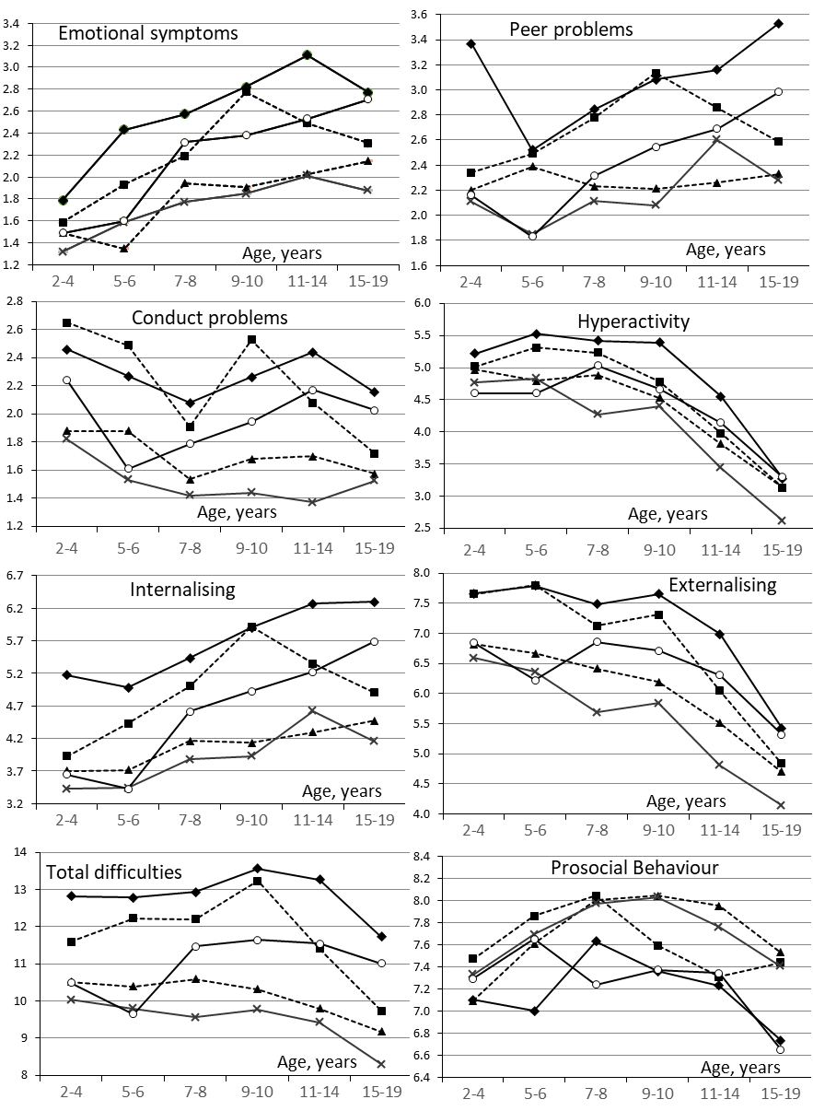

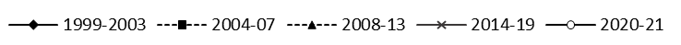

Figure S1. Mean scores on the Strength and Difficulties Questionnaire by age for time period.
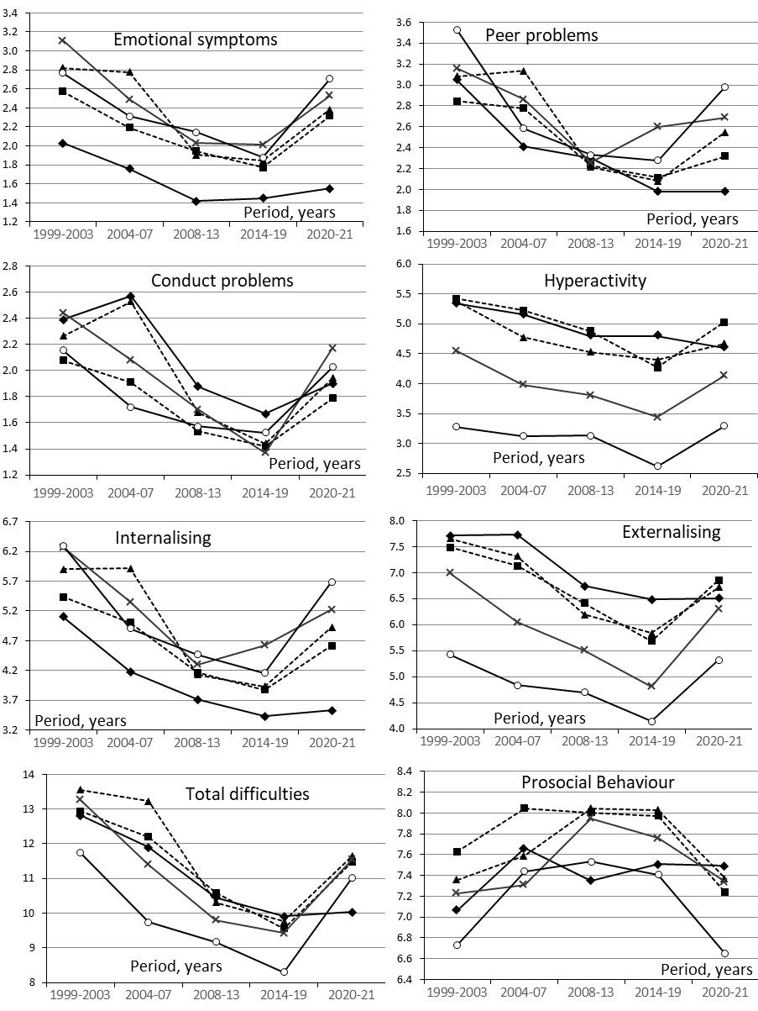

Figure S2. Mean scores on the Strength and Difficulties Questionnaire by time period for age groups.
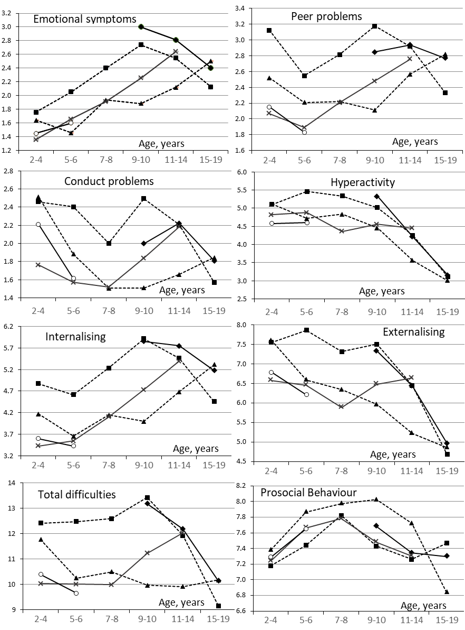

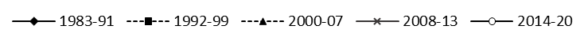

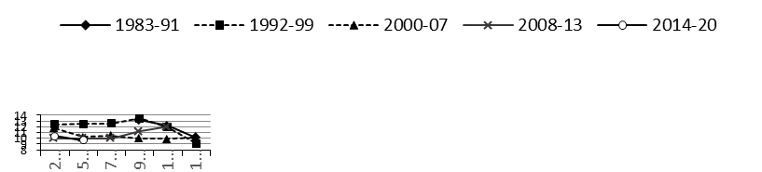
Figure S3. Mean scores on the Strength and Difficulties Questionnaire by age for birth cohorts.
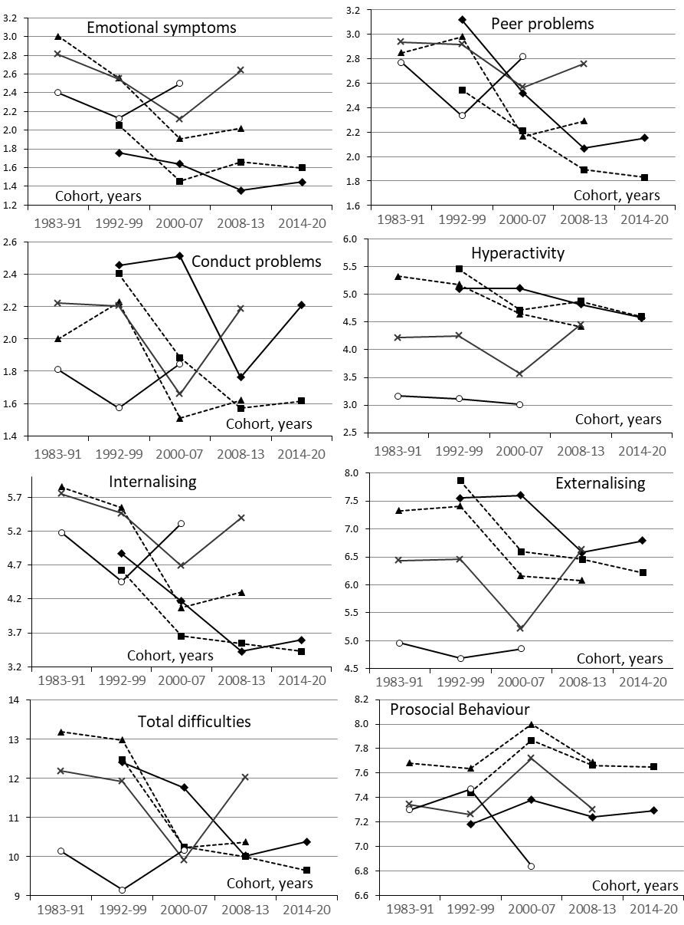

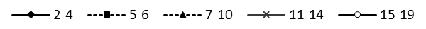

Figure S4. Mean scores on the Strength and Difficulties Questionnaire by birth cohorts for age groups.
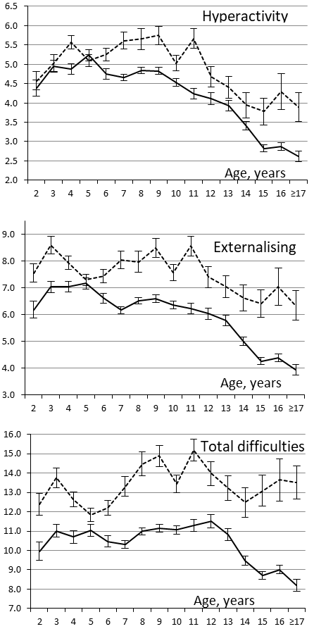

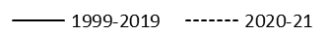

Figure S5. Mean hyperactivity, externalising and total difficulties scores, adjusted for urban/rural status, gender and period, by age before and during the pandemic. Bars represent standard errors.
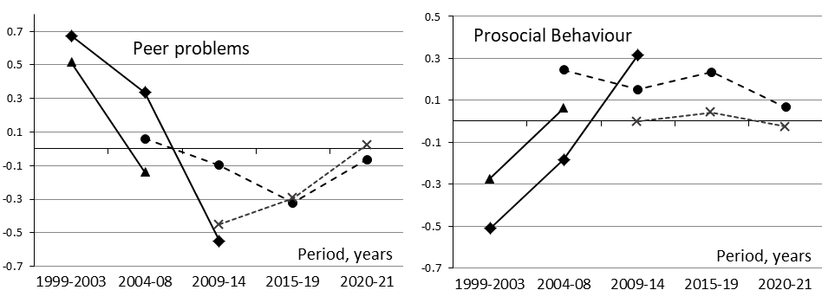

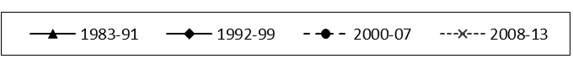

Figure S6. Residuals of peer problems and prosocial behaviour scores, adjusted for urban/rural status, gender, age and the pandemic, by time period for birth cohorts.

