Supplementary figure 1: Sample size estimation using PS power and sample size calculator

- For all study participants
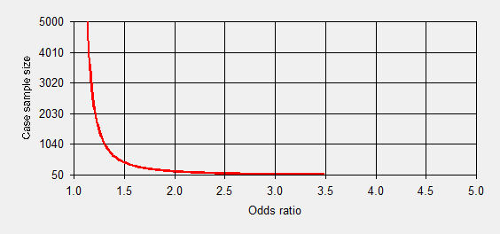

For an independent cases and controls with 1 control(s) per case and the prior information from Global adult tobacco survey, 2016-17 (GATS)¹ indicating the prevalence of tobacco to be 0.29 among Indian adults, the sample size required to obtain a true odds ratio 1.8² for GBC I will be 215 case patients and 215 control
*Note: Power has been considered 80% and the type I error probability has been considered 5%.

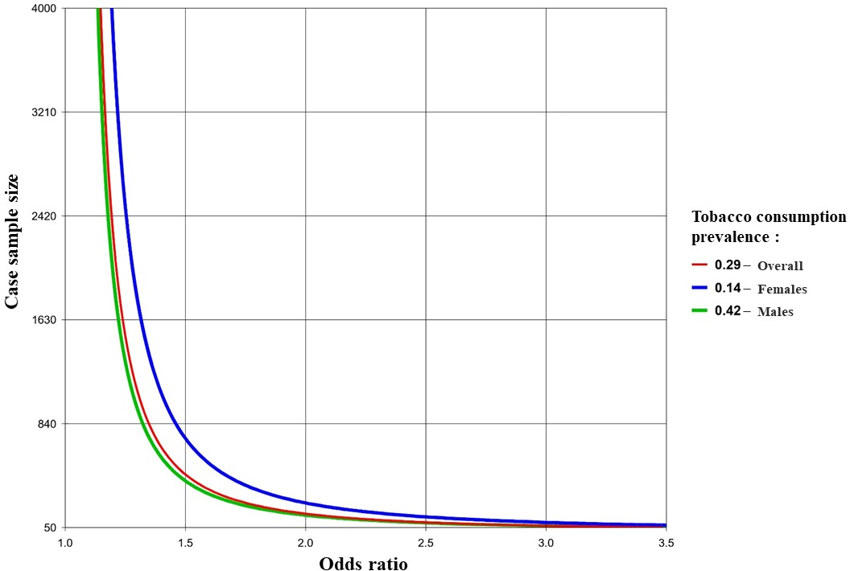
- Sample size estimation for gender stratified analysis

As per GATS (2016-17) prevalence of tobacco use (%) is 42.4% in males and 14.2% in females.¹ For studying tobacco consumption effects separately in males and females, we planned an independent cases and controls study with 1 control(s) per case and, true odds ratio for the disease in exposed relative to unexposed subjects was 1.8.² Therefore, the sample size required for gender stratified analysis among males was calculated to be 196 case patients and 196 control patients, while among females it was 335 case patients and 335 control patients
*Note: Power has been considered 80% and the type I error probability has been considered 5%
**References:
- Global Adult Tobacco Survey: India 2016-17 Report
- PMID: 22890893 - Jain K, et al. Risk factors for gallbladder cancer: A case–control study

