Supplementary material
Glycine-induced synthesis of vaterite via direct aqueous mineral carbonation of flue gas desulfurization gypsum
Xuemin Liu ª, Zhihe Pan ^{c}, Huaigang Cheng ^{c}, Zhien Zhang ^{d*}, Fangqin Cheng ^{c*}, Bo Wang ^{b*}
ª Jinxi Industries Group Co., LTD, Taiyuan 030027, People’s Republic of China
^{b} Institute of Process Engineering, Chinese Academy Sciences, Beijing 100190, People’s Republic of China
^{c} Institute of Resources and Environmental Engineering, Shanxi University, Taiyuan 030006, People’s Republic of China
^{d} Department of Chemical and Biomedical Engineering, West Virginia University, Morgantown, WV 26506-6695, United State of America
*Corresponding authors: Zhien Zhang, Fangqin Cheng, and Bo Wang
Fax: +86 0351-7018553; Tel: +86 0351-7018553
E-mail: zhien.zhang@mail.wvu.edu, cfangqin@sxu.edu.cn, and wangbo@ipe.ac.cn

Fig. S1. Scanning electron microscope images of products from FGDG carbonation in the presence of gylcine (wt%) a) 0, b) 5, c)10, d) 15, e) 20, f) 40.
Fig. S2. Fourier transform infrared spectra of carbonation products prepared with different glycine concentration.
Fig. S3. Thermogravimetry and differential scanning calorimetry curve of mineralization products under 20 wt% glycine.

Fig. S1.
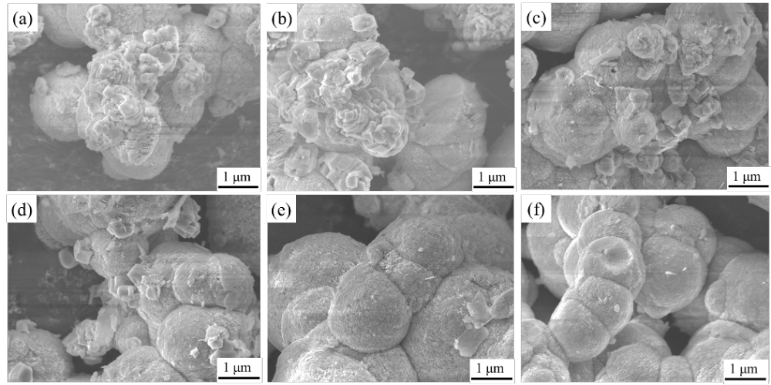

Fig. S1. Scanning electron microscope images of products from FGDG carbonation in the presence of gylcine (wt%) a) 0, b) 5, c)10, d) 15, e) 20, f) 40.

All carbonation products obtained at different concentration of glycine were analyzed by SEM (Fig. S1). The as-prepared samples obtained in the absence of glycine shown sphere-like and rhombohedral particles structure (Fig. S1a), which are similar with our previous result (Wang et al. 2019). However, the sphere-like vaterite gradually increased with increasement of glycine concentration, and finally vaterite was dominated phase (Fig. S1b-f). The SEM images furtherly revealed that these microspheres were composed of the aggregation of numerous primary nanoparticles (Fig. S1e-f). Many vaterite microspheres were observed to be interconnected with each other demonstrating there were a tendency of conglutination or clustering between vaterite particles.

Fig. S2.
Fig. S2. Fourier transform infrared spectra of carbonation products prepared with different glycine concentration.

Carbonation products were analyzed by FTIR. With the increase of the concentration of glycine, the characteristic peak of calcite at 712 cm-1 gradually weakened, and the characteristic peak of vaterite (745 cm-1) gradually increased (Fig. S2).

Fig. S3.

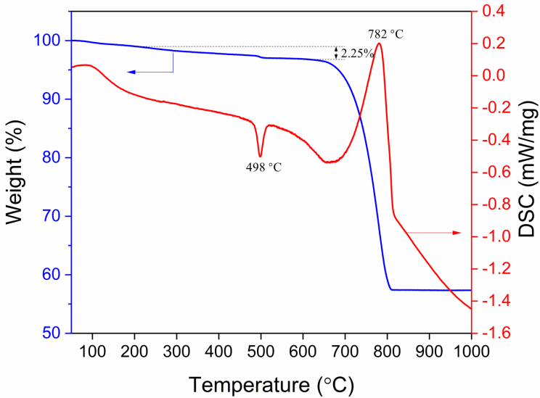

Fig. S3. Thermogravimetry and differential scanning calorimetry curve of mineralization products under 20 wt% glycine.

Fig. S3 shows the TG-DSC curve of carbonation product at the glycine concentration of 20 wt%. TG curve has three temperature ranges of weight loss at 50–200 °C, 200–600 °C and 600–850 °C were ascribed to water evaporation, glycine decomposition and CaCO₃ decomposition respectively. For DSC curve, the endothermic peaks near 100 °C and 782 °C are due to water evaporation and CaCO₃ decomposition. The exothermic peak near 498 °C is due to the phase transformation of vaterite to calcite under high temperature. The TG results further showed that there was a small amount of glycine in CaCO₃ products, which could stabilize the metastable vaterite and prevent it from transforming into calcite (Lai et al. 2015; Luo et al. 2015).

References
Lai Y, Chen L, Bao W, Ren Y, Gao Y, Yin Y, Zhao Y (2015) Glycine-mediated, selective preparation of monodisperse spherical vaterite calcium carbonate in various reaction systems. Cryst Growth Des 15:1194–1200 doi: 10.1021/cg5015847
Luo J, Kong F, Ma X (2015) Role of aspartic acid in the synthesis of spherical vaterite by the Ca(OH)₂–CO₂ reaction. Cryst Growth Des 16:728–736 doi:10.1021/acs.cgd.5b01333Wang B, Pan Z, Du Z, Wang B, Pan Z, Du Z, Cheng H, Cheng F (2019) Effect of impure components in flue gas desulfurization (FGD) gypsum on the generation of polymorph CaCO₃ during carbonation reaction. J Hazard Mater 369:236–243 doi: 10.1016/j.jhazmat.2019.02.002

