SUPPORTING INFORMATION

Formation of insoluble Anderson-type heteropoly molybdates in citrate Ni–Mo and Co–Mo impregnation solutions used to prepare HDS catalysts: Causes and effects on catalytic activity
Sergey V. Budukva*, Mikhail V. Parfenov, Mikhail E. Revyakin, Evgenii A. Suprun, Elizaveta S. Bykova, Daria D. Uvarkina, Maxim O. Kazakov
Boreskov Institute of Catalysis SB RAS, Novosibirsk 630090, Russia
zsm@catalysis.ru

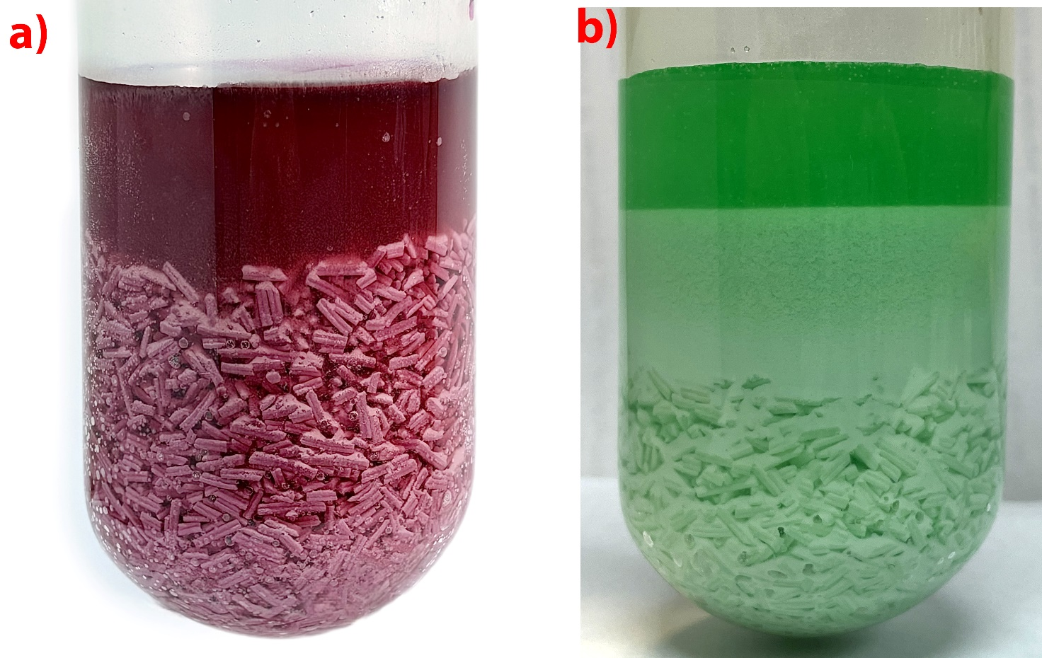
Figure S1. Precipitates formed during impregnation of γ-Al₂O₃ support granules with
CoMo (a) and NiMo (b) citrate solutions.

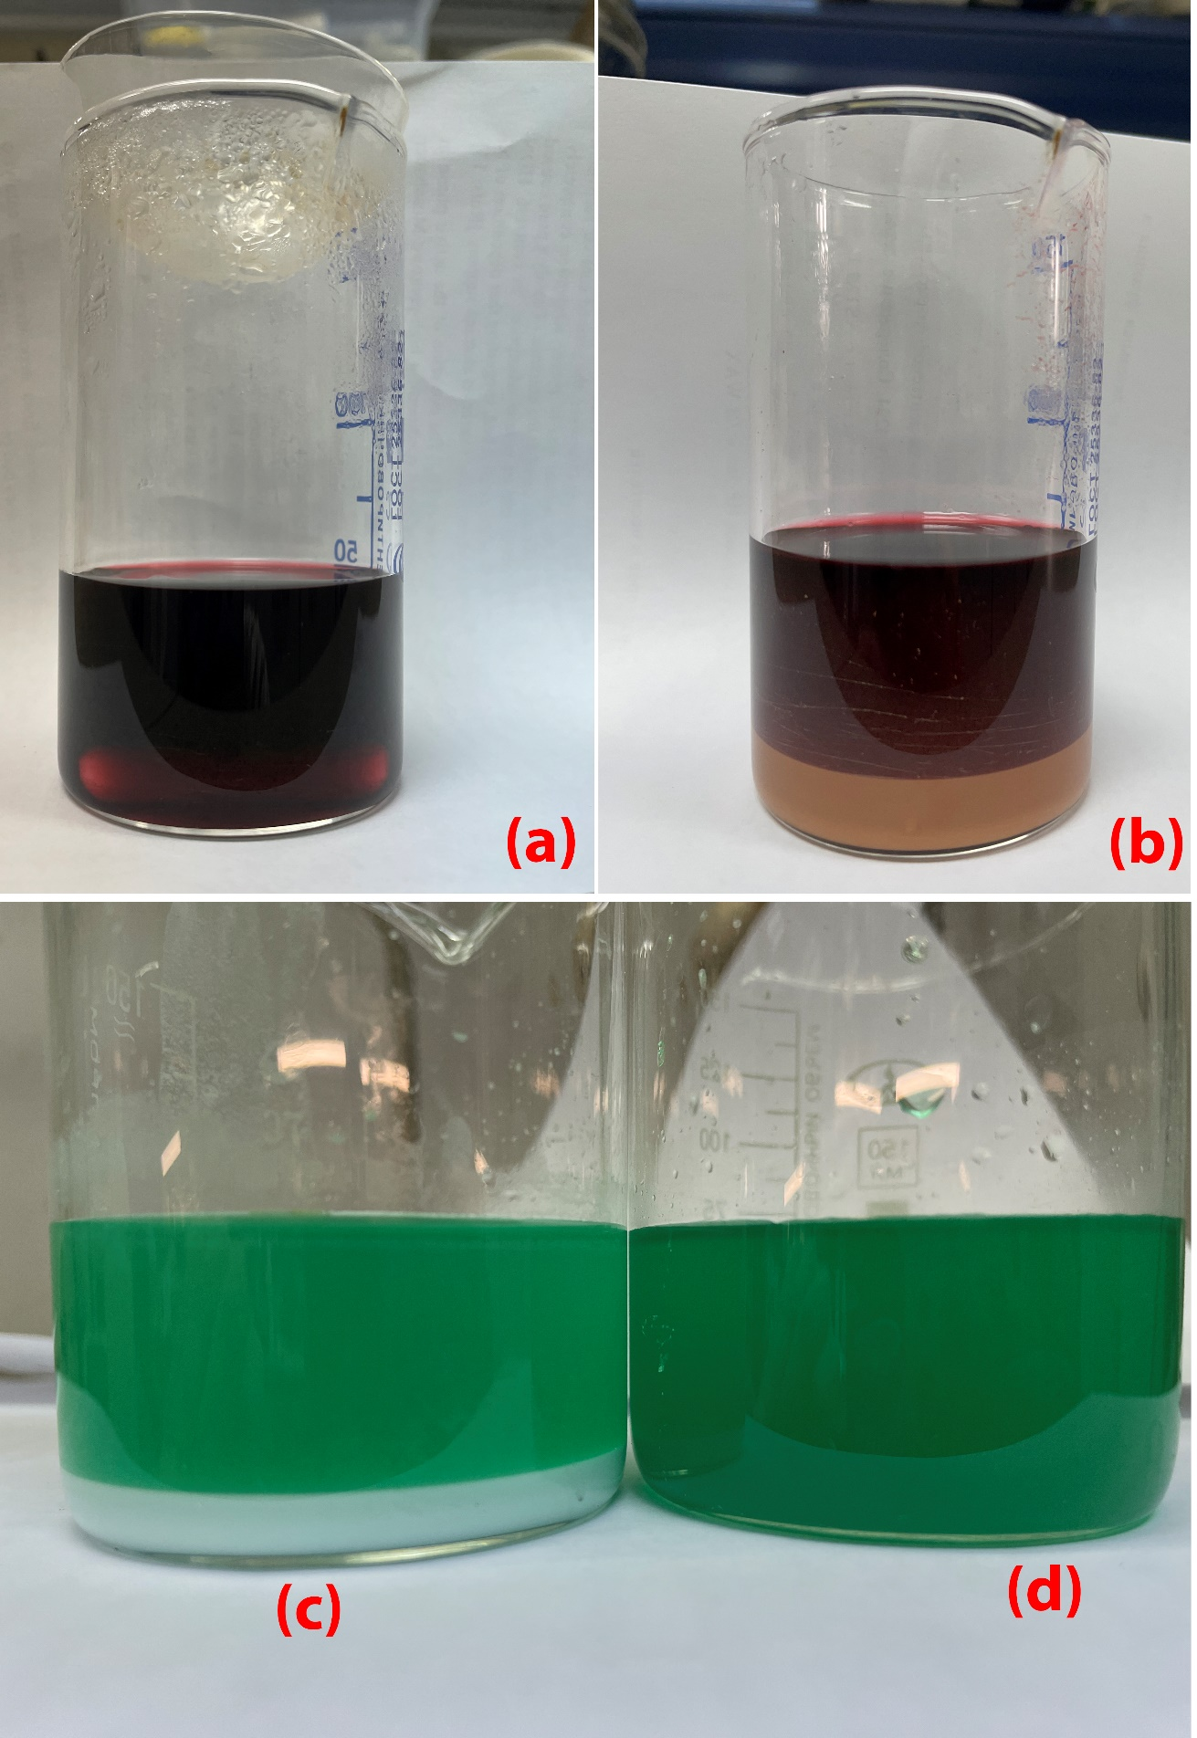
Figure S2. Precipitates formed in citrate impregnation solutions for Co-Mo (top) and Ni-Mo (bottom) at different citric acid concentrations.

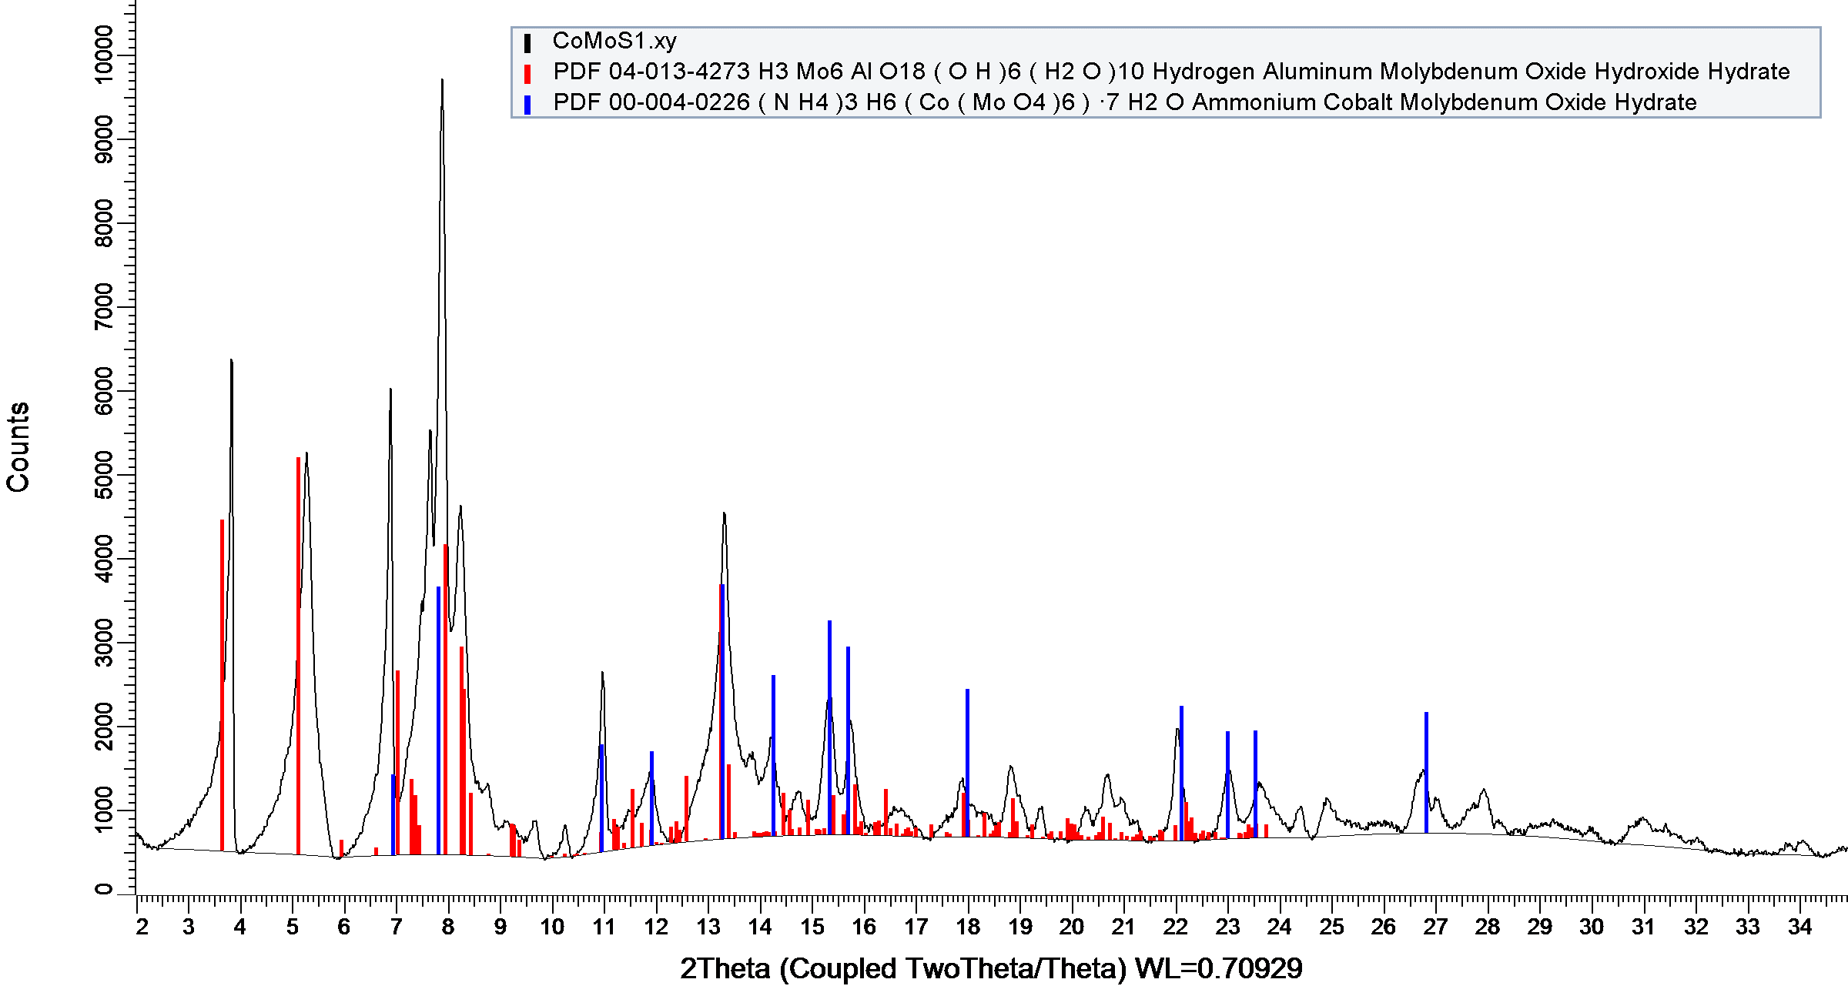

Figure S3. XRD pattern of CoMo-S1.

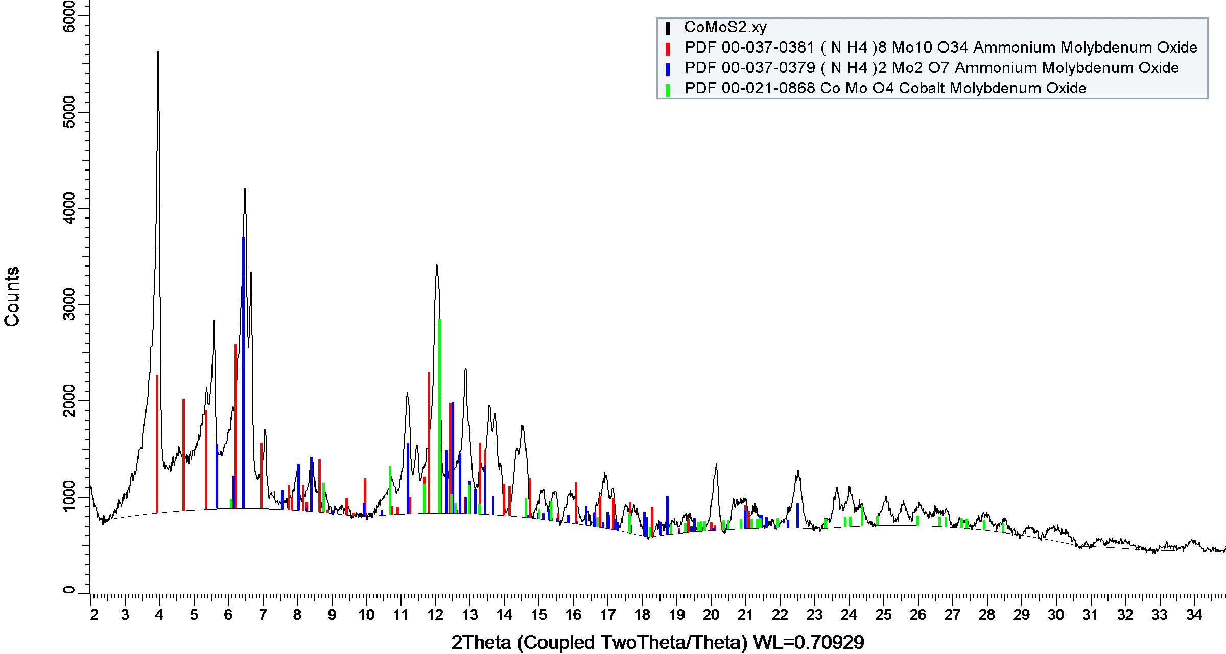
Figure S4. XRD pattern of CoMo-S2.

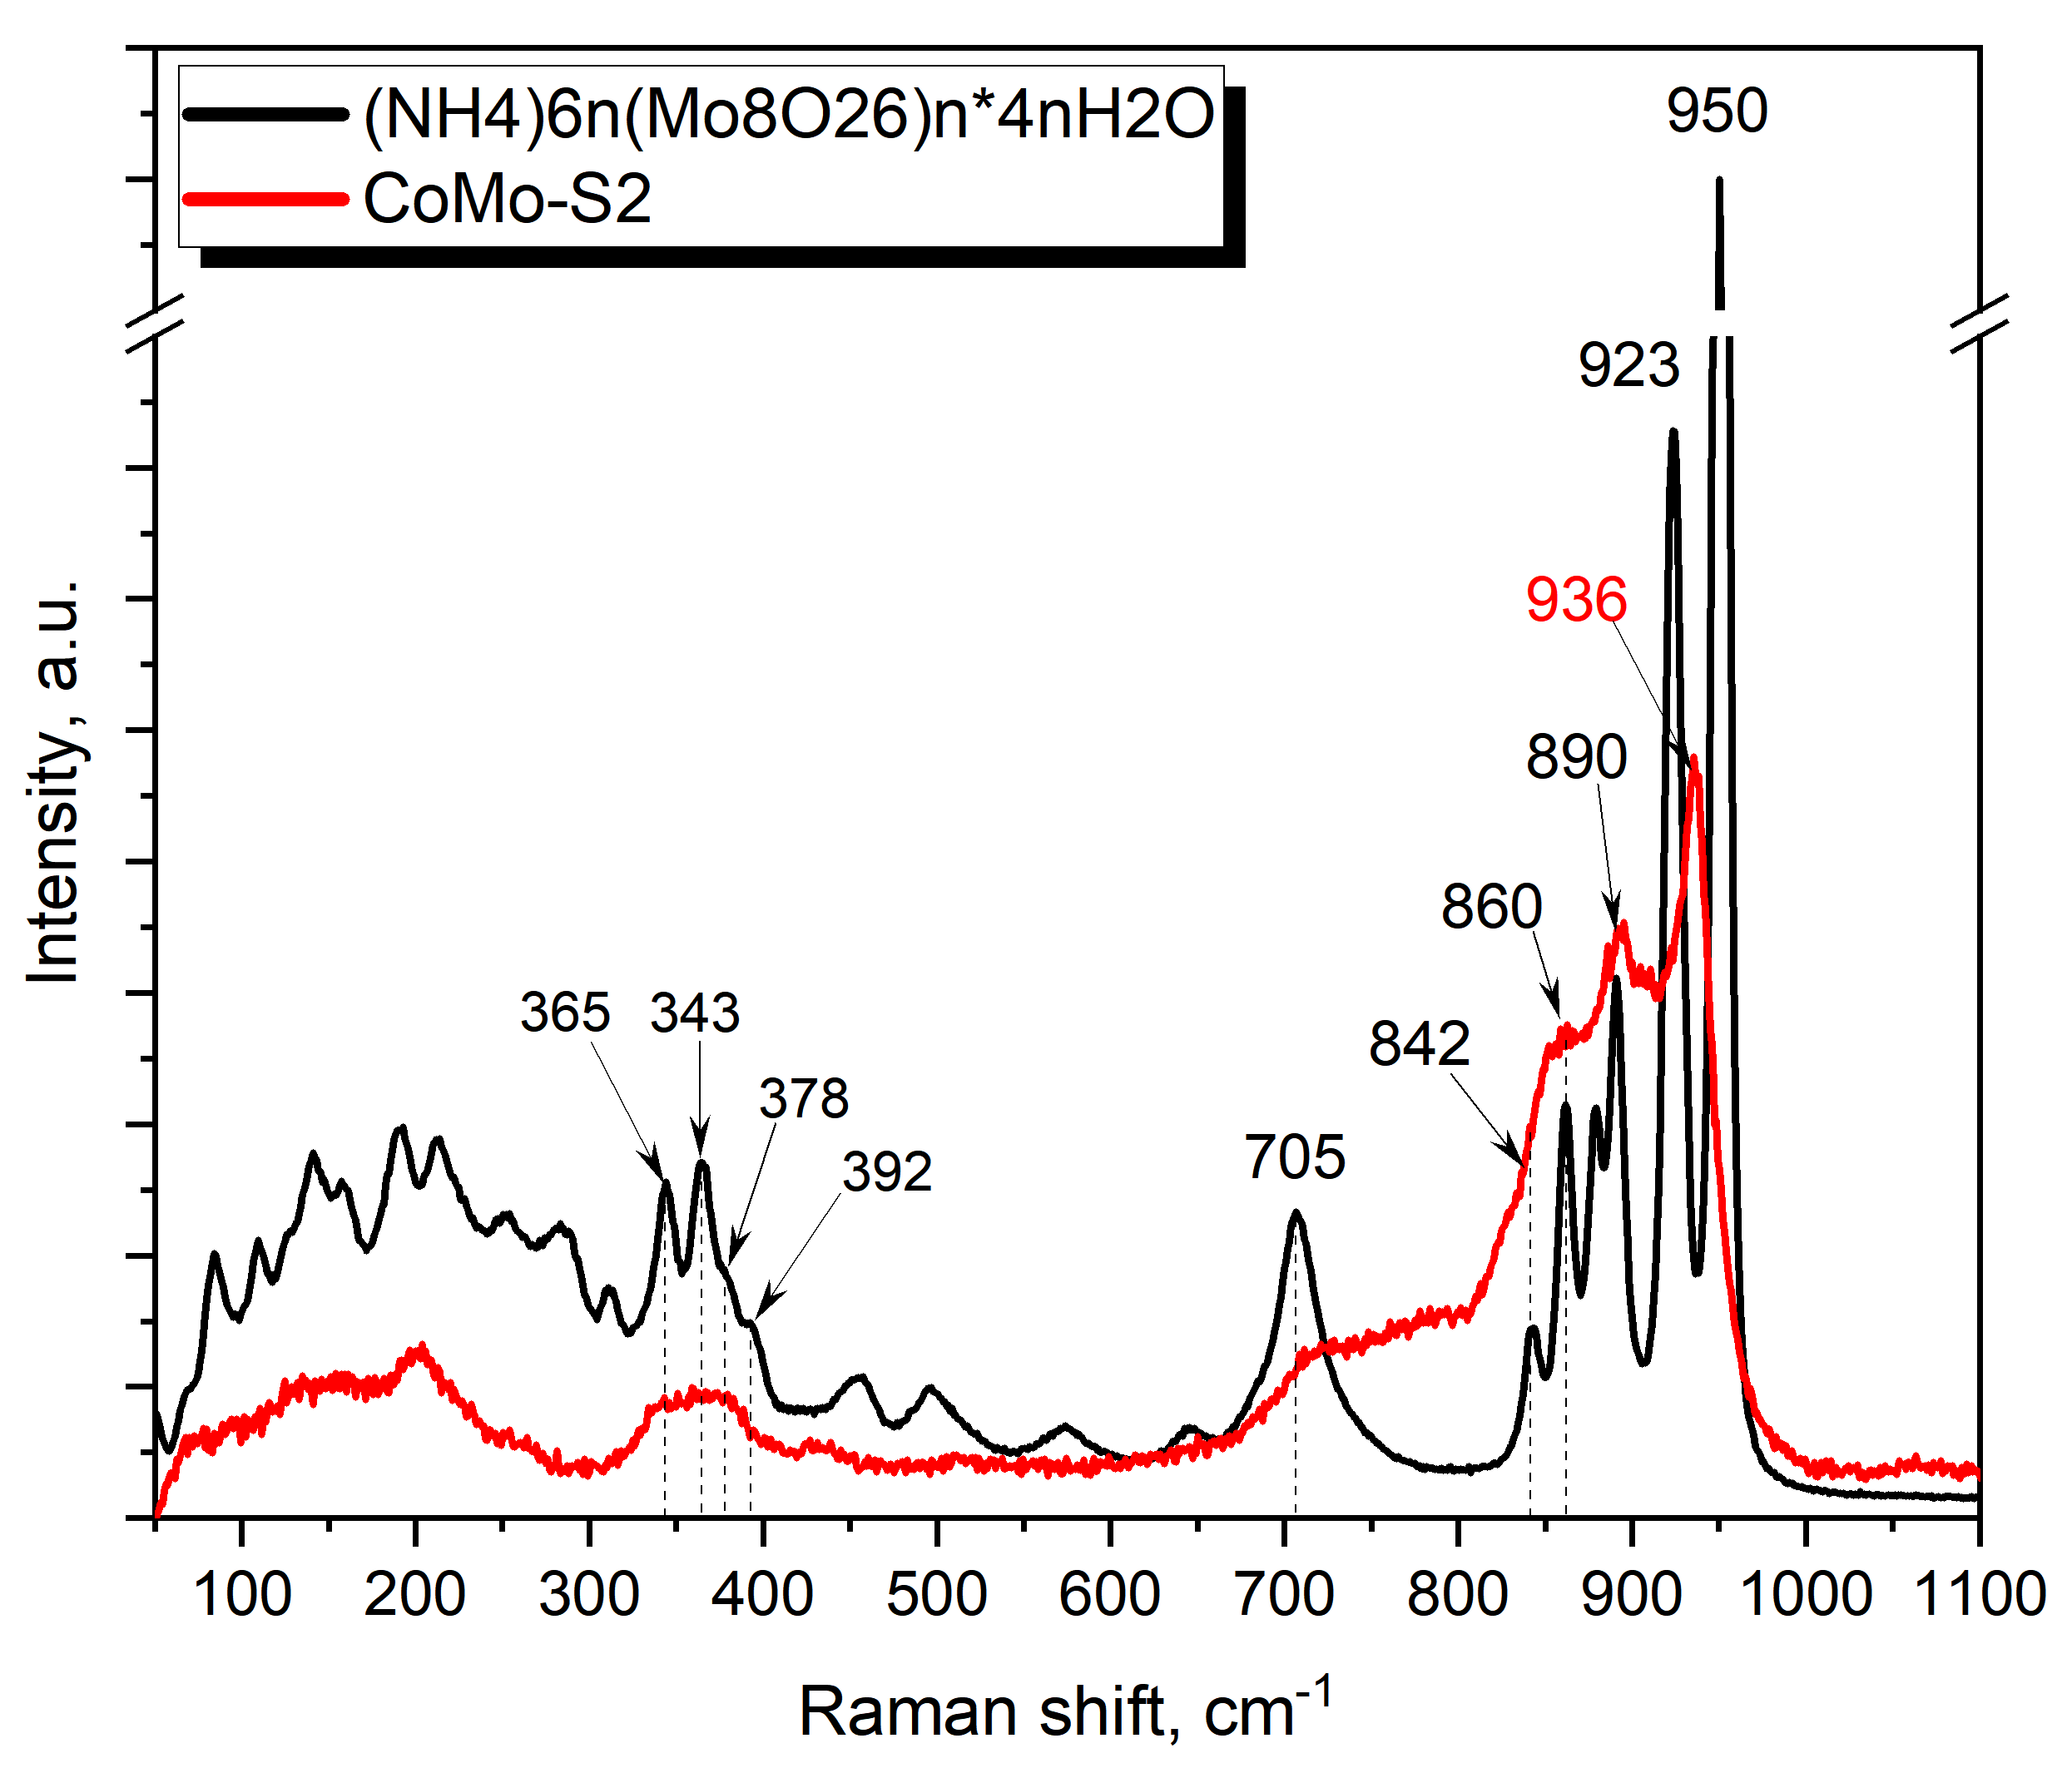
Figure S5. Raman spectra of CoMo-S2 and ammonium polyoctamolybdate obtained by the method of [1].
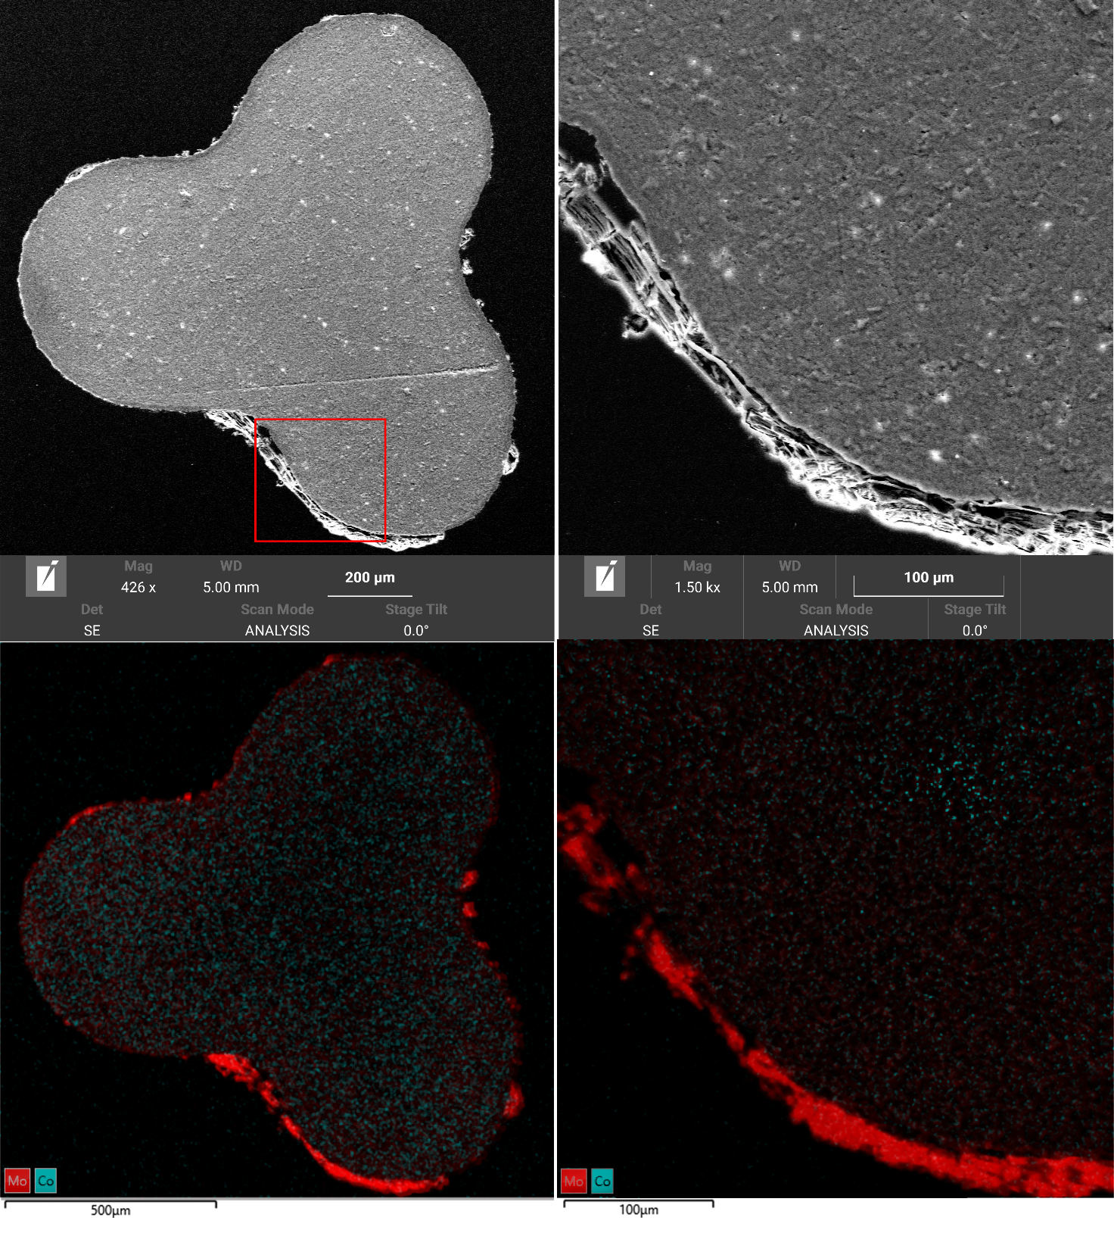

Figure S6. Image of a cross-section of the CoMo-1 granule.

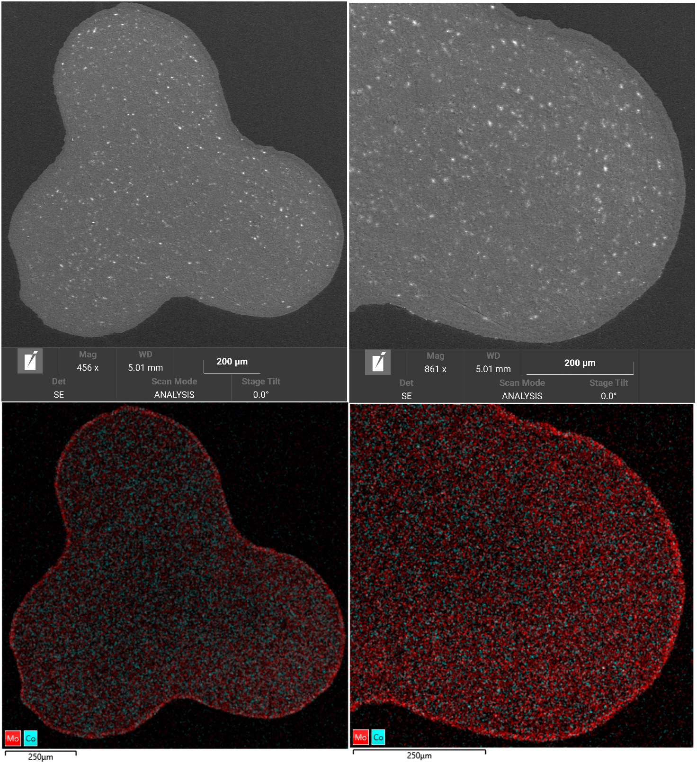
Figure S7. Image of a cross-section of the CoMo-2 granule.

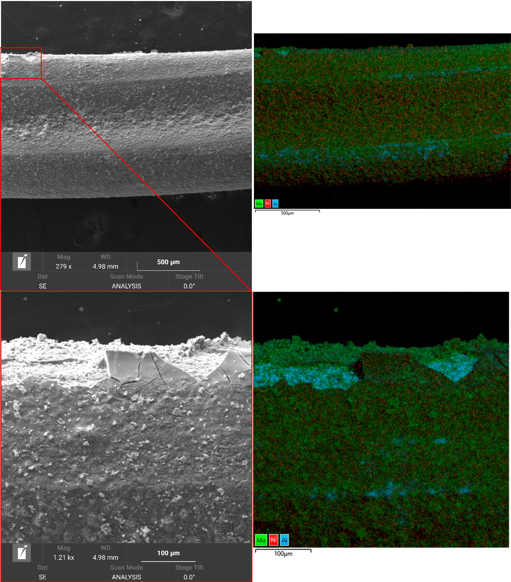
Figure S8. SEM-EDX images of the surface of the CoMo-1 catalyst.

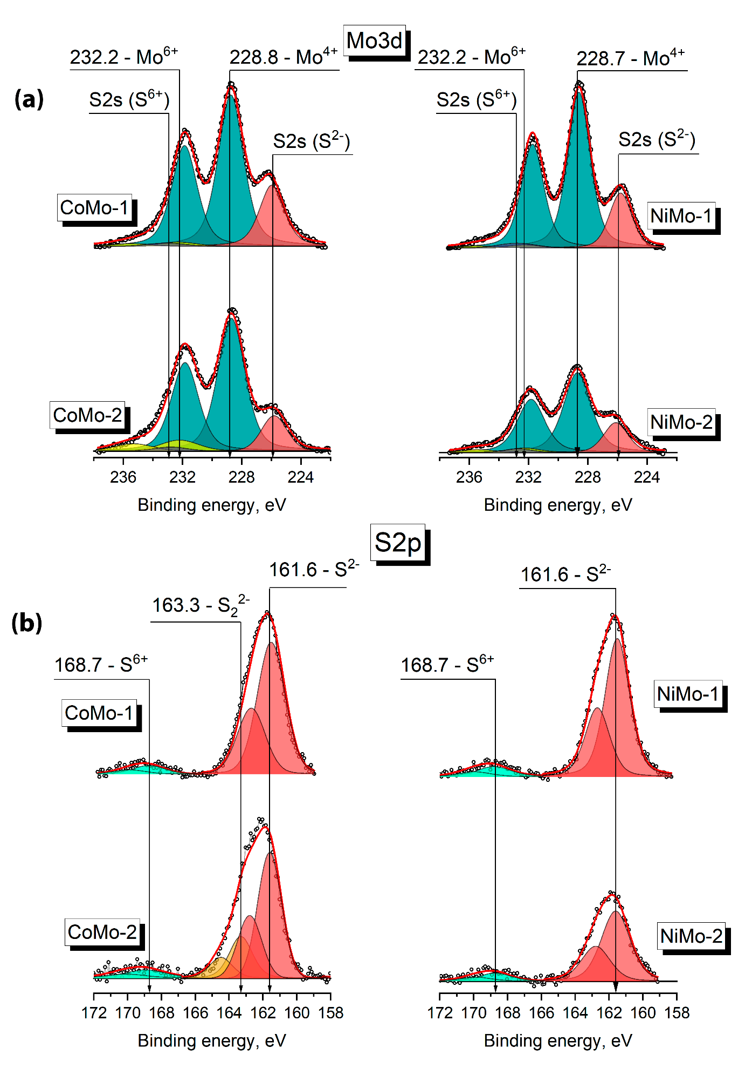
Figure S9. Mo2p (a) and S2p (b) XPS spectra of the catalysts.

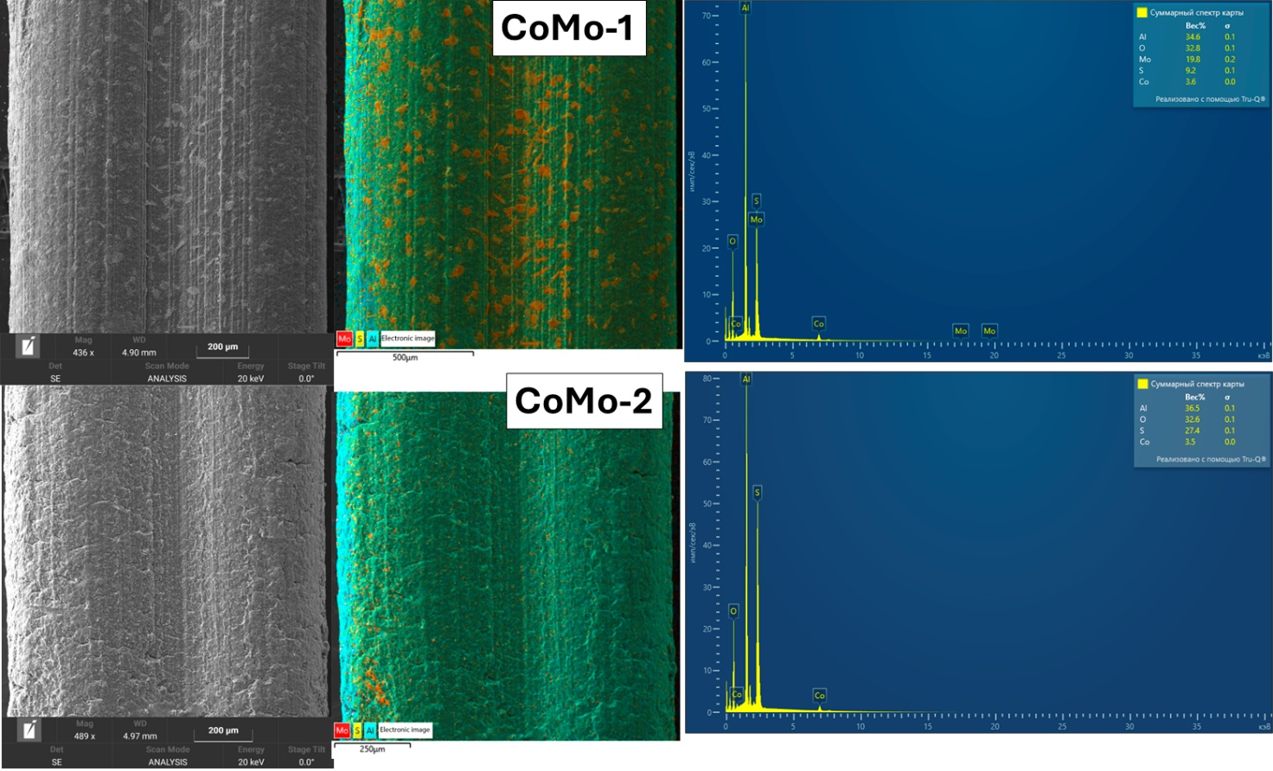
Figure S10. SEM-EDX images of the surface of a sulfided CoMo-1 and CoMo-2 catalysts.

Reference
- Brauer G. Handbook of Preparative Inorganic Chemistry, 1981. V.6

