Extended Data Fig. and Legends
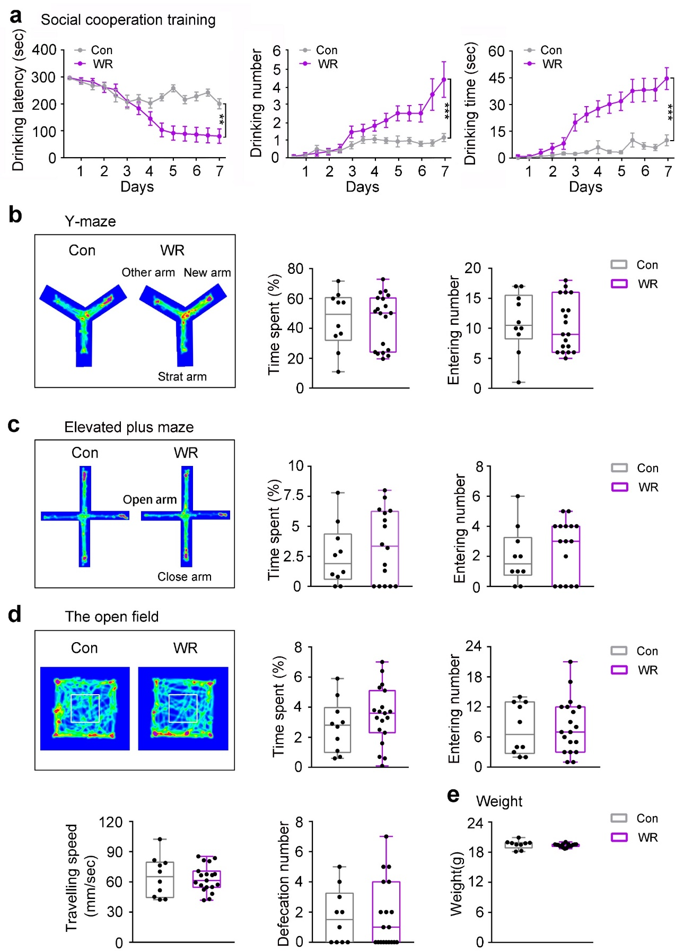
Extended Data Fig. 1 | Water restriction did not change mouse locomotion, exploration, anxiety, cognition, memory, and social behavior significantly.
a, Water restriction (from 11:00 pm to 7:00 am) reduced drinking latency (F(1, 220) = 12.920, P = 0.001), and increased times of cooperation (F(1, 220) = 14.901, P = 0.0001) and total time of cooperation during the training period (F(1, 220) = 34.208, P = 0.0001). b, The spatial working memory performance of water restriction (WR) and control (Con) mice in the Y-maze testing. c, The anxiety levels of WR and Con mice examined by the elevated plus maze test. d, Locomotion, and exploration behavior of WR and Con mice in the open field. e, Water restriction (WR) didn’t decrease mice’s weight. All data are from 2 months old male C57BL/6 mice. Data are presented as mean ± SEM from 10 mice in Con group and 17 mice in WR group. Data in a were analyzed by repeated-measures ANOVA with post hoc Student-Newman-Keuls test; Data in b, e were analyzed by two-tailed Student’s t-tests.

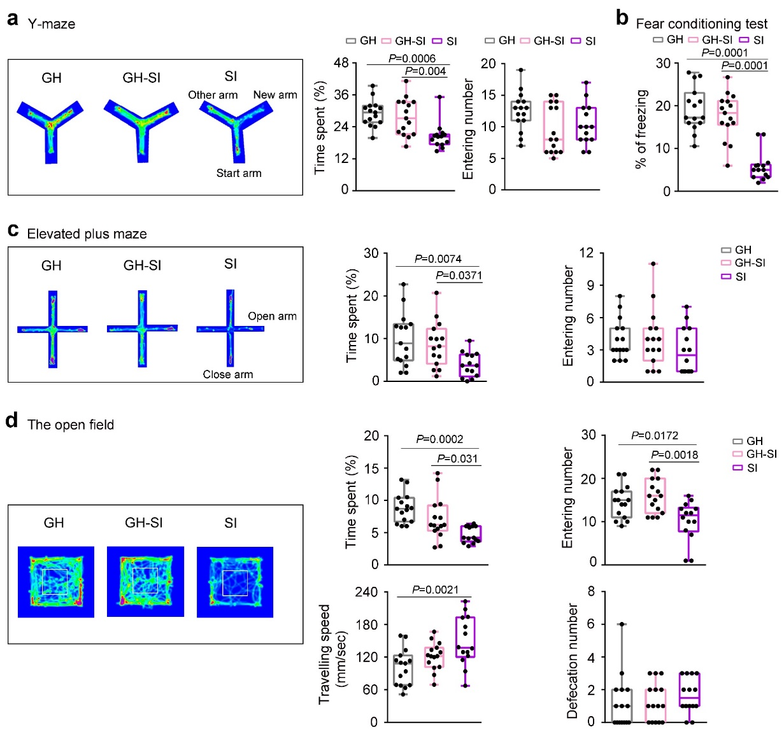
Extended Data Fig. 2 | Resocialization of SI mice with GH mice (GH-SI) restored the fear memory, spatial working memory, exploring activities and anxiety-like defect.
a, The spatial working memory performance of group housing (GH), resocialization of SI mice with GH mice (GH-SI) and social isolation (SI) mice in the Y-maze testing. b, Fear memory performance of GH, GH-SI and SI mice in fear conditioning test. c, The anxiety levels of GH, GH-SI and SI mice examined by the elevated plus maze test. d, Locomotion, and exploration behavior of GH, GH-SI and SI mice in the open field. All data are from 3 months old male C57BL/6 mice. All data are represented as mean ± SEM from 15 mice in GH group, 15 mice in GH-SI group and 14 mice in SI group. Data were analyzed by One-way ANOVA followed by Tukey's post hoc test.

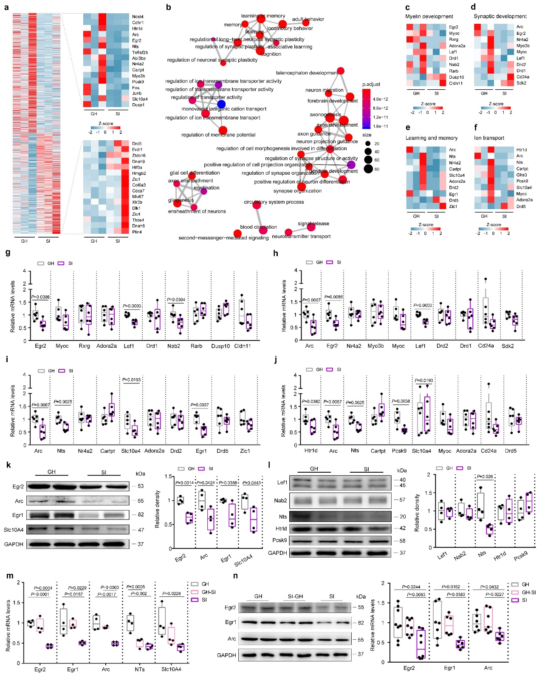
Extended Data Fig. 3 | RNA-seq and validation for possible genes regulating cooperative behavior.
a, Z score heatmap showing 1265 differentially expressed (DE) genes identified by the RNA-seq; right panel shows a zoomed view of the 16 mostly downregulated (up) and upregulated (bottom) genes in SI mice. b, Clustering of the top 40 groups of DE genes. Genes are enriched in 4 pathways: myelin development, synaptic development, learning and memory, and ion transport; for each pathway, the 10 mostly altered genes are shown in c-f for RNA-seq data, and confirmed by qPCR in g-j, respectively. n = 6 for each group. k-l, Western blot evaluating protein expression of the qPCR-confirmed candidate genes (from g-j); right panels show the corresponding quantification; n = 4 for each group. m, qPCR evaluating the Western blot-confirmed genes (from k-l) in resocialization (GH-SI) mice; n = 4 for each group. n, Western blot evaluating protein expression of the 3 qPCR-confirmed genes (from m) in GH-SI mice. n = 6-8 for each group. Data are from 2 months (in a-l) or 3 months (in m-n) old male C57BL/6 mice. Data were presented as heatmap in a-f, and as box plot with dots in g-n; Data were analyzed by two-tailed Student’s t-tests in a-l, and by One-way ANOVA followed by Tukey's post hoc test in m, n.

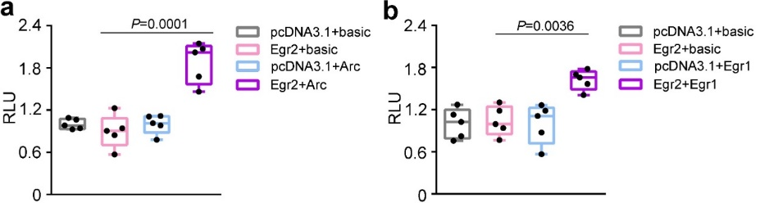
Extended Data Fig. 4 | Dual-luciferase reporter assay revealed transcriptional upregulation of Arc and Egr1 by Egr2.
a-b, Arc promoter- (in a) and Egr1 promoter- (in b) driven luciferase activities in 293 cells with the indicated transfections (n = 5 per group). Data were analyzed by two-way ANOVA followed by Tukey’s post hoc test.

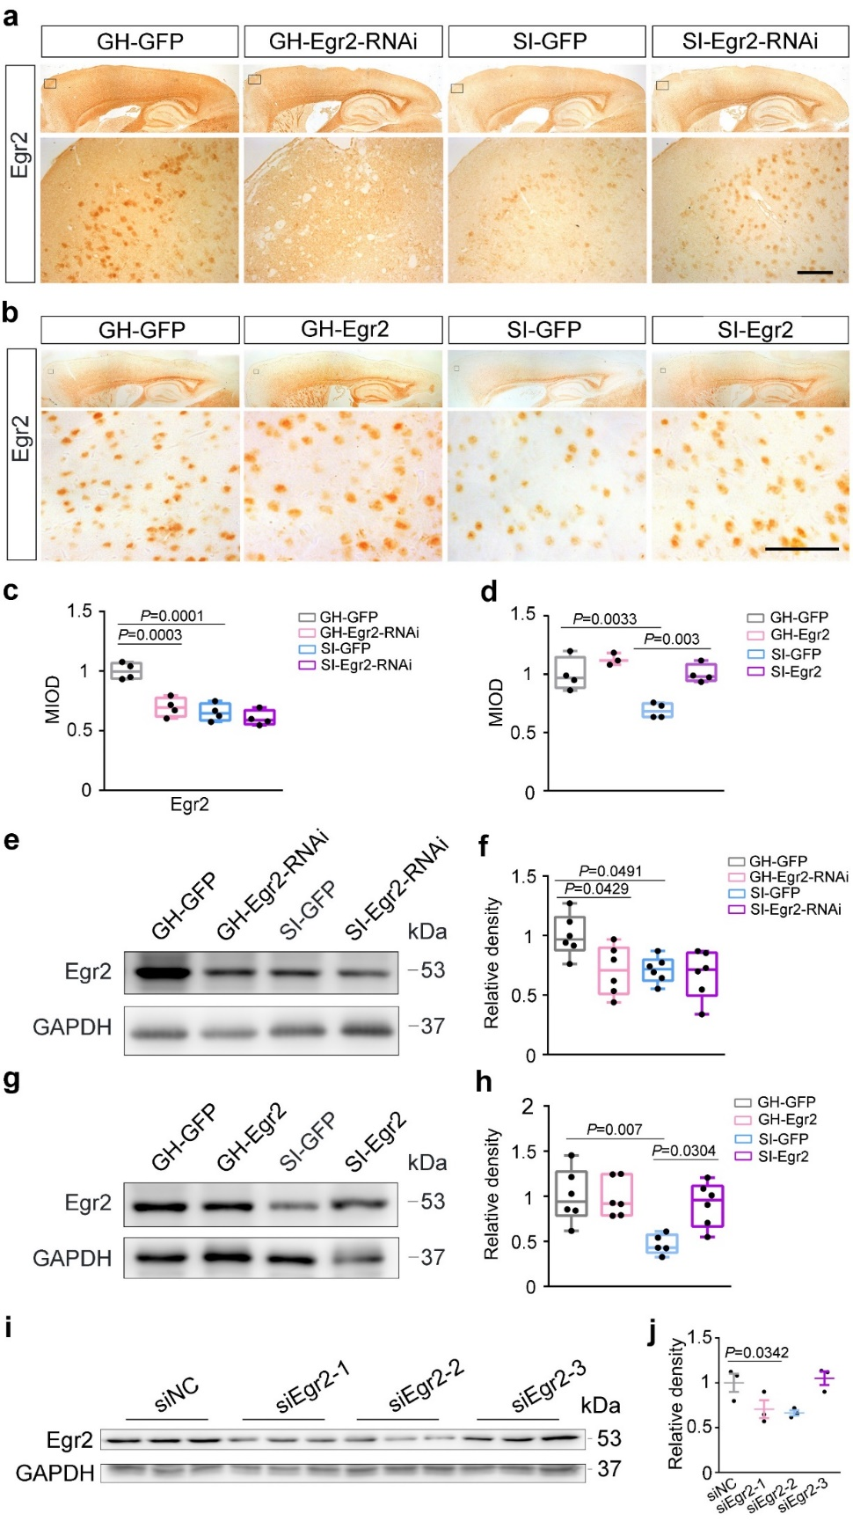
Extended Data Fig. 5 | Verification of interference efficiency of Egr2.
a, e, Representative immunohistology images (a) and western blot (e) showing Egr2 expression in GH-GFP, GH-Egr2, SI-GFP and SI-Egr2 mice. c, f, are the respective quantified analysis of a (n = 4) & e (n = 6). b, g, Representative immunohistology images (b) and western blot (g) showing Egr2 expression in GH-GFP, GH-Egr2-RNAi, SI-GFP and SI-Egr2-RNAi mice. d, h, are the respective quantified analysis of b (n =4 ), g (n = 5-6). Representative western blot images (i) and the corresponding quantified graph (j) showing Egr2 protein expression in primary oligodendrocyte with indicated siRNA treatments (n = 3). Data in a-h are from 2 months old male C57BL/6 mice. Data are presented as mean ± SEM. Data in a-h were analyzed by Two-way ANOVA followed by Tukey's post hoc test. Data in i-j were analyzed by One-way ANOVA followed by Tukey's post hoc test. GH-GFP: GH mice with AAV-GFP virus injection; GH-Egr2-RNAi: GH mice with AAV-Egr2-RNAi virus injection; SI-GFP: SI mice with AAV-GFP virus injection; SI-Egr2-RNAi: SI mice with AAV-Egr2-RNAi virus injection.

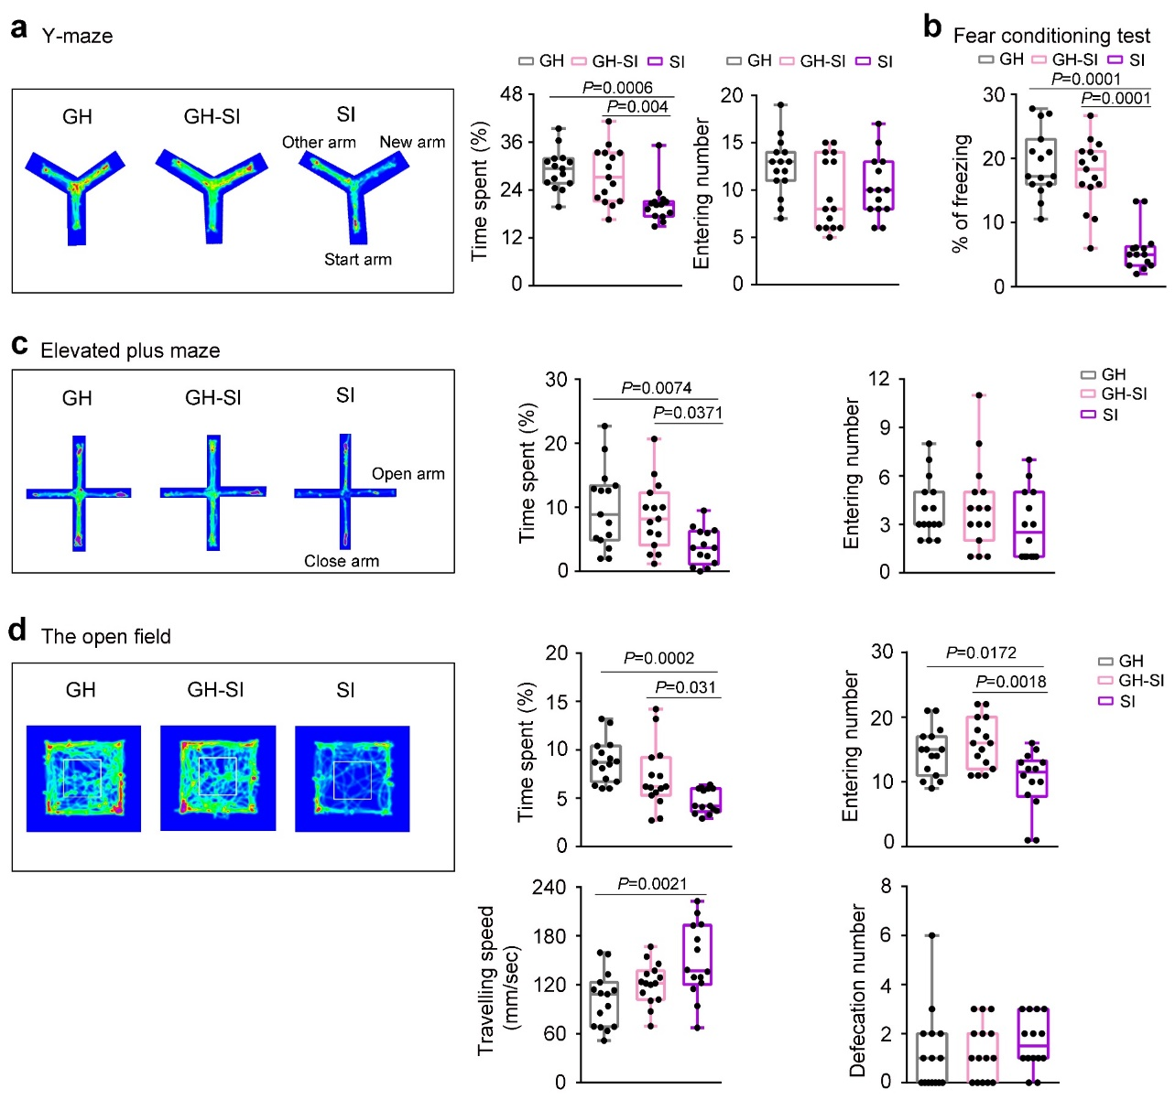
Extended Data Fig. 6 | Knocking down of Egr2 in the mPFC of GH mice did not affect exploring activities, spatial working memory, anxiety-like behavior, and fear memory.
a, The spatial working memory performance of GH mice with AAV-GFP virus injection (GH-GFP), GH mice with AAV-Egr2-RNAi virus injection (GH-Egr2-RNAi), SI mice with AAV-GFP virus injection (SI-GFP) and SI mice with AAV-Egr2-RNAi virus injection (SI-Egr2-RNAi) mice in the Y-maze testing. b, Fear memory performance of GH-GFP, GH-Egr2-RNAi, SI-GFP and SI-Egr2-RNAi mice in fear conditioning test. c, The anxiety levels of GH-GFP, GH-Egr2-RNAi, SI-GFP and SI-Egr2-RNAi mice examined by the elevated plus maze test. d, Locomotion, and exploration behavior of GH-GFP, GH-Egr2-RNAi, SI-GFP and SI-Egr2-RNAi mice in the open field. All data are from 2 months old male C57BL/6 mice. Data are presented as mean ± SEM from GH-GFP, GH-Egr2-RNAi, SI-GFP and SI-Egr2-RNAi mice; n = 20 mice for each group. Data are presented as mean ± SEM. All data were analyzed by Two-way ANOVA followed by Tukey's post hoc test.

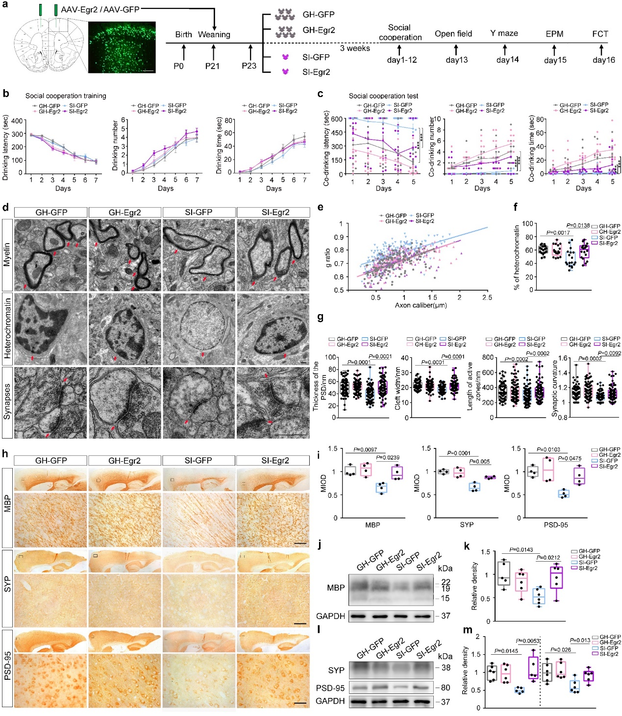
Extended Data Fig. 7 | Overexpressing Egr2 in the mPFC of SI mice mitigated cooperation defect and restores myelination impairments.
a, A timeline diagram showing mice receiving weanling, AAV virus injection, social isolation, cooperative water-drinking test, and other behavioral tests. b, Graphs showing the time before the first drinking (drinking latency), the times of drinking (drinking number), and the total time spent on drinking (drinking time) each day in different groups in the 7 consecutive training days. Note the decline of the drinking latency and the rise of the drinking number and drinking time. c, Overexpressing Egr2 in the mPFC of SI mice improved their cooperation performance, as assessed by decreased drinking latency (F(1, 145) = 5.506, P = 0.023), increased drinking number (F(1, 145) = 22.172, P = 0.0001), and increased drinking time (F(1, 145) = 16.916, P = 0.0001). d, Representative electron microscopy images showing myelin, heterochromatin, and synaptic morphology in the mPFC of GH-GFP, GH-Egr2, SI-GFP, and SI-Egr2 mice; red arrows in each row indicate representative myelin (top), heterochromatins (middle), and synapses (bottom) respectively; scale bar, 500 nm. e, Scatter plot of g-ratios with linear least squares fitting in GH-GFP, GH-Egr2, SI-GFP, and SI-Egr2 mice; n = 154, 134, 172 and 144 axons respectively; statistical significance was assessed by sum-of-squares F test of the slopes generated by linear fitting. f, Graphs showing altered percentage of nuclear heterochromatin in GH-GFP, GH-Egr2, SI-GFP, and SI-Egr2 mice; n = 20, 17, 18 and 18 nuclear respectively. g, Graphs showing quantified analysis of postsynaptic dense, synaptic cleft width, length of the active zones and synaptic curvature in GH-GFP, GH-Egr2, SI-GFP, and SI-Egr2 mice; n = 77, 85, 87 and 77 synapses respectively. h-m, Representative immunohistology (h) and Western blot images (j , l) showing MBP, Synaptophysin and PSD-95 expression in the mPFC of GH-GFP, GH-Egr2, SI-GFP, and SI-Egr2 mice; respective quantified analysis are shown in i (for h), k (for j), and m (for l); scale bar, 50 µm. All data were from 2 months old male C57BL/6 mice. n = 4 for each group in i; n = 5-6 in k, m. Data were represented as mean ± SEM. Data in b, c were from 18 mice in GH-GFP group, 22 mice in GH-Egr2 group, 30 mice in SI-GFP group and 28 mice in SI-Egr2 group analyzed by repeated-measures ANOVA with post hoc Student-Newman-Keuls test; Data were presented as line plot in b and with dots representing values of each sample in c. Data in d-m were analyzed by two-way ANOVA followed by Tukey's post hoc test; GH-GFP: GH mice with AAV-GFP virus injection, GH-Egr2: GH mice with AAV-Egr2 virus injection, SI-GFP: SI mice with AAV-GFP virus injection, SI-Egr2: SI mice with AAV-Egr2 virus injection.

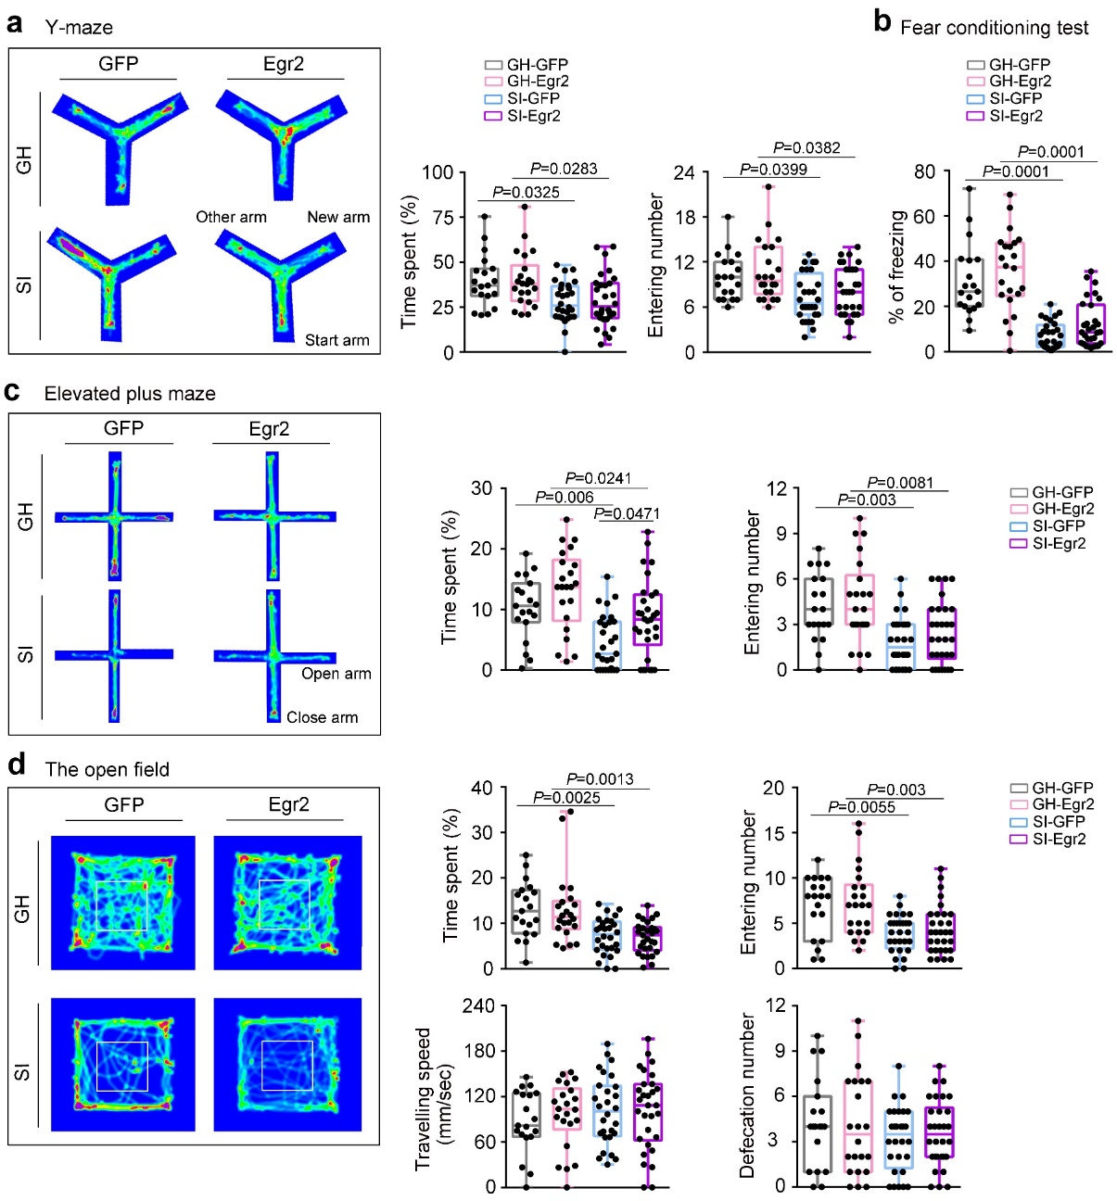
Extended Data Fig. 8 | Over-expression of Egr2 in the mPFC of SI mice mitigated abnormal anxiety-like extent and fear memory, but not exploring activities and spatial working memory.
a, The spatial working memory performance of GH mice with AAV-GFP virus injection (GH-GFP), GH mice with AAV-Egr2 virus injection (GH-Egr2), SI mice with AAV-GFP virus injection (SI-GFP) and SI mice with AAV-Egr2 virus injection (SI-Egr2) mice in the Y-maze testing. b, Fear memory performance of GH-GFP, GH-Egr2, SI-GFP and SI-Egr2 mice in fear conditioning test. c, The anxiety levels of GH-GFP, GH-Egr2, SI-GFP and SI-Egr2 mice examined by the elevated plus maze test. d, Locomotion, and exploration behavior of GH-GFP, GH-Egr2, SI-GFP and SI-Egr2 mice in the open field. All data are from 2 months old male C57BL/6 mice. Data are represented as mean ± SEM from 19 mice in GH-GFP group, 23 mice in GH-Egr2 group, 28 mice in SI-GFP group and 28 mice in SI-Egr2 group. All data were analyzed by Two-way ANOVA followed by Tukey's post hoc test.

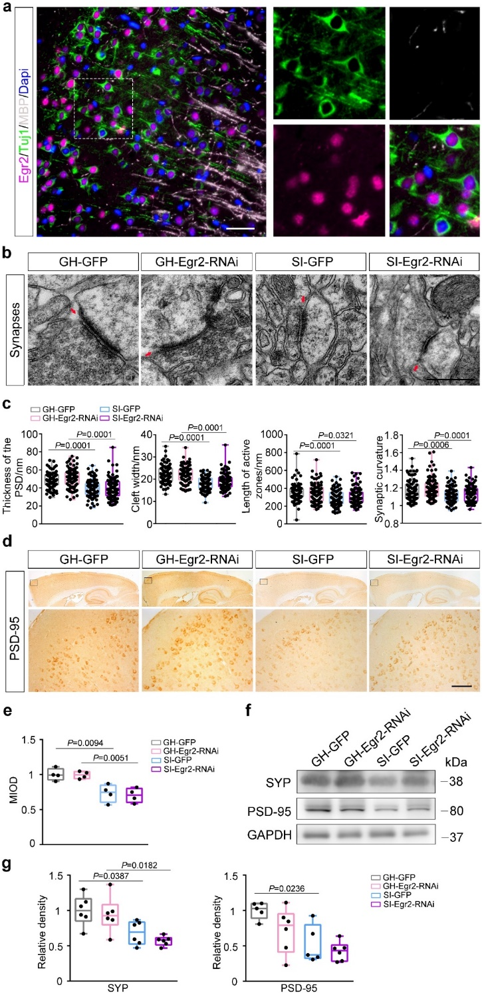
Extended Data Fig. 9 | Knock down Egr2 in mPFC of GH mice did not generate synaptic impairments.
a, Representative immunofluorescence images showing Egr2 expression in many Tuj1-labeled neurons and MBP-labeled oligodendrocyte in the mPFC region; scale bar, 50 µm. b, Representative electron microscopy (EM) image showing synaptic morphology in GH-GFP, GH-Egr2-RNAi, SI-GFP and SI-Egr2-RNAi mice; red arrows indicate representative synapses; c, Graphs showing quantified analysis of postsynaptic dense, synaptic cleft width, length of the active zones and synaptic curvature in GH-GFP, GH-Egr2-RNAi, SI-GFP and SI-Egr2-RNAi mice; n = 88, 89, 94 and 98 synapses respectively. d, Representative immunohistology images showing synaptic in GH-GFP, GH-Egr2-RNAi, SI-GFP and SI-Egr2-RNAi mice; e, shows the quantified analysis of PSD-95 expression. f, Representative western blot images showing expression of synaptic marker proteins in GH-GFP, GH-Egr2-RNAi, SI-GFP and SI-Egr2-RNAi mice. g, is the corresponding quantified analysis of f. All data are from 2 months old male C57BL/6 mice. Data in e, n = 4 for each group. Data in g, n = 5-6 for each group. Data are presented as mean ± SEM. All data were analyzed by Two-way ANOVA followed by Tukey's post hoc test. GH-GFP: GH mice with AAV-GFP virus injection, GH-Egr2-RNAi: GH mice with AAV-Egr2-RNAi virus injection, SI-GFP: SI mice with AAV-GFP virus injection, SI-Egr2-RNAi: SI mice with AAV-Egr2-RNAi virus injection.

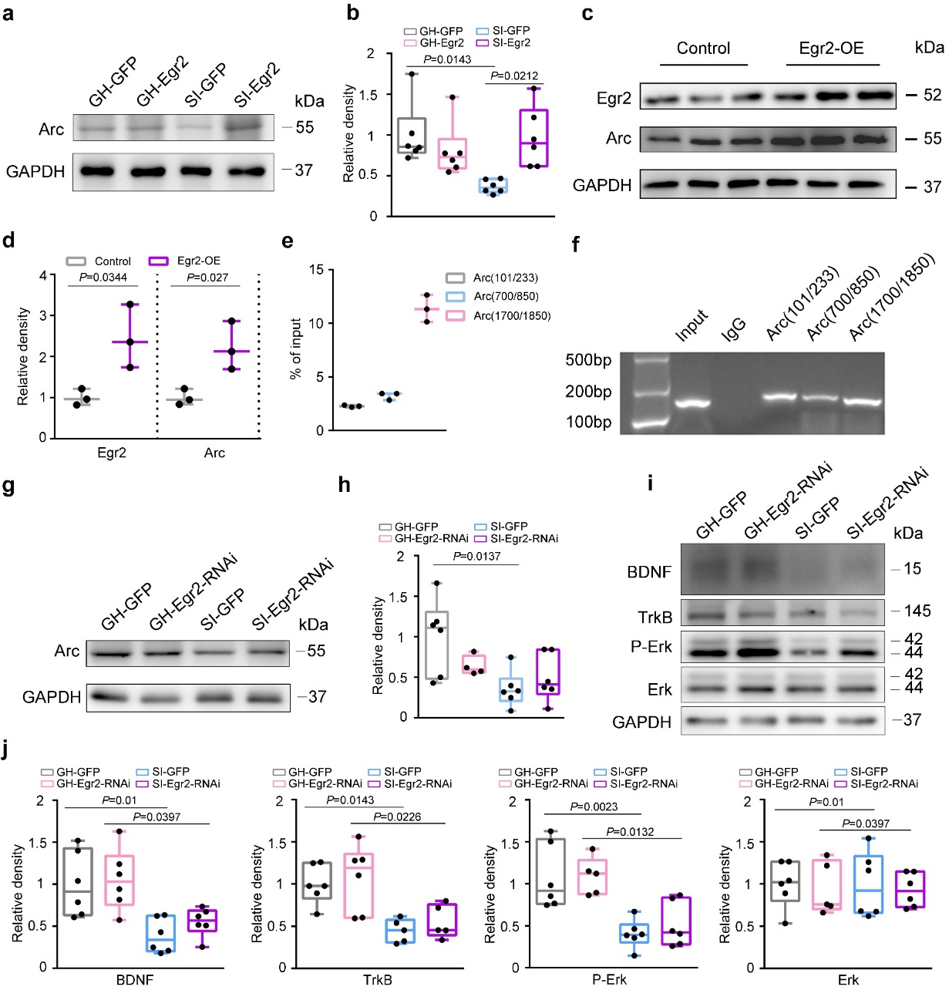
Extended Data Fig. 10 | EGR2 promoted Arc expression in neurons.
a, b, Representative western blot images (a) and the corresponding quantified graph (b) showing Arc expression in GH-GFP, GH-Egr2, SI-GFP and SI-Egr2 mice. c, Representative western blot images showing altered Arc expression in Egr2-overexpressing Neuro-2a cells; d, shows the quantified graph analysis; protein levels are normalized to GAPDH. e, shows binding ability of Egr2 with different Arc promoter regions as measured by qPCR with primers targeting specific regions on DNA fragments pulled down by an Egr2 Chromatin IP antibody; f, shows a representative ChIP agarose gel electrophoresis image. g, h, Representative western blot images (g) and the corresponding quantified graph (h) showing Arc expression in GH-GFP, GH-Egr2-RNAi, SI-GFP and SI-Egr2-RNAi mice. i, j, Representative western blot images (i) and the corresponding quantified graph (j) showing BDNF, TrkB, and Erk expression in GH-GFP, GH-Egr2-RNAi, SI-GFP and SI-Egr2-RNAi mice. Note of the modest elevated expression of BDNF, TrkB and Erk in SI-Egr2-RNAi mice. Protein levels are normalized to GAPDH. Data in a-b, g-j are from 2 months old male C57BL/6 mice; n = 3 per group for d, e; n = 5-6 per group for b, h and j. data are analyzed by two-tailed Student’s t-tests (in d) or Two-way ANOVA (in b, h and j) and presented as mean ± SEM. GH-GFP: GH mice with AAV-GFP virus injection, GH-Egr2: GH mice with AAV-Egr2 virus injection, SI-GFP: SI mice with AAV-GFP virus injection, SI-Egr2: SI mice with AAV-Egr2 virus injection.

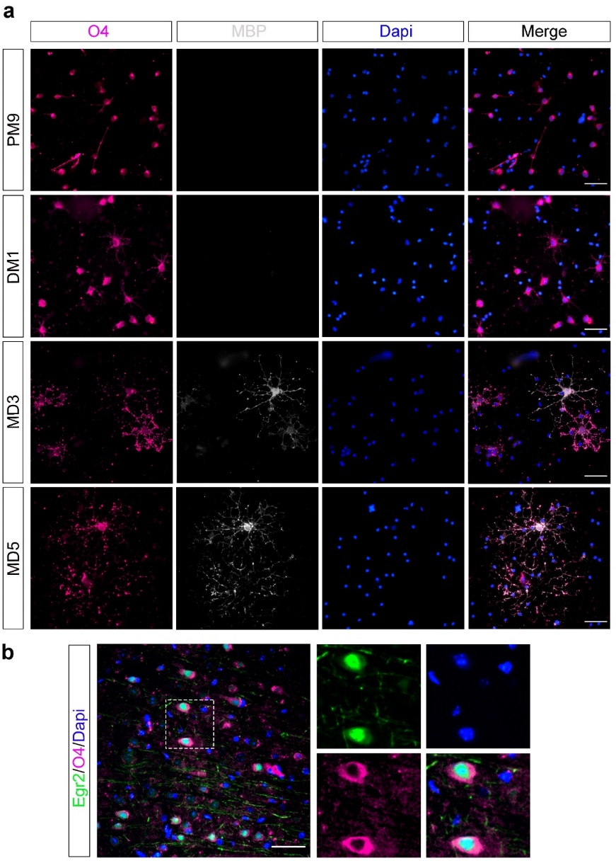
Extended Data Fig. 11 | Egr2 was expressed in early- and late-stage oligodendrocytes.
a, Representative immunofluorescence images showing the expression of O4 and MBP in differentiating oligodendrocytes. OPC: oligodendrocyte progenitor cell; PM9: the ninth day of OPC in proliferation medium; DM1: the first day of oligodendrocyte in differentiation medium. b, Representative immunofluorescence images showing the expression of Egr2 in O4 positive oligodendrocyte.

Supplementary Tables and Videos
Supplementary Table 1 and Videos 1-3 are in separate files.

