Supplementary Materials
Historical redlining, the present-day alcohol environment, and binge drinking in early midlife

Included materials
Table S1. Binge drinking intensity under sex-specific thresholds
Table S2. Risk difference, prevalence ratio, E-value, and sex interaction
Table S3. Complete-case versus multiple-imputation comparison
Table S4. Combined structural mediation through physical and social availability
Table S5. Psychosocial variables as candidate mediators of the redlining and binge drinking association
Table S6. Race/ethnicity-stratified regression and interaction test
Table S7. Race/ethnicity-stratified mediation
Figure S1. Nested regression models for cumulative redlining exposure and binge drinking
Figure S2. Dose-response by number of waves in a HOLC grade C or D tract
Table S8. Dose-response and worst-grade sensitivity analyses
Table S9. Restricted residential-history comparison
Supplementary results. Additional sensitivity analyses
Supplementary note. County-level excessive drinking prevalence (exploratory mediator)
Table S10. Alternative exposure separating grade C from grade D

Table S1. Survey-weighted logistic regression for binge drinking intensity (sex-specific threshold), National Longitudinal Study of Adolescent to Adult Health, United States, 1994 to 2018 (n = 7,723)
 | Model 0 | Model 1 | Model 5
Characteristic | OR | OR | OR
Historical redlining exposure
Never redlined | 1.00 (referent) | 1.00 (referent) | 1.00 (referent)
Ever redlined | 0.83 (0.69, 0.99) | 0.89 (0.75, 1.07) | 0.89 (0.74, 1.07)
Sex
Female |  | 1.00 (referent) | 1.00 (referent)
Male |  | 1.44 (1.21, 1.72) | 1.46 (1.23, 1.74)
Race/Ethnicity
Non-Hispanic White |  | 1.00 (referent) | 1.00 (referent)
Hispanic |  | 1.12 (0.87, 1.46) | 1.07 (0.80, 1.42)
Non-Hispanic Asian |  | 0.68 (0.45, 1.04) | 0.68 (0.44, 1.04)
Non-Hispanic Black |  | 0.72 (0.57, 0.91) | 0.64 (0.48, 0.86)
Non-Hispanic Native American |  | 1.77 (0.73, 4.27) | 1.65 (0.67, 4.08)
Education
Less than high school |  | 1.00 (referent) | 1.00 (referent)
High school graduate |  | 0.57 (0.40, 0.80) | 0.58 (0.41, 0.82)
Some college |  | 0.42 (0.31, 0.55) | 0.44 (0.33, 0.58)
College graduate |  | 0.27 (0.19, 0.38) | 0.29 (0.21, 0.42)
Graduate degree or higher |  | 0.20 (0.13, 0.29) | 0.21 (0.14, 0.32)
Age (years) |  | 0.97 (0.93, 1.02) | 0.98 (0.93, 1.02)
Gentrification status
No rise in housing |  |  | 1.00 (referent)
Intense |  |  | 1.06 (0.74, 1.52)
Moderate |  |  | 1.05 (0.69, 1.60)
No educ rise |  |  | 1.16 (0.83, 1.61)
Not eligible |  |  | 1.02 (0.72, 1.44)
Neighborhood concentrated disadvantage |  |  | 2.66 (0.54, 13.2)
Alcohol outlet density (z-score) |  |  | 0.96 (0.84, 1.10)
State alcohol policy stringency (z-score) |  |  | 1.00 (0.87, 1.15)
Cells are odds ratios with 95% confidence intervals.

Table S2. Additional sensitivity and modeling specifications, National Longitudinal Study of Adolescent to Adult Health, United States, 1994 to 2018 (n = 7,758)
Specification | Estimate (95% CI)
Absolute risk difference (Model 5) | 3.8 pp (0.1, 7.5)
Poisson prevalence ratio (robust SE) | 1.075 (1.002, 1.152)
E-value for the point estimate | 1.36
E-value for the lower confidence limit | 1.04
Sex by redlining interaction | P = 0.90
Each specification uses the full analytic sample and the Model 5 covariate set. E-values computed after converting the odds ratio to a risk-ratio scale (Zhang-Yu); the sex interaction is a design-adjusted likelihood-ratio test.
Abbreviations: CI, confidence interval; OR, odds ratio; pp, percentage points; SE, standard error.

Table S3. Complete-case (CC) versus multiple-imputation (MI) comparison, National Longitudinal Study of Adolescent to Adult Health, United States, 1994 to 2018
Model | CC (n = 7,758) | MI (n = 9,149)
M1 | 1.198 (1.02, 1.40) | 1.188 (1.02, 1.39)
M2 | 1.197 (1.02, 1.40) | 1.187 (1.01, 1.39)
M3 | 1.204 (1.03, 1.41) | 1.190 (1.02, 1.39)
M4 | 1.192 (1.02, 1.40) | 1.177 (1.01, 1.37)
M5 | 1.173 (1.00, 1.37) | 1.155 (0.99, 1.35)
Cells are odds ratios for ever-redlined with 95% confidence intervals.
MI pooled across 20 imputations by Rubin's rules (mitools::MIcombine).

Table S4. Combined structural mediation through physical and social availability, National Longitudinal Study of Adolescent to Adult Health, United States, 1994 to 2018 (n = 7,272)
Pathway | Logit / ACME (95% CI) | % Mediated
Total effect (no mediators) | 0.2091 (0.0446, 0.3736)
Direct effect (both controlled) | 0.1603 (-0.0045, 0.3251)
Physical availability (AOD) | 0.0065 (0.0019, 0.0131) | ~14%
Social availability (CDRINK) | 0.0091 (0.0022, 0.0177) | ~18%
Combined indirect (difference) | 0.0488 | ~23%
Total and direct effects are logit coefficients for ever-redlined.
AOD and CDRINK tested as parallel mediators; combined indirect via the difference method.
Quasi-Bayesian CIs from 1,000 simulations. Abbreviations: ACME, average causal mediation effect.

Table S5. Psychosocial variables as candidate mediators of the redlining and binge drinking association, National Longitudinal Study of Adolescent to Adult Health, United States, 1994 to 2018 (n = 7,758)
Variable | Redlining to variable, coefficient (95% CI) | Variable to binge drinking, OR (95% CI)
Perceived Stress (PSS-4) | -0.1383 (-0.3761, 0.0996) | 1.034 (1.013, 1.055)
Everyday Discrimination (EDS) | -0.0754 (-0.2820, 0.1312) | 1.035 (1.011, 1.061)
Depressive Symptoms (CES-D) | -0.0044 (-0.2352, 0.2265) | 1.069 (1.038, 1.100)
Childhood SES | 0.0368 (-0.0479, 0.1216) | 1.040 (0.963, 1.122)
Unfair Police Contact | 0.0214 (-0.0156, 0.0585) | 1.294 (1.090, 1.535)
Religious Attendance | -0.0826 (-0.2219, 0.0567) | 0.857 (0.820, 0.897)
Abbreviations: CES-D, Center for Epidemiologic Studies Depression scale; CI, confidence interval; EDS, Everyday Discrimination Scale; OR, odds ratio; PSS-4, four-item Perceived Stress Scale; SES, socioeconomic status.
The coefficient column is from survey-weighted regression of each variable on redlining, adjusted for sex, race/ethnicity, education, and age; the OR column is from survey-weighted logistic regression of binge drinking on each variable, adjusted for redlining and the same covariates.
No redlining-to-variable association reached significance, so the psychosocial variables cannot mediate the redlining and binge drinking association.

Table S6. Race/ethnicity-stratified survey-weighted logistic regression of binge drinking on cumulative HOLC redlining exposure, National Longitudinal Study of Adolescent to Adult Health, United States, 1994 to 2018
Race/Ethnicity | N | Redlining OR (95% CI)
Non-Hispanic White | 4,664 | 1.23 (1.00, 1.50)
Non-Hispanic Black | 1,454 | 1.11 (0.75, 1.63)
Hispanic | 1,100 | 0.88 (0.51, 1.51)
Non-Hispanic Asian | 488 | 0.81 (0.36, 1.78)
Each model adjusts for the Model 5 covariate set, fit within strata via subset() on the survey design.
Design-adjusted likelihood-ratio test for the redlining x race interaction, P = 0.049.

Table S7. Race/ethnicity-stratified mediation analysis of the AOD and CDRINK pathways, National Longitudinal Study of Adolescent to Adult Health, United States, 1994 to 2018
Subgroup | Mediator | N | ACME | ACME p | ADE | % Mediated
Non-Hispanic White | AOD | 4,664 | 0.0090 (0.0022, 0.0179) | 0.004 | 0.0485 (0.0001, 0.0968) | 15.4%
Non-Hispanic White | CDRINK | 4,397 | 0.0099 (0.0020, 0.0205) | 0.006 | 0.0528 (0.0007, 0.1024) | 15.9%
Non-Hispanic Black | AOD | 1,454 | -0.0006 (-0.0078, 0.0048) | 0.816 | 0.0218 (-0.0659, 0.1094) | -0.1%
Non-Hispanic Black | CDRINK | 1,341 | 0.0002 (-0.0064, 0.0081) | 0.988 | 0.0220 (-0.0712, 0.1114) | 0.1%
Hispanic | AOD | 1,100 | -0.0023 (-0.0137, 0.0050) | 0.626 | -0.0265 (-0.1365, 0.0930) | 0.7%
Hispanic | CDRINK | 1,035 | -0.0014 (-0.0312, 0.0290) | 0.898 | 0.0020 (-0.1234, 0.1279) | 4.8%
Quasi-Bayesian confidence intervals from 1,000 simulations (seed 7349).
Models adjusted for sex, education, age, gentrification, NCD, and SAPS.
Abbreviations: ACME, average causal mediation effect; ADE, average direct effect.

Figure S1. Cumulative residence in a HOLC grade C or D tract and past-year binge drinking across nested adjustments, National Longitudinal Study of Adolescent to Adult Health, United States, 1994 to 2018 (n = 7,758).
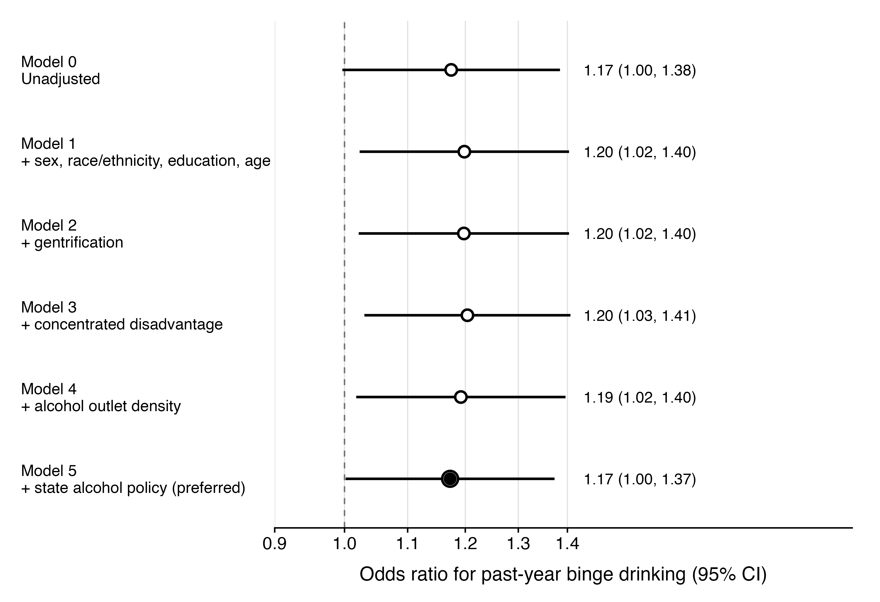
Note. Odds ratios with 95% confidence intervals from survey-weighted logistic regression, plotted on a logarithmic scale; each model adds the listed covariates to the previous one. Model 0 is unadjusted; Model 1 adds sex, race and ethnicity, educational attainment, and age; Model 2 adds gentrification; Model 3 adds neighborhood concentrated disadvantage; Model 4 adds alcohol outlet density; Model 5 adds state alcohol policy stringency. The dashed line marks the null (OR = 1.0), and Model 5 (filled point) is the a priori preferred estimate. The estimate strengthens slightly after demographic adjustment, consistent with negative confounding by race and ethnicity. Estimates correspond to Table 2 in the main text. CI, confidence interval; HOLC, Home Owners’ Loan Corporation; OR, odds ratio.
Alt text: Forest plot of six odds ratios with 95% confidence interval bars on a logarithmic axis, one for each nested model from Model 0 to Model 5. All points lie between 1.17 and 1.20, above the null line at 1.0, and Model 5 appears as a filled point at 1.17.

Figure S2. Dose-response association between number of Add Health waves reporting residence in a HOLC grade C or D tract and past-year binge drinking at Wave V.
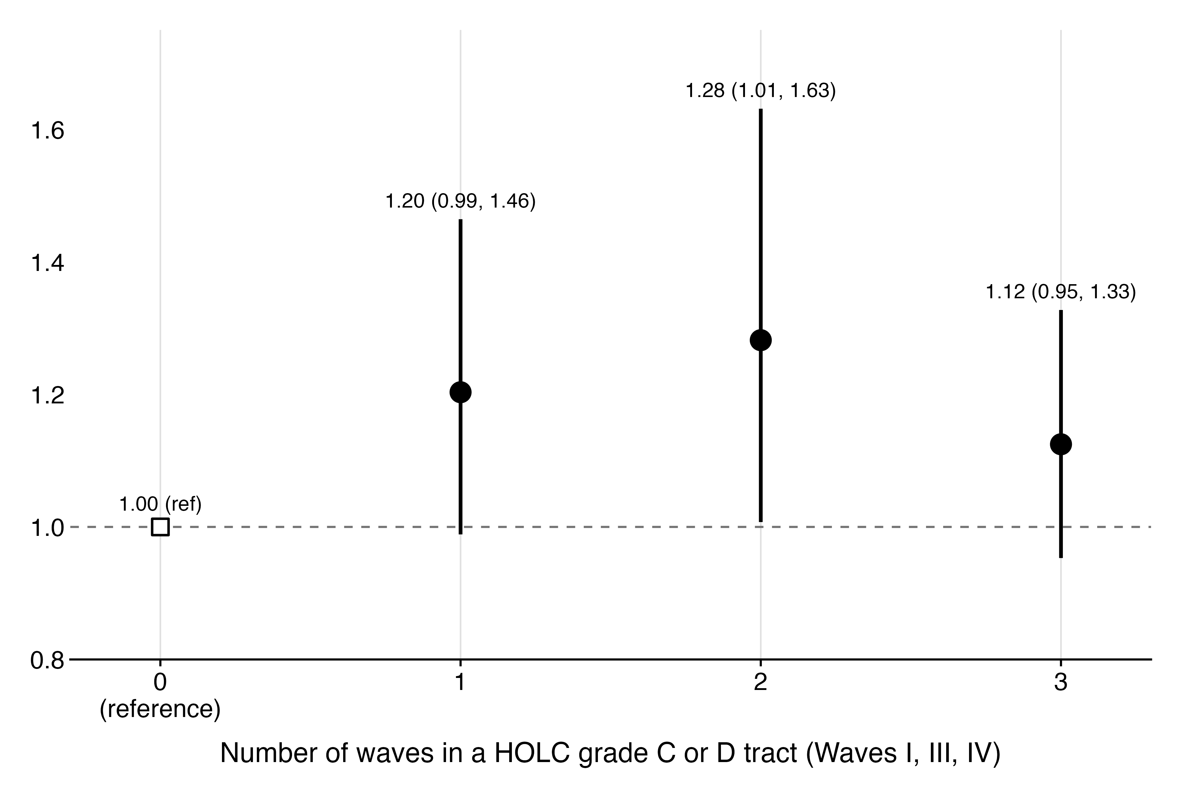
Note. Survey-weighted logistic regression of past-year binge drinking on the number of Add Health waves (Wave I, Wave III, Wave IV) at which the respondent resided in a HOLC grade C or D tract, restricted to respondents with non-missing HOLC at all three waves. Point estimates with 95% confidence intervals are shown. The association is elevated at two waves (odds ratio = 1.28; 95% CI, 1.01 to 1.63) and attenuates at three waves (non-monotonic), reflecting the racial composition of the three-wave-exposed subgroup, which is disproportionately non-Hispanic Black, a group with lower binge drinking prevalence in this cohort.
Alt text: Plot of odds ratios with 95% confidence interval bars for residence in a HOLC grade C or D tract at one, two, or three waves, relative to zero waves. The two-wave estimate is highest at 1.28 and the three-wave estimate returns toward the null.

Table S8. Sensitivity analyses for alternative redlining operationalizations, National Longitudinal Study of Adolescent to Adult Health, United States, 1994 to 2018 (n = 7,758)
Characteristic | OR (95% CI)
Dose-response (waves in C/D)
1 wave | 1.20 (0.99, 1.46)
2 waves | 1.28 (1.01, 1.63)
3 waves | 1.12 (0.95, 1.33)
Worst-ever HOLC grade
B (Desirable) | 1.03 (0.76, 1.40)
C (Declining) | 1.23 (0.94, 1.61)
D (Hazardous) | 1.16 (0.90, 1.51)
Reference: 0 waves in C/D (dose-response) and grade A (worst-grade).
Dose-response restricted to respondents with HOLC observed at all three waves; worst-grade uses the full sample.

Table S9. Restricted comparison of HOLC A/B-only versus C/D-only residential histories, National Longitudinal Study of Adolescent to Adult Health, United States, 1994 to 2018 (n = 5,126)
Specification | Value
HOLC A or B at all waves (n) | 1,469
HOLC C or D at all waves (n) | 3,657
OR for C/D vs A/B (Model 5) | 1.12 (0.95, 1.33)
Excludes respondents with mixed A/B and C/D histories or any missing HOLC grade. Covariates as in Model 5.
Supplementary results. Additional sensitivity analyses
The dose-response model showed elevated odds of past-year binge drinking at two waves of cumulative exposure (OR = 1.28; 95% CI, 1.01 to 1.63) and a non-monotonic pattern at three waves (Figure S2, Table S8) that reflects the racial composition of the most-exposed group. Binge drinking intensity defined by sex-specific NIAAA thresholds showed no association with redlining (OR = 0.89; Table S1). Mediation sensitivity analysis indicated that the residual correlation between mediator and outcome residuals would need to reach rho = 0.75 for the alcohol-outlet-density indirect effect to be nullified. Adjusting for adolescent drinking at Wave I (n = 4,424) changed the redlining OR by less than 2%, indicating that early drinking does not substantially confound the association. In a restricted comparison excluding respondents with mixed A and B versus C and D residential histories (n = 5,126), the association was attenuated (OR = 1.12; 95% CI, 0.95 to 1.33), consistent with some compositional contribution to the primary estimate (Table S9).

Supplementary note. County-level excessive drinking prevalence (exploratory mediator)
County-level excessive drinking prevalence (CDRINK) was a continuous measure of the proportion of adults reporting excessive drinking in the respondent's residential county at Wave V, drawn from CDC PLACES estimates and standardized. The measure is retained in the supplementary materials rather than the main text for two reasons. It is assessed at the county scale, which is broader than the tract scale at which the exposure, alcohol outlet density, and neighborhood covariates are measured, and it is assessed concurrently with the Wave V outcome, so temporal ordering between mediator and outcome is not satisfied. No tract-level measure of drinking norms is available in the Add Health contextual database; community drinking norms are conceptualized as operating over a broader geography than retail availability, but the county scale remains a coarse proxy. Treated as an exploratory single mediator, CDRINK yielded an average causal mediation effect of 0.0091 (95% CI, 0.0022 to 0.0177; approximately 18% of the total effect mediated). In race-stratified models, the CDRINK pathway was statistically significant only among non-Hispanic White respondents (average causal mediation effect = 0.010; 95% CI, 0.002 to 0.021; approximately 15.9% mediated; Table S7). Mediation sensitivity analysis indicated that the indirect effect would be nullified at rho = 0.80. Combined difference-method mediation through alcohol outlet density and CDRINK jointly was approximately 23% (Table S4). These estimates should be interpreted as descriptive of the social alcohol environment rather than causal mediation.

Table S10. Alternative exposure definitions separating HOLC grade C from grade D, fully adjusted models, National Longitudinal Study of Adolescent to Adult Health, United States, 1994 to 2018 (n = 7,758)
Exposure | Weighted prevalence, % | OR (95% CI) | P value
Ever grade C or D (primary) | 79.5 | 1.17 (1.00, 1.37) | 0.048
Ever grade D | 42.5 | 1.01 (0.88, 1.16) | 0.873
Grade C worst (vs never C or D) | 37.0 | 1.21 (1.00, 1.45) | 0.044
Ever grade D (vs never C or D) | 42.5 | 1.14 (0.97, 1.35) | 0.119
Each OR is from a survey-weighted logistic regression with the Model 5 covariate set.
Rows 1-2 use binary exposures with all other respondents as referent; rows 3-4 are from a single three-level model (never C or D as referent).

