Unique nanoparticle via regulated assembly pattern in Zein, acetylated oligosaccharide and tannic acid tertiary system and controlled release function
Sheng Ke^{1,2}, Xinyu Guo², Jing Wang², Bing Wang³, Chris Blanchard³, Padraig Strappe⁴, Zhongkai Zhou^{1,2,3}*, Guohua Zhao⁵*

¹College of Food Science, Southwest University, Chongqing 400715, China
²College of Food Science and Engineering, Tianjin University of Science and Technology, Tianjin 300457, China
³Gulbali Institute Agriculture Water Environment, Charles Sturt University, Wagga Wagga, NSW 2678, Australia
⁴Curtin Health Innovation Research Institute (CHIRI), Curtin Medical School, Curtin University, Bentley, WA 6102, Australia
⁵College of Life Science, Sichuan Normal University, Chengdu 610101, China
Contact information for Corresponding authors
Prof. Zhongkai Zhou (PhD), FRSC
E-mail: zzhou@csu.edu.au
Prof. Guohua Zhao (PhD)
E-mail: zhaogh@swu.edu.cn

Fig. S1. The influence of different concentrations (0-10 μM) of ligands (AMOS, TA, Cur) on the fluorescence intensity of Zein at pH12.0.

Fig. S2. The 1D (¹H, ¹³C) (A, B) and 2D (COSY, HSQC, HMBC) (C, D, E) NMR of Z/A-NPs, Z/T-NPs, Cur@Z/A-NPs, Cur@Z/T-NPs.

Fig. S3. The XRD spectra of AMOS, TA, Cur.

Fig. S4. The secondary structure diagram (A) and 3D diagram (B) of AMOS in molecular docking.

Fig. S5. The PDI of nanoparticles in different environments (NaCl, pH, 4 ℃).

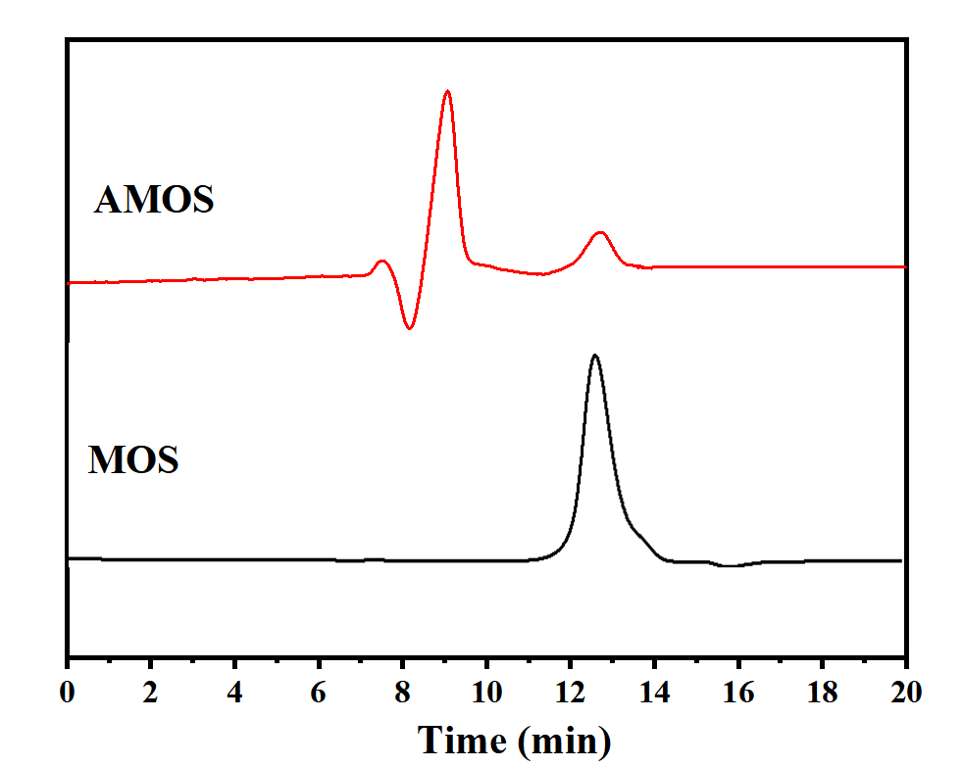
Fig. S6. Molecular weight (M_{W}) of MOS and AMOS.

Fig. S7. The solubility in water and ethanol of MOS and AMOS.

Fig. S8. The FTIR spectra of MOS, AMOS, TA, Zein.

Fig. S9. SEM images of MOS and AMOS.

Table S1 Molecular weight (M_{W}) of MOS samples.
Samples | Peak1 |  |  | Peak2
Samples | Time (min) | Mw (kDa) | Area (%) | Time (min) | Mw (kDa) | Area (%)
MOS |  |  |  | 12.656 | 4.629 | 100
AMOS | 8.752 | 82.362 | 82.971 | 12.659 | 4.618 | 17.029

