SUPPLEMENTARY MATERIAL

Flow behaviour in free surface constructed wetlands with different vegetation distribution patterns

Nurul Neesa Idris^{a,b*}, Lloyd HC Chua^{b}, Zahiraniza Mustaffa^{c}, Subrat Das^{b} and Husna Takaijudinª
ªDepartment of Civil and Environmental Engineering, Universiti Teknologi PETRONAS, 32610 Seri Iskandar, Perak, Malaysia
^{b}School of Engineering, Faculty of Science, Engineering and Built Environment, Deakin University, 75 Pigdons Road, Waurn Ponds, VIC 3216, Australia
^{c}Integrated Engineering Department, Universiti Teknologi PETRONAS, 32610 Seri Iskandar, Perak, Malaysia

*Corresponding author. Email: nurulneesa.idris@research.deakin.edu.au

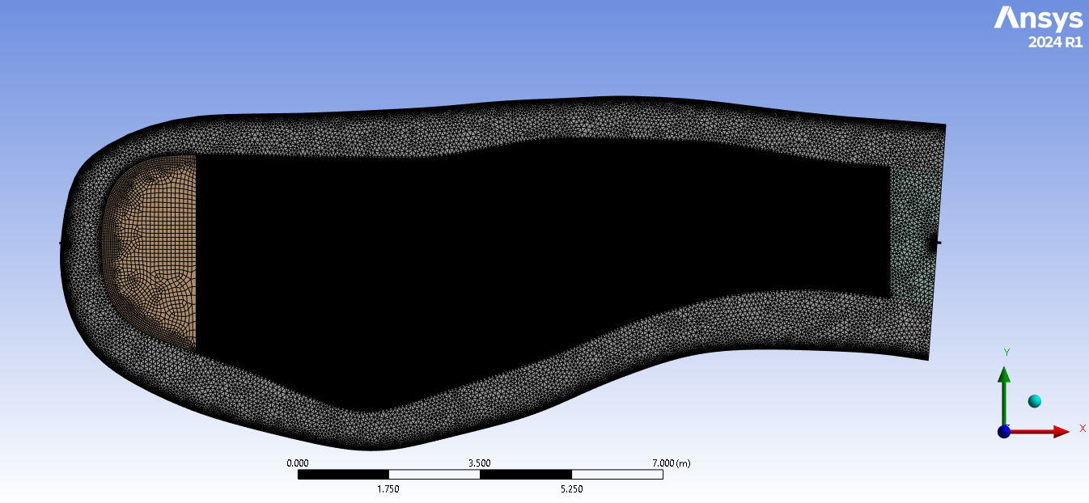
Inlet
Outlet
a.
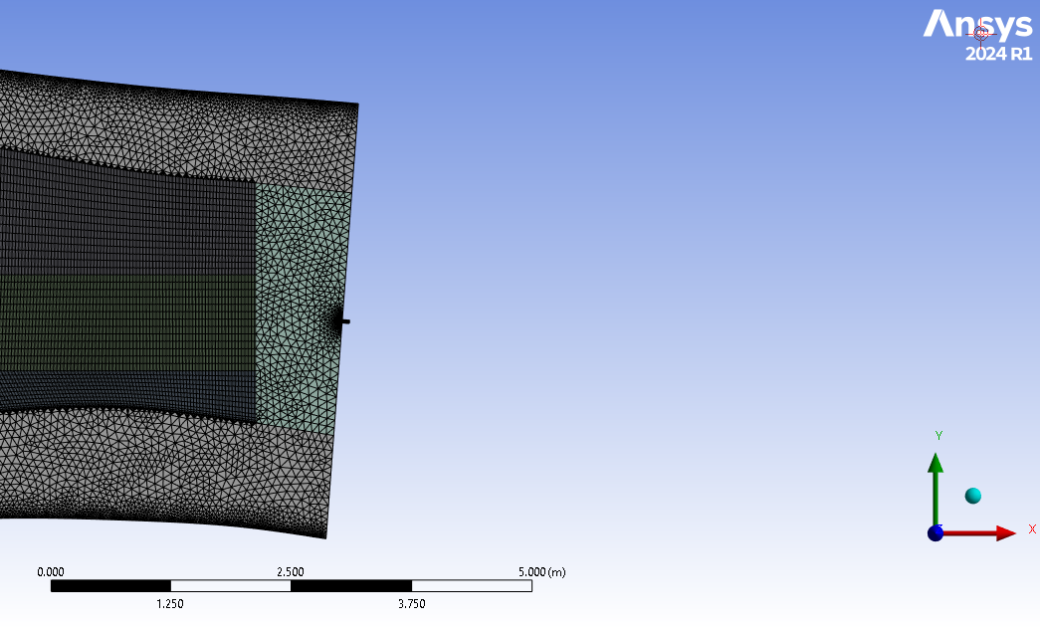
Outlet
b.
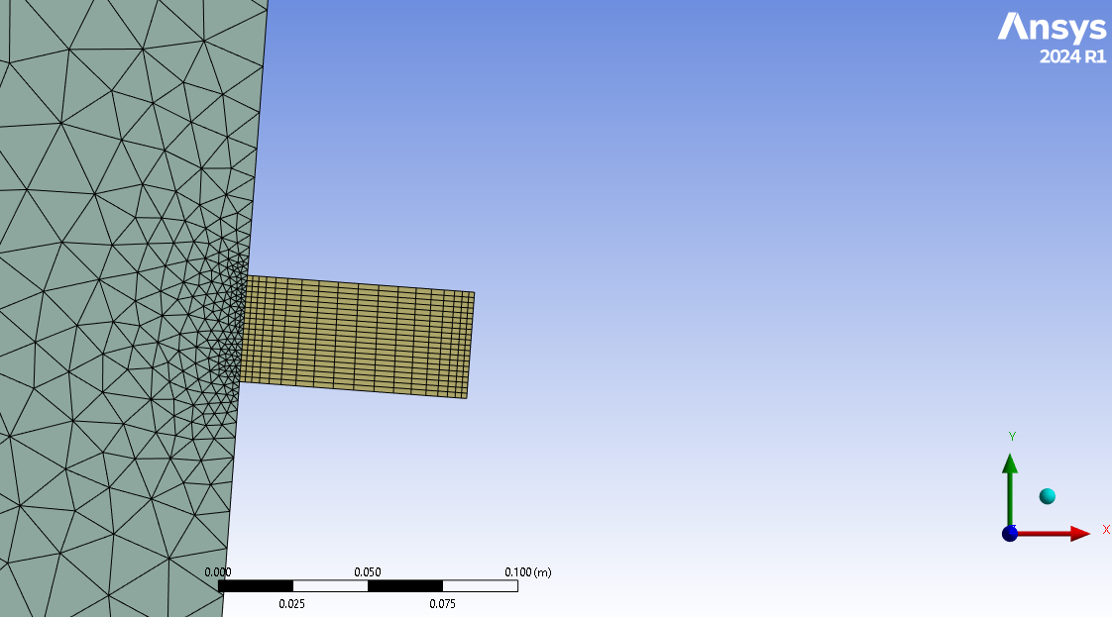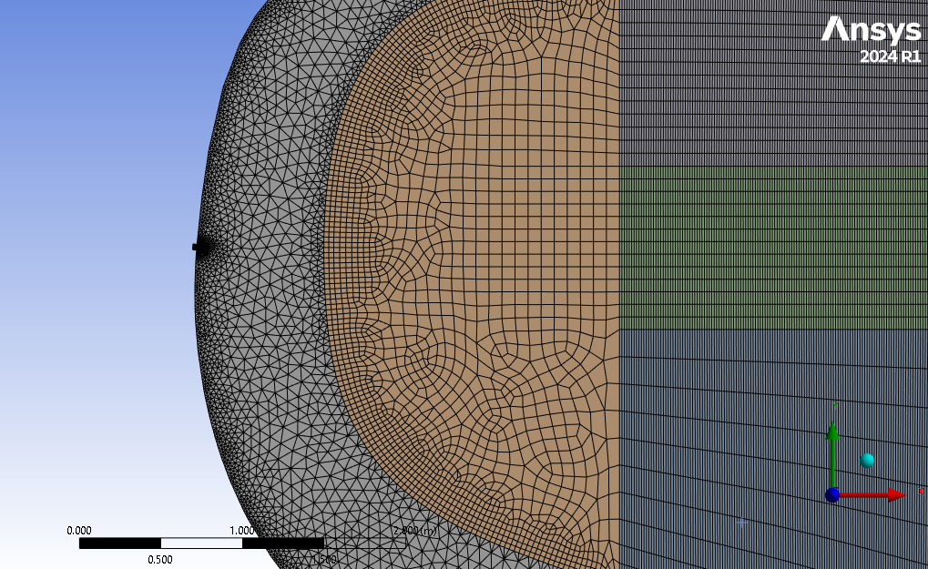
d.
c.
Figure S1: Finalized meshing (a) View of meshing in all bodies of model (b) View of meshing at the bodies near to the outlet (c) View of meshing at the outlet body (d) View of meshing near to the inlet body
Wetland length, L | 18000 mm
Wetland height, H | 300 mm
Wetland width, W | 6000 mm
Inlet diameter, D_{i} | 25 mm
Outlet diameter, D_{o} | 100 mm
Inlet
Width of vegetation coverage, w
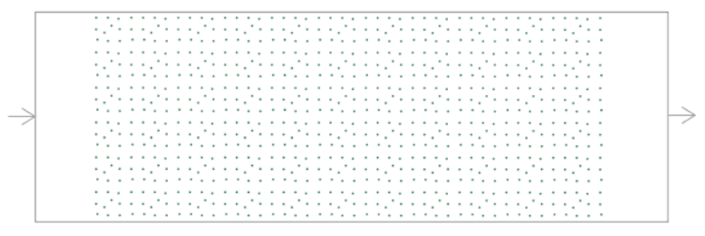
Outlet
Figure S2: Illustration of generic model showing length (l) and width (w) with 36 plants per square meter for Case FU1 (Full vegetation distribution) (Not to scale)

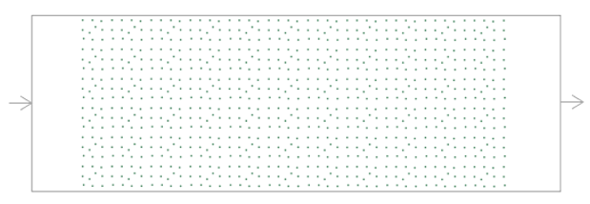 | 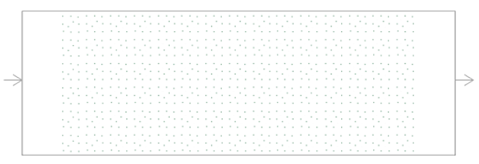
(a) | (b)
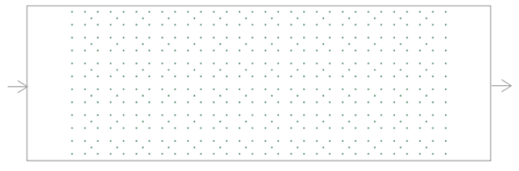
(c)

Figure S3: Illustration of different plant density for generic models in full vegetation distribution (a) FU1, (b) FU2 and (c) FU3

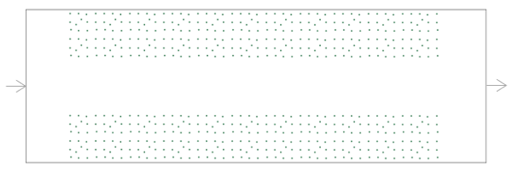 | 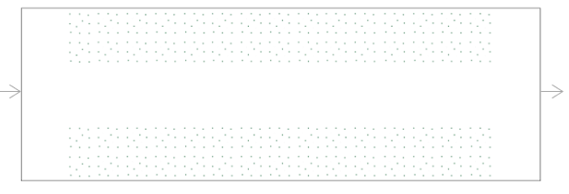
(a) | (b)
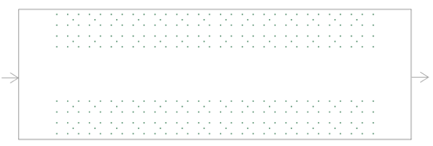
(c)
Figure S4:Illustration of different plant density for generic models in 1.5 m width fringing vegetation distribution (a) FRI, (b) FR2 and (c) FR3

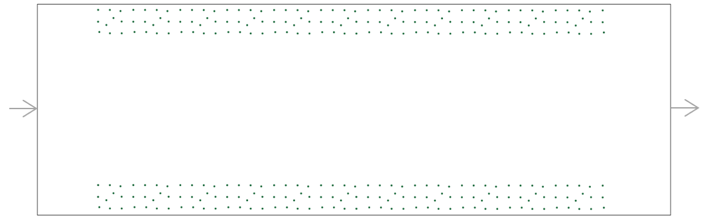  (a) | 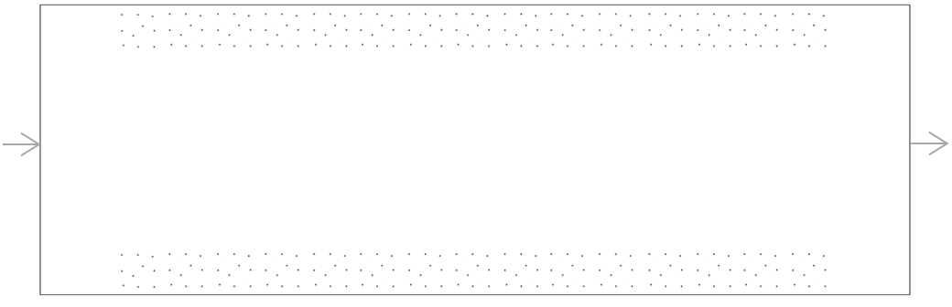  (b)
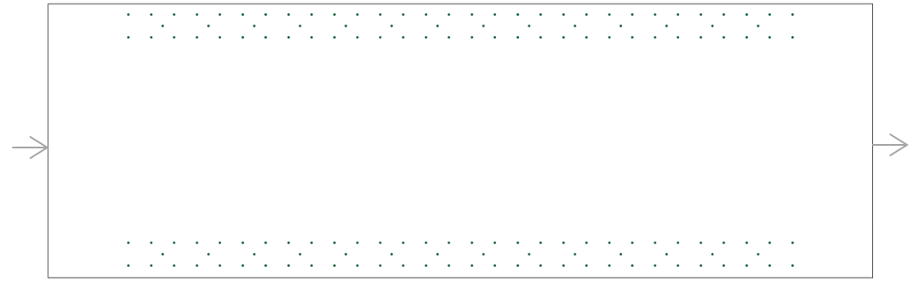
(c)

Figure S5: Illustration of different plant density for generic model in 0.75 m width fringing vegetation distribution (a) FR4, (b) FR5 and (c) FR6
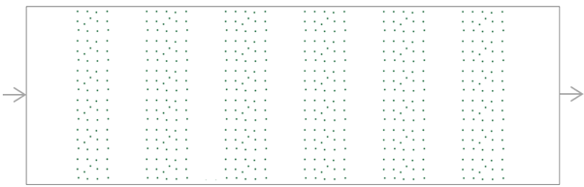 | 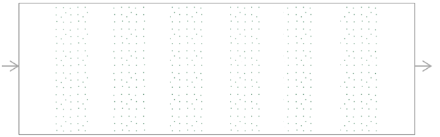
(a) | (b)
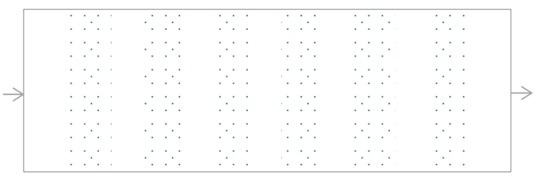
(c)
Figure S6: Illustration of different plant density for generic model in 6 banded vegetation distribution (a) BA1, (b) BA2 and (c) BA3

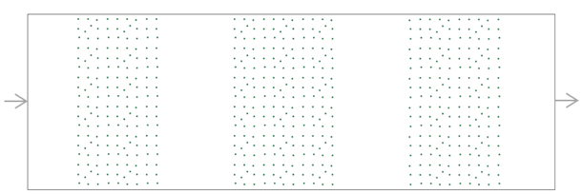 | 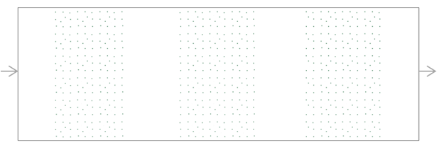
(a) | (b)
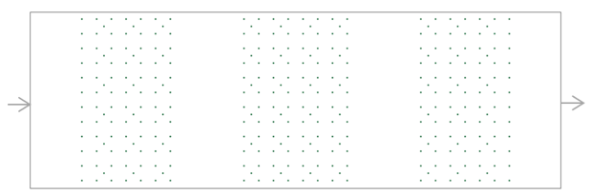
(c)
Figure S7: Illustration of different plant density for generic model in 3 banded vegetation distribution (a) BA4, (b) BA5 and (c) BA6

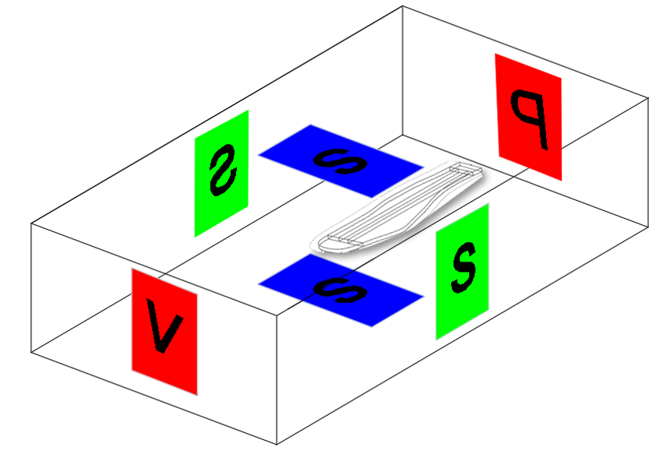
Figure S8: Illustration of the computational domain showing inlet velocity (V), outlet pressure (P), and stationary (S) wall boundary conditions used

Table S1: Hydraulic performance of simulated NIS constructed wetland model
Case ID | Vegetation distributions | t_{n}  (h) | t_{p}  (h) | t₁₀  (h) | S | $$λ$$ | e | $τ$ | $$σ^{2}$$
E1 | No vegetation | 24 | 5.2 | 8.0 | 0.33 | 0.22 | 0.50 | 12.01 | 16.10
E3 | Full vegetation | 24 | 14.2 | 11.8 | 0.49 | 0.59 | 0.61 | 14.74 | 21.17
E5 | Fringing vegetation | 24 | 8.1 | 5.2 | 0.22 | 0.34 | 0.48 | 11.51 | 12.43
Nominal residence time, t_{n} (h); Peak time, t_{p} (h); Time at 10% tracer response peak, t₁₀ (h); Short-circuit, S (t₁₀ / t_{n}); Hydraulic efficiency, $λ ($t_{p} / t_{n}); Effective volume ratio, e ($τ/t_{n})$; mean HRT, $τ \left(Eq.2-2\right) ;variance, σ^{2}$(Eq. 2-6)

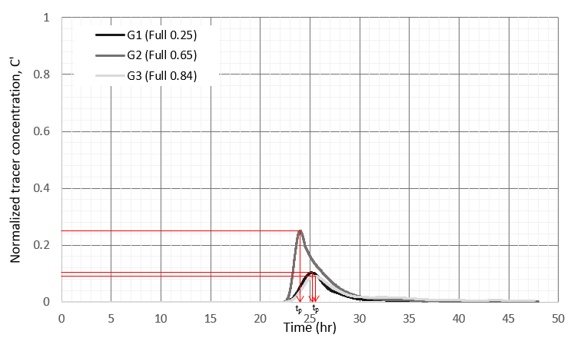
FU1

FU2

FU3
Normalized tracer concentration, C’

Time (hr)
- Case FU1, FU2 and FU3
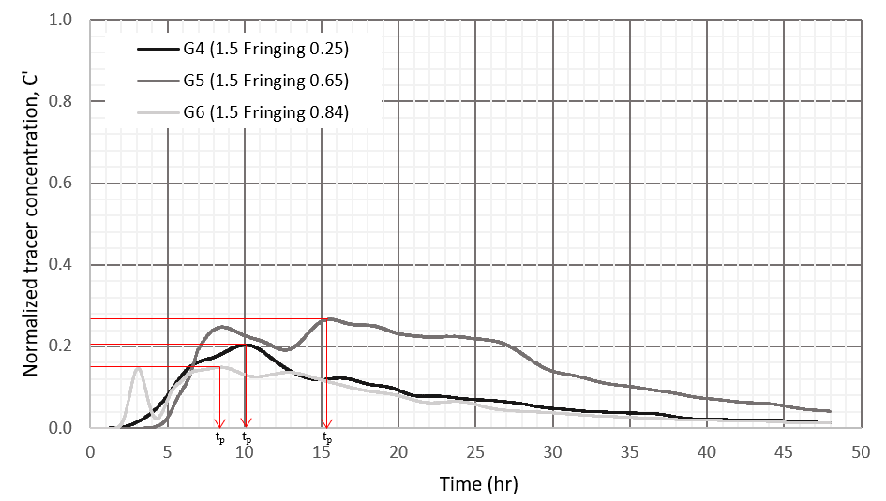
FR1

FR2

FR3
Normalized tracer concentration, C’

Time (hr)

- Case FR1, FR2 and FR3, 1.5 m width fringing

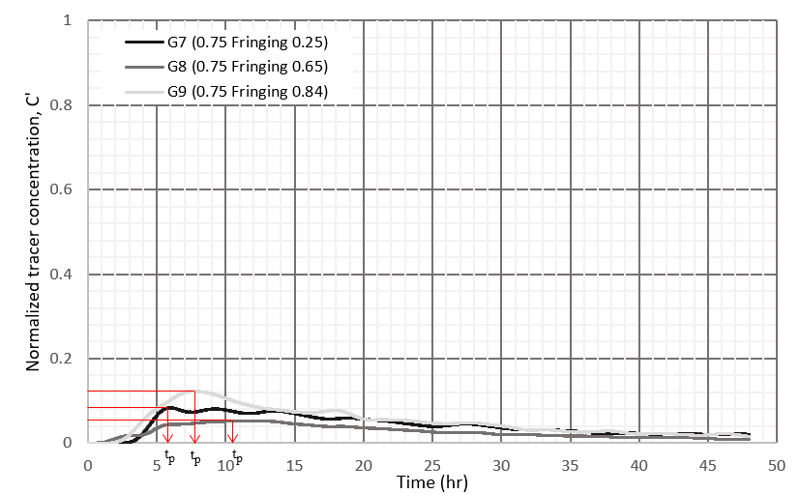
FR4

FR5

FR6
Normalized tracer concentration, C’

Time (hr)

- Case FR4, FR5 and FR6, 0.75 m width fringing

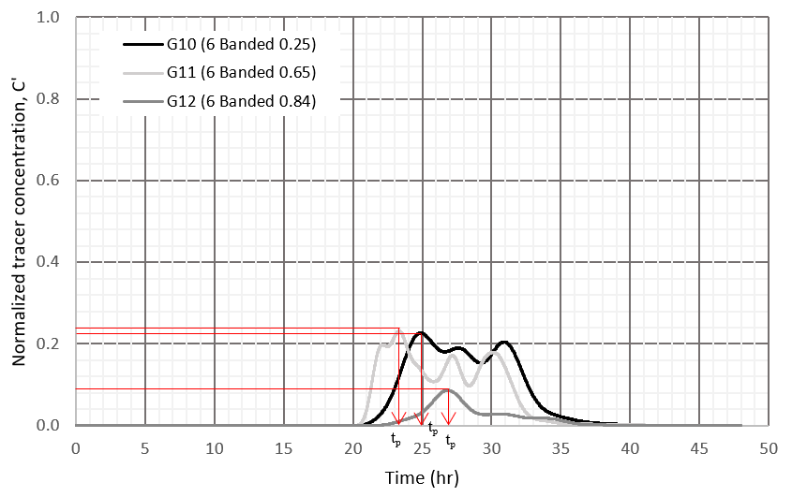
BA1

BA2

BA3
Normalized tracer concentration, C’

Time (hr)

- Cases BA1, BA2 and BA3, 6 banded vegetation
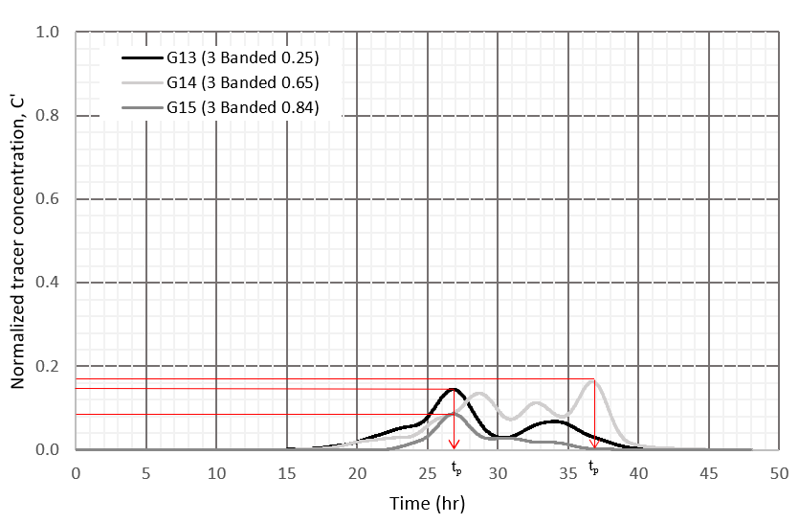
BA4

BA5

BA6
Normalized tracer concentration, C’

Time (hr)

(e) Cases BA4, BA5 and BA6, 3 banded vegetation
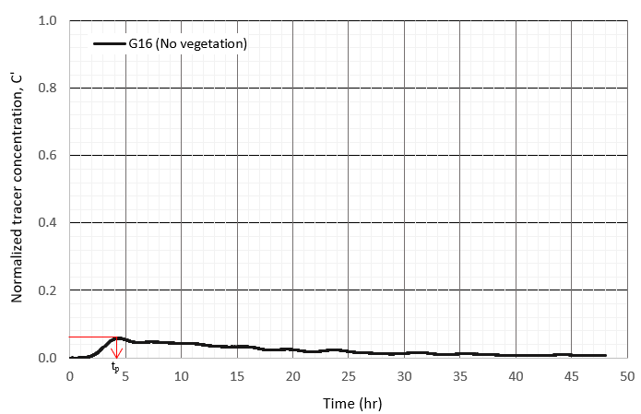
NV
Normalized tracer concentration, C’

- No vegetation case
Figure S9: Normalized tracer concentration over time for (a) full vegetation, (b,c) fringing, (d, e) banded and (e) no vegetation
Table S2: Tracer mass recovery rate of generic (rectangle) constructed wetland model
Case ID | Case Name | Porosity | Tracer mass recovery rate (%) | Weight (kg)
FU1 | Full 0.25 | 0.25 | 60.7 | 33.4
FU2 | Full 0.65 | 0.65 | 66.6 | 36.6
FU3 | Full 0.84 | 0.84 | 58.4 | 32.1
FR1 | 1.5 Fringing 0.25 | 0.25 | 51.8 | 28.5
FR2 | 1.5 Fringing 0.65 | 0.65 | 55.9 | 30.7
FR3 | 1.5 Fringing 0.84 | 0.84 | 50.9 | 28.0
FR4 | 0.75 Fringing 0.25 | 0.25 | 45.2 | 24.9
FR5 | 0.75 Fringing 0.65 | 0.65 | 41.8 | 23.0
FR6 | 0.75 Fringing 0.84 | 0.84 | 46.6 | 25.7
BA1 | 6 Banded 0.25 | 0.25 | 63.6 | 35.0
BA2 | 6 Banded 0.65 | 0.65 | 58.4 | 32.1
BA3 | 6 Banded 0.84 | 0.84 | 61.9 | 34.1
BA4 | 3 Banded 0.25 | 0.25 | 55.4 | 30.5
BA5 | 3 Banded 0.65 | 0.65 | 60.4 | 33.2
BA6 | 3 Banded 0.84 | 0.84 | 60.9 | 33.5
NV | No vegetation | 1 | 51.1 | 28.1

Table S3: Comparison of the simulated hydraulic performance of a constructed wetland model and experimental data for validation
Indices | Assessment method | Case ID
Indices | Assessment method | E1(No vegetation) | E3 (Full vegetation) | E5 (Fringing vegetation)
S | Experimental | 0.24 | 0.31 | 0.13
S | Numerical | 0.33 | 0.49 | 0.22
S | Variation (%) | 37 | 58 | 69
$$λ$$ | Experimental | 0.28 | 0.44 | 0.36
$$λ$$ | Numerical | 0.22 | 0.59 | 0.34
$$λ$$ | Variation (%) | 21 | 34 | 5
e | Experimental | 0.51 | 0.51 | 0.52
e | Numerical | 0.50 | 0.61 | 0.48
e | Variation (%) | 2 | 20 | 8
$$σ^{2}$$ | Experimental | 11.74 | 11.79 | 11.60
$$σ^{2}$$ | Numerical | 16.10 | 21.17 | 12.43
$$σ^{2}$$ | Variation (%) | 37 | 80 | 7

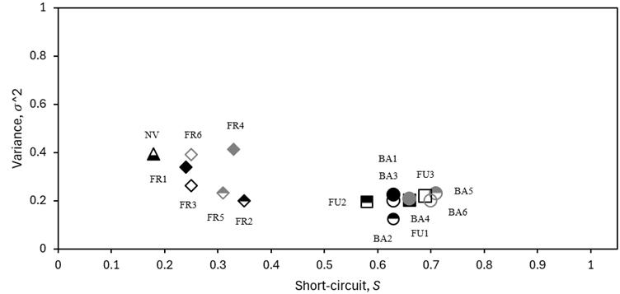

Figure S10: Comparison of variance and short-circuiting to porosity

