Appendix A: Supplementary Material

Table S1. Floristic composition and abundance of native tree species sampled in three secondary Atlantic Forest communities with different land-use histories, located at the UFJF Botanical Garden, Minas Gerais, Brazil. Abbreviations indicate the different silvicultural legacies: Second growth forest after silvicultural system with management (SGAM), Second growth forest after enriched silvicultural system (SGAE), and Second growth forest after silvicultural system (SGA).

Species | SGA | SGAE | SGAM
Abarema cochliacarpos | 0 | 2 | 0
Albizia polycephala | 0 | 7 | 0
Alchornea glandulosa | 1 | 19 | 15
Alchornea sidifolia | 0 | 0 | 1
Alchornea triplinervia | 20 | 6 | 5
Allophylus edulis | 4 | 10 | 1
Allophylus racemosus | 0 | 6 | 0
Amaioua glomerulata | 0 | 0 | 2
Amaioua guianensis | 4 | 0 | 0
Amaioua intermedia | 0 | 2 | 0
Anadenanthera colubrina | 7 | 3 | 16
Anadenanthera peregrina | 0 | 0 | 1
Andira fraxinifolia | 0 | 2 | 0
Annona glabra | 1 | 0 | 0
Annona sylvatica | 0 | 5 | 0
Aparisthmium cordatum | 0 | 5 | 0
Apuleia leiocarpa | 16 | 5 | 3
Aspidosperma australe | 0 | 3 | 0
Aspidosperma sp | 1 | 0 | 0
Aspidosperma spruceanum | 0 | 1 | 0
Astronium fraxinifolium | 2 | 0 | 0
Bougainvillea glabra | 1 | 0 | 0
Brosimum guianense | 5 | 3 | 0
Cabralea canjerana | 4 | 20 | 1
Campomanesia laurifolia | 3 | 5 | 5
Casearia aculeata | 0 | 0 | 1
Casearia arborea | 32 | 3 | 6
Casearia decandra | 4 | 1 | 1
Casearia obliqua | 2 | 0 | 0
Casearia oblongifolia | 0 | 3 | 0
Casearia sylvestris | 0 | 2 | 0
Cassia ferruginea | 0 | 1 | 0
Cecropia glaziovii | 0 | 1 | 15
Cecropia pachystachya | 0 | 0 | 6
Cedrela fissilis | 0 | 2 | 0
Ceiba speciosa | 0 | 13 | 3
Cheiloclinium serratum | 0 | 2 | 0
Chiococca alba | 0 | 0 | 1
Cordia ecalyculata | 0 | 5 | 0
Cordia glabrata | 0 | 1 | 0
Cordia sellowiana | 0 | 0 | 2
Cordia sp | 1 | 0 | 0
Coutarea hexandra | 0 | 22 | 0
Croton floribundus | 0 | 2 | 1
Cupania ludowigii | 44 | 15 | 8
Cupania oblongifolia | 11 | 16 | 19
Cupania vernalis | 0 | 7 | 0
Cybistax antisyphilitica | 10 | 1 | 8
Dalbergia frutescens | 0 | 1 | 0
Dalbergia nigra | 46 | 17 | 3
Dalbergia villosa | 5 | 2 | 0
Didymopanax morototoni | 6 | 1 | 0
Didymopanax vinosus | 4 | 0 | 0
Enterolobium contortisiliquum | 0 | 0 | 1
Erythroxylum acuminatum | 0 | 0 | 1
Erythroxylum citrifolium | 46 | 0 | 0
Erythroxylum mucronatum | 0 | 1 | 0
Erythroxylum pelleterianum | 14 | 0 | 0
Eugenia cerasiflora | 0 | 1 | 0
Eugenia florida | 7 | 4 | 2
Eugenia sp | 1 | 0 | 0
Eugenia subundulata | 13 | 0 | 0
Euterpe edulis | 4 | 689 | 35
Ficus adhatodifolia | 0 | 2 | 0
Ficus clusiifolia | 0 | 4 | 0
Ficus enormis | 0 | 2 | 1
Ficus insipida | 0 | 2 | 0
Ficus sp | 1 | 0 | 0
Geonoma schottiana | 0 | 2 | 0
Guapira hirsuta | 0 | 6 | 0
Guapira opposita | 0 | 5 | 1
Guapira sp | 1 | 0 | 0
Guarea macrophylla | 2 | 1 | 0
Guatteria guianensis | 0 | 6 | 0
Guatteria sellowiana | 4 | 0 | 0
Guatteria villosissima | 4 | 1 | 0
Guettarda viburnoides | 0 | 1 | 0
Handroanthus chrysotrichus | 5 | 1 | 0
Handroanthus heptaphyllus | 0 | 0 | 2
Himatanthus bracteatus | 1 | 0 | 0
Hortia brasiliana | 0 | 1 | 0
Hymenolobium janeirense | 16 | 0 | 0
Hyptidendron sp | 1 | 0 | 0
Inga cylindrica | 12 | 1 | 0
Inga vera | 0 | 1 | 0
Ixora brevifolia | 2 | 0 | 0
Jacaranda micrantha | 55 | 6 | 1
Jupunba brachystachya | 1 | 0 | 0
Kielmeyera lathrophyton | 1 | 0 | 0
Lacistema pubescens | 35 | 6 | 8
Lamanonia speciosa | 0 | 1 | 0
Laplacea fruticosa | 2 | 0 | 0
Lecythis pisonis | 1 | 0 | 7
Licania kunthiana | 1 | 0 | 0
Luehea divaricata | 0 | 4 | 0
Luehea grandiflora | 0 | 1 | 0
Machaerium acutifolium | 1 | 0 | 0
Machaerium brasiliense | 13 | 0 | 0
Machaerium nyctitans | 32 | 24 | 4
Machaerium stipitatum | 2 | 6 | 4
Maclura tinctoria | 0 | 3 | 0
Macropeplus dentatus | 0 | 1 | 0
Maprounea guianensis | 63 | 11 | 0
Matayba elaeagnoides | 1 | 11 | 3
Melanoxylon brauna | 4 | 0 | 0
Miconia cinnamomifolia | 15 | 0 | 3
Miconia urophylla | 167 | 0 | 0
Mimosa bimucronata | 0 | 1 | 0
Monteverdia gonoclados | 36 | 2 | 6
Monteverdia ilicifolia | 1 | 0 | 0
Myrcia guianensis | 3 | 0 | 0
Myrcia neoobscura | 0 | 1 | 0
Myrcia splendens | 82 | 6 | 7
Myrciaria glazioviana | 0 | 1 | 0
Myrsine guianensis | 2 | 0 | 0
Nectandra megapotamica | 1 | 0 | 0
Nectandra oppositifolia | 38 | 13 | 10
Ocotea aciphylla | 0 | 1 | 0
Ocotea bicolor | 6 | 0 | 0
Ocotea corymbosa | 0 | 7 | 0
Ocotea diospyrifolia | 108 | 23 | 0
Ocotea odorifera | 7 | 2 | 2
Ocotea puberula | 0 | 12 | 0
Ocotea villosa | 0 | 2 | 0
Ouratea sp | 1 | 0 | 0
Palicourea sessilis | 42 | 1 | 1
Peltophorum dubium | 0 | 1 | 0
Piper arboreum | 0 | 12 | 0
Piptadenia gonoacantha | 0 | 76 | 94
Piptocarpha macropoda | 12 | 8 | 138
Platypodium elegans | 0 | 1 | 0
Pleroma granulosum | 1 | 1 | 0
Plinia peruviana | 3 | 2 | 24
Pogonophora schomburgkiana | 1 | 0 | 0
Pouteria guianensis | 0 | 0 | 5
Prunus myrtifolia | 1 | 1 | 0
Pseudobombax grandiflorum | 0 | 3 | 0
Psidium rufum | 1 | 0 | 0
Qualea sp | 2 | 0 | 0
Roupala montana | 22 | 0 | 0
Rudgea sp | 1 | 0 | 0
Seguieria langsdorffii | 0 | 7 | 0
Senna macranthera | 3 | 0 | 13
Siparuna guianensis | 38 | 3 | 11
Siphoneugenea sp | 0 | 1 | 0
Sloanea guianensis | 8 | 0 | 0
Sloanea hirsuta | 0 | 1 | 0
Solanum acerifolium | 0 | 0 | 1
Solanum leucodendron | 0 | 1 | 0
Solanum pseudoquina | 0 | 2 | 0
Sorocea guilleminiana | 2 | 34 | 1
Sparattosperma leucanthum | 3 | 15 | 7
Stryphnodendron polyphyllum | 22 | 1 | 1
Swartzia sp | 1 | 0 | 0
Syagrus romanzoffiana | 4 | 42 | 0
Symplocos nitens | 1 | 0 | 0
Tabernaemontana acuminata | 0 | 0 | 1
Tabernaemontana laeta | 0 | 10 | 0
Tachigali vulgaris | 2 | 0 | 0
Tapirira guianensis | 16 | 0 | 0
Terminalia corrugata | 1 | 0 | 0
Trema micranthum | 0 | 1 | 0
Trichilia albicans | 1 | 0 | 0
Trichilia catigua | 1 | 1 | 0
Trichilia elegans | 1 | 9 | 0
Trichilia hirta | 0 | 1 | 0
Verbesina glabrata | 1 | 0 | 0
Vernonanthura discolor | 1 | 0 | 0
Vernonanthura divaricata | 1 | 2 | 1
Vismia guianensis | 88 | 0 | 1
Vismia magnoliifolia | 5 | 0 | 3
Vitex sellowiana | 2 | 2 | 0
Vitex sp | 2 | 0 | 0
Vochysia magnifica | 1 | 0 | 0
Xylopia brasiliensis | 41 | 21 | 0
Xylopia sericea | 311 | 81 | 30
Zanthoxylum rhoifolium | 0 | 0 | 3

Table S1. Candidate mixed effect models predicting taxonomic diversity based on Hill Numbers with Poisson error distribution (q0; generalized linear mixed effects model – GLMM) and Gaussian error distribution (q1 and q2; linear mixed effects model - LMM). Predictors are elevation (m), soil texture fractions (sand, silt, and clay), soil chemical properties, such as organic matter (OM), exchangeable aluminum (Al), pH, total exchangeable bases (SB), and effective cation exchange capacity (ECEC), and litter attributes (C:N ratio and litter dry mass).

Response variable | Model | Predictor | R² fixed | R² total | Estimate | Z value | p | ICC | AIC | d.f.
q0 | ~ Sand_sc + (1|GROUP) | Sand_sc | 0.002 | 0.127 | -0.014 | -0.378 | 0.706 | 0.012 | 762.838 | -
q0 | ~ Silt + (1|GROUP) | Silt | 0.018 | 0.138 | 0.009 | 1.541 | 0.123 | 0.012 | 760.604 | -
q0 | ~ Clay + (1|GROUP) | Clay | 0.004 | 0.093 | -0.002 | -0.492 | 0.623 | 0.009 | 762.74 | -
q0 | ~ pH + (1|GROUP) | pH | 0.003 | 0.125 | 0.067 | 0.48 | 0.631 | 0.012 | 762.751 | -
q0 | ~ Al + (1|GROUP) | Al | 0.001 | 0.097 | 0.015 | 0.184 | 0.854 | 0.009 | 762.947 | -
q0 | ~ MO + (1|GROUP) | MO | 0.041 | 0.075 | 0.108 | 1.774 | 0.076 | 0.003 | 759.78 | -
q0 | ~ SB + (1|GROUP) | SB | 0.026 | 0.185 | 0.053 | 1.388 | 0.165 | 0.017 | 761.057 | -
q0 | ~ t + (1|GROUP) | t | 0.025 | 0.125 | 0.097 | 1.956 | 0.05 | 0.01 | 759.227 | -
q0 | ~ C_N_Litter_z + (1|GROUP) | C_N_Litter_z | 0.03 | 0.082 | 0.053 | 1.546 | 0.122 | 0.005 | 760.389 | -
q0 | ~ W_Litter + (1|GROUP) | W_Litter | 0.001 | 0.109 | 0.003 | 0.233 | 0.816 | 0.01 | 741.924 | -
q0 | ~ Elevation_sc + (1|GROUP) | Elevation_sc | 0.042 | 0.084 | 0.063 | 2.093 | 0.036 | 0.004 | 758.749 | -
q0 | ~ Sand + Elevation_sc + (1|GROUP) | Sand | 0.108 | 0.108 | 0.004 | 2.139 | 0.032 | 0 | 758.833 | -
 |  | Elevation_sc |  |  | 0.088 | 3.702 | *** |  |  | -
q0 | ~ Silt + Elevation_sc + (1|GROUP) | Silt | 0.037 | 0.094 | 0.003 | 0.499 | 0.618 | 0.005 | 760.503 | -
 |  | Elevation_sc |  |  | 0.053 | 1.436 | 0.151 |  |  | -
q0 | ~ Clay + Elevation_sc + (1|GROUP) | Clay | 0.115 | 0.115 | -0.005 | -2.389 | 0.017 | 0 | 757.69 | -
 |  | Elevation_sc |  |  | 0.079 | 3.301 | 0.001 |  |  | -
q0 | ~ pH + Elevation_sc + (1|GROUP) | pH | 0.041 | 0.086 | 0.016 | 0.109 | 0.913 | 0.004 | 760.737 | -
 |  | Elevation_sc |  |  | 0.062 | 2.003 | 0.045 |  |  | -
q0 | ~ Al + Elevation_sc + (1|GROUP) | Al | 0.101 | 0.101 | 0.069 | 1.888 | 0.059 | 0 | 759.809 | -
 |  | Elevation_sc |  |  | 0.069 | 2.665 | 0.008 |  |  | -
q0 | ~ MO + Elevation_sc + (1|GROUP) | MO | 0.07 | 0.088 | 0.072 | 1.114 | 0.265 | 0.002 | 759.514 | -
 |  | Elevation_sc |  |  | 0.049 | 1.517 | 0.129 |  |  | -
q0 | ~ SB + Elevation_sc + (1|GROUP) | SB | 0.039 | 0.122 | 0.036 | 0.881 | 0.378 | 0.008 | 760.006 | -
 |  | Elevation_sc |  |  | 0.054 | 1.746 | 0.081 |  |  | -
q0 | ~ t + Elevation_sc + (1|GROUP) | t | 0.049 | 0.102 | 0.071 | 1.347 | 0.178 | 0.005 | 758.958 | -
 |  | Elevation_sc |  |  | 0.048 | 1.513 | 0.13 |  |  | -
q0 | ~ C_N_Litter + Elevation_sc + (1|GROUP) | C_N_Litter | 0.141 | 0.141 | 0.023 | 3.264 | 0.001 | 0 | 752.444 | -
 |  | Elevation_sc |  |  | 0.082 | 3.429 | 0.001 |  |  | -
q0 | ~ W_Litter + Elevation_sc + (1|GROUP) | W_Litter | 0.093 | 0.108 | 0.016 | 1.17 | 0.242 | 0.001 | 736.606 | -
 |  | Elevation_sc |  |  | 0.087 | 2.956 | 0.003 |  |  | -
q1 | ~ Sand + (1|GROUP) | Sand | 0.005 | 0.365 | -0.019 | -0.736 | 0.463 | 0.362 | 749.415 | 141.247
q1 | ~ Silt + (1|GROUP) | Silt | 0.012 | 0.355 | 0.076 | 1.462 | 0.146 | 0.347 | 746.346 | 147.985
q1 | ~ Clay + (1|GROUP) | Clay | 0 | 0.317 | 0 | -0.005 | 0.996 | 0.317 | 749.482 | 137.425
q1 | ~ pH + (1|GROUP) | pH | 0.001 | 0.336 | 0.525 | 0.414 | 0.68 | 0.335 | 741.921 | 144.356
q1 | ~ Al + (1|GROUP) | Al | 0.001 | 0.353 | -0.167 | -0.244 | 0.808 | 0.353 | 743.285 | 77.241
q1 | ~ MO + (1|GROUP) | MO | 0.014 | 0.269 | 0.659 | 1.279 | 0.203 | 0.259 | 742.319 | 135.379
q1 | ~ SB + (1|GROUP) | SB | 0.022 | 0.42 | 0.531 | 1.572 | 0.118 | 0.407 | 742.398 | 144.788
q1 | ~ t + (1|GROUP) | t | 0.018 | 0.335 | 0.873 | 1.891 | 0.061 | 0.323 | 740.549 | 147.503
q1 | ~ C_N_Litter + (1|GROUP) | C_N_Litter | 0.029 | 0.252 | 0.153 | 1.914 | 0.058 | 0.23 | 744.16 | 143.799
q1 | ~ W_Litter + (1|GROUP) | W_Litter | 0.001 | 0.344 | -0.039 | -0.31 | 0.757 | 0.344 | 725.649 | 143.636
q1 | ~ Elevation_sc + (1|GROUP) | Elevation_sc | 0.02 | 0.28 | 0.46 | 1.631 | 0.105 | 0.265 | 742.492 | 138.15
q1 | ~ Sand + Elevation_sc + (1|GROUP) | Sand | 0.019 | 0.292 | -0.002 | -0.07 | 0.944 | 0.278 | 749.903 | 108.88
 |  | Elevation_sc |  |  | 0.45 | 1.488 | 0.139 |  |  | 120.046
q1 | ~ Silt + Elevation_sc + (1|GROUP) | Silt | 0.02 | 0.315 | 0.047 | 0.792 | 0.429 | 0.302 | 747.718 | 146.494
 |  | Elevation_sc |  |  | 0.337 | 1.057 | 0.292 |  |  | 137.691
q1 | ~ Clay + Elevation_sc + (1|GROUP) | Clay | 0.026 | 0.263 | -0.012 | -0.389 | 0.698 | 0.243 | 749.44 | 112.913
 |  | Elevation_sc |  |  | 0.482 | 1.687 | 0.094 |  |  | 124.492
q1 | ~ pH + Elevation_sc + (1|GROUP) | pH | 0.019 | 0.3 | 0.42 | 0.333 | 0.739 | 0.286 | 742.094 | 139.613
 |  | Elevation_sc |  |  | 0.454 | 1.603 | 0.111 |  |  | 138.836
q1 | ~ Al + Elevation_sc + (1|GROUP) | Al | 0.018 | 0.355 | -0.402 | -0.578 | 0.565 | 0.343 | 743.157 | 75.411
 |  | Elevation_sc |  |  | 0.484 | 1.665 | 0.098 |  |  | 143.577
q1 | ~ MO + Elevation_sc + (1|GROUP) | MO | 0.028 | 0.267 | 0.371 | 0.65 | 0.517 | 0.246 | 743.366 | 146.001
 |  | Elevation_sc |  |  | 0.376 | 1.201 | 0.232 |  |  | 146.516
q1 | ~ SB + Elevation_sc + (1|GROUP) | SB | 0.028 | 0.379 | 0.464 | 1.373 | 0.172 | 0.361 | 743.098 | 140.167
 |  | Elevation_sc |  |  | 0.404 | 1.42 | 0.158 |  |  | 143.238
q1 | ~ t + Elevation_sc + (1|GROUP) | t | 0.029 | 0.311 | 0.719 | 1.494 | 0.137 | 0.29 | 741.905 | 146.051
 |  | Elevation_sc |  |  | 0.332 | 1.133 | 0.259 |  |  | 141.647
q1 | ~ C_N_Litter + Elevation_sc + (1|GROUP) | C_N_Litter | 0.123 | 0.243 | 0.222 | 2.75 | 0.007 | 0.137 | 741.003 | 95.04
 |  | Elevation_sc |  |  | 0.708 | 2.515 | 0.014 |  |  | 74.795
q1 | ~ W_Litter + Elevation_sc + (1|GROUP) | W_Litter | 0.042 | 0.296 | 0.036 | 0.287 | 0.774 | 0.265 | 723.378 | 131.485
 |  | Elevation_sc |  |  | 0.677 | 2.241 | 0.027 |  |  | 119.591
q2 | ~ Sand + (1|GROUP) | Sand | 0.004 | 0.417 | -0.015 | -0.641 | 0.523 | 0.414 | 717.976 | 144.552
q2 | ~ Silt + (1|GROUP) | Silt | 0.004 | 0.396 | 0.041 | 0.865 | 0.388 | 0.394 | 716.157 | 147.879
q2 | ~ Clay + (1|GROUP) | Clay | 0.001 | 0.391 | 0.007 | 0.253 | 0.801 | 0.391 | 717.863 | 143.789
q2 | ~ pH + (1|GROUP) | pH | 0.001 | 0.387 | 0.3 | 0.262 | 0.793 | 0.387 | 710.462 | 146.356
q2 | ~ Al + (1|GROUP) | Al | 0.001 | 0.41 | -0.156 | -0.251 | 0.802 | 0.41 | 711.703 | 95.993
q2 | ~ MO + (1|GROUP) | MO | 0.004 | 0.351 | 0.324 | 0.694 | 0.489 | 0.348 | 711.842 | 143.819
q2 | ~ SB + (1|GROUP) | SB | 0.01 | 0.444 | 0.336 | 1.099 | 0.274 | 0.439 | 712.021 | 145.97
q2 | ~ t + (1|GROUP) | t | 0.007 | 0.386 | 0.528 | 1.264 | 0.208 | 0.382 | 710.943 | 147.272
q2 | ~ C_N_Litter + (1|GROUP) | C_N_Litter | 0.025 | 0.314 | 0.132 | 1.831 | 0.069 | 0.297 | 712.842 | 146.813
q2 | ~ W_Litter + (1|GROUP) | W_Litter | 0.002 | 0.408 | -0.059 | -0.527 | 0.599 | 0.407 | 695.408 | 143.979
q2 | ~ Elevation_sc + (1|GROUP) | Elevation_sc | 0.005 | 0.357 | 0.21 | 0.821 | 0.413 | 0.354 | 712.845 | 144.787
q2 | ~ Sand + Elevation_sc + (1|GROUP) | Sand | 0.004 | 0.388 | -0.008 | -0.343 | 0.732 | 0.385 | 720.334 | 132.922
 |  | Elevation_sc |  |  | 0.173 | 0.627 | 0.532 |  |  | 137.815
q2 | ~ Silt + Elevation_sc + (1|GROUP) | Silt | 0.005 | 0.38 | 0.029 | 0.543 | 0.588 | 0.377 | 718.584 | 146.986
 |  | Elevation_sc |  |  | 0.135 | 0.466 | 0.642 |  |  | 143.378
q2 | ~ Clay + Elevation_sc + (1|GROUP) | Clay | 0.004 | 0.366 | 0.002 | 0.085 | 0.933 | 0.364 | 720.103 | 137.262
 |  | Elevation_sc |  |  | 0.206 | 0.787 | 0.432 |  |  | 141.114
q2 | ~ pH + Elevation_sc + (1|GROUP) | pH | 0.005 | 0.371 | 0.261 | 0.228 | 0.82 | 0.368 | 712.694 | 144.714
 |  | Elevation_sc |  |  | 0.208 | 0.807 | 0.421 |  |  | 144.218
q2 | ~ Al + Elevation_sc + (1|GROUP) | Al | 0.006 | 0.414 | -0.274 | -0.431 | 0.668 | 0.41 | 713.776 | 97.925
 |  | Elevation_sc |  |  | 0.229 | 0.87 | 0.386 |  |  | 145.902
q2 | ~ MO + Elevation_sc + (1|GROUP) | MO | 0.007 | 0.348 | 0.198 | 0.384 | 0.701 | 0.343 | 714.186 | 146.963
 |  | Elevation_sc |  |  | 0.166 | 0.584 | 0.56 |  |  | 147
q2 | ~ SB + Elevation_sc + (1|GROUP) | SB | 0.011 | 0.427 | 0.308 | 1.001 | 0.319 | 0.42 | 714.432 | 143.848
 |  | Elevation_sc |  |  | 0.176 | 0.681 | 0.497 |  |  | 145.435
q2 | ~ t + Elevation_sc + (1|GROUP) | t | 0.009 | 0.377 | 0.468 | 1.074 | 0.285 | 0.371 | 713.519 | 145.786
 |  | Elevation_sc |  |  | 0.128 | 0.481 | 0.631 |  |  | 145.314
q2 | ~ C_N_Litter + Elevation + (1|GROUP) | C_N_Litter | 0.065 | 0.297 | 0.17 | 2.267 | 0.025 | 0.248 | 719.325 | 130.545
 |  | Elevation |  |  | 0.021 | 1.533 | 0.128 |  |  | 116.371
q2 | ~ W_Litter + Elevation_sc + (1|GROUP) | W_Litter | 0.013 | 0.377 | -0.018 | -0.158 | 0.875 | 0.369 | 696.377 | 139.551
 |  | Elevation_sc |  |  | 0.371 | 1.336 | 0.184 |  |  | 134.258

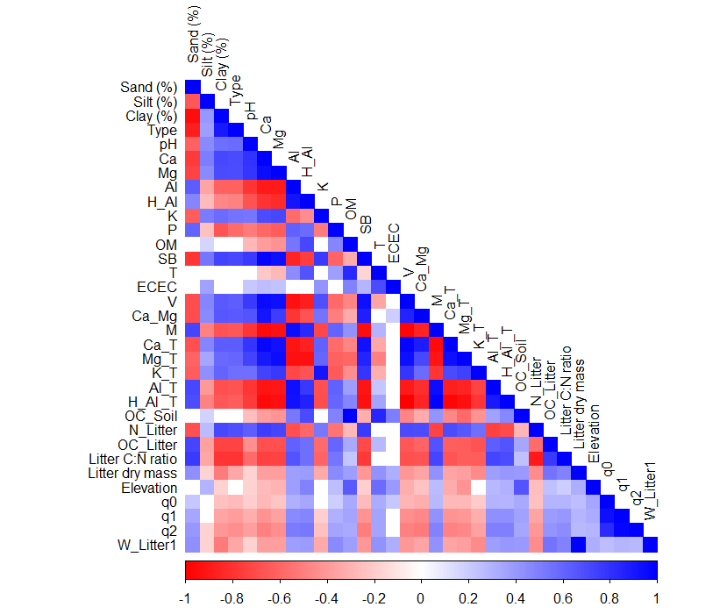
Figure S1. Spearman correlation among all individual variables measured in 75 plots along forest patches. The following properties are included: elevation (m), soil texture fractions (sand, silt, and clay), soil chemical properties, such as organic matter (OM), exchangeable aluminum (Al), pH, total exchangeable bases (SB), and effective cation exchange capacity (ECEC), and litter attributes (C:N ratio and litter dry mass).

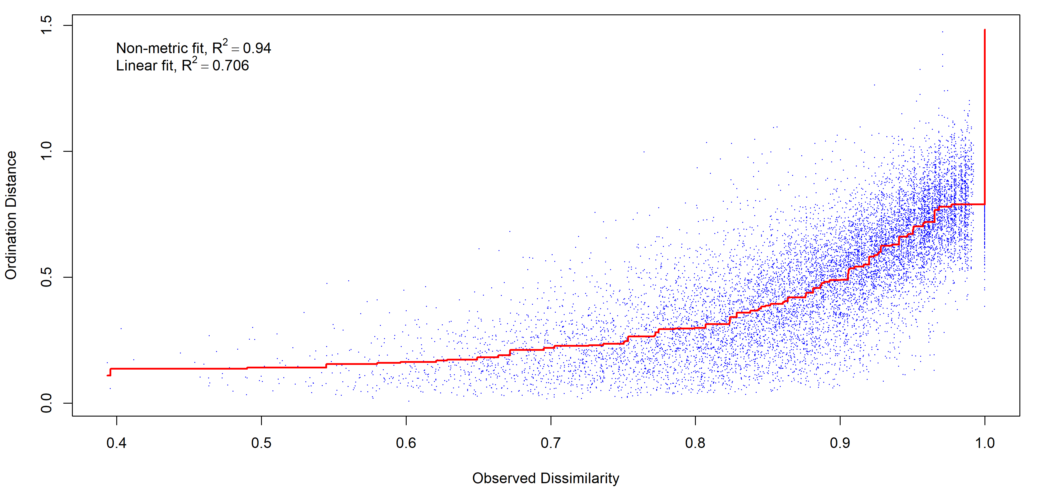
Figure S2. Stress plot evaluating the goodness-of-fit of the non-metric multidimensional scaling (NMDS) ordination based on tree species composition. Blue points represent the relationship between observed dissimilarities and ordination distances, while the red line indicates the monotonic regression. The high non-metric fit (R² = 0.94) demonstrates that the two-dimensional ordination adequately represents the original dissimilarity matrix.
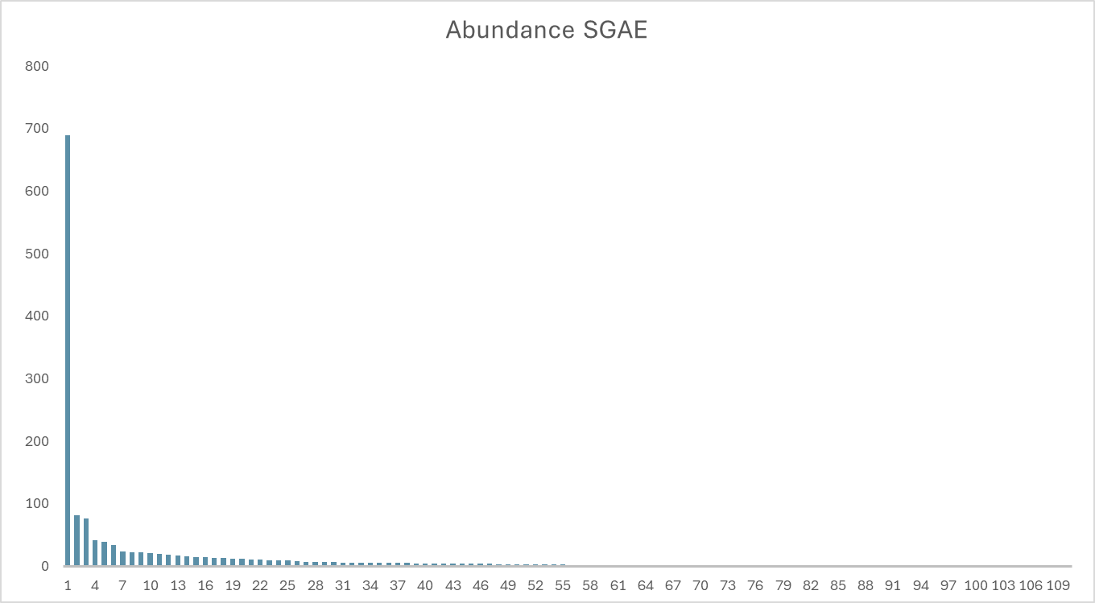
Figure S3. Species abundance distribution in the Second Growth Forest after Enriched Silvicultural System (SGAE) community. Species are ranked from the most to the least abundant along the x-axis, and bar height indicates the number of individuals recorded for each species.
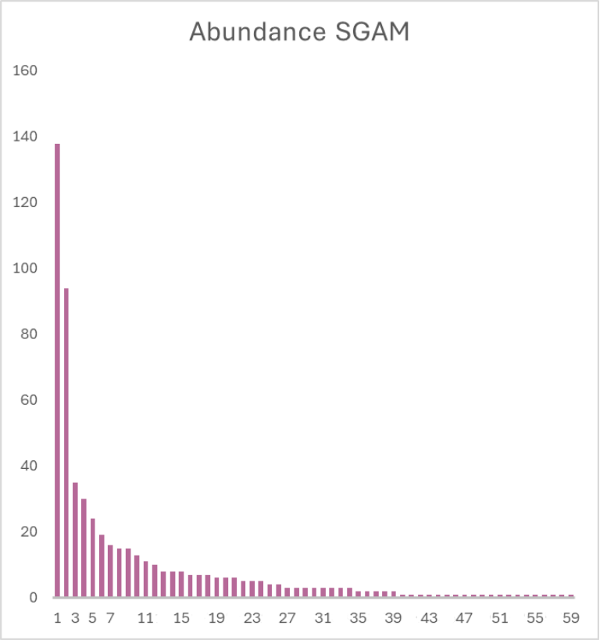
Figure S4. Species abundance distribution in the Second Growth Forest after Silvicultural System with Management (SGAM) community. Species are ranked from the most to the least abundant along the x-axis, and bar height indicates the number of individuals recorded for each species.
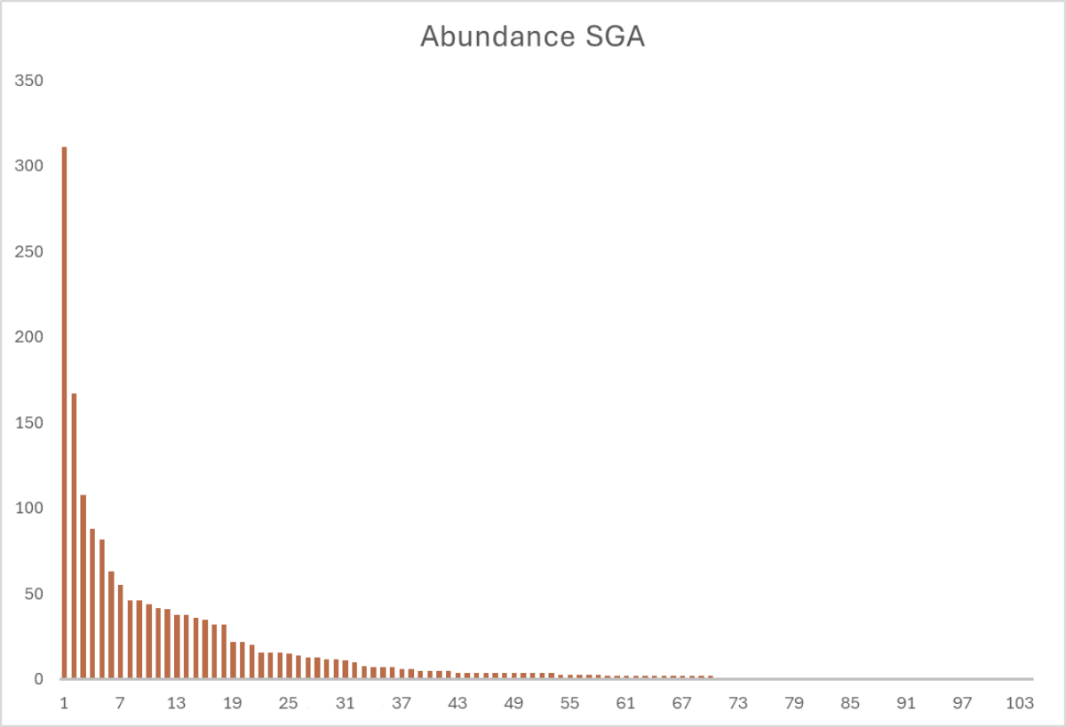

Figura S5. Species abundance distribution in the Second Growth Forest after Silvicultural System (SGA) community. Species are ranked from the most to the least abundant along the x-axis, and bar height indicates the number of individuals recorded for each species.
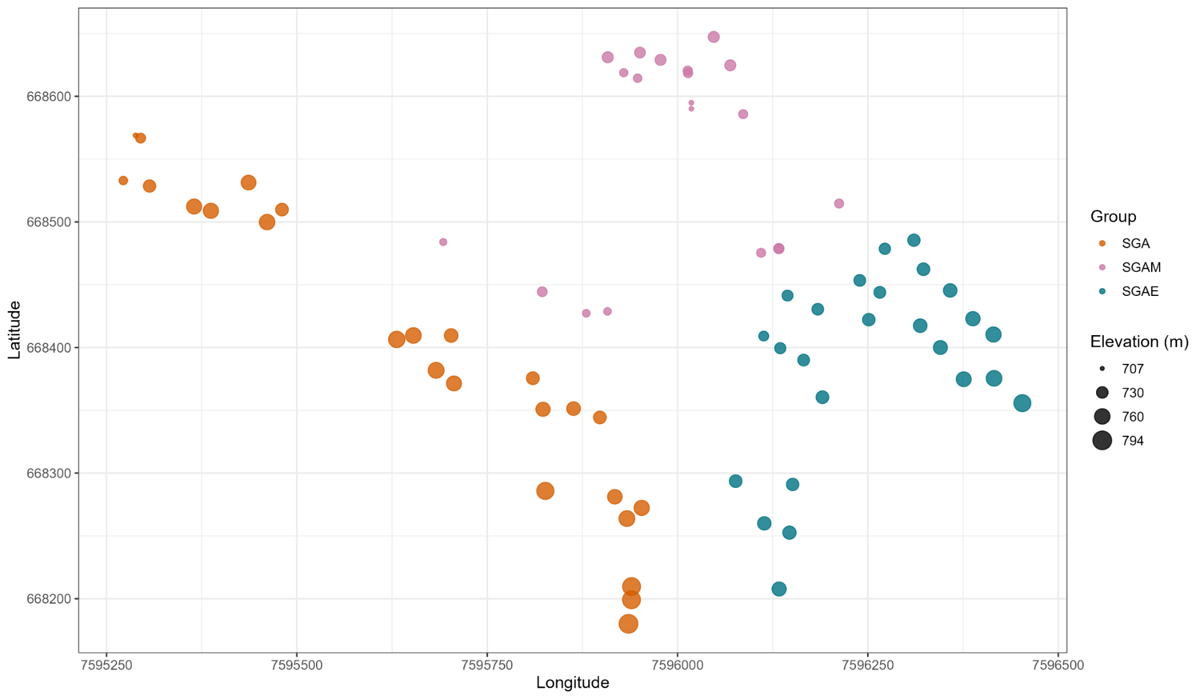
Figura S6. Spatial distribution of sampling plots across the three management groups (SGA, SGAM, and SGAE). Plot locations are shown using UTM coordinates (longitude and latitude), and point size is proportional to elevation (m), illustrating the altitudinal gradient across the study area. Abbreviations indicate the different silvicultural legacies: Second growth forest after silvicultural system with management (SGAM), Second growth forest after enriched silvicultural system (SGAE), and Second growth forest after silvicultural system (SGA).

