Supporting information
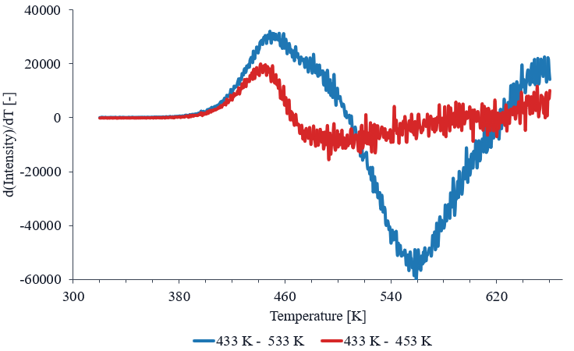
Figure S1 Comparison of the difference thermoluminescence (TL) glow curves used to determine $T_{max}$ at $T_{stop}=433$K for Mn²⁺-doped Na–Al phosphate glass irradiated with 100 Gy.

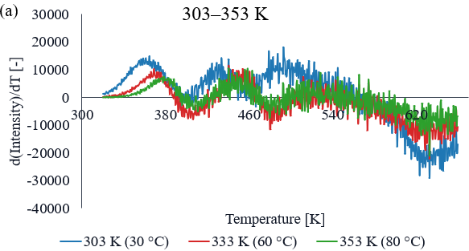
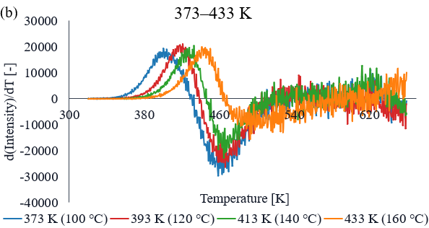
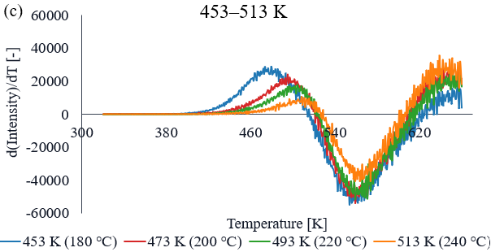
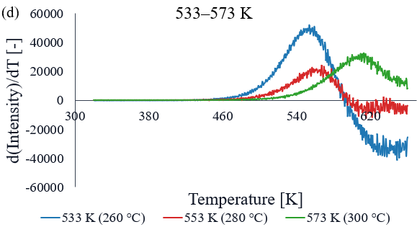
Figure S2 Fig. S2 First-derivative curves used to determine $T_{max}$in the $T_{max}$–$T_{stop}$ analysis of Mn²⁺-doped Na–Al phosphate glass irradiated with 100 Gy. The curves are grouped according to $T_{stop}$: (a) 303–353 K, (b) 373–433 K, (c) 453–513 K, and (d) 533–573 K.

