Supplementary Information 1. Original full-length Western Blots corresponding to Figure 2B

This Supplementary Information provides the original full-length Western blot images corresponding to the cropped panels presented in Figure 2B of the manuscript, in accordance with the Scientific Reports editorial policy on digital image integrity.
Each original blot is accompanied by a description that identifies the lanes used to generate the corresponding cropped panel shown in the main figure. For each blot, the lanes used to generate the cropped images shown in Figure 2B are explicitly identified below. Cropping was performed solely to improve figure presentation and did not modify the experimental data or affect the interpretation of the results.
The original full-length blots are provided to ensure transparency and to allow evaluation of the correspondence between the published cropped panels and their respective original images. The original full-length blots are presented below in the same order as they appear in Figure 2B.

Original full-lenght blot corresponding to Figure 2B – SOD-1
Lanes 1, 3, 5, and 7: Control group
Lanes 2, 4, 6, and 8: Ethanol-exposed group
Note: The SOS-1 panel shown in Figure 2B was generated from lanes 5 and 6 of the original full-length blot presented below.

Original full-length blot corresponding to Figure 2B – CATALASE
Lanes 1, 3, and 5: Control group
Lanes 2, 4, and 6: Ethanol-exposed group
Note: The Catalase panel shown in Figure 2B was generated from lanes 1 and 2 of the original full-length blot presented below.
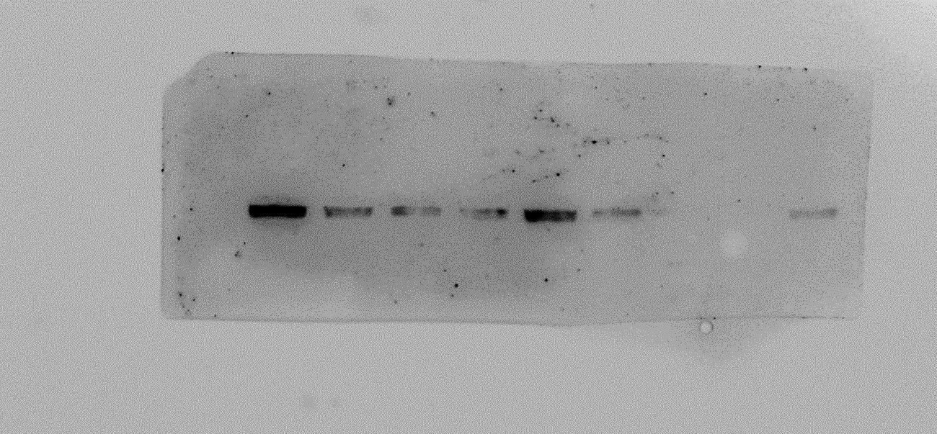

Original full-length blot corresponding to Figure 2B – GPx 1/2
Lanes 1, 3, 5, 7, and 9: Ethanol-exposed group
Lanes 2, 4, 6, and 8: Control group
Note: The GPx1/2 panel shown in Figure 2B was generated from lanes 2 and 1 of the original full-length blot. For consistency with the presentation of the other proteins in Figure 2B, the order of these two lanes was reversed during figure assembly. This adjustment was made solely for presentation purposes and did not alter the original data or their interpretation.
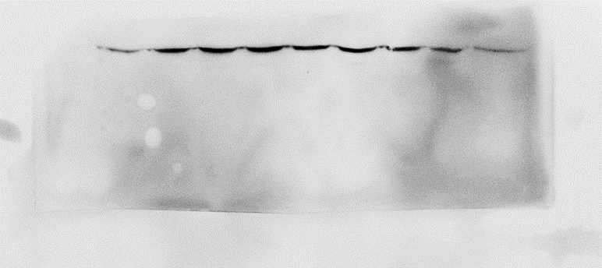

Original full-length blot corresponding to Figure 2B – β-actin
Lanes 1, 3, 5, and 7: Control group
Lanes 2, 4, 6, and 8: Ethanol-exposed group
Note: The β-actin panel shown in Figure 2B was generated from lanes 1 and 2 of the original full-length blot presented below.
