SUPPLEMENTARY MATERIAL
Table S1. Results of PERMANOVA based on morphometric variables, included pairwise comparisons of morphological variables Permutational multivariate analysis of variance (PERMANOVA) testing for differences in morphometric traits as a function of temperature (Te), developmental stage (St), and their interaction (Te × St). Analyses were performed on log(x+1)-transformed and normalized data using Euclidean distances. Statistical significance was assessed using 9999 permutations under a reduced model.
Source of variation | df | SS | MS | Pseudo-F | p(perm)
Temperature (Te) | 2 | 56.499 | 28.249 | 27.778 | 0.0001
Stage (St) | 2 | 2863.000 | 1431.500 | 1407.600 | 0.0001
Te × St | 4 | 59.336 | 14.834 | 14.587 | 0.0001
Residual | 746 | 758.660 | 1.017 | – | –
Total | 754 | 3770.000 | – | – | –
(a) Stage: organo
Comparison (T°C) | t | p(perm)
24 vs 26 | 2.6168 | 0.0024
24 vs 30 | 2.1347 | 0.0153
26 vs 30 | 4.2074 | 0.0001
(b) Stage: activation
Comparison (T°C) | t | p(perm)
24 vs 26 | 2.8129 | 0.0014
24 vs 30 | 2.2834 | 0.0077
26 vs 30 | 4.2104 | 0.0001
(c) Stage: growth
Comparison (T°C) | t | p(perm)
24 vs 26 | 7.2602 | 0.0001
24 vs 30 | 4.4082 | 0.0001
26 vs 30 | 3.6070 | 0.0001

Table S2. Morphology changes and egg wet weight lineal relationship of of O. maya embryos from thermally stressed females (30°C) and maintained at different temperatures.
Table S3. Two-way ANOVA of the Routine metabolic (RMR) rate of O. maya embryos from thermal stressed females and maintained at 24, 26 and 30°C.
ANOVA table | SS (Type III) | DF | MS | F (DFn, DFd) | P value
Interaction | 0.01352 | 4 | 0.003379 | F (4, 243) = 1.905 | P=0.1102
Stage | 0.1008 | 2 | 0.05040 | F (2, 243) = 28.41 | P<0.0001
Temperature | 0.007817 | 2 | 0.003909 | F (2, 243) = 2.204 | P=0.1126
Residual | 0.4310 | 243 | 0.001774
Total | 0.5535 | 251

Table S4. Two-way ANOVA of the maximum metabolic rate (MMR) of O. maya embryos from thermal stressed females and maintained at 24, 26 and 30°C.
ANOVA table | SS (Type III) | DF | MS | F (DFn, DFd) | P value
Interaction | 0.03664 | 4 | 0.009161 | F (4, 248) = 4.423 | P=0.0018
Row Factor | 0.07477 | 2 | 0.03738 | F (2, 248) = 18.05 | P<0.0001
Column Factor | 0.04206 | 2 | 0.02103 | F (2, 248) = 10.15 | P<0.0001
Residual | 0.5137 | 248 | 0.002071
Total | 0.6683 | 256

Table S5. Two-way ANOVA of the standard metabolic rate (SMR) of O. maya embryos from thermal stressed females and maintained at 24, 26 and 30°C.
ANOVA table | SS (Type III) | DF | MS | F (DFn, DFd) | P value
Interaction | 0.01182 | 4 | 0.002955 | F (4, 224) = 3.126 | P=0.0158
Row Factor | 0.1287 | 2 | 0.06437 | F (2, 224) = 68.08 | P<0.0001
Column Factor | 0.05839 | 2 | 0.02920 | F (2, 224) = 30.88 | P<0.0001
Residual | 0.2118 | 224 | 0.0009455
Total | 0.4310 | 232

Table S6. Results of PERMANOVA based on Antioxidant defense mechanisms (ADM) and oxidative damage (OD), included pairwise comparisons of O. maya embryos. Permutational multivariate analysis of variance (PERMANOVA) testing for differences in ADM and OD traits as a function of temperature (Te), developmental stage (St), and their interaction (Te × St). Analyses were performed on log(x+1)-transformed and normalized data using Euclidean distances. Statistical significance was assessed using 9999 permutations under a reduced model.
PERMANOVA table of results
Source | Df | SS | MS | Pseudo-F | P(perm)
Temperature (Te) | 2 | 327.950 | 163.980 | 43.273 | 0.0001
Stage (St) | 2 | 200.030 | 100.010 | 26.394 | 0.0001
Te × St | 4 | 61.434 | 15.359 | 4.053 | 0.0001
Residual | 247 | 935.950 | 3.789 | – | –
Total | 255 | 1530.000 | – | – | –
Within level 'organo' of factor 'Estadio'
Groups | T | P(perm)
24 vs 26 | 1.3976 | 0.0716
24 vs 30 | 4.7024 | 0.0001
26 vs 30 | 4.3897 | 0.0001
Within level 'activation' of factor 'Estadio'
Groups | T | P(perm)
24 vs 26 | 1.4213 | 0.0962
24 vs 30 | 4.3929 | 0.0001
26 vs 30 | 4.2011 | 0.0001
Within level 'growth' of factor 'Estadio'
Groups | T | P(perm)
24 vs 26 | 4.6261 | 0.0001
24 vs 30 | 4.8526 | 0.0001
26 vs 30 | 4.3994 | 0.0001

Table S7. Results of PERMANOVA on comparisons of esterases in Octopus maya embryos
Permutational multivariate analysis of variance (PERMANOVA) testing for differences as a function of temperature (Te), developmental stage (St), and their interaction (Te × St). Analyses were performed on log(x+1)-transformed and normalized data using Euclidean distances. Statistical significance was assessed using 9999 permutations under a reduced model. Table
S11. Pairwise PERMANOVA comparisons for esterasas in Octopus maya embryos Pairwise tests following PERMANOVA examining differences among temperature levels within each developmental stage. Analyses were based on log(x+1)-transformed and normalized data using Euclidean distances. Significance was assessed using 9999 permutations.

Source of variation | df | SS | MS | Pseudo-F | p(perm)
Temperature (Te) | 2 | 119.500 | 59.750 | 42.737 | 0.0001
Stage (St) | 2 | 1.060 | 0.530 | 0.379 | 0.8178
Te × St | 4 | 33.866 | 8.467 | 6.056 | 0.0001
Residual | 240 | 335.540 | 1.398 | – | –
Total | 248 | 496.000 | – | – | –
(a) Stage: organo
Comparison (°C) | t | p(perm)
24 vs 26 | 1.5125 | 0.1042
24 vs 30 | 5.1524 | 0.0001
26 vs 30 | 7.1003 | 0.0001
(b) Stage: activation
Comparison (°C) | t | p(perm)
24 vs 26 | 2.7418 | 0.0012
24 vs 30 | 3.2669 | 0.0001
26 vs 30 | 5.0365 | 0.0001

(c) Stage: growth
Comparison (°C) | t | p(perm)
24 vs 26 | 3.1681 | 0.0003
24 vs 30 | 5.9881 | 0.0001
26 vs 30 | 3.6099 | 0.0001

Table S8. One-way ANOVA of the effects of temperature on the growth rate (% d⁻¹) of O. maya juveniles from thermal stressed females and maintained at 24, 26 and 30°C.
ANOVA table | SS | DF | MS | F (DFn, DFd) | P value
Temperature | 160.0 | 2 | 79.98 | F (2, 73) = 96.48 | P<0.0001
Residual (within columns) | 60.51 | 73 | 0.8290
Total | 220.5 | 75

Table S9. One-way ANOVA of the effects of temperature on the Routine metabolic rate (RMR) of O. maya juveniles from thermal stressed females and maintained at 24, 26 and 30°C.
ANOVA table | SS | DF | MS | F (DFn, DFd) | P value
Temperature | 0.9183 | 2 | 0.4591 | F (2, 19) = 16.50 | P<0.0001
Residual (within columns) | 0.5287 | 19 | 0.02783
Total | 1.447 | 21

Table S10. One-way ANOVA of the effects of temperature on the standard metabolic rate (SMR) of O. maya juveniles from thermal stressed females and maintained at 24, 26 and 30°C.
ANOVA table | SS | DF | MS | F (DFn, DFd) | P value
Temperature | 0.01887 | 2 | 0.009437 | F (2, 19) = 2.306 | P=0.1269
Residual (within columns) | 0.07776 | 19 | 0.004093
Total | 0.09664 | 21

Table S11. One-way ANOVA of the effects of temperature on the maximum metabolic rate (MMR) of O. maya juveniles from thermal stressed females and maintained at 24, 26 and 30°C.
ANOVA table | SS | DF | MS | F (DFn, DFd) | P value
Treatment (between columns) | 0.03029 | 2 | 0.01515 | F (2, 20) = 0.2508 | P=0.7806
Residual (within columns) | 1.208 | 20 | 0.06040
Total | 1.238 | 22

Table S12. Results of PERMANOVA based on Antioxidant defense mechanisms (ADM) and oxidative damage (OD), included pairwise comparisons of O. maya juveniles. Permutational multivariate analysis of variance (PERMANOVA) testing for differences in ADM and OD traits as a function of temperature (Te). Analyses were performed on log(x+1)-transformed and normalized data using Euclidean distances. Statistical significance was assessed using 9999 permutations under a reduced model.

Source of variation |  | df | SS |  | MS |  | Pseudo-F | p(perm)
Temperature (Te) |  | 2 | 64.560 |  | 32.280 |  | 6.581 | 0.0001
Residual |  | 48 | 235.440 |  | 4.905
Total |  | 50 | 300.000
Comparison (°C) | t |  |  | p(perm)
24 vs 26 | 1.8372 |  |  | 0.0138
24 vs 30 | 3.2564 |  |  | 0.0001
26 vs 30 | 1.9788 |  |  | 0.0169

Table S13. Results of PERMANOVA based on Esterases activities (AChE and CbE) included pairwise comparisons of O. maya juveniles. Permutational multivariate analysis of variance (PERMANOVA) testing for differences in esterases traits as a function of temperature (Te). Analyses were performed on log(x+1)-transformed and normalized data using Euclidean distances. Statistical significance was assessed using 9999 permutations under a reduced model.
Source of variation |  | df | SS |  | MS |  | Pseudo-F | p(perm)
Temperature (Te) |  | 2 | 54.291 |  | 27.146 |  | 28.506 | 0.0001
Residual |  | 48 | 45.709 |  | 0.952 |  | – | –
Total |  | 50 | 100.000 |  | – |  | – | –
Comparison (°C) | t |  |  | p(perm)
24 vs 26 | 2.9235 |  |  | 0.0027
24 vs 30 | 7.4285 |  |  | 0.0001
26 vs 30 | 2.5335 |  |  | 0.0063

Fig. S1. Morphological changes of O. maya embryos from thermally stressed females (30°C) and exposed to different experimental temperatures. Raw data of embryos maintained at 24°C (blue), 26°C (orange) and 30°C (red).

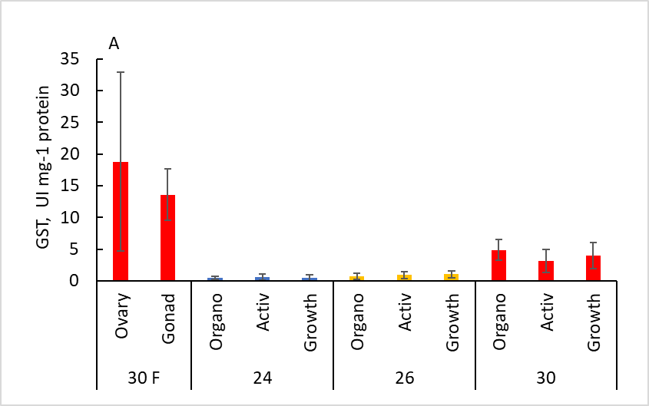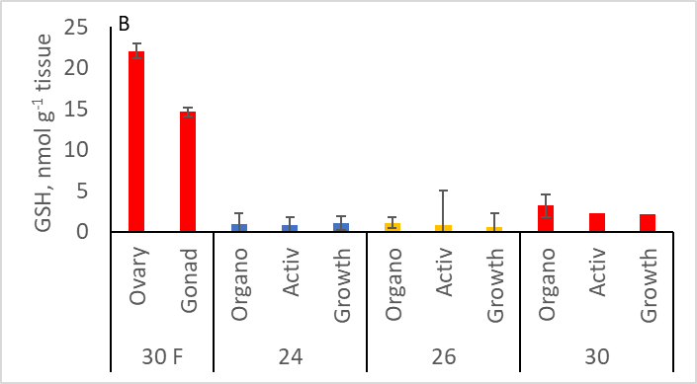
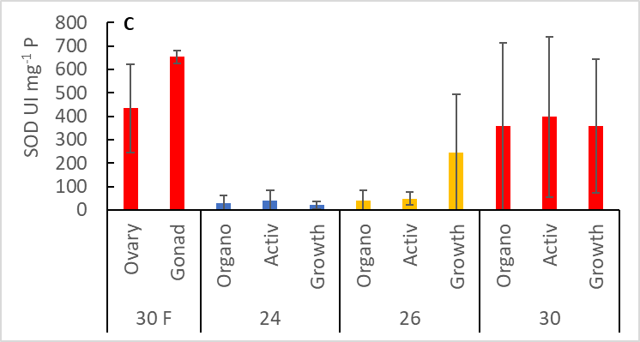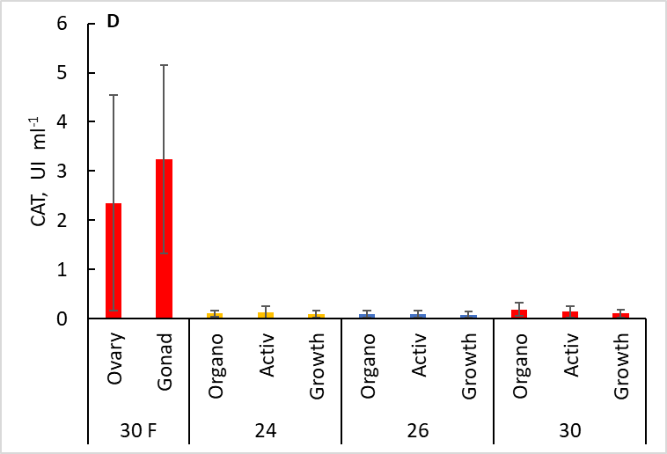
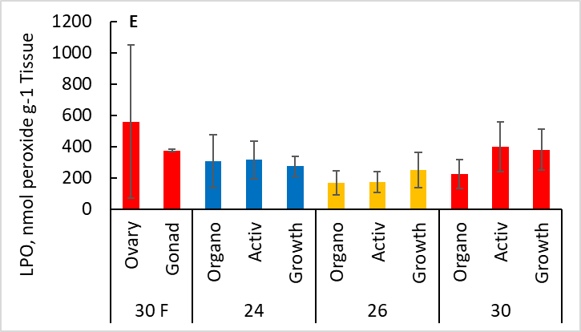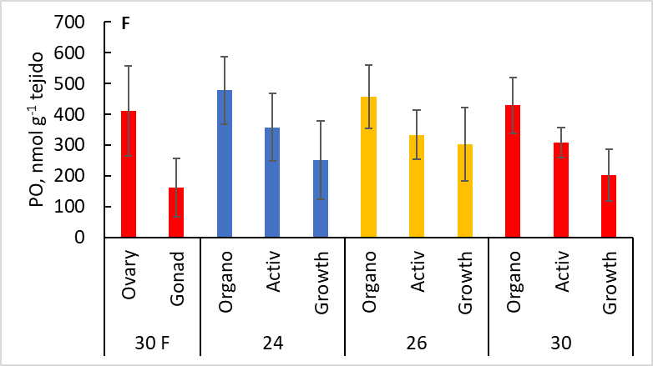
Fig. S2. Antioxidant defence enzymes and molecules of thermally stressed females (30F) and its Octopus maya embryos maintained at different temperatures. GsT = Glutathione-s-transferase (A), GSH = Total Glutathione (B); SOD = Superoxide dismutase (C); CAT = Catalase (D); LPO = Lipoperoxidation (E); PO = Protein oxidized (F). Values as mean + SD. Stages as Organo = Organogenesis; Activ = Activation

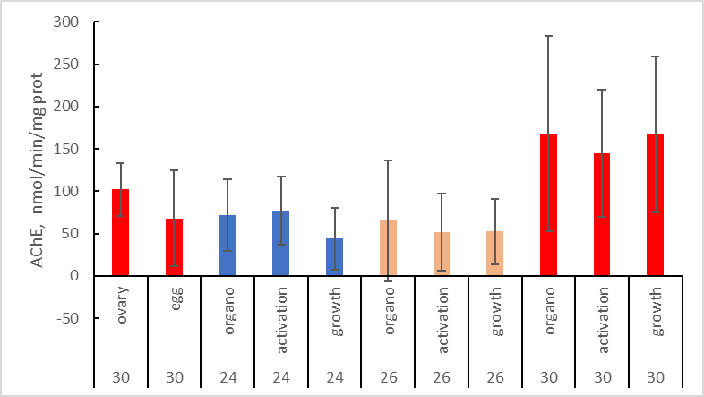
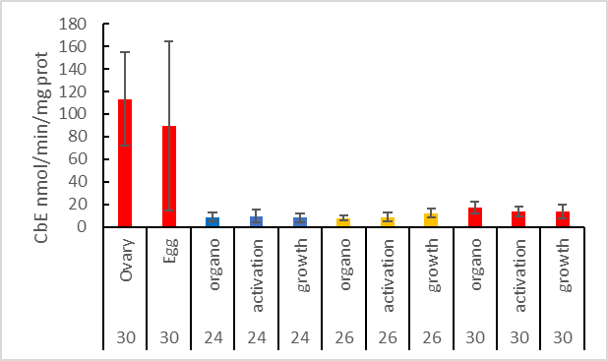
Fig. S3. Esterases of thermally stressed females (30F) and its Octopus maya embryos maintained at different temperatures. AChE = acetyl cholinesterase; CbE = carboxyl esterase. Values as mean + SD. Stages as Organo = Organogenesis; Activ = Activation

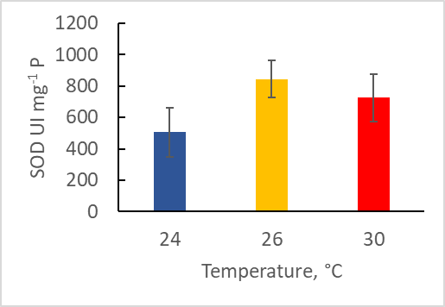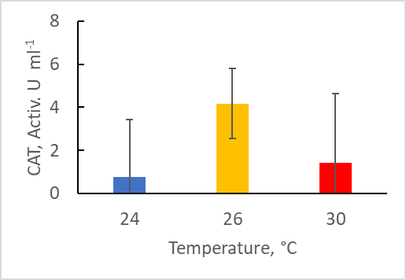
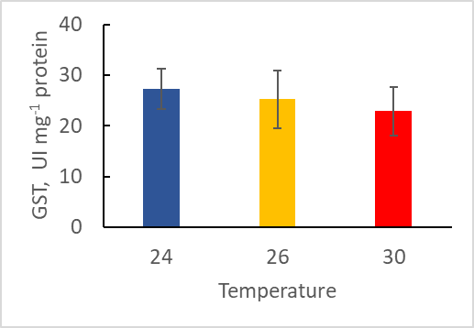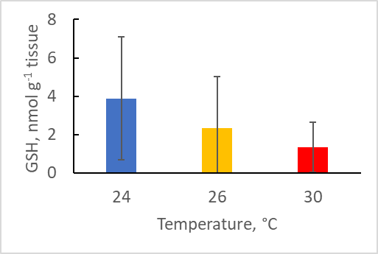
Fig. S4. Antioxidant defence mechanism of thermally stressed females (30F) and its Octopus maya juveniles maintained at different temperatures. GsT = Glutathione-s-transferase, GSH = Total Glutathione; SOD = Superoxide dismutase; CAT = Catalase; Values as mean + SD.

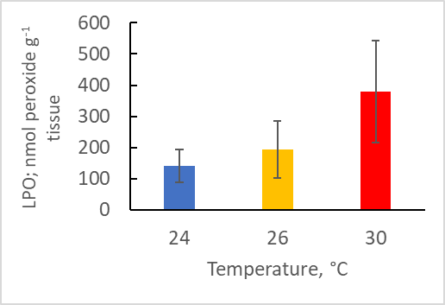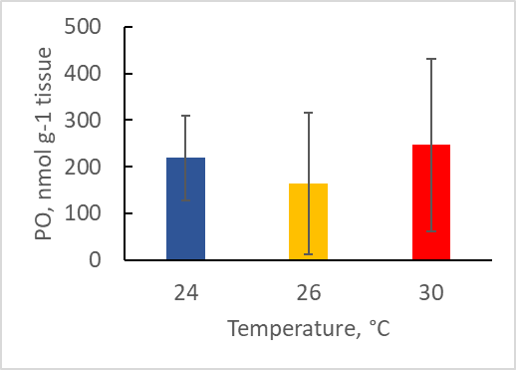
Fig. S5. Oxidant damage of Octopus maya juveniles maintained at different temperatures LPO = Lipoperoxidation (E); PO = Protein oxidized. Values as mean + SD

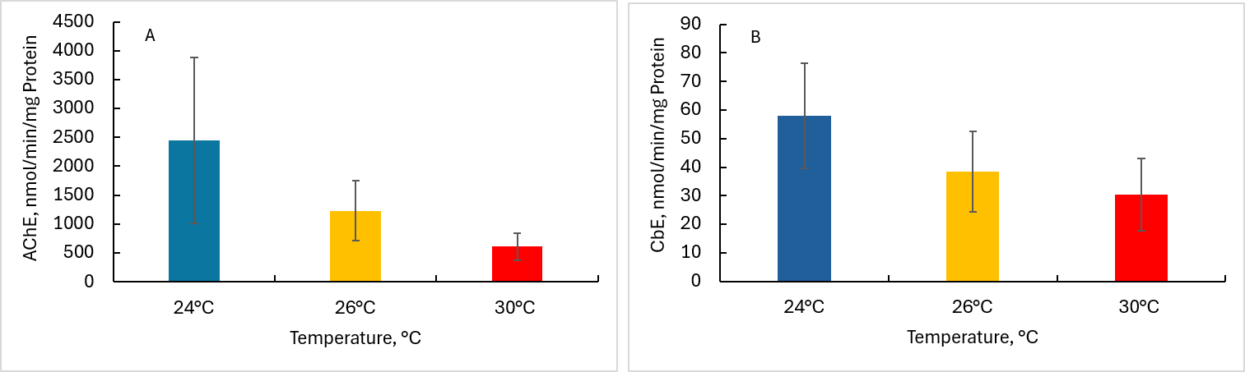
Fig. S6. Esterases of Octopus maya juveniles maintained at different temperatures AChE Acetyl cholinesterase (A); CbE = Carboxyl esterase (B). Values as mean + SD

