Supplemental Figures
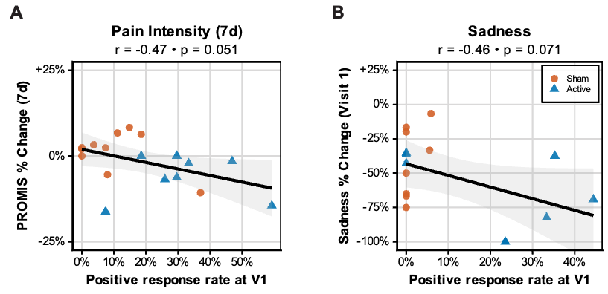
Supplementary Figure 1. Immediate subjective reports marginally predict subsequent pain intensity and sadness improvement. Linear models depicting correlations between positive-valenced immediate subjective response rate at visit one (V1) and clinical score changes in sham (orange) and active (blue) conditions. Immediate subjective responses versus (A) Patient-Reported Outcomes Measurement Information System (PROMIS) pain intensity score changes at seven days post-stimulation among chronic pain participants; and, (B) Positive and Negative Affect Schedule Expanded (PANAS-x) sadness subscale scores from pre to post-stimulation among treatment-resistant depression (TRD) participants. Subjective effects on the x-axis reported as percentage of total trials scored as ‘positive’ during the V1 stimulation session. Clinical scores along the y-axis are reported as percentage change relative to baseline. Solid line indicates the least-squares linear regression fit. Pearson correlation coefficients (r) and associated two-tailed p-values are shown. Shaded regions represent 95% confidence band.
Supplemental Methods
Crossover Criteria
The chronic pain study required participants to maintain an average 24-hour pain score ≥3 (range, 0–10) to proceed to crossover, ensuring persistent symptom severity prior to the second condition. The TRD study instead used fixed crossover timing at one week. Both trials included post-stimulation monitoring through seven days.
Participants
Chronic pain cohort: Participants had a primary diagnosis of chronic pain present for ≥3 months. Pain etiologies were heterogeneous and included fibromyalgia (n=10), neuropathy (n=3), migraine (n=3), arthritis (n=3), and many other chronic pain syndrome co-morbidities. At baseline, the mean Brief Pain Inventory (BPI) 24-hour Numeric Rating Scale (NRS, 0–10) was 5.3 and the Patient-Reported Outcomes Measurement Information System (PROMIS) pain intensity score average was 64, corresponding to a moderate-to-severe pain severity. The sample was 60% female with mean age 46.6 years.
TRD cohort: Participants met diagnostic criteria for treatment-resistant depression (≥2 failed first-line therapies), currently experiencing a depressive episode without psychotic features lasting ≥2 months. Primary DSM-5 diagnoses were major depressive disorder (91%) and bipolar disorder (9%). At baseline, the mean 6-item Hamilton Depression Rating Scale (HDRS-6) score was 11.7 and the mean Quick Inventory of Depressive Symptomatology (QIDS-SR) score was 17.8, reflecting moderate-to-severe illness. The sample was 64% female with a mean age of 39.5 years.

Treatment Sessions
Chronic pain cohort (Fig. 1A-B). Block A included sixteen 30-second sonications of 0.7-second burst intervals delivered to eight candidate targets throughout ACC in randomized order (without replacement), with each target stimulated twice. Blocks B and C each consisted of six 3-minute sonications delivered to selected targets in randomized order.
TRD cohort (Fig. 1C-D). Block A included three to five 60-second sonications with 1.4-second burst intervals delivered across an anterior, middle and posterior sgACC. Block B included six 3-minute sonications with 1.4-second burst intervals. Block C included six 3-minute sonications with 0.7-second burst intervals.

Target Mapping
Individual, participant-specific stimulation targets were normalized to the ICBM 2009a Nonlinear Symmetric template [1, 2], as this template directly matches the Yale Brain Atlas (YBA), our selected mapping atlas. Target normalization was accomplished by: 1) masking the native space T1-weighted MPRAGE images using Synthstrip [3] (Freesurfer 8.1.0); 2) masking the ICBM T1-weighted template image with the bundled brain mask; 3) removing bias field inhomogeneity from the skull-stripped native space image using N4ITK [4] that is bundled with Advanced Normalization Tools (ANTs) 2.5.3 [5]; 4) calculating the non-linear warp from the skull-stripped native space image to the skull-stripped template image using the antsRegistrationSyN.sh script with symmetric normalization; and, 5) applying the warp field to the native space coordinates using antsApplyTransformsToPoints. After normalization, coordinates were assigned to a YBA parcel label. Because the YBA has partial-voluming voxels that do not have a label, we used a custom growth algorithm that iteratively assigns non-labeled voxels the label of the nearest atlas label based on center of mass.

References
1. Fonov V, Evans A, McKinstry R, Almli C, Collins D. Unbiased nonlinear average age-appropriate brain templates from birth to adulthood. NeuroImage. 2009;47:S102.
2. Fonov V, Evans AC, Botteron K, Almli CR, McKinstry RC, Collins DL. Unbiased average age-appropriate atlases for pediatric studies. NeuroImage. 2011;54:313–327.
3. Hoopes A, Mora JS, Dalca AV, Fischl B, Hoffmann M. SynthStrip: skull-stripping for any brain image. NeuroImage. 2022;260:119474.
4. Tustison NJ, Avants BB, Cook PA, Zheng Y, Egan A, Yushkevich PA, et al. N4ITK: Improved N3 Bias Correction. IEEE Trans Med Imaging. 2010;29:1310–1320.
5. Avants BB, Tustison NJ, Song G, Cook PA, Klein A, Gee JC. A reproducible evaluation of ANTs similarity metric performance in brain image registration. NeuroImage. 2011;54:2033–2044.

