Supplemental Materials
Crustose coralline algae and coral larval settlement induction in southeast Florida

Authors and Affiliation
Danielle Macias, National Coral Reef Institute, Halmos College of Arts and Sciences, Nova Southeastern University, Dania Beach, FL, USA, ORCID: 0009-0004-0081-4255
Corresponding author: danimac1126@gmail.com
Aurora Giorgi, King Abdullah University of Science and Technology, Saudia Arabia, ORCID: 0009-0005-0784-4382, ORCID: 0009-0005-0784-4382
Maggie D. Johnson, King Abdullah University of Science and Technology, Saudi Arabia, ORCID: 0000-0002-1319-2545
Joana Figueiredo, National Coral Reef Institute, Halmos College of Arts and Sciences, Nova Southeastern University, Dania Beach, FL, USA, ORCID: 0000-0001-6597-0268,

Methods

Coral species and larvae acquisition
Gametes from five coral species, Montastraea cavernosa, Orbicella faveolata, Pseudodiploria strigosa, P. clivosa, and Colpophyllia natans were released at ex situ nurseries at NSU, The Florida Coral Rescue Center, and The Cooperative Institute for Marine and Atmospheric Studies. At these institutions, corals were kept year-round under conditions mimicking annual temperature and light cycles of Southeast Florida to induce spawning (as described in Laforest et al. 2024) or gametes were collected in spawning nets in situ. For each species, the gametes were fertilized by pooling eggs and sperm of at least 5 colonies at a sperm density ≤ 10⁶ mL⁻¹, the embryos were reared in 80-100L static or recirculating tanks with daily 20-50% water changes with 1µm filtered seawater or artificial saltwater until the post-gastrula stage. Larvae were transported to Nova Southeastern University (NSU) in Nalgene bottles at a maximum larval density 20,000 L⁻¹ inside ORCA® coolers by car. Upon arrival at NSU, larvae were cleaned using a 100µm filter and provided new saltwater (made with Brightwell Aquatics NeoMarine salt at 35 PSU). For each species, competency was determined based on the settlement competency curves reported in Dobbelaere et al. 2025 and confirmed in the lab based on downward swimming behavior (Limer et al. 2024).

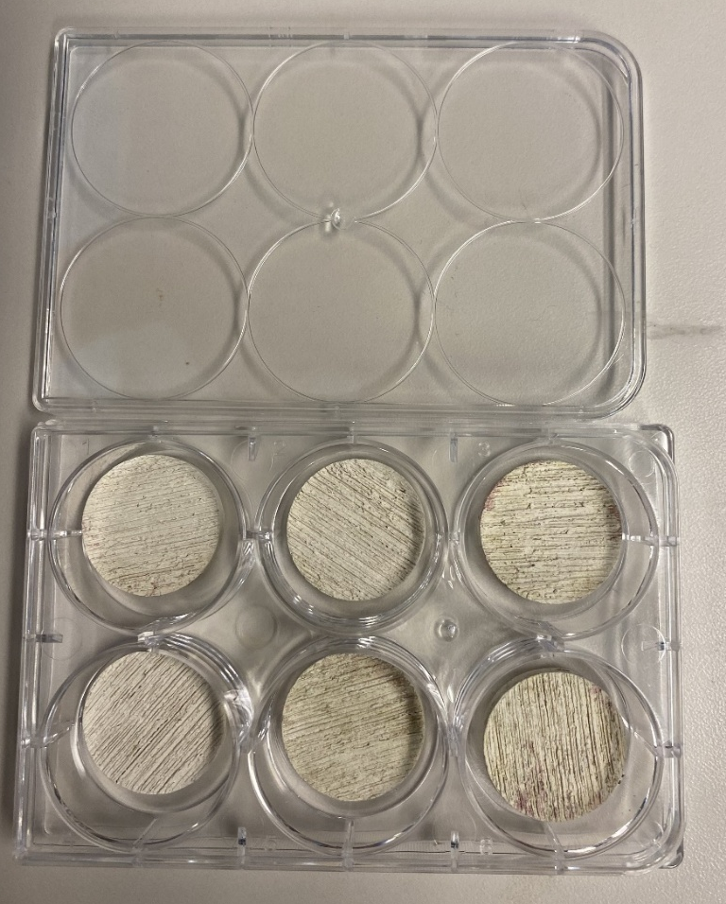
Figure S1: Six well-plate experiment setup model.
Results

Colpophyllia natans
Full model
mod.1<-glm((`Settled and Meta`/Larvae)~
+ Tile*CCA, weights = Larvae,
+ family = 'binomial', data = Day_3_CNAT)

anova(mod.1, test="Chisq")
Df Deviance Resid. Df Resid. Dev Pr(>Chi)
NULL 31 30.797
Tile 1 12.737 30 18.060 0.0003585 ***
CCA 3 7.383 27 10.677 0.0606417 .
Tile:CCA 3 0.000 24 10.677 1.0000000

Selected model
mod.3<-glm((`Settled and Meta`/Larvae)~
+ Tile, weights = Larvae,
+ family = 'binomial', data = Day_3_CNAT)

anova(mod.3, test="Chisq")

Df Deviance Resid. Df Resid. Dev Pr(>Chi)
NULL 31 30.797
Tile 1 12.737 30 18.060 0.0003585 ***

(mod.3$null.deviance- mod.3$deviance)/ mod.3$null.deviance
0.4135842 #Approximate R2

Montastraea cavernosa
mod.1<-glm((`Settled and Meta`/Larvae)~ Tile*CCA, weights = Larvae,
+ family = 'binomial', data = Day_3_MCAV)

mod.1$deviance / mod.1$df.residual
1.780284 # overdispersed

mod.1q<-glm((SettleMeta/Larvae)~
Tile*CCA, weights = Larvae,
family = 'quasibinomial', data = Day_3_MCAV)

anova(mod.1q, test="Chisq")

Df Deviance Resid. Df Resid. Dev Pr(>Chi)
NULL 31 57.037
Tile 1 1.1315 30 55.906 0.4165
CCA 3 4.5459 27 51.360 0.4484
Tile:CCA 3 8.6330 24 42.727 0.1691

Orbicella faveolata
mod.1<-glm((`Settled and Meta`/Larvae)~ Tile*CCA, weights = Larvae,
family = 'binomial', data = Day_3_OFAV)

anova(mod.1, test="Chisq")

Df Deviance Resid. Df Resid. Dev Pr(>Chi)
NULL 31 20.596
Tile 1 0.0000 30 20.596 1.0000
CCA 3 4.5624 27 16.033 0.2068
Tile:CCA 3 1.7517 24 14.281 0.6255

Pseudodiploria clivosa
Full model
mod.1<-glm((`Settled and Meta`/Larvae)~
+ Tile*CCA, weights = Larvae,
+ family = 'binomial', data = Day_3_PCLI)

anova(mod.1, test="Chisq")

Df Deviance Resid. Df Resid. Dev Pr(>Chi)
NULL 31 75.414
Tile 1 41.285 30 34.129 1.316e-10 ***
CCA 3 5.348 27 28.781 0.14801
Tile:CCA 3 6.594 24 22.187 0.08601 .

Selected model
mod.3<-glm((`Settled and Meta`/Larvae)~
+ Tile, weights = Larvae,
+ family = 'binomial', data = Day_3_PCLI)

anova(mod.3, test="Chisq")

Df Deviance Resid. Df Resid. Dev Pr(>Chi)
NULL 31 75.414
Tile 1 41.285 30 34.129 1.316e-10 ***

(mod.3$null.deviance- mod.3$deviance)/ mod.3$null.deviance
0.5474392 #Approximate R2

Pseudodiploria strigosa
Full model
mod.1<-glm((SettleMeta/Larvae)~
+ Tile*CCA, weights = Larvae,
+ family = 'binomial', data = Day_3_PSTR)

anova(mod.1, test="Chisq")

Df Deviance Resid. Df Resid. Dev Pr(>Chi)
NULL 31 103.493
Tile 1 71.529 30 31.964 < 2e-16 ***
CCA 3 8.669 27 23.295 0.03403 *
Tile:CCA 3 0.000 24 23.295 1.00000

Selected model
mod.2<-glm((SettleMeta/Larvae)~
+ Tile+CCA, weights = Larvae,
+ family = 'binomial', data = Day_3_PSTR)

anova(mod.2, test="Chisq")
Df Deviance Resid. Df Resid. Dev Pr(>Chi)
NULL 31 103.493
Tile 1 71.529 30 31.964 < 2e-16 ***
CCA 3 8.669 27 23.295 0.03403 *

(mod.2$null.deviance- mod.2$deviance)/ mod.2$null.deviance
0.7749126 #Approximate R2

Posthoc tests
library(emmeans)
emm.mod2 <- emmeans(mod.2, ~ CCA|Tile)
pairs(emm.mod2)

Tile = conditioned:
contrast estimate SE df z.ratio p.value
Lithophyllum – Boreolithothamnion -0.442 0.472 Inf -0.935 0.7859
Lithophyllum - no 1.099 0.590 Inf 1.863 0.2440
Lithophyllum - Porolithon -0.116 0.483 Inf -0.241 0.9951
Boreolithothamnion- no 1.540 0.577 Inf 2.671 0.0380 *
Boreolithothamnion- Porolithon 0.325 0.467 Inf 0.697 0.8984
no - Porolithon -1.215 0.585 Inf -2.076 0.1609

Tile = non-conditioned:
contrast estimate SE df z.ratio p.value
Lithophyllum – Boreolithothamnion -0.442 0.472 Inf -0.935 0.7859
Lithophyllum - no 1.099 0.590 Inf 1.863 0.2440
Lithophyllum - Porolithon -0.116 0.483 Inf -0.241 0.9951
Boreolithothamnion- no 1.540 0.577 Inf 2.671 0.0380
Boreolithothamnion- Porolithon 0.325 0.467 Inf 0.697 0.8984
no - Porolithon -1.215 0.585 Inf -2.076 0.1609

Results are given on the log odds ratio (not the response) scale.
P value adjustment: tukey method for comparing a family of 4 estimates

