Supplementary Information
Synthesis of Novel 1,2,3-Triazole-Linked Isatin and 5-Fluoroisatin Hybrids: Anticancer and Antibacterial Evaluation Supported by Molecular Docking, Molecular Dynamics, and ADMET Studies
Mohammed A. Al-Salehi^{1,2,} **, Mohammed ALSaeedy³, ZabnAllah M. Alaizeri⁴, Anjali B. Thakkar⁵, Dharmesh Kher⁵, Anju Kunjadiya⁵, Jignesh H. Trivedi^{2,} *

1 Department of Chemistry, Sana’a University, Sana'a, Yemen
2 Department of Chemistry, Sardar Patel University, Vallabh Vidyanagar, Gujarat, India
3 Department of Chemistry, Faculty of Arts & Sciences, Kocaeli University, Kocaeli, Turkey
4 Department of Physics and Astronomy, College of Science, King Saud University, Riyadh, Saudi Arabia.
5 Centre for Interdisciplinary Studies in Science and Technology (CISST), Sardar Patel University, Gujarat, India
* Corresponding author: Jignesh H. Trivedi, E-mail: drjignesh2575@yahoo.co.in
** Co-corresponding author: Mohammed A. Al-Salehi, E-mail: mohammed.alsalehi@su.edu.ye

Contents: | Page
- The general procedure for the synthesis of 3a-g and 4a-g  - ¹H NMR, ¹³C NMR, and FT-IR spectra for all hybrids  - HRMS of compounds 3f, 4a, 4c, 4d, and 4g. | 3  3-24  24-26

- The general procedure for the synthesis of 3a-g and 4a–g
Compound 1 (0.35 mmol) was solubilized in dimethylformamide (DMF), with subsequent addition of the in-situ generation of the catalytic system using CuSO₄.5H₂O with sodium ascorbate. The corresponding Ar-N₃ (2a-g) (0.35 mmol) was charged while stirring at RT for 1 h. Reaction progress was assessed by TLC and an-hexane and EtOAc (50:50, v/v) as a solvent system. Once the reaction was complete, resulting mixture was carefully poured onto cold water to facilitate quenching and precipitation of the crude product. By filtration, washed thoroughly with water, and then dried, the yield was collected. The obtained solid was then recrystallized using ethanol, yielding the isatin-based 1,2,3-triazole–phenyl conjugates (3a-g) and (4a-g) (Scheme 1).

- ¹H NMR, ¹³C NMR, and FT-IR spectra for all hybrids
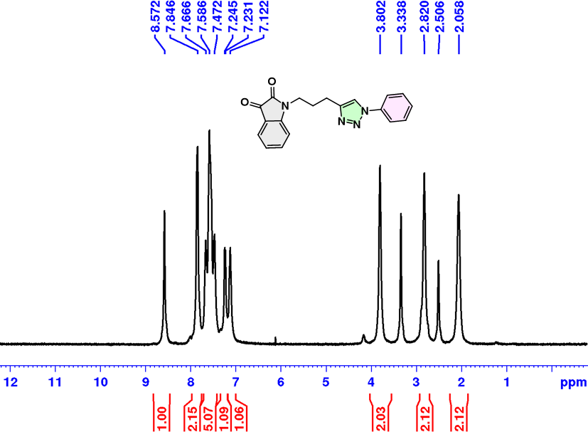
Figure S1. ¹H NMR of 1-(3-(1-phenyl-1H-1,2,3-triazol-4-yl)propyl)indoline-2,3-dione (3a).

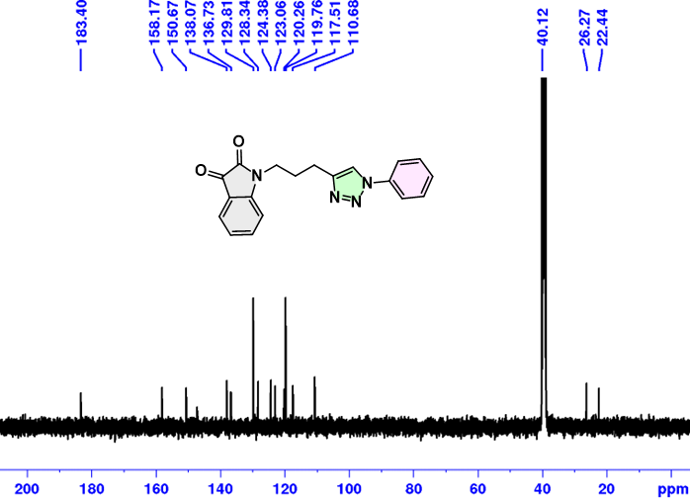
Figure S2. ¹³C NMR of 1-(3-(1-phenyl-1H-1,2,3-triazol-4-yl)propyl)indoline-2,3-dione (3a).
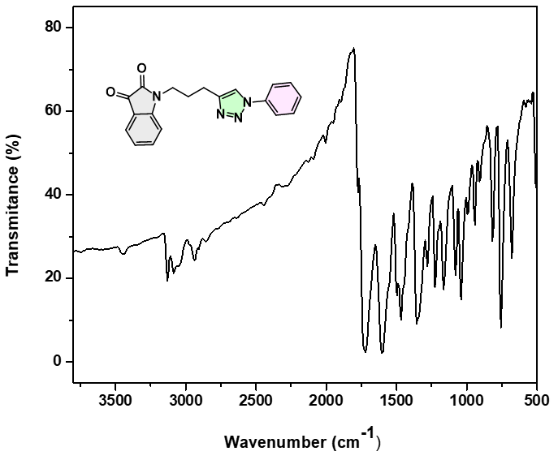
Figure S3. IR Spectra of 1-(3-(1-phenyl-1H-1,2,3-triazol-4-yl)propyl)indoline-2,3-dione (3a).
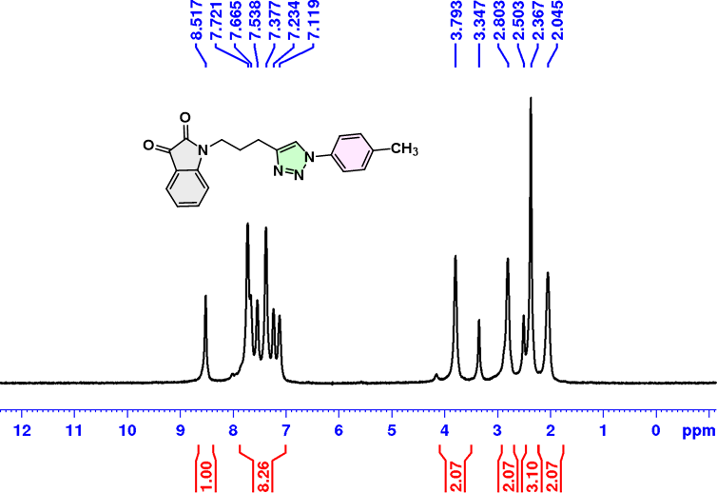
Figure S4. ¹H NMR of 1-(3-(1-(p-tolyl)-1H-1,2,3-triazol-4-yl)propyl)indoline-2,3-dione (3b).

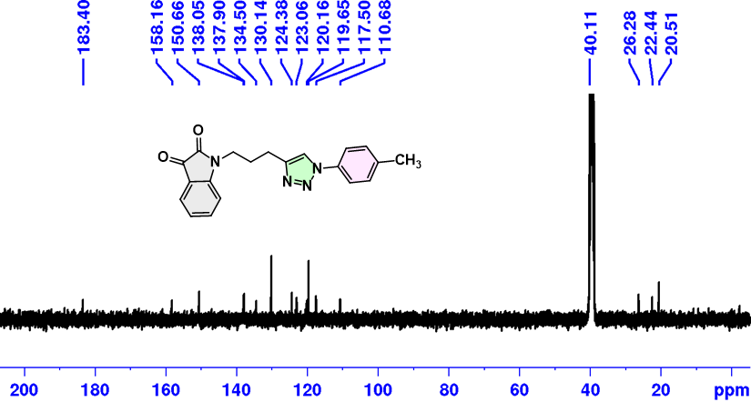
Figure S5. ¹³C NMR of 1-(3-(1-(p-tolyl)-1H-1,2,3-triazol-4-yl)propyl)indoline-2,3-dione (3b).

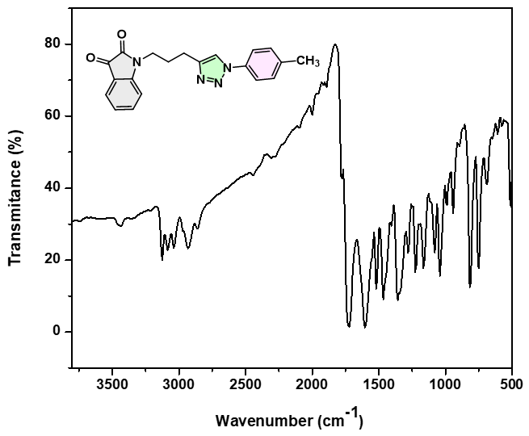
Figure S6. IR Spectra of 1-(3-(1-(p-tolyl)-1H-1,2,3-triazol-4-yl)propyl)indoline-2,3-dione (3b).

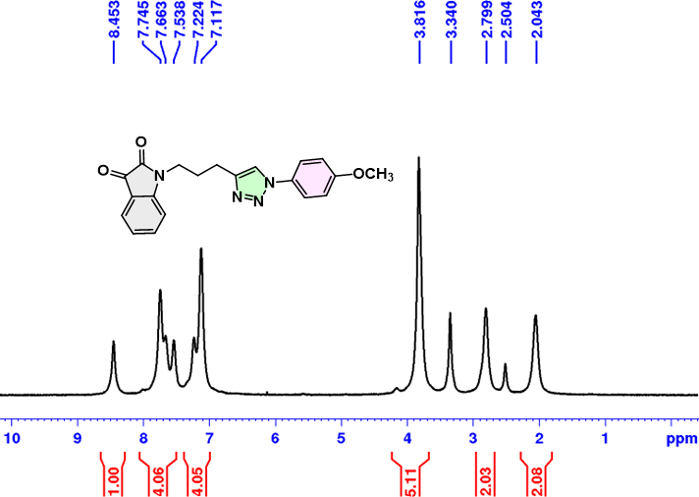
Figure S7. ¹H NMR of 1-(3-(1-(4-methoxyphenyl)-1H-1,2,3-triazol-4-yl)propyl)indoline-2,3-dione (3c).
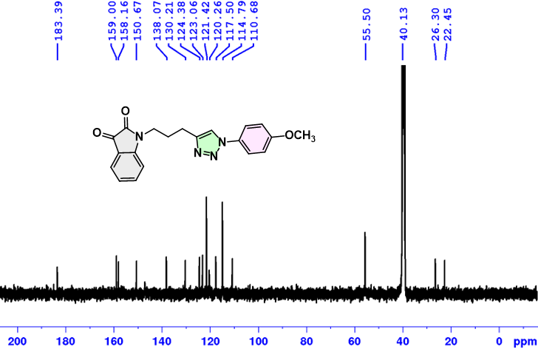
Figure S8. ¹³C NMR of 1-(3-(1-(4-methoxyphenyl)-1H-1,2,3-triazol-4-yl)propyl)indoline-2,3-dione (3c).
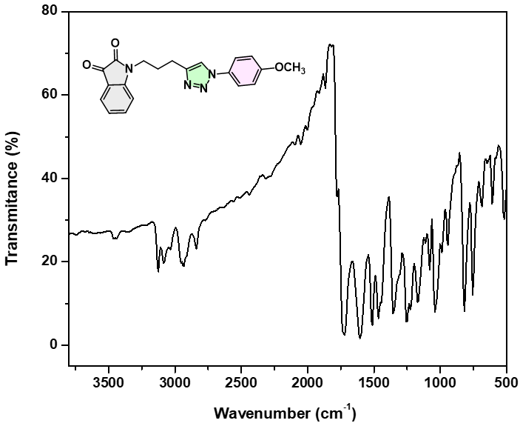
Figure S9. IR Spectra of 1-(3-(1-(4-methoxyphenyl)-1H-1,2,3-triazol-4-yl)propyl)indoline-2,3-dione (3c).

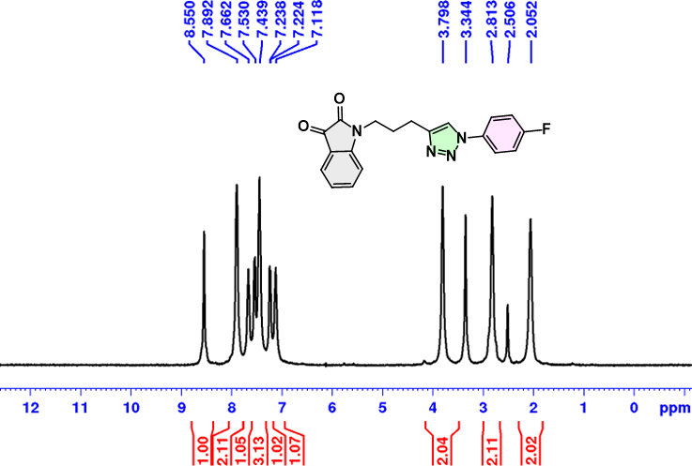
Figure S10. ¹H NMR of 1-(3-(1-(4-fluorophenyl)-1H-1,2,3-triazol-4-yl)propyl)indoline-2,3-dione (3d).

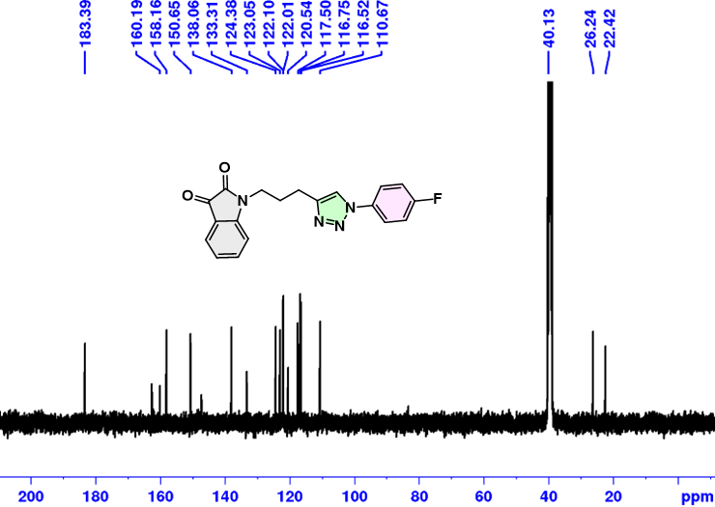
Figure S11. ¹³C NMR of 1-(3-(1-(4-fluorophenyl)-1H-1,2,3-triazol-4-yl)propyl)indoline-2,3-dione (3d).
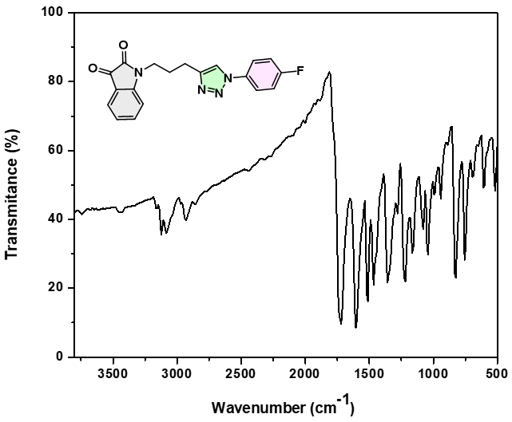
Figure S12. IR Spectra of 1-(3-(1-(4-fluorophenyl)-1H-1,2,3-triazol-4-yl)propyl)indoline-2,3-dione (3d).
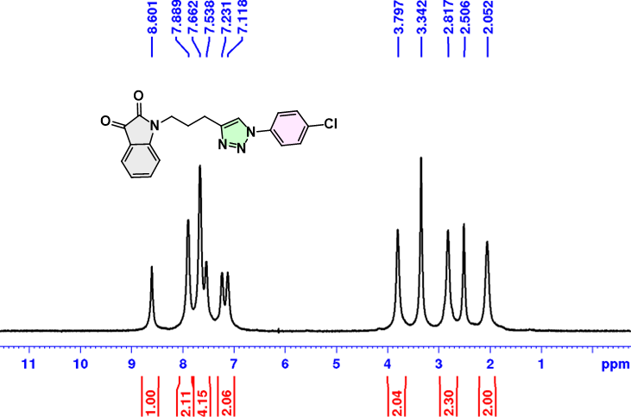
Figure S13. ¹H NMR of 1-(3-(1-(4-chlorophenyl)-1H-1,2,3-triazol-4-yl)propyl)indoline-2,3-dione (3e).

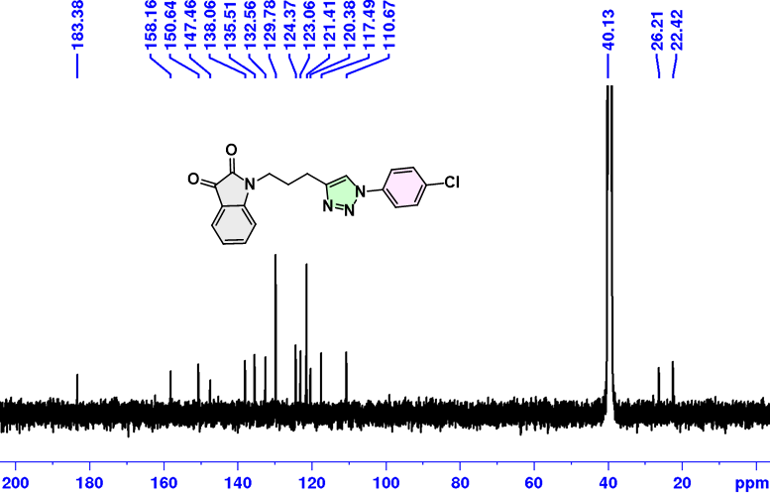
Figure S14. ¹³C NMR of 1-(3-(1-(4-chlorophenyl)-1H-1,2,3-triazol-4-yl)propyl)indoline-2,3-dione (3e).
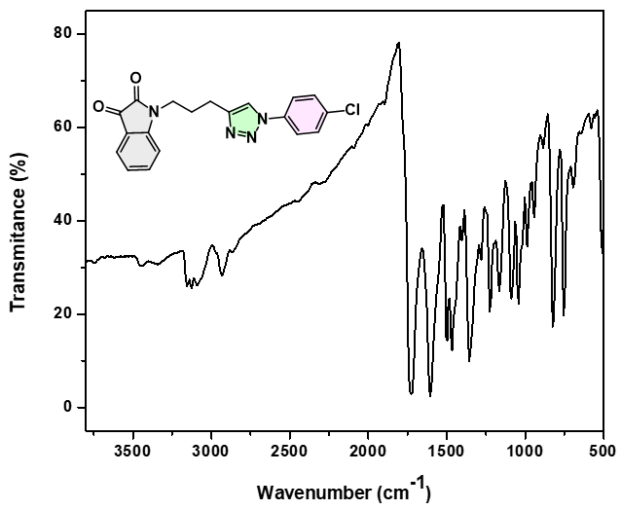
Figure S15. IR Spectra of 1-(3-(1-(4-chlorophenyl)-1H-1,2,3-triazol-4-yl)propyl)indoline-2,3-dione (3e).

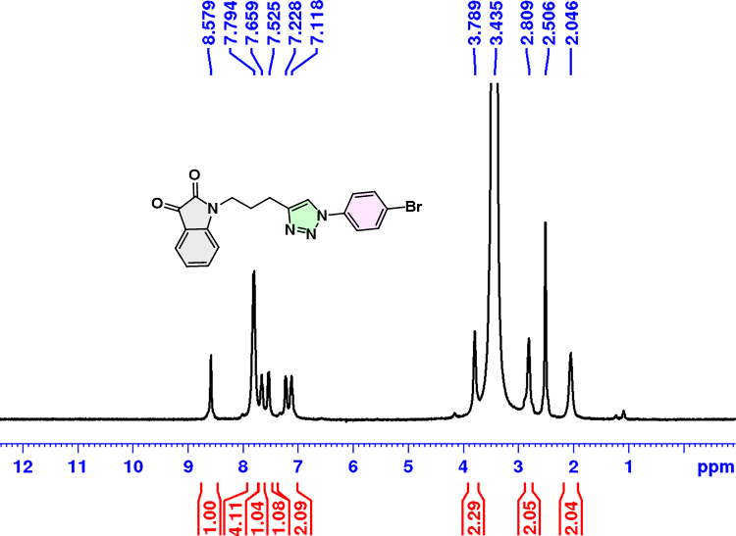
Figure S16. ¹H NMR of 1-(3-(1-(4-bromophenyl)-1H-1,2,3-triazol-4-yl)propyl)indoline-2,3-dione (3f).

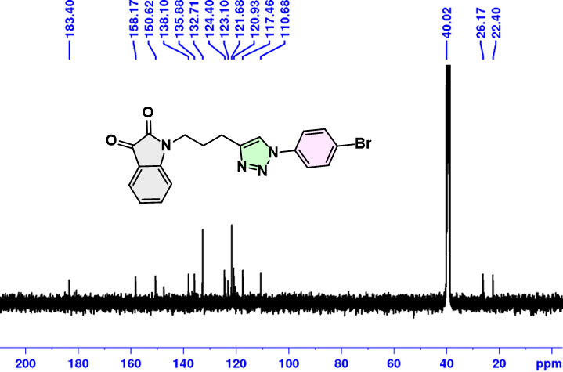
Figure S17. ¹³C NMR of 1-(3-(1-(4-bromophenyl)-1H-1,2,3-triazol-4-yl)propyl)indoline-2,3-dione (3f).

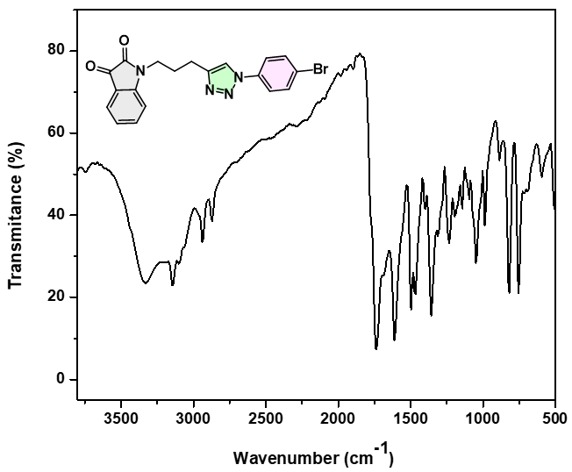
Figure S18. IR Spectra of 1-(3-(1-(4-bromophenyl)-1H-1,2,3-triazol-4-yl)propyl)indoline-2,3-dione (3f).
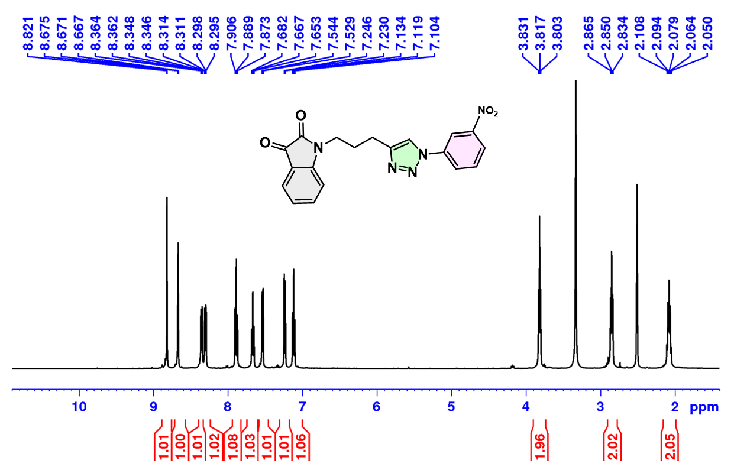
Figure S19. ¹H NMR of 1-(3-(1-(3-nitrophenyl)-1H-1,2,3-triazol-4-yl)propyl)indoline-2,3-dione (3g).

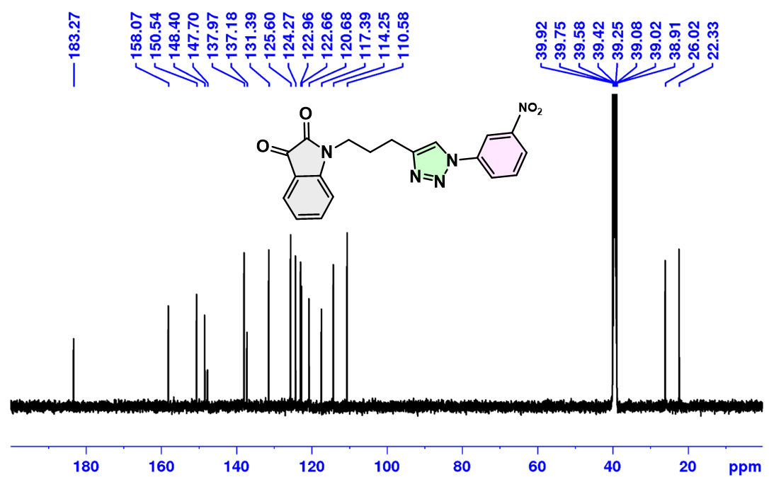
Figure S20. ¹³C NMR of 1-(3-(1-(3-nitrophenyl)-1H-1,2,3-triazol-4-yl)propyl)indoline-2,3-dione (3g).
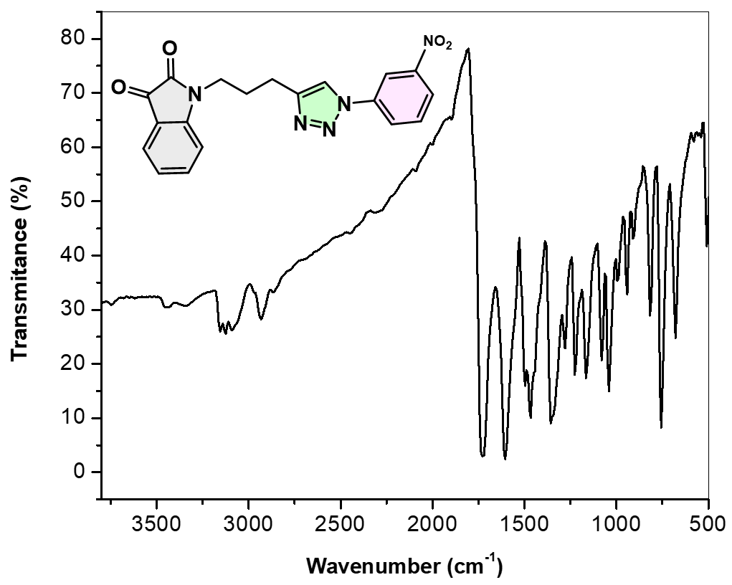
Figure S21. IR Spectra of 1-(3-(1-(3-nitrophenyl)-1H-1,2,3-triazol-4-yl)propyl)indoline-2,3-dione (3g).

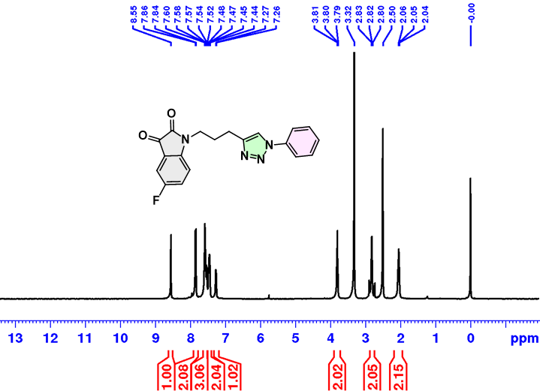
Figure S22. ¹H NMR of 5-fluoro-1-(3-(1-phenyl-1H-1,2,3-triazol-4-yl)propyl)indoline-2,3-dione (4a).
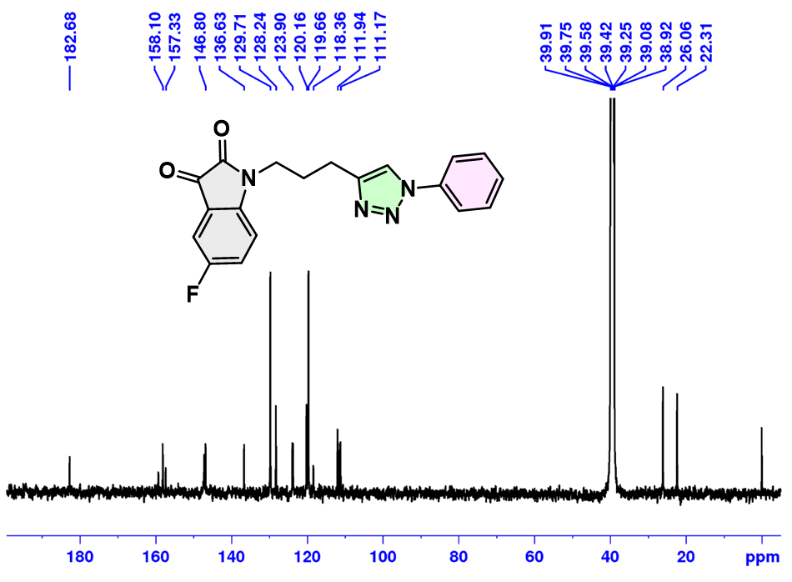
Figure S23. ¹³C NMR of 5-fluoro-1-(3-(1-phenyl-1H-1,2,3-triazol-4-yl)propyl)indoline-2,3-dione (4a).

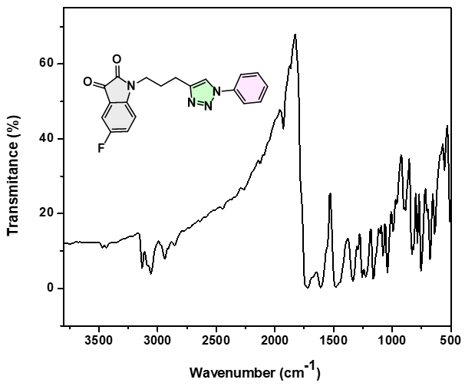
Figure S24. IR Spectra of 5-fluoro-1-(3-(1-phenyl-1H-1,2,3-triazol-4-yl)propyl)indoline-2,3-dione (4a).
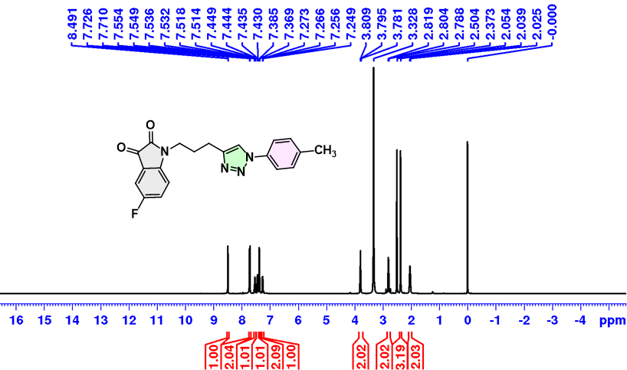
Figure S25. ¹H NMR of 5-fluoro-1-(3-(1-(p-tolyl)-1H-1,2,3-triazol-4-yl)propyl)indoline-2,3-dione (4b).
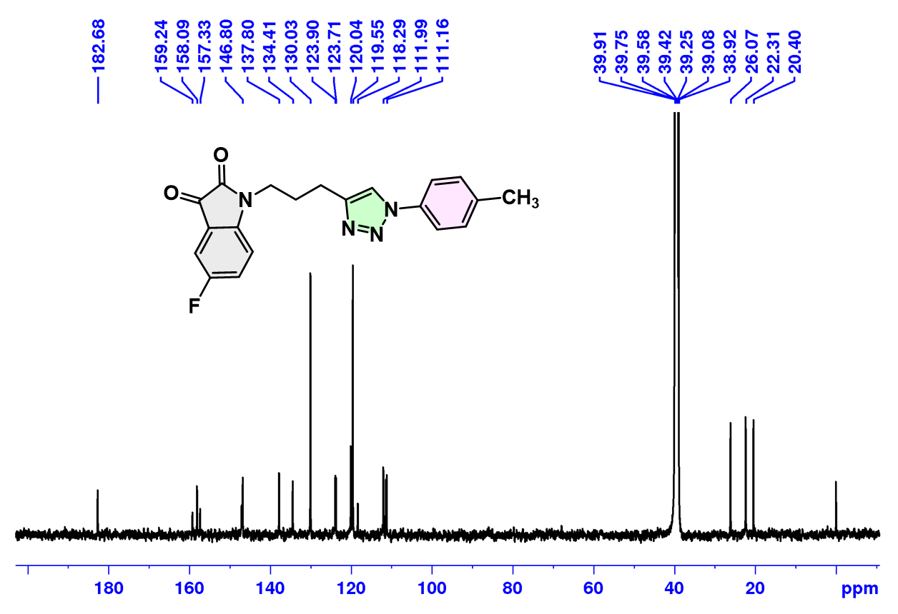
Figure S26. ¹³C NMR of 5-fluoro-1-(3-(1-(p-tolyl)-1H-1,2,3-triazol-4-yl)propyl)indoline-2,3-dione (4b).
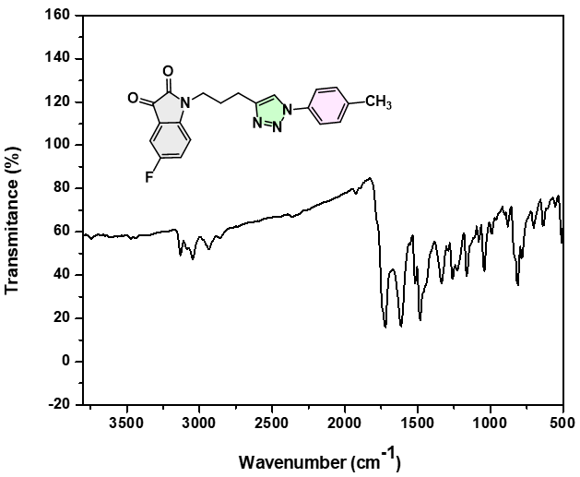
Figure S27. IR Spectra of 5-fluoro-1-(3-(1-(p-tolyl)-1H-1,2,3-triazol-4-yl)propyl)indoline-2,3-dione (4b).
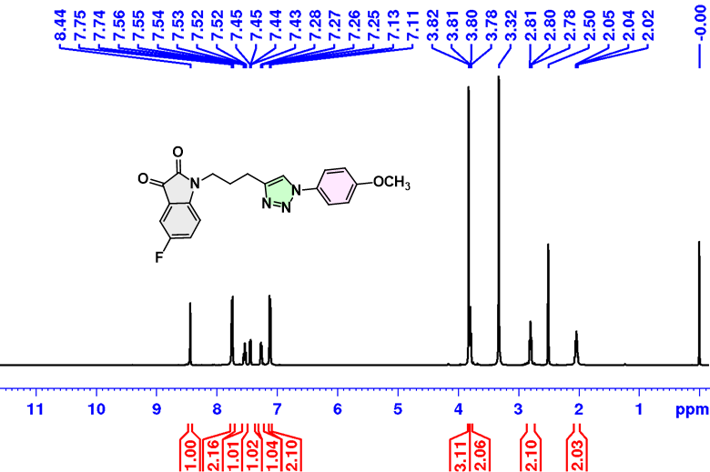
Figure S28. ¹H NMR of 5-fluoro-1-(3-(1-(4-methoxyphenyl)-1H-1,2,3-triazol-4-yl)propyl)indoline-2,3-dione (4c).
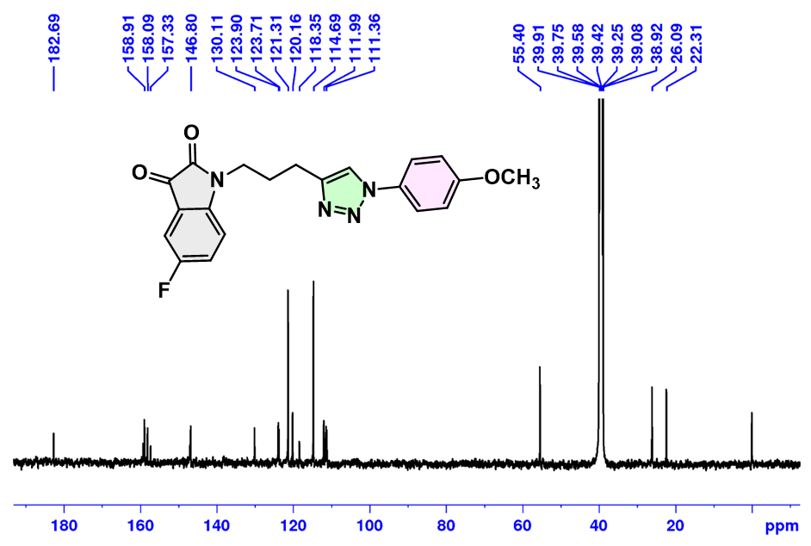
Figure S29. ¹³C NMR of 5-fluoro-1-(3-(1-(4-methoxyphenyl)-1H-1,2,3-triazol-4-yl)propyl)indoline-2,3-dione (4c).

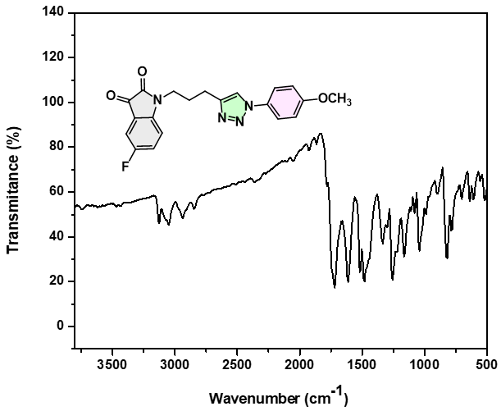
Figure S30. IR Spectra of 5-fluoro-1-(3-(1-(4-methoxyphenyl)-1H-1,2,3-triazol-4-yl)propyl)indoline-2,3-dione (4c).
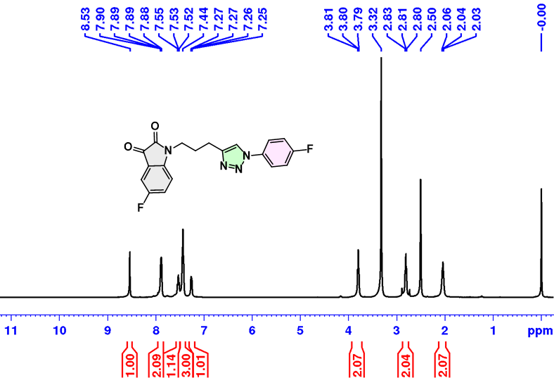
Figure S31. ¹H NMR of 5-fluoro-1-(3-(1-(4-fluorophenyl)-1H-1,2,3-triazol-4-yl)propyl)indoline-2,3-dione (4d).

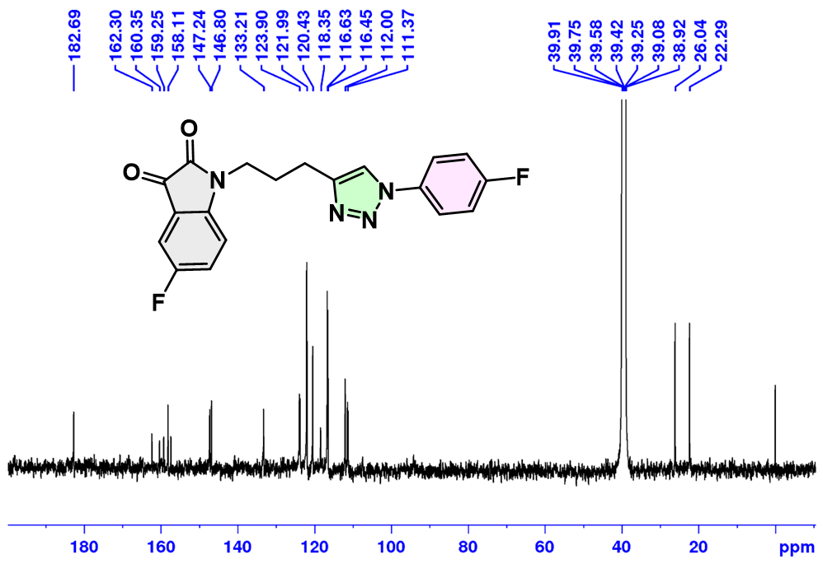
Figure S32. ¹³C NMR of 5-fluoro-1-(3-(1-(4-fluorophenyl)-1H-1,2,3-triazol-4-yl)propyl)indoline-2,3-dione (4d).
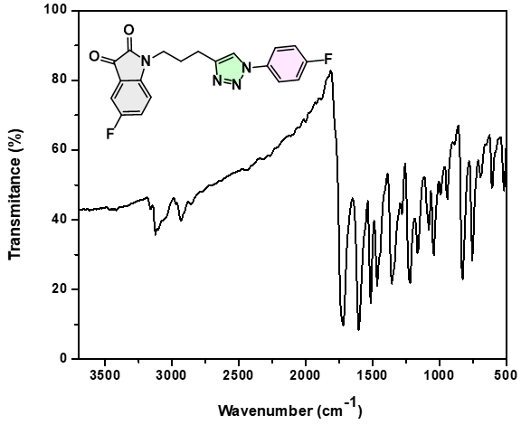
Figure S33. IR Spectra of 5-fluoro-1-(3-(1-(4-fluorophenyl)-1H-1,2,3-triazol-4-yl)propyl)indoline-2,3-dione (4d).

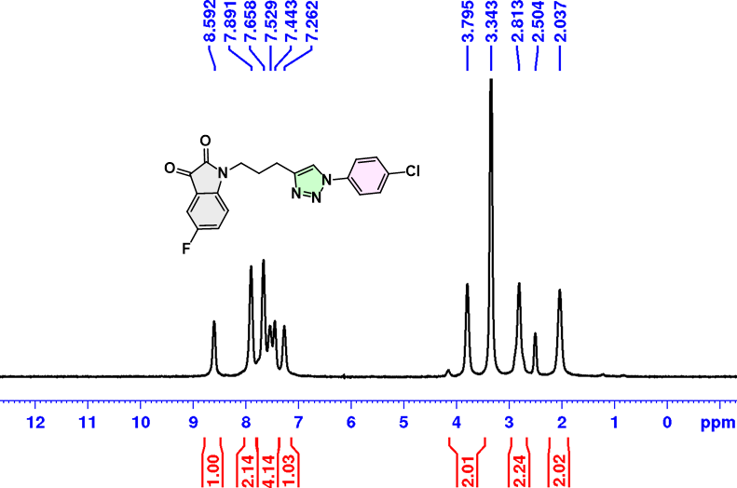
Figure S34. ¹H NMR of 1-(3-(1-(4-chlorophenyl)-1H-1,2,3-triazol-4-yl)propyl)-5-fluoroindoline-2,3-dione (4e).

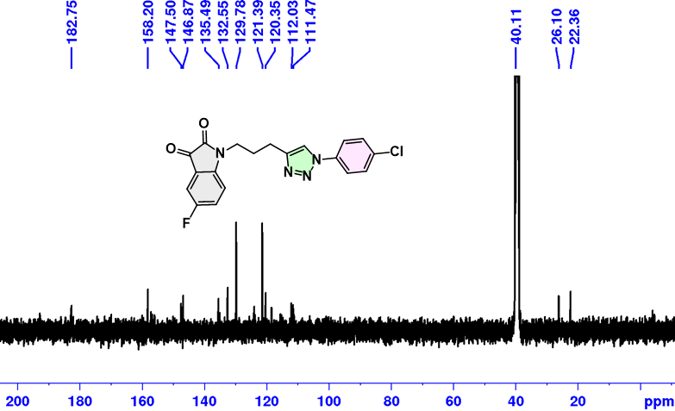
Figure S35. ¹³C NMR of 1-(3-(1-(4-chlorophenyl)-1H-1,2,3-triazol-4-yl)propyl)-5-fluoroindoline-2,3-dione (4e).

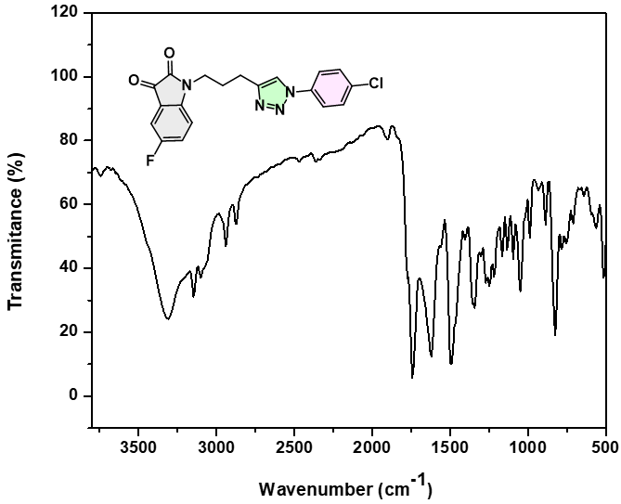
Figure S36. IR Spectra of 1-(3-(1-(4-chlorophenyl)-1H-1,2,3-triazol-4-yl)propyl)-5-fluoroindoline-2,3-dione (4e).
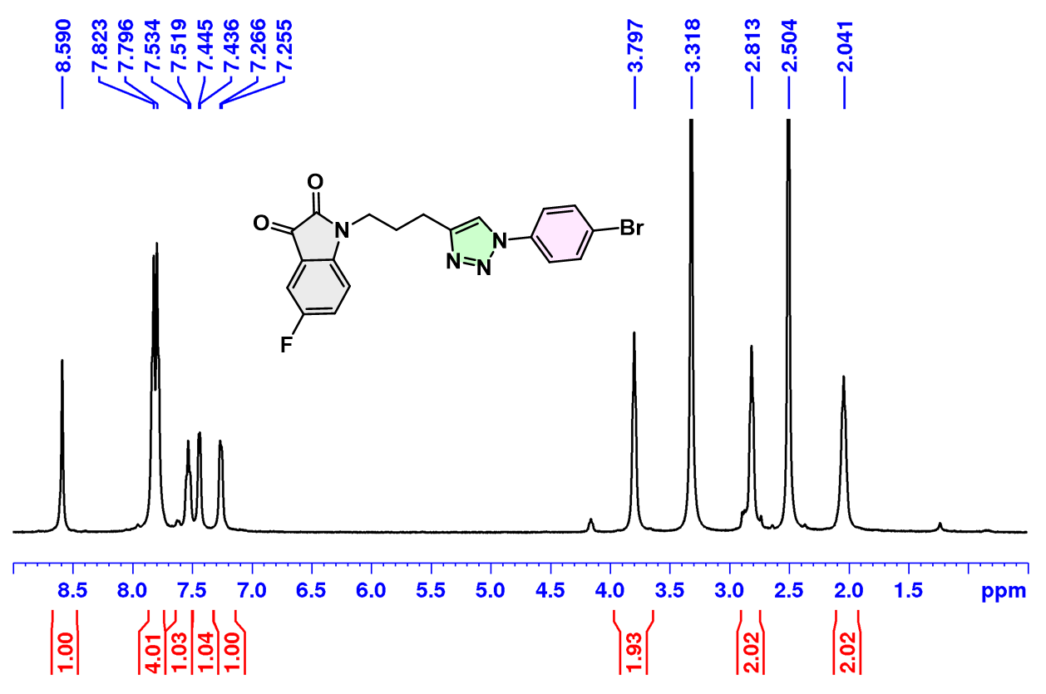
Figure S37. ¹H NMR of 1-(3-(1-(4-bromophenyl)-1H-1,2,3-triazol-4-yl)propyl)-5-fluoroindoline-2,3-dione (4f).
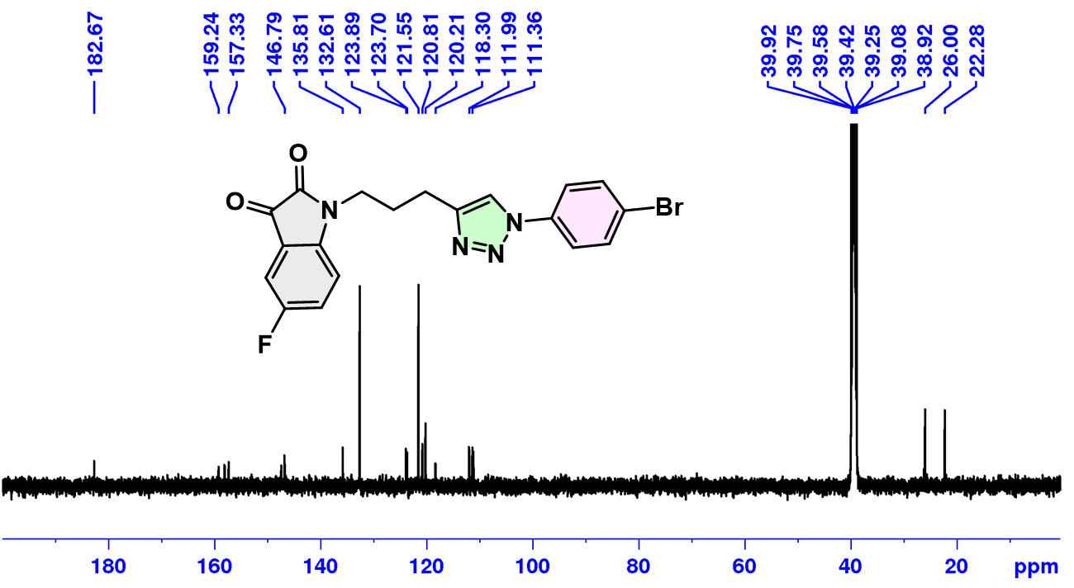
Figure S38. ¹³C NMR of 1-(3-(1-(4-bromophenyl)-1H-1,2,3-triazol-4-yl)propyl)-5-fluoroindoline-2,3-dione (4f).
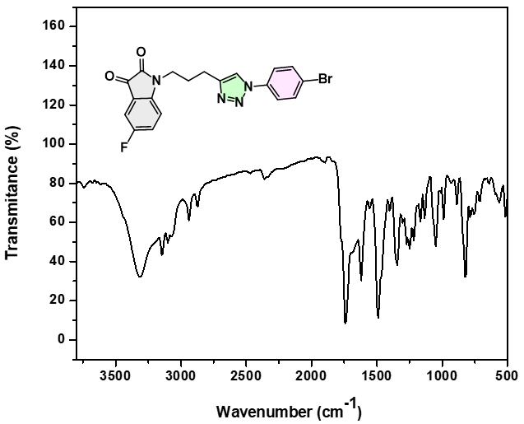
Figure S39. IR Spectra of 1-(3-(1-(4-bromophenyl)-1H-1,2,3-triazol-4-yl)propyl)-5-fluoroindoline-2,3-dione (4f).

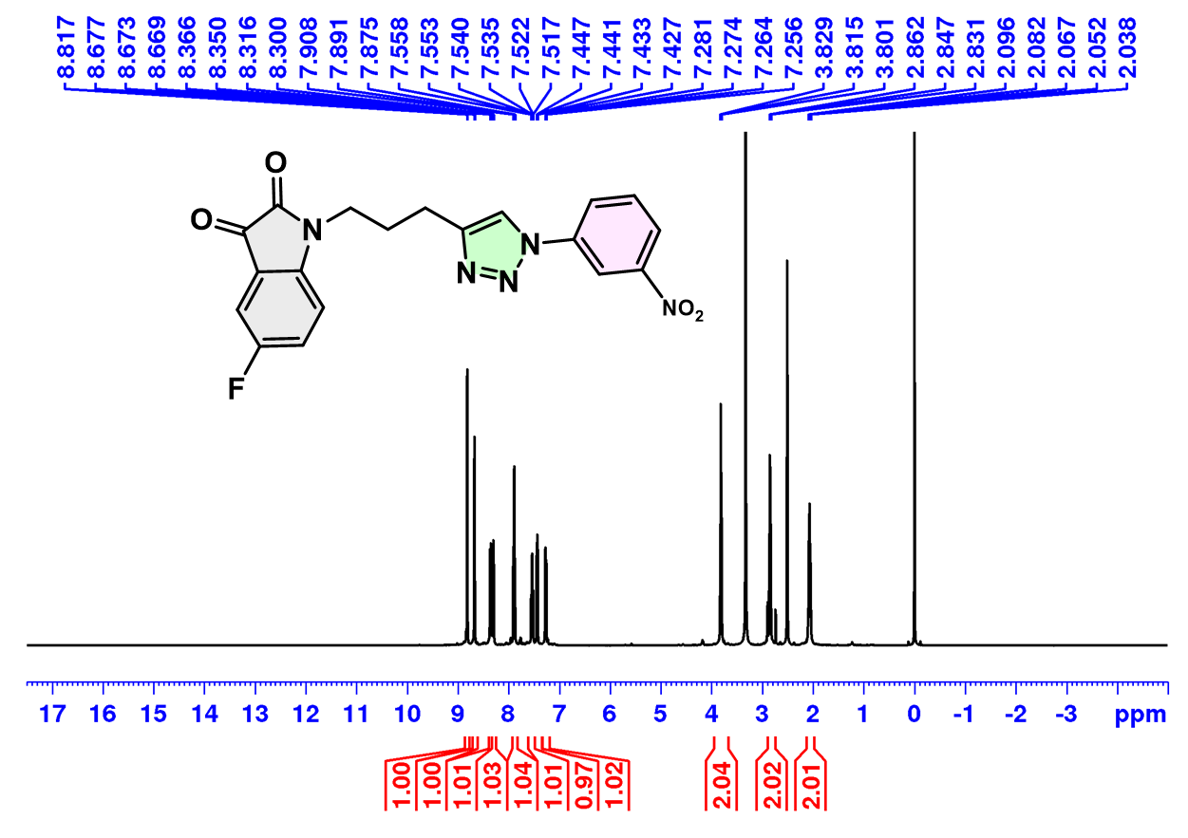
Figure S40. ¹H NMR of 5-fluoro-1-(3-(1-(3-nitrophenyl)-1H-1,2,3-triazol-4-yl)propyl)indoline-2,3-dione (4g).
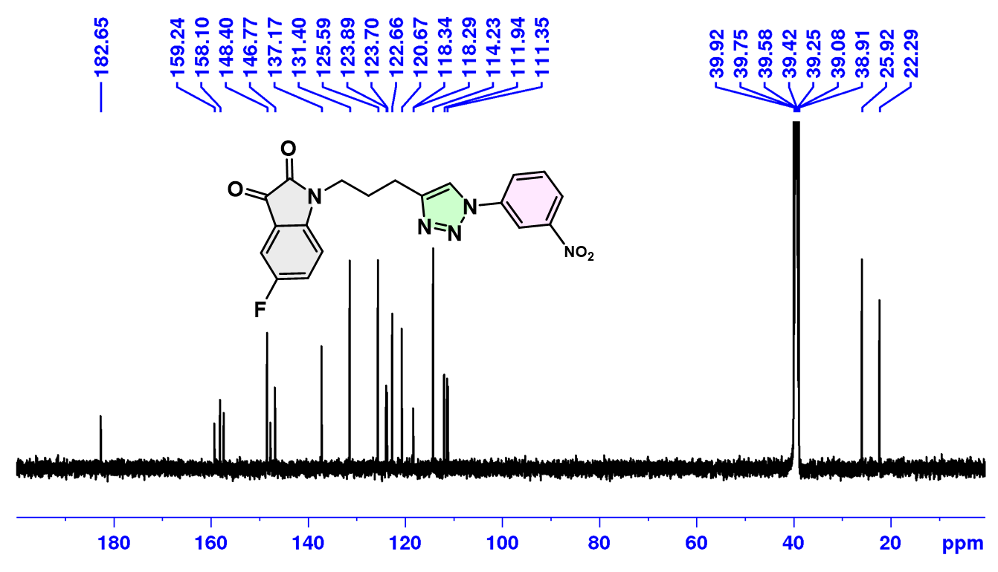
Figure S41. ¹³C NMR of 5-fluoro-1-(3-(1-(3-nitrophenyl)-1H-1,2,3-triazol-4-yl)propyl)indoline-2,3-dione (4g).

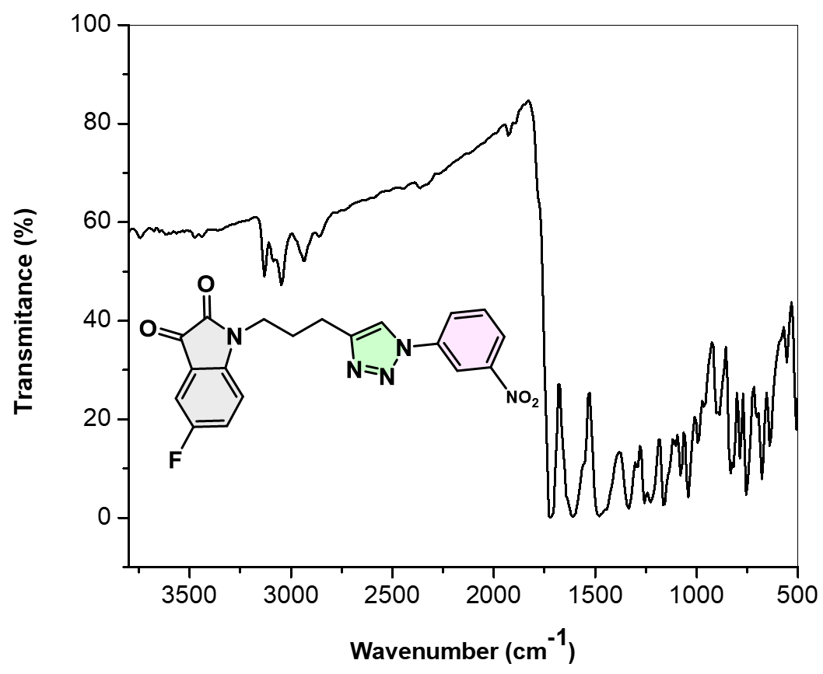
Figure S42. IR Spectra of 5-fluoro-1-(3-(1-(3-nitrophenyl)-1H-1,2,3-triazol-4-yl)propyl)indoline-2,3-dione (4g).

- HRMS of compounds 3f, 4a, 4c, 4d, and 4g
Figure S43. HRMS of 1-(3-(1-(4-bromophenyl)-1H-1,2,3-triazol-4-yl)propyl)indoline-2,3-dione (3f).
Figure S44. HRMS of 5-fluoro-1-(3-(1-phenyl-1H-1,2,3-triazol-4-yl)propyl)indoline-2,3-dione (4a).

Figure S45. HRMS of 5-fluoro-1-(3-(1-(4-methoxyphenyl)-1H-1,2,3-triazol-4-yl)propyl) indoline-2,3-dione (4c).

Figure S46. HRMS of 5-fluoro-1-(3-(1-(4-fluorophenyl)-1H-1,2,3-triazol-4-yl)propyl)indoline-2,3-dione (4d).

Figure S47. HRMS of 5-fluoro-1-(3-(1-(3-nitrophenyl)-1H-1,2,3-triazol-4-yl)propyl)indoline-2,3-dione (4g).

