Figures
Figure 1. Average annual loss/average annual number of people affected per square kilometre due to TC-induced wind and surge risk for each asset in the current 2020 scenario and in the future 2050 scenarios under RCP4.5 and RCP8.5. The future scenarios take into account economic growth and climate change with sea level rise and assume increased TC intensity and decrease in TC frequency (+I/-F) relative to current levels.
 | Wind |  |  | Surge
 | Current | RCP4.5 | RCP8.5 | Current | RCP4.5 | RCP8.5
House | 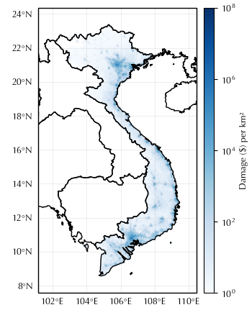 | 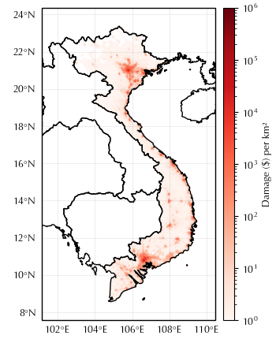 | 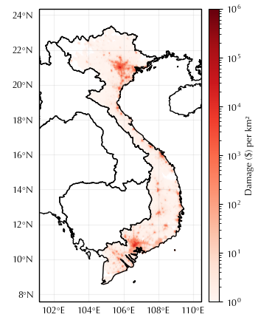 | 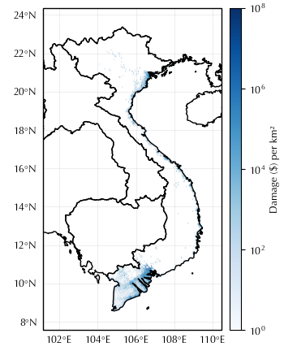 | 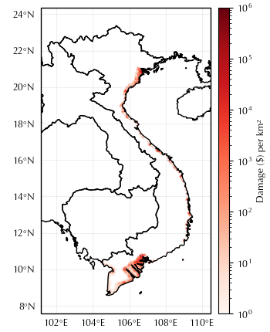 | 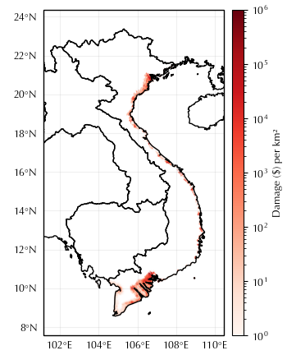
Agriculture | 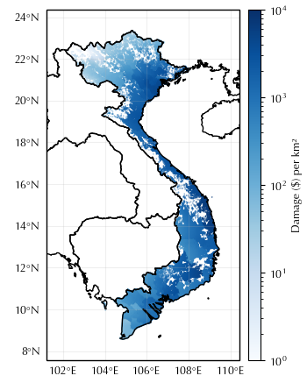 | 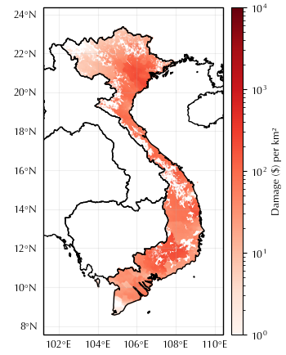 | 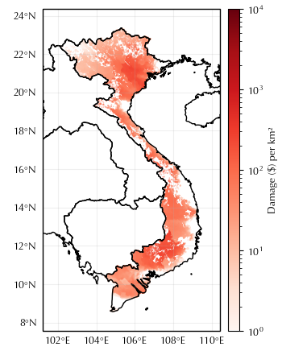 | 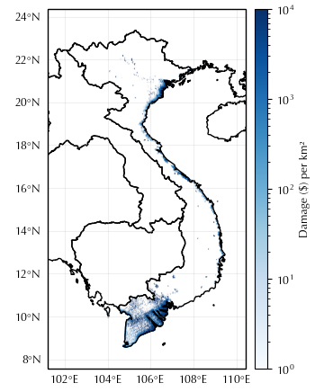 | 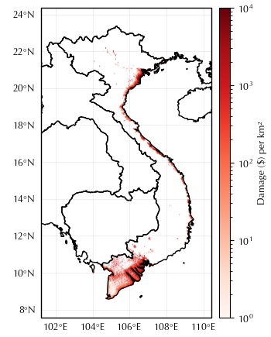 | 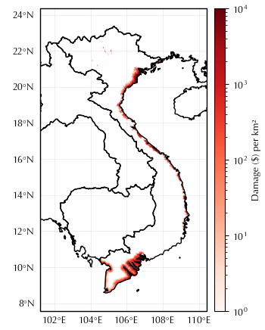
Population | 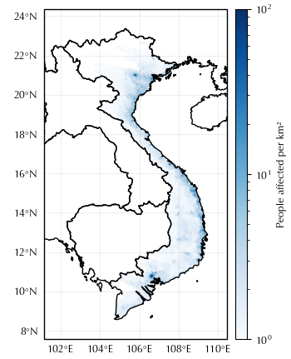 | 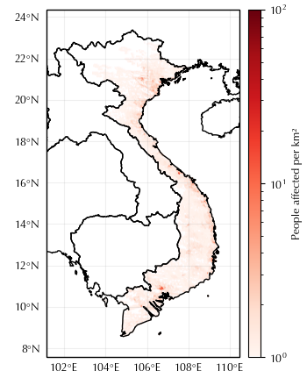 | 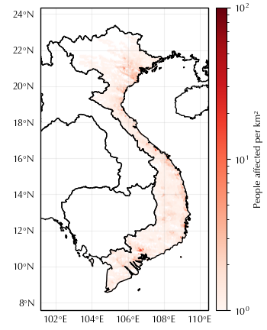 | 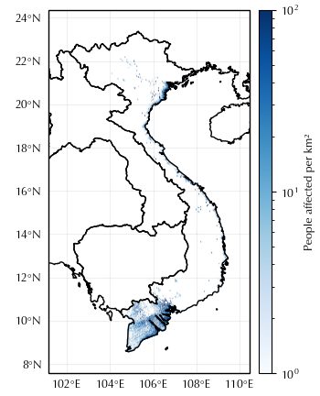 | 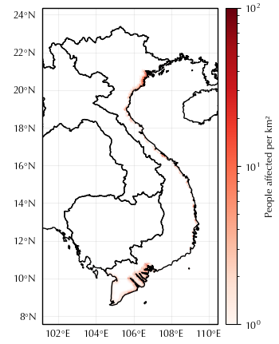 | 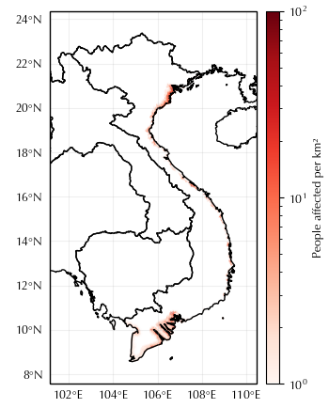

Figure 2. Damage caused/number of people affected by wind and surge across each asset and for different severity levels (return period). The damage/number of people impacted is calculated under current and future 2050 climate scenarios (RCP4.5 and RCP8.5) assuming TC intensity increases with decrease in TC frequency (+I/-F). The impact of economic growth and adaptation measures are also modelled under both future climate scenarios assuming (+I/-F).
 | Wind |  | Surge
 | Climate Scenarios | Climate Scenarios including Economic Growth and Adaptation | Climate Scenarios | Climate Scenarios including Economic Growth and Adaptation
House | 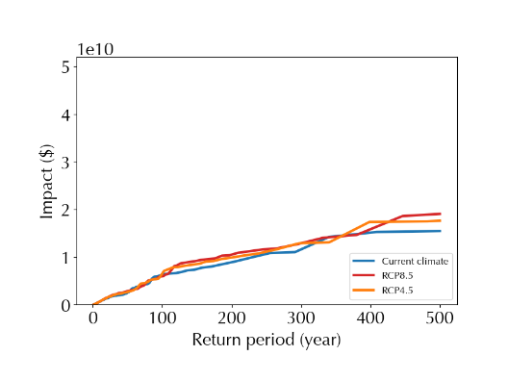 | 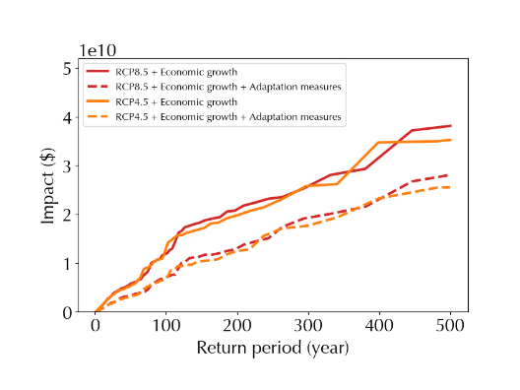 | 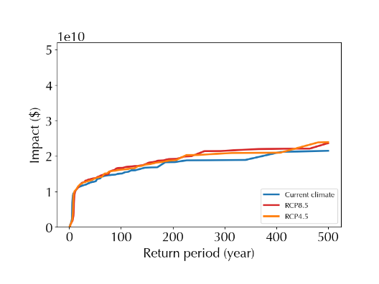 | 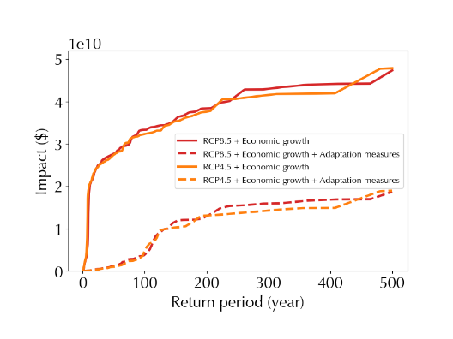
Agriculture | 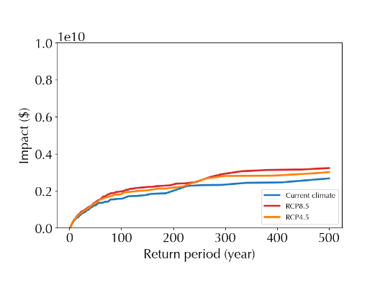 | 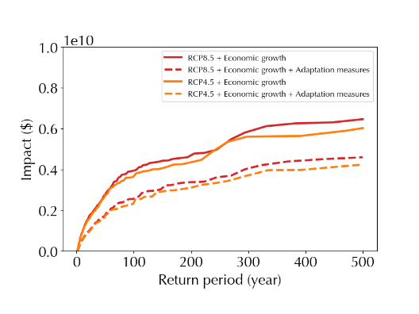 | 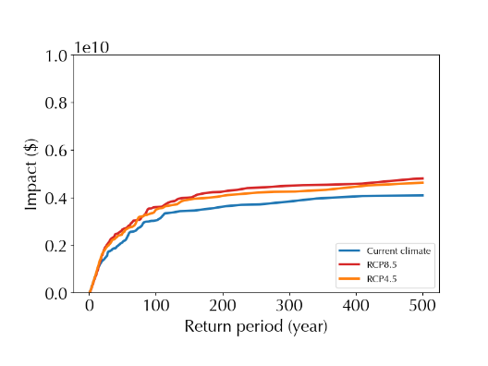 | 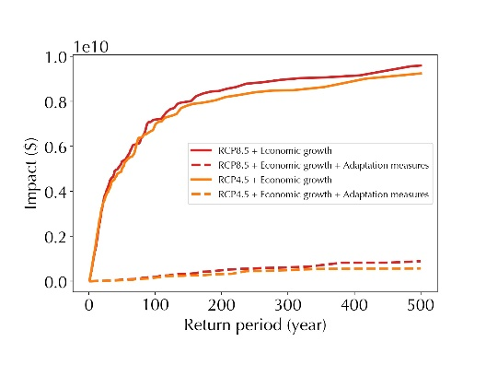
Population | 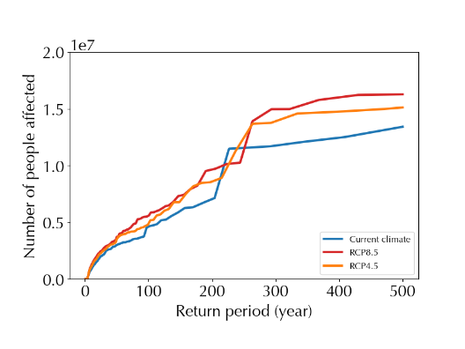 | 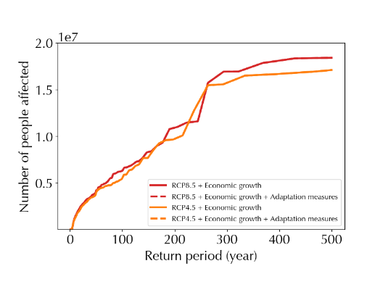 | 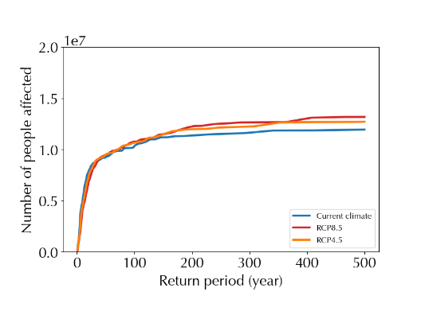 | 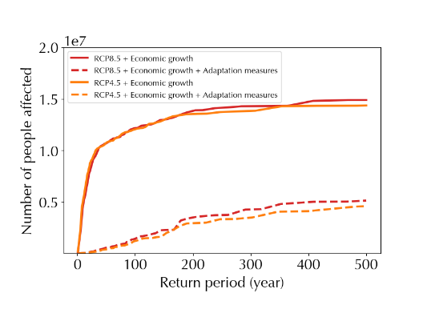

Tables
Table 1. The average annual loss (AAL), an estimate of the total damage expected to occur/number of people impacted on average every year due to TC wind and storm surge based on modelling in CLIMADA, is presented per asset. The AAL is calculated for the current and future scenarios. The latter take into account two climate change scenarios, RCP4.5 and RCP8.5, and economic growth. For each future scenario two sets of assumptions were used: increased intensity and decreased frequency of TCs (+I/-F) as per Knutson et. al. 2015 and increased intensity and no change in frequency (+I/0F) relative to current levels. These differing assumptions allow model sensitivity to be tested.

Asset/Events | Current Climate |  | Future RCP4.5 (+I/0F) |  | Future RCP8.5 (+I/0F) |  | Future RCP4.5 (+I/-F) |  | Future RCP8.5 (+I/-F)
TC Module | Wind | Surge | Wind | Surge | Wind | Surge | Wind | Surge | Wind | Surge
House  ($ million) | 345 | 2650 | 445 | 2930 | 517 | 3080 | 364 | 2300 | 363 | 2010
Agriculture ($ million ) | 168 | 307 | 216 | 410 | 250 | 465 | 177 | 325 | 175 | 307
Population (Thousand) | 315 | 1940 | 443 | 2080 | 539 | 2160 | 374 | 1630 | 398 | 1410

Table 2. Annual average loss for houses and agriculture is provided under future scenario RCP 8.5 assuming increased TC intensity and no change in frequency (+I/0F) and taking into account economic growth without adaptation measures. This is compared to the same scenario with adaptation measures in place. Insurance is applied to the residual risk remaining after adaptation measures: the AAL transferred is the portion of TC losses that insurers will bear on average every year. The AAL that remains after adaptation measures and risk transfer is the annual losses on average to be borne by the government, population and private sector.

Asset | Houses |  | Agriculture
Hazard | Wind | Surge | Wind | Surge
Annual Average Loss  Without adaptation  ($ million) | 1030 | 6170 | 500 | 930
Annual Average Loss  With adaptation  ($ million) | 584 | 299 | 284 | 12.3
Risk transferred  ($ million) | 251 | 186 | 125 | 7.07
Annual Average Loss Retained  (after adaptation and risk transfer)  ($ million) | 333 | 113 | 159 | 5.23

