Supplementary data
Supplementary Figure 1.
Log2-transformed expression values for EZH2 and NK ligands were obtained from the R2 Genomics Analysis and Visualisation Platform (R2 Genomics Analysis and Visualisation Platform) A) GSE16476 (88 microarray samples) B) Westerman-579 (579 RNA-seq samples). C) GSE62564 (498 RNA-seq samples).

A

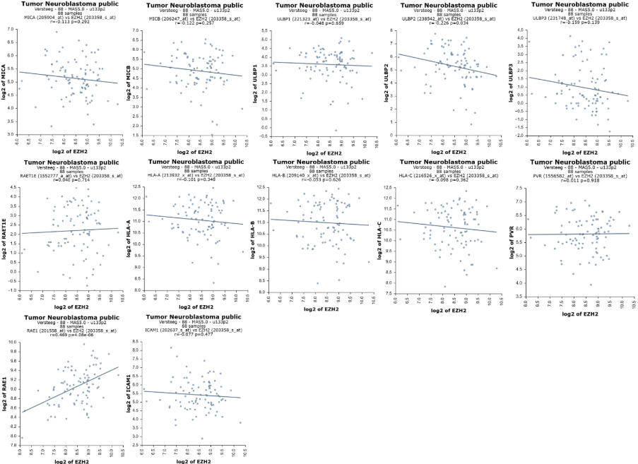

B
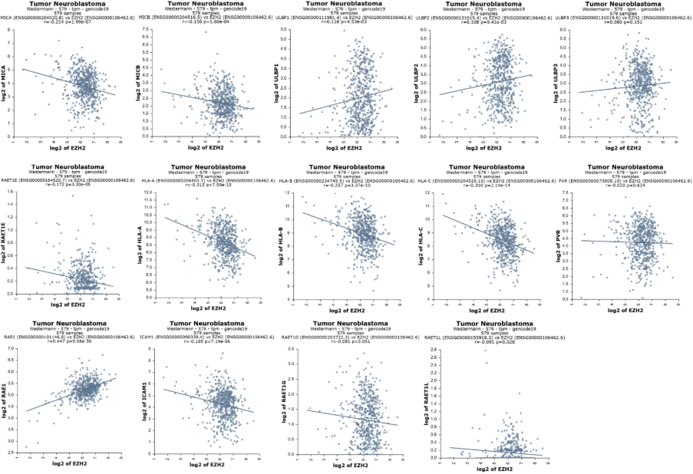

C
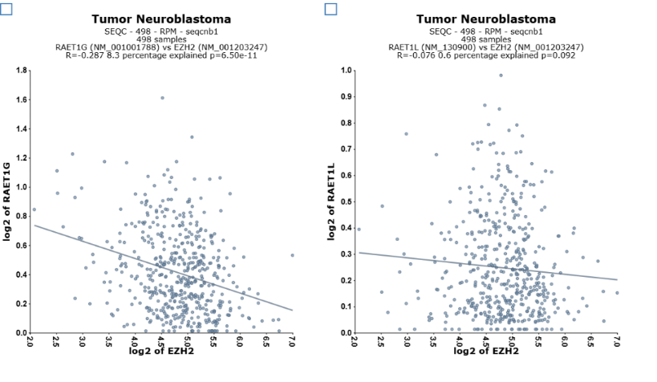

Supplementary Figure 2.
Gating strategies A NK ligand expression: Representative flow cytometry gating strategy for analysis of surface protein expression. Kelly cells were identified by forward and side scatter, dead cells excluded by DAPI staining, and live single cells were analysed for marker expression (example shown for ULBP-1). B GD2 expression: Representative flow cytometry gating strategy for analysis of GD2 protein expression. Live NB cells were identified by forward and side scatter, and single cells were analysed for marker expression. C ADCC assays: Representative dot plots used to identify Whole PBMC and Isolated NK populations.

A
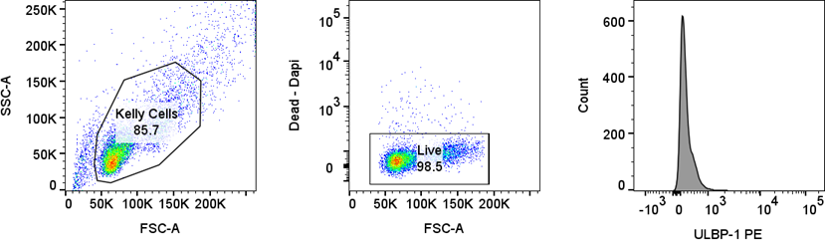

B
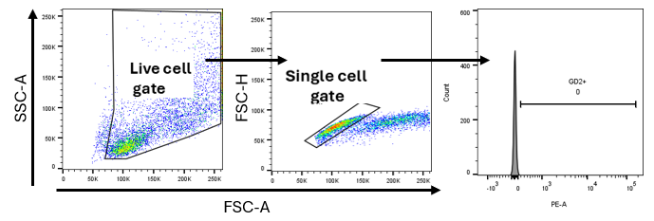

C
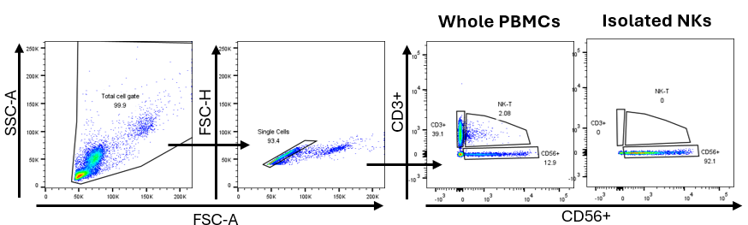

Supplementary Figure 3. GD2 expression following TAZ treatment in different NB cell lines and MICA/B expression following Taz treatment in Kelly cells. A GD2 expression of Human and mouse NB cell lines left untreated (left) or after 6 days Taz treatment (Right) Blue square highlights cell lines which increase GD2 expression after Taz treatment. B GD2 expression following Taz treatment in IMR-32 cells. Orange Represents GD2 level in DMSO, green represents GD2 levels of Taz treated cells. C MICA/B expression levels following Taz treatment on Kelly cells. Culture media used 9464D & 9464D-GD2 (RPMI + 10% FCS + 1%PS + 2%NEAA). COG-N519, CHLA-20 and CHLA-90 (IMDM + 10% FCS + 0.5x PS + 0.5x ITS solution, 1x NEAA, 4mM Glutamine).
