Additional files
Additional file: Table S1. List of crud drug extracts in Kampo library.
ID.No. | Crude drug extract name | ID.No. | Crude drug extract name | ID.No. | Crude drug extract name
1 | Clematis Root | 41 | Asiasarum Root | 81 | Citrus Unshiu Peel
2 | Artemisia Capillaris Flower | 42 | Saffron | 82 | Gastrodia Tuber
3 | Turmeric | 43 | Smilax Rhizome | 83 | Asparagus Root
4 | Lindera Root | 44 | Gardenia Fruit | 84 | Benincasa Seed
5 | Corydalis Tuber | 45 | Panax Notoginseng Root | 85 | Angelica Dahurica Root
6 | Astragalus Root | 46 | Cornus Fruit | 86 | Codonopsis Root
7 | Scutellaria Root | 47 | Japanese Zanthoxylum Peel | 87 | Peach Kernel
8 | Phellodendron Bark | 48 | Jujube Seed | 88 | Aralia Rhizome
9 | Cherry Bark | 49 | Dioscorea Rhizome | 89 | Eucommia Bark
10 | Coptis Rhizome | 50 | Sparganium Rhizome | 90 | Cistanche Herb
11 | Polygala Root | 51 | Rehmannia Root | 91 | Ginseng
12 | Artemisiae Leaf | 52 | Eleutherococcus Senticosus Rhizome | 92 | Fritillaria Bulb
13 | Polygonum Root | 53 | Lycium Bark | 93 | Densefruit Pittany Root Bark
14 | Curcuma Rhizome | 54 | Tribulus Fruit | 94 | Ophiopogon Root
15 | Pueraria Root | 55 | Peony Root | 95 | Mentha Herb
16 | Trichosanthes Root | 56 | Plantago Seed | 96 | Pinellia Tuber
17 | Processed Ginger | 57 | Processed Rehmannia Root | 97 | Japanese Angelica Root
18 | Glycyrrhiza | 58 | Amomum Seed | 98 | Atractylodes Rhizome
19 | Platycodon Root | 59 | Ginger | 99 | Loquat Leaf
20 | Chrysanthemum Flower | 60 | Cimicifuga Rhizome | 100 | Areca
21 | Immature Orange | 61 | Magnolia Flower | 101 | Poria Sclerotium
22 | Notopterygium | 62 | Gentiana Macrophylla Root | 102 | Sinomenium Stem and Rhizome
23 | Apricot Kernel | 63 | Red Peony Root | 103 | Imperata Rhizome
24 | Sophora Root | 64 | Cnidium Rhizome | 104 | Saposhnikovia Root and Rhizome
25 | Sasa Leaf | 65 | Ginseng | 105 | Processed Aconite Root
26 | Schizonepeta Spike | 66 | Atractylodes Lancea Rhizome | 106 | Quercus Bark
27 | Suberect Spatholobus Stem | 67 | Mulberry Bark | 107 | Malaytea Scurfpea Fruit
28 | Cinnamom Bark | 68 | Mulberry Leaf | 108 | Moutan Bark
29 | Scrophularia Root | 69 | Dipsacus Root | 109 | Ephedra Herb
30 | Safflower | 70 | Perilla Herb | 110 | Hemp Fruit
31 | Silktree Albizia Bark | 71 | Rhubarb | 111 | Shrub Chaste Tree Fruit
32 | Red Ginseng | 72 | Jujube | 112 | Saussurea Root
33 | Cyperus Rhizome | 73 | Alisma Tuber | 113 | Myrrh
34 | Magnolia Bark | 74 | Salvia Miltiorrhiza Root | 114 | Bitter Cardamon
35 | Achyranthes Root | 75 | Bamboo Culm | 115 | Leonurus Herb
36 | Euodia Fruit | 76 | Panax Japonicus Rhizome | 116 | Coix Seed
37 | Burdock Fruit | 77 | Anemarrhena Rhizome | 117 | Japanese Gentian
38 | Sesame | 78 | Clove | 118 | Alpinia Officinarum Rhizome
39 | Schisandra Fruit | 79 | Uncaria Hook | 119 | Ganoderma
40 | Bupleurum Root | 80 | Polyporus Sclerotium | 120 | Forsythia Fruit

Additional file: Table S2. List of compounds in Kampo library.
ID.No. | Compound name | ID.No. | Compound name | ID.No. | Compound name
1 | Acontine | 33 | Dehydrocorydaline Nitrate | 65 | (Z)-Ligustilide
2 | Albiflorin | 34 | Dehydrocostuslactone | 66 | Limonin
3 | Alisol A | 35 | Demethoxycurcumine | 67 | Liquiritin
4 | Alison B | 36 | Dihydrocapsaicin | 68 | Loganin
5 | Alkanin | 37 | Dimethylsculetin | 69 | Luteolin
6 | Amygdalin | 38 | Eleutheroside B | 70 | Magnolol
7 | Arbutin | 39 | (-)-Epigallocathechin Gallate | 71 | Mesaconitine
8 | Astragaloside IV | 40 | Epihesperidine | 72 | Naringin
9 | Atractylenolide III | 41 | Ergosterol | 73 | Nodakenin
10 | Atractylodin | 42 | β- Eudesmol | 74 | Osthol
11 | Atropin Sulphate | 43 | Evodiamine | 75 | Oxymatrine
12 | Aucubin | 44 | (E)-Ferulic acid | 76 | Paeoniflorin
13 | Baicalein | 45 | Geniposide | 76 | Paeoniflorin
14 | Baicalin | 46 | Geniposidic Acid | 77 | Paeonol
15 | Barbaloin | 47 | Gentiopicroside | 78 | Palmatine Chloride
16 | Benzoylmesaconine Hydrochloride | 48 | (6)-Gingerol | 79 | Perillaldhyde
17 | Berberin Chloride | 49 | Ginsenoside-Rb1 | 81 | Puerarin
18 | Bergenin | 50 | Ginsenoside-Rc | 82 | Rhynchophylline
19 | Bisdemethoxycurcumin | 51 | Ginsenoside-Rd | 83 | Rosmaric Acid
20 | Bufalin | 52 | Ginsenoside-Re | 84 | Saikosaponin a
21 | Bufotalin | 53 | Ginsenoside-Rg1 | 85 | Saikosaponin b2
22 | Cappillarisin | 54 | Glabridine | 86 | Saikosaponin c
23 | (E)-Capsaicin | 55 | Glycyrrhizic Acid | 87 | Saikosaponin d
24 | Catalpol | 56 | Gomison A | 88 | Schizandrin
25 | (E)-Chlorogenic Acid | 57 | Gomison N | 89 | Sennoside A
26 | (E)-Cinnamic Acid | 58 | Hesperidin | 90 | Sennoside B
27 | Cinobufagin | 59 | Hirsutine | 91 | Shikonin
28 | Cinobufotalin | 60 | Honokiol | 92 | (6)-Shogaol
29 | Coptisine Chloride | 61 | Hypacontine | 93 | Sinomenine
30 | Corydalin | 62 | Icariin | 94 | Swertiamarin
31 | Costunolide | 63 | Isofraxidine | 95 | Timosaponin A-III
32 | Curcumin | 64 | Isorhynchophyllin | 96 | Wogonin

Additional file: Table S3. In vitro antimalarial activities against P. falciparum CQ/mefloquine (MQ)-sensitive (3D7) strains and the cytotoxicities using Adult Mouse Brian Cell (AMB) of crude drug extracts.
Name | IC₅₀ (µg/mL) | CC₅₀ (µg/mL) | SI
Coptis Rhizome | 1.9 | > 500 | >263
Phellodendron Bark | 6.7 | 23.5 | 3.5
Clove | 18.5 | > 500 | >27
Quercus Bark | 44 | > 500 | >11.7
Rhubarb | 61.3 | > 500 | >8.2
Sesame | 81.2 | > 500 | >6.1

IC₅₀: 50% inhibitory concentration.
CC₅₀: 50% cytotoxic concentration using adult mouse brain cells
SI: Selectivity Index
Values are the mean from two independent experiments performed in duplicate.

Additional file: Table S4. Formulation of herbal extracts percentage by weight in Orengedokuto (Toyama verses Tsumura composition of Kampo formula Orengedokuto).
Formula (Company) | Herbal extracts | %
Orengedokuto (Toyama) | Coptise Rhizome | 33.3
Orengedokuto (Toyama) | Phellodendron Bark | 22.2
Orengedokuto (Toyama) | Scutellaria Root | 22.2
Orengedokuto (Toyama) | Gardenia Fruit | 22.2
Orengedokuto (Tsumura) | Coptise Rhizome | 23.5
Orengedokuto (Tsumura) | Phellodendron Bark | 17.6
Orengedokuto (Tsumura) | Scutellaria Root | 35.2
Orengedokuto (Tsumura) | Gardenia Fruit | 23.5

The content of crude drug in a formulated Orengedokuto calculated based on their weight in gram. The information obtained from University of Toyama, traditional medicine, and pharmaceutical data base. Source: http://dentomed.toyama-wakan.net/en/information_on_experimental_crude_drug_extracts/ and Tsumura company: https://www.tsumura.co.jp/products/qr_lp/english.html.

Additional file: Table S5. The average percentage parasitemia and suppression profile of Orengedokuto and Coptis Rhizome.
Treatment | Dose in mg/kg/day | % parasitemia  (%suppression)
Treatment | Dose in mg/kg/day | Day 3 | Day 4 | Day 5 | Day 6 | Day 7
Orengedokuto | 365 | 0.60 ± 0.20  (23.18) | 2.89 ± 0.63  (42.48) | 12.07 ± 0.42  (22.13) | 16.87 ± 2.65  (11.25) | 13.75 ± 4.91  (8.07)
Coptis Rhizome | 122 | **0.34 ± 0.16  (59.25) | *2.48 ± 0.82  (50.38) | **6.96 ± 0.39  (55.21) | **5.66 ± 1.35  (70.57) | **3.94 ± 0.87  (72.13)
NC (DW) | 0.2 mL | 0.85 ± 0.46  (0) | 5.11 ± 0.52  (0) | 15.54 ± 0.84  (0) | 19.32 ± 5.23  (0) | 14.72 ± 2.80  (0)
PC (CQ) | 10 | 0.1 ± 0.022  (100) | 0.0005 + 0.001  (100) | 0  (100) | 0  (100) | 0  (100)

Data are presented mean + SD (five mice for each group). The average percentage parasitemia and suppression activity of CR and OGT treated C57BL/6N mice infected with a mefloquine-resistant and CQ-sensitive strain of P. yoelii. CR: Coptis Rhizome, OGT: Orengedokuto, NC (DW): (Negative control, Distilled water), PC (CQ): (Positive control, Chloroquine).
* P value < 0.05, ** P value < 0.01

Additional file: Table S6. Detection of Coptis Rhizome and its bioactive compounds in mice fed with Orengedokuto and Coptis Rhizome.
Compounds | m/z | Coptis Rhizome ext. | Plasma from  Orengedokuto fed mice |  |  |  |  | Plasma from  Coptis Rhizome fed mice
Compounds | m/z | Coptis Rhizome ext. | 1 | 2 | 3 | 4 | 5 | 1 | 2 | 3 | 4 | 5
Berberine | 336.1 | ○ | ○ | ○ | ○ | ○ | ○ | ○ | ○ | ○ | - | ○
Palmatine | 352.1 | ○ | ○ | ○ | ○ | - | - | ○ | ○ | - | - | ○
Coptisine | 320.1 | ○ | - | - | ○ | - | - | ○ | ○ | - | - | ○
Detection of Coptise Rhizome and its bioactive compounds namely berberine, palmatine and coptisine after the mice received oral administration of Coptis Rhizome and Orengedokuto with a doses of 122mg/kg and 365mg/kg for each group, respectively. Five mice were used for each groups. The blood was collected 1hr after administration and plasma concentration was measured by LC-MS.
〇: the signal of compound was detected. -: the signal was not detected.

Additional file: Figure S1. LCMS chromatogram of Coptis Rhizome and Orengedokuto treated mice plasma.
- Coptis Rhizome
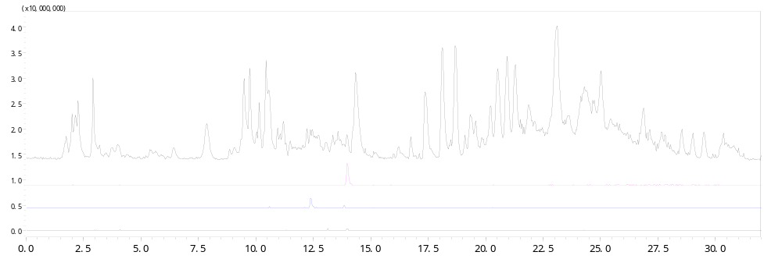
TIC
EIC m/z 336.1
EIC m/z 352.1
EIC m/z 320.1
- Orengedokuto
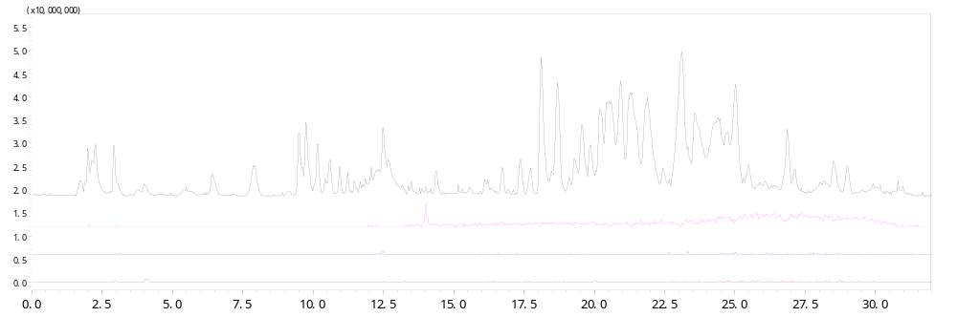
TIC
EIC m/z 336.1
EIC m/z 352.1
EIC m/z 320.1
LCMS chromatogram of Coptis Rhizome and Orengedokuto treated mice plasma. The plasma samples from Coptis Rhizome (a, 122 mg/kg) and Orengedokuto (b, 365 mg/kg) administrated mice were analysed. Blood samples were collected after 1 hr of oral administration. For each chromatogram, top shows total ion chromatogram (TIC). Second to forth chromatogram show the extracted ion chromatogram (EIC) at m/z 336, 352, and 320, respectively. The signal intensities for three EIC are magnified 10 times of TIC. The arrows indicate the signals of berberine (m/z 336.1, t_{R} 14.0 min.), palmatine (m/z 352.1, t_{R} 13.8 min.), and coptisine (m/z 320.1, t_{R} 13.1 min.), respectively.

Additional file: Table S7. The average percentage parasitemia and suppression profile of coptisine chloride
Treatment | Dose in mg/kg/day | % parasitemia  (% suppression)
Treatment | Dose in mg/kg/day | Day 3 | Day 4 | Day 5 | Day 6
Coptisine chloride | 30 | **0.075 ± 0.04  (89) | **0.45 ± 0.24  (87) | ***1.70 ± 0.43  (82) | ***2.6 ± 0.89  (81)
NC (DW) | 0.2 mL | 0.69 ± 0.16  (0) | 3.42 ± 0.75  (0) | 9.2 ± 1.48  (0) | 14.0 ± 0.79  (0)
PC (CQ) | 10 | 0  (100) | 0  (100) | 0  (100) | 0  (100)

Data are presented mean + SD (five mice for each group). The average percentage parasitemia and suppression activity of CC treated C57BL/6N mice infected with a mefloquine-resistant and CQ-sensitive strain of P. yoelii. CC: Coptisine chloride, NC (DW): (Negative control, distilled water), PC (CQ): (Positive control, Chloroquine).
* P value < 0.05, ** P value < 0.01, ***p value < 0.001

