Supplementary Figures
Contents
Supplementary Figure S1. Tomato fruit biomass summary across nutrient regimes.
Supplementary Figure S2. Cumulative tomato fruit biomass by treatment and cultivar.
Supplementary Figure S3. Treatment-by-nutrient grid linking mean plant sap nutrient concentrations with plant-associated fungi.
Supplementary Figure S1. Tomato fruit biomass summary across nutrient regimes. Panel A: cumulative fruit biomass accumulation over the harvest window by treatment (mean ± SD). Panel B: final yield (kg/plant) by cultivar and treatment.
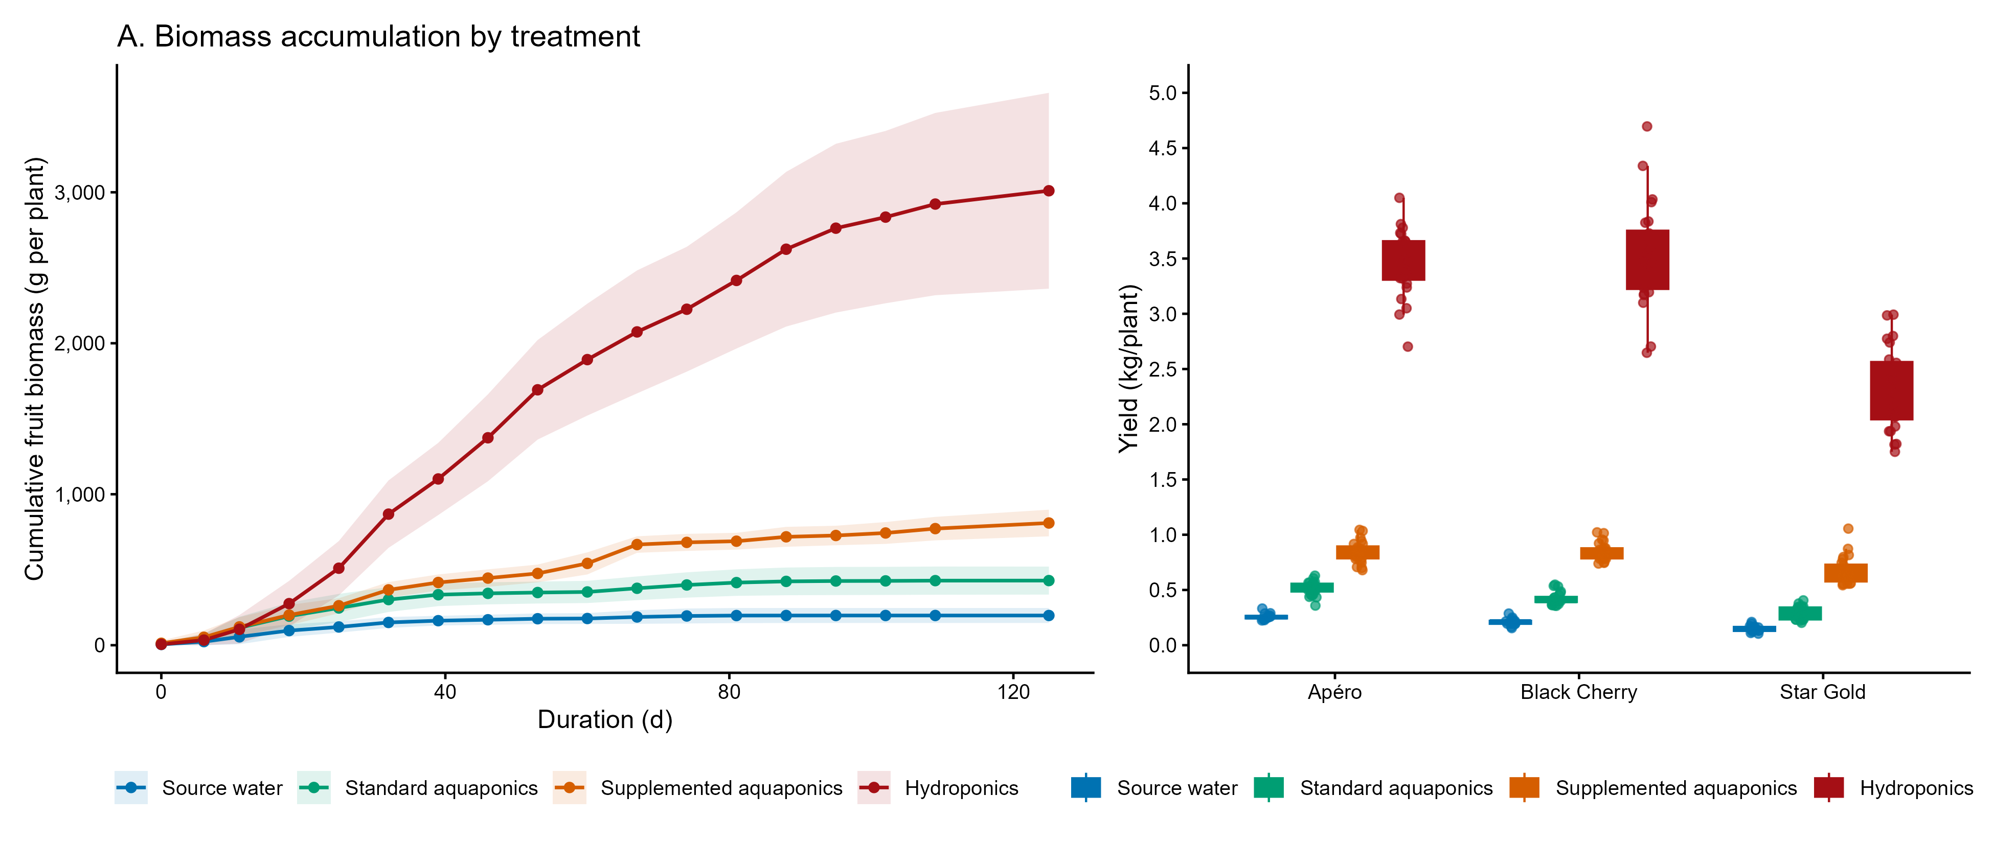
Supplementary Figure S2. Cumulative tomato fruit biomass by treatment and cultivar. Rows are nutrient regimes (source water, standard aquaponics, supplemented aquaponics, hydroponics); columns are cultivars (Apéro, Black Cherry, Star Gold). Lines show gutter-level means (G1–G3) of plant cumulative fruit mass; ribbons are mean ± SD across plants in each gutter. Y-axis scales are free within panels; x-axis is days since first harvest.
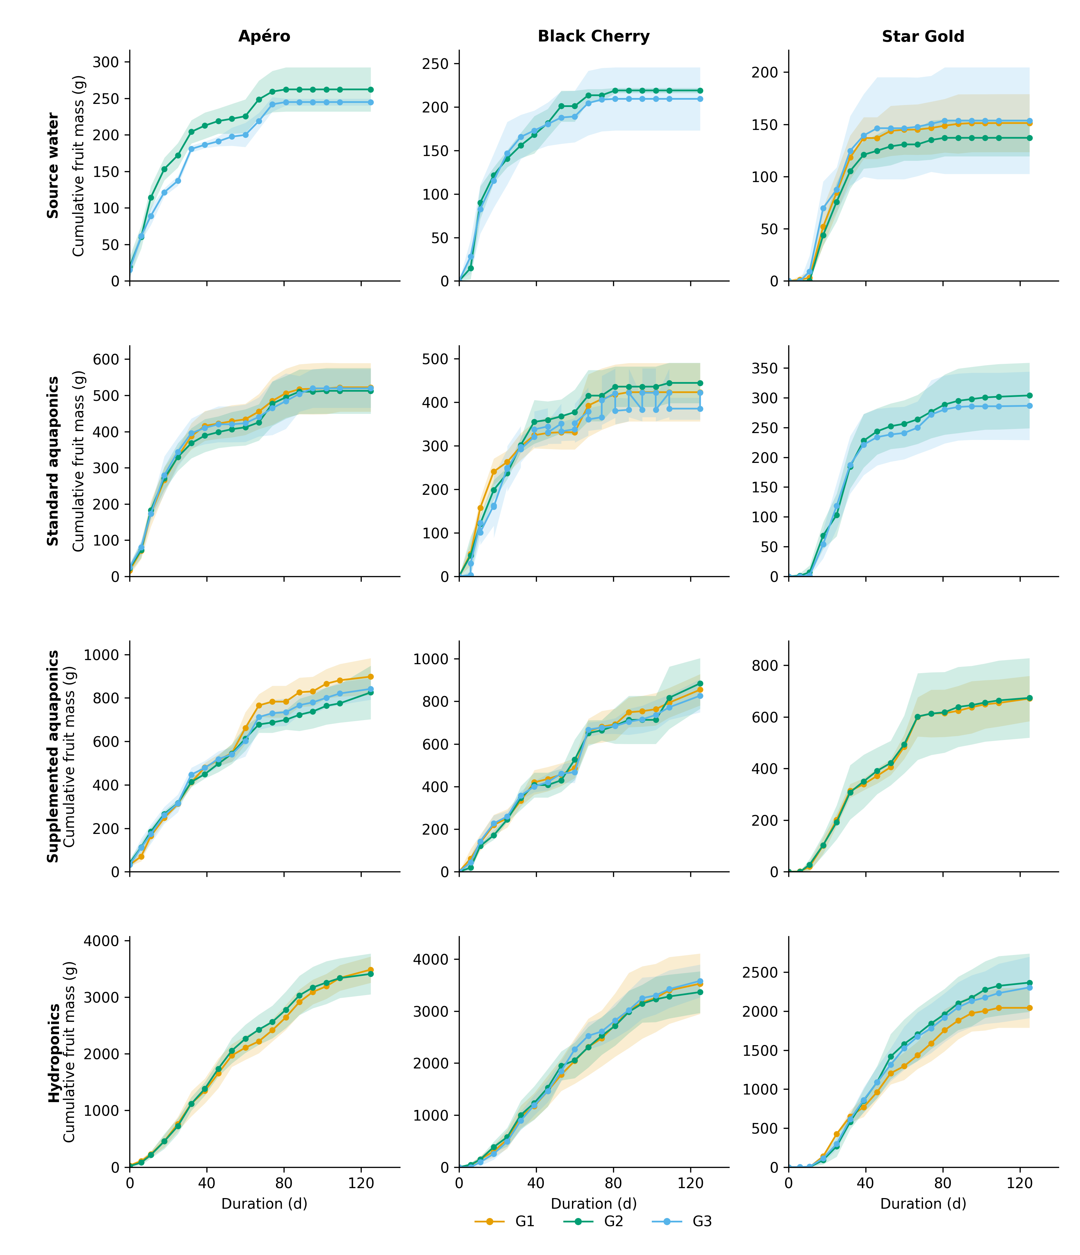
Supplementary Figure S3. Treatment-by-nutrient grid linking mean plant sap nutrient concentrations with plant-associated fungi.
