Supplement 2: Supplementary Materials
Table of Contents

Material 1: Ethics Review Approval Document of the Ethics Committee of Beijing University of Chinese Medicine 2
Material 2: Funding source 5
Figure 1: Defecation diary card 7
Figure 2: Line charts of primary and secondary endpoints. 8
Table 1: Credibility and expectancy assessment. 9
Table 2: Covariate analysis results of primary endpoint. 9
Table 3: blinding assessment. 9

Material 1: Ethics Review Approval Document of the Ethics Committee of Beijing University of Chinese Medicine
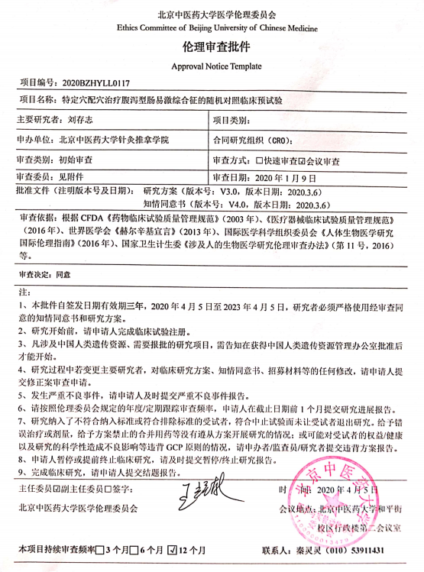

Ethical Committee of Beijing University of Chinese Medicine
Approval Notice Template
Project Number: 2020BZHYLL0117
Project Name: Acupuncture based on specific acupoint theory for Diarrhea irritable bowel syndrome: a randomized controlled pilot trial
Principal Investigator: Cun-Zhi Liu | Project Type:
Application Department: School of Acupuncture-Moxibustion and Tuina, Beijing University of Chinese Medicine | Contract Research Organization (CRO):
Review Type: Initial review | Review Mode: Meeting review
Review Members: See attachment | Review Data: January 9, 2020
Approval Documents (State the version number and date):
Study protocol (V3.0, March 6, 2020);
Informed consent (V4.0, March 6, 2020).
Review based on “Guidelines for ethical review of drug clinical trials”(2003), “Standard for quality management of medical device clinical trials” (2016) issued by State food and drug administration of the People's Republic of China (CFDA) ; “Helsinki declaration” (2013) issued by World Medical Association; “International Ethical Guide to Human Biomedical Research” (2016) issued by Council for International Organizations of Medical Sciences; “Methods of ethical review of biomedical research involving human beings” (2016) issued by Ministry of Health of the People's Republic of China, etc.
Review Decision: Agree
Note:
1. This approval is issued from April 5, 2020 to April 5, 2023. Researchers must strictly use the approved informed consent form and study protocol.
2. Applicants are requested to complete clinical trial registration before the study beginning.
3. Any research project involving human genetic resources in China can only be carried out after obtaining approval from the China Human Genetic Resources Management Office.
4. If the principal investigator is changed during the study, any modification of the clinical protocol, informed consent, recruitment materials, etc., the applicant shall submit an amendment for review.
5. In case of serious adverse events, please submit the report of serious adverse events in time.
6. Please follow the annual / regular follow-up review frequency set by the ethics committee, and the applicant should submit the research progress report 1 month before the deadline.
7. If there is any violation during the study, please submit the violation report. For example, patients who did not meet the inclusion/exclusion criteria were included, or were given the wrong treatment.
8. If the applicant suspends or terminates the clinical study in advance, please submit the suspension/termination report in time.
9. After completing the clinical study, please submit the final report.
Ethical Committee of Beijing University of Chinese Medicine
Date: April 5, 2020
Frequency of periodical review: 12 months Contact: Ling- Ling Qin (010) 53911431

Material 2: Funding source
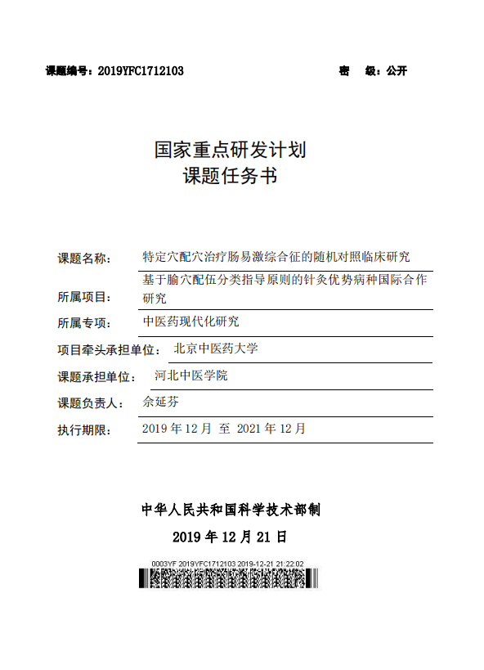

Subject number：2019YFC1712103 Secret level: public

National Key Research and Development Program of China

Subject name
Acupuncture in specific acupoints for irritable bowel syndrome: a randomized controlled trial
Affiliated to subject
International Cooperation of Superior Acupuncture Diseases Based on Guiding Principles of Acupoint Compatibility Classification
Type of project
Research on Modernization of Traditional Chinese Medicine
Project undertaker
Beijing University of Chinese Medicine
Subject undertaker
Hebei University of Chinese Medicine
Person in charge: Yan-Fen She
Time for execution: From December 2019 to December 2021
Ministry of Science and Technology of the People's Republic of China
December 21, 2019

知情同意书• 知情告知页

Figure 1: Defecation diary card
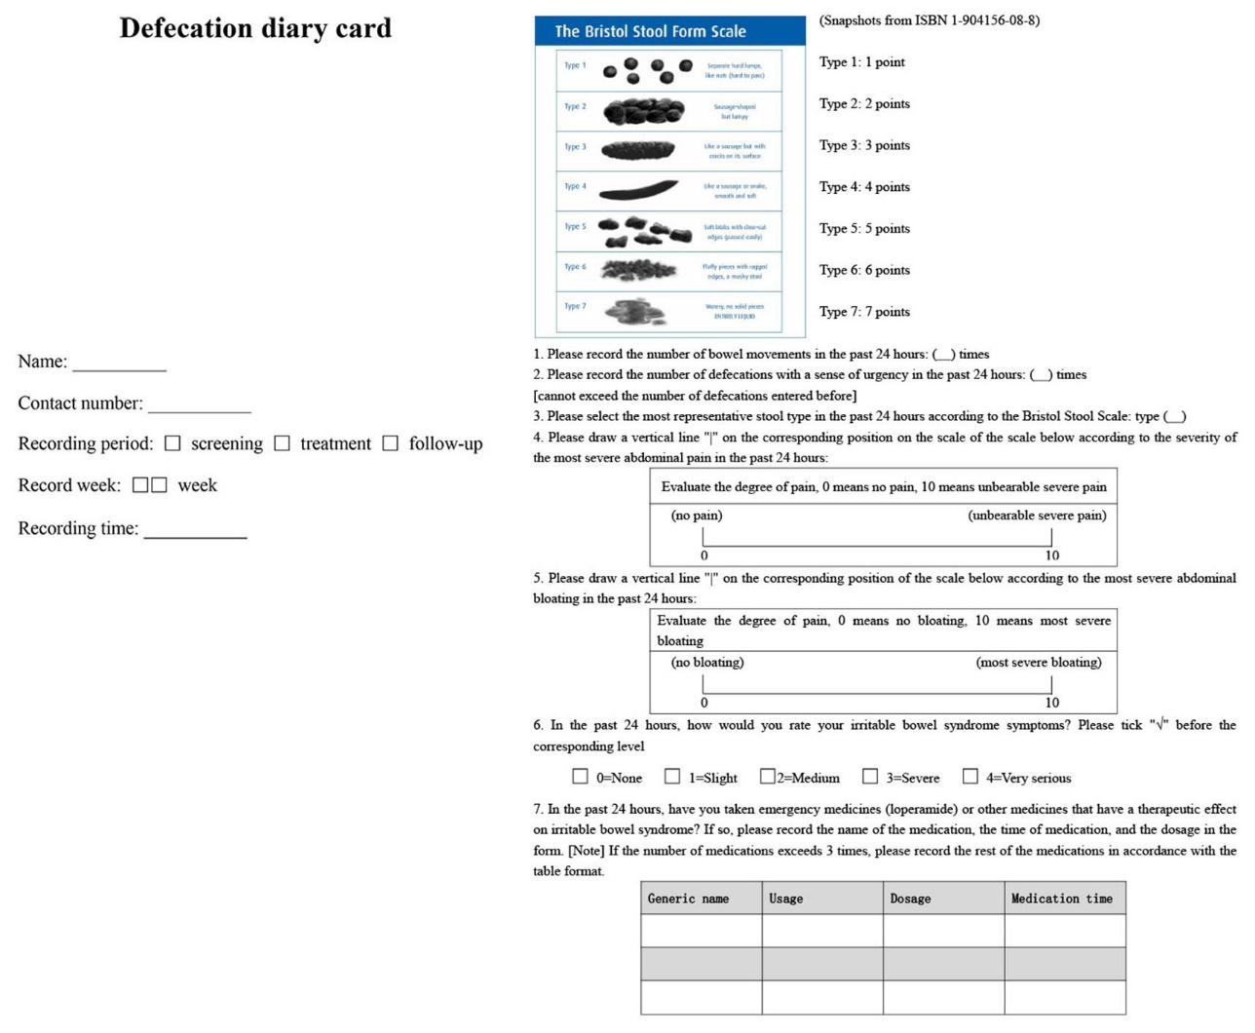

Figure 2: Line charts of primary and secondary endpoints.
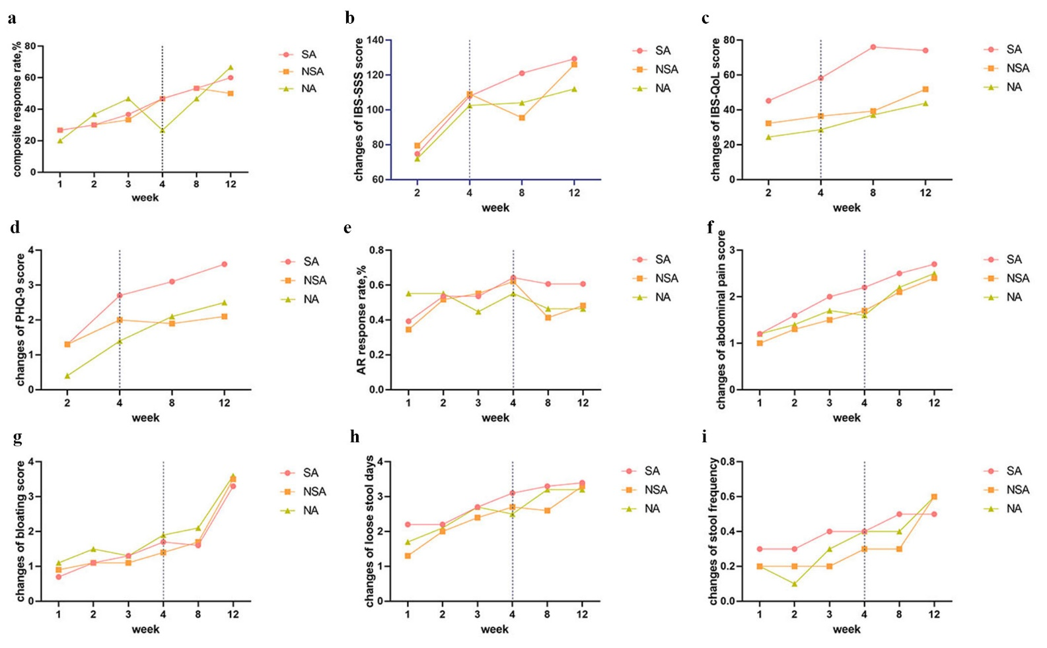
(a) composite response rate; (b) changes of IBS-SSS score; (c) changes of IBS-QoL score; (d) changes of PHQ-9 score; (e) AR response rate; (f) changes of abdominal pain score; (g) changes of bloating score; (h) changes of loose stool days; (i) changes of stool frequency.

Table 1: Credibility and expectancy assessment.
Group | SA | NSA | NA | P
Credibility, (SD) | -0.2 (3.3) | 0.1 (2.3) | -0.2 (3.3) | 0.862
Expectancy, (SD) | -0.7 (3.0) | 0.4 (1.9) | -0.1 (3.7) | 0.292
Note: before the credibility and expectancy assessment, one patient from SA group withdrew.

Table 2: Covariate analysis results of primary endpoint.
Group | OR (95%CI) | P
Baseline abdominal pain score | 1.2 (0.7-1.3) | 0.689
Baseline stool consistency | 0.9 (0.9-1.6) | 0.263

Table 3: blinding assessment.
Group | successful blinding (n) | failure blinding (n) | success rate, % | P
SA (n=30) | 9 | 18 | 33.3
NSA (n=30) | 11 | 17 | 39.2 | 0.880
NA (n=30) | 11 | 16 | 40.7
Note: before the blinding assessment, the number of patients falling out of each group: SA=3, NSA=2, NA=3.

