Supplementary material
Functional trait database
Supplementary Table 01. Biological traits of Trichoptera taxa evaluated in the study. For each taxon, we report family, subfamily, taxon name, other taxa used when the species is absent from the trait database, number of ESVs, endemism, persistence, ecological preferences (stream zonation, temperature, altitude, microhabitat/substrate), feeding type, maximum female forewing length, emergence/flight period, duration of emergence period, lifespan, and reproductive traits.
Supplementary Table 01-1. Color code legend indicating the source of trait data used in the study. Colors correspond to the origin of the information for each trait, as detailed in the subsequent trait tables.
GBIF
Field data
freshwaterecology.info
freshwaterecology.info averaged at genus level
Bibliographic references
expert judgement (R. Vieira)
Assumed from the nearest specie with available information (A. obscurata)
Mean for the genus calculated from the species of that genus present in this table
Supplementary Table 01-2. Taxonomic, population genetic, and biogeographic information for each taxon. Endemism and persistence indicate the biogeographic status and temporal continuity of the taxon, respectively.
ID | Family | Taxon | Other taxa used | nº ESVs | Endemism | Persistence
1 | GLOSSOSOMATIDAE | Agapetus fuscipes |  | 1 | Non endemic | Last year
2 | GLOSSOSOMATIDAE | Agapetus sp. | Agapetus fuscipes | 3 | Non endemic | NA
3 | LIMNEPHILIDAE | Allogamus auricollis |  | 1 | Non endemic | Last year
4 | LIMNEPHILIDAE | Allogamus sp. | Allogamus auricollis | NA | Non endemic | NA
5 | LIMNEPHILIDAE | Annitella pyranea |  | 1 | Pyrenean endemic | NA
6 | LIMNEPHILIDAE | Annitella sp. | Annitella pyrenaea | 13 | Non endemic | NA
7 | LIMNEPHILIDAE | Anomalopterygella chauviniana |  | 1 | Non endemic | Between 4 and 5 years
8 | APATANIIDAE | Apatania fimbriata |  | NA | Non endemic | Between 2 and 3 years
9 | APATANIIDAE | Apatania stylata |  | 2 | Pyrenean endemic | Between 4 and 5 years
10 | BERAEIDAE | Beraea maurus |  | 1 | Non endemic | Last year
11 | LIMNEPHILIDAE | Chaetopteryx villosa |  | 3 | Non endemic | Last year
12 | LIMNEPHILIDAE | Drusus discolor |  | NA | Non endemic | Last year
13 | LIMNEPHILIDAE | Drusus ingridae |  | NA | Pyrenean micro-endemic | +5 years
14 | LIMNEPHILIDAE | Drusus monticola |  | NA | Non endemic | Last year
15 | LIMNEPHILIDAE | Drusus rectus |  | 9 | Pyrenean endemic | Between 4 and 5 years
16 | LIMNEPHILIDAE | Drusus sp. | Drusus dataset | NA | Non endemic | NA
17 | LIMNEPHILIDAE | Ecclisopteryx guttulata |  | 3 | Non endemic | Last year
18 | GLOSSOSOMATIDAE | Glossosoma boltoni |  | 2 | Non endemic | Last year
19 | GLOSSOSOMATIDAE | Glossosoma conformis |  | 1 | Non endemic | Last year
20 | LIMNEPHILIDAE | Halesus digitatus |  | 0 | Non endemic | Last year
21 | LIMNEPHILIDAE | Halesus radiatus |  | 7 | Non endemic | Last year
22 | HYDROPSYCHIDAE | Hydropsyche dinarica |  | 3 | Non endemic | Last year
23 | HYDROPSYCHIDAE | Hydropsyche instabilis |  | 2 | Non endemic | Last year
24 | LIMNEPHILIDAE | Melampophylax mucoreus |  | 3 | Non endemic | Last year
25 | LIMNEPHILIDAE | Melampophylax sp. | Melampophylax mucoreus | NA | Non endemic | NA
26 | BRACHYCENTRIDAE | Micrasema cenerentola |  | 2 | Non endemic | Between 4 and 5 years
27 | BRACHYCENTRIDAE | Micrasema longulum |  | 2 | Non endemic | Between 4 and 5 years
28 | BRACHYCENTRIDAE | Micrasema minimum |  | 2 | Non endemic | Between 2 and 3 years
29 | BRACHYCENTRIDAE | Micrasema vestitum |  | 4 | Pyrenean endemic | Between 4 and 5 years
30 | ODONTOCERIDAE | Odontocerum albicorne |  | 3 | Non endemic | Last year
31 | ODONTOCERIDAE | Odontocerum sp. | Odontocerum albicorne | NA | Non endemic | NA
32 | PHILOPOTAMIDAE | Philopotamus montanus |  | 4 | Non endemic | Last year
33 | PHILOPOTAMIDAE | Philopotamus variegatus |  | 0 | Non endemic | Last year
34 | POLYCENTROPODIDAE | Plectrocnemia geniculata |  | 1 | Non endemic | Last year
35 | POLYCENTROPODIDAE | Plectrocnemia laetabilis |  | 2 | Non endemic | Between 4 and 5 years
36 | POLYCENTROPODIDAE | Polycentropus kingi |  | NA | Non endemic | Last year
37 | LIMNEPHILIDAE | Potamophylax cingulatus |  | 6 | Non endemic | Last year
38 | LIMNEPHILIDAE | Potamophylax latipennis |  | 1 | Non endemic | Last year
39 | LIMNEPHILIDAE | Potamophylax sp. | Potamophylax dataset | NA | Non endemic | NA
40 | PTILOCOLEPIDAE | Ptilocolepus granulatus |  | 1 | Non endemic | Last year
41 | RHYACOPHILIDAE | Rhyacophila sp. | Rhyacophila dataset | NA | Non endemic | NA
42 | RHYACOPHILIDAE | Rhyacophila angelieri |  | 1 | Pyrenean micro-endemic | Between 4 and 5 years
43 | RHYACOPHILIDAE | Rhyacophila aquitanica |  | NA | Non endemic | Last year
44 | RHYACOPHILIDAE | Rhyacophila eatoni |  | NA | Pyrenean endemic | +5 years
45 | RHYACOPHILIDAE | Rhyacophila evoluta |  | 6 | Non endemic | Between 4 and 5 years
46 | RHYACOPHILIDAE | Rhyacophila intermedia |  | 0 | Non endemic | Last year
47 | RHYACOPHILIDAE | Rhyacophila mocsaryi |  | 3 | Non endemic | Between 4 and 5 years
48 | RHYACOPHILIDAE | Rhyacophila obliterata |  | 0 | Non endemic | Last year
49 | RHYACOPHILIDAE | Rhyacophila occidentalis |  | 1 | Non endemic | Between 4 and 5 years
50 | RHYACOPHILIDAE | Rhyacophila praemorsa |  | 3 | Non endemic | Last year
51 | RHYACOPHILIDAE | Rhyacophila rupta |  | 1 | Pyrenean endemic | Between 4 and 5 years
52 | RHYACOPHILIDAE | Rhyacophila tristis |  | 4 | Non endemic | Last year
53 | SERICOSTOMATIDAE | Sericostoma sp. | Sericostoma dataset | NA | Non endemic | NA
54 | SERICOSTOMATIDAE | Sericostoma personatum |  | 2 | Non endemic | Last year
55 | SERICOSTOMATIDAE | Sericostoma pyrenaicum |  | 3 | Non endemic | +5 years
56 | GOERIDAE | Silo sp. | Silo nigricornis | NA | Non endemic | NA
57 | GOERIDAE | Silo graellsii | Silo nigricornis | 0 | Non endemic | Between 4 and 5 years
58 | GOERIDAE | Silo nigricornis |  | 0 | Non endemic | Last year
59 | LIMNEPHILIDAE | Stenophylax sequax | S. crossotus, S. espanioli, S. mitis, S. vibex | 0 | Non endemic | Last year
60 | GLOSSOSOMATIDAE | Synagapetus placidus |  | 0 | Pyrenean endemic | Between 4 and 5 years
61 | UENOIDAE | Thremma gallicum |  | 3 | Non endemic | Between 4 and 5 years
62 | PHILOPOTAMIDAE | Wormaldia sp. | W. occipitalis, W. triangulifera, W. saldetica | 0 | Non endemic | NA
63 | PHILOPOTAMIDAE | Wormaldia triangulifera |  | 1 | Non endemic | +5 years

Supplementary Table 01-3. Stream zonation preference and temperature range for each taxon. Codes indicate: euc = eucrenal, hyc = hypocrenal, erh = epirhithral, mrh = metarhithral, hrh = hyporhithral, epo = epipotamal, mpo = metapotamal, hpo = hypopotamal; lit = lithophilic, pro = protoplanktonic, cos = cosmopolitan, was = warm-adapted, eut = eurythermal.
ID | Stream zonation preference |  |  |  |  |  |  |  |  |  | Temperature range
ID | euc | hyc | erh | mrh | hrh | epo | mpo | hpo | lit | pro | cos | was | eut
1 | 6 | 3 | 1 | 0 | 0 | 0 | 0 | 0 | 0 | 0 | 1 | 0 | 0
2 | 6 | 3 | 1 | 0 | 0 | 0 | 0 | 0 | 0 | 0 | 1 | 0 | 0
3 | 0 | 2 | 3 | 3 | 2 | 0 | 0 | 0 | 0 | 0 | 0 | 0 | 1
4 | 0 | 2 | 3 | 3 | 2 | 0 | 0 | 0 | 0 | 0 | 0 | 0 | 1
5 | 0 | 0 | 3 | 4 | 3 | 0 | 0 | 0 | 0 | 0 | 1 | 0 | 0
6 | 0 | 0 | 3 | 4 | 3 | 0 | 0 | 0 | 0 | 0 | 1 | 0 | 0
7 | 0 | 0 | 3 | 4 | 2 | 1 | 0 | 0 | 0 | 0 | 0 | 1 | 0
8 | 6 | 4 | 0 | 0 | 0 | 0 | 0 | 0 | 0 | 0 | 1 | 0 | 0
9 | 5 | 5 | 0 | 0 | 0 | 0 | 0 | 0 | 0 | 0 | 1 | 0 | 0
10 | 9 | 1 | 0 | 0 | 0 | 0 | 0 | 0 | 0 | 0 | 1 | 0 | 0
11 | 1 | 2 | 2 | 2 | 2 | 1 | 0 | 0 | 0 | 0 | 0 | 0 | 1
12 | 1 | 7 | 2 | 0 | 0 | 0 | 0 | 0 | 0 | 0 | 1 | 0 | 0
13 | 5 | 5 | 0 | 0 | 0 | 0 | 0 | 0 | 0 | 0 | 1 | 0 | 0
14 | 2 | 5 | 3 | 0 | 0 | 0 | 0 | 0 | 0 | 0 | 1 | 0 | 0
15 | 3 | 4 | 3 | 0 | 0 | 0 | 0 | 0 | 0 | 0 | 1 | 0 | 0
16 | 2,75 | 5,25 | 2 | 0 | 0 | 0 | 0 | 0 | 0 | 0 | 1 | 0 | 0
17 | 0 | 0 | 1 | 8 | 1 | 0 | 0 | 0 | 0 | 0 | 1 | 0 | 0
18 | 0 | 0 | 0 | 4 | 5 | 1 | 0 | 0 | 0 | 0 | 1 | 0 | 0
19 | 0 | 1 | 7 | 2 | 0 | 0 | 0 | 0 | 0 | 0 | 1 | 0 | 0
20 | 0 | 0 | 0 | 2 | 4 | 4 | 0 | 0 | 0 | 0 | 0 | 0 | 1
21 | 0 | 0 | 1 | 3 | 3 | 3 | 0 | 0 | 0 | 0 | 0 | 0 | 1
22 | 0 | 0 | 4 | 5 | 1 | 0 | 0 | 0 | 0 | 0 | 0 | 1 | 0
23 | 0 | 0 | 4 | 4 | 2 | 0 | 0 | 0 | 0 | 0 | 0 | 1 | 0
24 | 0 | 0 | 3 | 4 | 3 | 0 | 0 | 0 | 0 | 0 | 1 | 0 | 0
25 | 0 | 0 | 3 | 4 | 3 | 0 | 0 | 0 | 0 | 0 | 1 | 0 | 0
26 | 0 | 0 | 3 | 4 | 3 | 0 | 0 | 0 | 0 | 0 | 1 | 0 | 0
27 | 0 | 0 | 3 | 7 | 0 | 0 | 0 | 0 | 0 | 0 | 1 | 0 | 0
28 | 0 | 0 | 1 | 8 | 1 | 0 | 0 | 0 | 0 | 0 | 1 | 0 | 0
29 | 0 | 3 | 4 | 3 | 0 | 0 | 0 | 0 | 0 | 0 | 1 | 0 | 0
30 | 0 | 2 | 7 | 1 | 0 | 0 | 0 | 0 | 0 | 0 | 1 | 0 | 0
31 | 0 | 2 | 7 | 1 | 0 | 0 | 0 | 0 | 0 | 0 | 1 | 0 | 0
32 | 0 | 1 | 8 | 1 | 0 | 0 | 0 | 0 | 0 | 0 | 0 | 0 | 1
33 | 0 | 0 | 5 | 5 | 0 | 0 | 0 | 0 | 0 | 0 | 0 | 0 | 1
34 | 6 | 3 | 1 | 0 | 0 | 0 | 0 | 0 | 0 | 0 | 1 | 0 | 0
35 | 0 | 0 | 3 | 4 | 3 | 0 | 0 | 0 | 0 | 0 | 1 | 0 | 0
36 | 0 | 0 | 3 | 3 | 3 | 1 | 0 | 0 | 0 | 0 | 1 | 1 | 0
37 | 1 | 2 | 3 | 3 | 1 | 0 | 0 | 0 | 0 | 0 | 0 | 1 | 0
38 | 0 | 1 | 1 | 1 | 3 | 1 | 1 | 0 | 2 | 0 | 0 | 1 | 0
39 | 0,38 | 1,63 | 2 | 2,125 | 1,88 | 0,5 | 0,5 | 0 | 1 | 0 | 0 | 1 | 0
40 | 8 | 2 | 0 | 0 | 0 | 0 | 0 | 0 | 0 | 0 | 1 | 0 | 0
41 | 0,45 | 2,41 | 3,95 | 2,591 | 0,59 | 0 | 0 | 0 | 0 | 0 | 1 | 0 | 0
42 | 0 | 3 | 4 | 3 | 0 | 0 | 0 | 0 | 0 | 0 | 1 | 0 | 0
43 | 0 | 3 | 4 | 3 | 0 | 0 | 0 | 0 | 0 | 0 | 1 | 0 | 0
44 | 3 | 4 | 3 | 0 | 0 | 0 | 0 | 0 | 0 | 0 | 1 | 0 | 0
45 | 0 | 2 | 5 | 3 | 0 | 0 | 0 | 0 | 0 | 0 | 1 | 0 | 0
46 | 0 | 5 | 5 | 0 | 0 | 0 | 0 | 0 | 0 | 0 | 1 | 0 | 0
47 | 0 | 2 | 4 | 4 | 2 | 0 | 0 | 0 | 0 | 0 | 1 | 0 | 0
48 | 0 | 0 | 2 | 7 | 1 | 0 | 0 | 0 | 0 | 0 | 1 | 0 | 0
49 | 0 | 0 | 3 | 4 | 3 | 0 | 0 | 0 | 0 | 0 | 1 | 0 | 0
50 | 0 | 3 | 7 | 0 | 0 | 0 | 0 | 0 | 0 | 0 | 1 | 0 | 0
51 | 0 | 3 | 4 | 3 | 0 | 0 | 0 | 0 | 0 | 0 | 1 | 0 | 0
52 | 2 | 2 | 3 | 2 | 1 | 0 | 0 | 0 | 0 | 0 | 1 | 0 | 0
53 | 1,75 | 2,75 | 2,5 | 1,5 | 1 | 0,5 | 0 | 0 | 0 | 0 | 1 | 0 | 0
54 | 2 | 3 | 3 | 2 | 0 | 0 | 0 | 0 | 0 | 0 | 1 | 0 | 0
55 | 2 | 3 | 3 | 2 | 0 | 0 | 0 | 0 | 0 | 0 | 1 | 0 | 0
56 | 1,5 | 3,5 | 3 | 1 | 1 | 0 | 0 | 0 | 0 | 0 | 0 | 0 | 1
57 | 0 | 3 | 3 | 2 | 2 | 0 | 0 | 0 | 0 | 0 | 0 | 0 | 1
58 | 0 | 3 | 3 | 2 | 2 | 0 | 0 | 0 | 0 | 0 | 0 | 0 | 1
59 | 0 | 2 | 4 | 4 | 2 | 0 | 0 | 0 | 0 | 0 | NA | NA | NA
60 | 3 | 5 | 2 | 0 | 0 | 0 | 0 | 0 | 0 | 0 | 1 | 0 | 0
61 | 2 | 4 | 3 | 1 | 0 | 0 | 0 | 0 | 0 | 0 | 1 | 0 | 0
62 | 4 | 4 | 1 | 1 | 0 | 0 | 0 | 0 | 0 | 0 | 1 | 0 | 0
63 | 0 | 3 | 4 | 3 | 0 | 0 | 0 | 0 | 0 | 0 | 1 | 0 | 0
Supplementary Table 01-4. Altitude preference for each taxon. Codes indicate: niv = nivicol, sni = subnival, alp = alpine, sal = subalpine, mon = montane, smo = submontane, col = colline, pla = plain
ID | Altitude preference
ID | niv | sni | alp | sal | mon | smo | col | pla
1 | 0 | 0 | 0 | 0 | 0 | 1 | 4 | 5
2 | 0 | 0 | 0 | 0 | 0 | 1 | 4 | 5
3 | 0 | 0 | 1 | 1 | 2 | 2 | 2 | 2
4 | 0 | 0 | 1 | 1 | 2 | 2 | 2 | 2
5 | 0 | 0 | 4 | 5 | 1 | 0 | 0 | 0
6 | 0 | 0 | 4 | 5 | 1 | 0 | 0 | 0
7 | 0 | 0 | 0 | 0 | 5 | 5 | 0 | 0
8 | 0 | 0 | 2 | 3 | 3 | 2 | 0 | 0
9 | 0 | 0 | 4 | 4 | 2 | 0 | 0 | 0
10 | 0 | 0 | 1 | 1 | 2 | 2 | 2 | 2
11 | 0 | 1 | 1 | 1 | 2 | 2 | 2 | 1
12 | 0 | 1 | 3 | 3 | 2 | 1 | 0 | 0
13 | 0 | 0 | 0 | 0 | 3 | 4 | 3 | 0
14 | 0 | 3 | 3 | 2 | 2 | 0 | 0 | 0
15 | 0 | 2 | 2 | 2 | 2 | 2 | 0 | 0
16 | 0 | 1,5 | 2 | 1,75 | 2,25 | 1,75 | 0,75 | 0
17 | 0 | 0 | 0 | 0 | 2 | 5 | 3 | 0
18 | 0 | 0 | 0 | 0 | 0 | 5 | 5 | 0
19 | 0 | 0 | 0 | 1 | 2 | 3 | 3 | 1
20 | 0 | 0 | 1 | 1 | 2 | 3 | 3 | 0
21 | 0 | 0 | 0 | 0 | 1 | 3 | 3 | 3
22 | 0 | 0 | 0 | 0 | 4 | 4 | 2 | 0
23 | 0 | 0 | 0 | 0 | 3 | 3 | 3 | 1
24 | 0 | 0 | 1 | 4 | 3 | 1 | 1 | 0
25 | 0 | 0 | 1 | 4 | 3 | 1 | 1 | 0
26 | 0 | 0 | 0 | 0 | 10 | 0 | 0 | 0
27 | 0 | 0 | 0 | 0 | 1 | 4 | 4 | 1
28 | 0 | 0 | 0 | 2 | 5 | 2 | 1 | 0
29 | 0 | 0 | 0 | 2 | 5 | 3 | 0 | 0
30 | 0 | 0 | 0 | 1 | 2 | 4 | 2 | 1
31 | 0 | 0 | 0 | 1 | 2 | 4 | 2 | 1
32 | 0 | 0 | 0 | 1 | 1 | 3 | 4 | 1
33 | 0 | 0 | 1 | 1 | 1 | 4 | 4 | 1
34 | 0 | 0 | 0 | 1 | 2 | 2 | 6 | 1
35 | 0 | 0 | 0 | 2 | 5 | 3 | 0 | 0
36 | 0 | 0 | 0 | 2 | 2 | 2 | 2 | 2
37 | 0 | 1 | 2 | 2 | 2 | 2 | 1 | 0
38 | 0 | 1 | 2 | 2 | 2 | 2 | 1 | 0
39 | 0 | 1 | 2 | 2 | 2 | 2 | 1 | 0
40 | 0 | 0 | 0 | 2 | 3 | 3 | 2 | 0
41 | 0 | 0,45 | 1,09 | 1,91 | 3,227 | 2,591 | 0,64 | 0,09
42 | 0 | 2 | 3 | 3 | 2 | 0 | 0 | 0
43 | 0 | 0 | 0 | 5 | 5 | 0 | 0 | 0
44 | 0 | 0 | 0 | 0 | 5 | 5 | 0 | 0
45 | 0 | 0 | 1 | 1 | 4 | 4 | 0 | 0
46 | 0 | 0 | 2 | 3 | 3 | 2 | 0 | 0
47 | 0 | 0 | 1 | 2 | 3 | 3 | 2 | 0
48 | 0 | 0 | 0 | 0 | 3 | 4 | 3 | 0
49 | 0 | 0 | 0 | 1 | 4 | 4 | 1 | 0
50 | 0 | 0 | 2 | 2 | 3 | 3 | 0 | 0
51 | 0 | 2 | 2 | 2 | 2 | 2 | 0 | 0
52 | 0 | 1 | 1 | 2 | 2 | 2 | 1 | 1
53 | 0 | 0 | 0 | 0,5 | 1,75 | 3 | 3 | 1,75
54 | 0 | 0 | 0 | 2 | 2 | 2 | 2 | 2
55 | 0 | 0 | 0 | 0 | 0 | 3 | 4 | 3
56 | 0 | 0 | 0,5 | 0,5 | 2,5 | 2,5 | 2,5 | 1,5
57 | 0 | 0 | 0 | 0 | 1 | 2 | 4 | 3
58 | 0 | 0 | 0 | 0 | 1 | 2 | 4 | 3
59 | 0 | 0 | 0 | 1 | 1 | 4 | 5 | 0
60 | 0 | 0 | 0 | 10 | 0 | 0 | 0 | 0
61 | 0 | 1 | 1 | 1 | 2 | 2 | 2 | 1
62 | 0 | 0 | 1 | 1 | 3 | 4 | 3 | 0
63 | 0 | 0 | 1 | 2 | 3 | 3 | 1 | 0
Supplementary Table 01-5. Microhabitat and substrate preferences for each taxon. Codes indicate: arg = large stones/rocks, pel = pebbles, psa = sand, aka = coarse detritus, mil = fine detritus, mal = macrophytes, hpe = hyporheic, alg = algae, mph = mosses, pom = submerged wood, woo = woody debris, mad = mud, oth = other.
ID | Microhabitat/substrate preference
ID | arg | pel | psa | aka | mil | mal | hpe | alg | mph | pom | woo | mad | oth
1 | 0 | 0 | 0 | 0 | 5 | 5 | 0 | 0 | 0 | 0 | 0 | 0 | 0
2 | 0 | 0 | 0 | 0 | 5 | 5 | 0 | 0 | 0 | 0 | 0 | 0 | 0
3 | 0 | 0 | 2 | 0 | 3 | 3 | 0 | 0 | 0 | 2 | 0 | 0 | 0
4 | 0 | 0 | 2 | 0 | 3 | 3 | 0 | 0 | 0 | 2 | 0 | 0 | 0
5 | 0 | 0 | 2 | 2 | 2 | 2 | 0 | 0 | 0 | 2 | 0 | 0 | 0
6 | 0 | 0 | 2 | 2 | 2 | 2 | 0 | 0 | 0 | 2 | 0 | 0 | 0
7 | 0 | 0 | 0 | 0 | 5 | 5 | 0 | 0 | 0 | 0 | 0 | 0 | 0
8 | 0 | 0 | 0 | 0 | 5 | 5 | 0 | 0 | 0 | 0 | 0 | 0 | 0
9 | 0 | 0 | 0 | 0 | 5 | 5 | 0 | 0 | 0 | 0 | 0 | 0 | 0
10 | 0 | 0 | 0 | 0 | 0 | 0 | 0 | 0 | 0 | 0 | 0 | 10 | 0
11 | 0 | 0 | 0 | 2 | 2 | 2 | 0 | 0 | 0 | 4 | 0 | 0 | 0
12 | 0 | 0 | 0 | 0 | 3 | 7 | 0 | 0 | 0 | 0 | 0 | 0 | 0
13 | 0 | 0 | 0 | 0 | 3 | 7 | 0 | 0 | 0 | 0 | 0 | 0 | 0
14 | 0 | 0 | 0 | 0 | 3 | 7 | 0 | 0 | 0 | 0 | 0 | 0 | 0
15 | 0 | 0 | 0 | 0 | 3 | 7 | 0 | 0 | 0 | 0 | 0 | 0 | 0
16 | 0 | 0 | 0 | 0 | 3 | 7 | 0 | 0 | 0 | 0 | 0 | 0 | 0
17 | 0 | 0 | 0 | 0 | 3 | 7 | 0 | 0 | 0 | 0 | 0 | 0 | 0
18 | 0 | 0 | 0 | 0 | 5 | 5 | 0 | 0 | 0 | 0 | 0 | 0 | 0
19 | 0 | 0 | 0 | 0 | 5 | 5 | 0 | 0 | 0 | 0 | 0 | 0 | 0
20 | 0 | 0 | 0 | 0 | 0 | 0 | 0 | 0 | 0 | 5 | 5 | 0 | 0
21 | 0 | 0 | 0 | 0 | 0 | 0 | 0 | 0 | 0 | 5 | 5 | 0 | 0
22 | 0 | 0 | 0 | 0 | 3 | 3 | 0 | 0 | 2 | 0 | 2 | 0 | 0
23 | 0 | 0 | 0 | 0 | 3 | 3 | 0 | 0 | 2 | 0 | 2 | 0 | 0
24 | 0 | 0 | 0 | 2 | 3 | 3 | 0 | 0 | 0 | 2 | 0 | 0 | 0
25 | 0 | 0 | 0 | 2 | 3 | 3 | 0 | 0 | 0 | 2 | 0 | 0 | 0
26 | 0 | 0 | 0 | 0 | 0 | 8 | 0 | 0 | 2 | 0 | 0 | 0 | 0
27 | 0 | 0 | 0 | 0 | 2 | 4 | 0 | 0 | 4 | 0 | 0 | 0 | 0
28 | 0 | 0 | 0 | 0 | 2 | 4 | 0 | 0 | 4 | 0 | 0 | 0 | 0
29 | 0 | 0 | 0 | 0 | 0 | 5 | 0 | 0 | 5 | 0 | 0 | 0 | 0
30 | 0 | 0 | 2 | 2 | 2 | 2 | 0 | 0 | 0 | 0 | 2 | 0 | 0
31 | 0 | 0 | 2 | 2 | 2 | 2 | 0 | 0 | 0 | 0 | 2 | 0 | 0
32 | 0 | 0 | 0 | 0 | 5 | 5 | 0 | 0 | 0 | 0 | 0 | 0 | 0
33 | 0 | 0 | 0 | 0 | 5 | 5 | 0 | 0 | 0 | 0 | 0 | 0 | 0
34 | 0 | 0 | 0 | 0 | 2 | 2 | 0 | 0 | 2 | 2 | 2 | 0 | 0
35 | 0 | 0 | 0 | 10 | 0 | 0 | 0 | 0 | 0 | 0 | 0 | 0 | 0
36 | 0 | 0 | 0 | 0 | 10 | 0 | 0 | 0 | 0 | 0 | 0 | 0 | 0
37 | 0 | 0 | 0 | 0 | 3 | 3 | 0 | 0 | 0 | 4 | 0 | 0 | 0
38 | 0 | 0 | 0 | 0 | 3 | 3 | 0 | 0 | 0 | 4 | 0 | 0 | 0
39 | 0 | 0 | 0 | 0 | 3 | 3 | 0 | 0 | 0 | 4 | 0 | 0 | 0
40 | 0 | 0 | 0 | 0 | 0 | 0 | 0 | 0 | 10 | 0 | 0 | 0 | 0
41 | 0 | 0 | 0 | 0 | 5 | 5 | 0 | 0 | 0 | 0 | 0 | 0 | 0
42 | 0 | 0 | 0 | 0 | 5 | 5 | 0 | 0 | 0 | 0 | 0 | 0 | 0
43 | 0 | 0 | 0 | 0 | 5 | 5 | 0 | 0 | 0 | 0 | 0 | 0 | 0
44 | 0 | 0 | 0 | 0 | 5 | 5 | 0 | 0 | 0 | 0 | 0 | 0 | 0
45 | 0 | 0 | 0 | 0 | 5 | 5 | 0 | 0 | 0 | 0 | 0 | 0 | 0
46 | 0 | 0 | 0 | 0 | 5 | 5 | 0 | 0 | 0 | 0 | 0 | 0 | 0
47 | 0 | 0 | 0 | 0 | 5 | 5 | 0 | 0 | 0 | 0 | 0 | 0 | 0
48 | 0 | 0 | 0 | 0 | 5 | 5 | 0 | 0 | 0 | 0 | 0 | 0 | 0
49 | 0 | 0 | 0 | 0 | 5 | 5 | 0 | 0 | 0 | 0 | 0 | 0 | 0
50 | 0 | 0 | 0 | 0 | 5 | 5 | 0 | 0 | 0 | 0 | 0 | 0 | 0
51 | 0 | 0 | 0 | 0 | 5 | 5 | 0 | 0 | 0 | 0 | 0 | 0 | 0
52 | 0 | 0 | 0 | 0 | 5 | 5 | 0 | 0 | 0 | 0 | 0 | 0 | 0
53 | 0 | 1 | 2 | 2 | 2 | 0 | 0 | 0 | 0 | 2 | 1 | 0 | 0
54 | 0 | 1 | 2 | 2 | 2 | 0 | 0 | 0 | 0 | 2 | 1 | 0 | 0
55 | 0 | 0 | 4 | 2 | 0 | 0 | 0 | 0 | 0 | 4 | 0 | 0 | 0
56 | 0 | 0 | 0 | 0 | 5 | 5 | 0 | 0 | 0 | 0 | 0 | 0 | 0
57 | 0 | 0 | 0 | 0 | 5 | 5 | 0 | 0 | 0 | 0 | 0 | 0 | 0
58 | 0 | 0 | 0 | 0 | 5 | 5 | 0 | 0 | 0 | 0 | 0 | 0 | 0
59 | NA | NA | NA | NA | NA | NA | NA | NA | NA | NA | NA | NA | NA
60 | 0 | 0 | 0 | 0 | 5 | 5 | 0 | 0 | 0 | 0 | 0 | 0 | 0
61 | 0 | 0 | 0 | 2 | 4 | 4 | 0 | 0 | 0 | 0 | 0 | 0 | 0
62 | 0 | 0 | 0 | 0 | 5 | 5 | 0 | 0 | 0 | 0 | 0 | 0 | 0
63 | 0 | 0 | 0 | 0 | 5 | 5 | 0 | 0 | 0 | 0 | 0 | 0 | 0
Supplementary Table 01-6. Feeding type and maximum forewing length of females for each taxon. Feeding type codes indicate: gra = grazer, min = miner, xyl = xylophagous, shr = shredder, gat = gatherer, aff = affinity, pff = predator/facultative feeder, pre = predator, par = parasite, oth.1 = other. Female.max indicates maximum forewing length (mm).
ID | Feeding type |  |  |  |  |  |  |  |  |  | Forewing female length max
ID | gra | min | xyl | shr | gat | aff | pff | pre | par | oth.1 | female.max
1 | 8 | 0 | 0 | 0 | 2 | 0 | 0 | 0 | 0 | 0 | 5
2 | 8 | 0 | 0 | 0 | 2 | 0 | 0 | 0 | 0 | 0 | 5
3 | 3 | 0 | 0 | 2 | 0 | 0 | 3 | 2 | 0 | 0 | 16
4 | 3 | 0 | 0 | 2 | 0 | 0 | 3 | 2 | 0 | 0 | 8
5 | 2 | 0 | 0 | 6 | 0 | 0 | 0 | 2 | 0 | 0 | 12
6 | 2 | 0 | 0 | 6 | 0 | 0 | 0 | 2 | 0 | 0 | 12
7 | 6 | 0 | 0 | 4 | 0 | 0 | 0 | 0 | 0 | 0 | 0
8 | 8 | 0 | 0 | 0 | 2 | 0 | 0 | 0 | 0 | 0 | 7
9 | 10 | 0 | 0 | 0 | 0 | 0 | 0 | 0 | 0 | 0 | 9
10 | 3 | 0 | 0 | 7 | 0 | 0 | 0 | 0 | 0 | 0 | 5
11 | 3 | 0 | 0 | 4 | 2 | 0 | 0 | 1 | 0 | 0 | 12
12 | 1 | 0 | 0 | 0 | 0 | 0 | 4 | 5 | 0 | 0 | 14
13 | NA | NA | NA | NA | NA | NA | NA | NA | NA | NA | 0
14 | 8 | 0 | 0 | 1 | 1 | 0 | 0 | 0 | 0 | 0 | 13
15 | 10 | 0 | 0 | 0 | 0 | 0 | 0 | 0 | 0 | 0 | 7
16 | 4,5 | 0 | 0 | 0,5 | 0,5 | 0 | 2 | 2,5 | 0 | 0 | 8,5
17 | 8 | 0 | 0 | 1 | 1 | 0 | 0 | 0 | 0 | 0 | 15
18 | 8 | 0 | 0 | 0 | 2 | 0 | 0 | 0 | 0 | 0 | 9
19 | 8 | 0 | 0 | 0 | 2 | 0 | 0 | 0 | 0 | 0 | 9
20 | 1 | 0 | 0 | 7 | 0 | 0 | 0 | 2 | 0 | 0 | 23
21 | 1 | 0 | 0 | 7 | 0 | 0 | 0 | 2 | 0 | 0 | 23
22 | 2 | 0 | 0 | 0 | 0 | 0 | 5 | 3 | 0 | 0 | 0
23 | 2 | 0 | 0 | 0 | 0 | 0 | 5 | 3 | 0 | 0 | 0
24 | 8 | 0 | 0 | 1 | 0 | 0 | 0 | 1 | 0 | 0 | 16
25 | 8 | 0 | 0 | 1 | 0 | 0 | 0 | 1 | 0 | 0 | 16
26 | 10 | 0 | 0 | 0 | 0 | 0 | 0 | 0 | 0 | 0 | NA
27 | 5 | 0 | 0 | 5 | 0 | 0 | 0 | 0 | 0 | 0 | 0
28 | 5 | 0 | 0 | 5 | 0 | 0 | 0 | 0 | 0 | 0 | 5
29 | 10 | 0 | 0 | 0 | 0 | 0 | 0 | 0 | 0 | 0 | NA
30 | 3 | 0 | 0 | 3 | 0 | 0 | 0 | 4 | 0 | 0 | 19
31 | 3 | 0 | 0 | 3 | 0 | 0 | 0 | 4 | 0 | 0 | 19
32 | 0 | 0 | 0 | 0 | 0 | 0 | 10 | 0 | 0 | 0 | 13
33 | 0 | 0 | 0 | 0 | 0 | 0 | 10 | 0 | 0 | 0 | 14
34 | 0 | 0 | 0 | 0 | 0 | 0 | 1 | 9 | 0 | 0 | 7
35 | 0 | 0 | 0 | 0 | 0 | 0 | 0 | 10 | 0 | 0 | 12
36 | 0 | 0 | 0 | 0 | 0 | 0 | 0 | 10 | 0 | 0 | 10
37 | 2 | 0 | 0 | 6 | 0 | 0 | 0 | 2 | 0 | 0 | 20
38 | 2 | 0 | 0 | 6 | 0 | 0 | 0 | 2 | 0 | 0 | 20
39 | 2 | 0 | 0 | 6 | 0 | 0 | 0 | 2 | 0 | 0 | 20
40 | 2 | 0 | 0 | 6 | 2 | 0 | 0 | 0 | 0 | 0 | 0
41 | 0,27 | 0 | 0 | 0,27 | 0 | 0 | 0 | 9,45 | 0 | 0 | 4,954545455
42 | 0 | 0 | 0 | 0 | 0 | 0 | 0 | 10 | 0 | 0 | 0
43 | 0 | 0 | 0 | 0 | 0 | 0 | 0 | 10 | 0 | 0 | 10
44 | 0 | 0 | 0 | 0 | 0 | 0 | 0 | 10 | 0 | 0 | 0
45 | 0 | 0 | 0 | 0 | 0 | 0 | 0 | 10 | 0 | 0 | 0
46 | 0 | 0 | 0 | 0 | 0 | 0 | 0 | 10 | 0 | 0 | 15
47 | 1 | 0 | 0 | 1 | 0 | 0 | 0 | 8 | 0 | 0 | 0
48 | 0 | 0 | 0 | 0 | 0 | 0 | 0 | 10 | 0 | 0 | 0
49 | 1 | 0 | 0 | 1 | 0 | 0 | 0 | 8 | 0 | 0 | 0
50 | 0 | 0 | 0 | 0 | 0 | 0 | 0 | 10 | 0 | 0 | 13
51 | 0 | 0 | 0 | 0 | 0 | 0 | 0 | 10 | 0 | 0 | 7
52 | 1 | 0 | 0 | 1 | 0 | 0 | 0 | 8 | 0 | 0 | 10
53 | 0 | 0 | 0 | 9 | 0 | 0 | 0 | 1 | 0 | 0 | 8,5
54 | 0 | 0 | 0 | 9 | 0 | 0 | 0 | 1 | 0 | 0 | 17
55 | 1 | 0 | 0 | 7 | 1 | 0 | 0 | 1 | 0 | 0 | NA
56 | 9,5 | 0 | 0 | 0 | 0,5 | 0 | 0 | 0 | 0 | 0 | 6
57 | 9 | 0 | 0 | 0 | 1 | 0 | 0 | 0 | 0 | 0 | 12
58 | 9 | 0 | 0 | 0 | 1 | 0 | 0 | 0 | 0 | 0 | 12
59 | NA | NA | NA | NA | NA | NA | NA | NA | NA | NA | 11
60 | 10 | 0 | 0 | 0 | 0 | 0 | 0 | 0 | 0 | 0 | 4
61 | 10 | 0 | 0 | 0 | 0 | 0 | 0 | 0 | 0 | 0 | 0
62 | 0 | 0 | 0 | 0 | 0 | 0 | 10 | 0 | 0 | 0 | 0
63 | 0 | 0 | 0 | 0 | 0 | 0 | 10 | 0 | 0 | 0 | 0
Supplementary Table 01-7. Emergence and flight period, emergence duration, life span, and reproduction traits for each taxon. Emergence/flight period codes indicate: win = winter, spr = spring, sum = summer, aut = autumn. Duration of emergence period codes: sho = short, lon = long. Life span codes: min1year = minimum 1 year, sup1year = more than 1 year. Reproduction codes: inf1 = oviposition in 1 event, eq1 = equal distribution of eggs, sup1 = multiple oviposition events.
ID | Emergence/flight period |  |  |  | Duration emergence period |  | Life span |  | Reproduction
ID | win | spr | sum | aut | sho | lon | min1year | sup1year | inf1 | eq1 | sup1
1 | 0 | 3 | 4 | 3 | 0 | 1 | 3 | 0 | 0 | 3 | 1
2 | 0 | 3 | 4 | 3 | 0 | 1 | 3 | 0 | 0 | 3 | 1
3 | 0 | 0 | 5 | 5 | 1 | 0 | 3 | 0 | 0 | 3 | 0
4 | 0 | 0 | 5 | 5 | 1 | 0 | 3 | 0 | 0 | 3 | 0
5 | 0 | 0 | 0 | 10 | 1 | 0 | NA | NA | NA | NA | NA
6 | 0 | 0 | 0 | 10 | 1 | 0 | NA | NA | NA | NA | NA
7 | 0 | 0 | 5 | 5 | 1 | 0 | 1 | 0 | 0 | 3 | 0
8 | 0 | 0 | 5 | 5 | 0 | 1 | 3 | 1 | 1 | 3 | 0
9 | 0 | 0 | 10 | 0 | 1 | 0 | 3 | 1 | 1 | 3 | 0
10 | 0 | 1 | 8 | 1 | 0 | 1 | 3 | 0 | 0 | 3 | 0
11 | 5 | 0 | 0 | 5 | 0 | 1 | 3 | 0 | 0 | 3 | 0
12 | 0 | 1 | 8 | 1 | 0 | 1 | 3 | 1 | 1 | 3 | 0
13 | 0 | 0 | 2 | 8 | 1 | 0 | 3 | 1 | 1 | 3 | 0
14 | NA | NA | NA | NA | 1 | 0 | 3 | 1 | 1 | 3 | 0
15 | 0 | 0 | 10 | 0 | 1 | 0 | 3 | 1 | 1 | 3 | 0
16 | 0 | 0,33 | 6,667 | 3 | 0,75 | 0,25 | 3 | 1 | 1 | 3 | 0
17 | 0 | 1 | 6 | 3 | 1 | 0 | 1 | 0 | 0 | 3 | 0
18 | 0 | 2 | 6 | 2 | 0 | 1 | 3 | 0 | 0 | 2 | 1
19 | 0 | 4 | 5 | 1 | 1 | 0 | 3 | 0 | 0 | 2 | 1
20 | 0 | 0 | 1 | 9 | 1 | 0 | 3 | 0 | 0 | 3 | 0
21 | 0 | 0 | 5 | 5 | 0 | 1 | 3 | 0 | 0 | 3 | 0
22 | 2 | 3 | 3 | 2 | 0 | 1 | 3 | 0 | 0 | 2 | 2
23 | 0 | 2 | 5 | 3 | 0 | 1 | 3 | 0 | 0 | 2 | 2
24 | 1 | 0 | 0 | 9 | 1 | 0 | 1 | 0 | 0 | 3 | 0
25 | 1 | 0 | 0 | 9 | 1 | 0 | 1 | 0 | 0 | 3 | 0
26 | NA | NA | NA | NA | NA | NA | 2 | 1 | 1 | 2 | 0
27 | 0 | 4 | 6 | 0 | 1 | 0 | 2 | 1 | 1 | 2 | 0
28 | 0 | 3 | 7 | 0 | 1 | 0 | 2 | 1 | 1 | 2 | 0
29 | NA | NA | NA | NA | NA | NA | 2 | 1 | 1 | 2 | 0
30 | 0 | 2 | 5 | 3 | 0 | 1 | 3 | 2 | 2 | 3 | 0
31 | 0 | 2 | 5 | 3 | 0 | 1 | 3 | 2 | 2 | 3 | 0
32 | 1 | 4 | 4 | 2 | 0 | 1 | 3 | 0 | 0 | 3 | 0
33 | 0 | 5 | 6 | 0 | 1 | 0 | 3 | 0 | 0 | 3 | 0
34 | 0 | 1 | 8 | 1 | 1 | 0 | 2 | 1 | 1 | 2 | 2
35 | 0 | 2 | 5 | 3 | 0 | 1 | 2 | 1 | 1 | 2 | 2
36 | 0 | 2 | 6 | 2 | 0 | 1 | 3 | 1 | 1 | 3 | 2
37 | 0 | 0 | 7 | 3 | 1 | 0 | NA | NA | NA | NA | NA
38 | 0 | 0 | 6 | 4 | 0 | 1 | NA | NA | NA | NA | NA
39 | 0 | 0 | 6,5 | 3,5 | 0,4 | 0,6 | NA | NA | NA | NA | NA
40 | 1 | 3 | 3 | 3 | 0 | 1 | 3 | 0 | 0 | 1 | 1
41 | 0,33 | 0,67 | 6,333 | 2,67 | 0,6667 | 0,3333 | 3 | 2 | 1 | 2 | 1
42 | NA | NA | NA | NA | NA | NA | 3 | 2 | 1 | 2 | 1
43 | 0 | 1 | 6 | 3 | 1 | 0 | 3 | 2 | 1 | 2 | 1
44 | NA | NA | NA | NA | NA | NA | 3 | 2 | 1 | 2 | 1
45 | 0 | 0 | 5 | 5 | 1 | 0 | 3 | 2 | 1 | 2 | 1
46 | 0 | 0 | 6 | 4 | 0 | 1 | 3 | 2 | 1 | 2 | 1
47 | 0 | 2 | 8 | 0 | 1 | 0 | 3 | 2 | 1 | 2 | 1
48 | 0 | 0 | 6 | 4 | 1 | 0 | 3 | 2 | 1 | 2 | 1
49 | 3 | 0 | 4 | 3 | 0 | 1 | 3 | 2 | 1 | 2 | 1
50 | 0 | 0 | 8 | 2 | 1 | 0 | 3 | 2 | 1 | 2 | 1
51 | 0 | 0 | 10 | 0 | 1 | 0 | 3 | 2 | 1 | 2 | 1
52 | 0 | 3 | 4 | 3 | 0 | 1 | 3 | 2 | 1 | 2 | 1
53 | 0 | 1,33 | 7,333 | 1,33 | 0,3333 | 0,6667 | 3 | 1 | 2 | 3 | 1
54 | 0 | 2 | 6 | 2 | 0 | 1 | 3 | 1 | 2 | 3 | 1
55 | 0 | 0 | 10 | 0 | 1 | 0 | 3 | 1 | 2 | 3 | 1
56 | 0 | 2 | 6 | 2 | 0 | 1 | 3 | 0 | 0 | 3 | 0
57 | 0 | 2 | 6 | 2 | 0 | 1 | 3 | 0 | 0 | 3 | 0
58 | 0 | 2 | 6 | 2 | 0 | 1 | 3 | 0 | 0 | 3 | 0
59 | 0 | 1 | 5 | 5 | 0 | 1 | NA | NA | NA | NA | NA
60 | 0 | 0 | 8 | 2 | 1 | 0 | 3 | 1 | 1 | 3 | 0
61 | 0 | 0 | 10 | 0 | 1 | 0 | 1 | 3 | 3 | 1 | 0
62 | 0 | 1 | 6 | 4 | 1 | 1 | NA | NA | NA | NA | NA
63 | 0 | 0 | 6 | 4 | 1 | 0 | 0 | 3 | 3 | 0 | 0
Supplementary Table 01-8. Reference codes for traits with specific literature sources. Columns indicate: Species = taxon name; Trait = trait measured; Reference Code = numeric or alphanumeric code corresponding to the original literature source for the trait data.
Specie | Trait | Reference Code
Apatania sylata | Altitude preference | 1, 2
Apatania sylata | Feeding type | 2
Anomalopterygella chauviniana | Temperature range | 3
Melampophylax mucoreus | Temperature range | 3, 4
Plectrocnemia laetabilis | Feeding type | 3
Polycentropus kingi | Feeding type | 3
Drusus rectus | Feeding type | 5, 6
Odontocerum albicorne | Temperature range | 3, 7
Philopotamus montanus | Temperature range | 1, 3
Philopotamus variegatus | Temperature range | 1, 3
Micrasema cenerentola | Microhabitat/substrate preference | 3, 8
Micrasema cenerentola | Feeding type | 1, 3
Micrasema vestitum | Microhabitat/substrate preference | 3
Micrasema vestitum | Feeding type | 1, 3
Sericostoma pyrenaicum | Endemism | 3
Sericostoma pyrenaicum | Feeding type | 3, 9
Sericostoma pyrenaicum | Microhabitat/substrate preference | 3
Sericostoma pyrenaicum | Life span | 3
Sericostoma pyrenaicum | Reproduction | 3
Wormaldia sp. | Endemism
Chaetoptery villosa | Life span | 10
Chaetoptery villosa | Reproduction | 10
Annitella sp | Endemism | 11
Synagapetus placidus | Feeding type | 8
Supplementary Table 01-9. Literature sources corresponding to reference codes. Columns indicate: Code Reference = numeric or alphanumeric code used in previous table; Reference = full citation of the original source for the trait data
Code Reference | Reference
1 | Décamps, H. (1968). VICARIANCES ÉCOLOGIQUES CHEZ LES TRICHOPTÈRES DES PYRÉNÉES. ANNALES DE LIMNOLOGIE, 4(1): 1-50
2 | Waringer, J. & W. Graff (2019). The larva and pupa of Apatania stylata stylata Navás  1916, with an updated key to larvae of the European. Freshwater Science 38(1). DOI: 10.1086/701800  species of genus Apatania Kolenati 1848  (Apataniidae, Trichoptera)
3 | Vieira, R. (2000). Las larvas de los tricópteros de Galicia (Insecta: Trichoptera). Tesis Doctoral. Universidad Santiago de Compostela
4 | Décamps, H. (1967). ÉCOLOGIE DES TRICHOPTÈRES DE LA VALLÉE D'AURE (HAUTES-PYRÉNÉES). ANNALES DE LIMNOLOGIE, 3(3): 399-577.
5 | Décamps, H. & Pujol, J.Y. (1975).LES LARVES DE DRUSINAE DES PYRÉNÉES  (TRICHOPTÈRES, LIMNEPHILDDAE). Annls Limnol. 11 (2): 157-167.
6 | Pauls, S., Graf, W., Haase, P., Lumbsch, T. & Waringer, J. (2008). Grazers, shredders and filtering carnivores – The evolution of feeding ecology in Drusinae (Trichoptera: Limnephilidae): insights from a genetic phylogeny. Mol. Phylogenet. Evol. 46(2): 776–791. doi:10.1016/j.ympev.2007.11.003.
7 | GLOBIOS Sampling
8 | Vieira, R. González, M.A, Cobo, F., Servia, M.J.(2008). The larva of Micrasema cenerentola Schmid, 1952  (Insecta: Trichoptera: Brachycentridae), Ferrantia 55: 133-150.
9 | Basaguren, A., Riaño, P. & J.Pozo (2002). Life history patterns and dietary changes of several  caddisfly (Trichoptera) species in a northern Spain. Arch. Hydrobiol. 155 (1): 23-41  stream
10 | Wagner, R.(1986).Egg development and life cycle of Chaetopteryx villosa (Trichoptera).Holartic ecology 9 (4): 294-300.
11 | De Mendoza (2013). Lake macroinvertebrates  and the altitudinal gradient in the Pyrenees. Ph.D. Thesis. University of Barcelona.

Environmental Variables
Supplementary Table 03. Physicochemical and hydromorphological variables measured at each sampling site across two seasons (Spring and Summer), used as explanatory variables in Mantel tests. Parameters include: pH, oxygen saturation (%), dissolved oxygen (mg/L), temperature (°C), conductivity (µS/cm), specific conductance (SPC, µS/cm at 25°C), total suspended solids (TSS, mg/L), channel width and depth (cm), minimum and maximum values for width and depth (cm), discharge (L/s), and River Habitat Index (IHF).
Site | Season | Date | pH | Oxygen % | Oxygen | Temp | Cond | SPC | TSS | Width | Depth | Max. width | Min. width | Max. depth | Discharge | IHF
GL1.1 | Spr | 14/06/21 | 7.63 | 99.6 | 9.79 | 12.9 | 48.9 | 63.7 |  | 166 | 5.6 | 210 | 110 | 20 | 5 | 68
GL1.2 | Spr | 14/06/21 | 7.53 | 88.6 | 9.45 | 12.4 | 49.1 | 64.5 | 64500 | 258.3 | 9.56 | 450 | 80 | 16 | 9.19 | 63
GL1.3 | Spr | 14/06/21 | 8.06 | 93.1 | 10.29 | 10.8 | 89.1 | 122.2 | 122200 | 381.6 | 9.71 | 480 | 280 | 20 | 45.21 | 63
GL2.1 | Spr | 15/06/21 |  |  |  |  |  |  | 0 | 210.8 | 8.22 | 300 | 135 | 20 | 36.05 | 52
GL2.2 | Spr | 15/06/21 | 8.17 | 87.3 | 10.63 | 7.1 | 95.7 | 145.2 | 145200 | 410 | 11.03 | 510 | 240 | 30 | 91.1 | 63
GL2.3 | Spr | 15/06/21 | 8.12 | 86.7 | 10.28 | 7.6 | 93.3 | 140.1 | 140100 | 329.16 | 15.05 | 510 | 215 | 35 | 64.82 | 59
GL3.1 | Spr | 10/06/20 | 5.95 | 80.7 | 8.92 | 10.8 | 29.3 | 40.2 | 40200 | 99 | 14.52 | 160 | 70 | 22 | 107.09 | 60
GL3.2 | Spr | 10/06/20 | 6.49 | 84.8 | 9.53 | 10.3 | 32.5 | 45.1 | 45100 | 173 | 14.7 | 260 | 80 | 30 | 165.85 | 81
GL3.3 | Spr | 10/06/20 | 6.44 | 86.6 | 10.2 | 8.3 | 30.7 | 45.1 | 45100 | 378 | 27 | 570 | 120 | 65 | 715.18 | 82
GL4.1 | Spr | 09/06/20 | 6.65 | 85.5 | 11.13 | 4.4 | 32 | 52.8 | 52800 | 278 | 12.93 | 520 | 160 | 29 | 209.49 | 84
GL4.2 | Spr | 09/06/20 | 6.67 | 89.8 | 11.13 | 6.2 | 38.7 | 60.2 | 60200 | 577 | 15.29 | 850 | 475 | 36 | 687.25 | 78
GL4.3 | Spr | 09/06/20 | 6.79 | 89.2 | 10.46 | 8.4 | 39.7 | 58.1 | 58100 | 712 | 32.64 | 950 | 480 | 67 | 1328.29 | 70
GL5.1 | Spr | 08/06/20 | 7.8 | 81.7 | 9,8 | 7.6 | 50.2 | 75.1 | 75100 | 325 | 12.575 | 450 | 200 | 35 | 200.07 | 70
GL5.2 | Spr | 08/06/20 | 7.65 | 89.5 | 11.35 | 5.3 | 62.1 | 99.5 | 99500 | 416 | 22.91 | 600 | 180 | 48 | 621.38 | 83
GL5.3 | Spr | 08/06/20 | 7.4 | 89.5 | 10.89 | 6.5 | 53.9 | 83.2 | 83200 | 600 | 24.43 | 600 |  | 50 | 1367.18 | 80
GL6.1 | Spr | 15/07/21 | 6.83 | 98.2 | 9.27 | 12.3 | 48.1 | 63.5 | 63500 | 346 | 11.49 | 400 | 290 | 24 | 92.73 | 59
GL6.2 | Spr | 15/07/21 | 6.82 | 77.2 | 7.38 | 16.9 | 48.4 | 57.2 | 57200 | 542.5 | 15.67 | 750 | 290 | 40 | 199.21 | 64
GL6.3 | Spr | 14/07/21 | 7.59 | 98.3 | 10.39 | 12.6 | 45.9 | 60 | 60000 | 487 | 20.72 | 770 | 360 | 57 | 175.49 | 82
GL7.1 | Spr | 17/06/20 | 6.02 | 84.2 | 10.27 | 6.7 | 26.1 | 40.1 | 40100 | 550 | 15.19 | 800 | 400 | 34 | 316.18 | 85
GL7.2 | Spr | 17/06/20 | 6.12 | 90.4 | 11.8 | 6.6 | 28.4 | 43.6 | 43600 | 482 | 18.87 | 600 | 450 | 40 | 377.21 | 72
GL7.3 | Spr | 17/06/20 | 6.07 | 94.7 | 10.98 | 8.7 | 30.3 | 43.4 | 43400 |  |  |  |  |  |  | 77
GL8.1 | Spr | 16/06/20 | 6.38 | 83 | 10.05 | 7.1 | 30.5 | 46.3 | 46300 | 172 | 9.7 | 280 | 100 | 26 | 44.98 | 69
GL8.2 | Spr | 16/06/20 | 6.47 | 85.5 | 10.15 | 7.9 | 34.3 | 50.6 | 50600 | 463 | 13.97 | 710 | 235 | 30 | 517.34 | 68
GL8.3 | Spr | 16/06/20 | 6.49 | 96.7 | 11.19 | 9 | 44.1 | 63.6 | 63600 | 442.5 | 31.85 | 500 | 390 | 69 | 1191.44 | 82
GL9.1 | Spr | 15/06/20 | 7.45 | 87.8 | 11.42 | 4.3 | 26.4 | 43.5 | 43500 | 384 | 15.26 | 690 | 180 | 37 | 251.58 | 61
GL9.2 | Spr | 15/06/20 | 6.79 | 89.2 | 11.1 | 6.2 | 26.2 | 40.9 | 40900 | 632.6 | 17.15 | 1200 | 148 | 70 | 512.84 | 82
GL9.3 | Spr | 15/06/20 | 6.99 | 86.8 | 10.38 | 7.6 | 30.3 | 45.4 | 45400 | 1398 | 21.79 | 1800 | 550 | 57 | 1206.93 | 93
GL10.1 | Spr | 26/06/20 | 6.12 | 83.7 | 9.91 | 8 | 30 | 44.6 | 44600 | 142 | 4.72 | 290 | 40 | 10 | 8.03 | 62
GL10.2 | Spr | 26/06/20 | 6.37 | 86.2 | 9.25 | 12.3 | 34.3 | 45.3 | 45300 | 682 | 21.76 | 1130 | 300 | 65 | 284.66 | 87
GL10.3 | Spr | 26/06/20 | 6.97 | 87.7 | 9.4 | 12.5 | 45.4 | 59.6 | 59600 |  |  |  |  |  |  | 85
GL11.1 | Spr | 25/06/20 | 7.31 | 89.7 | 10.63 | 8.1 | 38 | 56.1 | 56100 | 482 | 13.28 | 770 | 220 | 60 | 277.83 | 64
GL11.2 | Spr | 25/06/20 | 7.31 | 91.2 | 10.9 | 7.5 | 44.4 | 66.4 | 66400 | 877 | 18.94 | 1590 | 245 | 60 | 1186.5 | 76
GL11.3 | Spr | 25/06/20 | 7.37 | 94.9 | 10.94 | 93 | 60.9 | 86.9 | 86900 | 857 | 27.11 | 1200 | 625 | 85 | 1328.4 | 87
GL12.1 | Spr | 25/06/21 | 7.68 | 91.1 | 11.18 | 6.3 | 41.2 | 64.1 | 64100 | 954 | 16.67 | 1450 | 400 | 47 | 508.03 | 64
GL12.2 | Spr | 25/06/21 | 7.38 | 91.9 | 11.35 | 7.6 | 44.5 | 67.6 | 67600 | 1483 | 17.97 | 1900 | 865 | 49 | 1143.99 | 66
GL12.3 | Spr | 25/06/21 | 8.12 | 97.9 | 11.36 | 6.8 | 81.3 | 131.8 | 131800 | 836 | 9.13 | 1600 | 420 | 36 | 352.08 | 76
GL13.1 | Spr | 26/06/21 | 7.68 | 83.4 | 9.62 | 8.9 | 47 | 67.7 | 67700 | 322 | 12.42 | 480 | 140 | 45 | 220.76 | 71
GL13.2 | Spr | 26/06/21 | 7.75 | 82 | 9.24 | 10.3 | 45.1 | 62.6 | 62600 | 632 | 21.66 | 880 | 380 | 60 | 669.18 | 72
GL13.3 | Spr | 26/06/21 | 7.7 | 92.2 | 10.63 | 9.8 | 47.2 | 68.2 | 68200 | 1086 | 17.03 | 1340 | 840 | 30 | 815.77 | 82
GL14.1 | Spr | 27/06/21 | 7.52 | 86 | 9.9 | 9.7 | 59.4 | 82.3 | 82300 | 794.4 | 18.86 | 1050 | 319 | 64 | 265.11 | 64
GL14.2 | Spr | 27/06/21 | 7.24 | 97.1 | 10.69 | 10.8 | 60.5 | 83.2 | 83200 | 824 | 25.07 | 1330 | 580 | 56 | 1052.3 | 76
GL14.3 | Spr | 27/06/21 | 7.18 | 96 | 11.34 | 7.9 | 55.3 | 82.1 | 82100 | 1035 | 17.14 | 1035 | 1035 | 35 | 1099.48 | 46
GL15.1 | Spr | 28/06/21 | 8.49 | 87.2 | 10.14 | 8.3 | 126.6 | 187.5 | 187500 | 328 | 16.75 | 370 | 270 | 40 | 277.23 | 80
GL15.2 | Spr | 28/06/21 | 8.59 | 91.6 | 10.37 | 9.9 | 134.2 | 188.9 | 188900 | 794 | 23.09 | 980 | 670 | 76 | 675.03 | 70
GL15.3 | Spr | 28/06/21 | 8.71 | 93.2 | 9.37 | 15.2 | 194 | 238.6 | 238600 | 312 | 16.37 | 500 | 120 | 48 | 20.64 | 55
GL16.1 | Spr | 29/06/21 | 8.67 | 90.2 | 11.01 | 6.6 | 100.7 | 154.7 | 154700 |  |  |  |  |  |  | 54
GL16.2 | Spr | 29/06/21 | 8.49 | 102.3 | 12.43 | 7.6 | 105.6 | 157.8 | 157800 |  |  |  |  |  |  | 54
GL16.3 | Spr | 29/06/21 | 8.49 | 100.8 | 11.66 | 9.2 | 116.8 | 167.4 | 167400 | 1200 | 25.28 | 1330 | 1070 | 43 | 1334.37 | 65
GL17.1 | Spr | 30/06/21 | 8.46 | 93.6 | 10.55 | 10.2 | 84 | 117.1 | 117100 | 716 | 25.38 | 1330 | 420 | 49 | 1334.66 | 61
GL17.2 | Spr | 30/06/21 | 8.61 | 96.6 | 10.47 | 12.2 | 107.2 | 141.72 | 141720 |  |  |  |  |  | 3336
GL17.3 | Spr | 01/07/21 | 8.43 | 97.5 | 11.56 | 8.1 | 101.3 | 153.7 | 153700 |  |  |  |  |  | 4294.9 | 67
GL1.1 | Smr | 02/09/19 | 6.61 | 85.7 | 9.19 | 12.2 | 24.6 | 32.8 | 2.2 | 93.2 | 4.84 | 205 | 34 | 16 | 3.62 | 63
GL1.2 | Smr | 02/09/19 |  | 83.9 | 9.04 | 12 | 27.8 | 37.2 | 2.1 | 126.2 | 6.96 | 180 | 45 | 24 | 2.94 | 67
GL1.3 | Smr | 02/09/19 |  | 86 | 9.38 | 11.5 | 81.1 | 109.9 | 2.3 | 148.75 | 9.22 | 260 | 100 | 40 | 13.21 | 78
GL2.1 | Smr | 03/09/19 | 7.53 | 81.2 | 9.76 | 7.4 | 72.9 | 110.3 | 1.8 | 160.6 | 8.8 | 260 | 70 | 20 | 19.74 | 65
GL2.2 | Smr | 03/09/19 | 7.57 | 83 | 8.52 | 14 | 101 | 128 | 5.3 | 194 | 21.96 | 340 | 50 | 60 | 59.69 | 57
GL2.3 | Smr | 03/09/19 | 7.56 | 83.4 | 8.51 | 14.5 | 92.5 | 117.1 | 4.7 | 287 | 17.06 | 460 | 140 | 56 | 59.16 | 60
GL3.1 | Smr | 04/09/19 | 6.35 | 82.6 | 9.18 | 10.5 | 16.6 | 23.1 | 7.7 | 141.4 | 6.55 | 230 | 79 | 23 | 5.40 | 67
GL3.2 | Smr | 04/09/19 | 6.55 | 81.6 | 7.81 | 17.3 | 26.5 | 31 | 9.1 | 152.2 | 7.85 | 280 | 70 | 17 | 7.73 | 80
GL3.3 | Smr | 04/09/19 | 6.48 | 81.8 | 8.11 | 15.6 | 27.2 | 33.2 | 4.6 | 170.2 | 14.8 | 260 | 93 | 34 | 70.38 | 85
GL4.1 | Smr | 05/09/19 | 6.4 | 81.1 | 9.75 | 7.1 | 24.2 | 36.7 | 1.5 | 177 | 9.35 | 400 | 60 | 28 | 9.94 | 70
GL4.2 | Smr | 05/09/19 | 6.45 | 86.4 | 9.49 | 11.1 | 33 | 45 | 1.1 | 391.75 | 8.27 | 440 | 280 | 21 | 93.19 | 59
GL4.3 | Smr | 05/09/19 | 6.56 | 87.4 | 8.97 | 14.1 | 41.6 | 52.8 | 9.3 | 403 | 20.59 | 550 | 308 | 45 | 219.40 | 69
GL5.1 | Smr | 06/09/19 | 6.92 | 81.8 | 10.78 | 3.6 | 87 | 51.2 | 4 | 124 | 6.65 | 210 | 60 | 25 | 23.04 | 61
GL5.2 | Smr | 06/09/19 | 7.07 | 83.5 | 10.92 | 4 | 65.2 | 109.6 | 3.9 | 241 | 11.9 | 450 | 80 | 41 | 85.15 | 65
GL5.3 | Smr | 06/09/19 | 7.04 | 84.8 | 10.14 | 7.4 | 55.9 | 84.9 | 4.2 | 516 | 12.16 | 590 | 300 | 27 | 120.80 | 64
GL6.1 | Smr | 28/09/19 | 4.87 | 74.6 | 7.88 | 12.9 | 25.9 | 33.6 | 0.1 | 312 | 12.78 | 435 | 60 | 45 | 101.15 | 68
GL6.2 | Smr | 28/09/19 | 5.35 | 74.2 | 7.5 | 14.7 | 23 | 28.5 | 2.4 | 802 | 14.97 | 1730 | 330 | 46 | 166.53 | 66
GL6.3 | Smr | 28/09/19 | 5.4 | 82.2 | 8.9 | 11.5 | 21.6 | 29 | 3.6 | 527 | 16.45 | 1000 | 350 | 42 | 217.23 | 80
GL7.1 | Smr | 27/09/19 | 6.91 | 74.3 | 7.74 | 13.5 | 22.3 | 28.5 | 3.9 | 387 | 9.24 | 550 | 270 | 30 | 40.67 | 68
GL7.2 | Smr | 27/09/19 | 6.7 | 81.7 | 8.22 | 14.7 | 28.2 | 35 | 4.1 | 280 | 12.56 | 500 | 100 | 36 | 69.57 | 74
GL7.3 | Smr | 27/09/19 | 6.64 | 82.5 | 8.85 | 12.2 | 27.5 | 36.4 | 3.7 | 829 | 16.88 | 1000 | 745 | 42 | 83.08 | 72
GL8.1 | Smr | 12/09/19 |  | 8.58 | 82.9 | 13.9 | 21.3 | 30.1 | 3.7 | 112 | 9.03 | 140 | 80 | 24 | 26.93 | 59
GL8.2 | Smr | 12/09/19 | 6.41 | 87.1 | 8.86 | 14.5 | 30.3 | 37.9 | 11.6 | 206 | 18.43 | 300 | 90 | 44 | 96.45 | 76
GL8.3 | Smr | 13/09/19 | 6.5 | 90.1 | 10.42 | 9 | 34.3 | 49.9 | 2.4 | 367.5 | 28.11 | 460 | 300 | 60 | 382.52 | 80
GL9.1 | Smr | 11/09/19 | 6.4 | 82.9 | 10.33 | 5.8 | 16.3 | 26.1 | 0.5 | 149 | 13.58 | 250 | 60 | 26 | 42.72 | 43
GL9.2 | Smr | 11/09/19 | 6.42 | 84.7 | 10.13 | 7.5 | 17.6 | 26.6 | 3.7 | 505 | 12.93 | 720 | 225 | 28 | 78.33 | 66
GL9.3 | Smr | 12/09/19 | 6.34 | 83 | 10.1 | 6.7 | 19.6 | 30 | 3.6 | 1031 | 13.21 | 2130 | 300 | 42 | 284.45 | 68
GL10.1 | Smr | 10/09/19 | 6.5 | 79.4 | 9.22 | 8.9 | 18.7 | 27.5 | 0.7 | 76 | 5.18 | 120 | 50 | 13 | 0.35 | 56
GL10.2 | Smr | 10/09/19 | 6.46 | 88.3 | 9.22 | 12.4 | 15.2 | 22.3 | 3.9 | 270 | 18.06 | 600 | 80 | 69 | 21.77 | 74
GL10.3 | Smr | 11/09/19 | 6.29 | 83.2 | 9.35 | 10.1 | 25.5 | 35.5 | 0.3 | 462 | 12.47 | 660 | 300 | 37 | 144.99 | 82
GL11.1 | Smr | 09/09/19 | 6.88 | 81.5 | 9.01 | 11.5 | 40.8 | 50.2 | 5.2 | 140 | 9.26 | 180 | 80 | 30 | 34.37 | 53
GL11.2 | Smr | 09/09/19 | 7.07 | 85.6 | 9.8 | 9.4 | 40.8 | 56.4 | 2.9 | 128 | 18.21 | 200 | 60 | 50 | 32.11 | 60
GL11.3 | Smr | 09/09/19 | 7.3 | 86.5 | 9.82 | 9.7 | 54.5 | 77.3 | 0.7 | 338.4 | 15.72 | 450 | 200 | 48 | 182.36 | 63
GL12.1 | Smr | 16/09/19 | 6.72 | 78 | 8.71 | 10.5 | 22.9 | 31.7 | 3.8 | 550 | 17.87 | 1300 | 200 | 85 | 75.83 | 57
GL12.2 | Smr | 16/09/19 | 6.31 | 78.3 | 8.23 | 13.1 | 23.8 | 31 | 9.1 | 1017 | 11.43 | 1150 | 540 | 41 | 442.24 | 77
GL12.3 | Smr | 16/09/19 | 7.57 | 82.4 | 9.16 | 10.2 | 121.9 | 170.1 | 3.3 | 463.8 | 13.16 | 1110 | 200 | 45 | 32.03 | 69
GL13.1 | Smr | 17/09/19 | 6.99 | 74 | 8.23 | 10.7 | 31.6 | 43.5 | 0.9 | 255.8 | 7.35 | 415 | 84 | 23 | 65.69 | 65
GL13.2 | Smr | 17/09/19 | 6.8 | 77.2 | 8.48 | 11.2 | 27.1 | 36.8 | 0.6 | 352 | 17.5 | 550 | 200 | 91 | 157.71 | 71
GL13.3 | Smr | 17/09/19 | 6.88 | 82.6 | 9.15 | 10.5 | 36.5 | 50.5 | 7.6 | 848 | 12 | 1150 | 340 | 53 | 55.74 | 78
GL14.1 | Smr | 19/09/19 | 6.88 | 76.8 | 9.2 | 7.6 | 41.1 | 61.6 | 0.4 | 510 | 11.58 | 700 | 100 | 38 | 92.58 | 78
GL14.2 | Smr | 19/09/19 | 7 | 80.6 | 9.23 | 9.2 | 39.7 | 57 | 0.5 | 7094 | 13.29 | 1100 | 400 | 37 | 188.25 | 73
GL14.3 | Smr | 18/09/19 | 5.61 | 80.9 | 8.59 | 12.3 | 47.3 | 62.3 | 4.4 | 680 | 17.3 | 800 | 530 | 43 | 551.93 | 52
GL15.1 | Smr | 19/09/19 | 7.66 | 77.1 | 8.05 | 13.3 | 146.1 | 188 | 4.2 | 257 | 6.69 | 460 | 140 | 23 | 14.3 | 80
GL15.2 | Smr | 19/09/19 | 7.56 | 80.4 | 8.8 | 14.7 | 178.6 | 22.5 | 3 | 138 | 6.87 | 200 | 80 | 35 | 2.31 | 72
GL15.3 | Smr | 20/09/19 | 7.72 | 82.5 | 8.82 | 12.5 | 166.8 | 219.3 | 3.9 | 450 | 18.78 | 800 | 250 | 74 | 81.95 | 75
GL16.1 | Smr | 26/09/19 | 7.7 | 79.2 | 8.76 | 10.9 | 102.4 | 140.3 | 6.6 | 774 | 16.8 | 900 | 680 | 78 |  | 57
GL16.2 | Smr | 26/09/19 | 7.65 | 80 | 8.95 | 10.4 | 110.9 | 153.8 | 4.9 | 286 | 28.85 | 500 | 80 | 80 | 313.21 | 54
GL16.3 | Smr | 26/09/19 | 7.66 | 81.8 | 8.7 | 12.5 | 123.5 | 162.5 | 4.4 | 304 | 17.41 | 440 | 180 | 39 |  | 63
GL17.1 | Smr | 25/09/19 | 7.29 | 78.1 | 8.53 | 11.5 | 72.7 | 98 | 3.4 | 493 | 19.52 | 735 | 315 | 46 | 343.33 | 64
GL17.2 | Smr | 25/09/19 | 7.47 | 80.1 | 8.67 | 11.8 | 89.8 | 120.3 | 0.1 | 635 | 24.58 | 800 | 500 | 65 | 738.49 | 64
GL17.3 | Smr | 25/09/19 | 7.37 | 85.3 | 9.22 | 11.4 | 96.2 | 129.7 | 1.9 | 726 | 26.62 | 1600 | 420 | 62 | 890.81 | 80

Vulnerability values
Supplementary Table 02. Scoring of traits in each category in response to climate change (1–4), and calculation of the species vulnerability score. Columns indicate: ID = species identifier; Endemism = level of endemism; Persistence = species persistence; Stream zonation = preferred stream zone; Temperature = thermal tolerance; Altitude = altitude preference; Microhabitat/substrate = preferred microhabitat or substrate; Feeding type = feeding habit; Maximum female forewing length; Lifespan; Reproductive traits; Emergence period; species vulnerability score = overall vulnerability of each species to climate change based on trait scoring.

ID | Endemism | Persistence | Stream zonation | Temperature | Altitude | Microhabitat/ substrate | feeding type | Maximum female forewing length | Lifespan | Reproductive traits | Emergence period | species vulnerability score
1 | 1 | 1 | 4 | 4 | 1 | 3 | 3 | 3 | 1 | 3 | 4 | 2,49
2 | 1 | NA | 4 | 4 | 1 | 3 | 3 | 3 | 1 | 3 | 4 | 2,64
3 | 1 | 1 | 3 | 1 | 1 | 2 | 1 | 1 | 4 | 3 | 3 | 1,89
4 | 1 | NA | 3 | 1 | 1 | 2 | 1 | 3 | 4 | 3 | 3 | 2,18
5 | 3 | NA | 2 | 4 | 2 | 1 | 2 | 2 | 4 | NA | 3 | 2,59
6 | 1 | NA | 2 | 4 | 2 | 1 | 2 | 2 | 4 | NA | 3 | 2,37
7 | 1 | 3 | 2 | 1 | 1 | 3 | 3 | 4 | 4 | 3 | 3 | 2,55
8 | 1 | 2 | 4 | 4 | 2 | 3 | 3 | 3 | 1 | 3 | 3 | 2,63
9 | 3 | 3 | 4 | 4 | 2 | 3 | 4 | 3 | 4 | 3 | 4 | 3,40
10 | 1 | 1 | 4 | 4 | 1 | 4 | 3 | 3 | 1 | 3 | 4 | 2,66
11 | 1 | 1 | 3 | 1 | 2 | 2 | 1 | 2 | 1 | 3 | 2 | 1,65
12 | 1 | 1 | 4 | 4 | 2 | 3 | 2 | 2 | 1 | 3 | 4 | 2,48
13 | 4 | 4 | 4 | 4 | 1 | 3 | NA | 4 | 4 | 3 | 3 | 3,43
14 | 1 | 1 | 4 | 4 | 3 | 3 | 2 | 2 | 4 | 3 | NA | 2,67
15 | 3 | 3 | 4 | 4 | 2 | 3 | 4 | 3 | 4 | 3 | 4 | 3,38
16 | 1 | NA | 4 | 4 | 2 | 3 | 1 | 3 | 4 | 3 | 4 | 2,91
17 | 1 | 1 | 2 | 4 | 1 | 3 | 2 | 1 | 4 | 3 | 4 | 2,36
18 | 1 | 1 | 1 | 4 | 1 | 3 | 3 | 3 | 1 | 2 | 4 | 2,25
19 | 1 | 1 | 3 | 4 | 1 | 3 | 3 | 3 | 4 | 2 | 4 | 2,67
20 | 1 | 1 | 1 | 1 | 1 | 3 | 2 | 1 | 4 | 3 | 3 | 1,95
21 | 1 | 1 | 2 | 1 | 1 | 3 | 2 | 1 | 1 | 3 | 3 | 1,68
22 | 1 | 1 | 2 | 1 | 1 | 2 | 2 | 4 | 1 | 2 | 1 | 1,70
23 | 1 | 1 | 2 | 1 | 1 | 2 | 2 | 4 | 1 | 2 | 4 | 1,96
24 | 1 | 1 | 2 | 4 | 2 | 2 | 2 | 1 | 4 | 3 | 3 | 2,24
25 | 1 | NA | 2 | 4 | 2 | 2 | 2 | 1 | 4 | 3 | 3 | 2,36
26 | 1 | 3 | 2 | 4 | 1 | 3 | 4 | NA | NA | 3 | NA | 2,67
27 | 1 | 3 | 2 | 4 | 1 | 2 | 3 | 4 | 4 | 3 | 4 | 2,88
28 | 1 | 2 | 2 | 4 | 1 | 2 | 3 | 3 | 4 | 3 | 4 | 2,68
29 | 3 | 3 | 3 | 4 | 1 | 3 | 4 | NA | NA | 3 | NA | 3,07
30 | 1 | 1 | 3 | 4 | 1 | 1 | 2 | 1 | 1 | 3 | 4 | 2,05
31 | 1 | NA | 3 | 4 | 1 | 1 | 2 | 1 | 1 | 3 | 4 | 2,16
32 | 1 | 1 | 3 | 1 | 1 | 3 | 4 | 2 | 1 | 3 | 1 | 1,92
33 | 1 | 1 | 3 | 1 | 1 | 3 | 4 | 2 | 4 | 3 | 4 | 2,42
34 | 1 | 1 | 4 | 4 | 1 | 1 | 3 | 3 | 4 | 2 | 4 | 2,58
35 | 1 | 3 | 2 | 4 | 1 | 4 | 4 | 2 | 1 | 2 | 4 | 2,60
36 | 1 | 1 | 2 | 3 | 1 | 4 | 4 | 2 | 1 | 3 | 4 | 2,28
37 | 1 | 1 | 3 | 1 | 2 | 2 | 2 | 1 | 4 | NA | 4 | 2,07
38 | 1 | 1 | 2 | 1 | 2 | 2 | 2 | 1 | 1 | NA | 4 | 1,65
39 | 1 | NA | 2 | 1 | 2 | 2 | 2 | 1 | 1 | NA | 4 | 1,79
40 | 1 | 1 | 4 | 4 | 1 | 4 | 2 | 4 | 1 | 2 | 1 | 2,29
41 | 1 | NA | 3 | 4 | 2 | 3 | 2 | 4 | 4 | 3 | 1 | 2,62
42 | 4 | 3 | 3 | 4 | 3 | 3 | 4 | 4 | NA | 3 | NA | 3,36
43 | 1 | 1 | 3 | 4 | 2 | 3 | 4 | 2 | 4 | 3 | 4 | 2,75
44 | 3 | 4 | 4 | 4 | 1 | 3 | 4 | 4 | NA | 3 | NA | 3,25
45 | 1 | 3 | 3 | 4 | 1 | 3 | 4 | 4 | 4 | 3 | 3 | 3,00
46 | 1 | 1 | 4 | 4 | 2 | 3 | 4 | 1 | 1 | 3 | 4 | 2,45
47 | 1 | 3 | 3 | 4 | 1 | 3 | 2 | 4 | 4 | 3 | 4 | 2,88
48 | 1 | 1 | 2 | 4 | 1 | 3 | 4 | 4 | 4 | 3 | 4 | 2,78
49 | 1 | 3 | 2 | 4 | 1 | 3 | 2 | 4 | 1 | 3 | 4 | 2,53
50 | 1 | 1 | 3 | 4 | 2 | 3 | 4 | 2 | 4 | 3 | 4 | 2,76
51 | 3 | 3 | 3 | 4 | 2 | 3 | 4 | 3 | 4 | 3 | 4 | 3,27
52 | 1 | 1 | 3 | 4 | 2 | 3 | 2 | 2 | 1 | 3 | 4 | 2,31
53 | 1 | NA | 3 | 4 | 1 | 1 | 3 | 3 | 1 | 3 | 4 | 2,41
54 | 1 | 1 | 3 | 4 | 1 | 1 | 3 | 1 | 1 | 3 | 4 | 2,14
55 | 1 | 4 | 3 | 4 | 1 | 2 | 1 | NA | 4 | 3 | 4 | 2,73
56 | 1 | NA | 3 | 1 | 1 | 3 | 3 | 3 | 1 | 3 | 4 | 2,34
57 | 1 | 3 | 3 | 1 | 1 | 3 | 3 | 2 | 1 | 3 | 4 | 2,25
58 | 1 | 1 | 3 | 1 | 1 | 3 | 3 | 2 | 1 | 3 | 4 | 2,06
59 | 1 | 1 | 3 | NA | 1 | NA | NA | 2 | 1 | NA | 3 | 1,66
60 | 3 | 3 | 4 | 4 | 2 | 3 | 4 | 4 | 4 | 3 | 4 | 3,46
61 | 1 | 3 | 4 | 4 | 2 | 2 | 4 | 4 | 4 | 4 | 4 | 3,17
62 | 1 | NA | 4 | 4 | 1 | 3 | 4 | 4 | 1 | NA | 4 | 2,88
63 | 1 | 4 | 3 | 4 | 1 | 3 | 4 | 4 | 4 | 4 | 4 | 3,31

Correlation of MARXAN site selections across data types and proportion thresholds
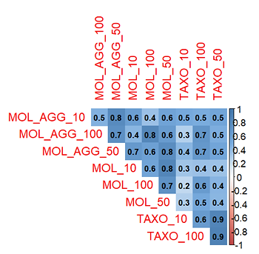
Supplementary Figure 01. Correlation matrix comparing MARXAN site selection outcomes across different data types (taxonomic, genetic, and genetic aggregated) and maximum proportion thresholds (10%, 50%, 100% of species distribution). Values represent the pairwise correlation of selection frequency across sites over 100 bootstrap iterations. The figure illustrates that aggregated genetic selections are well correlated with both taxonomic and genetic runs, while taxonomic and genetic selections alone are weakly correlated, highlighting how data aggregation and proportion thresholds influence MARXAN site prioritization.
MARXAN selection frequency scenarios
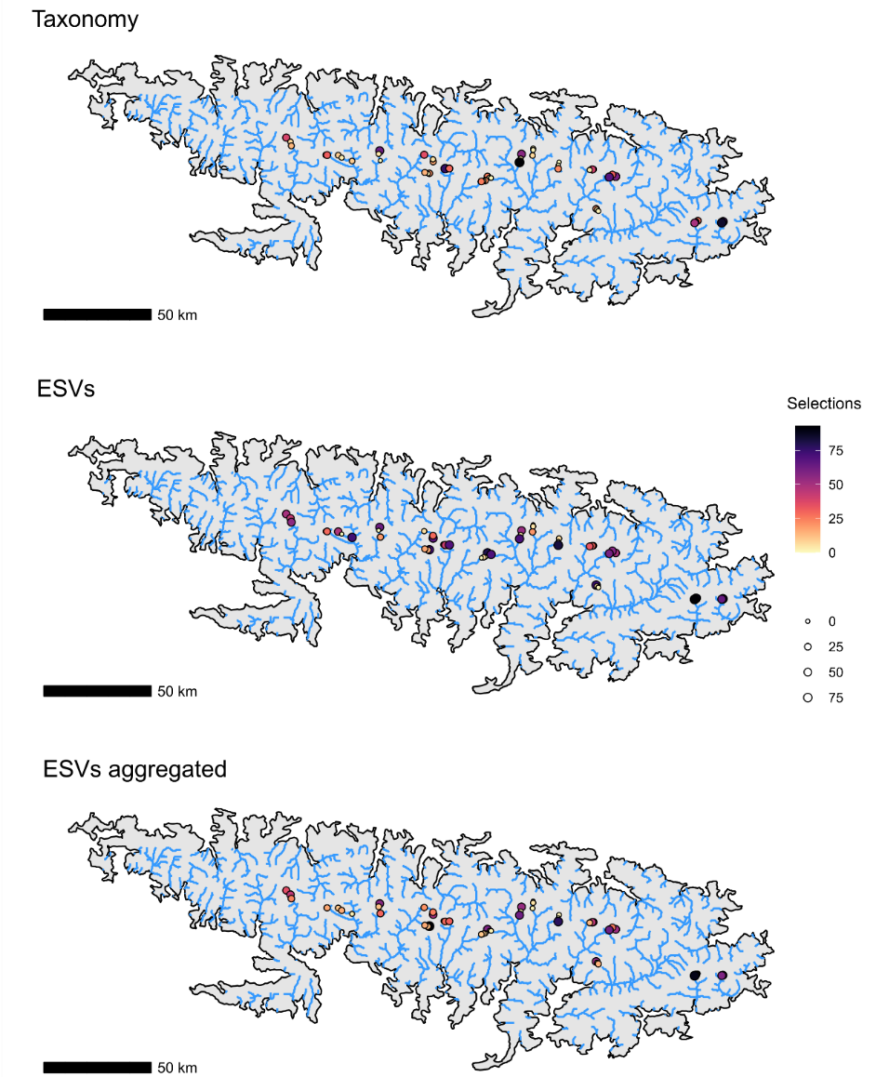Supplementary Figure 02. Site selection frequency across 100 iterations maps in the MARXAN analyses for the taxonomic, ESVs, and ESVs-aggregated analyses. Colors and size represent the number of selections of each site, with colder colors indicating a higher number of selections across bootstrap iterations.

MARXAN biplots
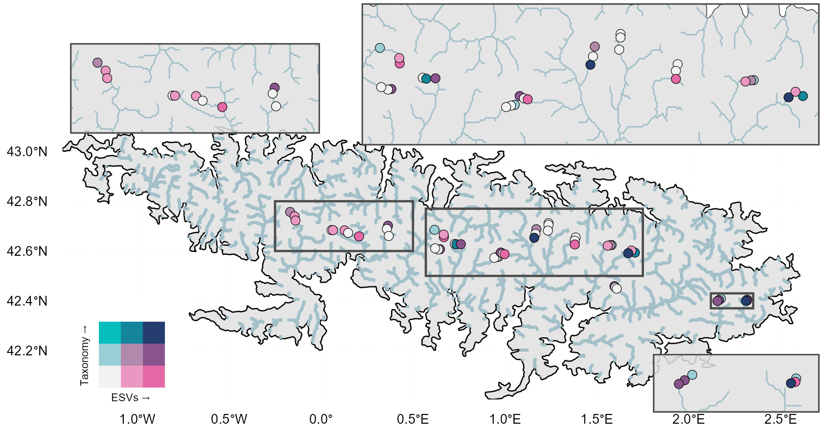
Supplementary Figure 03. MARXAN biplot between taxonomy and ESVs scenarios site selection frequency

Supplementary Figure 04. MARXAN biplot between taxonomy and ESVs_agregated scenarios site selection frequency
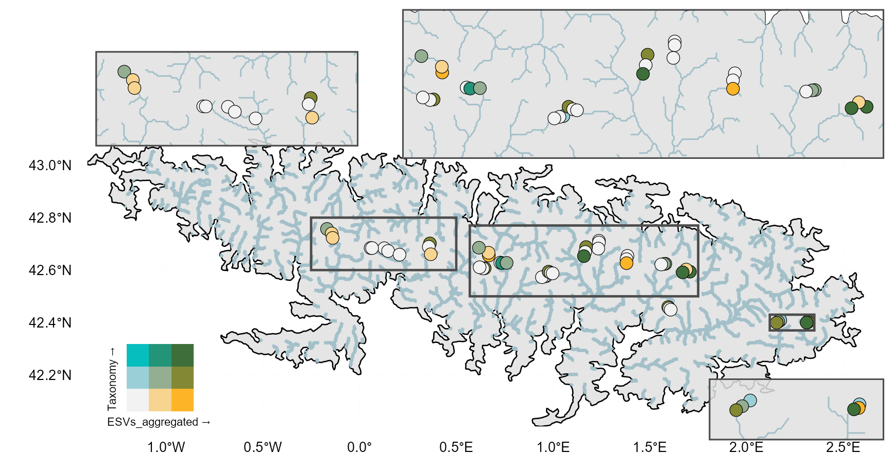

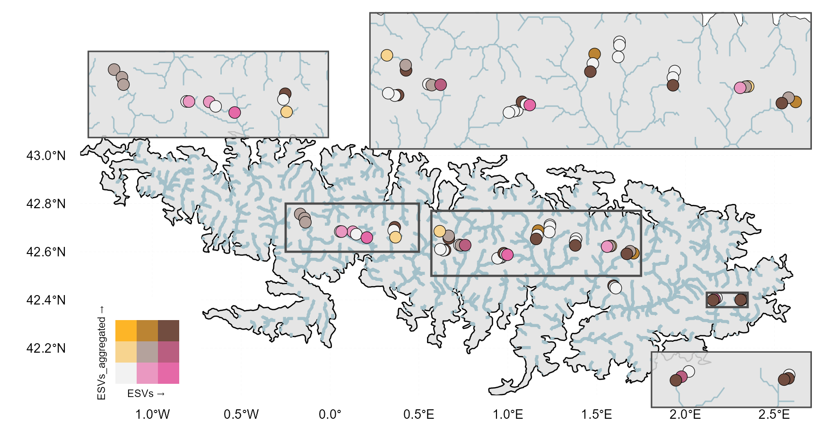Supplementary Figure 05. MARXAN biplot between ESVs and ESVs_agregated scenarios site selection frequency
MARXAN and site vulnerability relationship
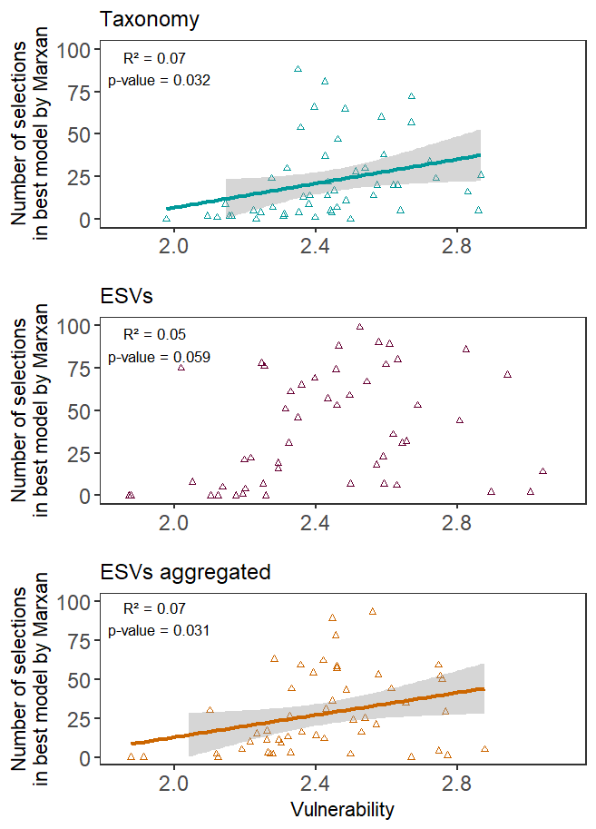
Supplementary Figure 06. Relationship between site community vulnerability and conservation prioritization for each scenario. Scatterplots show the association between mean vulnerability values and the number of times each site was selected across the 100 iterations in the best MARXAN solution for taxonomic, ESVs, and ESVs-aggregated data. Solid lines represent linear regressions with 95% confidence intervals (grey shading). Reported R² and p-values indicate the strength and significance of the relationships.

