Table 1 SiRNA sequences for gene silencing
Gene symbol （Mus） | Primer sequences (5’-3’)
siGPX4 #1  siGPX4 #2 | Forward: GGAAAUGGAUGAAAGUCCATT
siGPX4 #1  siGPX4 #2 | Reverse: UGGACUUUCAUCCAUUUCCTT
siGPX4 #1  siGPX4 #2 | Forward: GCUGCGUGGUGAAGCGCUATT
 | Reverse: GGAGAUGAAUUUCACAAUATT
siLAMP2A #1 | Forward: GGAGAUGAAUUUCACAAUATT
 | Reverse: UAUUGUGAAAUUCAUCUCCTT
siLAMP2A #2 | Forward: CACUAGUGAUAGCACAGUATT
 | Reverse: UACUGUGCUAUCACUAGUGTT
siLAMP2A #3 | Forward: CCUCAAAGUGCUCAACUUATT
 | Reverse: UAAGUUGAGCACUUUGAGGTT
siNC | Forward: UUCUCCGAACGUGUCACGUTT
 | Reverse: ACGUGACACGUUCGGAGAATT

Table2 Real-time PCR primers
Gene symbol （Mus） | Primer sequences (5’-3’)
Gapdh  Gpx4 | Forward: TCCAAAATCAAGTGGGGCGA
Gapdh  Gpx4 | Reverse: AAATGAGCCCCAGCCTTCTC
Gapdh  Gpx4 | Forward: CGCTGTGGAAGTGGATGAAG
 | Reverse: TTGTCGATGAGGAACTGTGG
Col2a1 | Forward: CAAGGACCCAGAGGTGATCG
 | Reverse: CCAGCCTTCTCGTCATACCC
Acan | Forward: GATGGAAACCAGCACGGAGA
 | Reverse: CCTGGGAAACAGTGGGTTCA
Adamts-5 | Forward: CCAAGGCCAAATGGTGTGTC
 | Reverse: CAATGGCGGTAGGCAAACTG
Mmp13 | Forward: TACCATCCTGCGACTCTTGC
 | Reverse: TTCACCCACATCAGGCACTC
Mmp3 | Forward: GCAGCAGGAGAAGAAGAAGAC
 | Reverse: TCAGGAGGAGGAGGAGAAGAT

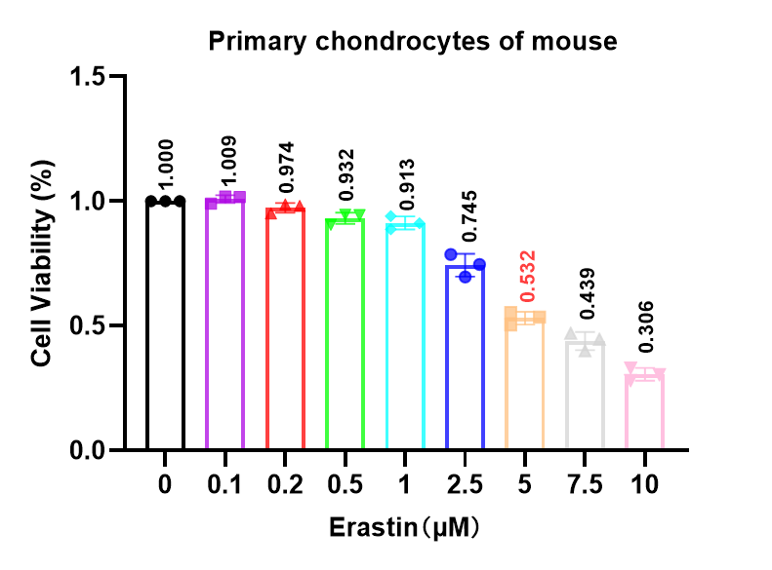
Fig S1: Erastin decreases the viability of primary mouse chondrocytes in a dose-dependent manner. Primary chondrocytes isolated from mice were treated with Erastin at the indicated concentrations (0, 0.1, 0.2, 0.5, 1, 2.5, 5, 7.5, and 10 μM), and cell viability was quantified using a colorimetric viability assay. Data are normalized to the 0 μM group (set to 1) and presented as mean ± SD; each symbol represents one independent replicate (n = 3).

Fig S2: (A) Representative Western blot showing GPX4 protein levels in chondrocytes treated with vehicle, RSL3 alone, RSL3 plus 4MC (40 μM), or RSL3 plus ferrostatin-1 (Fer-1, 1 μM). β-actin served as the loading control. (B) Quantification of GPX4 protein levels normalized to β-actin and expressed relative to the control group. Statistical significance: Data are presented as mean ± SD from three independent primary murine chondrocyte isolations (n = 3). *p < 0.05; **p < 0.01; ***p < 0.001; ****p < 0.0001. ns = not significant.

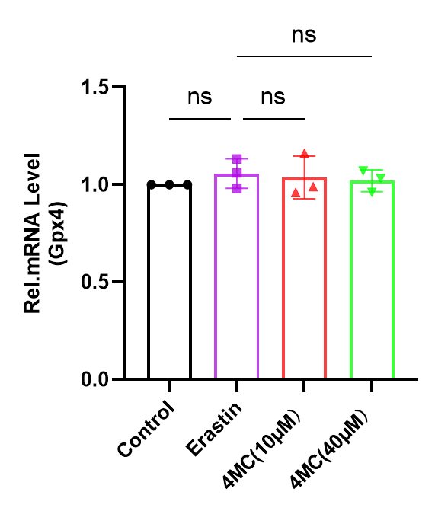
Fig S3: qPCR analysis of Gpx4 mRNA in cells treated with Erastin or 4MC (10 or 40 μM). Expression was normalized to Control and presented as mean ± SD (n = 3). Statistical significance: Data are presented as mean ± SD from three independent primary murine chondrocyte isolations (n = 3). *p < 0.05; **p < 0.01; ***p < 0.001; ****p < 0.0001. ns = not significant.

Fig S4: Increased LAMP2A expression in the weight-bearing area of human OA cartilage.
(A) Representative X-ray image and gross specimen indicating the collection of paired cartilage samples from the weight-bearing and matched non-weight-bearing area of the same osteoarthritic knee joint.(B) Representative immunohistochemical staining of LAMP2A in paired human OA cartilage samples. The weight-bearing region displayed a higher proportion of LAMP2A-positive chondrocytes than the matched non-weight-bearing region. Red arrows indicate positive staining. Scale bar, 20 μm.(C) Quantitative analysis of LAMP2A-positive cells shown in (B).Data are presented as mean ± SD; n = 9 independent human OA donors. Statistical significance: *p < 0.05; **p < 0.01; ***p < 0.001; ****p < 0.0001. ns = not significant.
Fig S5: (A) Representative Western blot of GPX4 (22 kDa) in cells treated with Erastin (±), with or without 4MC and/or bafilomycin A1 (Baf A1); Actin (41 kDa) served as the loading control.(B) Densitometric quantification of GPX4 normalized to Actin and expressed relative to the control group. Statistical significance:Data are presented as mean ± SD from three independent primary murine chondrocyte isolations (n = 3). *p < 0.05; **p < 0.01; ***p < 0.001; ****p < 0.0001. ns = not significant.

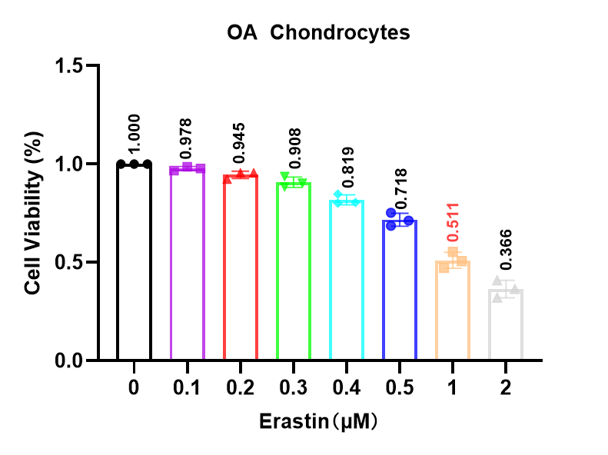
Fig S6: Erastin dose-dependently reduces viability of OA chondrocytes. Viability was normalized to 0 μM (set to 1) and shown as mean ± SD (n = 3).

