Supplementary materials
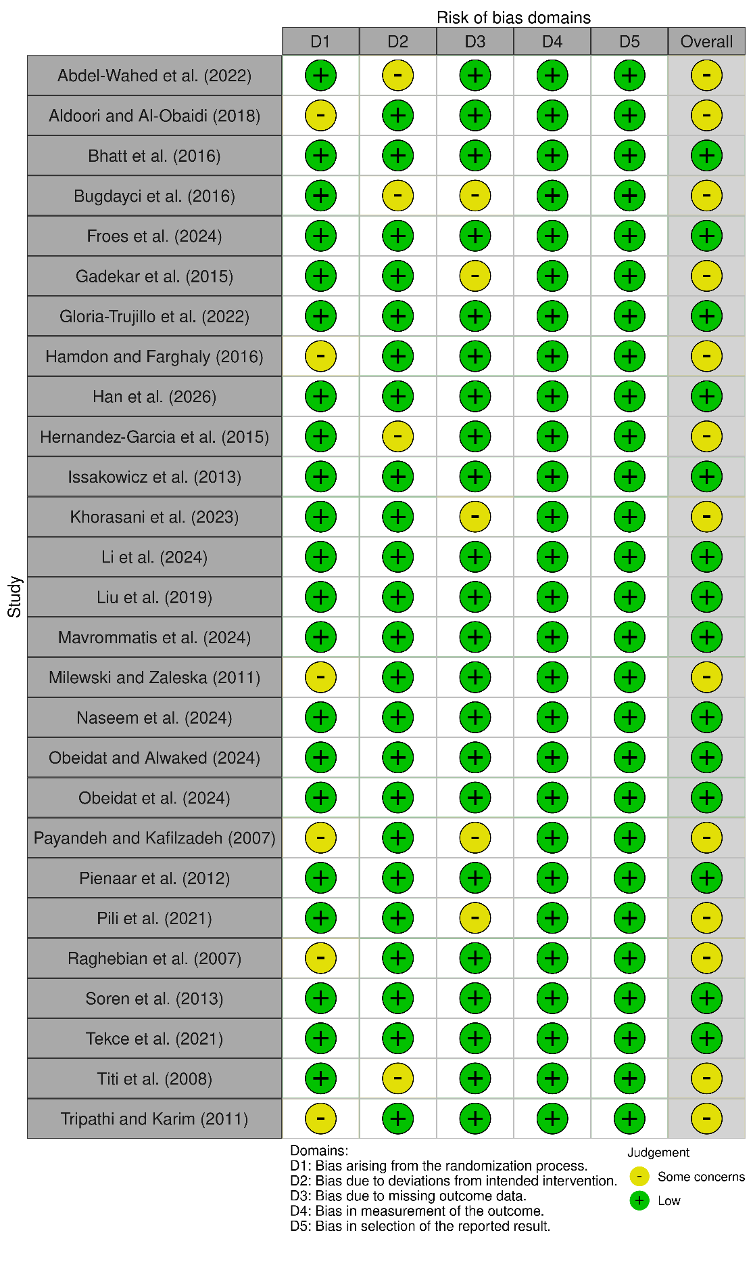
Fig. S1 Traffic light plot of risk of bias assessment.

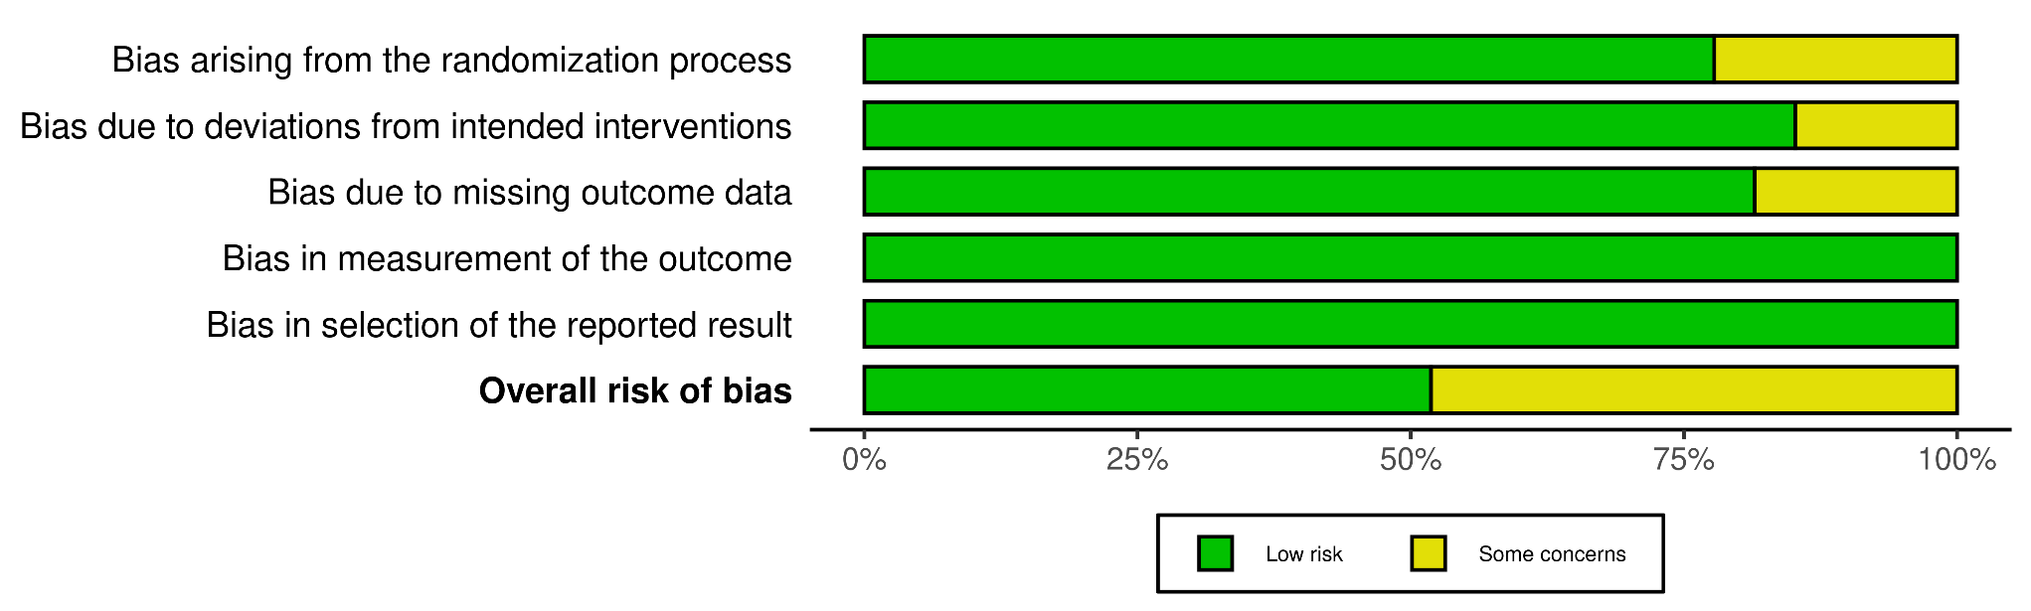
Fig. S2 Summary plot of risk of bias assessment.

