Phytoplankton Diversity Shapes Microbial Enzymatic Processes and Organic Matter Turnover in the Greenland Sea

Carmela Caroppo^{1,}°, Federica Cerino^{2,}°, Manuel Bensi², Gabriella Caruso³, Franco Decembrini^{3,}°°, Vedrana Kovacevic², Giovanna Maimone³, Luisa Patrolecco⁴, Francesca Spataro⁴, Maurizio Azzaro³

¹ National Research Council, Institute for Marine Biological Resources and Biotechology (CNR-IRBIM), via Roma 3, 74121 Taranto (Italy)
² Institute of Oceanography and Applied Geophysics, Section of Oceanography, via Auguste Piccard 54, 34151 Trieste (Italy)
³ National Research Council, Institute of Polar Sciences (CNR-ISP), Spianata S. Raineri 86, 98122 Messina (Italy)
⁴ National Research Council, Institute of Polar Sciences (CNR-ISP), Via Salaria km 29,300, 00015 Rome (Italy)

° These authors contributed equally to the work
°° Corresponding author: Franco Decembrini, franco.decembrini@cnr.it

Fig. S1 Particulate organic carbon (POC) (a) and dissolved organic carbon (DOC) (b) concentrations in all stations at different depths along the 75° N transect with evidence of different water masses (Polar Water in light red, Transition Zone in yellow, Surface Atlantic Water in light blue, Atlantic Water in dark blue).

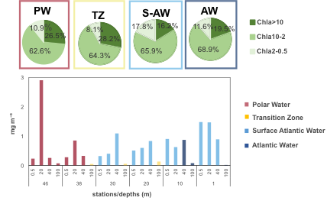
Fig. S2 Total chlorophyll a concentration (bars) and mean percentage (pie charts) of the three phytoplankton size fractions: microphytoplankton (Chla>10), nanophytoplankton (Chla10-2), and picophytoplankton (Chla2-0.5) along the 75° N transect with evidence of different water masses (PW in light red, TZ in yellow, S-AW in light blue, AW in dark blue).

Fig. S3 Non-metric multidimensional scaling (nMDS) ordination plots of phytoplankton assemblages at the different stations (a) and in the water masses (b). Overlaid green filled circles indicate significantly (at the 5% significance level) distinct groups identified by the SIMPROF test. Blue vectors representing abiotic variables are superimposed, indicating the discriminating factors responsible for the separation of samples. Tem: temperature; Sal: salinity; O₂: dissolved oxygen; Tur: turbidity; NO2: nitrite; NO3: nitrate; NH4: ammonium; PO4: phosphate; H4SiO4: silicate.

Fig. S4 Percentage contribution to total POC of detritus, prokaryotic (Prok) and phytoplankton (Phyto) biomasses in the different water masses (PW: Polar Water; TZ: Transition Zone; S-AW: Surface Atlantic Water; AW: Atlantic Water).

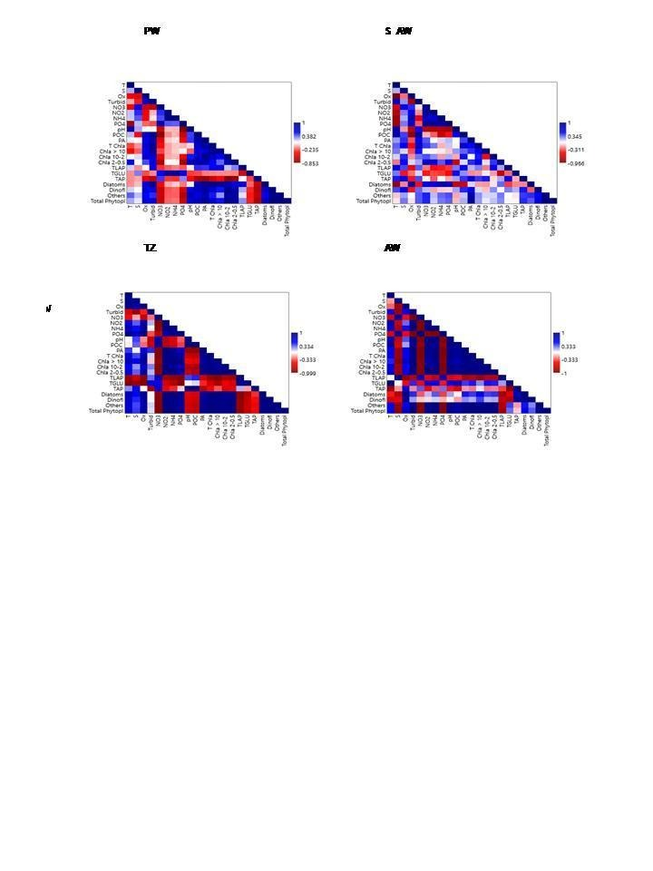

Fig. S5 Heatmaps showing the significant relationships among microbial metabolism and phytoplankton observed in each water mass separately (PW: Polar Water; TZ: Transition Zone; S-AW: Surface Atlantic Water; AW: Atlantic Water).

