1. Supplementary methods

1.1 Overview of the study area
The sampling site for this study is located in the Iškoras permafrost peatland within the Finnmarksvidda mountains of northern Norway, as shown in Fig. S1. The region is characterized by a subarctic or polar climate, with a mean annual temperature of -1.2°C during the period from 1991 to 2020, and a strong rise in temperature over the past decades, promoting rapid permafrost thaw (Kjær et al., 2024). The average summer temperature is approximately 10°C, and the mean annual precipitation is 417 mm, based on measurements from meteorological station SN97251, situated about 15 km north of Iškoras (Kjellman et al., 2018). The development of the Iškoras peatland commenced around 9200 calibrated years before present (cal yr BP), while permafrost formation in the area dates to the Little Ice Age. Radiocarbon dating of a single core indicates that permafrost formation occurred approximately 800 cal yr BP. The dominant soil type in this peatland is organic soil with low peat bulk density (0.08–0.28 g cm⁻³), which is significantly influenced by active layer dynamics and excess ice content (Kjær et al., 2024). The peatland in Iškoras reaches a thickness of up to 155 cm, with a maximum active layer thickness of 90 cm. The surface is primarily covered by lichens and evergreen dwarf shrubs, such as Empetrum nigrum, Andromeda polifolia, Rubus chamaemorus, and Vaccinium uliginosum, while shallow pond areas are dominated by Sphagnum mosses (Pirk et al., 2024).

1.2 Sample collection
In September 2022, surface sediment samples (0–20 cm depth, n=4, parallel cores) were systematically collected from a shallow pond situated in the central region of the Iškoras permafrost peatland (69.20°N, 25.17°E; elevation: 360 m). Each sample was subdivided on site into three subsamples: two subsamples were allocated for incubation experiments and sediment property analyses, while the third was reserved for subsequent molecular microbial analysis. After transportation to the laboratory under cold conditions, the subsamples were stored at 4°C and -80°C, respectively, for subsequent analyses.

1.3 Determination of environmental factors
Sediment moisture content (MC) was determined using the oven-drying method: approximately 5 g of fresh sediment was weighed and recorded in a container, then dried in an oven at 60 °C for 48 hours, the samples were repeatedly dried and weighed until a constant weight was achieved. For further analyses, sediment samples were vacuum freeze-dried, homogenized, and sieved through a 100-mesh sieve. Two aliquots of the processed samples were placed in sample boats, and total carbon (TC) and inorganic carbon (IC) were determined using a total organic carbon analyzer (TOC-VCPH, Shimadzu Corporation, Japan); total organic carbon (TOC) was calculated as TOC = TC - IC. Total nitrogen (TN) content in the sediment was measured using a TNM-1 total nitrogen measurement unit connected to the TOC analyzer (Wei et al., 2023). To determine pH and oxidation-reduction potential (ORP), approximately 5 g of fresh sediment was mixed with 25 ml of ultrapure water (soil-to-water ratio 1:5). The mixture was subjected to shaking at 250 rpm for 30 minutes at 25°C, followed by a 30-minute settling period. The supernatant was then analyzed for pH and ORP using a SensION+ PH3 pH and ORP combination sensor (HACH LANGE, USA). Dissolved organic carbon (DOC) was determined using the same pretreatment method, the supernatant was filtered through a 0.45 µm membrane, and the filtrate was analyzed using the TOC analyzer (Kjær et al., 2024).
The physicochemical properties of the sediment determined by the above methods were as follows: MC, 92.71 ± 3.24%; TN and TOC contents, 20.63 ± 1.52 mg/g and 393.05 ± 34.83 mg/g, respectively; pH, 4.68 ± 0.22; ORP, 130.50 ± 13.50 mV; and DOC, 81.23 ± 30.63 mg L⁻¹.

1.4 Culture experiment
We placed fresh sediment (19.9±0.05 g) in 120 ml sterile serum bottles and sealed them with a rubber stopper in a helium-filled anaerobic chamber. Using an automatic manifold to flush headspace with helium 6.0 (He), alternately evacuating and filling the headspace three times, we ensured that the experimental systems were anoxic. The PFOA used in this study (molecular weight of 414.07, molecular formula C₈HF₁₅O₂, CAS number 335-67-1) was purchased from Sigma-Aldrich, Norway. A PFOA stock solution (1000 μ/mL) was prepared by dissolving 0.5 g of PFOA powder in 500 mL of Milli-Q water. Working solutions with lower concentrations (20, 10, 0.8, and 0.4 μg/mL) were subsequently prepared by serially diluting the stock solution. To minimize impact on sediment characteristics, we added 0.1 ml of these pre-prepared PFOA solutions of different concentrations to each experimental system to achieve final PFOA concentrations of 0, 2, 4, 50, 100, and 5000 ng/g sediment (See table S1). This range was chosen to cover concentrations from typical remote areas (permafrost sediments) in the low ng/g range to polluted (10-100 ng/g) and concentrations typically found in heavy contaminated sites (sites near PFAS manufacturing plants, of extensive firefighting foam use and landfills or wastewater treatment receiving industrial effluent; see Table S1 for further detail).
A total of 24 microcosms was established (four replicates for each of the six PFOA concentrations) and incubated in the dark at 10°C in a temperature-controlled water bath equipped with automated gas analysis (Kjær et al., 2024; Molstad et al., 2007). The incubator included a water bath placed under the robotic arm of an autosampler (GC-Pal, CTC).

1.5 Gas measurements and production characteristics
Gas measurements were performed by the autosampler that repeatedly pierced the bottle septa with hypodermic needles. A peristaltic pump (Gilson 222XL) transferred approximately 1 mL of headspace gas to a multipurpose, multi-detector gas chromatograph (GC; Agilent 7890A) fitted with an automated injection system. After injection, the pump was reversed to return the residual sample to the bottle, maintaining a pressure of approximately 1 atm in the bottles. The GC system included two columns—a PoraPLOT Q column for CH₄ separation and a Molesieve column for O₂/Ar/N₂ separation—as well as three detectors (TCD, FID, and ECD). Bottles containing standard gas mixtures of known concentration (AGA, Norway) were included in each measurement sequence for calibration and to assess dilution caused by He back-purging. Bottles filled with He were used to evaluate potential O₂ leakage into the measurement system. Peak areas were converted to parts per million by volume (ppmv), and further to nmol per gram soil added for CO₂ and CH₄ by accounting for gas solubility in peat water (Wilhelm et al., 1977) and sample dilution during He back-purging and O₂ leakage. CO₂ and CH₄ concentration dynamics were characterized using the framework as described previously in Carlsen et al. (Carlsen et al., 2025). Here we added two additional descriptors: the end concentration of CO₂ and CH₄, and take-off time (time to reach 5% of max. rate). For further methodological details, see Kjær et al. (2024) and Molstad et al. (2007).
The total incubation period was approximately 180 hours. Headspace gas concentrations were monitored every 6 hours to achieve a high-resolution assessment of CO₂ and CH₄ dynamics from the sediment samples exposed to different PFOA concentrations. Details of the CO₂ and CH₄ calculations are provided in the supplementary material. Following incubation, sediment samples were freeze-dried and stored at -80 °C for subsequent molecular microbiological analyses.

1.6 Library preparation and sequencing
DNA was extracted from 0.05 g of vacuum freeze-dried sediment using the PowerSoil DNA Isolation Kit (MO BIO Laboratories, USA) following the manufacturer’s instructions. The quantity and purity of the extracted DNA were measured using a NanoDrop NC2000 spectrophotometer (Thermo Scientific, USA), and DNA integrity was assessed by 1% (w/v) agarose gel electrophoresis. All DNA samples were stored at −20°C until further analysis.
A two-step PCR protocol was carried out for amplification of the bacterial 16S rRNA gene (V4–V5 region), as well as the functional genes mcrA (methanogens) and pmoA (methanotrophs). In the first PCR, gene-specific primers with Illumina adapter overhangs were used to amplify the target fragments. The second PCR step incorporated sample-specific indices and full-length Illumina adapters. Details of primer sequences are provided in Table S2. PCR products from both steps were verified by 1% (w/v) agarose gel electrophoresis and purified using Agencourt AMPure XP magnetic beads (Beckman Coulter, USA). Final PCR products were quantified using PicoGreen, pooled in equimolar concentrations to construct the sequencing library, further purified by agarose gel extraction, and quantified prior to sequencing. High-throughput sequencing was performed on the Illumina MiSeq platform (2×300 bp, Norwegian Sequencing Center).
Raw paired-end reads were merged using FLASH v1.2.11. Quality filtering was conducted with Trimmomatic v0.33, and primer sequences were trimmed using cutadapt v1.9.1. Denoising, merging, and chimera removal were conducted using the DADA2 pipeline within QIIME2 v2020.6 to generate amplicon sequence variants (ASVs). Taxonomic assignment for 16S rRNA gene ASVs was performed using a naïve Bayes classifier trained on the SILVA 138 reference database. Functional gene ASVs (mcrA and pmoA) were annotated using the FunGene database.

1.7 Bacterial (prokaryotic) numbers
Samples for bacterial counts were fixed with glutaraldehyde at a final concentration of 2% and stored at 4 °C prior to analyses. Cells were stained with the fluorescent nucleic acid stain SYBR green I (Molecular probes, Invitrogen, Waltham, Massachusetts, USA) for at least 30 min (1x final concentration) and counted with an Attune® NxT Acoustic Focusing Cytometer (Thermo Fisher) equipped with an Invitrogen Attune® NxT Autosampler and a 488 nm laser using green fluorescence for triggered particle scoring.

References
Carlsen ECL, Wei J, Lejzerowicz F, Trier Kjær S, Westermann S, Hessen DO, et al. Redox determines greenhouse gas production kinetics and metabolic traits in water-saturated thawing permafrost peat. ISME Communications 2025;5:ycaf009.
Kjær ST, Westermann S, Nedkvitne N, Dörsch P. Carbon degradation and mobilisation potentials of thawing permafrost peatlands in northern Norway inferred from laboratory incubations. Biogeosciences 2024;21:4723–37.
Kjellman SE, Axelsson PE, Etzelmüller B, Westermann S, Sannel ABK. Holocene development of subarctic permafrost peatlands in Finnmark, northern Norway. The Holocene 2018;28:1855–69.
Molstad L, Dörsch P, Bakken LR. Robotized incubation system for monitoring gases (O2, NO, N2O N2) in denitrifying cultures. J Microbiol Meth 2007;71:202–11.
Pirk N, Aalstad K, Mannerfelt ES, Clayer F, De Wit H, Christiansen CT, et al. Disaggregating the carbon exchange of degrading permafrost peatlands using bayesian deep learning. Geophys Res Lett 2024;51:e2024GL109283.
Wei J, Fontaine L, Valiente N, Dörsch P, Hessen DO, Eiler A. Trajectories of freshwater microbial genomics and greenhouse gas saturation upon glacial retreat. Nat Commun 2023;14:3234.
Wilhelm Emmerich, Battino Rubin, Wilcock RJ. Low-pressure solubility of gases in liquid water. Chem Rev 1977;77:219–62.

Supplementary tables

Table. S1. Incubation experiment information for different concentrations of Perfluorooctanoic acid (PFOA). Final PFOA concentrations are given in ng/g of sediment. References provide a basis for the used PFOA concentrations.
Final PFOA Concentration | 0 ng/g | 2 ng/g | 4 ng/g | 50 ng/g | 100 ng/g | 5000 ng/g
Group Name | Control | PFOA2 | PFOA4 | PFOA50 | PFOA100 | PFOA5000
Group Description | Control | Low concentration |  | Medium concentration |  | High concentration
Group Basis | Blank control | Natural environmental level |  | Wastewater/sludge monitoring level |  | Extremely high concentration as a pilot study
Reference | / | Cabrerizo et al., 2018; Saritha et al., 2023 |  | Arvaniti and Stasinakis, 2015 |  | Chen et al., 2021; Tang et al., 2022
References
Arvaniti OS, Stasinakis AS. Review on the occurrence, fate and removal of perfluorinated compounds during wastewater treatment. Science of the Total Environment 2015;524:81–92.
Cabrerizo A, Muir DCG, De Silva AO, Wang X, Lamoureux SF, Lafrenière MJ. Legacy and Emerging Persistent Organic Pollutants (POPs) in Terrestrial Compartments in the High Arctic: Sorption and Secondary Sources. Environ Sci Technol 2018;52:14187–97. https://doi.org/10.1021/acs.est.8b05011.
Chen H, Zou M, Zhou Y, Zeng L, Yang X. Monitoring the nitrous oxide emissions and biological nutrient removal from wastewater treatment: impact of perfluorooctanoic acid. Journal of Hazardous Materials 2021;402:123469.
Saritha VK, Krishnan KP, Mohan M. Perfluorooctanoic acid in the sediment matrices of Arctic fjords, Svalbard. Marine Pollution Bulletin 2023;192:115061.
Tang L, Su C, Fan C, Li R, Wang Y, Gao S, et al. Long-term effect of perfluorooctanoic acid on the anammox system based on metagenomics: Performance, sludge characteristic and microbial community dynamic. Bioresource Technology 2022;351:127002.

Table. S2. Primers used in this study
Primer name | Primer sequences (5-3) | Target gene | References
515F  806R | GTGCCAGCMGCCGCGGTAA  GGACTACHVGGGTWTCTAAT | 16S rRNA | Apprill et al., 2015
ME1F  ME2R | GCMATGCARATHGGWATGTC  TCATBGCRTAGTTDGGRTAGT | mcrA | Luton et al., 2002
A189F  mb661R | GGNGACTGGGACTTCTGG  CCGGMGCAACGTCYTTACC | pmoA | Bourne et al., 2001

References
Apprill A, McNally S, Parsons R, Weber L. Minor revision to V4 region SSU rRNA 806R gene primer greatly increases detection of SAR11 bacterioplankton. Aquatic Microbial Ecology 2015;75:129–37.
Bourne DG, McDonald IR, Murrell JC. Comparison of pmoA PCR Primer Sets as Tools for Investigating Methanotroph Diversity in Three Danish Soils. Appl Environ Microbiol 2001;67:3802–9.
Luton PE, Wayne JM, Sharp RJ, Riley PW. The mcrA gene as an alternative to 16S rRNA in the phylogenetic analysis of methanogen populations in landfill. Microbiology 2002;148:3521–30.

Table. S3. ANOVAs on mixed-effects models for CO₂ dynamics-related descriptors. These models were applied to assess the effects of PFOA addition and source environment on the concentration of CO₂ at the end of the experiment (End concentrations), the maximum production rate and lag phase assessed by the framework described in Carlsen et al. (2025), and take-off time. The latter was defined by production rates exceeding a threshold defined by core specific maximum production rates.
Response variable | Factor | df | F-value | p-value
End concentration | core | 3 | 4.86 | 0.014*
End concentration | log₁₀(PFOA+1) | 1 | 0.04 | 0.840
End concentration | core : log₁₀(PFOA + 1) | 3 | 0.77 | 0.530
Maximum production rate | core | 3 | 6.46 | 0.005**
Maximum production rate | PFOA | 1 | 1.42 | 0.240
Maximum production rate | core : PFOA | 3 | 1.03 | 0.410
lag-phase | core | 3 | 0.63 | 0.610
lag-phase | PFOA | 1 | 0.14 | 0.710
lag-phase | core : PFOA | 3 | 0.04 | 0.990
Take-off time | core | 3 | 7.98 | 0.002 **
Take-off time | log₁₀(PFOA+1) | 1 | 6.42 | 0.022 *
Take-off time | core : log₁₀(PFOA + 1) | 3 | 0.81 | 0.510
References
Carlsen ECL, Wei J, Lejzerowicz F, Trier Kjær S, Westermann S, Hessen DO, et al. Redox determines greenhouse gas production kinetics and metabolic traits in water-saturated thawing permafrost peat. ISME Communications 2025;5:ycaf009.

Table. S4. ANOVAs on mixed-effects models for cell counts. These models were applied to assess the effects of PFOA addition and source environment on cell counts.
Response variable | Factor | df | F-value | p-value
Cell counts | core | 3 | 2.66 | 0.084
Cell counts | log₁₀(PFOA+1) | 1 | 2.75 | 0.120
Cell counts | core : log₁₀(PFOA + 1) | 3 | 0.94 | 0.440

Table. S5. ANOVAs on mixed-effects models for α-diversity. These models were applied to assess the effects of PFOA addition and source environment on various α-diversity indices (response variable).
Response variable | Factor | df | F-value | p-value
ACE | core | 3 | 1.06 | 0.390
ACE | log₁₀(PFOA+1) | 1 | 1.11 | 0.310
ACE | core : log₁₀(PFOA+ 1) | 3 | 1.95 | 0.160
Chao1 | core | 3 | 1.10 | 0.380
Chao1 | log₁₀(PFOA+1) | 1 | 1.09 | 0.310
Chao1 | core : log₁₀(PFOA + 1) | 3 | 1.98 | 0.160
Simpson | core | 3 | 11.05 | <0.0001***
Simpson | log₁₀(PFOA+1) | 1 | 0.89 | 0.360
Simpson | core : log₁₀(PFOA + 1) | 3 | 7.16 | 0.003 **
Shannon | core | 3 | 8.97 | 0.001 **
Shannon | log₁₀(PFOA+1) | 1 | 0.58 | 0.460
Shannon | core : log₁₀(PFOA + 1) | 3 | 6.08 | 0.006 **

Supplementary figtures
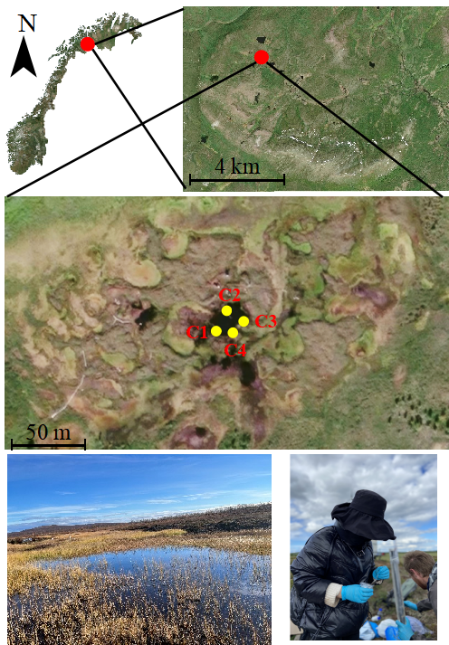

Figure. S1. Map of sampling locations and photos from the sampling.

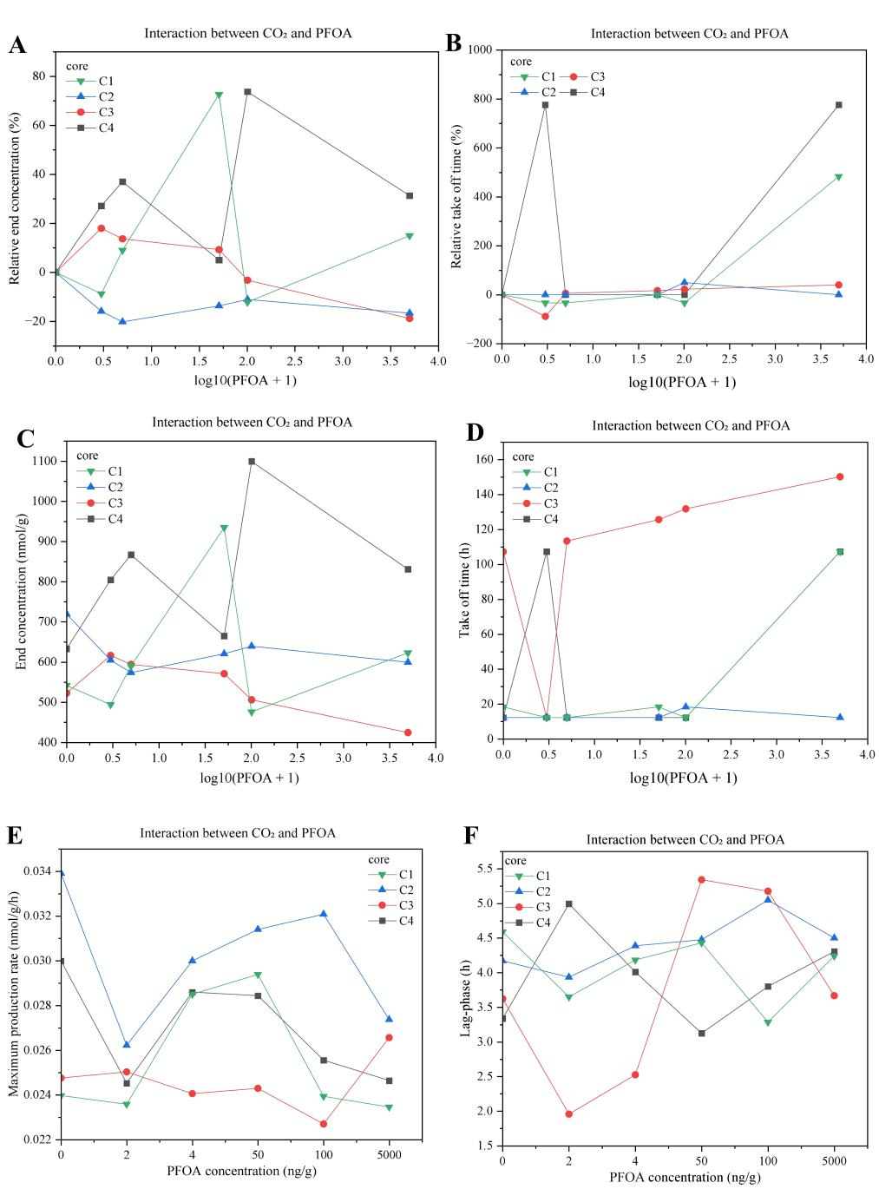

Figure. S2. Interaction between CO₂ dynamics-related descriptors and PFOA concentrations across cores. The colors indicate the various cores (C1-C4); (A) relative CO₂ end concentration and (B) relative take-off time across log₁₀(x+1)-transformed PFOA concentrations; (C) absolute CH₄ end concentrations and (D) take-off time across log10(x+1)-transformed PFOA concentrations; (E) represents the maximum production rates at different PFOA concentrations; and (F) the lag phase assessed by the framework described in Carlsen et al. (2025).
References
Carlsen ECL, Wei J, Lejzerowicz F, Trier Kjær S, Westermann S, Hessen DO, et al. Redox determines greenhouse gas production kinetics and metabolic traits in water-saturated thawing permafrost peat. ISME Communications 2025;5:ycaf009.

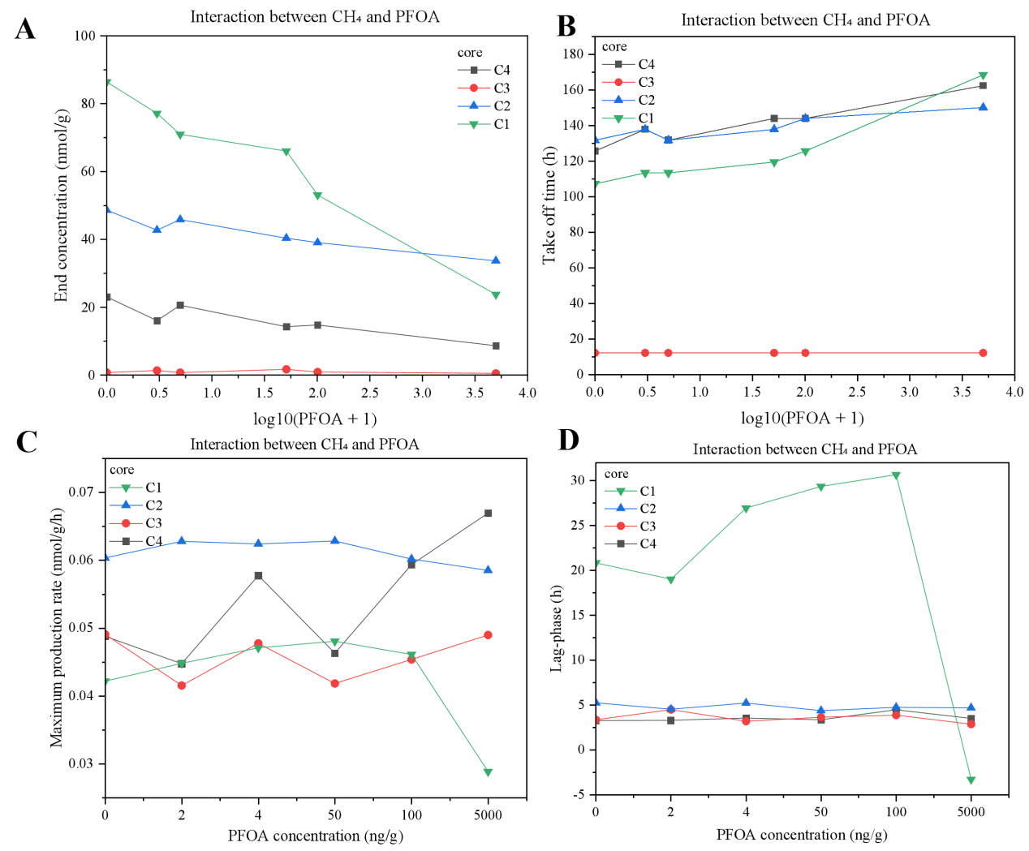

Figure. S3. Interaction between CH₄ dynamics-related descriptors and PFOA concentrations across cores. The colors indicate the various cores (C1-C4). (A) Absolute CH₄ end concentrations and (B) take-off time across log10(x+1)-transformed PFOA concentrations; (C) represents the maximum production rates at different PFOA concentrations; and (D) the lag phase assessed by the framework described in Carlsen et al. (2025).

References
Carlsen ECL, Wei J, Lejzerowicz F, Trier Kjær S, Westermann S, Hessen DO, et al. Redox determines greenhouse gas production kinetics and metabolic traits in water-saturated thawing permafrost peat. ISME Communications 2025;5:ycaf009.

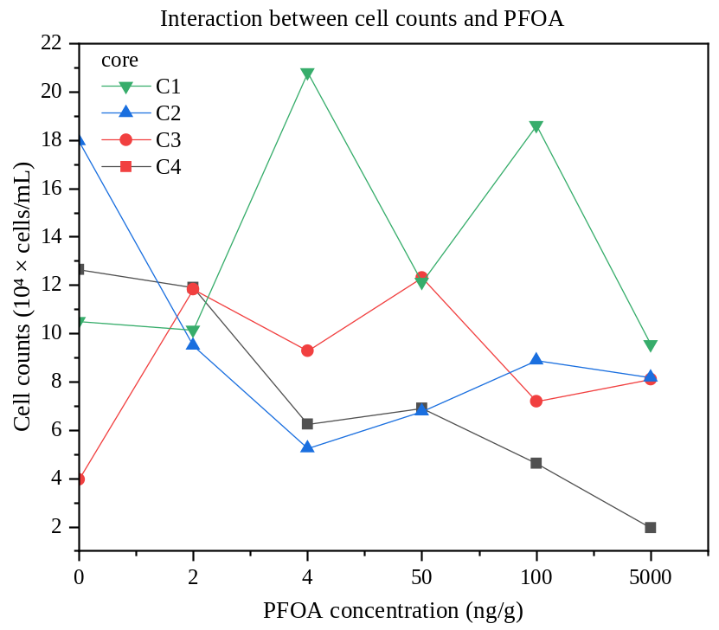

Figure. S4. Interaction between cell counts and PFOA concentrations across cores. The colors indicate the various cores (C1-C4).

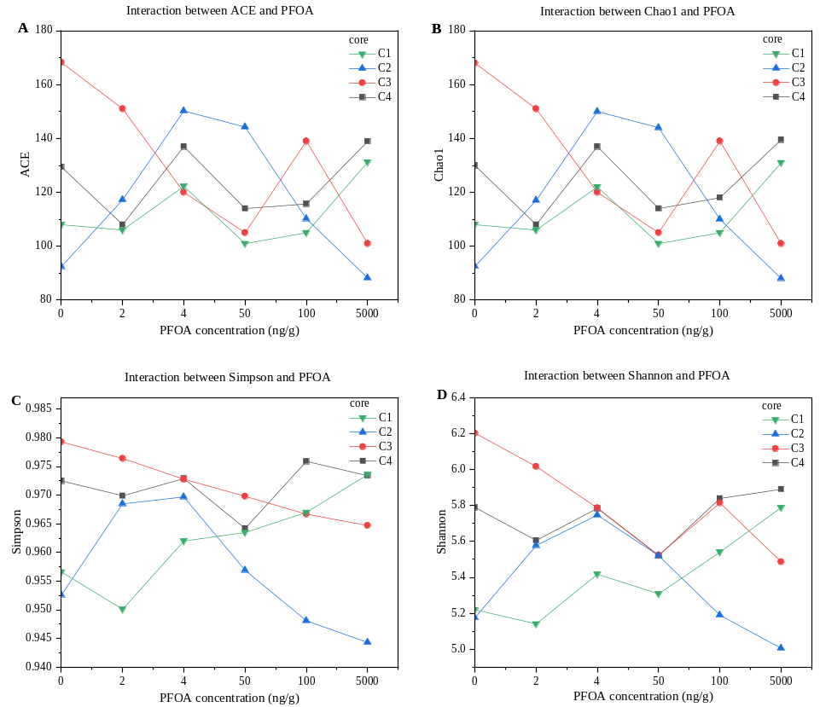

Figure. S5. Interaction between α-diversity and PFOA concentrations across cores. A: ACE index; B: Chao1 index; C: Simpson index; D: Shannon index. The colors indicate the various cores (C1-C4).

Figure. S6. NMDS plots of microbial community structures under different treatment conditions: raw (original samples), Control (0 ng/g) and PFOA concentrations (2-5000 ng/g) (A) and among sediment cores (B). The colors indicate the various cores (C1-C4).

Figure. S7. LEfSe analysis of key biomarkers in different groups.
The phylogenetic relationship among amplicon sequence variances are given by a cladogram with the identified key biomarkers highlighted (B); Results from LEfSe analysis highlighting taxa associated with various treatments: raw (original samples), Control (0 ng/g) and PFOA concentrations (2-5000 ng/g).

Figure. S8. α-diversity of CH₄-related microbial communities under different treatment conditions: raw (original samples), Control (0 ng/g) and PFOA concentrations (2-5000 ng/g)
A: Chao1 index of methanogenic communities;
B: Shannon index of methanogenic communities;
C: Chao1 index of methanotrophic communities;
D: Shannon index of methanotrophic communities.

Figure. S9. NMDS ordinations of methanogenic and methanotrophic community structures under different treatment conditions: raw (original samples), Control (0 ng/g) and PFOA concentrations (2-5000 ng/g) and among sediment cores (C1-C4).
A: Methanogenic communities grouped by PFOA concentrations;
B: Methanogenic communities grouped by sediment cores;
C: Methanotrophic communities grouped by PFOA concentrations;
D: Methanotrophic communities grouped by sediment cores.

