Supplementary material included in the manuscript file

Supplementary Table S1. Modified Robson operational definitions
Supplementary Table S1 Modified Robson operational definitions
Group | Label | Algorithm
1 | Nulliparous, term, singleton, cephalic, spontaneous labor | Singleton; cephalic; ≥37 weeks; no previous cesarean; nulliparous proxy; spontaneous labor
2 | Nulliparous, term, singleton, cephalic, induced labor or prelabor cesarean | As group 1, but induced labor (2a) or prelabor cesarean (2b)
3 | Multiparous without previous cesarean, term, singleton, cephalic, spontaneous labor | Singleton; cephalic; ≥37 weeks; no previous cesarean; multiparous proxy; spontaneous labor
4 | Multiparous without previous cesarean, term, singleton, cephalic, induced labor or prelabor cesarean | As group 3, but induced labor (4a) or prelabor cesarean (4b)
5 | Previous cesarean, term, singleton, cephalic | Singleton; cephalic; ≥37 weeks; one or more previous cesareans
6 | Nulliparous singleton breech | Singleton; breech; nulliparous proxy
7 | Multiparous singleton breech | Singleton; breech; multiparous proxy
8 | Multiple pregnancy | Plurality >1, regardless of other characteristics
9 | Singleton with other/non-cephalic, non-breech presentation | Singleton; NVSS presentation category “other”
10 | Singleton cephalic, preterm | Singleton; cephalic; <37 weeks
Parity proxy used live-birth order, with any recorded previous cesarean overriding a first-live-birth code.
Source fields and fixed-width positions are documented in the accompanying analysis code.
Supplementary Table S2 Subgroups 2a, 2b, 4a, and 4b
Year | Subgroup | Births, n | Population share, % | Cesareans, n | Cesarean rate, % | Relative contribution, %
2016 | 2a | 415,181 | 10.80 | 127,672 | 30.75 | 10.29
2016 | 2b | 103,267 | 2.69 | 103,267 | 100.00 | 8.32
2016 | 4a | 446,524 | 11.62 | 27,042 | 6.06 | 2.18
2016 | 4b | 94,308 | 2.45 | 94,308 | 100.00 | 7.60
2024 | 2a | 554,964 | 15.76 | 161,296 | 29.06 | 13.83
2024 | 2b | 90,630 | 2.57 | 90,630 | 100.00 | 7.77
2024 | 4a | 529,474 | 15.04 | 31,746 | 6.00 | 2.72
2024 | 4b | 78,561 | 2.23 | 78,561 | 100.00 | 6.74
2a and 4a indicate induced labor; 2b and 4b indicate cesarean before labor in the corresponding term singleton cephalic parity groups.
Supplementary Table S3 Quasi-Poisson trend models
Model | Years | APC, % | 95% CI | P value
Overall primary | 2016–2024 (n=9) | 0.358 | 0.221 to 0.494 | <0.001
Overall excluding 2020-2021 | 2016–2024 (n=7) | 0.357 | 0.210 to 0.504 | <0.001
Overall excluding modified group 9 | 2016–2024 (n=9) | 0.423 | 0.302 to 0.545 | <0.001
Group 1 | 2016–2024 (n=9) | 0.311 | -0.050 to 0.674 | 0.091
Group 2 | 2016–2024 (n=9) | -1.615 | -2.203 to -1.022 | <0.001
Group 3 | 2016–2024 (n=9) | 0.674 | 0.278 to 1.071 | <0.001
Group 4 | 2016–2024 (n=9) | -2.503 | -3.391 to -1.608 | <0.001
Group 5 | 2016–2024 (n=9) | -0.492 | -0.533 to -0.450 | <0.001
Group 6 | 2016–2024 (n=9) | 0.182 | 0.076 to 0.289 | <0.001
Group 7 | 2016–2024 (n=9) | 0.255 | 0.149 to 0.361 | <0.001
Group 8 | 2016–2024 (n=9) | 0.266 | 0.087 to 0.446 | 0.004
Group 9 | 2016–2024 (n=9) | -2.711 | -3.261 to -2.157 | <0.001
Group 10 | 2016–2024 (n=9) | 1.512 | 1.314 to 1.711 | <0.001
APC, annual percent change. Models used annual cesarean counts with classified births as the offset and Pearson-scaled standard errors.
Supplementary Table S4 Classification completeness and conflicts
Year | Known delivery | Classified | Complete, % | First-live-birth/previous-cesarean conflict | Induction-yes/trial-no conflict
2016 | 3,881,491 | 3,842,865 | 99.00 | 1,089 | 46,579
2017 | 3,791,928 | 3,766,429 | 99.33 | 1,050 | 45,232
2018 | 3,728,401 | 3,704,214 | 99.35 | 1,001 | 43,381
2019 | 3,683,526 | 3,666,091 | 99.53 | 972 | 37,851
2020 | 3,540,475 | 3,525,527 | 99.58 | 861 | 40,327
2021 | 3,581,796 | 3,562,590 | 99.46 | 971 | 42,267
2022 | 3,582,885 | 3,562,553 | 99.43 | 984 | 42,815
2023 | 3,511,240 | 3,496,219 | 99.57 | 999 | 43,652
2024 | 3,539,096 | 3,520,814 | 99.48 | 1,051 | 44,432
Conflicts were retained under prespecified rules and are presented for auditability.
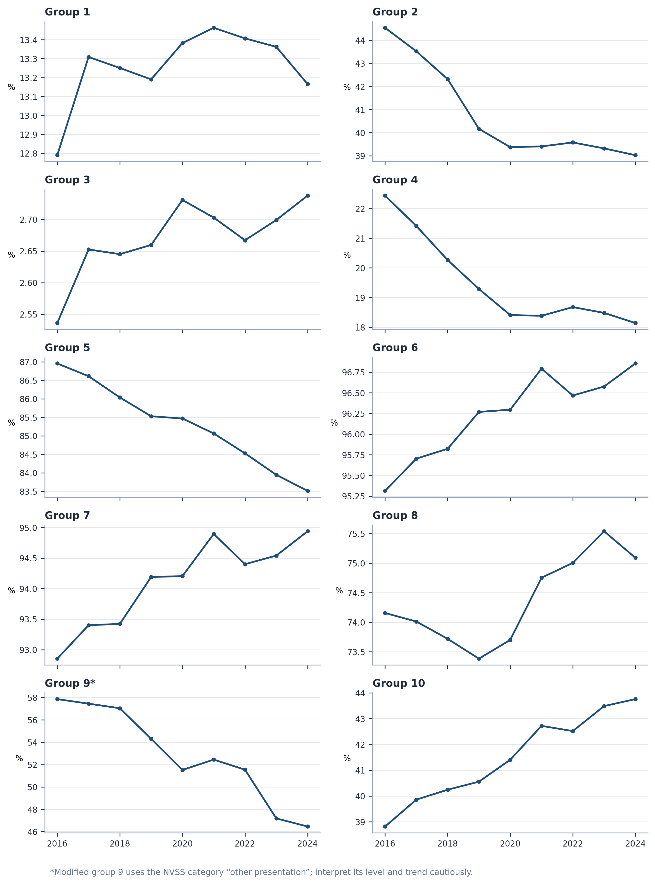
Supplementary Figure S1 Group-specific cesarean delivery rates, 2016–2024. Each panel uses its own y-axis scale to make within-group temporal change visible. Modified group 9 uses the NVSS “other presentation” category.

